Supporting Information

Synthesis, fluorescence properties, and electrochemical behavior of highly substituted imidazole/benzofuran hybrid derivatives

Erfan Jalilzadeh-Galeh¹, Zarrin Ghasemi^{1,*}, Somayeh Rashtabad Jadidi¹, Farima Shiri¹
ª Department of Organic Chemistry and Biochemistry, Faculty of Chemistry, University of Tabriz, 51666-16471, Tabriz, Iran
z.ghasemi@tabrizu.ac.ir

1. Physical characteristics and spectral data of 2a-d compounds:
1.1. Ethyl 5-(2,4,5-triphenyl-1H-imidazol-1-yl)benzofuran-2-carboxylate (2a)
White solid (0.45 g, 94%); m.p. 117 ºC; R_{f}: 0.24 (hexane: EtOAc 16:4 v/v); FT-IR (KBr, ν, cm⁻¹): 3059, 2979, 2927, 1728, 1604, 1569, 1474, 1445, 1374, 1303, 1261, 1217, 1165; ¹H NMR (400 MHz, CDCl₃, ppm): 1.45-1.49 (t, 3H, OCH₂CH₃), 4.47- 4.52 (m, 2H, OCH₂CH₃), 7.15-7.91 (m, 19H, Ar-H); ¹³C NMR (100 MHz, CDCl₃, ppm): 14.4 (OCH₂CH₃), 61.9 (OCH₂CH₃), 113.0, 113.7, 122.7, 126.8, 127.4, 127.5, 128.0, 128.2, 128.3, 128.4, 128.5, 129.0 ,130.5, 130.6, 131.2, 133.3, 134.4, 138.4, 147.3, 154.6, 159.1 (O-C=O). Anal. Calcd for: C₃₂H₂₄N₂O₃: C, 79.32; H, 4.99; N, 5.78; Found: C, 79.01; H, 5.10; N, 5.83.
1.2. Ethyl 5-[4,5-diphenyl-2-(p-tolyl)-1H-imidazol-1-yl]benzofuran-2-carboxylate (2b)
White solid (0.43 g, 89%); m.p. 120 ºC; R_{f}: 0.34 (hexane: EtOAc 16:4 v/v); FT-IR (KBr, ν, cm⁻¹): 3058, 2979, 2921, 1727, 1570, 1473, 1374, 1301, 1264, 1218, 1170; ¹H NMR (400 MHz, CDCl₃, ppm): 1.45-1.49 (t, 3H, 7.5 Hz, OCH₂CH₃), 2.35 (s, 3H, PhCH₃), 4.47- 4.52 (q, 2H, 7.5 Hz, OCH₂CH₃), 7.10-7.69 (m, 18H, Ar-H); ¹³C NMR (100 MHz, CDCl₃, ppm): 14.4 (OCH₂CH₃), 21.3 (PhCH₃), 61.8 (OCH₂CH₃), 112.9, 113.7, 122.8, 126.7, 127.4, 127.5, 127.6, 128.0, 128.2, 128.5, 128.9, 129.0 ,130.7, 131.0, 131.2, 133.4, 134.5, 138.3, 138.4, 147.2, 147.4, 154.6, 159.1 (O-C=O). Anal. Calcd for: C₃₃H₂₆N₂O₃: C, 79.50; H, 5.26; N, 5.62; Found: C, 79.20; H, 5.00; N, 5.77.
2.3. Ethyl 5-[2-(4-methoxyphenyl)-4,5-diphenyl-1H-imidazol-1-yl]benzofuran-2-carboxylate (2c)
White solid (0.43 g, 96%); m.p. 126 ºC; R_{f}: 0.24 (hexane: EtOAc 16:4 v/v); FT-IR (KBr, ν, cm⁻¹): 3058, 2980, 2934, 1728, 1608, 1573, 1476, 1445, 1375, 1300, 1252, 1178; ¹H NMR (250 MHz, CDCl₃, ppm): 1.37-1.43 (t, 3H, 7.5 Hz, OCH₂CH₃), 3.74 (s, 3H Ph-OCH₃), 4.39- 4.47 (m, 2H, 7.5 Hz, OCH₂CH₃), 6.31-7.61 (m, 18H, Ar-H); ¹³C NMR (65 MHz, CDCl₃, ppm): 13.4 (OCH₂CH₃), 54.1 (Ph-OCH₃), 60.8 (OCH₂CH₃), 112.0, 112.7, 114.8, 121.8, 121.9, 126.4, 127.1, 127.2, 127.5, 129.4, 129.6, 129.8, 130.1, 132.4, 133.4, 137.1, 140.6, 146.2, 150.3, 153.6, 158.1, 158.7 (O-C=O). Anal. Calcd for: C₃₃H₂₆N₂O₄: C, 77.03; H, 5.09; N, 5.44; Found: C, 77.21; H, 5.17; N, 5.68.
2.4. Ethyl 5-[2-(3-nitrophenyl)-4,5-diphenyl-1H-imidazol-1-yl]benzofuran-2-carboxylate (2d)
White solid (0.44 g, 95%); m.p. 120 ºC; R_{f}: 0.21 (hexane: EtOAc 16:4 v/v); FT-IR (KBr, ν, cm⁻¹): 3051, 2982, 2927, 1728, 1604, 1573, 1533, 1473, 1445, 1348, 1304, 1259, 1174; ¹H NMR (250 MHz, CDCl₃, ppm): 1.38-1.44 (t, 3H, 7.5 Hz, OCH₂CH₃), 4.39- 4.48 (q, 2H, 7.5 Hz, OCH₂CH₃), 6.70-8.30 (m, 18H, Ar-H); ¹³C NMR (65 MHz, CDCl₃, ppm): 13.3 (OCH₂CH₃), 60.9 (OCH₂CH₃), 112.5, 121.7, 122.0, 122.5, 122.6, 126.1, 126.4. 126.6, 126.7, 127.1, 127.4, 127.5, 127.6, 127.9, 128.3, 128.9, 128.3, 130.0 ,130.9, 131.3, 132.8, 133.2, 137.9, 143.6, 146.6, 147.1, 153.8, 159.1 (O-C=O). Anal. Calcd for: C₃₂H₂₃N₃O₅: C, 72.58; H, 4.38; N, 7.94; Found: C, 72.67; H, 4.55; N, 8.02.

2. Physical characteristics and spectral data of 3a-h compounds:
2.1. (E)- Ethyl -3-[2-hydroxy-5-(2,4,5-triphenyl-1H-imidazol-1-yl)phenyl]acrylates (3a)
Light yellow solid (1.21 g, 100%); m.p. 103 ºC; R_{f}: 0.37 (hexane: EtOAc 13:7 v/v); FT-IR (KBr, ν, cm⁻¹): 3430, 3057, 2981, 2931, 1706, 1629, 1602, 1505, 1439, 1289, 1165; ¹H NMR (250 MHz, CDCl₃, ppm): 1.27-1.32 (t, J= 7.5 Hz, 3H, OCH₂CH₃), 4.14-4.25 (m, 2H, OCH₂CH₃), 6.32-6.6.38 (d, J= 15 Hz, 1H, CH=CH-C=O), 6.65-7.69 (m, 18H, Ar-H), 7.71-7.77 (d, J= 15 Hz, 1H, CH=CH-C=O); ¹³C NMR (63 MHz, CDCl₃, ppm): 14.3 (OCH₂CH₃), 60.3 (OCH₂CH₃), 117.2, 119.2, 122.3, 126.6, 127.5, 128.0, 128.1, 128.3, 128.5, 128.7, 129.0, 130.2, 130.4, 131.1, 132.0, 132.2, 132.6, 134.2, 137.9, 139.9, 147.1, 157.2, 167.5 (O-C=O). Anal. Calcd for: C₃₂H₂₆N₂O₃: C, 78.99; H, 5.39; N, 5.76. Found: C, 78.81; H, 5.20; N, 5.83.
2.2. (E)-Ethyl-3-{5-[4,5-diphenyl-2-(p-tolyl)-1H-imidazol-1-yl]-2-hydroxyphenyl} acrylate (3b)
Yellow solid (1.22 g, 98%); m.p. 98 ºC; R_{f}: 0.4 (hexane: EtOAc 13:7 v/v); FT-IR (KBr, ν, cm⁻¹): 3432, 3055, 2957, 2931, 1705, 1625, 1503, 1446, 1290, 1167; ¹H NMR (250 MHz, CDCl₃, ppm): 0.90-0.95 (t, J= 7.5 Hz, 3H, OCH₂CH₃), 2.28 (s, 3H, PhCH₃), 4.15-4.24 (q, J= 7.5 Hz, 2H, OCH₂CH₃), 6.33-6.39 (d, J= 15 Hz, 1H, CH=CH-C=O), 6.67-6.70 (d, J= 7.5 Hz, 1H, Ar-H_{a}), 6.64-7.55 (m, 16H, Ar-H), 7.72-7.78 (d, 1H, J= 15 Hz, CH=CH-C=O), ¹³C NMR (63 MHz, CDCl₃, ppm): 13.6 (OCH₂CH₃), 23.6 (PhCH₃), 60.2 (OCH₂CH₃), 117.5, 118.5, 122.2, 126.6, 127.6, 127.9, 128.1, 128.3, 128.8, 130.6, 131.1, 134.2, 137.8, 138.2, 140.4, 147.3, 153.1,154.7, 158.3, 167.7 (O-C=O). Anal. Calcd for: C₃₃H₂₈N₂O₃: C, 79.18; H, 5.64; N, 5.60. Found: C, 79.11; H, 5.73; N, 5.72.
2.3. (E) -Ethyl 3-{2-hydroxy-5-[2-(4-methoxyphenyl)-4,5-diphenyl-1H-imidazol-1-yl]phenyl} acrylate (3c)
White solid (1.29 g, 100%); m.p. 228 ºC; R_{f}: 0.3 (hexane: EtOAc 13:7 v/v); FT-IR (KBr, ν, cm⁻¹): 3443, 3053, 2958, 2932, 1706, 1630, 1606, 1443, 1289, 1252, 1173, 1113; ¹H NMR (250 MHz, CDCl₃, ppm): 0.90-0.95 (m, 3H, OCH₂CH₃₎, 3.77 (s, 3H, PhOCH₃), 4.17-4.25 (q, J= 7.5 Hz, 2H, OCH₂CH₃), 6.32-6.38 (d, J= 15 Hz, 1H, CH=CH-C=O), 6.68-7.68 (m, 17H, Ar-H, OH), 7.72-7.78 (d, J= 15 Hz, 1H, CH=CH-C=O); ¹³C NMR (63 MHz, CDCl₃, ppm): 13.5 (OCH₂CH₃), 55.1 (PhOCH₃), 60.3 (OCH₂CH₃), 113.6, 117.1, 119.2, 122.3, 122.6, 126.6, 127.6, 128.1, 128.3, 128.8, 130.4, 131.1, 134.1, 137.6, 139.9, 147.2, 157.0, 159.7, 167.6 (O-C=O). Anal. Calcd for: C₃₃H₂₈N₂O₄: C, 76.73; H, 5.46; N, 5.42. Found: C, 76.50; H, 5.39; N, 5.50.
2.4. (E)-Ethyl -3-{2-hydroxy-5-[2-(3-nitrophenyl)-4,5-diphenyl-1H-imidazol-1-yl] phenyl} acrylate (3d)
Yellow solid (1.28 g, 96%); m.p. 101 ºC; R_{f}: 0.37 (hexane: EtOAc 13:7 v/v); FT-IR (KBr, ν, cm⁻¹): 3447, 3058, 2980, 2929, 1706, 1630, 1506, 1533, 1439, 1348, 1290, 1165; ¹H NMR (250 MHz, CDCl₃, ppm): 1.24-1.30 (m, 3H, OCH₂CH₃), 4.14-4.23 (q, J= 7.5 Hz, 2H, OCH₂CH₃), 6.34-6.40 (d, J= 15 Hz, 1H, CH=CH-C=O), 6.81-6.83 (d, J= 5 Hz, 1H, Ar-H_{a}), 7.11-7.69 (m, 13H, Ar-H), 7.73-7.79 (d, 1H, J= 15 Hz, CH=CH-C=O), 8.01 (s, 1H, Ar-OH), 8.06-8.10 (m, 1H, NO₂-CH-C-Im-CH_{b}) 8.39-8.40 (m, 1H, NO₂-CH_{c}-C-Im); ¹³C NMR (63 MHz, CDCl₃, ppm): 14.3 (OCH₂CH₃), 60.4 (OCH₂CH₃), 117.6, 119.3, 122.7, 123.5, 126.9, 127.4, 128.3, 128.6, 128.8, 129.1, 130.0, 130.3, 130.7, 131.0, 132.0, 132.1, 132.3, 133.9, 134.2, 138.6, 139.7, 144.4, 148.0, 158.1, 167.5 (O-C=O). Anal. Calcd for: C₃₂H₂₅N₃O₅: C, 72.31; H, 4.74; N, 7.91. Found: C, 72.41; H, 4.81; N, 5.66.
2.5. (E)-Ethyl-3-{5-[4,5-diphenyl-2-(thiophen-3-yl)-1H-imidazol-1-yl]-2-hydroxy phenyl } acrylate (3e)
Yellow solid (1.14 g, 97%); m.p. 80-82 ºC; R_{f}: 0.37 (hexane: EtOAc 13:7 v/v); FT-IR (KBr, ν, cm⁻¹): 3437, 3059, 2957, 2930, 1705, 1637, 1503, 1446, 1373, 1291, 1167; ¹H NMR (250 MHz, CDCl₃, ppm): 0.91-0.96 (t, J= 7.5 Hz 3H, OCH₂CH₃), 4.17-4.26 (q, J= 7.5 Hz, 2H, OCH₂CH₃), 6.43-6.50 (d, J= 17.5 Hz, 1H, CH=CH-C=O), 6.66-7.54 (m, 16H, Ar-H), 7.80-7.87 (d, 1H, J= 17.5 Hz, CH=CH-C=O); ¹³C NMR (63 MHz, CDCl₃, ppm): 13.6 (OCH₂CH₃), 60.3 (OCH₂CH₃), 117.5, 119.0, 122.6, 124.3, 125.1, 126.7, 127.6, 127.9, 128.1, 128.3, 128.9, 130.2, 130.6, 131.0, 134.0, 137.6, 140.1, 143.7, 158.5, 167.6 (O-C=O). Anal. Calcd for: C₃₀H₂₄N₂O₃S: C, 73.15; H, 4.91; N, 5.69; S, 6.51. Found: C, 73.00; H, 4.89; N, 5.77; S, 6.49.
2.6. (E)-Ethyl-3-{2-hydroxy-5-[2-(4-isopropylphenyl)-4,5-diphenyl-1H-imidazol-1-yl] phenyl} acrylate (3f)
White solid (1.26 g, 95%); decomposition degree 230 ºC; R_{f}: 0.4 (hexane: EtOAc 13:7 v/v); FT-IR (KBr, ν, cm⁻¹): 3443, 3044, 2960, 1708, 1627, 1503, 1433, 1374, 1289, 1160, 1113; ¹H NMR (250 MHz, CDCl₃, ppm): 1.18-1.20 (d, J= 5 Hz, 6H, H₃CCHCH₃), 1.26-1.32 (t, J= 7.5 Hz, 3H, OCH₂CH₃), 2.81-87 (m, 1H, H₃CCHCH₃) 4.16-4.25 (q, J= 7.5 Hz, 2H, OCH₂CH₃) , 6.28-6.35 (d, J= 17.5 Hz, 1H, CH=CH-C=O), 6.61-7.56 (m, 18H, Ar-H), 7.73-7.80 (d, J= 17.5 Hz, 1H, CH=CH-C=O); ¹³C NMR (63 MHz, CDCl₃, ppm): 14.3 (OCH₂CH₃), 23.7 (PhCH(CH₃)₂), 33.8 (PhCH(CH₃)₂), 60.3 (OCH₂CH₃), 117.4, 118.9, 122.3, 126.2, 126.6, 127.5, 128.1, 128.3, 128.8, 130.7, 131.1, 134.3, 137.9, 140.0, 142.3, 147.3, 149.1, 157.3, 167.6 (O-C=O). Anal. Calcd for: C₃₅H₃₂N₂O₃: C, 79.52; H, 6.10; N, 5.30. Found: C, 79.47; H, 6.18; N, 5.19.
2.7. (E)-Ethyl -3-{5-[2-(4-chlorophenyl)-4,5-diphenyl-1H-imidazol-1-yl]-2-hydroxy phenyl}acrylate (3g)
White solid (1.18 g, 94%); m.p. 110-112 ºC; R_{f}: 0.4 (hexane: EtOAc 13:7 v/v); FT-IR (KBr, ν, cm⁻¹): 3412, 3056, 2931, 2866, 1703, 1625, 1505, 1446, 1375, 1290, 1163; ¹H NMR (250 MHz, CDCl₃, ppm): 0.90-0.95 (t, J= 7.5 Hz 3H, OCH₂CH₃), 4.16- 4.25 (q, J= 7.5 Hz , 2H, OCH₂CH₃), 6.36- 6.42 (d, J= 15 Hz, 1H, CH=CH-C=O), 6.72-7.56 (m, 17H, Ar-H), 7.73-7.79 (d, J= 15 Hz, 1H, CH=CH-C=O), 8.02 (s, 1H, Ar-OH); ¹³C NMR (63 MHz, CDCl₃, ppm): 13.6 (OCH₂CH₃), 60.3 (OCH₂CH₃), 117.3, 119.0, 122.3, 126.7, 127.4, 127.6, 128.1, 128.4, 128.7, 128.8, 130.1, 130.4, 131.1, 131.5 ,134.1, 134.3, 140.0, 145.9, 158.1, 167.5 (O-C=O). Anal. Calcd for: C₃₂H₂₅ClN₂O₃: C, 73.77; H, 4.84; N, 5.38. Found: C, 73.69; H, 4.58; N, 5.49.
2.8. (E)-Ethyl-3-{5-[4,5-diphenyl-1-(p-tolyl)-1H-imidazol-2-yl]-2-hydroxyphenyl} acrylate (3h)
White solid (1.13 g, 90%); m.p. 107 ºC; R_{f}: 0.4 (hexane: EtOAc 13:7 v/v); FT-IR (KBr, ν, cm⁻¹): 3436, 3046, 2938, 2870, 1706, 1619, 1511, 1448, 1382, 1294, 1169; ¹H NMR (250 MHz, CDCl₃, ppm): 0.89-0.95 (m, 3H, OCH₂CH₃), 2.32 (s, 3H, PhCH₃), 4.14-4.25 (m, 2H, OCH₂CH₃), 6.05-6.12 (d, J= 17.5 Hz, 1H, CH=CH-C=O), 6.62-6.66 (d, J= 10 Hz, 1H, Ar-H_{a}), 6.85-7.59 (m, 18H, Ar-H), 7.79-7.86 (d, J= 17.5 Hz, 1H, CH=CH-C=O); ¹³C NMR (63 MHz, CDCl₃, ppm): 14.3 (OCH₂CH₃), 23.7 (PhCH₃), 60.0 (OCH₂CH₃), 116.8, 117.9, 120.8, 121.6, 126.6, 127.6, 128.2, 129.2, 129.8, 130.5, 131.1, 131.9, 134.0, 134.3, 137.6, 138.5, 140.3, 147.0, 157.6, 167.6 (O-C=O). Anal. Calcd for: C₃₃H₂₈N₂O₃: C, 79.18; H, 5.64; N, 5.60. Found: C, 79.10; H, 5.74 N, 5.71.

3. Physical characteristics and spectral data of 4a-h compounds:
3.1. (E)-Ethyl -3-[2-(2-ethoxy-2-oxoethoxy)-5-(2,4,5-triphenyl-1H-imidazol-1-yl)phenyl] acrylate (4a)
White solid (1.30 g, 98%); m.p. 181ºC; R_{f}: 0.37 (hexane: EtOAc 15:5 v/v); FT-IR (KBr, ν, cm⁻¹): 3051, 2980, 1741, 1707, 1631, 1442, 1265, 1239, 1175 ; ¹H NMR (250 MHz, CDCl₃, ppm): 1.26-1.33 (t, 6H, OCH₂CH₃), 4.08-4.28 (m, 4H, OCH₂CH₃), 4.57 (s, 2H, OCH₂C=O), 6.35-6.42 (d, J= 17.5 Hz, 1H, CH=CH-C=O), 6.60-7.68 (m, 18H, Ar-H), 7.73-7.80 (d, J= 17.5 Hz, 1H, CH=CH-C=O); ¹³C NMR (63 MHz, CDCl₃, ppm): 14.1 (OCH₂CH₃), 14.3 (OCH₂CH₃), 60.4 (OCH₂CH₃), 61.6 (OCH₂CH₃), 65.8 (OCH₂C=O), 112.4, 121.2, 124.7, 125.3, 126.6, 127.3, 128.2, 128.2, 128.4, 128.5, 128.6, 128.9, 129.2, 130.4, 130.6, 130.9, 131.1, 131.7, 131.9, 132.1, 133.4, 133.9, 134.4, 138.4, 146.9, 155.8, 166.9 (O-C=O), 167.8 (O-C=O). Anal. Calcd for: C₃₆H₃₂N₂O₅: C, 75.51; H, 5.63; N, 4.89. Found: C, 75.40; H, 5.71; N, 4.96.
3.2. (E)-ethyl -3-{5-[4,5-diphenyl-2-(p-tolyl)-1H- imidazol -1-yl] -2- [2-ethoxy-2-oxoethoxy] phenyl}acrylate (4b)
Light yellow (1.27 g, 96%); m.p. 150 ºC; R_{f}: 0.37 (hexane: EtOAc 15:5 v/v); FT-IR (KBr, ν, cm⁻¹): 3061, 2979, 2932, 1734, 1698, 1633, 1437, 1282, 1173; ¹H NMR (250 MHz, CDCl₃, ppm): 1.26- 1.33 (m, 6H, OCH₂CH₃), 2.31 (s, 3H, Ph-CH₃), 4.19-4.31 (m, 4H, OCH₂CH₃), 4.66 (s, 2H, OCH₂C=O), 6.35-6.42 (d, J= 17.5 Hz, 1H, CH=CH-C=O), 6.62-6.65 (d, J= 7.5 Hz, 1H, H_{a}), 6.94-7.61 (m, 15H, Ar-H), 7.75-7.82 (d, J= 17.5 Hz, 1H, CH=CH-C=O); ¹³C NMR (63 MHz, CDCl₃, ppm): 14.1 (OCH₂CH₃), 14.3 (OCH₂CH₃), 21.2 (Ph-CH₃) 60.5 (OCH₂CH₃), 61.6 (OCH2CH3), 65.9 (OCH₂C=O), 112.3, 121.2, 124.7, 126.6, 127.3, 128.1, 128.5, 128.9, 129.2, 130.6, 131.1, 133.9, 134.4, 138.4, 147.1, 155.8, 166.9, (O-C=O), 167.9 (O-C=O). Anal. Calcd for: C₃₇H₃₄N₂O₅: C, 75.75; H, 5.84; N, 4.77. Found: C, 75.79; H, 5.80; N, 4.89.
3.3. (E)-ethyl-3-{2-[2-ethoxy-2-oxoethoxy]-5-[2-(4-methoxyphenyl)-4,5-diphenyl-1H-imidazol-1-yl]phenyl}acrylate (4c)
White solid (1.36 g, 98%); m.p. 178 ºC; R_{f}: 0.33 (hexane: EtOAc 15:5 v/v); FT-IR (KBr, ν, cm⁻¹): 3042, 2977, 2936, 1740, 1709, 1631, 1444, 1258, 1177; ¹H NMR (250 MHz, CDCl₃, ppm): 1.26-1.31 (m, 6H, OCH₂CH₃), 3.79 (s, 3H, OCH₃), 4.20-4.29 (m, 4H, OCH₂CH₃), 4.67 (s, 2H, OCH₂C=O), 6.37-6.44 (d, J= 17.5 Hz, 1H, CH=CH-C=O), 6.63-6.66 (d, J= 7.5 Hz, 1H, H_{a}), 6.77-7.60 (m, 16H, Ar-H), 7.75-7.82 (d, J= 17.5 Hz, 1H, CH=CH-C=O); ¹³C NMR (63 MHz, CDCl₃, ppm): 14.1 (OCH₂CH₃), 14.3 (OCH₂CH₃), 55.2 (OCH₃) , 60.5 (OCH₂CH₃), 61.7 (OCH₂CH₃), 65.8 (OCH₂C=O), 112.3, 113.7, 121.2, 122.9, 124.7, 126.6, 127.3, 128.1, 128.5, 129.3, 130.3, 130.6, 131.1, 134.4, 138.0, 138.4, 146.9, 155.7, 159.6, 167.0 (O-C=O), 167.9 (O-C=O). Anal. Calcd for: C₃₇H₃₄N₂O₆: C, 73.74; H, 5.69; N, 4.65. Found: C, 73.80; H, 5.57; N, 4.71.
3.4. (E)-Ethyl -3-{2-[2-ethoxy-2-oxoethoxy]-5-[2-(3-nitrophenyl)-4,5-diphenyl-1H-imidazol-1-yl]phenyl}acrylate (4d)
Yellow solid (1.35 g, 95%); m.p. 140 ºC; R_{f}: 0.4 (hexane: EtOAc 15:5 v/v); FT-IR (KBr, ν, cm⁻¹): 3091, 3058, 2981, 2929, 1738, 1701, 1632, 1528, 1502, 1439, 1377, 1266, 1237, 1181; ¹H NMR (250 MHz, CDCl₃, ppm): 1.21-1.35 (t, 6H, OCH₂CH₃), 4.18-4.31 (m, 4H, OCH₂CH₃), 4.68 (s, 2H, OCH₂C=O), 6.41-6.47 (d, J= 15 Hz, 1H, CH=CH-C=O), 6.70-6.74 (d, J= 10 Hz, 1H, H_{a}) 7.02-8.05 (m, 15H, Ar-H), 7.75-7.81 (d, J= 15 Hz, 1H, CH=CH-C=O), 8.10-8.13 (m, 1H, Im-C-CH-C-NO₂-CH), 8.31-8.33 (m, 1H, NO₂-CH-C-Im); ¹³C NMR (63 MHz, CDCl₃, ppm): 14.0 (OCH₂CH₃), 14.2 (OCH₂CH₃), 21.2 (PhCH₃) , 60.5 (OCH₂CH₃), 61.7 (OCH₂CH₃), 65.9 (OCH₂C=O), 112.9, 121.6, 122.8, 123.4, 125.3, 126.9, 127.2, 128.2, 128.4, 128.6, 129.0, 129.3, 129.9, 130.4, 131.0, 133.3, 134.0, 138.0, 138.8, 144.3, 148.1, 156.4, 162.5, 166.8, 167.7 (O-C=O), 167.7 (O-C=O). Anal. Calcd for: C₃₆H₃₁N₃O₇: C, 70.01; H, 5.06; N, 6.80. Found: C, 69.92; H, 5.15; N, 6.91.
3.5. (E)-Ethyl -3-{5-[4,5-diphenyl-2-(thiophen-3-yl)-1H-imidazol-1-yl]-2-[2-ethoxy-2-oxoethoxy]phenyl}acrylate (4e)
Light yellow (1.28 g, 96%); m.p. 165 ºC; R_{f}: 0.37 (hexane: EtOAc 15:5 v/v); FT-IR (KBr, ν, cm⁻¹): 3046, 2974, 2928, 1738, 1701, 1631, 1293, 1233, 1178; ¹H NMR (250 MHz, CDCl₃, ppm): 1.27-1.34 (m, 6H, OCH₂CH₃), 4.20-4.32 (m, 4H, OCH₂CH₃), 4.70 (s, 2H, OCH₂C=O), 6.45-6.51 (d, J= 15 Hz, 1H, CH=CH-C=O), 6.70-6.74 (d, J= 10 Hz, 1H, H_{a}), 7.04-7.60 (m, 13 H, Ar-H), 7.80-7.86 (d, J= 15 Hz, 1H, CH=CH-C=O); ¹³C NMR (63 MHz, CDCl₃, ppm): 14.1 (OCH₂CH₃), 14.3 (OCH₂CH₃), 60.5 (OCH₂CH₃), 61.7 (OCH₂CH₃), 65.9 (OCH₂C=O), 112.5, 121.4, 124.1, 125.0, 125.3, 126.7, 127.3, 127.9, 128.2, 128.5, 129.4, 130.3, 130.8, 131.0, 134.1, 138.2, 156.2, 166.9 (O-C=O), 167.8 (O-C=O). Anal. Calcd for: C₃₄H₃₀N₂O₅S: C, 70.57; H, 5.23; N, 4.84; S, 5.54. Found: C, 70.61; H, 5.29; N, 4.78; S, 5.63.
3.6. (E)-Ethyl-3-{2-[2-ethoxy-2-oxoethoxy]-5-[2-(4-isopropylphenyl)-4,5-diphenyl-1H-imidazol-1-yl]phenyl}acrylate (4f)
White solid (1.39 g, 98%); m.p. 192 ºC; R_{f}: 0.47 (hexane: EtOAc 15:5 v/v); FT-IR (KBr, ν, cm⁻¹): 3058, 2962, 1732, 1632, 1442, 1277, 1243, 1172; ¹H NMR (250 MHz, CDCl₃, ppm): 1.20-1.23 (d, J= 7.5 Hz 6H, H₃CCHCH₃), 1.26-1.33 (m, 6H, OCH₂CH₃), 2.81-2.95 (m, 1H, H₃CCHCH₃), 4.21-4.28 (m, 4H, OCH₂CH₃), 4.66 (s, 2H, OCH₂C=O), 6.32-6.39 (d, J= 17.5 Hz, 1H, CH=CH-C=O), 6.62-6.66 (d, J= 10 Hz, 1H, Ar-H_{a}), 6.95-6.61 (m, 16H, Ar-H), 7.76-7.83 (d, J= 17.5 Hz, 1H, CH=CH-C=O); ¹³C NMR (63 MHz, CDCl₃, ppm): 14.10 (OCH₂CH₃), 14.3 (OCH₂CH₃), 23.7 (PhCH(CH₃)₂), 33.8 (PhCH(CH₃)₂) , 60.5 (OCH₂CH₃), 61.6 (OCH₂CH₃), 65.9 (OCH₂C=O), 112.3, 121.1, 124.8, 126.3, 126.6, 127.3, 128.1, 128.5, 128.8, 129.2, 130.6, 131.1, 134.4, 138.4, 147.1, 149.2, 155.7,166.9 (O-C=O), 167.9 (O-C=O). Anal. Calcd for: C₃₉H₃₈N₂O₅: C, 76.20; H, 6.23; N, 4.56. Found: C, 76.28; H, 6.19; N, 4.49.
3.7. (E)-Ethyl -3-{5-[2-(4-chlorophenyl)-4,5-diphenyl-1H-imidazol-1-yl]-2-[2-ethoxy-2-oxoethoxy]phenyl}acrylate (4g)
White solid (1.36 g, 97%); m.p. 181 ºC; R_{f}: 0.43 (hexane: EtOAc 15:5 v/v); FT-IR (KBr, ν, cm⁻¹): 3061, 2977, 2930, 1739, 1708, 1632, 1602, 1442, 1265, 1240, 1176; ¹H NMR (250 MHz, CDCl₃, ppm): 1.23-1.33 (m, 6H, OCH₂CH₃), 4.16-4.32 (m, 4H, OCH₂CH₃), 4.67 (s, 2H, OCH₂C=O), 6.38-6.44 (d, J= 15 Hz, 1H, CH=CH-C=O), 6.64-6.68 (d, J= 10 Hz, 1H, Ph-H_{a}), 6.92-7.59 (m, 16 H, Ar-H), 7.75-7.81 (d, J= 15 Hz, 1H, CH=CH-C=O); ¹³C NMR (63 MHz, CDCl₃, ppm): 14.1 (OCH₂CH₃), 14.3 (OCH₂CH₃), 60.5 (OCH₂CH₃), 61.7 (OCH₂CH₃), 65.8 (OCH₂C=O), 112.5, 121.4, 125.0, 126.7, 127.3, 128.2, 128.3, 128.5, 129.1, 130.0, 130.4, 130.7, 131.1, 134.4, 138.2, 145.8, 156.0, 166.9 (O-C=O), 167.8 (O-C=O). Anal. Calcd for: C₃₆H₃₁ClN₂O₅: C, 71.22; H, 5.15; N, 4.61. Found: C, 71.14; H, 5.26; N, 4.73.
3.8. (E)-Ethyl -3-{5-[4,5-diphenyl-1-(p-tolyl)-1H-imidazol-2-yl]-2-[2-ethoxy-2-oxoethoxy]phenyl}acrylate (4h)
White solid (1.29 g, 96%); m.p. 140 ºC; R_{f}: 0.43 (hexane: EtOAc 15:5 v/v); FT-IR (KBr, ν, cm⁻¹): 3055, 2982, 1758, 1703, 1612, 1440, 1266, 1237, 1181; ¹H NMR (250 MHz, CDCl₃, ppm): 1.26-1.35 (m, 6H, OCH₂CH₃), 2.35 (s, 3H, PhCH₃), 4.19-4.31 (m, 4H, OCH₂CH₃), 4.67 (s, 2H, OCH₂C=O), 6.10-6.17 (d, J= 17.5 Hz, 1H, CH=CH-C=O), 6.67-6.70 (d, J= 7.5 Hz, 1H, H_{a}), 6.89-7.62 (m, 16H, Ar-H), 7.86-8.93 (d, J= 17.5 Hz, 1H, CH=CH-C=O); ¹³C NMR (63 MHz, CDCl₃, ppm): 14.1 (OCH₂CH₃), 14.3 (OCH₂CH₃), 21.1 (PhCH₃), 60.3 (OCH₂CH₃), 61.5 (OCH₂CH₃), 65.7 (OCH₂C=O), 111.8, 119.8, 123.6, 124.2, 126.60, 127.3, 128.2, 129.0, 129.9, 131.1, 131.7, 134.4, 138.7, 139.1, 145.7, 156.2, 167.1 (O-C=O), 168.3 (O-C=O). Anal. Calcd for: C₃₇H₃₄N₂O₅: C, 75.75; H, 5.84; N, 4.77. Found: C, 75.80; H, 5.79; N, 4.87.
4. Physical characteristics and spectral data of 5a-h compounds:
4.1. Ethyl 3-(2-ethoxy-2-oxoethyl)-5-(2,4,5-triphenyl-1H-imidazol-1-yl)-2,3-dihydro benzofuran-2-carboxylate (5a)
White solid (0.66 g, 78%); m.p. 96 ºC; R_{f}: 0.43 (hexane: EtOAc 14:6 v/v); FT-IR (KBr, ν, cm⁻¹): 3059, 2978, 2928, 1735 (C=O), 1603, 1486, 1446, 1377, 1189; ¹H NMR (250 MHz, CDCl₃, ppm): 1.19-1.33 (m, 6H, OCH₂CH₃), 2.33-2.64 (m, 2H, CH₂C=O), 3.87-3.95 (m, 1H, CH-CH₂C=O), 4.02-4.14 (m, 2 H, OCH₂CH₃), 4.17-4.34 (m, 2H, OCH₂CH₃), 4.90-5.92 (d, J= 5 Hz, 1H, OCHC=O), 6.73-7.62 (m, 18 H, Ar-H); ¹³C NMR (63 MHz, CDCl₃, ppm): 14.1 (OCH₂CH₃), 39.1 (CH-CH₂C=O), 42.4 (CH-CH₂C=O), 61.0 (OCH₂CH3), 61.7 (OCH₂CH₃), 84.7 (OCHC=O), 110.2, 124.6, 126.5, 127.3, 128.1, 128.3, 128.9, 129.3, 130.8, 131.1, 134.5, 138.1, 142.3, 147.0, 153.4, 158.4, 168.5 (O-C=O), 170.4 (O-C=O). Anal. Calcd for: C₃₆H₃₂N₂O₅: C, 75.51; H, 5.63; N, 4.89. Found: C, 75.58; H, 5.57; N, 4.95.
4.2. Ethyl 5-[4,5-diphenyl-2-(p-tolyl)-1H-imidazol-1-yl]-3-(2-ethoxy-2-oxoethyl)-2,3-dihydrobenzofuran-2-carboxylate (5b)
Light yellow (0.67 g, 76%); m.p. 105 ºC; R_{f}: 0.36 (hexane: EtOAc 14:6 v/v); FT-IR (KBr, ν, cm⁻¹): 3058, 2978, 2926, 1734 (C=O), 1606, 1486, 1445, 1188; ¹H NMR (250 MHz, CDCl₃, ppm): 1.18-1.33 (m, 6H, OCH₂CH₃), 2.32 (s, 3H, PhCH₃), 2.42-2.57 (m, 2H, CH₂C=O), 3.87-3.95 (m, 1H, CH-CH₂C=O), 4.08-4.17 (m, 2H, OCH₂CH₃), 4.21-4.35 (m, 2H, OCH₂CH₃), 5.26-5.29 (d, J= 7.5 Hz, 1H, OCHC=O), 6.44-7.60 (m, 17H, Ar-H); ¹³C NMR (63 MHz, CDCl₃, ppm): 14.1 (OCH₂CH₃), 21.2 (PhCH₃), 39.2 (CH-CH₂C=O), 42.4 (CH-CH₂C=O), 60.9 (OCH₂CH3), 61.8 (OCH₂CH₃), 84.7 (OCHC=O), 110.2, 124.6, 126.5, 127.3, 127.8, 128.1, 128.3, 128.8, 129.4, 130.9, 131.2, 134.5, 138.1, 147.1, 158.3, 169.8 (O-C=O), 170.4 (O-C=O) Anal. Calcd for: C₃₇H₃₄N₂O₅: C, 75.75; H, 5.84; N, 4.77. Found: C, 75.69; H, 5.75; N, 4.82.
4.3. Ethyl 3-(2-ethoxy-2-oxoethyl)-5-[2-(4-methoxyphenyl)-4,5-diphenyl-1H-imidazol-1-yl]-2,3-dihydrobenzofuran-2-carboxylate (5c)
Light yellow (0.70 g, 78%); m.p. 110 ºC; R_{f}: 0.28 (hexane: EtOAc 14:6 v/v); FT-IR (KBr, ν, cm⁻¹): 3059, 2980, 2934, 1735 (C=O), 1608, 1445, 1296, 1251, 1181; ¹H NMR (250 MHz, CDCl₃, ppm): 1.19-1.33 (m, 6H, OCH₂CH₃), 2.43-2.58 (m, 2H, CH₂C=O), 3.79 (s, 3H, OCH₃), 3.78-3.95 (m, 1H, CH-CH₂C=O), 4.05-4.16 (m, 2H, OCH₂CH₃), 4.22-4.31 (m, 2H, OCH₂CH₃), 4.90-4.93 (d, 6.5 Hz, 1H, OCHC=O), 6.73-7.60 (m, 17 H, Ar-H); ¹³C NMR (63 MHz, CDCl₃, ppm): 14.1 (OCH₂CH₃), 39.2 (CH-CH₂C=O), 42.4 (CH-CH₂C=O), 55.2 (OCH₃), 60.9 (OCH₂CH₃), 61.8 (OCH₂CH₃), 84.7 (OCHC=O), 110.2 ,113.6 ,123.1 ,124.6 ,126.5 ,127.3 ,127.8 ,128.1 ,128.3 ,128.8 ,129.4 ,130.2, 130.6,,130.9, 131.2, 134.6, 137.9, 146.9, 158.3, 159.6, 169.8 (O-C=O), 170.4 (O-C=O). Anal. Calcd for: C₃₇H₃₄N₂O₆: C, 73.74; H, 5.69; N, 4.65. Found: C, 73.77; H, 5.71; N, 4.59.
4.4. Ethyl 3-(2-ethoxy-2-oxoethyl)-5-[2-(3-nitrophenyl)-4,5-diphenyl-1H-imidazol-1-yl]-2,3-dihydrobenzofuran-2-carboxylate (5d)
Yellow solid (0.63 g, 71%); m.p. 65 ºC; R_{f}: 0.32 (hexane: EtOAc 14:6 v/v); FT-IR (KBr, ν, cm⁻¹): 3061, 2980, 2929, 1733 (C=O), 1606, 1445, 1193; ¹H NMR (250 MHz, CDCl₃, ppm): 1.26-1.34 (m, 6H, OCH₂CH₃), 2.52-2.65 (m, 2H, CH₂C=O), 3.91-3.99 (m, 1H, CH-CH₂C=O), 4.08-4.16 (m, 2H, OCH₂CH₃), 4.21-4.35 (m, 2 H, OCH₂CH₃), 4.92-4.95 (d, J = 7.5 Hz, 1H, OCHC=O), 6.78-8.12 (m, 17H, Ar-H); ¹³C NMR (63 MHz, CDCl₃, ppm): 14.1 (OCH₂CH₃), 39.3 (CH-CH₂C=O), 42.3 (CH-CH₂C=O), 61.0 (OCH₂CH₃), 61.9 (OCH₂CH₃), 84.9 (OCHC=O), 110.7, 122.6, 124.7 ,126.9, 127.2, 128.2, 128.5, 129.1, 129.3, 130.1, 131.1, 132.2, 134.2, 144.3, 148.1, 159.0, 169.7 (O-C=O), 170.4 (O-C=O). Anal. Calcd for: C₃₆H₃₁N₃O₇: C, 70.01; H, 5.06; N, 6.80. Found: C, 69.96; H, 5.12; N, 6.86.
4.5. Ethyl 5-[4,5-diphenyl-2-(thiophen-3-yl)-1H-imidazol-1-yl]-3-(2-ethoxy-2-oxoethyl)-2,3-dihydrobenzofuran-2-carboxylate (5e)
Light yellow (0.69 g, 79%); m.p. 158 ºC; R_{f}: 0.39 (hexane: EtOAc 14:6 v/v); FT-IR (KBr, ν, cm⁻¹): 3059, 2976, 2928, 1734 (C=O), 1604, 1444, 1272, 1186; ¹H NMR (250 MHz, CDCl₃, ppm): 1.19-1.34 (m, 6H, OCH₂CH₃), 2.52-2.62 (m, 2H, CH₂C=O), 3.92-4.00 (m, 1H, CH-CH₂C=O), 4.06-4.14 (m, 2 H, OCH₂CH₃), 4.23-4.33 (m, 2H, OCH₂CH₃), 4.95-4.97 (d, J= 7.5 Hz, 1H, OCHC=O), 6.82-7.60 (m, 16H, Ar-H); ¹³C NMR (63 MHz, CDCl₃, ppm): 14.1 (OCH₂CH₃), 39.1 (CH-CH₂C=O), 42.4 (CH-CH₂C=O), 61.0 (OCH₂CH3), 61.9 (OCH₂CH₃), 84.8 (OCHC=O), 110.4, 123.8, 124.8, 124.9, 126.6, 127.3, 127.9, 128.1, 128.3, 129.1, 129.6, 130.6, 131.1, 131.6, 134.4, 137.9, 158.9, 169.8 (O-C=O), 170.4 (O-C=O). Anal. Calcd for: C₃₄H₃₀N₂O₅S: C, 70.57; H, 5.23; N, 4.84; S, 5.54. Found: C, 70.63; H, 5.31; N, 4.91; S, 5.42.
4.6. Ethyl 3-(2-ethoxy-2-oxoethyl)-5-[2-(4-isopropylphenyl)-4,5-diphenyl-1H-imidazol-1-yl]-2,3-dihydrobenzofuran-2-carboxylate (5f)
White solid (0.72 g, 79%); m.p. 167 ºC; R_{f}: 0.46 (hexane: EtOAc 14:6 v/v); FT-IR (KBr, ν, cm⁻¹) 3059, 2966, 1739, 1607, 1487, 1377, 1194; ¹H NMR (250 MHz, CDCl₃, ppm): 1.21-1.33 (m, 12 H, CH₃CHCH₃, OCH₂CH₃), 2.25-2.62 (m, 2H, CH₂C=O), 2.82-2.95 (m, 1H, CH₃CHCH₃), 3.90-2.95 (m, 1H, CH-CH₂C=O), 4.05-4.14 (m, 2 H, OCH₂CH₃), 4.20-4.32 (m, 2H, OCH₂CH₃), 4.90-4.93 (d, J = 7.5 Hz, 1H, OCHC=O), 6.74-7.61 (m, 17H, Ar-H); ¹³C NMR (63 MHz, CDCl₃, ppm): 14.1 (OCH₂CH₃), 23.7, 23.8 (CH₃CHCH₃), 33.8 (CH₃CHCH₃), 39.2 (CH-CH₂C=O), 42.4 (O-CH-CH-CH₂C=O), 60.9 (OCH₂CH₃), 61.8 (OCH₂CH₃), 84.7 (OCHC=O), 110.2, 124.6, 124.7, 126.2, 126.5, 127.3, 127.8, 128.1, 128.3, 128.8, 129.2, 129.4, 130.9, 131.2, 134.6, 138.0, 147.1 , 149.0, 158.3, 169.8 (O-C=O), 170.4 (O-C=O). Anal. Calcd for: C₃₉H₃₈N₂O₅: C, 76.20; H, 6.23; N, 4.56. Found: C, 76.27; H, 6.18; N, 4.62.
4.7. Ethyl 5-[2-(4-chlorophenyl)-4,5-diphenyl-1H-imidazol-1-yl]-3-(2-ethoxy-2-oxoethyl )-2,3-dihydrobenzofuran-2-carboxylate (5g)
Light yellow (0.65 g, 74%); m.p. 140 ºC; R_{f}: 0.46 (hexane: EtOAc 14:6 v/v); FT-IR (KBr, ν, cm⁻¹): 3059, 2979, 2935, 1733 (C=O), 1608, 1487, 1444, 1253, 1179; ¹H NMR (250 MHz, CDCl₃, ppm): 1.20-1.34 (m, 6H, OCH₂CH₃), 2.47-2.60 (m, 2H, CH₂C=O), 3.91-3.93 (m, 1H, CH-CH₂C=O), 4.08-4.11 (m, 2 H, OCH₂CH₃), 4.23-4.32, (m, 2H, OCH₂CH₃) 4.92-4.94 (d, J= 5 Hz, 1H, OCHC=O), 6.75-7.90 (m, 17H, Ar-H); ¹³C NMR (63 MHz, CDCl₃, ppm): 14.1 (OCH₂CH₃), 39.1 (CH-CH₂C=O), 42.3 (CH-CH₂C=O), 61.0 (OCH₂CH3), 61.9 (OCH₂CH₃), 84.7 (OCHC=O), 110.4, 124.6, 126.7, 127.3, 128.0, 128.2, 129.0, 129.3, 130.0, 130.5, 131.1, 134.3, 138.3, 145.8, 158.6, 169.7 (O-C=O), 170.4 (O-C=O). Anal. Calcd for: C₃₆H₃₁ClN₂O₅: C, 71.22; H, 5.15; N, 4.61. Found: C, 71.30; H, 5.08; N, 4.72.
4.8. Ethyl 5-[4,5-diphenyl-1-(p-tolyl)-1H-imidazol-2-yl]-3-(2-ethoxy-2-oxoethyl)-2,3-dihydrobenzofuran-2-carboxylate (5h)
white solid (0.60 g, 68%); m.p. 102 ºC; R_{f}: 0.5 (hexane: EtOAc 14:6 v/v); FT-IR (KBr, ν, cm⁻¹): 3057, 2980, 2928, 1735 (C=O), 1607, 1512, 1476, 1447, 1376, 1190; ¹H NMR (250 MHz, CDCl₃, ppm): 1.24-1.34 (m, 6H, OCH₂CH₃), 2.32 (s, 3H, PhCH₃), 2.54-2.68 (m, 2H, CH₂C=O), 3.92-4.00 (m, 1H, CH-CH₂C=O), 4.11-4.31 (m, 4H, OCH₂CH₃), 4.94-4.96 (d, J= 5 Hz, 1H, OCHC=O), 6.67-7.60 (m, 17H, Ar-H); ¹³C NMR (63 MHz, CDCl₃, ppm): 14.1 (OCH₂CH₃), 20.2 (PhCH₃), 34.6 (CH-CH₂C=O), 41.7 (CH-CH₂C=O), 60.0 (OCH₂CH3), 60.6 (OCH₂CH₃), 83.7 (OCHC=O), 108.5, 123.2, 124.2, 125.6, 126.4, 126.8, 126.9, 127.0, 127.2, 127.4, 128.8, 129.0, 129.2, 129.6, 129.7, 130.2, 133.2, 137.2, 145.9, 169.9 (O-C=O), 170.1 (O-C=O) Anal. Calcd for: C₃₇H₃₄N₂O₅: C, 75.75; H, 5.84; N, 4.77. Found: C, 75.68; H, 5.77; N, 4.83.
5. Physical characteristics and spectral data of 6a-h compounds:
5.1. Ethyl 3-(2-ethoxy-2-oxoethyl)-5-(2,4,5-triphenyl-1H-imidazol-1-yl)benzofuran-2-carboxylate (6a)
Light brown oily (0.25 g, 43%); R_{f}: 0.41 (hexane: EtOAc 14:6 v/v); FT-IR (KBr, ν, cm⁻¹): 3062, 2922, 2855, 1737 (C=O), 1671, 1619, 1483, 1373, 1303, 1182 ; ¹H NMR (250 MHz, DMSO-d₆, ppm): 1.06-1.13 (m, 3H, OCH₂CH₃), 1.15-1.21 (m, 3H, OCH₂CH₃), 3.89 (s, 2H, CH₂C=O), 3.93-4.04 (m, 2 H, OCH₂CH₃), 4.11-4.19 (m, 2H, OCH₂CH₃), 6.86-8.13 (m, 18 H, Ar-H); ¹³C NMR (63 MHz, DMSO-d₆, ppm): 13.3 (OCH₂CH₃), 13.4 (OCH₂CH₃), 37.5 (CH₂C=O), 59.7 (OCH₂CH₃), 60.7 (OCH₂CH₃), 109.3 ,112.1 ,113.0 ,113.8 ,115.3 ,116.0 ,119.1 ,120.1 ,121.3 ,123.6, 123.9, 125.2, 126.4, 126.7, 127.3, 127.8, 128.9, 130.7, 132.9, 139.7, 157.8, 159.6 (O-C=O), 170.1 (O-C=O). Anal. Calcd for: C₃₆H₃₀N₂O₅: C, 75.77; H, 5.30; N, 4.91. Found: C, 75.69; H, 5.34; N, 4.83.
5.2. Ethyl 5-[4,5-diphenyl-2-(p-tolyl)-1H-imidazol-1-yl]-3-(2-ethoxy-2-oxoethyl) benzofuran-2-carboxylate (6b)
Light brown oily (0.15 g, 25%); R_{f}: 0.34 (hexane: EtOAc 14:6 v/v); FT-IR (KBr, ν, cm⁻¹): 3060, 2920, 2853, 1735 (C=O), 1669, 1614, 1477, 1372, 1301, 1184; ¹H NMR (250 MHz, CDCl₃, ppm): 1.17-1.34 (m, 6H, OCH₂CH₃), 2.39 (s, 3H, Ph-CH₃), 3.75 (s, 2H, CH₂C=O), 4.06-4.18 (m, 2 H, OCH₂CH₃), 4.24-4.30 (m, 2H, OCH₂CH₃), 6.86-7.82 (m, 17 H, Ar-H); ¹³C NMR (63 MHz, CDCl₃, ppm): 14.1 (OCH₂CH₃), 21.6 (Ph-CH₃), 42.6 (CH₂C=O), 60.8 (OCH₂CH₃), 61.6 (OCH₂CH₃), 109.7, 110.5, 117.0, 121.2, 126.0, 127.2, 128.4, 128.6, 128.8, 129.3, 129.3, 130.1, 131.0, 132.4, 141.4, 132.4, 143.6, 156.2 (O-C=O), 170.0 (O-C=O). Anal. Calcd for: C₃₇H₃₂N₂O₅: C, 76.01; H, 5.52; N, 4.79. Found: C, 76.08; H, 5.60; N, 4.68.
5.3. Ethyl 3-(2-ethoxy-2-oxoethyl)-5-(2-(4-methoxyphenyl)-4,5-diphenyl-1H-imidazol-1-yl)benzofuran-2-carboxylate (6c)
Light brown oily (0.24 g, 40%); R_{f}: 0.25 (hexane: EtOAc 14:6 v/v); FT-IR (KBr, ν, cm⁻¹); 3062, 2968, 2925, 1735 (C=O), 1670, 1608, 1484, 1452, 1374, 1307, 1254, 1175; ¹H NMR (250 MHz, CDCl₃, ppm): 1.18-1.32 (m, 6H, OCH₂CH₃), 3.78 (s, 2H, CH₂C=O), 3.81 (s, 3H, OCH₃), 4.04-4.15 (m, 2 H, OCH₂CH₃), 4.20-4.30 (m, 2H, OCH₂CH₃), 6.47-7.81 (m, 17 H, Ar-H); 13C NMR (63 MHz, CDCl₃, ppm): 14.1 (OCH₂CH₃), 41.0 (CH₂C=O), 55.4 (OCH₃), 60.8 (OCH₂CH₃), 61.6 (OCH₂CH₃), 109.6 , 113.4, 113.7, 116.9 ,121.3 ,124.4 ,125.9 ,127.2 ,127.7 ,128.4 ,128.8, 130.6, 131.0, 131.3, 132.4, 134.4, 135.3, 136.5, 138.5, 140.2, 143.8, 163.4 (O-C=O), 178.7 (O-C=O). Anal. Calcd for: C₃₇H₃₂N₂O₆: C, 73.99; H, 5.37; N, 4.66. Found: C, 74.05; H, 5.32; N, 4.72.
5.4. Ethyl 3-(2-ethoxy-2-oxoethyl)-5-[2-(3-nitrophenyl)-4,5-diphenyl-1H-imidazol-1-yl]benzofuran-2-carboxylate (6d)
brown oily (0.24 g, 39%); R_{f}: 0.30 (hexane: EtOAc 14:6 v/v); FT-IR (KBr, ν, cm⁻¹): 3073, 2983, 1719 (C=O), 1676, 1616, 1532, 1485, 1350, 1295, 1186 ; ¹H NMR (250 MHz, DMSO-d₆, ppm): 1.06-1.11 (m, 3H, OCH₂CH₃), 1.16-1.21 (m, 3H, OCH₂CH₃), 3.85 (s, 2H, CH₂C=O), 3.92-3.99 (m, 2 H, OCH₂CH₃), 4.10-4.19 (m, 2H, OCH₂CH₃), 6.73-8.35 (m, 17 H, Ar-H); ¹³C NMR (63 MHz, DMSO-d₆, ppm): 13.3 (OCH₂CH₃), 13.4 (OCH₂CH₃), 41.2 (CH₂C=O), 59.7 (OCH₂CH₃), 60.7 (OCH₂CH₃), 109.5, 123.1 123.8, 124.1, 125.3, 126.2, 127.4, 128.1, 128.2, 129.2, 129.6, 129.7, 132.3, 138.2, 139.1, 139.4, 146.8, 158.2 (O-C=O), 170.0 (O-C=O). Anal. Calcd for: C₃₆H₂₉N₃O₇: C, 70.23; H, 4.75; N, 6.83. Found: C, 70.31; H, 4.82; N, 6.76.
5.5. Ethyl 3-(2-ethoxy-2-oxoethyl)-5-[2-(4-isopropylphenyl)-4,5-diphenyl-1H-imidazol-1-yl]benzofuran-2-carboxylate (6f)
Light brown oily (0.23 g, 37%); R_{f}: 0.43 (hexane: EtOAc 14:6 v/v); FT-IR (KBr, ν, cm⁻¹); 3062, 2961, 2924, 1737 (C=O), 1671, 1616, 1486, 1486, 1373, 1303, 1303, 1190; ¹H NMR (400 MHz, CDCl₃, ppm): 1.25-1.28 (m, 6H, PhCH(CH₃)₂), 1.29-1.32 (m, 3H, OCH₂CH₃) 1.33-1.37 (m, 3H, OCH₂CH₃), 2.90-2.96 (m, 1H, PhCH(CH₃)₂), 3.95 (s, 2H, CH₂C=O), 4.11-4.19 (m, 2 H, OCH₂CH₃), 4.25-4.36 (m, 2H, OCH₂CH₃), 6.23-8.04 (m, 17 H, Ar-H); 13C NMR (100 MHz, CDCl₃, ppm): 14.2 (OCH₂CH₃), 14.3 (OCH₂CH₃), 23.7 (PhCH(CH₃)₂, 23.8 (PhCH(CH₃)₂, 33.9 (PhCH(CH₃)2), 42.4 (CH₂C=O), 61.0 (OCH₂CH₃), 61.9 (OCH₂CH₃), 110.3 , 112.4, 121.3 , 122.0, 123.7, 124.6 ,126.5 ,126.6 ,127.1 ,128.0 ,128.1, 128.3, 128.5, 128.7, 128.8, 128.9, 129.0, 129.3, 129.4, 130.2, 130.6, 131.1, 132.2, 133.2, 158.6 (O-C=O), 170.5 (O-C=O). Anal. Calcd for: C₃₉H₃₆N₂O₅: C, 76.45; H, 5.92; N, 4.57. Found: C, 76.51; H, 5.87; N, 4.63.
5.6. Ethyl 5-[2-(4-chlorophenyl)-4,5-diphenyl-1H-imidazol-1-yl]-3-(2-ethoxy-2-oxoethyl)benzofuran-2-carboxylate (6g)
Light brown oily (0.20 g, 34%); R_{f}: 0.25 (hexane: EtOAc 14:6 v/v); FT-IR (KBr, ν, cm⁻¹): 3064, 2980, 2931, 1735 (C=O), 1672, 1594, 1484, 1373, 1299, 1174 ; ¹H NMR (250 MHz, DMSO-d₆, ppm): 1.07-1.13 (m, 3H, OCH₂CH₃), 1.14-1.23 (m, 3H, OCH₂CH₃), 3.87 (s, 2H, CH₂C=O), 3.93-4.04 (m, 2 H, OCH₂CH₃), 4.20-4.23 (m, 2H, OCH₂CH₃), 6.92-7.93 (m, 17 H, Ar-H); ¹³C NMR (63 MHz, DMSO-d₆, ppm): 13.4 (OCH₂CH₃), 41.2 (CH₂C=O), 59.8 (OCH₂CH₃), 60.7 (OCH₂CH₃), 109.4 ,114.7, 116.6, 123.9, 126.4, 127.1, 127.3, 128.0, 128.1, 129.0, 130.1, 131.0, 132.8, 135.0, 135.5, 135.6, 137.8, 139.6, 142.2, 155.6, 157.9, 158.8 (O-C=O), 170.1 (O-C=O). Anal. Calcd for: C₃₆H₂₉ClN₂O₅: C, 71.46; H, 4.83; N, 4.63. Found: C, 71.52; H, 4.90; N, 4.56.
5.7. Ethyl 5-[4,5-diphenyl-1-(p-tolyl)-1H-imidazol-2-yl]-3-(2-ethoxy-2-oxoethyl) benzofuran-2-carboxylate (6h)
Light brown oily (0.23 g, 39%); R_{f}: 0.46 (hexane: EtOAc 14:6 v/v); FT-IR (KBr, ν, cm⁻¹): 3061, 2979, 2928, 1737 (C=O), 1665, 1611, 1487, 1446, 1373, 1249, 1196; ¹H NMR (250 MHz, DMSO-d₆, ppm): 1.11-1.25 (m, 6H, OCH₂CH₃), 2.31 (s, 3H, Ph-CH₃), 3.89 (s, 2H, CH₂C=O), 3.99-4.24 (m, 4H, OCH₂CH₃), 6.70-7.81 (m, 17 H, Ar-H); ¹³C NMR (63 MHz, DMSO-d₆, ppm): 13.3 (OCH₂CH₃), 13.4 (OCH₂CH₃), 20.1 (Ph-CH₃), 34.3 (CH₂C=O), 59.8 (OCH₂CH₃), 60.8 (OCH₂CH₃), 108.6, 119.0, 121.3, 125.1, 125.5, 126.3, 126.4, 127.0, 127.3, 127.8, 128.2, 128.4, 128.9, 129.0, 129.3, 129.7, 129.9, 130.5, 131.0, 132.1, 132.5, 137.6, 137.7, 139.9, 145.7, 159.0 (O-C=O), 170.2 (O-C=O). Anal. Calcd for: C₃₇H₃₂N₂O₅: C, 76.01; H, 5.52; N, 4.79. Found: C, 76.07; H, 5.59; N, 4.69.
Ethyl 5-(2,4,5-triphenyl-1H-imidazol-1-yl)benzofuran-2-carboxylate (2a):
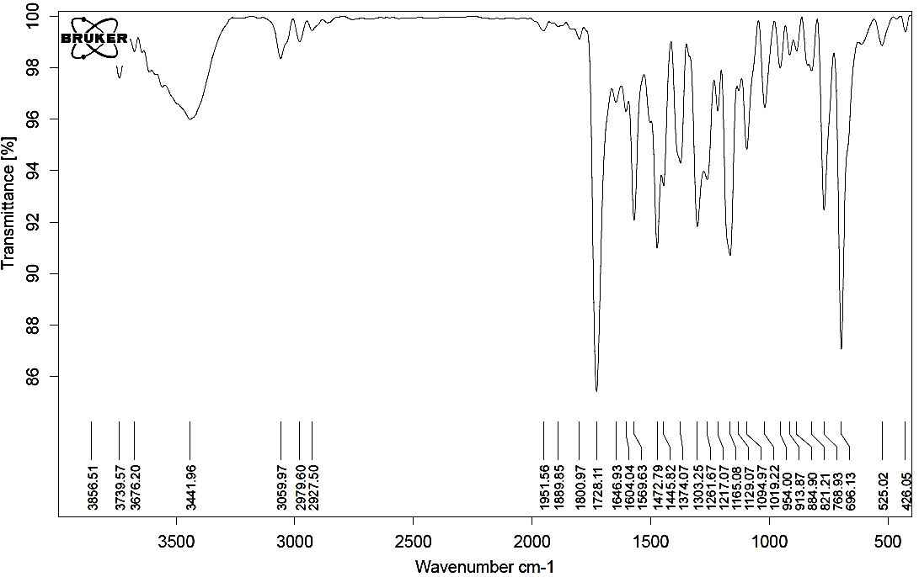Figure 1. FT-IR spectrum of compound 2a.

Figure 2. ¹H NMR spectrum (400 MHz) of compound 2a in CDCl₃.
Figure 3. Expanded (1) ¹H NMR spectrum (400 MHz) of compound 2a in CDCl₃.

Figure 4. Expanded (2) ¹H NMR spectrum (400 MHz) of compound 2a in CDCl₃.
Figure 5. ¹³C NMR spectrum (100 MHz) of compound 2a in CDCl₃.

Ethyl 5-[4,5-diphenyl-2-(p-tolyl)-1H-imidazol-1-yl]benzofuran-2-carboxylate (2b)
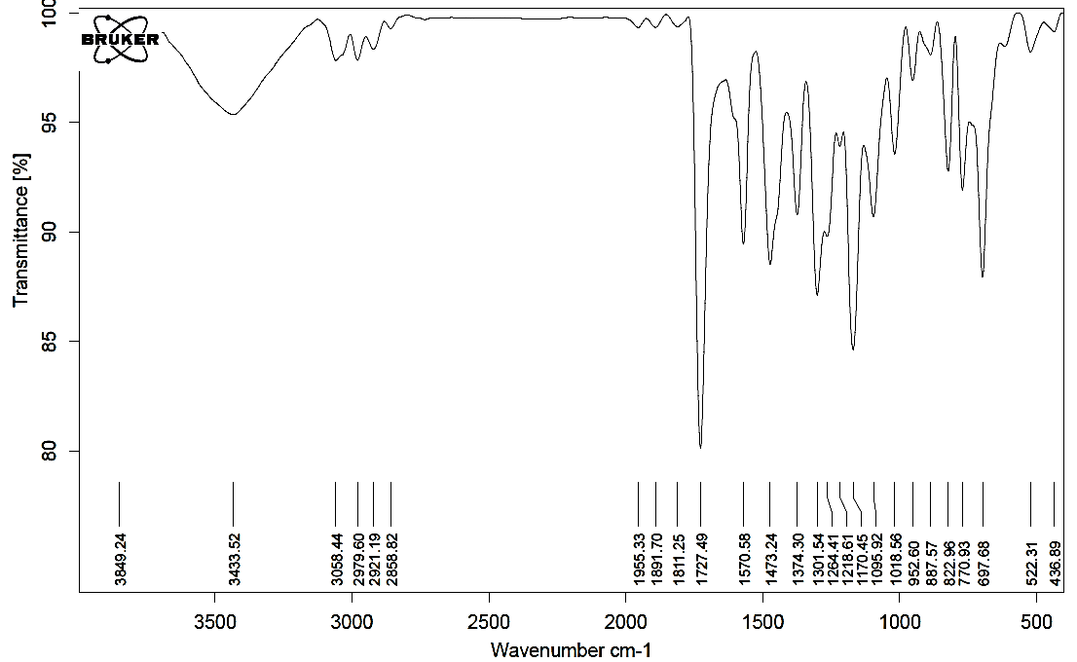
Figure 6. FT-IR spectrum of compound 2b.

Figure 7. ¹H NMR spectrum (400 MHz) of compound 2b in CDCl₃.

Figure 8. Expanded (1) ¹H NMR spectrum (400 MHz) of compound 2b in CDCl₃.
Figure 9. Expanded (2) ¹H NMR spectrum (400 MHz) of compound 2b in CDCl₃.
Figure 10. ¹³C NMR spectrum (100 MHz) of compound 2b in CDCl₃.

Ethyl 5-[2-(4-methoxyphenyl)-4,5-diphenyl-1H-imidazol-1-yl]benzofuran-2-carboxylate (2c)
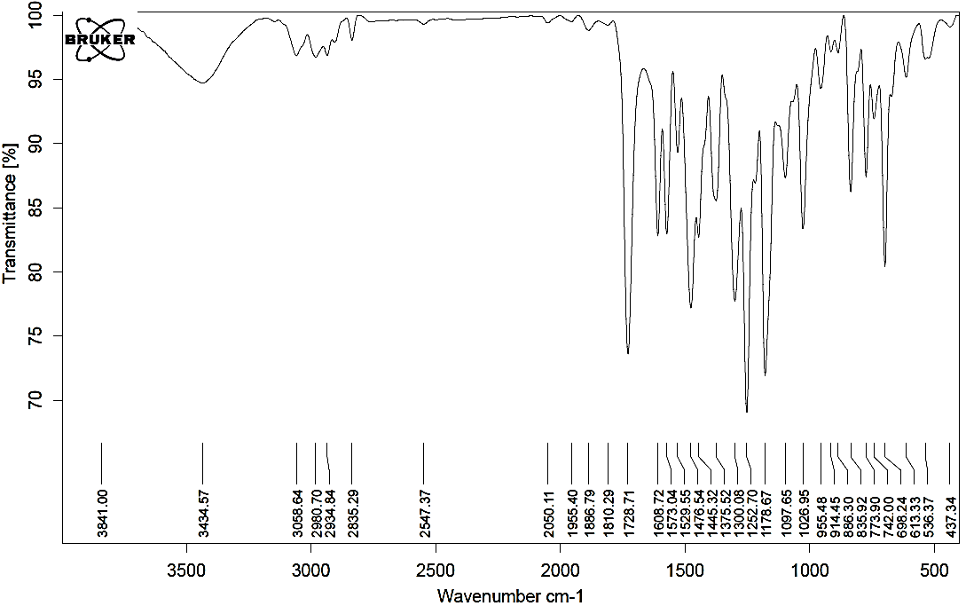
Figure 11. FT-IR spectrum of compound 2c.

Figure 12. ¹H NMR spectrum (250 MHz) of compound 2c in CDCl₃.
Figure 13. Expanded (1) ¹H NMR spectrum (250 MHz) of compound 2c in CDCl₃.

Figure 14. Expanded (2) ¹H NMR spectrum (250 MHz) of compound 2c in CDCl₃.
Figure 15. ¹³C NMR spectrum (65 MHz) of compound 2c in CDCl₃.
Ethyl 5-[2-(3-nitrophenyl)-4,5-diphenyl-1H-imidazol-1-yl]benzofuran-2-carboxylate (2d)
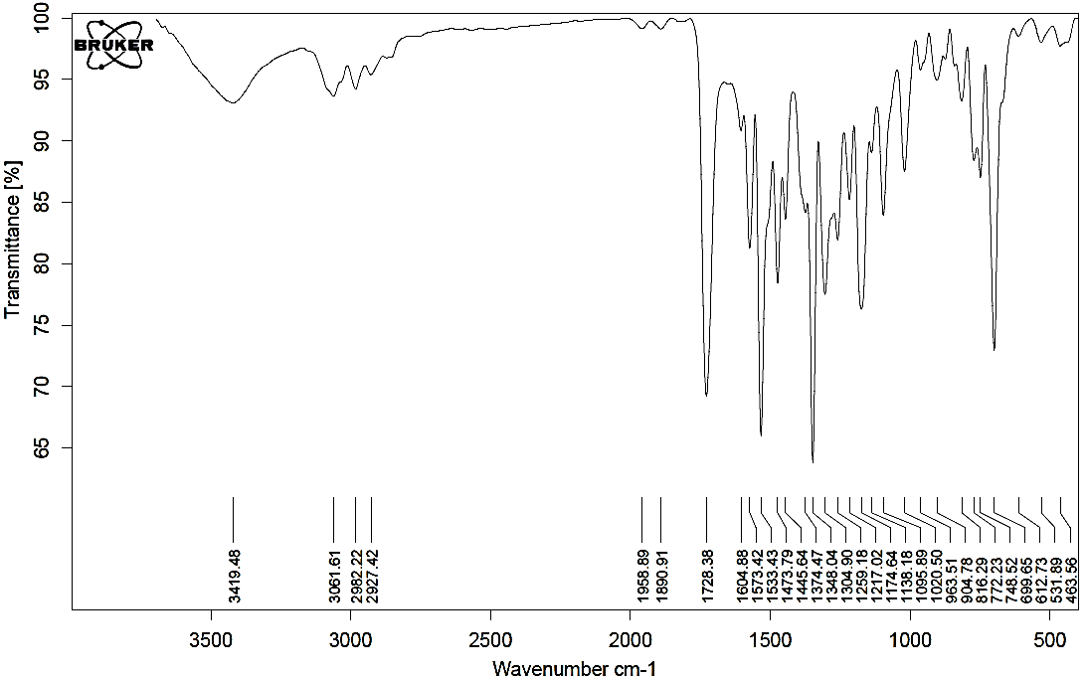Figure 16. FT-IR spectrum of compound 2d.
Figure 17. ¹H NMR spectrum (250 MHz) of compound 2d in CDCl₃.

Figure 18. Expanded (1) ¹H NMR spectrum (250 MHz) of compound 2d in CDCl₃.
Figure 19. Expanded (2) ¹H NMR spectrum (250 MHz) of compound 2d in CDCl₃.

Figure 20. ¹³C NMR spectrum (65 MHz) of compound 2d in CDCl₃.

(E)- Ethyl -3-[2-hydroxy-5-(2,4,5-triphenyl-1H-imidazol-1-yl)phenyl]acrylate (3a)
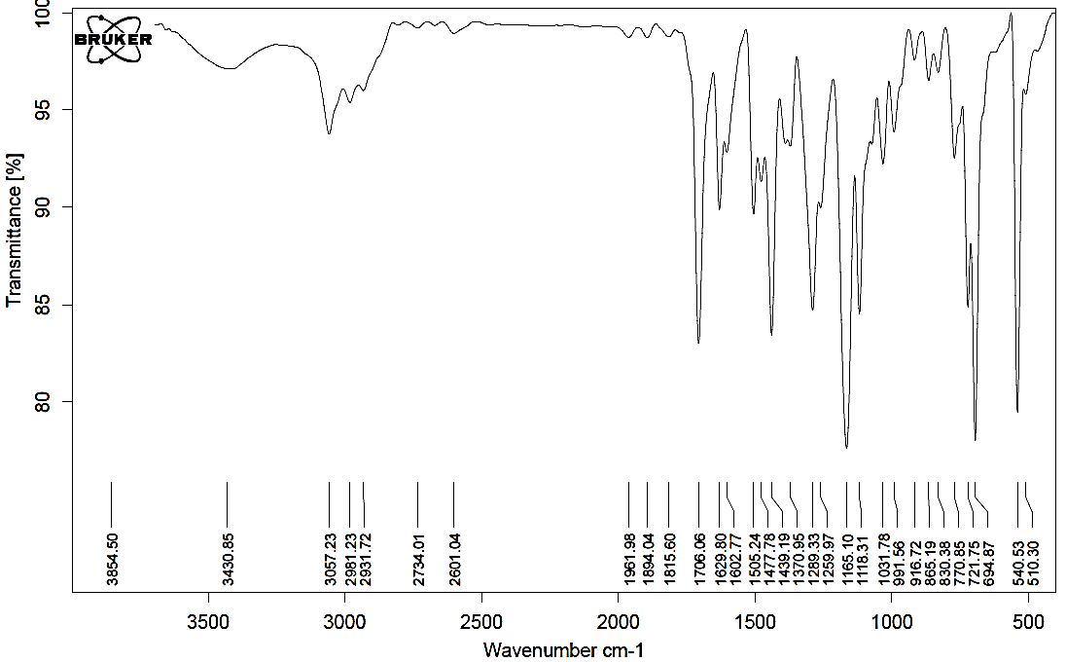Figure 21. FT-IR spectrum of compound 3a.

Figure 22. ¹H NMR spectrum (250 MHz) of compound 3a in CDCl₃.
Figure 23. Expanded (1) ¹H NMR spectrum (250 MHz) of compound 3a in CDCl₃.

Figure 24. Expanded (2) ¹H NMR spectrum (250 MHz) of compound 3a in CDCl₃.
Figure 25. ¹³C NMR spectrum (65 MHz) of compound 3a in CDCl₃.

(E)-Ethyl-3-{5-[4,5-diphenyl-2-(p-tolyl)-1H-imidazol-1-yl]-2-hydroxyphenyl} acrylate (3b)
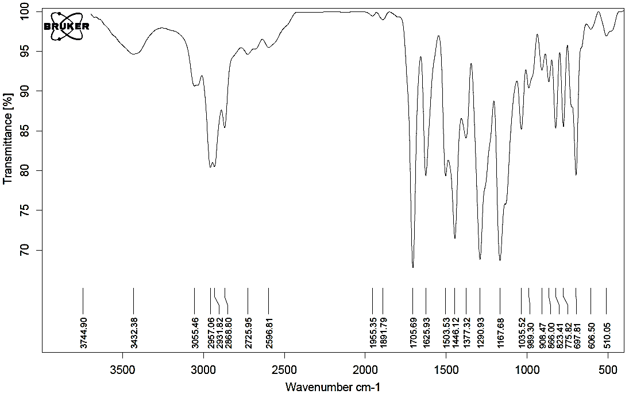Figure 26. FT-IR spectrum of compound 3b.
Figure 27. ¹H NMR spectrum (250 MHz) of compound 3b in CDCl₃.

Figure 28. Expanded (1) ¹H NMR spectrum (250 MHz) of compound 3b in CDCl₃.
Figure 29. Expanded (2) ¹H NMR spectrum (250 MHz) of compound 3b in CDCl₃.
a

Figure 30. ¹³C NMR spectrum (65 MHz) of compound 3b in CDCl₃.
(E) -Ethyl 3-{2-hydroxy-5-[2-(4-methoxyphenyl)-4,5-diphenyl-1H-imidazol-1-yl]phenyl} acrylate (3c)
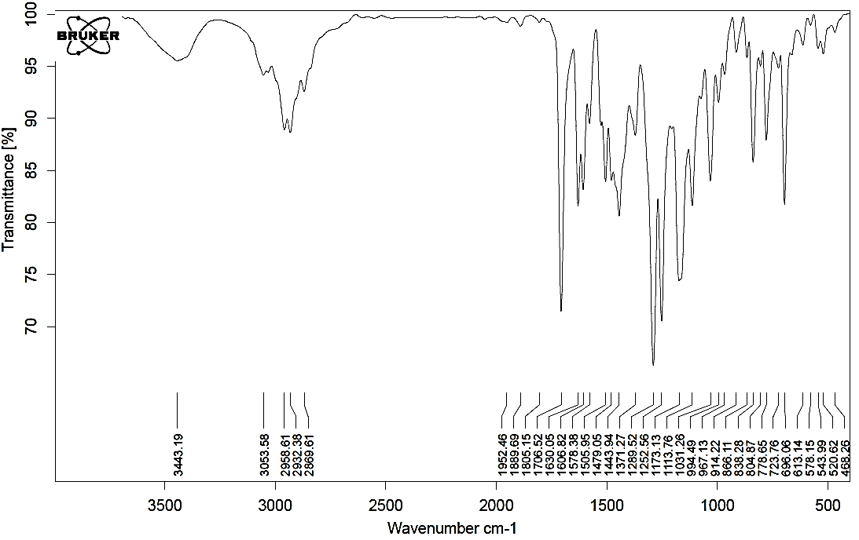Figure 31. FT-IR spectrum of compound 3c.

Figure 32. ¹H NMR spectrum (250 MHz) of compound 3c in CDCl₃.
Figure 33. Expanded (1) ¹H NMR spectrum (250 MHz) of compound 3c in CDCl₃.

Figure 34. Expanded (2) ¹H NMR spectrum (250 MHz) of compound 3c in CDCl₃.
a
Figure 35. ¹³C NMR spectrum (65 MHz) of compound 3c in CDCl₃.

(E)-Ethyl -3-{2-hydroxy-5-[2-(3-nitrophenyl)-4,5-diphenyl-1H-imidazol-1-yl] phenyl} acrylate (3d)
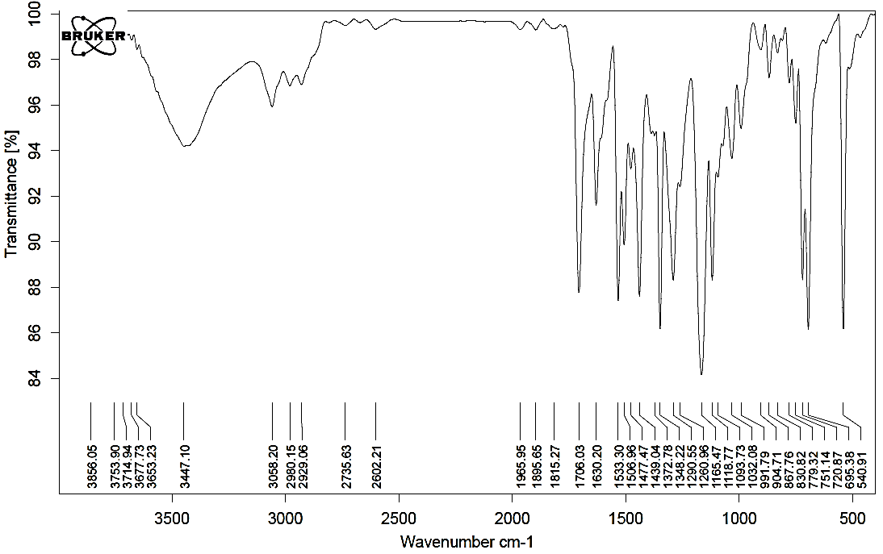Figure 36. FT-IR spectrum of compound 3d.
Figure 37. ¹H NMR spectrum (250 MHz) of compound 3d in CDCl₃.
a
c
b

Figure 38. Expanded (1) ¹H NMR spectrum (250 MHz) of compound 3d in CDCl₃.
Figure 39. Expanded (2) ¹H NMR spectrum (250 MHz) of compound 3d in CDCl₃.
c
b
a

Figure 40. ¹³C NMR spectrum (65 MHz) of compound 3d in CDCl₃.
(E)-Ethyl-3-{5-[4,5-diphenyl-2-(thiophen-3-yl)-1H-imidazol-1-yl]-2-hydroxy phenyl } acrylate (3e)
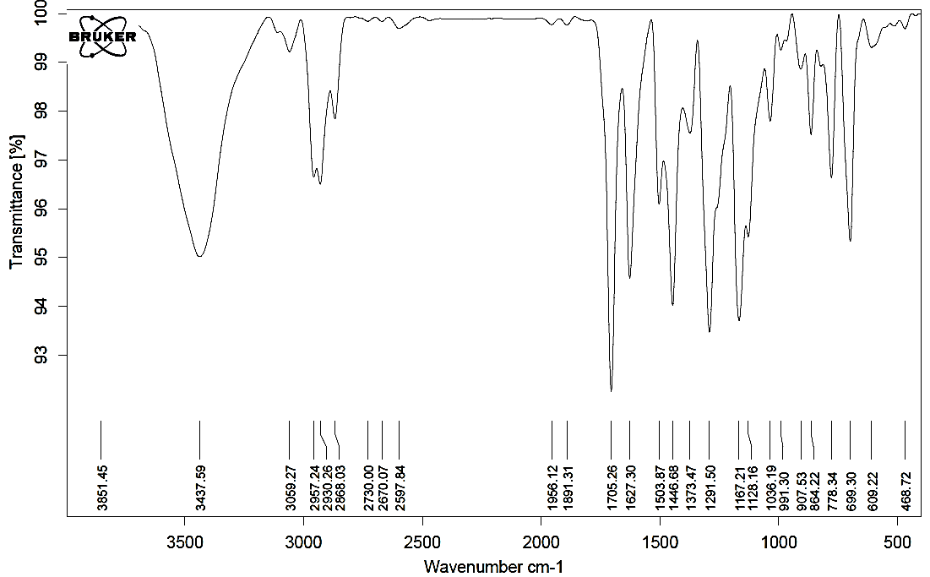Figure 41. FT-IR spectrum of compound 3e.

Figure 42. ¹H NMR spectrum (250 MHz) of compound 3e in CDCl₃.
Figure 43. Expanded (1) ¹H NMR spectrum (250 MHz) of compound 3e in CDCl₃.

Figure 44. Expanded (2) ¹H NMR spectrum (250 MHz) of compound 3e in CDCl₃.
Figure 45. ¹³C NMR spectrum (65 MHz) of compound 3e in CDCl₃.

(E)-Ethyl-3-{2-hydroxy-5-[2-(4-isopropylphenyl)-4,5-diphenyl-1H-imidazol-1-yl] phenyl} acrylate (3f)
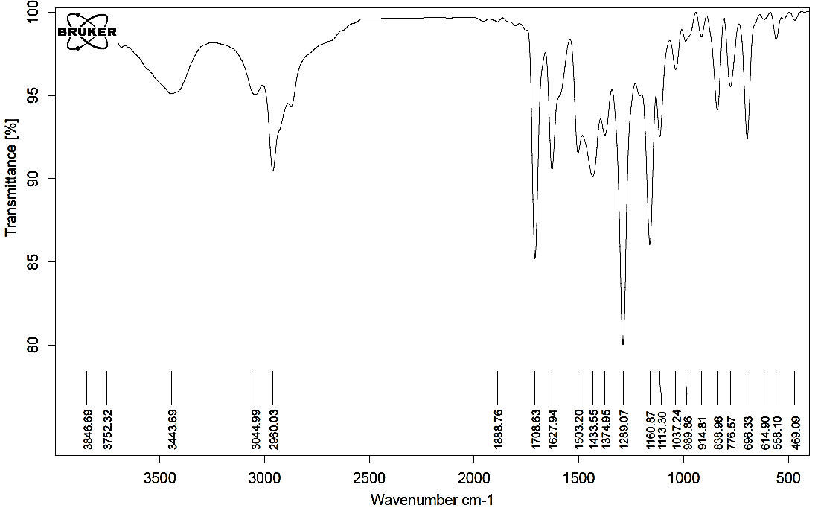Figure 46. FT-IR spectrum of compound 3f.
Figure 47. ¹H NMR spectrum (250 MHz) of compound 3f in CDCl₃.

Figure 48. Expanded (1) ¹H NMR spectrum (250 MHz) of compound 3f in CDCl₃.
Figure 49. Expanded (1) ¹H NMR spectrum (250 MHz) of compound 3f in CDCl₃.

Figure 50. ¹³C NMR spectrum (65 MHz) of compound 3f in CDCl₃.
(E)-Ethyl -3-{5-[2-(4-chlorophenyl)-4,5-diphenyl-1H-imidazol-1-yl]-2-hydroxy phenyl}acrylate (3g)
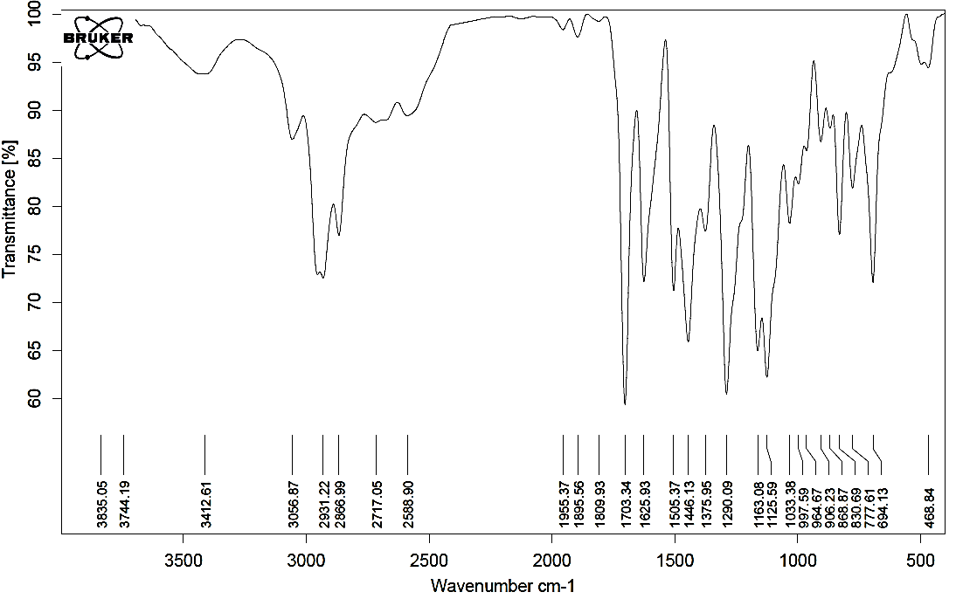Figure 51. FT-IR spectrum of compound 3g.

Figure 52. ¹H NMR spectrum (250 MHz) of compound 3g in CDCl₃.
Figure 53. Expanded (1) ¹H NMR spectrum (250 MHz) of compound 3g in CDCl₃.

Figure 54. Expanded (2) ¹H NMR spectrum (250 MHz) of compound 3g in CDCl₃.
Figure 55. ¹³C NMR spectrum (65 MHz) of compound 3g in CDCl₃.

(E)-ethyl-3-{5-[4,5-diphenyl-1-(p-tolyl)-1H-imidazol-2-yl]-2-hydroxyphenyl} acrylate (3h):
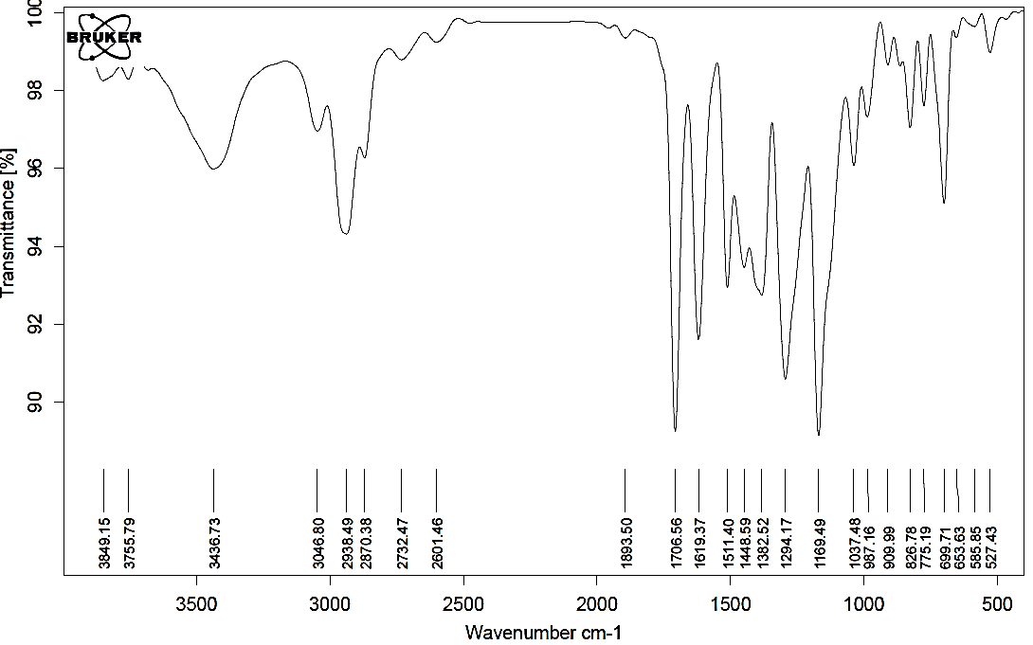Figure 56. FT-IR spectrum of compound 3h.
Figure 57. ¹H NMR spectrum (250 MHz) of compound 3h in CDCl₃.

Figure 58. Expanded (1) ¹H NMR spectrum (250 MHz) of compound 3h in CDCl₃.
Figure 59. Expanded (2) ¹H NMR spectrum (250 MHz) of compound 3h in CDCl₃.

Figure 60. ¹³C NMR spectrum (65 MHz) of compound 3h in CDCl₃.
(E)-Ethyl -3-[2-(2-ethoxy-2-oxoethoxy)-5-(2,4,5-triphenyl-1H-imidazol-1-yl)phenyl] acrylate (4a)
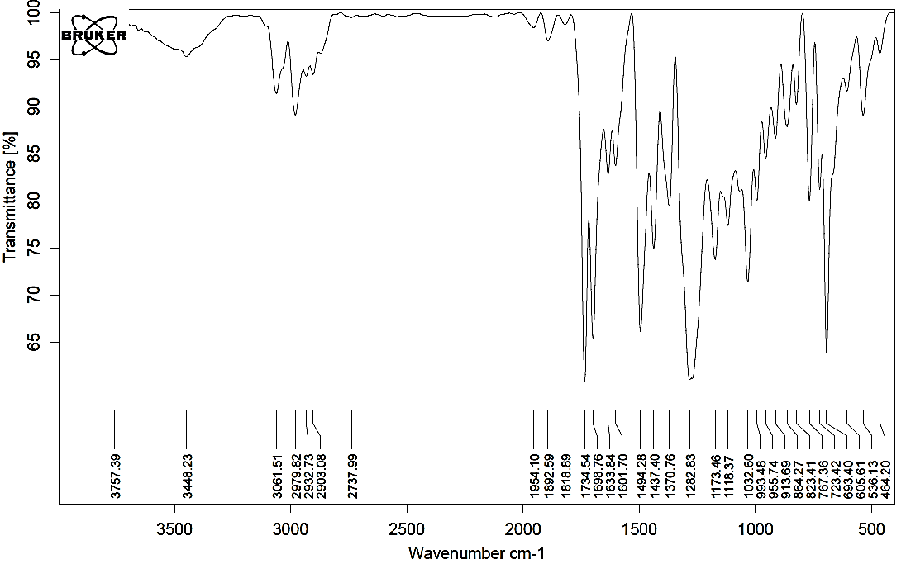Figure 61. FT-IR spectrum of compound 4a.

Figure 62. ¹H NMR spectrum (250 MHz) of compound 4a in CDCl₃.
Figure 63. Expanded (1) ¹H NMR spectrum (250 MHz) of compound 4a in CDCl₃.

Figure 64. Expanded (2) ¹H NMR spectrum (250 MHz) of compound 4a in CDCl₃.
Figure 65. ¹³C NMR spectrum (65 MHz) of compound 4a in CDCl₃.
(E)-ethyl -3-{5-[4,5-diphenyl-2-(p-tolyl)-1H- imidazol -1-yl] -2- [2-ethoxy-2-oxoethoxy] phenyl}acrylate (4b)
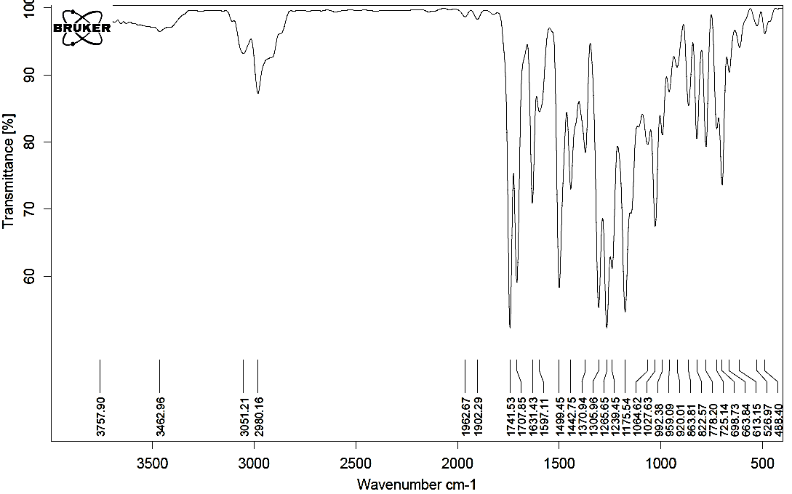Figure 66. FT-IR spectrum of compound 4b.
Figure 67. ¹H NMR spectrum (250 MHz) of compound 4b in CDCl₃.

Figure 68. Expanded (1) ¹H NMR spectrum (250 MHz) of compound 4b in CDCl₃.
Figure 69. Expanded (2) ¹H NMR spectrum (250 MHz) of compound 4b in CDCl₃.

Figure 70. Expanded (3) ¹H NMR spectrum (250 MHz) of compound 4b in CDCl₃.
a
Figure 71. ¹³C NMR spectrum (65 MHz) of compound 4b in CDCl₃.

(E)-Ethyl-3-{2-[2-ethoxy-2-oxoethoxy]-5-[2-(4-methoxyphenyl)-4,5-diphenyl-1H-imidazol-1-yl]phenyl}acrylate (4c)
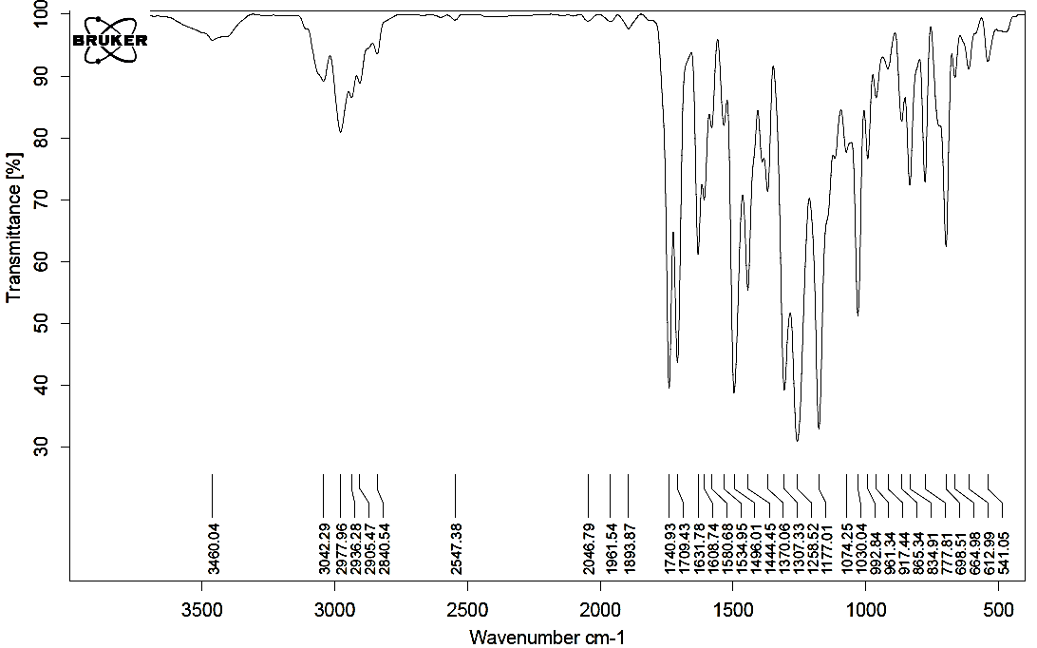Figure 72. FT-IR spectrum of compound 4c.
Figure 73. ¹H NMR spectrum (250 MHz) of compound 4c in CDCl₃.

Figure 74. Expanded (1) ¹H NMR spectrum (250 MHz) of compound 4c in CDCl₃.
Figure 75. Expanded (2) ¹H NMR spectrum (250 MHz) of compound 4c in CDCl₃.

Figure 76. Expanded (3) ¹H NMR spectrum (250 MHz) of compound 4c in CDCl₃.
Figure 77. ¹³C NMR spectrum (65 MHz) of compound 4c in CDCl₃.

(E)-Ethyl -3-{2-[2-ethoxy-2-oxoethoxy]-5-[2-(3-nitrophenyl)-4,5-diphenyl-1H-imidazol-1-yl]phenyl}acrylate (4d):
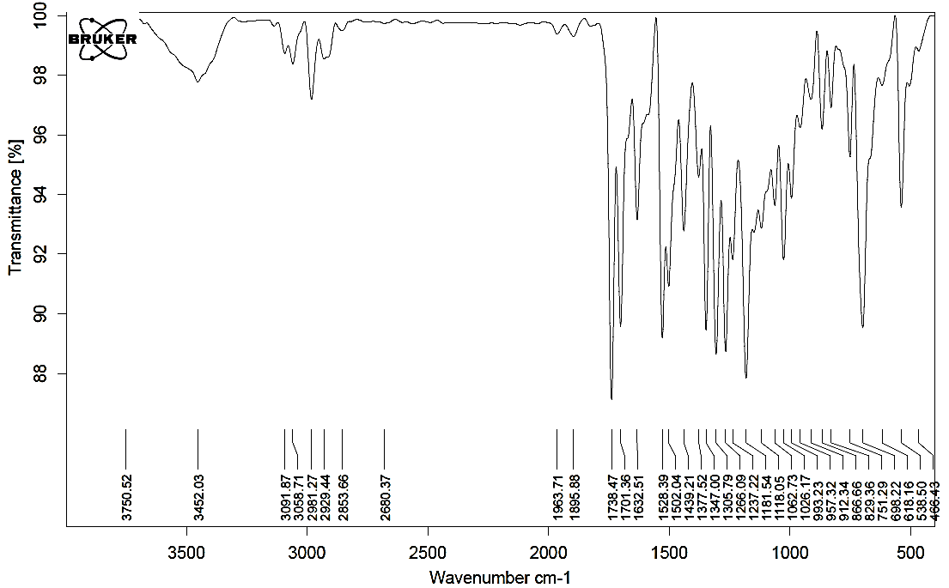Figure 78. FT-IR spectrum of compound 4d.
Figure 79. ¹H NMR spectrum (250 MHz) of compound 4d in CDCl₃.

Figure 80. Expanded (1) ¹H NMR spectrum (250 MHz) of compound 4d in CDCl₃.
Figure 81. Expanded (2) ¹H NMR spectrum (250 MHz) of compound 4d in CDCl₃.
b
c
a

Figure 82. ¹³C NMR spectrum (65 MHz) of compound 4d in CDCl₃.
(E)-Ethyl -3-{5-[4,5-diphenyl-2-(thiophen-3-yl)-1H-imidazol-1-yl]-2-[2-ethoxy-2-oxoethoxy]phenyl}acrylate (4e)
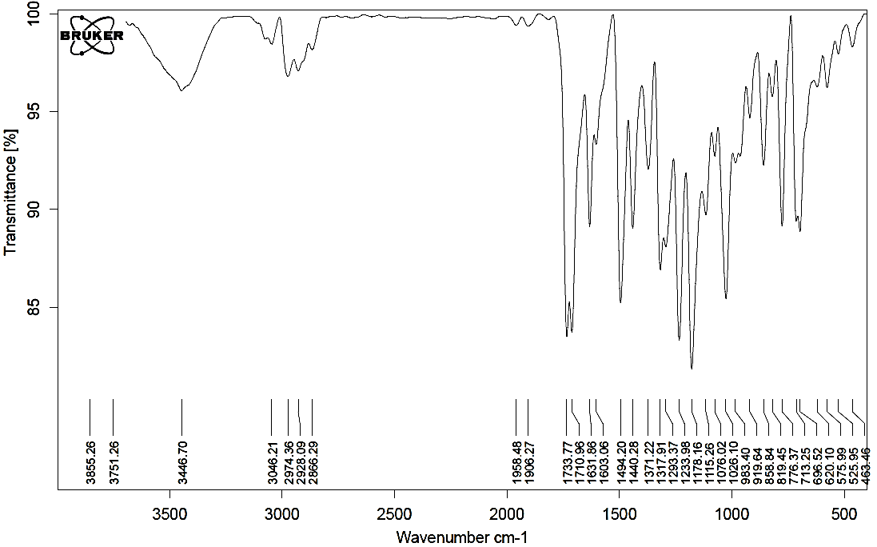Figure 83. FT-IR spectrum of compound 4e.
Figure 84. ¹H NMR spectrum (250 MHz) of compound 4e in CDCl₃.
Figure 85. Expanded (1) ¹H NMR spectrum (250 MHz) of compound 4e in CDCl₃.

Figure 86. Expanded (2) ¹H NMR spectrum (250 MHz) of compound 4e in CDCl₃.
a
Figure 87. ¹³C NMR spectrum (65 MHz) of compound 4e in CDCl₃.

(E)-Ethyl-3-{2-[2-ethoxy-2-oxoethoxy]-5-[2-(4-isopropylphenyl)-4,5-diphenyl-1H-imidazol-1-yl]phenyl}acrylate (4f)
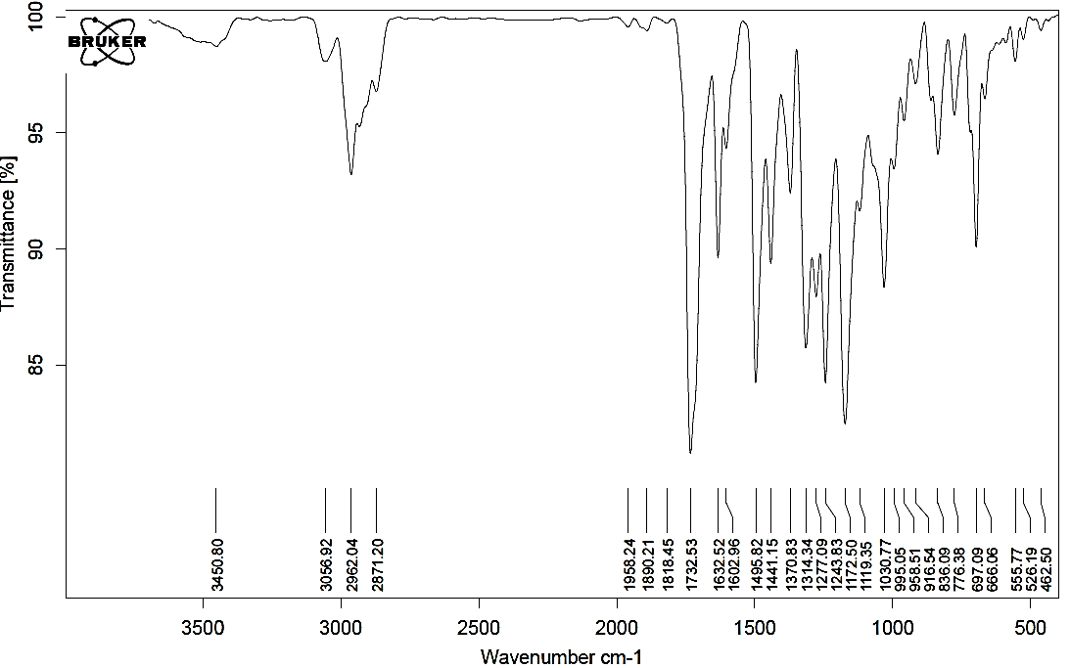Figure 88. FT-IR spectrum of compound 4f.
Figure 89. ¹H NMR spectrum (250 MHz) of compound 4f in CDCl₃.

Figure 90. Expanded (1) ¹H NMR spectrum (250 MHz) of compound 4f in CDCl₃.
Figure 91. Expanded (2) ¹H NMR spectrum (250 MHz) of compound 4f in CDCl₃.

Figure 92. ¹³C NMR spectrum (65 MHz) of compound 4f in CDCl₃.
(E)-Ethyl -3-{5-[2-(4-chlorophenyl)-4,5-diphenyl-1H-imidazol-1-yl]-2-[2-ethoxy-2-oxoethoxy]phenyl}acrylate (4g)
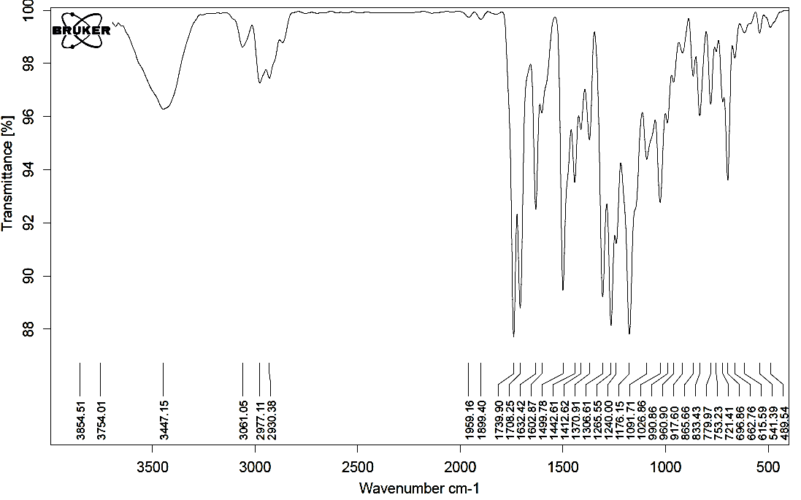Figure 93. FT-IR spectrum of compound 4g.

Figure 94. ¹H NMR spectrum (250 MHz) of compound 4g in CDCl₃.
Figure 95. Expanded (1) ¹H NMR spectrum (250 MHz) of compound 4g in CDCl₃.

Figure 96. Expanded (2) ¹H NMR spectrum (250 MHz) of compound 4g in CDCl₃.
a
Figure 97. ¹³C NMR spectrum (65 MHz) of compound 4g in CDCl₃.

(E)-Ethyl -3-{5-[4,5-diphenyl-1-(p-tolyl)-1H-imidazol-2-yl]-2-[2-ethoxy-2-oxoethoxy]phenyl}acrylate (4h):
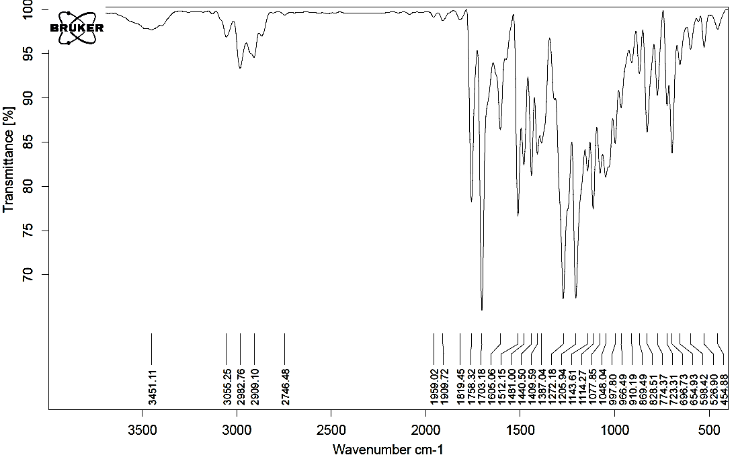Figure 98. FT-IR spectrum of compound 4h.
Figure 99. ¹H NMR spectrum (250 MHz) of compound 4h in CDCl₃.
Figure 100. Expanded (1) ¹H NMR spectrum (250 MHz) of compound 4h in CDCl₃.

Figure 101. Expanded (2) ¹H NMR spectrum (250 MHz) of compound 4h in CDCl₃.

Figure 102. ¹³C NMR spectrum (65 MHz) of compound 4h in CDCl₃.
Ethyl 3-(2-ethoxy-2-oxoethyl)-5-(2,4,5-triphenyl-1H-imidazol-1-yl)-2,3-dihydro benzofuran-2-carboxylate (5a)
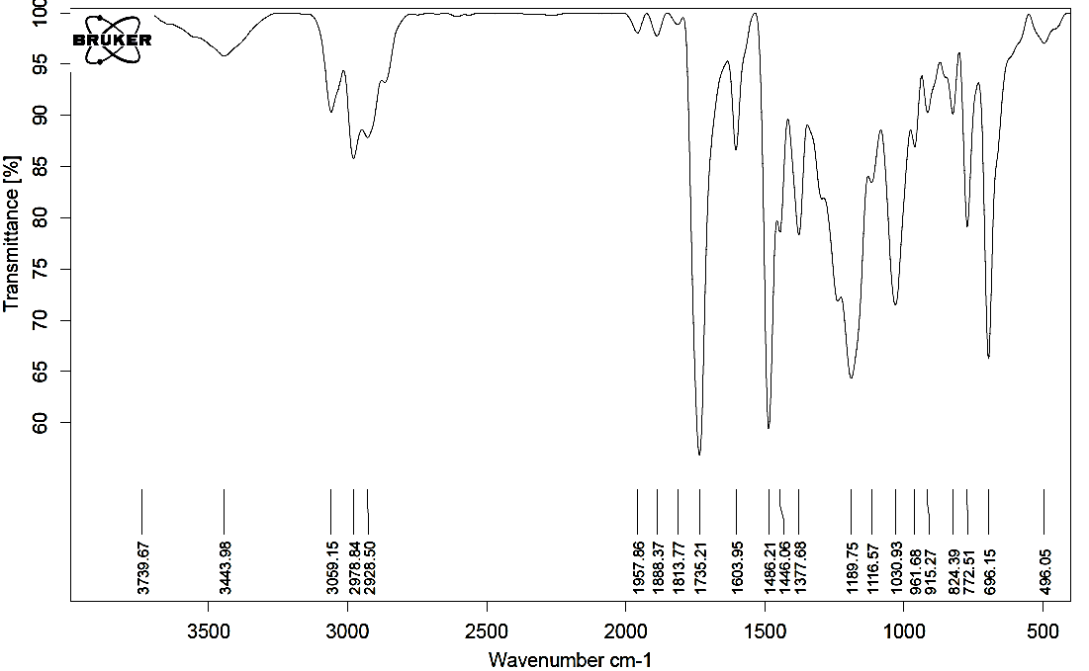Figure 103. FT-IR spectrum of compound 5a.

Figure 104. ¹H NMR spectrum (250 MHz) of compound 5a in CDCl₃.
Figure 105. Expanded (1) ¹H NMR spectrum (250 MHz) of compound 5a in CDCl₃.

Figure 106. Expanded (2) ¹H NMR spectrum (250 MHz) of compound 5a in CDCl₃.
Figure 107. ¹³C NMR spectrum (65 MHz) of compound 5a in CDCl₃.

Ethyl 5-[4,5-diphenyl-2-(p-tolyl)-1H-imidazol-1-yl]-3-(2-ethoxy-2-oxoethyl)-2,3-dihydrobenzofuran-2-carboxylate (5b)
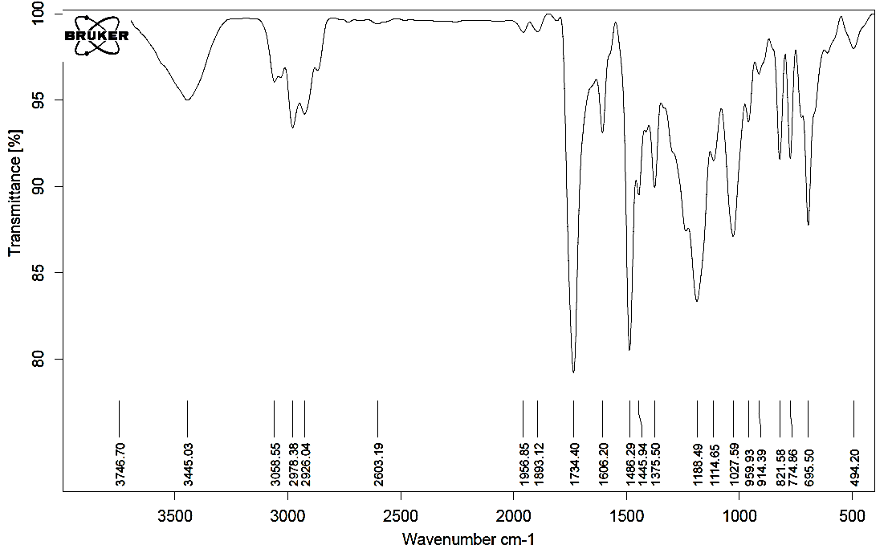Figure 108. FT-IR spectrum of compound 5b.
Figure 109. ¹H NMR spectrum (250 MHz) of compound 5b in CDCl₃.

Figure 110. Expanded (1) ¹H NMR spectrum (250 MHz) of compound 5b in CDCl₃.
Figure 111. Expanded (2) ¹H NMR spectrum (250 MHz) of compound 5b in CDCl₃.

Figure 112. ¹³C NMR spectrum (65 MHz) of compound 5b in CDCl₃.
Ethyl 3-(2-ethoxy-2-oxoethyl)-5-[2-(4-methoxyphenyl)-4,5-diphenyl-1H-imidazol-1-yl]-2,3-dihydrobenzofuran-2-carboxylate (5c)
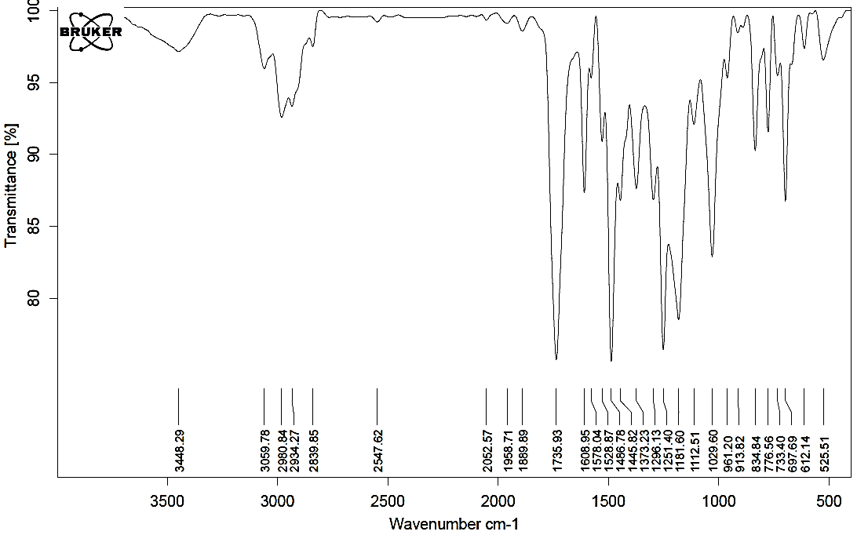Figure 113. FT-IR spectrum of compound 5c.
Figure 114. ¹H NMR spectrum (250 MHz) of compound 5c in CDCl₃.
Figure 115. Expanded (1) ¹H NMR spectrum (250 MHz) of compound 5c in CDCl₃.

Figure 116. Expanded (2) ¹H NMR spectrum (250 MHz) of compound 5c in CDCl₃.
Figure 117. ¹³C NMR spectrum (65 MHz) of compound 5c in CDCl₃.

Ethyl 3-(2-ethoxy-2-oxoethyl)-5-[2-(3-nitrophenyl)-4,5-diphenyl-1H-imidazol-1-yl]-2,3-dihydrobenzofuran-2-carboxylate (5d)
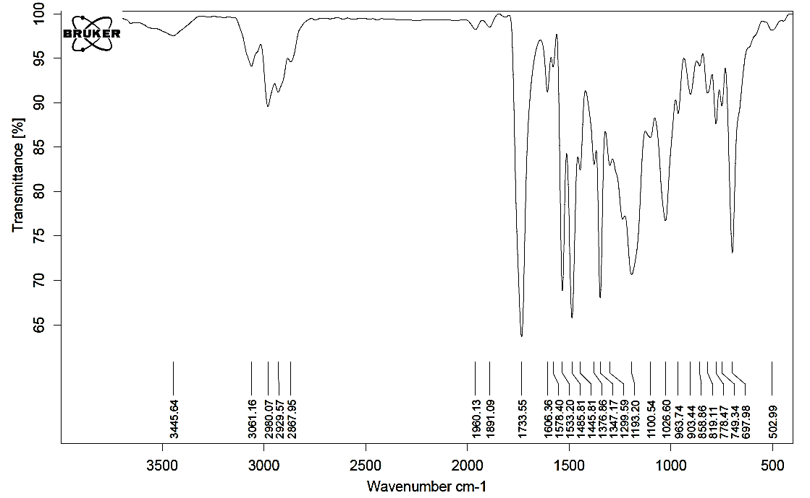Figure 118. FT-IR spectrum of compound 5d.
Figure 119. ¹H NMR spectrum (250 MHz) of compound 5d in CDCl₃.

Figure 120. Expanded (1) ¹H NMR spectrum (250 MHz) of compound 5d in CDCl₃.
Figure 121. Expanded (2) ¹H NMR spectrum (250 MHz) of compound 5d in CDCl₃.

Figure 122. ¹³C NMR spectrum (65 MHz) of compound 5d in CDCl₃.
Ethyl 5-[4,5-diphenyl-2-(thiophen-3-yl)-1H-imidazol-1-yl]-3-(2-ethoxy-2-oxoethyl)-2,3-dihydrobenzofuran-2-carboxylate (5e)
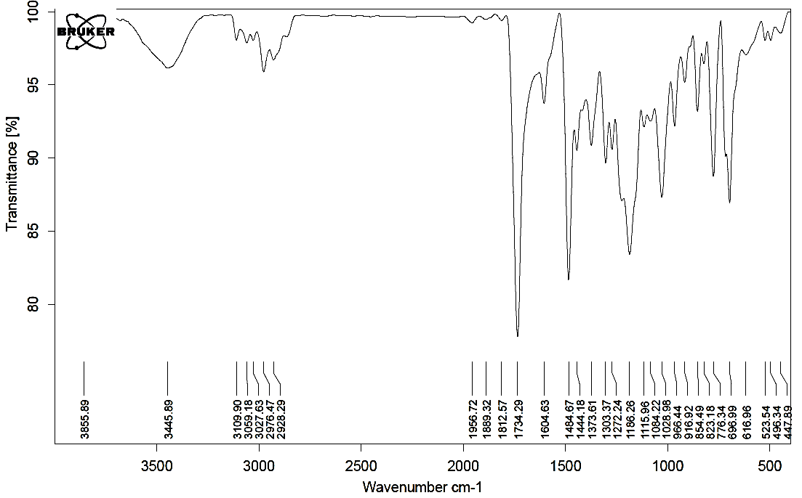Figure 123. FT-IR spectrum of compound 5e.

Figure 124. ¹H NMR spectrum (250 MHz) of compound 5e in CDCl₃.
Figure 125. Expanded (1) ¹H NMR spectrum (250 MHz) of compound 5e in CDCl₃.

Figure 126. Expanded (2) ¹H NMR spectrum (250 MHz) of compound 5e in CDCl₃.
Figure 127. ¹³C NMR spectrum (65 MHz) of compound 5e in CDCl₃.

Ethyl 3-(2-ethoxy-2-oxoethyl)-5-[2-(4-isopropylphenyl)-4,5-diphenyl-1H-imidazol-1-yl]-2,3-dihydrobenzofuran-2-carboxylate (5f)
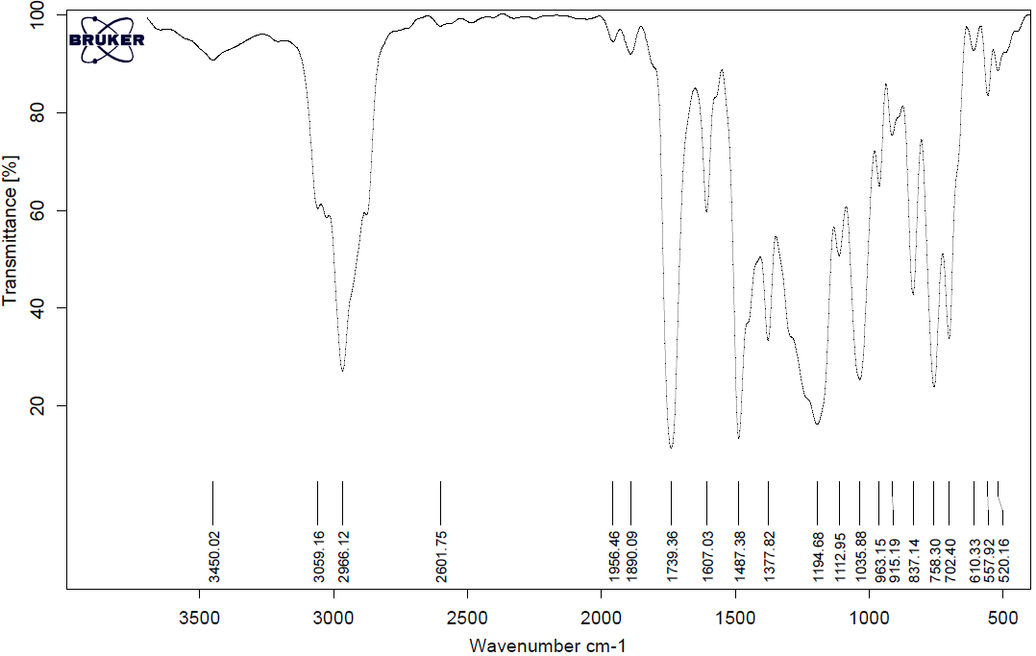Figure 128. FT-IR spectrum of compound 5f.
Figure 129. ¹H NMR spectrum (250 MHz) of compound 5f in CDCl₃.

Figure 130. Expanded (1) ¹H NMR spectrum (250 MHz) of compound 5f in CDCl₃.
Figure 131. Expanded (2) ¹H NMR spectrum (250 MHz) of compound 5f in CDCl₃.

Figure 132. ¹³C NMR spectrum (65 MHz) of compound 5f in CDCl₃.
Ethyl 5-[2-(4-chlorophenyl)-4,5-diphenyl-1H-imidazol-1-yl]-3-(2-ethoxy-2-oxoethyl )-2,3-dihydrobenzofuran-2-carboxylate (5g)
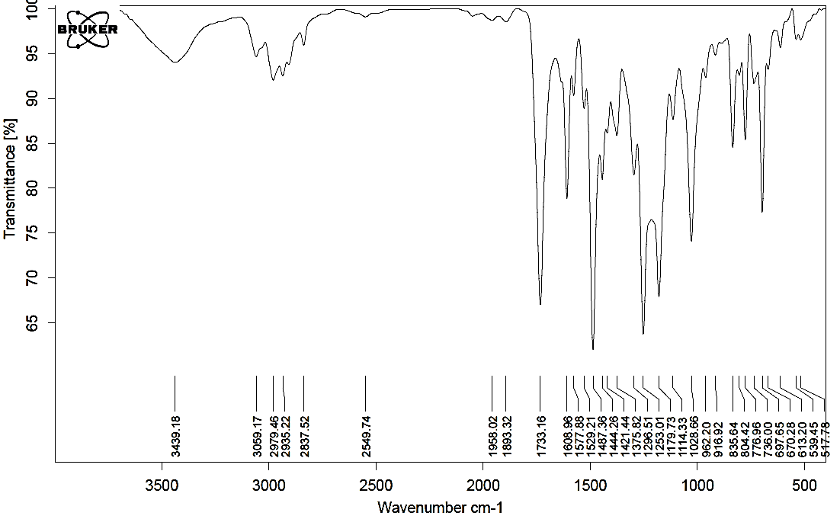Figure 133. FT-IR spectrum of compound 5g.

Figure 134. ¹H NMR spectrum (250 MHz) of compound 5g in CDCl₃.
Figure 135. Expanded (1) ¹H NMR spectrum (250 MHz) of compound 5g in CDCl₃.

Figure 136. Expanded (2) ¹H NMR spectrum (250 MHz) of compound 5g in CDCl₃.
Figure 137. ¹³C NMR spectrum (65 MHz) of compound 5g in CDCl₃.
Ethyl 5-[4,5-diphenyl-1-(p-tolyl)-1H-imidazol-2-yl]-3-(2-ethoxy-2-oxoethyl)-2,3-dihydrobenzofuran-2-carboxylate (5h)
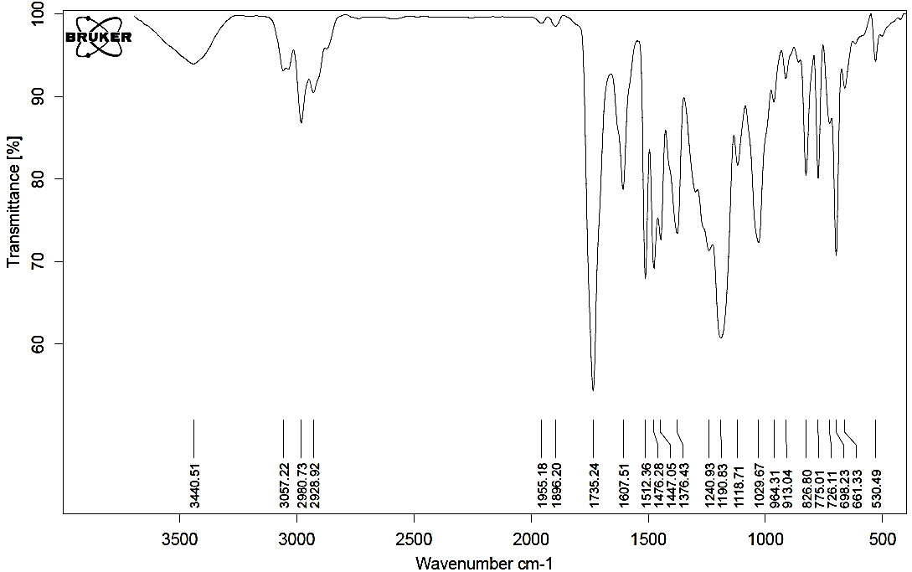Figure 138. FT-IR spectrum of compound 5h.

Figure 139. ¹H NMR spectrum (250 MHz) of compound 5h in CDCl₃.

Figure 140. Expanded (1) ¹H NMR spectrum (250 MHz) of compound 5h in CDCl₃.
Figure 141. Expanded (2) ¹H NMR spectrum (250 MHz) of compound 5h in CDCl₃.

Figure 142. ¹³C NMR spectrum (65 MHz) of compound 5g in CDCl₃.
Ethyl 3-(2-ethoxy-2-oxoethyl)-5-(2,4,5-triphenyl-1H-imidazol-1-yl)benzofuran-2-carboxylate (6a)
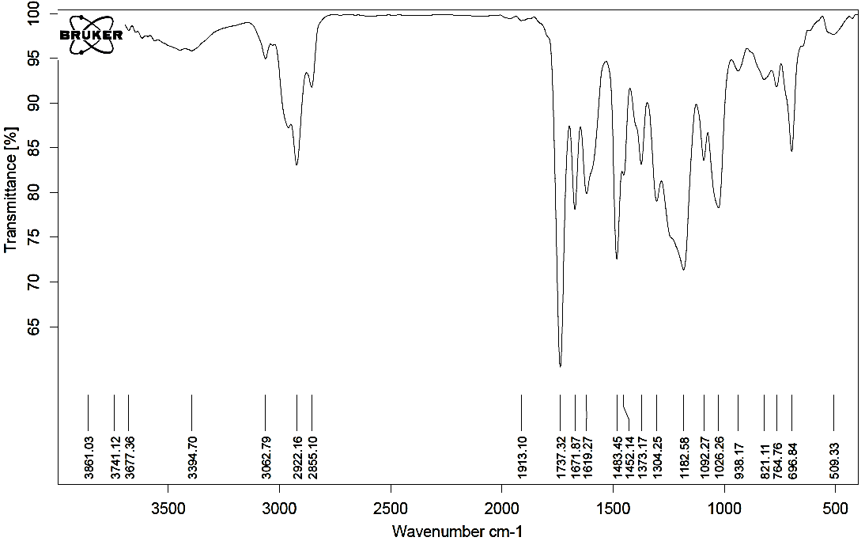Figure 143. FT-IR spectrum of compound 6a.
Figure 144. ¹H NMR spectrum (250 MHz) of compound 6a in DMSO-d₆.

Figure 145. Expanded (1) ¹H NMR spectrum (250 MHz) of compound 6a in DMSO-d₆.
Figure 146. Expanded (2) ¹H NMR spectrum (250 MHz) of compound 6a in DMSO-d₆.

Figure 147. Expanded (3) ¹H NMR spectrum (250 MHz) of compound 6a in DMSO-d₆.
Figure 148. ¹³C NMR spectrum (65 MHz) of compound 6a in DMSO-d₆.

Ethyl 5-[4,5-diphenyl-2-(p-tolyl)-1H-imidazol-1-yl]-3-(2-ethoxy-2-oxoethyl) benzofuran-2-carboxylate (6b)
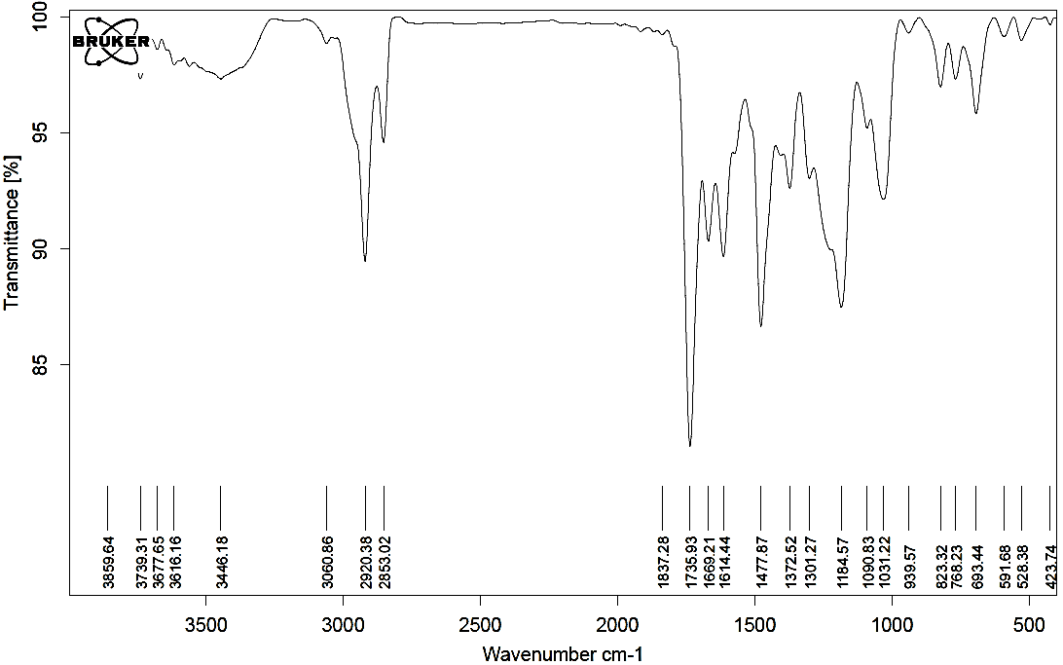Figure 149. FT-IR spectrum of compound 6b.
Figure 150. ¹H NMR spectrum (250 MHz) of compound 6b in CDCl₃.

Figure 151. Expanded (1) ¹H NMR spectrum (250 MHz) of compound 6b in CDCl₃.
Figure 152. Expanded (2) ¹H NMR spectrum (250 MHz) of compound 6b in CDCl₃.

Figure 153. Expanded (3) ¹H NMR spectrum (250 MHz) of compound 6b in CDCl₃.
Figure 154. ¹³C NMR spectrum (65 MHz) of compound 6b in CDCl₃.

Ethyl 3-(2-ethoxy-2-oxoethyl)-5-(2-(4-methoxyphenyl)-4,5-diphenyl-1H-imidazol-1-yl)benzofuran-2-carboxylate (6c)
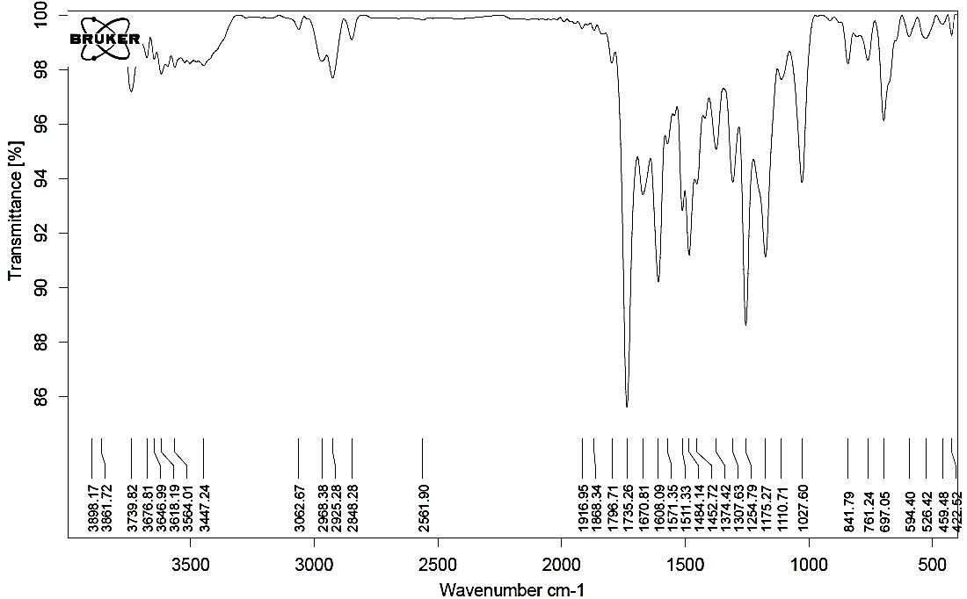Figure 155. FT-IR spectrum of compound 6c.
Figure 156. ¹H NMR spectrum (250 MHz) of compound 6c in CDCl₃.

Figure 157. Expanded (1) ¹H NMR spectrum (250 MHz) of compound 6c in CDCl₃.
Figure 158. Expanded (2) ¹H NMR spectrum (250 MHz) of compound 6c in CDCl₃.

Figure 159. Expanded (3) ¹H NMR spectrum (250 MHz) of compound 6c in CDCl₃.
Figure 160. ¹³C NMR spectrum (65 MHz) of compound 6c in CDCl₃.

Ethyl 3-(2-ethoxy-2-oxoethyl)-5-[2-(3-nitrophenyl)-4,5-diphenyl-1H-imidazol-1-yl]benzofuran-2-carboxylate (6d)
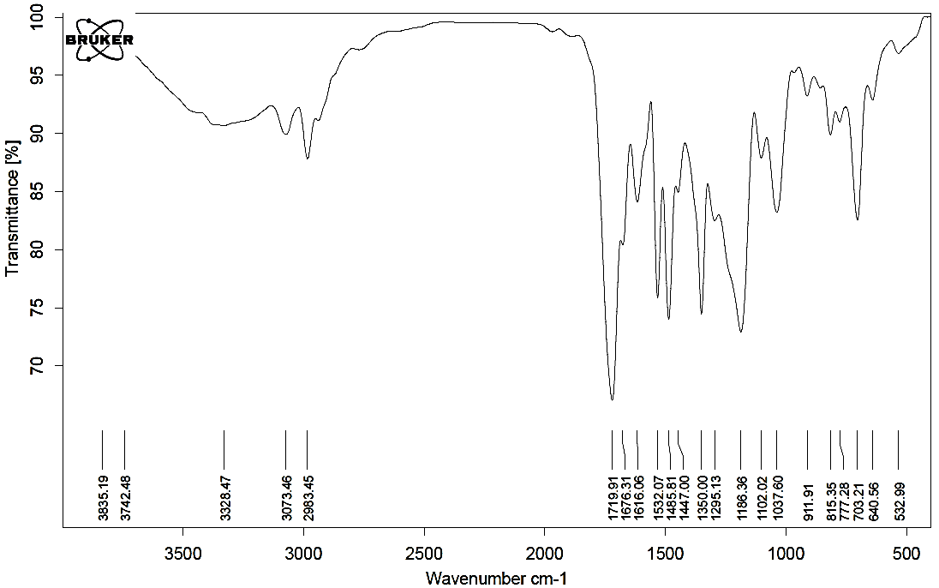Figure 161. FT-IR spectrum of compound 6d.
Figure 162. ¹H NMR spectrum (250 MHz) of compound 6d in DMSO-d₆.

Figure 163. Expanded (1) ¹H NMR spectrum (250 MHz) of compound 6d in DMSO-d₆.
Figure 164. Expanded (2) ¹H NMR spectrum (250 MHz) of compound 6d in DMSO-d₆.

Figure 165. Expanded (3) ¹H NMR spectrum (250 MHz) of compound 6d in DMSO-d₆.
Figure 166. ¹³C NMR spectrum (65 MHz) of compound 6d in DMSO-d₆.

Ethyl 3-(2-ethoxy-2-oxoethyl)-5-[2-(4-isopropylphenyl)-4,5-diphenyl-1H-imidazol-1-yl]benzofuran-2-carboxylate (6f)
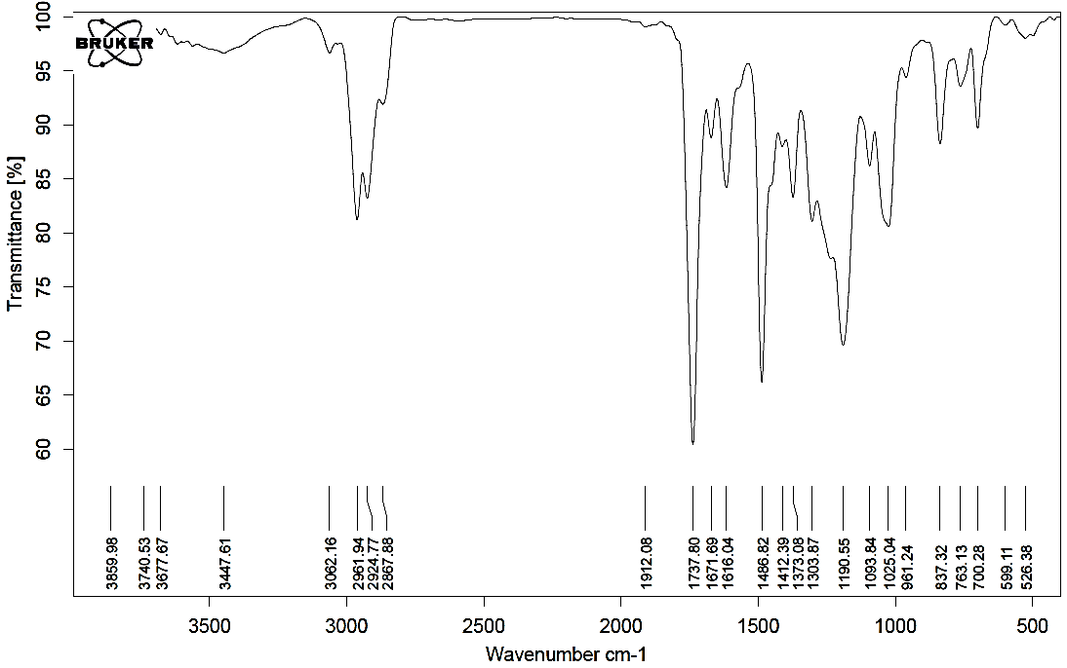Figure 167. FT-IR spectrum of compound 6f.
Figure 168. ¹H NMR spectrum (400 MHz) of compound 6f in CDCl₃.

Figure 169. Expanded (1) ¹H NMR spectrum (400 MHz) of compound 6f in CDCl₃.
Figure 170. Expanded (2) ¹H NMR spectrum (400 MHz) of compound 6f in CDCl₃.

Figure 171. Expanded (3) ¹H NMR spectrum (400 MHz) of compound 6f in CDCl₃.
Figure 172. ¹³C NMR spectrum (100 MHz) of compound 6f in CDCl₃.

Ethyl 5-[2-(4-chlorophenyl)-4,5-diphenyl-1H-imidazol-1-yl]-3-(2-ethoxy-2-oxoethyl)benzofuran-2-carboxylate (6g)
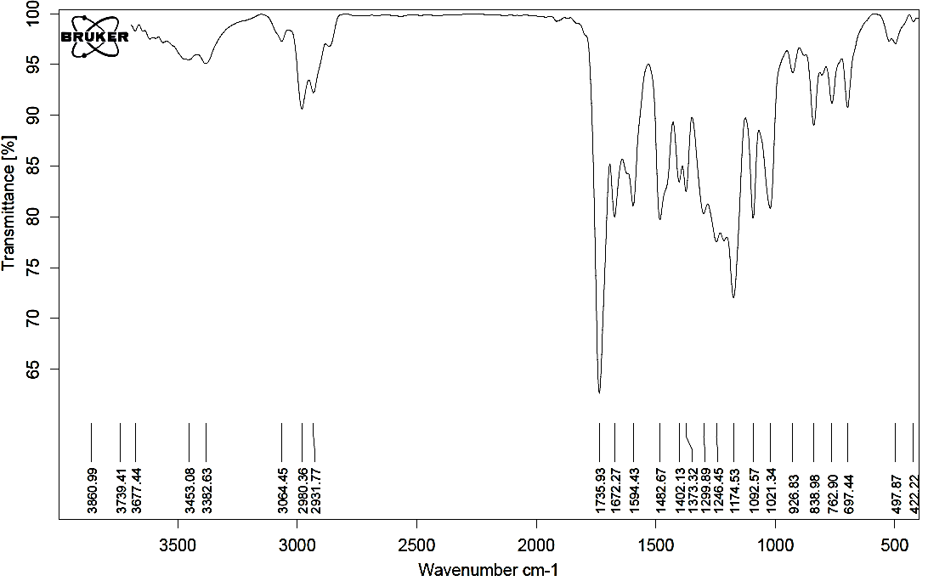Figure 173. FT-IR spectrum of compound 6g.
Figure 174. ¹H NMR spectrum (250 MHz) of compound 6g in DMSO-d₆.

Figure 175. Expanded (1) ¹H NMR spectrum (250 MHz) of compound 6g in DMSO-d₆.
Figure 176. Expanded (2) ¹H NMR spectrum (250 MHz) of compound 6g in DMSO-d₆.

Figure 177. Expanded (3) ¹H NMR spectrum (250 MHz) of compound 6g in DMSO-d₆.
Figure 178. ¹³C NMR spectrum (65 MHz) of compound 6g in DMSO-d₆.

Ethyl 5-[4,5-diphenyl-1-(p-tolyl)-1H-imidazol-2-yl]-3-(2-ethoxy-2-oxoethyl) benzofuran-2-carboxylate (6h)
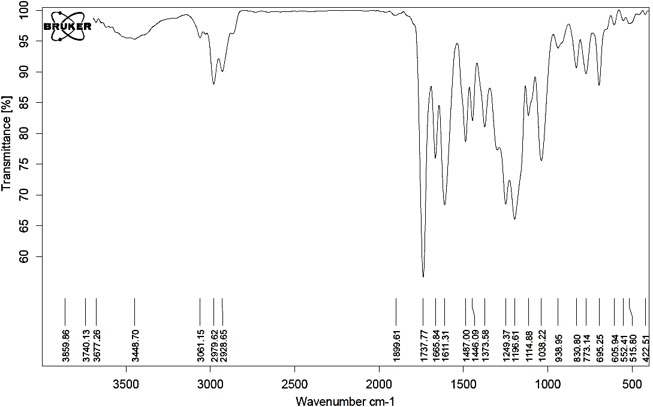Figure 179. FT-IR spectrum of compound 6h.
Figure 180. ¹H NMR spectrum (250 MHz) of compound 6h in DMSO-d₆.

Figure 181. Expanded (1) ¹H NMR spectrum (250 MHz) of compound 6h in DMSO-d₆.
Figure 182. Expanded (2) ¹H NMR spectrum (250 MHz) of compound 6h in DMSO-d₆.

Figure 183. ¹³C NMR spectrum (65 MHz) of compound 6h in DMSO-d₆.

Figure 184. UV-Vis spectra of products 2a-d in ethanol solution (10⁻⁵ M).

Figure 185. UV-Vis spectra of products 3a-h in ethanol solution (10⁻⁵ M).

Figure 186. UV-Vis spectra of products 4a-h in ethanol solution (10⁻⁵ M).

Figure 187. UV-Vis spectra of products 5a-g in ethanol solution (10⁻⁵ M).

Figure 188. UV-Vis spectra of products 6a-h in ethanol solution (10⁻⁵ M).

