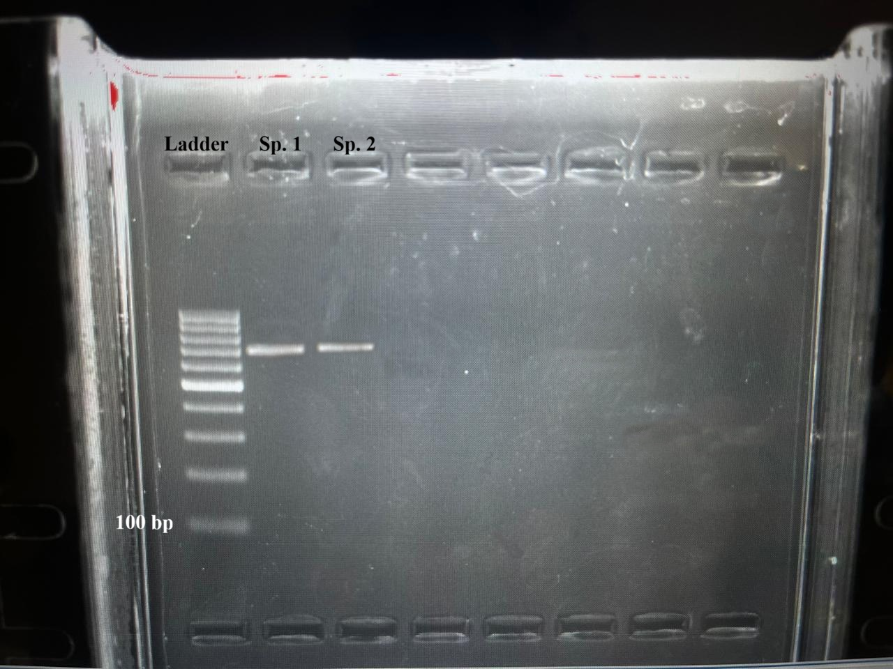
Supplementary File S1. Original Uncropped Gel and Blot Images Used for Gene Sequence Validation. Sp. 1: Cladiella pachyclados (Klunzinger, 1877) and Sp. 2: Aldersladum sodwanum (Benayahu, 1993)

