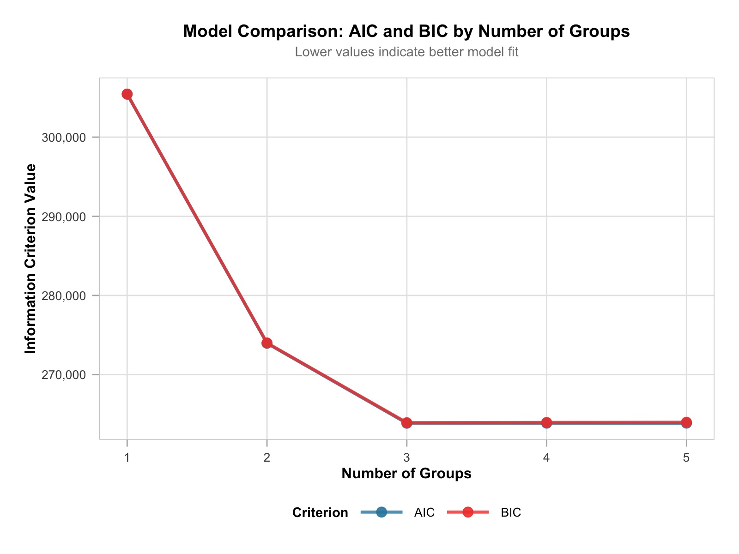
Figure S1. AIC and BIC for Group-Based Trajectory Modeling with varying numbers of trajectory groups.

Supplementary Table S1. Sensitivity analysis of joint associations of social isolation and nighttime sleep on functional disability trajectories.
Sensitivity analysis | Exposure group | Moderate-increasing vs low-stable | High-increasing vs low-stable
Sleep duration classified as normal, short, or long | Social isolation + Normal sleep | 1.56 (1.32, 1.83)** | 1.63 (1.22, 2.19)**
Sleep duration classified as normal, short, or long | No social isolation + Short sleep | 1.43 (1.19, 1.72)** | 2.08 (1.53, 2.83)**
Sleep duration classified as normal, short, or long | Social isolation + Short sleep | 2.23 (1.86, 2.66)** | 3.08 (2.30, 4.14)**
Sleep duration classified as normal, short, or long | No social isolation + Long sleep | 1.17 (0.74, 1.85) | 1.16 (0.50, 2.73)
Sleep duration classified as normal, short, or long | Social isolation + Long sleep | 1.29 (0.82, 2.02) | 3.48 (2.04, 5.93)**
Social isolation redefined without rural residence | Social isolation + Normal sleep | 1.11 (0.86, 1.43) | 1.13 (0.74, 1.73)
Social isolation redefined without rural residence | No social isolation + Abnormal sleep | 1.41 (1.24, 1.62)** | 2.00 (1.60, 2.49)**
Social isolation redefined without rural residence | Social isolation + Abnormal sleep | 1.49 (1.15, 1.93)* | 2.24 (1.54, 3.24)**
The reference outcome group was the low-stable trajectory. For each sensitivity analysis, the reference exposure group was participants without social isolation and with normal sleep. Models were adjusted for age, sex, hypertension, dyslipidemia, diabetes, smoking, drinking, educational level, and BMI.
**P<0.001, *P<0.05

