Supplementary Table S1. Definitions of outcomes, exclusion criteria, and covariates using ICD-10 and procedure codes
Category | Clinical definition | ICD-10 codes  (NHIS claims) | Procedure codes (NHIS EDI),  if applicable
Primary outcome | AKI | N17 | –
Secondary outcome | AIN | N10, N12, N14.2, N15.9 | C8513, C5602
Exclusion | Acute pyelonephritis | N10 | -
Exclusion | Tubulo-interstitial nephritis | N11, N12, N15 | -
Exclusion | Advanced CKD (Stage 5 or ESKD) | N18.5, N18.6 | -
Exclusion | Dialysis dependence / RRT | I12.0, I13.1, N25.0, Z49.0, Z49.1, Z49.2, Z99.2 | -
Exclusion | Kidney transplant status | Z94.0 | -
Exclusion | T1DM | E10 | -
Exclusion | Cancer | C00–C97, D00-D09, D37-D48 | –
Exclusion | HIV Infection/AIDS | B20-B24 | -
Exclusion | Primary immunodeficiency | D80-D83, D84.0-D84.1 | -
Exclusion | Secondary immunodeficiency | D84.8-D84.9 | -
Exclusion | Pregnancy | O00–O99 | –
Exclusion | Complications of transplanted organs and tissue | T86.1, T86.2, T86.3, T86.4, T86.8, T86.9 | -
Covariates | CKD | N18 (except N18.5–N18.6) | –
Covariates | Unspecified kidney failure | N19 | -
Covariates | HF | I11.0, I13.0, I13.2, I50 | –
Covariates | Hypertension | I10–I15 | –
Covariates | Dyslipidemia | E78 | –
Covariates | Autoimmune disease | K50, K51, D86, M32, M35.0, M05, M06, L40.5, M33, M34
Covariates | Viral infection | B25, P35.1, B27.1, B15-B19, B27.0, B33.4 | -
Covariates | Bacterial infection | A01, A02, A40, B95.0, B95.1, B95.2, B95.3, B95.4, B95.5, J13, J15.3, J15.4, J20.2, A04.6, A20, A28.2, A23, M49.1, A27 | -
Covariates | Sepsis | A40–A41, O85, A02.1, A20.7, A22.7, A24.1, A26.7, A32.7, A42.7, B00.7, B37.7, R65.1 | –
Covariates | Rhabdomyolysis | M62.8, T79.5, T79.6 | –
Covariates | Cardiac arrhythmias | I44.1-I44.3, I45.6, I45.9, I47.x-I49.x, R00.0, R00.1, R00.8, T82.1, Z45.0, Z95.0 | -
Covariates | Glomerular diseases | N00-N08 | -
Covariates | Gout/Hyperuricemia | M10, E79.0 | -
Abbreviations: AIDS, acquired immunodeficiency syndrome; AIN, acute interstitial nephritis; AKI, acute kidney injury; CKD, chronic kidney disease; EDI, electronic data interchange; ESKD, end-stage kidney disease; HF, heart failure; HIV, human immunodeficiency virus; ICD-10, International Classification of Diseases, 10th Revision; NHIS, National Health Insurance Service; RRT, renal replacement therapy; T1DM, type 1 diabetes mellitus.

Supplementary Table S2. Definitions of exposure drugs and comedications using ATC codes
Category | Drug class / Variable | ATC codes
Exposure | Metformin | A10BA02, A10BD07, A10BD08, A10BD10, A10BD11, A10BD13
Exposure | SGLT2i (dapagliflozin, empagliflozin, ipragliflozin, ertugliflozin) | A10BK
Exposure | SU (glimepiride, gliclazide, glibenclamide, glipizide, etc.) | A10BB
Exclusion | Insulin | A10A
Comedications | NSAIDs | M01A
Comedications | Radio-contrast agents | V08
Comedications | Thiazide diuretics | C03A, C03B
Comedications | Loop diuretics | C03C
Comedications | MRA | C03DA
Comedications | ACEi | C09AA, C09BA
Comedications | ARB | C09CA, C09DA
Comedications | CCB | C08
Comedications | Beta-blocker | C07
Comedications | Other antihypertensive agents | C02CA, C02AC, C02DB, C09XA
Comedications | Immunosuppressants | L04
Comedications | Antibiotics | J01
Comedications | Antivirals | J05
Comedications | Antifungal agents | J02
Comedications | Class III antiarrhythmics | C01BD, C07AA07
Comedications | Adrenergic agents | C01CA
Comedications | HMG-CoA reductase inhibitors | C10AA
Comedications | Fibrates | C10AB
Comedications | Xanthine oxidase inhibitors | M04AA
Comedications | Bisphosphonates | M05BA
Comedications | Antiplatelet agents | B01AC
Comedications | H2 blockers | A02BA
Comedications | PPI | A02BC
Comedications | Antidepressants | N06A
Comedications | Anticonvulsants | N03
Comedications | Benzodiazepines | N05BA
Comedications | Carbonic anhydrase inhibitor | S01EC
Abbreviations: ACEi, angiotensin-converting enzyme inhibitor; ARB, angiotensin II receptor blocker; ATC, Anatomical Therapeutic Chemical; CCB, calcium channel blocker; HMG-CoA, 3-hydroxy-3-methylglutaryl coenzyme A; MRA, mineralocorticoid receptor antagonist; NSAIDs, non-steroidal anti-inflammatory drugs; PPI, proton pump inhibitor; SGLT2i, sodium–glucose cotransporter 2 inhibitor; SU, sulfonylurea.

Supplementary Table S3. Subgroup-specific hazard ratios for AKI and interaction P-values
Subgroup | Incidence rate per 1000 PY, SGLT2i | Incidence rate per 1000 PY, SU | Adjusted HR  (95% CI) | P-value | P for interaction
HF: No (235,836) | 5.3 | 8.2 | 0.64 (0.55-0.74) | <0.001 | 0.609
HF: Yes (15,828) | 14.0 | 23.8 | 0.55 (0.39-0.78) | 0.002 | -
CKD: No (245,066) | 3.0 | 5.8 | 0.50 (0.42–0.60) | <0.001 | <0.001
CKD: Yes (6,598) | 117.1 | 129.7 | 0.94 (0.77–1.15) | 0.541 | -
HTN: No (141,448) | 3.7 | 6.7 | 0.55 (0.44–0.69) | <0.001 | 0.058
HTN: Yes (110,216) | 8.6 | 12.1 | 0.66 (0.56–0.79) | <0.001 | -
Dyslipidemia: No (58,322) | 3.9 | 7.0 | 0.58 (0.41-0.81) | 0.001 | 0.569
Dyslipidemia: Yes (193,342) | 6.4 | 9.6 | 0.63 (0.55-0.73) | <0.001 | -
Age < 65 (214,718) | 5.1 | 7.6 | 0.64 (0.55–0.75) | <0.001 | 0.596
Age ≥ 65 (36,946) | 10.5 | 16.6 | 0.59 (0.45–0.77) | <0.001 | -
Male (168,236) | 6.3 | 9.4 | 0.64 (0.55–0.75) | <0.001 | 0.558
Female (83,428) | 5.0 | 8.1 | 0.59 (0.46–0.76) | <0.001 | -
Note: HRs compare SGLT2i initiators with SU initiators as the reference group. Interaction P values test heterogeneity between strata of each subgroup variable.
Abbreviations: AKI, acute kidney injury; CI, confidence interval; CKD, chronic kidney disease; HF, heart failure; HR, hazard ratio; HTN, hypertension; PY, person-years; SGLT2i, sodium–glucose cotransporter 2 inhibitor; SU, sulfonylurea.

Supplementary Table S4. Association between SGLT2i use and risk of biopsy-confirmed AIN
Group | Follow-up Mean (SD), days | AIN events (n) | Incidence rate per 1000 PY (95% CI) | Adjusted HR (95% CI) | p-value
SGLT2i (125,832) | 179.37 (9.08) | 4 | 0.06 (0.02-0.18) | 0.55 (0.16–1.93) | 0.349
SU (125,832) | 179.89 (12.24) | 7 | 0.11 (0.05-0.24) | Reference | –
Note: The HR compares SGLT2i initiators with SU initiators as the reference group. Estimates should be interpreted cautiously because of the small number of events.
Abbreviations: AIN, acute interstitial nephritis; CI, confidence interval; HR, hazard ratio; PY, person-years; SD, standard deviation; SGLT2i, sodium–glucose cotransporter 2 inhibitor; SU, sulfonylurea.

Supplementary Table S5. Adjusted hazard ratios for AKI risk according to cumulative SGLT2i exposure levels (cDDD)
Group (N) | Follow-up  Mean (SD), days | AKI events (n) | Incidence rate  (per 1000 PY, 95% CI) | Adjusted HR  (95% CI) | p-value
SU (125,832) | 179.23 (9.98) | 552 | 8.95 (8.21–9.70) | Reference | -
SGLT2i
<90 (25,054) | 179.58 (14.12) | 170 | 13.79 (11.80–16.03) | 1.53 (1.28–1.81) | <0.001
90–179 (25,668) | 179.36 (8.35) | 139 | 11.02 (9.26–13.01) | 1.10 (1.00–1.20) | 0.053
180–209 (34,994) | 179.94 (2.49) | 28 | 1.62 (1.08–2.35) | 0.56 (0.49–0.63) | <0.001
≥210 (40,116) | 179.95 (1.96) | 28 | 1.42 (0.94–2.05) | 0.62 (0.56–0.68) | <0.001
Note: HRs compare each cumulative SGLT2i exposure category with SU initiators as the reference group. P for trend was estimated by modelling cDDD categories as an ordinal variable. P for trend <0.001.
Abbreviations: AKI, acute kidney injury; cDDD, cumulative defined daily dose; CI, confidence interval; HR, hazard ratio; PY, person-years; SD, standard deviation; SGLT2i, sodium–glucose cotransporter 2 inhibitor; SU, sulfonylurea.

Supplementary Table S6. Cohort-based sensitivity analyses for the association between SGLT2i initiation and AKI
Analysis | Population specification | SGLT2i, n | SU, n | SGLT2i events (IR*) | SU events (IR*) | Adjusted HR (95% CI)
IPTW | Exact-matched cohort weighted by inverse probability of treatment | 168109 | 168109 | 490 (5.92) | 742 (8.99) | 0.66 (0.59-0.74)
Lag analysis | 7-day lag period | 125800 | 125756 | 343 (5.54) | 490 (7.93) | 0.66 (0.58-0.76)
Restricted follow-up | Follow-up censored at 3 months | 125832 | 125832 | 228 (7.36) | 357 (11.54) | 0.59 (0.50-0.70)
Note: The IPTW analysis was conducted in the exact-matched cohort before propensity score matching; the 7-day lag and restricted follow-up analyses were conducted in the propensity score-matched cohort.
Abbreviations: AKI, acute kidney injury; CI, confidence interval; HR, hazard ratio; IPTW, inverse probability of treatment weighting; IR, incidence rate; PY, person-years; SGLT2i, sodium–glucose cotransporter 2 inhibitor; SU, sulfonylurea.

Supplementary Table S7. Treatment-specific self-controlled risk interval analyses of AKI after SGLT2i or SU initiation
Group | Risk interval | Events | Total follow-up, person-years | IRR (95% CI) | p-value
SGLT2i | 1–30 days | 93 | 10,333 | 2.03 (1.56–2.64) | <0.001
 | 31–90 days | 135 | 20,645 | 1.47 (1.16–1.87) | <0.001
 | 91–180 days | 137 | 30,886 | Reference | -
SU | 1–30 days | 179 | 10,335 | 2.73 (2.23–3.34) | <0.001
 | 31–90 days | 178 | 20,601 | 1.36 (1.11–1.67) | 0.003
 | 91–180 days | 195 | 30,740 | Reference | -
Note: Incidence rate ratios compare days 1–30 and 31–90 with days 91–180 as the reference interval within each treatment group. IRRs were estimated using conditional Poisson regression with patient-level conditioning and a log person-time offset. Because analyses were conducted separately by treatment group, treatment-specific IRRs should not be interpreted as formal between-group comparisons.
Abbreviations: AKI, acute kidney injury; CI, confidence interval; IRR, incidence rate ratio; SCRI, self-controlled risk interval; SGLT2i, sodium–glucose cotransporter 2 inhibitor; SU, sulfonylurea.

Supplementary Table S8. Sensitivity analysis: E-value estimates for the association between SGLT2i use and AKI risk
Outcome | Adjusted HR  (95% CI) | E-value | E-value for the confidence limit closest to the null
AKI | 0.63 (0.55-0.72) | 2.55 | 2.12
Note: E-values quantify the minimum strength of unmeasured confounding required to explain the observed association.
Abbreviations: AKI, acute kidney injury; CI, confidence interval; HR, hazard ratio; SGLT2i, sodium–glucose cotransporter 2 inhibitor.

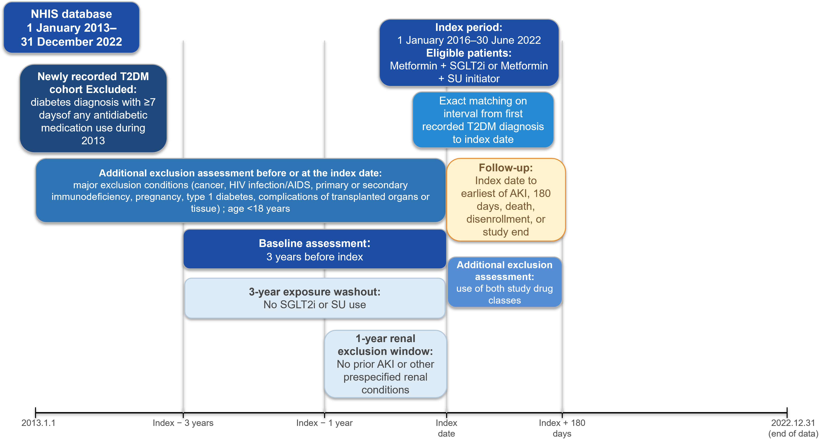
Supplementary Figure S1. Study design and assessment windows
The index date was defined as initiation of an SGLT2i or SU as add-on therapy to metformin. Baseline covariates were assessed during the preceding 3 years, whereas prespecified renal exclusion conditions were assessed during the preceding year. Follow-up continued for up to 180 days.
Abbreviations: AKI, acute kidney injury; CKD, chronic kidney disease; ESKD, end-stage kidney disease; NHIS, National Health Insurance Service; SGLT2i, sodium–glucose cotransporter 2 inhibitor; SU, sulfonylurea; T2DM, type 2 diabetes mellitus.

(A) | (B)
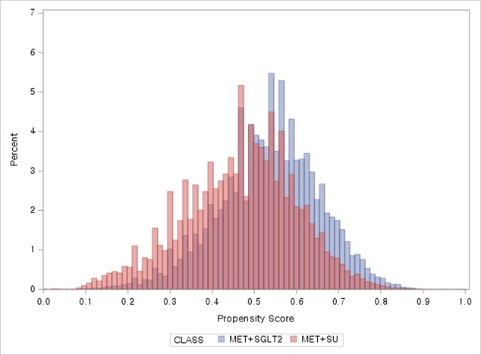 | 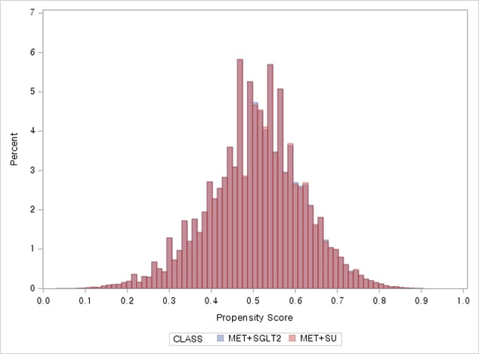

Supplementary Figure S2. Distribution of the logit of the propensity score before and after matching
Distribution of the logit of the propensity score before (A) and after (B) 1:1 propensity score matching.
Abbreviations: MET, metformin; SGLT2i, sodium–glucose cotransporter 2 inhibitor; SU, sulfonylurea.

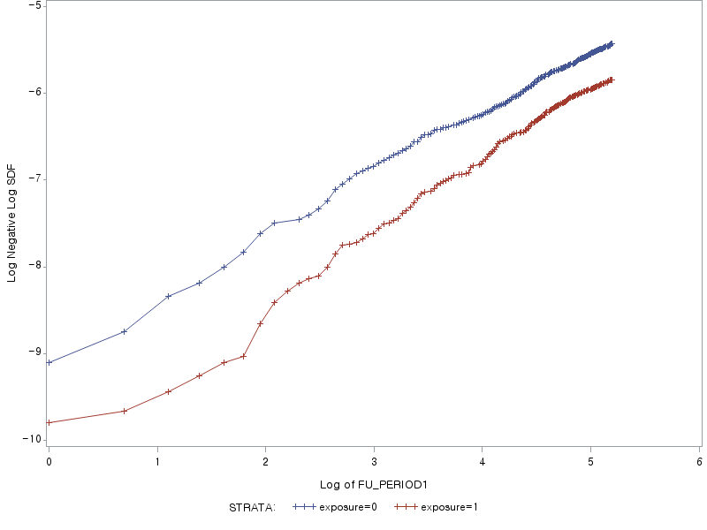
Supplementary Figure S3. Log-minus-log survival plots for assessment of the proportional hazards assumption by treatment group
Log-minus-log survival plots for acute kidney injury according to treatment group in the propensity score-matched cohort.
Abbreviations: AKI, acute kidney injury; SGLT2i, sodium–glucose cotransporter 2 inhibitor; SU, sulfonylurea.

Supplementary Figure S4. Ingredient-specific adjusted hazard ratios for AKI among individual SGLT2 inhibitors
Adjusted HRs for acute kidney injury associated with individual SGLT2i agents compared with SU initiation. Points and horizontal bars represent HRs and 95% CIs.
Abbreviations: AKI, acute kidney injury; CI, confidence interval; HR, hazard ratio; SGLT2i, sodium–glucose cotransporter 2 inhibitor; SU, sulfonylurea.
Supplementary Figure S5. Adjusted hazard ratios for acute kidney injury according to cumulative SGLT2 inhibitor exposure
Adjusted HRs for acute kidney injury according to cumulative SGLT2i exposure categories compared with SU initiation. Points and horizontal bars represent HRs and 95% CIs.
Abbreviations: AKI, acute kidney injury; cDDD, cumulative defined daily dose; CI, confidence interval; HR, hazard ratio; SGLT2i, sodium–glucose cotransporter 2 inhibitor; SU, sulfonylurea.

