        - Participant Information Sheet (PIS)
Project Title: An e-Delphi study to develop the proposal for sample size reporting in adaptive design trial grant applications and protocols
Invitation to Participate
You are invited to take part in a research study designed to gather expert insights on how sample sizes should be reported in adaptive design trials. This is an important area in clinical trials, and your contribution will be highly valuable. Please take the time to read this sheet carefully, and don’t hesitate to reach out if you have any questions or need clarification.
Background
The field of clinical trials is rapidly evolving, with a growing emphasis on efficiency and flexibility in trial designs. Adaptive design trials have become more common because they allow modifications to aspects of the trial based on interim results. These modifications might include changes to the sample size, allocation ratios, or even early stopping for efficacy or futility. This flexibility enhances the efficiency of clinical trials but also introduces challenges in how these trials are reported, particularly regarding sample size.
Our previous systematic review revealed a lack of standardised guidance for reporting sample sizes in trial grant applications and protocols for adaptive designs, and current reporting practices vary significantly across clinical trials and types of adaptive design. Our qualitative study indicates that clinical trial stakeholders broadly agree on the need for more detailed information regarding sample size and its flexibility when developing trial grant applications and protocols for adaptive designs. Based on these findings and stakeholder input, we have proposed a checklist to guide sample size reporting in grant applications and protocols for adaptive designs.
Purpose of the Study
This Delphi sub-study is nested within the Doctoral research investigating the reporting and communication of sample size for trials with adaptive design. The overarching aim of the Ph.D. study is to explore how the sample size(s) of adaptive design clinical trials should be reported in key trial documents including grant applications and protocols.
This study aims to develop a checklist for reporting sample size in trial grant applications and protocols for ADs. Through a structured consensus process involving a panel of experts, the study aims to develop and refine the proposal to ensure it is accurate, comprehensive, and relevant for use when reporting the sample size in trial grant applications and protocols.
Why You Have Been Invited
You are being asked to participate because of your expertise in clinical trials, particularly your knowledge of adaptive designs or involvement in trial management. We are seeking input from a range of experts, including statisticians, clinicians, methodologists, trial managers, and funding panel members, to ensure a diversity of perspectives.
Do I have to take part?
Participation is entirely voluntary. If you choose to participate, you may withdraw at any time without providing a reason. Withdrawal is possible before the data is analysed, which will happen at the end of the second round of the survey. Once the data analysis started, it will no longer be possible to remove individual responses from the dataset.
What Participation Involves
If you agree to participate, please kindly provide some background information via the link to the background survey questionnaire. We will then reach out to you at the earliest opportunity. Once the screening process is complete, you will receive a private link to an e-Delphi survey, which will consist of two rounds. In the first round, you will be asked to rate the importance of proposed items for sample size reporting in adaptive design trials on a scale of 1 to 9 (you can also choose ‘I am not sure’ if you are uncertain about the importance of some items.). Two weeks after the first round concludes, you will be invited to participate in the second round, where you will receive feedback from the first round, including your previous ratings and the group's aggregated responses, allowing you to reconsider your answers in light of the collective input. Each round will take approximately 30 minutes to complete, and each survey will remain open for four weeks.
Following the two survey rounds, an online consensus meeting will be held to provide participants an opportunity for open discussion and to reach a final agreement on the complete checklist, with additional expert input as needed. Participation in the Delphi survey does not require attendance at the consensus meeting, although we highly value your insights and hope you can contribute!
Benefits of Taking Part
Your willingness to take part is sincerely appreciated, and your involvement in this research is of the utmost value to us. However, your participation is entirely voluntary, and we are unable to offer any financial incentives or cover any expenses related to your involvement. Your contribution is received with gratitude, and we thank you for your kind support.
Risks of Taking Part
There are no risks involved in participating in this study. Your feedback will be collected anonymously and used solely for research purposes. All your personal data, including your contact details, will not be removed immediately after the study.
Expenses and Payments
There is no financial compensation or reimbursement for your participation in this study. Your time and expertise are greatly appreciated.
Data Confidentiality
Your responses will be treated with strict confidentiality. All personal information, including your identity, will be anonymised after the second round of the survey. Data collected through the online system, hosted by the Welphi platform, will be securely stored and accessed only by the relevant members of the research team at the University of Sheffield for processing. The system will use your email address solely for communication about the research study. The University of Sheffield will oversee the quality of the research, and only those directly involved in the study, audit, or data collection process will have access to identifying information. All other data will be stored securely on university servers and will be deleted three months after the study is completed. Aggregated and anonymised data may be used for future publications and presentations, but no personal information will be shared.
Legal Basis for Data Processing
The University of Sheffield will act as the data controller for this study, responsible for the management and protection of your data. The legal basis for processing your data is that it is necessary for the performance of a task carried out in the public interest. Further details on data protection policies can be found in the University’s Privacy Notice.
Results and Dissemination
The results of this study will be published in peer-reviewed journals and made available to the public. All data will be presented in aggregate form, and no individual participants will be identifiable. If you wish to be notified when the results are published, please let us know, and we will provide you with access to the final report.
Ethical Considerations
This study has been reviewed and approved by the University of Sheffield’s Ethics Committee to ensure that it meets ethical standards for research involving human participants.
Complaints Procedure
Should you have any concerns or need to report incidents, please do not hesitate to contact the Designated Safeguarding Contact (DSC) designated for this study (the contact details of DSC can be found in the consent form). For formal complaints or to address any issues that may arise during the study, kindly contact Dr Louise Preston, the Head of the Division of Population Health. You can find the contact details in the participants' informed consent form. Your communication is highly valued and will be handled with the utmost care and attention.
Contact for Further Information
For any questions or further information, please feel free to contact:
Qiang Zhang
PhD. Candidate
University of Sheffield
Sheffield Centre for Health and Related Research (SCHARR)
Clinical Trials Research Unit
Regent Court, 30 Regent Street
Sheffield
S1 4DA
Email: qzhang104@sheffield.ac.uk
Tel: +44 (0) 7542981411

Date of this version: 2024-11-22

        - Background information survey questionaire
- Country of current employment
(select name of country from the drop-down list)
- Approximate years of experience in clinical trials:

- Type of organisation(s) you are currently working for (select all that apply)
☐ Public-funded research organisation
☐ Private for-profit (e.g., companies/entities/industry)
☐ Private not-for-profit (e.g., charities/philanthropies)
☐ Academic research organisation
☐ Regulatory organisation
☐ Other (please specify):
- Roles in randomised clinical trial research (tick all that apply)
☐ Statistician/Biostatistician
☐ Trial Manager/Coordinator
☐ Clinician
☐ Clinical investigator/co-investigator
☐ Non-clinical investigator/co-investigator
☐ Health economist
☐ Director/deputy director of a clinical trials unit
☐ Academic researcher
☐ Non-academic researcher
☐ Trial grant application developer
☐ Grant application reviewer
☐ Member of a research funding panel
☐ Trial ethicist/ethics reviewer
☐ Regulator
☐ Journal editor
☐ Other (please specify):
- How would you describe the level of your awareness of adaptive designs?
☐ Not at all aware
☐ Slightly aware
☐ Somewhat aware
☐ Moderately aware
☐ Extremely aware
- How would you rate your experience in the design of adaptive trials?
☐ No experience
☐ Limited experience
☐ Moderate experience
☐ Extensive experience
- How would you rate your experience in the conduct of adaptive trials?
☐ No experience
☐ Limited experience
☐ Moderate experience
☐ Extensive experience
- I consent to the collection of the above information for sampling purposes and fully understand that this information will not be used for any other purpose if I am not included in the study.
☐ Yes
☐ No

(Two questions to be asked at the end of round 2 survey.)
- Would you be interested in taking part in the consensus meeting?
☐ Yes
☐ No
- Would you like to receive notifications regarding research outputs from this work in the future?
☐ Yes
☐ No

        - Initial checklist of the AD-DELTA²
No. | Main aspect of the trial design | Original Items | Item notes
Item 1 | Design Overview | Provide a summary of the trial design, referencing those factors that can feed into the sample size calculation, including the (initial) number of arms, the (initial) allocation ratio(s), the comparison framework (e.g., parallel group, crossover, factorial), the testing framework (e.g., superiority, equivalence, non-inferiority), and the type of adaptive design (AD). | New item
Item 2 | Outcome | Primary outcome(s) and any other outcome on which the sample size calculation is based including adaptation outcome(s) that are different from the primary outcome(s): | Modified DELTA² item 1
Item 2 | Outcome | - Where applicable, provide a rationale (e.g., clinical or/and statistical) for any adaptation outcome used to inform trial adaptations that are different from the primary outcome(s). | New sub item
Item 2 | Outcome | - If relevant, explain why the primary outcome(s) is(are) not used as the basis for sample size calculation. | Original sub-item of DELTA² item 1
Item 3a | Underlying non-adaptive design parameters | For the considered design features (e.g., cluster randomised, Bayesian), state and justify any non-adaptive: | Modified and combined DELTA² item 5b and item 5c
Item 3a | Underlying non-adaptive design parameters | - Inputs or parameters that feed into the sample size calculation (e.g., within-subject variation for crossover design or average cluster size for cluster-randomised trial). | Modified DELTA² item 5c
Item 3a | Underlying non-adaptive design parameters | - Adjustments (e.g., allowances for loss to follow-up, multiplicity corrections) that impact the required sample size and explain their rationale. | Modified DELTA² item 5b
Item 3b | Underlying adaptive design parameters | For the considered adaptive design, specify and justify any underlying assumptions and parameters related to the trial adaptations that feed into the sample size calculation (e.g., prevalence of subpopulations when adaptive population enrichment design is used or the correlation between an adaptation outcome and the primary outcome when they are different). | New item
Item 4a | Interim analysis | Clearly define the timing and frequency of interim analyses, and specify: | New item
Item 4a | Interim analysis | - ﻿Criteria that will trigger an interim analysis (e.g., achieving a specific percentage of participant recruitment or primary outcome follow-up, or reaching a predefined point in calendar time). | New sub item
Item 4a | Interim analysis | - Approach used to determine the number of 'evaluable participants' at each interim analysis (e.g., whether to include only participants who have completed the primary outcome follow-up or all recruited participants). | New sub item
Item 4a | Interim analysis | - If relevant, the rationale and methodology for using a flexible interim analysis plan (i.e., when the timing and/or the frequency of interim analyses is not pre-defined). | New sub item
Item 4b | Adaptation | Describe the trial adaptations and the criteria guiding the adaptation decision-making process. This covers: | New item
Item 4b | Adaptation | - Scope of trial adaptations and when these may be triggered (e.g., in which interim analysis). | New sub item
Item 4b | Adaptation | - Decision-making criteria for triggering trial adaptations at each interim analysis. | New sub item
Item 4b | Adaptation | - Criteria for claiming evidence in the final analysis. | New sub item
Item 4b | Adaptation | - Clarify whether decision-making criteria are binding or non-binding (e.g., futility). | New sub item
Item 4b | Adaptation | - Indicate whether the design’s underlying statistical methods permit unplanned adaptations (outside the scope of the pre-planned trial adaptations). | New sub item
Item 5 | Statistical methods | Describe the statistical methods underpinning the adaptive design and the calculation of the sample size, including statistical methods used to inform trial adaptations and guide interim decision-making (e.g., statistical formulas or methods for estimating relevant quantities). | New item
Item 6a | Calculation process | State the basis for the sample size determination (e.g., according to the calculation/simulation to achieve a desired statistical property or decide on feasibility): | Modified DELTA² item 5a
Item 6a | Calculation process | - When the sample size was determined by calculation, reference the formula/sample size calculation approach or the software/package/code for deriving the sample size. | Modified DELTA² item 5a
Item 6a | Calculation process | 2) If the sample size was determined based on a simulation method(s), refer to the appendix or relevant documents, including the simulation code, simulation protocol with assumptions, and results. | New sub-item
Item 6b | Calculation process | Describe the desired operating characteristics of the trial design which feed into the sample size calculation. This should be the desired statistical properties that the design aims to achieve, such as the statistical significance level (e.g., pairwise Type I error rate, familywise Type I error rate etc.), global power, the precision of estimation, or their analogues, and explain how these items were defined. When the sample size is dictated by feasibility rather than by the goal of achieving a specific statistical property (e.g., a certain level of power), explicitly state the rationale for this decision and reference the evaluation of the operating characteristics—such as the resulting power—under the planned sample size. | Modified DELTA² item 2
Item 6c | Treatment effect(s) related parameters | Express the treatment effect(s) related parameters that informed the sample size that depends on the nature of the primary outcome(s) and are critical in claiming evidence at the end of the trial (e.g., target difference in superiority trials, non-inferiority margin in non-inferiority trials). | Modified DELTA² item 3
Item 7 | Treatment effect(s) related parameters | The underlying basis used for specifying the treatment effect(s) related parameters (e.g., whether the effect size used in sample size calculation for superiority trial is an important and/or realistic difference). | Modified DELTA² item 6
Item 8 | Treatment effect(s) related parameters | Explain the choice of treatment effect-related parameters (e.g., the effect size in a superiority trial or the non-inferiority margin in a non-inferiority trial), specify and reference any formal method or previous research that informed their selection. | Modified DELTA² item 7
Item 9a | Adaptation on allocation | If relevant, describe any trial adaptations (e.g., response adaptive randomisation) made to the initial allocation ratio(s) and specify: | Modified DELTA² item 4 and item 4a
Item 9a | Adaptation on allocation | - The statistical method used for updating allocation ratio(s). | New sub item
Item 9a | Adaptation on allocation | - Any restrictions applied when modifying the allocation ratio(s). | New sub item
Item 9a | Adaptation on allocation | - The allocation ratio(s) employed during the burn-in period. | New sub item
Item 9b | Adaptation on allocation | Describe any changes to the allocation ratios resulting from other trial adaptations, in addition to adapting allocation ratios (e.g., changing the allocation ratio due to dropping treatment arms or populations). | New item
Item 10 | Metrics of sample size | State the total target sample size (and per treatment group) required to achieve the trial objectives, including the minimum sample size and the maximum sample size the trial might need. | Modified DELTA² item 5
Item 11 | Evaluation of operating characteristics | Provide the evaluations of the operating characteristics (statistical behaviour) of the design along with descriptions of how they were calculated or estimated (e.g., through simulation or analytical statistical methods) with assumptions made (e.g., under several or a specific range of treatment effects) to justify the chosen sample size and value of an AD as well as the appropriateness of AD-related aspects (e.g., decision rules). | Modified DELTA² item 5d

        - Qualitative analysis on comments regarding each item considered in the Delphi study
Item 1 [New Item]
Experts generally favoured a high-level trial description at this stage, highlighting the (initial) arms, allocation ratios, and comparison/testing frameworks, with one noting:
“Say whether Bayesian or frequentist at this point too?”
Item 2 [Modified DELTA² item 1]
Several comments underscored the need for ICH E9(R1) estimand alignment, emphasising not just naming the outcomes but integrating them into the estimand framework:
“Definition of the primary outcome should be part of the full definition of the primary estimand…”
Sub-item 1 [New]
While specifying adaptation outcomes is considered important, some felt the rationale is less crucial in a minimal reporting set:
“I am not convinced that the rationale for these outcomes is as important.”
Sub-item 2 [Original Sub-item of DELTA² item 1]
Experts noted that explaining why the primary outcome is not used for sample size calculation is optional when self-evident, reflecting Appendix 1.
“If it is obvious that the primary endpoint is overpowered… the rationale may not be needed.”
Item 3a [Modified and combined DELTA² item 5b and item 5c]
This item merges non-adaptive design elements (e.g., cluster-based features). Some observed these parameters are “not unique to adaptive designs”
Sub-item 1 [Modified DELTA² item 5c]
Inputs like cluster size or within-subject variation need minimal elaboration.
Sub-item 2 [Modified DELTA² item 5b]
Corrections for multiplicity, loss to follow-up, or other adjustments matter but do not require extensive justification:
“It would be more critical to describe the adjustments made to correct for multiplicity…”
Item 3b [New Item]
Specifying key assumptions and parameters for the adaptive design is seen as crucial, though detailed justification might be too extensive for a minimal set. This again touches on Appendix 1.
Item 4a [New item]
Clarifying “planned” timing and frequency of interim analyses was advised, especially given real-world disruptions:
“The Covid 19 pandemic taught us that things may need to change... so I would put ‘planned’ before interim analyses...”
This links to Appendix 1.
Sub-item 1
Criteria for triggering an interim analysis, with limited specific quotes, yet broadly deemed essential.
Sub-item 2
How to determine the number of ‘evaluable participants’ is considered “critically important” for protocols or SAP but less important for grant application, reflecting Appendix 1.
Sub-item 3
A method enabling flexible interim analyses must be specified, while the deeper rationale can remain minimal. Experts warned that incomplete detail might encourage unstructured flexibility.
Item 4b [New item]
Describing trial adaptations and their triggers is fundamental. Experts called for enumerating “each possible decision,” aligning with Appendix 1, to avoid confusion about scope and process.
Sub-item 1
Scope must be explicitly defined, as the term “scope” can appear vague.
Sub-item 2
Decision-making criteria can be finalised after the grant application, underscoring Appendix 1.
Sub-item 3
Criteria for claiming evidence at final analysis may fit better as a standalone point, with thresholds often finalised later.
Sub-item 4
Whether criteria are binding or non-binding is deemed key for the protocol but possibly extraneous at the grant stage.
Sub-item 5
Unplanned adaptations can compromise trial integrity if not clearly described at the plan stage:
“Given their unplanned nature, the consequences/impacts on trial integrity are hard to determine”
Item 5 [New item]
A high-level description of the statistical methods was encouraged to avoid duplication with sample size or adaptation sections; some considered the item scope “very broad,” linking to Appendix 1.
“This seems very broad and maybe could be refined… focus on the sample size calculation element.”
Item 6a [Modified DELTA² item 5a]
Stating whether sample size is derived analytically or via feasibility resonates with Appendix 1, the sub-item covers:
Sub-item 1
Referencing the formula or software for calculations is more critical in protocols than in grant applications, again highlighting Appendix 1.
Sub-item 2 [New]
Simulation-based methods are acceptable, but often too complex for grant documents:
“Not as important to include the simulation code or detailed results of all the simulated scenarios.”
Item 6b [Modified DELTA² item 2]
Specifies desired operating characteristics (e.g., Type I error, power); some recommended splitting feasibility-based rationale from purely statistical.
Item 6c [Modified DELTA² item 3]
Experts insisted on alignment with ICH E9 R1 on estimands:
“Again, this should be in line with the ICH E9 R1 addendum on estimands in clinical trials.”
Item 7 [Modified DELTA² item 6] and Item 8 [Modified DELTA² item 7]
Both address how the effect size is chosen and justified, prompting calls to consider merging them to reduce overlap:
“I think there is some overlap between items 7 and 8 - perhaps one could consider combining?”
Item 9a [Modified]
Any changes to the initial allocation ratio(s) (e.g., response-adaptive randomisation) could be partially covered by item 4b. Some found it redundant:
“Not clear how that is different from fully describing the design in the first place...”
Sub-items 1, 2, 3 [New]
Refinements on updating methods, restrictions, or burn-in ratio were viewed as secondary details, bridging with Appendix 1.
Item 9b [New item]
Additional changes to allocation ratios might again duplicate 9a:
“Not clear what would fall under this category given that even the example already falls under the above item.”
Item 10 [Modified DELTA² item 5]
Requiring both minimum and maximum sample sizes garnered diverse opinions:
“Bad question. What is a target sample size? The minimum and Maximum have to be prespecified.”
One user emphasised:
“At the grant application stage these are usually rough estimates… as long as the plan for finalizing the sample size is well-described.”
This item aligns strongly with Appendix 1, recurs in terms of early vs. final detail.
Item 11 [Modified DELTA² item 5d]
Experts widely recognised the importance of evaluating design performance but noted potential redundancy with item 6b:
“Important - but is this item starting to duplicate previous items?”
Full simulation or analytical detail may be impractical for a grant or even a protocol in many instances, Appendix 1
        - Main themes regarding participants’ comments on the items and checklist
Round 1 of the survey yielded 27 comments on the overall checklist and 95 comments on the individual items, while the revised checklist received 51 comments in Round 2. Given the number of participants (n = 59 in Round 1 and n = 42 in Round 2), this could indicate a reasonable level of research engagement.
Most comments on the overall checklist were supportive, although some participants provided suggestions for further consideration. In contrast, the comments on individual items tended to be more detailed. The results of the content analysis are presented below, while the detailed findings for each item-specific comment are included in 0.
After reviewing all the experts’ comments, several cross-item themes that capture the primary focus of their feedback were identified.
- Keep concise while ensuring sufficient detail for review
Across multiple items, experts expressed differing views on the level of detail required to meet a minimal essential reporting standard for sample size calculations in ADs. While some emphasised the need for thorough documentation, including references, formulae, and software details, the prevailing view was that the primary aim is to enable reproducibility and informed review of trial grant applications and protocols.
As noted by one statistical reviewer from a public funding panel:
“When people do this and I am reviewing an application, I attempt to replicate it from the information provided.” (Statistician/Biostatistician, member of a research funding panel)
There was broad agreement that while key assumptions and inputs should be stated, detailed justifications for each parameter were not always necessary for trial grant applications and protocols. Providing too much information in the main text of these documents was seen by some as counterproductive:
“Specifying these is a minimum requirement, but justifying them is not. This could lead to providing too much detail in the protocol.” (Statistician/Biostatistician, industry)
However, a contrasting view was expressed by a clinician also involved in funding decisions. They cautioned that, without justification, applicants might selectively choose assumptions that lead to a favourable sample size:
“In contrast to a previous commenter, I think these parameters need to be justified. It’s simple enough to pick parameters to come up with the sample size I want… which is fine, but it needs to be clear that's what’s happened.” (Trial clinician, member of a research funding panel)
To balance transparency and brevity, several participants recommended including key methods and assumptions in the main document, while placing more technical material, such as complete calculations, simulation code, or operating characteristic evaluations, in appendices, trial adaptation plans, or SAPs, with appropriate cross-referencing.
Regarding operating characteristics, views also varied. Some felt they should be presented directly in the main application and protocol, especially in ADs, to demonstrate a rigorous evaluation of statistical properties to address posed research questions:
“Would want this [evaluation of the operating characteristics] to be in the protocol and grant application, not just in the SAP. Important for the reviewers to see.” (Statistician, academic organisation with multidisciplinary experience)
However, many considered it impractical to include full simulation results at the application stage. Instead, a brief mention with reference to supporting accessible documents was preferred, where possible:
“I would suggest to include this information in the SAP rather than the protocol. But one could mention in the protocol that these investigations are documented in the SAP.” (Statistician with experience in industry)
“Full evaluation of operating characteristics in many ADs requires extensive simulations. It is often not possible to comprehensively explore operating characteristics at such early stages and with tight grant application deadlines.” (Statistician, academic organisation)
Even in protocols, participants acknowledged the need to tailor the level of detail to the document’s purpose and context, aiming for clarity without overwhelming reviewers with unnecessary complexity.
- Further clarification
Several expert comments in Round 1 suggested that some items required further clarification, as their initial wording lacked sufficient precision or specificity. For example, regarding Item 1, it was noted that the statistical framework should be explicitly stated, especially when a Bayesian approach is used. In Item 9a, one statistician recommended adding requirements for reporting the length of a ‘burn-in’ period where response adaptive randomisation is applied. Another expert stressed the importance of clarifying the term ‘minimum sample size’, pointing out that, since even non-adaptive trials may stop early for safety reasons, the notion could be ambiguous:
“Minimum sample size is quite ambiguous as any trial might stop early due to safety and hence would this not be always 1?” (Statistician in academic research organisation)
Such comments indicate the need to revise item wording to reduce ambiguity and improve interpretability.
In addition, several participants pointed to potential overlap between items, which could cause confusion. In particular, Items 9a and 9b, which concern reporting the adaptations and decision rules that directly (e.g. in response-adaptive randomisation) or indirectly (e.g. in adaptive treatment selection) affect the allocation ratio, were regarded by some as duplicative of Item 4b, which more generally requests the reporting of trial adaptations. As one expert remarked:
“Not clear what would fall under this category, given that even the example already falls under the above item.” (Statistician from an academic research organisation)
This perceived redundancy highlights the importance of refining item descriptions and, where appropriate, adding explanatory notes to distinguish between closely related concepts and ensure clarity for respondents.
- Reflecting the estimand framework
Experts, most with industry backgrounds, commented on items 2, 6c, and 7/9, which are related to trial outcome. They repeatedly emphasised the importance of incorporating the estimand framework outlined in ICH E9 (R1) (63).
“Definition of the primary outcome should be part of the full definition of the primary estimand, as per ICH E9 R1 addendum on estimands. So I advocate for providing the full primary estimand that is used for sample size calculations, including intercurrent events and their handling strategies, rather than just the outcome measure itself.” (Statistician with industry experience)
In practice, this involves specifying estimands attributes such the primary outcome and treatment effect parameters, identifying potential intercurrent events, and describing the strategies for handling them.
Nonetheless, some participants questioned the relevance of referencing the estimand framework in this context. One view was that the estimand framework should serve as a general requirement for trial planning and is not specific to the sample size section, making it unnecessary to highlight it in the current checklist.
“The Estimand statements are not specifically part of the SS section and should be detailed elsewhere.” (Statistician with industry experience)
Another view noted that while the estimand framework is applied rigorously in Clinical Trials of Investigational Medicinal Products (CTIMPS), its use in non-CTIMPS is less prescriptive. Therefore, as a general guidance document, the checklist should exercise caution in including estimand-related descriptions in the relevant items.
“I'd caution explicit use/reference of the estimands framework like this/suggested here. This framework was designed for CTIMPs and doesn't always work well (nor is mandatory) for trials of other interventions.” (Statistician in academic research organisation, grant application reviewer)
- Sample size metrics
Item 10 drew the most attention from experts, whose views diverged regarding how to report sample size metrics in an AD. Some argued that an AD may not have a single “target” sample size:
“I am not sure that all trials have a single ‘target sample size’. This would depend on what adaptations are made.” (Statistician with cross-sectional experience)
Others pointed out that the maximum sample size might be unknown at the planning stage when the addition of new arms is permitted, depending on the trial context.
“Not sure this can be specified if there is an option to add new interventions during a trial (although a minimum can probably be specified).” (Statistician with cross-sectional experience)
Experts also noted that the context to achieve the minimum and maximum sample size can differ across types of trial adaptation used.
“Clarify that depending on the AD being used, the minimum or maximum may equal the target; these do not have to be three distinct numbers.” (Statistician from academic research organisation).
- Flexible interim analysis plans and unplanned adaptations
In comments on flexible interim analysis plans (Item 4a sub-item 3) and unplanned adaptations (Item 4b sub-item 5), experts recognised the need to balance pre-planned design elements with pragmatic flexibility in response to unforeseen circumstances, particularly in dynamic research contexts such as the COVID-19 era. While acknowledging that some degree of flexibility may be necessary, experts consistently stressed that such flexibility must be underpinned by prespecified statistical methodology to maintain trial integrity.
“What is important is to specify the method that allows for such flexibility.”
(Regulator)
However, concerns were raised that explicitly including an item on flexible interim analyses might inadvertently signal that having no concrete plan is acceptable. One expert expressed caution about potentially weakening the expectation for applicants to define interim analyses strategies:
“I worry that the inclusion of this form of question may encourage people to think that having no real plan is as equally acceptable as other approaches. Personally, I think we need to be clear that a plan is expected and want to see the details.”
(Statistician with cross-sectoral experience)
Several experts also emphasised that any flexibility should not be based on accumulating trial results, but rather on clearly defined, prespecified events:
“Important to know that this isn't going to be ad hoc and based on results.”
(Statistician from industry)
Views were more critical of unplanned adaptations. While some acknowledged their relevance to ADs' broader transparency, many argued that their influence on sample size calculation is limited. Thus, they need not be explicitly reported in applications or protocols; consequently, only 73.8% of Round 2 participants rated this item as ‘critically important’.
“Clearly this element is critical for transparently reporting the design of the adaptive trial. But in terms of what's needed to justify the requested sample size, I don't think this is so important—usually the simulations required to quantify a design’s operating characteristics will be performed under some assumption about what adaptations will be performed.” (Statistician with industry experience)
Others highlighted the inherent difficulty in anticipating or evaluating the implications of unplanned adaptations, both for applicants and reviewers:
“Given their unplanned nature, the consequences/impacts on trial integrity are hard for both the applicants and grant review panel to determine. There are so many possible 'unplanned'/'unexpected' changes that could happen.” (Statistician with industry experience)
From a regulatory standpoint, unplanned adaptations were viewed with particular concern, as they risk undermining the credibility of the trial:
“Unplanned adaptations will put into question the trial and data integrity and should be avoided.” (Regulator)
In summary, participants supported the need for transparency in reporting flexible interim analyses but expressed scepticism about the appropriateness of including unplanned adaptations. Flexible interim analyses were generally considered acceptable if supported by pre-specified methods, although concerns were raised that vague plans could undermine trial rigour. Views on unplanned adaptations were mixed: some valued their acknowledgement, while others questioned their relevance to sample size justification and highlighted potential risks to trial integrity. Participants stressed that these items should be carefully worded to promote clarity and transparency without encouraging poorly defined or reactive planning.
- Stage-specific relevance of checklist items
Participants' comments indicated that some items in the checklist were perceived to be more relevant to the trial protocol than the grant application. For example, Item 4b, describing trial adaptations and decision rules, was noted as potentially too detailed for the funding application stage.
For sub-items 2 and 3 (decision criteria for interim and final analyses), although counter arguments could be made, participants suggested that while outlining the general plan is essential, specifying exact thresholds could be deferred until after funding is secured:
“An idea of what the plan is - is essential, I think, but the actual thresholds and specifics for making decisions I believe could be worked out after a successful grant application—as long as it is before starting the trial.” (Statistician in academic research organisation)
“I believe this could be worked up after a successful grant application, as long as it is before the trial opens.” (Statistician in academic research organisation)
Similarly, for sub-item 4 (whether the decision rule is binding or non-binding), a clear distinction was made between the grant and protocol stages:
“Not necessary for the grant application, but essential for the protocol.” (Statistician in academic research organisation)
Regarding calculation details, such as formulae or descriptions of underlying statistical methods, several participants felt these were more appropriate for the protocol and SAP than the grant application. A key reason cited was the practical constraints of the funding application process:
“I think we need to remember that there is very limited space in funding applications, and it's unlikely to be possible to cover all these things in that place. So there may need to be some further thinking about prioritising items for funding applications vs trial protocols (and SAPs).” (Statistician from public organisation with cross-sectoral experience)
Similar concerns were raised about item 11, which relates to evaluating operating characteristics:
“Full evaluation of operating characteristics in many adaptive designs requires extensive simulations. It is often not possible to comprehensively explore operating characteristics at such early stages and with tight grant application deadlines. I believe a detailed plan for investigating the operating characteristics should be a requirement, rather than the evaluations themselves.” (Statistician from public organisation)
Participants commonly felt that including too much methodological detail in grant applications, particularly regarding the scope of trial adaptations, statistical methodology, sample size calculations, and evaluation of operating characteristics, was often impractical. This view reflects realistic constraints: grant applications typically allow limited space and time for technical content, which may conflict with the complexity and demands of AD methods. Consequently, such details were considered more appropriate for trial protocols or SAPs inclusion.
        - Themes underlying the Revision of the initial checklist according to Round 1 results
Thematic rationale for checklist revisions | Item number
Theme 1 Concise reporting of essential information | Item 5 (Statistical methods)
Theme 2 Further clarification | Item 1 (Design Overview)  Item 3a and sub-item 1 (Underlying non-adaptive design parameters)  Item 4b and sub item 1 & 5 (Trial adaptation)  Item 6a and sub-item 1 & 2 (Calculation process)  Item 6b (Calculation process)  Item 9a sub-item 3 (Trial adaptation on allocation ratio)
Theme 3 Reflecting the estimand framework attributes | Item 2 (Outcome)  Item 6c, Item 7, Item 8 (Treatment effect(s) related parameters)
Theme 4 Sample size metrics & Theme 2 Further clarification | Item 10 (Metrics of sample size)
Theme 5 Flexible interim analyses plans and unplanned trial adaptations | Item 4a and sub-item 2 (Interim analyses)

        - Revision of the initial checklist after Round 1 survey
(Text in red was new added)
Item 1
Provide a summary of the trial design, referencing those factors that can feed into the sample size calculation, including the (initial) number of arms, the (initial) allocation ratio(s), the comparison framework (e.g., parallel group, crossover, factorial), the testing framework (e.g., superiority, equivalence, non-inferiority), the statistical framework (e.g., frequentist or Bayesian), and the type of adaptive design (AD)
Item 2
In accordance with the trial’s estimands framework, describe the primary outcome(s) and any other outcome(s) on which the sample size calculation is based, including adaptation outcome(s) that are different from the primary outcome(s). Also specify the specific measurement variable, analysis metric, and when the outcome(s) will be assessed:
Item 3a
For the considered design features (e.g., cluster randomised, Bayesian), state and justify any non-adaptive:[Modified and combined DELTA² item 5b and item 5c]
This item was not a completed piece for evaluation. It was combined with sub-item 1.
Item 3a sub-item 1
For the considered design features (e.g., cluster randomised, Bayesian), state and justify any non-adaptive:
1) inputs or parameters that feed into the sample size calculation (e.g., within-subject variation for crossover design or average cluster size for cluster-randomised trial).
Item 4a
Clearly define the planned timing and frequency of interim analyses, and specify:
Item 4a sub-item 2
approach rule used to determine the number of 'evaluable participants' at each interim analysis (e.g., whether to include only participants who have completed the primary outcome follow-up or all recruited participants).
Item 4b
Describe the trial adaptations (e.g., early trial stopping, treatment selection, sample size re-restimation) and the criteria guiding the adaptation decision-making process. This covers:
Item 4b sub-item 1
scope of trial adaptations (e.g., early trial or arm stopping for futility, efficacy or non-inferiority; blinded sample size re-estimation) and when these may be triggered (e.g., in which interim analysis).
Item 4b sub-item 5
indicate whether the design’s underlying statistical methods permit unplanned adaptations (outside the scope of the pre-planned trial adaptations, e.g., increase in sample size or adding new arms that was not planned).
Item 5
Describe or reference the statistical methods underpinning the adaptive design, including those used to inform trial adaptations (e.g., statistical formulas or methods for estimating relevant quantities).
Item 6a
State the basis for the sample size determination (e.g., according to the based on analytical calculation or simulation to achieve desired statistical properties/ only feasibility consideration).
Item 6a sub-item 1
when the sample size was determined by analytical calculation, reference the formula/sample size calculation approach or the software/package (with version)/code for deriving the sample size.
Item 6a sub-item 2
if the sample size was determined based on simulation methods, refer to the appendix or relevant documents, including the simulation protocol (covering simulation approach, key assumptions, parameter choices, and simulated scenarios), simulation code, and results.
Item 6b
Describe the desired operating characteristics of the trial design which feed into the sample size calculation. This should be the desired statistical properties that the design aims to achieve, such as the statistical significance level (e.g., pairwise Type I error rate, familywise Type I error rate etc.), global power, the precision of estimation, or their analogues, and explain how these items were defined.
When the sample size is dictated by feasibility rather than by the goal of achieving a specific statistical property (e.g., a certain level of power), explicitly state the rationale for this decision and reference the evaluation of the operating characteristics (e.g., the resulting power, under the planned sample size).
Item 6c
Express the treatment effect parameters that feed into the sample size calculation according to the estimand(s) framework for the trial (e.g., the target difference in superiority trials or the non-inferiority margin in non-inferiority trials).
Item 7
The underlying basis used for specifying the treatment effect(s) related parameters (as mentioned in item 6c, e.g., whether the effect size used in sample size calculation for superiority trial is an important size to one or more stakeholder groups/or realistic difference based on existing evidence, or expert opinion).
Item 8
Explain the choice of treatment effect-related parameters (as mentioned in item 6c, e.g., the effect size in a superiority trial or the non-inferiority margin in a non-inferiority trial), specify and reference any formal method (see Box 2 of the original DELTA² paper for examples) or previous research that informed their selection.
Item 9a sub-item 3
For response adaptive randomisation, the allocation ratio(s) applied during the burn-in period and the duration of the burn-in period (e.g., in terms of sample size or calendar time).
Item 10
State the total totalsample size (and per treatment group) required to achieve the trial objectives, including the minimum and the maximum sample size under trial adaptations.
Item 11
Provide the evaluations of the operating characteristics (i.e. statistical behaviour) of the design along with descriptions of how they were calculated or estimated (e.g., through simulation or analytical statistical methods) with assumptions made (e.g., under several or a specific range of treatment effects) to justify the chosen sample size and value of an AD as well as the appropriateness of AD-related aspects (e.g., decision rules). Cross-referencing relevant materials (e.g., in an appendix or statistical analysis plan) is sufficient.

        - Consistency analysis of rating between rounds
Main aspect | Item | N | Rating difference (R2-R1) |  | Pearson correlation (95% CI) | ICC (95% CI)
Main aspect | Item | N | Mean (SDª) | Median (Q1-Q3^{b}) | Pearson correlation (95% CI) | ICC (95% CI)
Design overview | Item 1 | 42 | 0.0 (0.2) | 0.0 (0.0-0.0) | 0.7 (0.5, 0.8) | 0.7 (0.4, 0.8)
Outcome | Item 2 | 42 | 0.1 (0.4) | 0.0 (0.0-0.0) | 0.3 (0.0, 0.6) | 0.2 (-0.1, 0.5)
 | Item 2 Sub-1 | 42 | 0.2 (0.5) | 0.0 (0.0-0.0) | 0.9 (0.9, 1.0) | 0.9 (0.9, 1.0)
 | Item 2 Sub-2 | 41 | 0.2 (0.8) | 0.0 (0.0-0.0) | 0.8 (0.7, 0.9) | 0.8 (0.7, 0.9)
Underlying non-adaptive design parameters | Item 3a Sub-1 | 40 | 0.1 (0.4) | 0.0 (0.0-0.0) | 1.0 (0.9, 1.0) | 1.0 (0.9, 1.0)
Underlying non-adaptive design parameters | Item 3a Sub-2 | 40 | 0.2 (0.5) | 0.0 (0.0-0.0) | 0.9 (0.9, 1.0) | 0.9 (0.9, 1.0)
Underlying adaptive design parameters | Item 3b | 39 | 0.2 (0.5) | 0.0 (0.0-0.0) | 0.7 (0.5, 0.9) | 0.7 (0.5, 0.8)
Interim analyses | Item 4a | 40 | 0.3 (0.7) | 0.0 (0.0-0.0) | 0.7 (0.6, 0.9) | 0.7 (0.5, 0.8)
 | Item 4a Sub-1 | 41 | 0.3 (0.6) | 0.0 (0.0-0.0) | 0.8 (0.6, 0.9) | 0.8 (0.6, 0.9)
 | Item 4a Sub-2 | 41 | 0.3 (0.9) | 0.0 (0.0-0.0) | 0.8 (0.6, 0.9) | 0.7 (0.6, 0.9)
 | Item 4a Sub-3 | 40 | 0.4 (1.0) | 0.0 (0.0-0.0) | 0.9 (0.8, 0.9) | 0.9 (0.8, 0.9)
Trial adaptations | Item 4b | 40 | 0.3 (0.8) | 0.0 (0.0-0.0) | 0.5 (0.3, 0.7) | 0.5 (0.2, 0.7)
 | Item 4b Sub-1 | 40 | 0.6 (1.3) | 0.0 (0.0-0.0) | 0.4 (0.1, 0.6) | 0.3 (0.0, 0.6)
 | Item 4b Sub-2 | 41 | 0.3 (0.9) | 0.0 (0.0-0.0) | 0.5 (0.2, 0.7) | 0.4 (0.1, 0.7)
 | Item 4b Sub-3 | 40 | 0.2 (0.7) | 0.0 (0.0-0.0) | 0.7 (0.5, 0.8) | 0.6 (0.4, 0.8)
 | Item 4b Sub-4 | 40 | 0.3 (0.9) | 0.0 (0.0-0.0) | 0.8 (0.6, 0.9) | 0.7 (0.5, 0.8)
 | Item 4b Sub-5 | 38 | 0.2 (1.0) | 0.0 (0.0-0.0) | 0.9 (0.8, 1.0) | 0.9 (0.8, 0.9)
Statistical methods | Item 5 | 40 | 0.4 (1.2) | 0.0 (0.0-0.0) | 0.6 (0.4, 0.8) | 0.6 (0.3, 0.7)
Calculation process | Item 6a | 41 | 0.2 (0.5) | 0.0 (0.0-0.0) | 0.7 (0.6, 0.9) | 0.7 (0.5, 0.8)
 | Item 6a Sub-1 | 42 | 0.1 (0.4) | 0.0 (0.0-0.0) | 0.9 (0.9, 1.0) | 0.9 (0.9, 1.0)
 | Item 6a Sub-2 | 42 | 0.3 (1.0) | 0.0 (0.0-0.0) | 0.9 (0.8, 0.9) | 0.9 (0.7, 0.9)
 | Item 6b | 41 | 0.2 (0.7) | 0.0 (0.0-0.0) | 0.7 (0.5, 0.8) | 0.6 (0.4, 0.8)
Treatment effect(s) related parameters | Item 6c | 38 | 0.2 (1.4) | 0.0 (0.0-0.0) | 0.5 (0.3, 0.7) | 0.5 (0.3, 0.7)
 | Item 7 | 40 | 0.3 (1.1) | 0.0 (0.0-0.0) | 0.9 (0.8, 0.9) | 0.9 (0.8, 0.9)
 | Item 8 | 38 | 0.7 (1.9) | 0.0 (0.0-0.0) | 0.5 (0.2, 0.7) | 0.4 (0.1, 0.6)
Trial adaptation on allocation ratios | Item 9a | 41 | 0.0 (1.2) | 0.0 (0.0-0.0) | 0.7 (0.6, 0.9) | 0.7 (0.5, 0.8)
 | Item 9a Sub-1 | 40 | 0.2 (0.4) | 0.0 (0.0-0.0) | 1.0 (0.9, 1.0) | 1.0 (0.9, 1.0)
 | Item 9a Sub-2 | 41 | 0.2 (0.7) | 0.0 (0.0-0.0) | 0.9 (0.8, 0.9) | 0.9 (0.8, 0.9)
 | Item 9a Sub-3 | 41 | 0.2 (1.1) | 0.0 (0.0-0.0) | 0.8 (0.7, 0.9) | 0.8 (0.7, 0.9)
 | Item 9b | 41 | 0.2 (0.5) | 0.0 (0.0-0.0) | 1.0 (0.9, 1.0) | 1.0 (0.9, 1.0)
Metrics for sample size | Item 10 | 42 | 0.1 (0.8) | 0.0 (0.0-0.0) | 0.7 (0.4, 0.8) | 0.6 (0.4, 0.8)
Evaluation of operating characteristics | Item 11 | 38 | 0.2 (0.7) | 0.0 (0.0-0.0) | 0.9 (0.9, 1.0) | 0.9 (0.9, 1.0)
 | Overall Person coefficient of ratings between rounds: 0.8 (0.7, 0.8)
a SD=standard deviation;
b Q1-Q3=interquartile range (1ST to 3rd quantile)

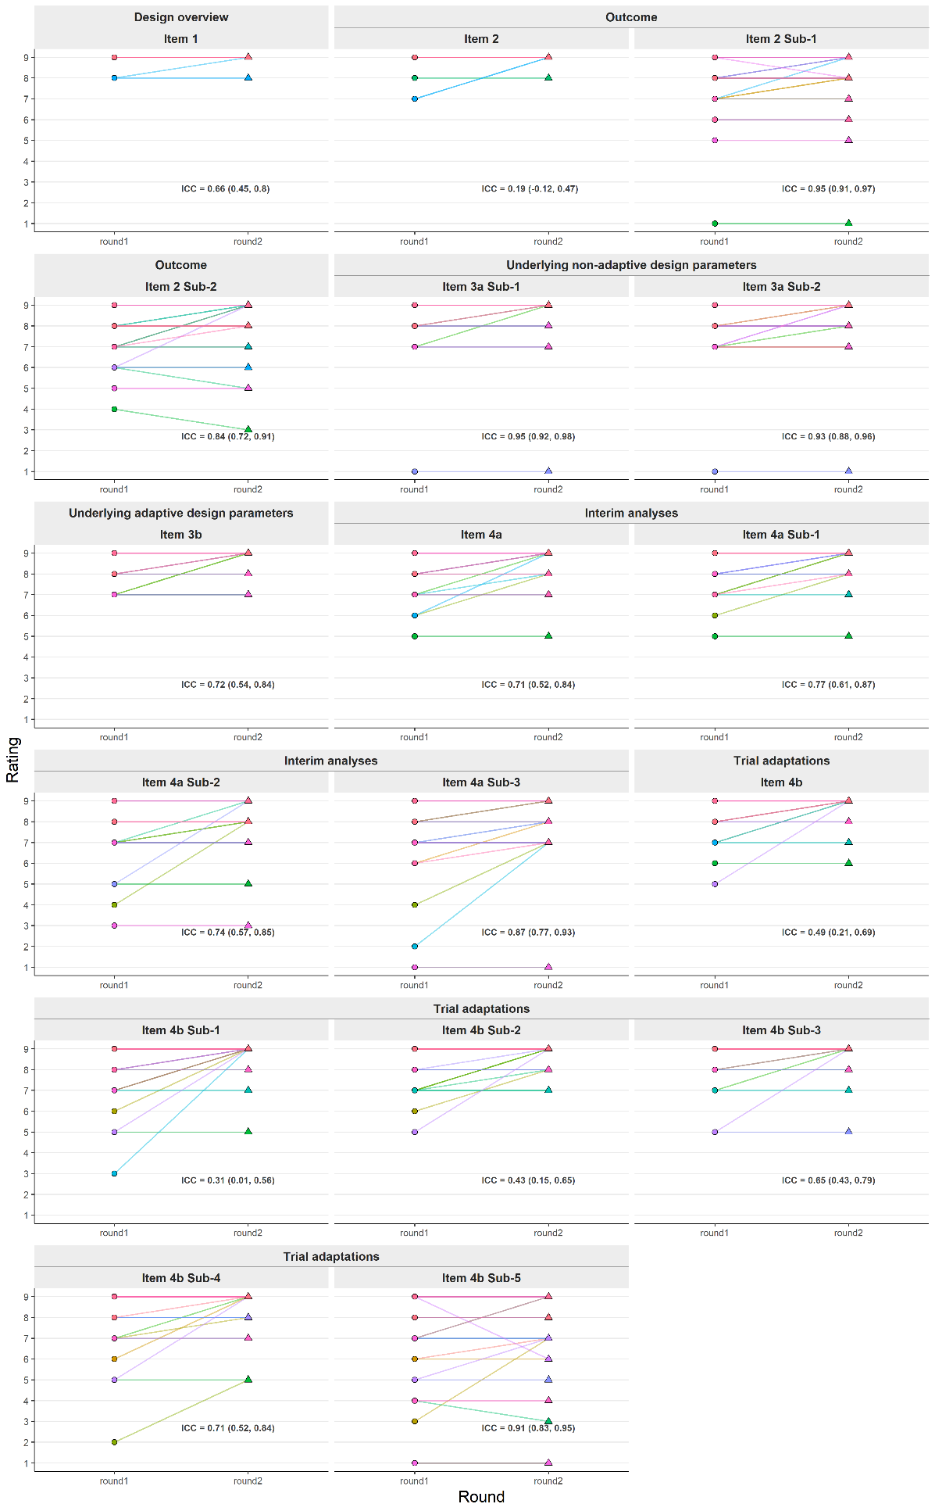
        - Participants' rating change between rounds
(Figure continues the next page)
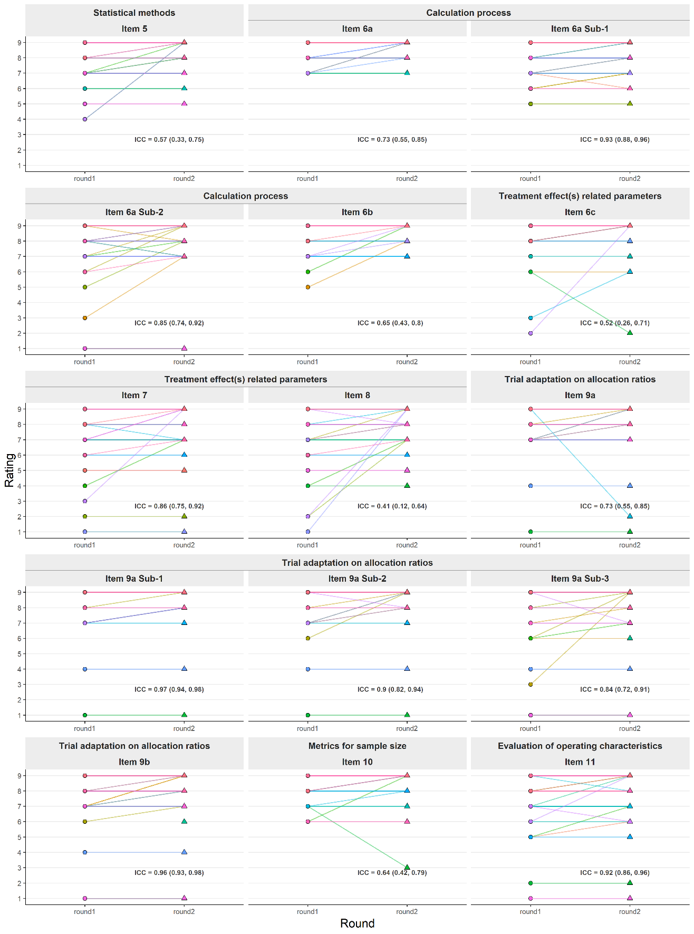

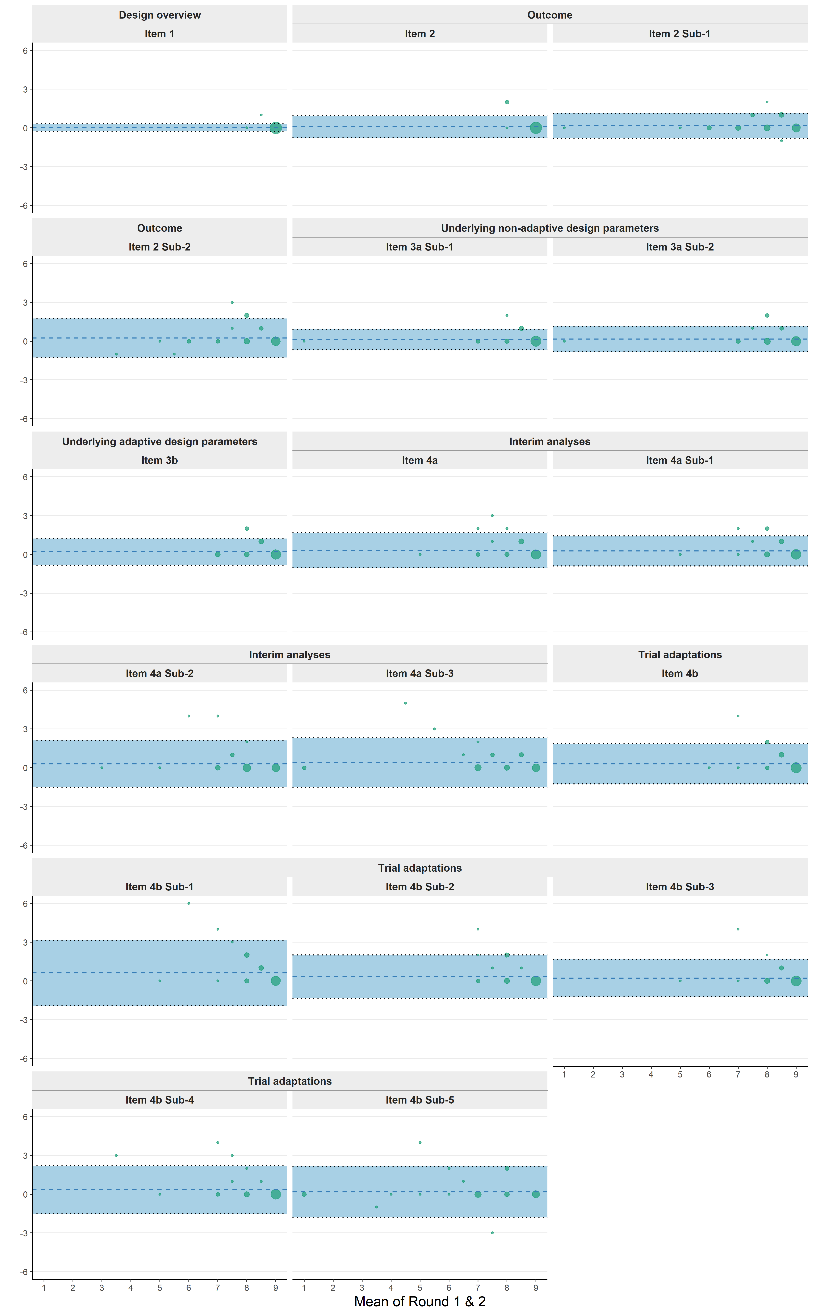
        - Bland-Altman plot for each item of the difference in ratings between two rounds (n=42)
(Figure continues the next page)
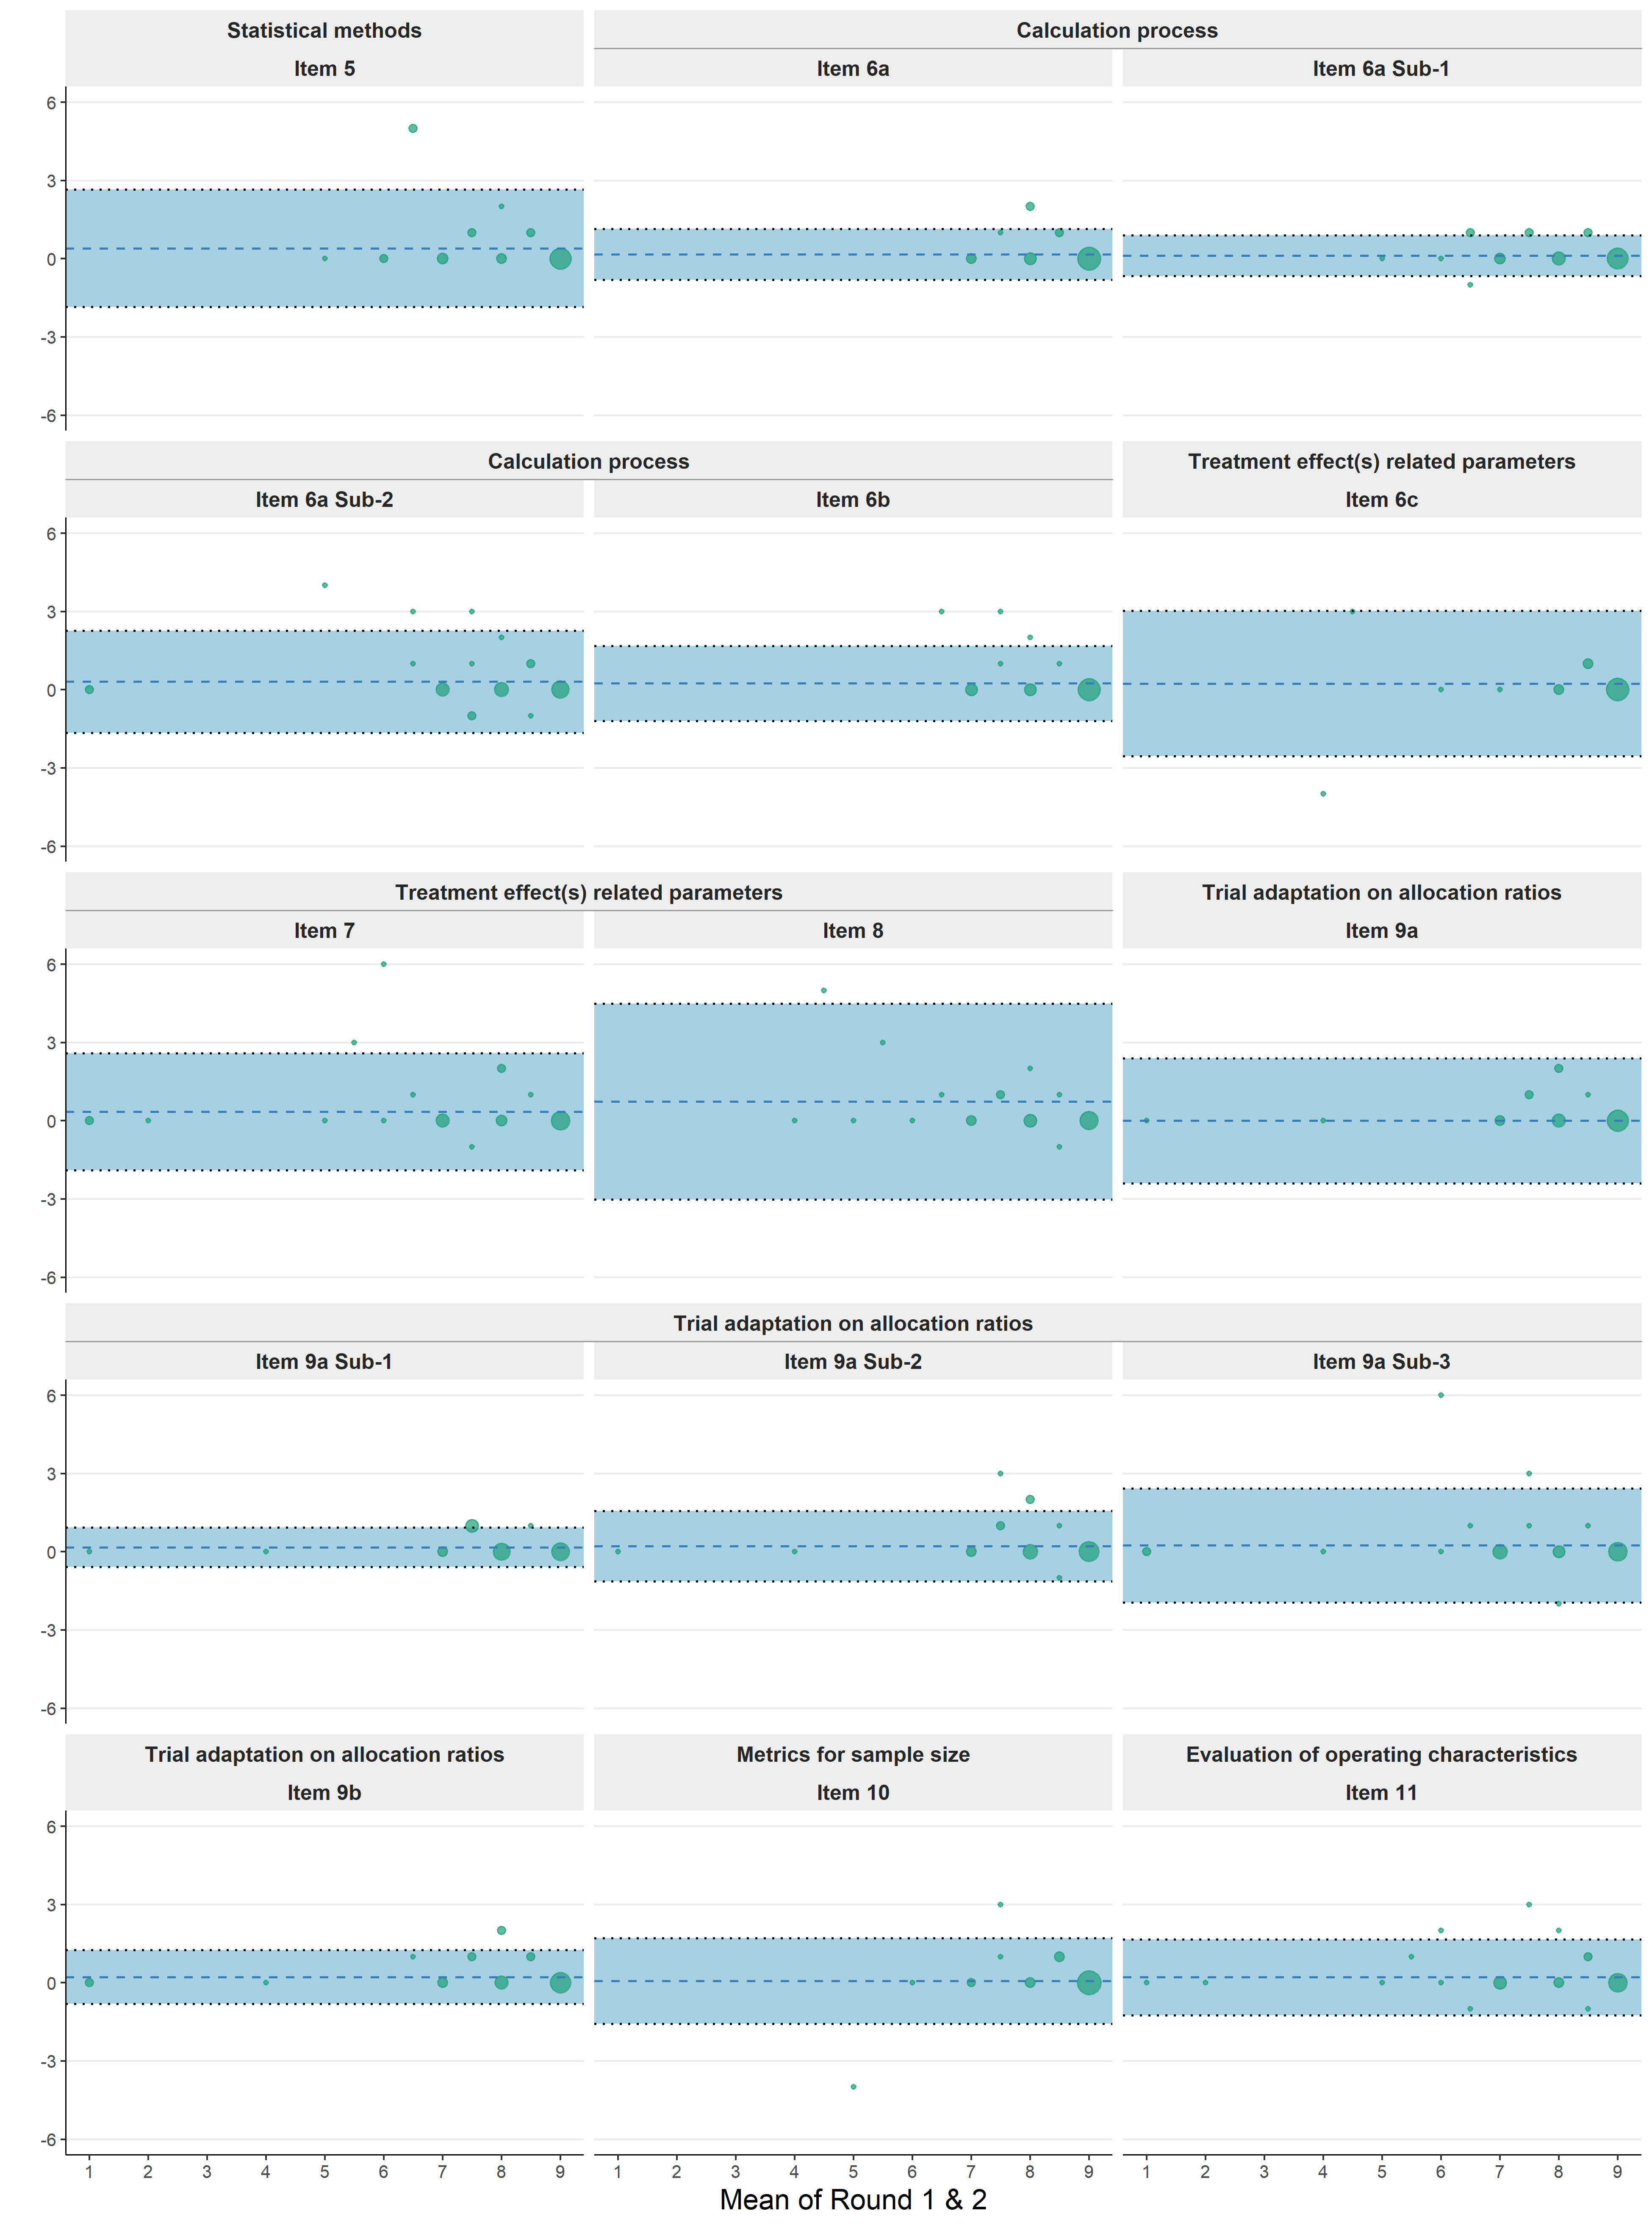

        - Round1 ratings between responder and non-responder
Main aspect | Item |  |  | Round 2 non-responder  N=17 |  |  | Round 2 responder  N=42
Main aspect | N | N | Mean  (SDª) | N | Mean  (SD) | Median  (Q1-Q3) | Z value | P value
Design overview | Item 1 | 17 | 8.9(0.3) | 42 | 9.0(0.2) | 9.0(9.0-9.0) | -0.96 | 0.337
Outcome | Item 2 | 17 | 8.9(0.2) | 42 | 8.9(0.5) | 9.0(9.0-9.0) | 0.21 | 0.833
 | Item 2 Sub-1 | 17 | 8.2(1.3) | 42 | 7.9(1.5) | 8.0(7.0-9.0) | 1.32 | 0.186
 | Item 2 Sub-2 | 17 | 8.2(1.2) | 41 | 8.0(1.3) | 9.0(7.0-9.0) | 0.48 | 0.634
Underlying non-adaptive design parameters | Item 3a | 14 | 7.9(2.3) | 34 | 7.5(2.2) | 8.5(6.2-9.0) | 1.17 | 0.244
 | Item 3a Sub-1 | 17 | 8.5(0.9) | 40 | 8.5(1.4) | 9.0(8.8-9.0) | -0.35 | 0.726
 | Item 3a Sub-2 | 17 | 8.4(1.3) | 40 | 8.2(1.4) | 9.0(8.0-9.0) | 0.53 | 0.599
Underlying adaptive design parameters | Item 3b | 16 | 8.0(1.5) | 39 | 8.5(0.8) | 9.0(8.0-9.0) | -0.67 | 0.503
Interim analyses | Item 4a | 17 | 8.4(1.9) | 40 | 8.3(1.0) | 9.0(8.0-9.0) | 1.42 | 0.155
 | Item 4a Sub-1 | 17 | 8.6(0.6) | 41 | 8.4(0.9) | 9.0(8.0-9.0) | 0.68 | 0.496
 | Item 4a Sub-2 | 17 | 8.1(1.0) | 41 | 7.8(1.4) | 8.0(7.0-9.0) | 0.30 | 0.766
 | Item 4a Sub-3 | 17 | 8.2(1.1) | 40 | 7.4(2.1) | 8.0(7.0-9.0) | 1.34 | 0.181
Trial adaptations | Item 4b | 17 | 8.5(1.9) | 40 | 8.5(0.9) | 9.0(8.0-9.0) | 1.20 | 0.230
 | Item 4b Sub-1 | 17 | 8.8(0.5) | 40 | 8.2(1.4) | 9.0(8.0-9.0) | 2.10 | 0.036
 | Item 4b Sub-2 | 17 | 8.5(0.8) | 41 | 8.4(1.0) | 9.0(8.0-9.0) | 0.21 | 0.832
 | Item 4b Sub-3 | 16 | 8.6(0.9) | 40 | 8.5(1.0) | 9.0(8.0-9.0) | 0.30 | 0.766
 | Item 4b Sub-4 | 14 | 7.8(1.6) | 40 | 8.2(1.5) | 9.0(8.0-9.0) | -1.10 | 0.269
 | Item 4b Sub-5 | 15 | 7.7(1.4) | 38 | 6.9(2.4) | 7.0(6.2-9.0) | 0.95 | 0.341
Statistical methods | Item 5 | 17 | 8.4(1.1) | 40 | 8.0(1.4) | 9.0(7.0-9.0) | 0.95 | 0.343
Calculation process | Item 6a | 16 | 8.8(0.4) | 41 | 8.5(0.7) | 9.0(8.0-9.0) | 1.16 | 0.246
 | Item 6a Sub-1 | 17 | 8.1(1.4) | 42 | 8.1(1.1) | 9.0(7.2-9.0) | 0.29 | 0.776
 | Item 6a Sub-2 | 17 | 7.9(1.3) | 42 | 7.5(1.9) | 8.0(7.0-9.0) | 0.39 | 0.700
 | Item 6b | 17 | 8.5(0.8) | 41 | 8.3(1.0) | 9.0(8.0-9.0) | 0.42 | 0.675
Treatment effect(s) related parameters | Item 6c | 17 | 8.8(0.4) | 38 | 8.3(1.6) | 9.0(8.0-9.0) | 1.05 | 0.293
 | Item 7 | 17 | 7.9(1.5) | 40 | 7.3(2.3) | 8.0(7.0-9.0) | 0.72 | 0.472
 | Item 8 | 17 | 8.2(1.0) | 39 | 7.4(2.2) | 8.0(7.0-9.0) | 0.97 | 0.330
Trial adaptation on allocation ratios | Item 9a | 17 | 8.2(2.0) | 41 | 8.1(1.5) | 9.0(8.0-9.0) | 0.88 | 0.381
 | Item 9a Sub-1 | 16 | 8.3(0.8) | 40 | 7.9(1.5) | 8.0(7.0-9.0) | 0.96 | 0.339
 | Item 9a Sub-2 | 16 | 8.1(1.0) | 41 | 8.0(1.6) | 9.0(8.0-9.0) | -0.20 | 0.840
 | Item 9a Sub-3 | 17 | 7.9(1.3) | 41 | 7.5(2.1) | 8.0(7.0-9.0) | 0.31 | 0.758
 | Item 9b | 17 | 7.7(2.1) | 41 | 7.9(1.9) | 9.0(7.0-9.0) | -0.16 | 0.875
Metrics for sample size | Item 10 | 16 | 8.6(1.0) | 42 | 8.5(0.9) | 9.0(8.0-9.0) | 0.75 | 0.455
Evaluation of operating characteristics | Item 11 | 15 | 7.7(1.3) | 40 | 7.5(1.9) | 8.0(7.0-9.0) | -0.08 | 0.936

        - Finalised AD-DELTA² checklist
Item no | Item Content
Design Overview
Item 1 | Provide a summary of the trial design, referencing those factors that can feed into the sample size calculation, including the (initial) number of arms, the (initial) allocation ratio(s), the comparison framework (e.g., parallel group, crossover, factorial), the testing framework (e.g., superiority, equivalence, non-inferiority), the statistical framework (state explicitly if Bayesian method is to be used), and the type of adaptive design (AD).
Outcome
Item 2 | Describe the primary outcome(s) and any other outcome(s) on which the sample size calculation is based, including adaptation outcome(s) that are different from the primary outcome(s). Also specify the specific measurement variable, analysis metric, method of aggregation, and when the outcome(s) will be assessed:  1) where applicable, provide a rationale (e.g., clinical or/and statistical) for any adaptation outcome used to inform trial adaptations that are different from the primary outcome(s)  2) if relevant, explain why the primary outcome(s) is(are) not used as the basis for sample size calculation.
Underlying non-adaptive design parameters
Item 3a | For the considered design features (e.g., cluster randomised, Bayesian), state and justify any non-adaptive:  1) inputs or parameters that feed into the sample size calculation (e.g., within-subject variation for crossover design or average cluster size for cluster-randomised trial).  2) adjustments (e.g., allowances for loss to follow-up, multiplicity corrections) that impact the required sample size and explain their rationale.
Underlying adaptive design parameters
Item 3b | For the considered adaptive design, specify and justify any underlying assumptions/parameters related to the trial adaptations that feed into the sample size calculation (e.g., the prevalence of subpopulations in adaptive enrichment design or correlation between adaptation and primary outcomes, if different).
Interim analysis
Item 4a | Clearly define the planned timing and frequency of interim analyses, and specify:  1) criteria for triggering an interim analysis (e.g., achieving a specific percentage of participant recruitment, primary outcome follow-up, or reaching a predefined point in calendar time).  2) rule used to determine the number of 'evaluable participants' at each interim analysis (e.g., whether to include only participants who have completed the primary outcome follow-up or all recruited participants).  3) if relevant, the rationale and methodology for using a flexible interim analysis plan (i.e., when the timing and/or the frequency of interim analyses is not pre-defined).
Adaptation
Item 4b | Describe the trial adaptations (e.g., early trial stopping, treatment selection, sample size re-estimation) and the criteria guiding the adaptation decision-making process. This covers:  1) scope of trial adaptations (e.g., early trial or arm stopping for futility, efficacy or non-inferiority; blinded sample size re-estimation) and when these may be triggered (e.g., in which interim analysis).  2) decision-making criteria for triggering trial adaptations at each interim analysis.  3) criteria for claiming evidence in the final analysis.  4) clarify whether decision-making criteria are binding or non-binding (e.g., futility).
Statistical methods
Item 5 | Describe or reference the statistical methods underpinning the adaptive design, including those used to inform trial adaptations (e.g., statistical formulas or methods for estimating relevant quantities).
Calculation process
Item 6a | State the basis for the sample size determination (e.g., based on analytical calculation/simulation to achieve a desired statistical property/only feasibility consideration):  1) when the sample size is determined by analytical calculation, clearly describe or provide a reference to the method used. Where relevant, include details of the software, package (with version), or code used to derive the sample size, or clearly reference where this information can be accessed  2) if the sample size was determined using simulation methods, describe the simulation approach, including key assumptions, parameter choices, and simulated scenarios. Specifying where the full simulation protocol, simulation code (including the seed used to generate a random sample), and key simulation results can be accessed (e.g., in an appendix or an online repository) is highly recommended to ensure transparency and reproducibility.
Item 6b | Describe the desired operating characteristics of the trial design which feed into the sample size calculation. This should be the desired statistical properties that the design aims to achieve, such as the statistical significance level (e.g., pairwise Type I error rate, familywise Type I error rate, etc.), power, the precision of estimation, or their analogues, and explain how these items were defined.  When the sample size is dictated by feasibility rather than by the goal of achieving a specific statistical property (e.g., a certain level of power), explicitly state the rationale for this decision and reference the evaluation of the operating characteristics (e.g., the resulting power, under the planned sample size).
Treatment effect(s) related parameters
Item 6c | Express the treatment effect parameters that feed into the sample size calculation (e.g., the target difference in superiority trials or the non-inferiority margin in non-inferiority trials)  1) Explain the rationale for the choice of the treatment effect parameter. Indicate how the parameter(s) was/were selected (e.g., based on prior studies, expert opinion, stakeholder input, or other methods), include references where appropriate.  2) When the interested parameter is a treatment difference, clarify whether it is a clinically meaningful one, a realistic one, or both.
Adaptation on allocation
Item 7a | If relevant, describe any trial adaptations (e.g., response adaptive randomisation) that may be made to the initial allocation ratio(s) and specify:  1) the statistical method planned to be used for updating allocation ratio(s).  2) any restrictions planned to be applied when modifying the allocation ratio(s).  3) for response adaptive randomisation, the allocation ratio(s) to be applied during the burn-in period and the duration of the burn-in period (e.g., in terms of sample size or calendar time).
Item 7b | Describe any changes that could be made to the allocation ratios resulting from other trial adaptations, in addition to adapting allocation ratios (e.g., changing the allocation ratio due to dropping treatment arms or populations).
Metrics of sample size
Item 8 | State the planned sample size (overall and per arm), needed for the currently specified comparison(s). Where relevant, also report the range of possible sample size, the minimum and maximum sample size under the planned adaptive features; if no fixed maximum sample size can be set (e.g., in a platform trial where the number of future comparisons is uncertain), explain the reason; it is recommended to describe the expected sample size and its potential variability under the planned adaptive features.
Operating characteristics
Item 9 | Provide a summary or indicate where to access the operating characteristics (i.e. statistical behaviour) of the design, when feasible, also provide descriptions of how they were calculated or estimated (e.g., through simulation or analytical statistical methods) with assumptions made (e.g., under several or a specific range of treatment effects) to justify the chosen sample size and value of an AD as well as the appropriateness of AD-related aspects (e.g., decision rules).

        - Voting results on the relevance of selected items to trial grant applications and trial protocols
 |  | Relevance to trial documents
Main aspect | Item number | Protocol only  N(%) | Grant application only  N(%) | Both  N(%) | Not sure  N(%)
Trial adaptations | Item 4b (n=18) | 1 (5.6) | 2 (11.1) | 14 (77.8) | 1 (5.6)
Trial adaptations | Item 4b-sub1 (n=18) | 4 (22.2) | 1 (5.6) | 12 (66.7) | 1 (5.6)
Trial adaptations | Item 4b-sub2 (n=17) | 9 (52.9) | 1 (5.9) | 6 (35.3) | 1 (5.9)
Trial adaptations | Item 4b-sub3 (n=18) | 4 (22.2) | 2 (11.1) | 8 (44.4) | 4 (22.2)
Trial adaptations | Item 4b-sub4 (n=18) | 8 (44.4) | 1 (5.6) | 7 (38.9) | 2 (11.1)
Calculation process | Item 6a (n=17) | 0 (0.0) | 1 (5.9) | 16 (94.1) | 0 (0.0)
Calculation process | Item 6a-sub1 (n=16) | 3 (18.8) | 2 (12.5) | 11 (68.8) | 0 (0.0)
Calculation process | Item 6a-sub2 (n=17) | 6 (35.3) | 1 (5.9) | 10 (58.8) | 0 (0.0)
Evaluation of operating characteristics | Item 11 (n=15) | 3 (20.0) | 1 (6.7) | 8 (53.3) | 3 (20.0)

        - Voting results on the inclusion of item 4b sub-5
Main aspect | Item number | Decision on the inclusion
 | Item number | Keep  N(%) | Discard  N(%) | Not sure  N(%)
Trial adaptations | 4b sub5 (n=17) | 3 (17.6) | 9 (52.9) | 5 (29.4)

