Supplementary Information
Fig. S1.
Quantification of magnesium and zinc contents in PMEZ and PMEZL scaffolds measured using inductively coupled plasma optical emission spectroscopy (ICP-OES).

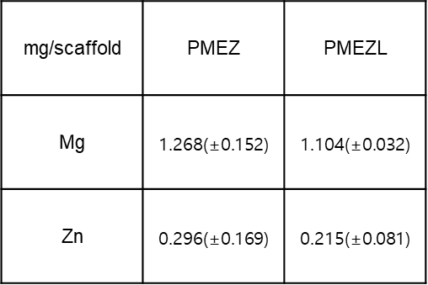

Fig. S2.
Cell viability of HK2 cells exposed to various concentrations of H₂O₂ to establish the oxidative stress model.

Fig. S3.
Zeta potential and PDI of LNP, dEV, hEV determined with dynamic light scattering (DLS).
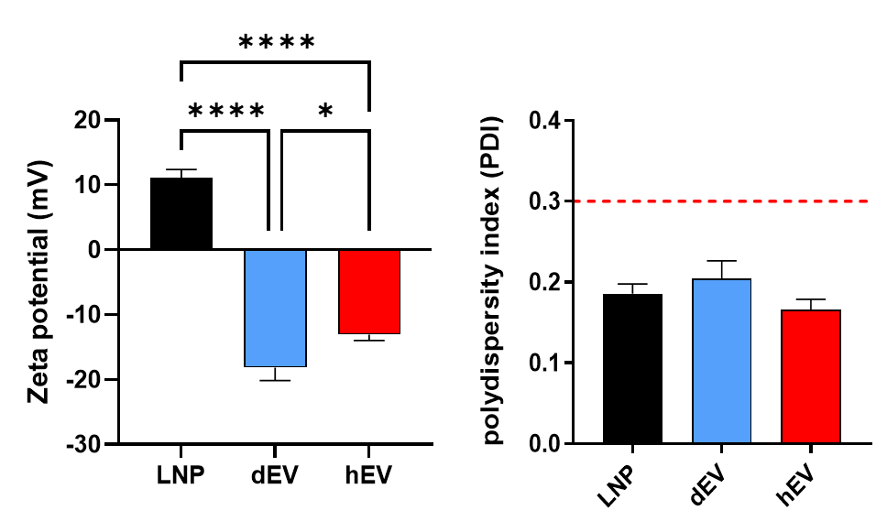

Fig. S4.
Cell viability of HK2 cells treated with increasing concentrations of lactoferrin, as assessed by CCK-8 assay.

Fig. S5.
Temporal monitoring of HK2 cell metabolic activity and proliferation on various scaffolds at days 1, 5, and 7.

