- PubMed / MEDLINE (Ovid)
- EMBASE (Ovid)
3. PsycINFO ( Ovid)

("Kearns-Sayre syndrome"/ or "Kearns-Sayre syndrome".ti,ab. or (Kearns adj2 Sayre).ti,ab. or KSS.ti,ab.) and ("endocrine dysfunction*" or "endocrine manifestation*" or "hormonal disorder*" or endocrinopathy or "endocrine abnormalit*" or "diabetes mellitus" or "hypothyroidism" or "hypoparathyroidism" or "hypogonadism" or "growth hormone deficiency" or "adrenal insufficiency" or "thyroid disorder*" or "pituitary disorder*" or "gonadal failure" or "hormone replacement" or "insulin" or "thyroxine" or "hydrocortisone" or "testosterone" or "growth hormone").ti,ab.

Filters:
* English language
* Human
* Year: Date of inception– sep, 2025
- Date Done -17-10-2025
- Advanced search results retrived -285
- Access through University of york

https://ovidsp.dc1.ovid.com/ovid-new-a/ovidweb.cgi?&S=fe2a77b6-b83f-4bb4-a2f4-7a4c2014789a%7cmain&SELECT=S.sh%7c&R=25&Process+Action=display

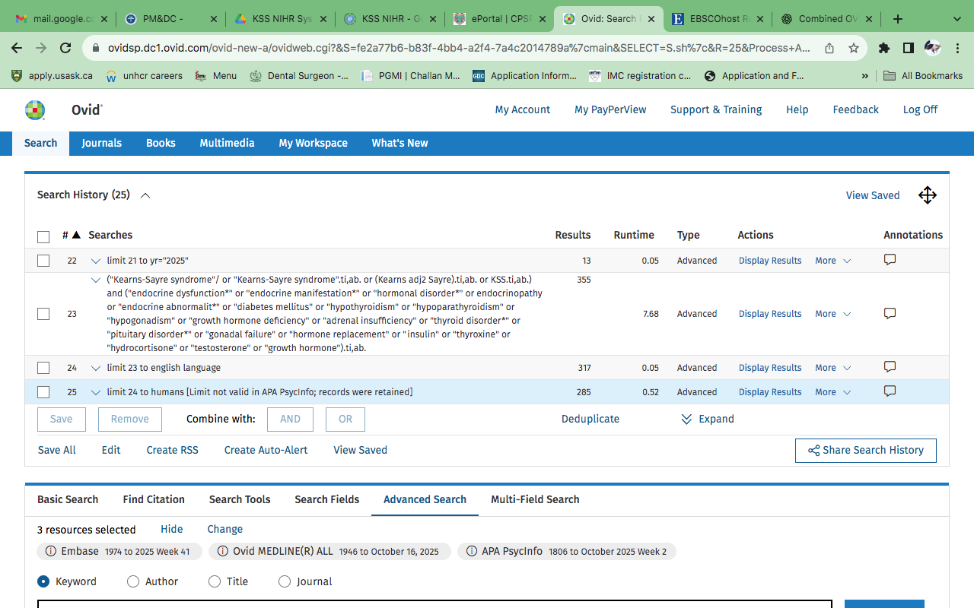

- Scopus

TITLE-ABS-KEY ( "Kearns-Sayre syndrome" OR ( Kearns W/2 Sayre ) OR KSS ) AND TITLE-ABS-KEY ( "endocrine dysfunction" OR "endocrine manifestation*" OR endocrinopathy OR "hormonal disorder*" OR "hormonal abnormalit*" OR "diabetes mellitus" OR hypothyroidism OR hypoparathyroidism OR hypogonadism OR "growth hormone deficiency" OR "adrenal insufficiency" OR "thyroid disorder*" OR "pituitary disorder*" OR "gonadal failure" OR "metabolic dysfunction*" OR "hormone replacement" OR insulin OR thyroxine OR hydrocortisone OR testosterone OR "growth hormone" ) AND ( LIMIT-TO ( DOCTYPE , "ar" ) ) AND ( LIMIT-TO ( LANGUAGE , "English" ) ) AND ( LIMIT-TO ( EXACTKEYWORD , "Human" ) OR LIMIT-TO ( EXACTKEYWORD , "Kearns Sayre Syndrome" ) )

Filters (from sidebar options):

- English
- Humans
- Article
- Kearns -sayre syndrom
- Date Done -17-10-2025
- Advanced search resuts retrived 190

https://www.scopus.com/results/results.uri?sort=plf-f&src=s&sid=64c88998299a3faa47ca3035b2dedcee&sot=a&sdt=a&cluster=scosubtype%2C%22ar%22%2Ct%2Bscolang%2C%22English%22%2Ct%2Bscoexactkeywords%2C%22Human%22%2Ct%2C%22Kearns+Sayre+Syndrome%22%2Ct&sl=553&s=TIT
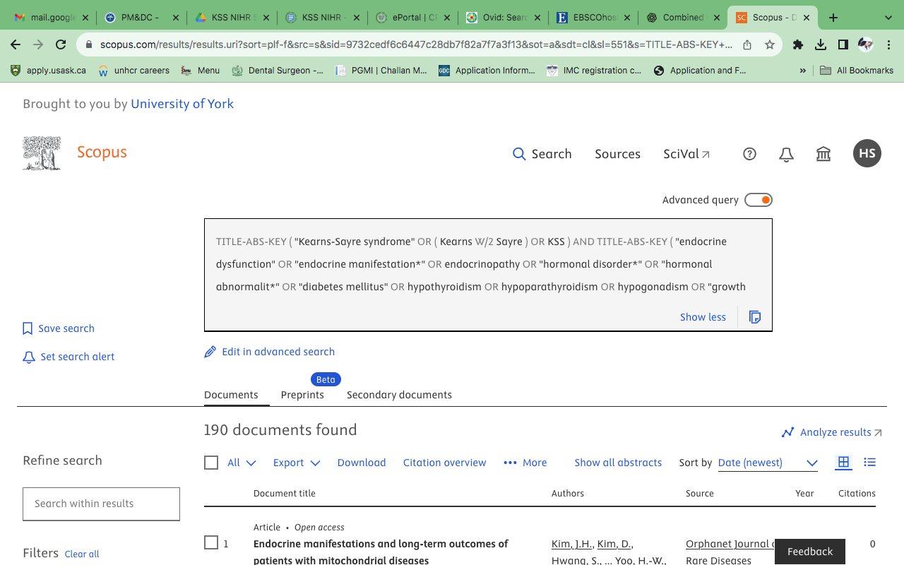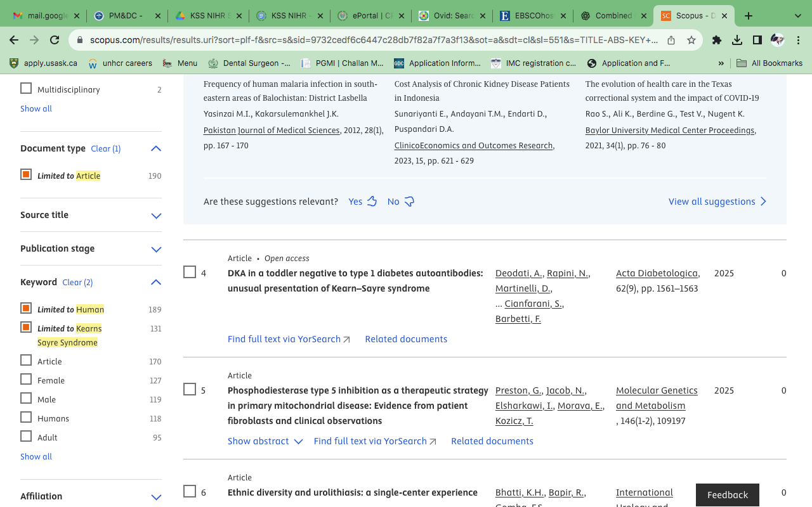

5. Web of Science Core Collection

TS=("Kearns-Sayre syndrome" OR "KSS" OR "mitochondrial disorder" OR "mitochondrial mutation" OR
"oculocraniosomatic syndrome")
AND TS=("endocrine dysfunction" OR "hormonal disorder" OR "diabetes mellitus" OR "hypothyroidism" OR
"hypoparathyroidism" OR "hypogonadism" OR "growth hormone deficiency" OR "adrenal insufficiency")
AND TS=("diagnosis" OR "diagnostic approach" OR "screening" OR "genetic testing")
AND TS=("management" OR "treatment" OR "therapeutic" OR "hormone replacement" OR
"insulin" OR "thyroxine" OR "hydrocortisone" OR "growth hormone")

Filters:

* Language: English
- Date Done -17-10-2025
- Advanced search resuts retrived 53

https://www.webofscience.com/wos/woscc/summary/e58a557c-c9ac-4c53-baae-76f81fb1bb14-0181bf9918/relevance/1

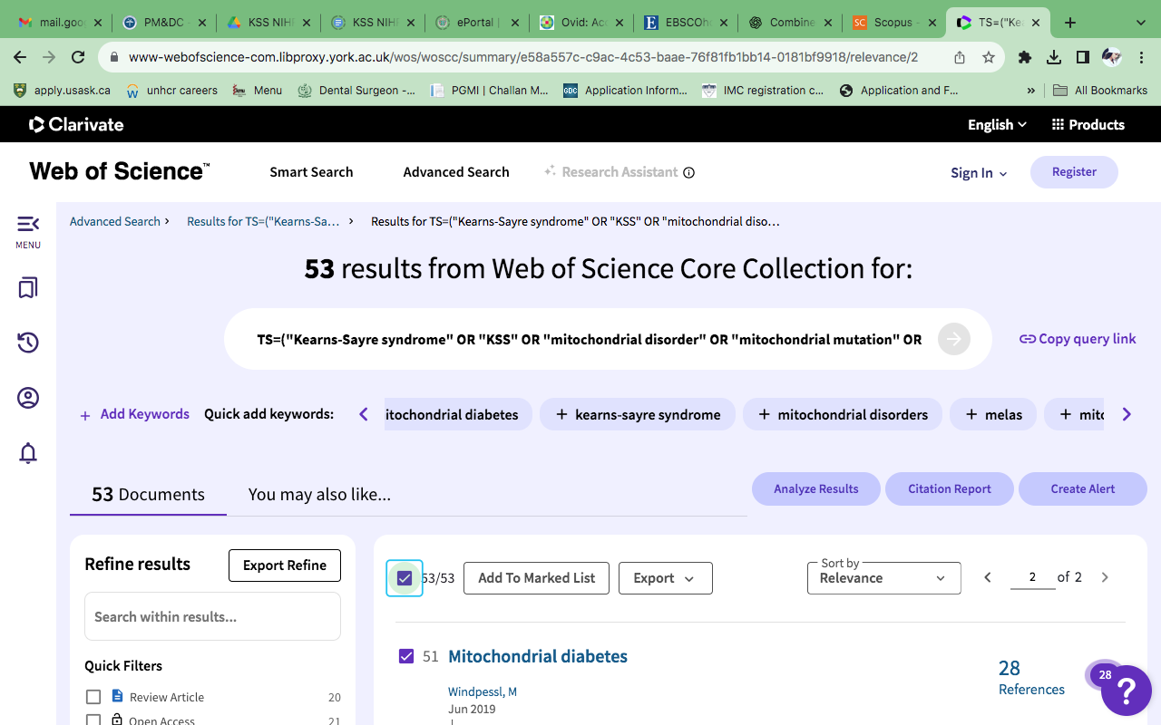

- CINAHL complete (EBSCOhost)

"Kearns-Sayre syndrome" OR KSS AND (endocrine OR hormonal OR endocrinopathy OR "diabetes mellitus" OR hypothyroidism OR hypoparathyroidism OR hypogonadism OR "growth hormone deficiency" OR "adrenal insufficiency" OR thyroid OR pituitary OR gonadal OR metabolic)

Limiters:

* English Language
* Human
* Year: Date of inception– sep, 2025
- Date Done -17-10-2025
- Advanced search resuts retrived 119

https://web.p.ebscohost.com/ehost/folder?vid=87&sid=e01016f0-35d4-454e-ab1e-3e9f50caf8ec%40redis
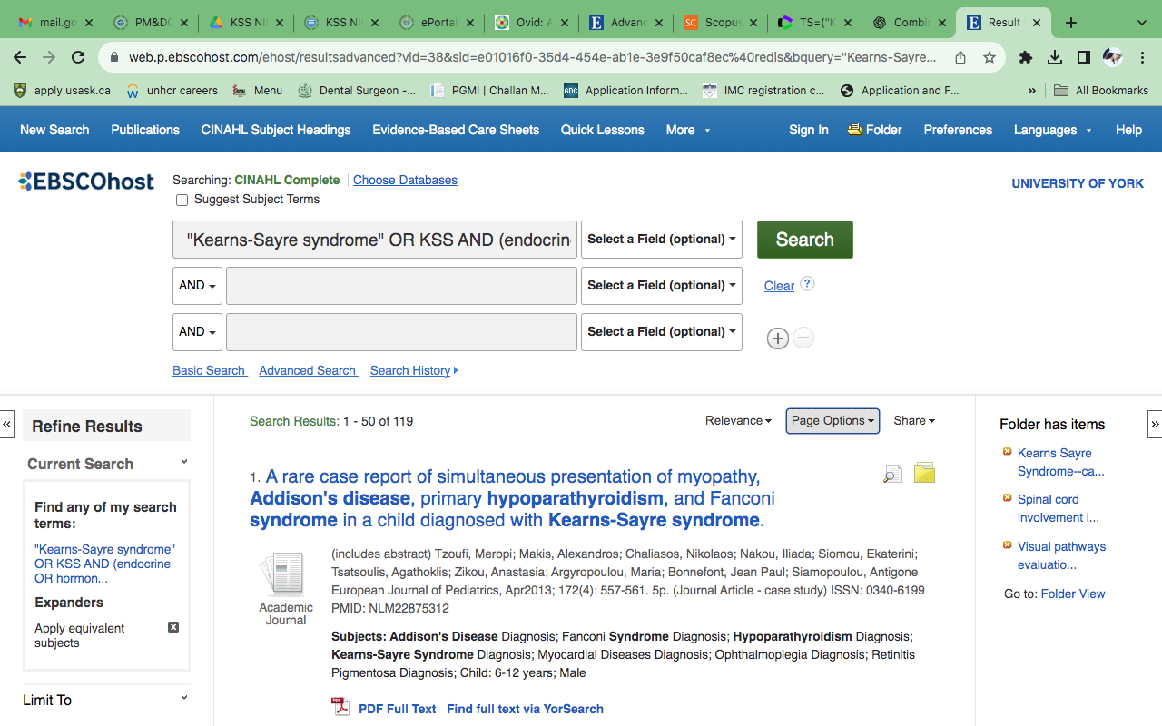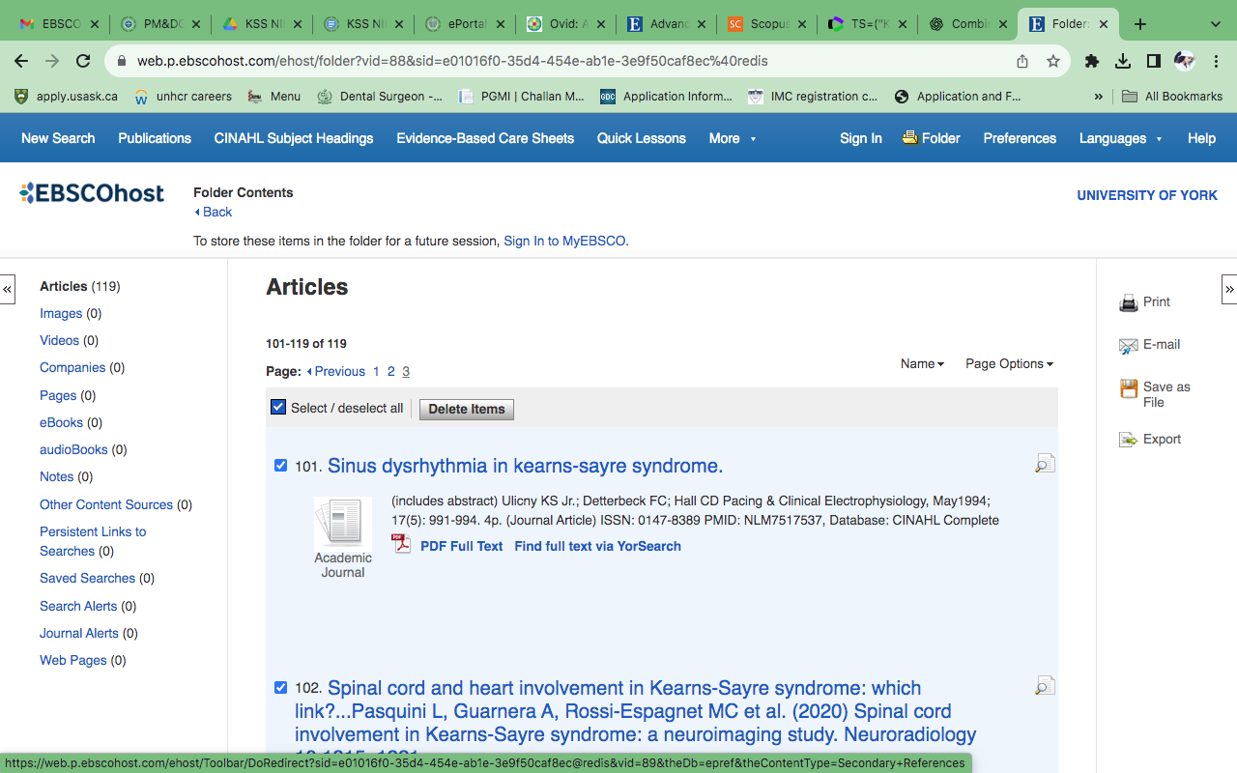

7. ProQuest
("Kearns-Sayre syndrome" OR (Kearns NEAR/2 Sayre) OR KSS)
AND
(endocrine OR hormonal OR metabolic OR diabetes OR thyroid OR adrenal OR gonadal OR pituitary)

Filters:

* Language: English
* Source type: Scholarly journals,clinical tria,Medical research,
* Publication date: All available years – sep,2025
* Exclude: dissertations, books
- Date Done -17-10-2025
- Advanced search resuts retrived 124
https://www.proquest.com/results/6BA9A6CBC3A54287PQ/2?accountid=15181#scrollTo

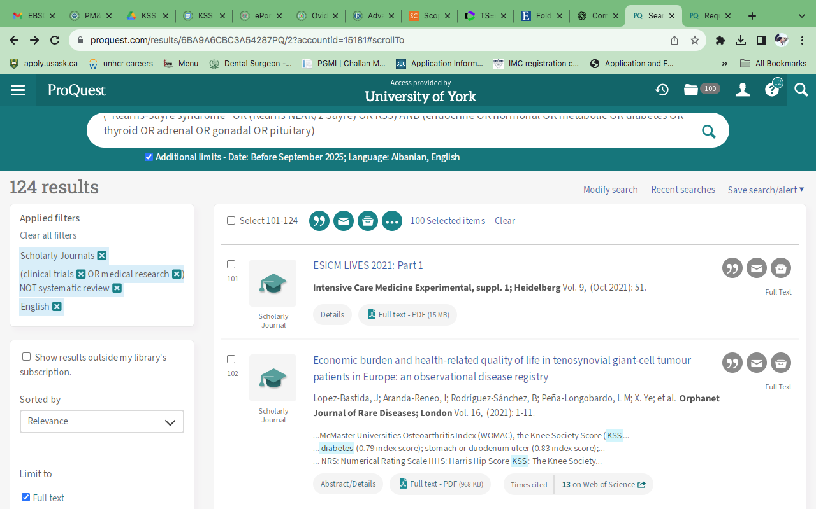

Grey literature Search

BASE (Bielefeld Academic Search Engine) ( 2 found but duplicate ) | https://www.base-search.net
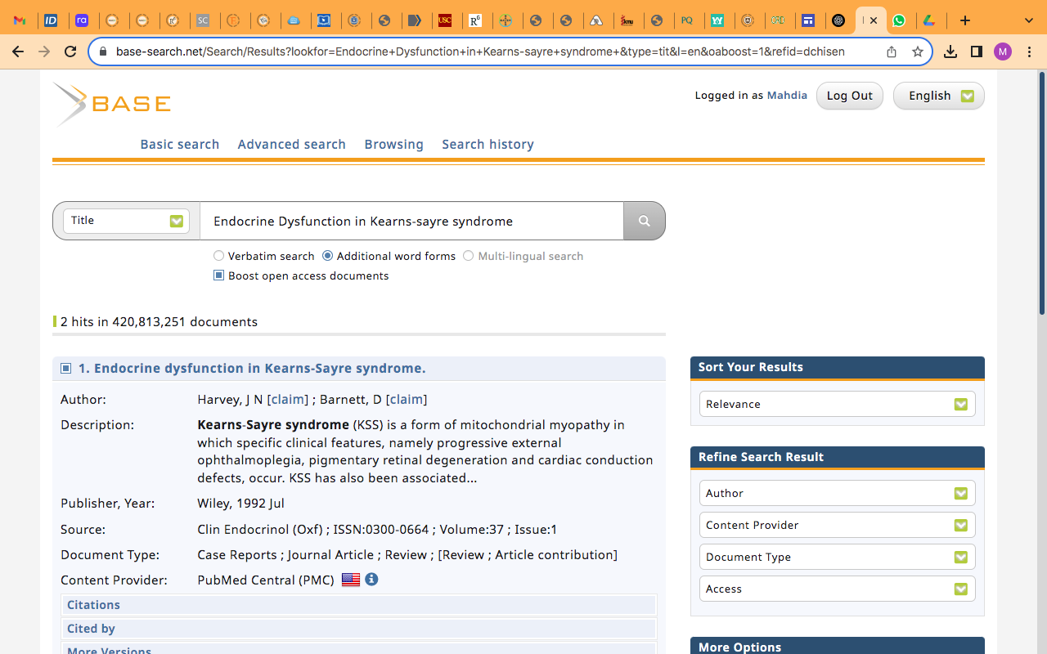
CORE (Aggregated open access research ) 5 found ,only 1 relevant ( duplicate ) | https://core.ac.uk/search/?q=Endocrine+Dysfunction+in+Kearns-sayre+Syndrome+AND+fieldsOfStudy%3A%22medicine%22+AND+documentType%3A%22research%22&page=1
OpenDOAR (Repository directory)0 found | https://v2.sherpa.ac.uk/opendoar
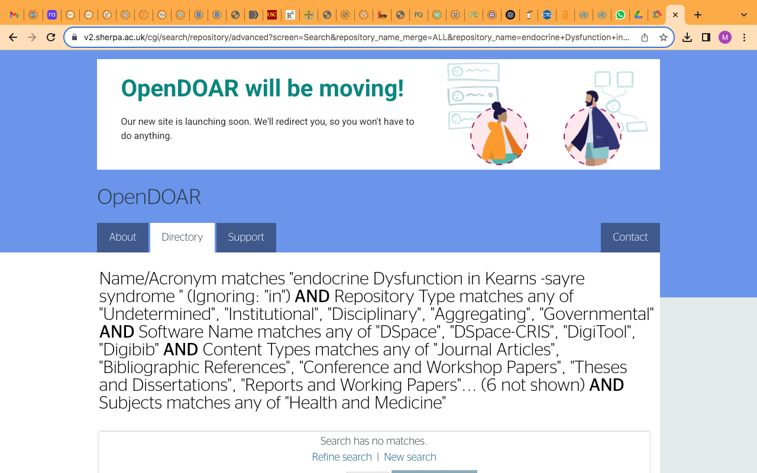

OpenGrey (Archived data only ) General Search 0 found | https://opengrey.eu (archived, still useful)
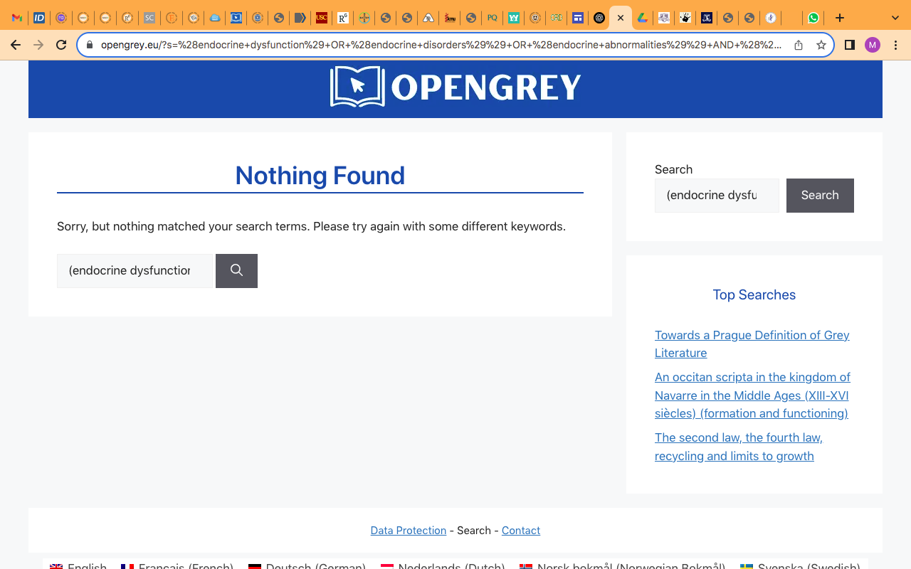

HEC Pakistan Repository | http://prr.hec.gov.pk , 10 found but all irrelevant

Clinical Trails & reasearch Registeries

ClinicalTrials.gov 0 found |https://clinicaltrials.gov/expert-search
ISRCTN Trial Registry 0 found | https://www.isrctn.comhttps://www.isrctn.com/search?q=endocrine+dysfunction+in+Kearns+-sayre+syndrome&searchType=advanced

WHO ICTRP (International Clinical Trials) | 0 found

https://trialsearch.who.int/

International and Government Reports

WHO Publications 7 found O relevant | https://bvsalud.org/queries/?s=endocrine+dysfunction+in+kearns+-sayre+syndrome+&l=en_US

UNICEF Reports 0 found | https://www.unicef.org/search?query=Endocrine+dysfunction+in+Kearns+-sayre+syndrome+&created%5Bmin%5D=&created%5Bmax%5D=

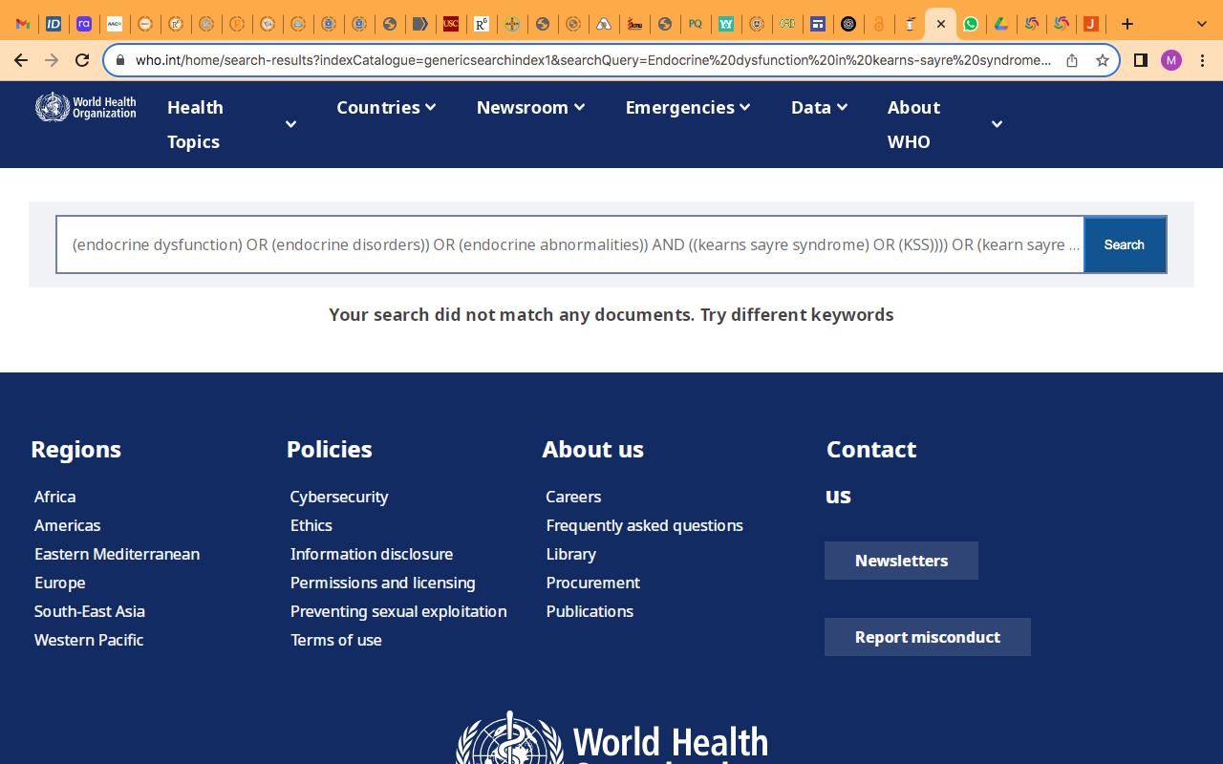

PILOT STUDY DATA Base search

