Supplementary Table S1. Standardized movement-task protocol used in the ReMAP assessment.
Task Pair | Task | Functional Demand | Camera View
Pair 1 | Weight transfer | Dynamic balance | AP
Pair 1 | Reach and return | Postural control | AP
Pair 2 | Step sequence | Coordination | AP
Pair 2 | Turning task | Motor planning | Lateral
Pair 3 | Functional mobility sequence | Integrated movement | AP + Lateral
AP, anterior–posterior view. ReMAP (Rehabilitation Movement Assessment Protocol) consists of standardized movement tasks designed to challenge complementary dimensions of movement behavior, including postural stability, motor control, coordination, and movement efficiency. All tasks were performed using standardized instructions and recorded using predefined camera positions.

Supplementary Table S2. Definitions and clinical interpretation of ReMAP-derived movement-quality metrics.
Metric | Domain | Description | Interpretation
Mediolateral sway | Postural stability | Variability of mediolateral COM displacement | Lower values indicate greater stability
Trajectory variability | Motor control | Variability of movement trajectories | Lower values indicate more consistent movement
Coordination | Coordination | Frequency of corrective adjustments | Higher values indicate greater adaptive control
Energy ratio | Movement efficiency | Relative movement burden | Lower values indicate greater efficiency
COM, center of mass. Metrics were derived from standardized video-based movement assessments using markerless pose estimation. Lower mediolateral sway, trajectory variability, and energy ratio values indicate more favorable movement quality, whereas higher coordination values indicate greater adaptive control.

Supplementary Table S3. Benefit-aligned change-score correlations among conventional rehabilitation outcomes and ReMAP-derived movement-quality metrics
Variable | WHODAS | EORTC PF | EORTC Fatigue | EORTC QoL | TUG | 6MWT | Grip Strength | One-leg Standing | ML Sway | Trajectory Variability | Coordination | Energy Ratio
WHODAS | 1.000
EORTC PF | 0.619 | 1.000
EORTC Fatigue | 0.537 | 0.550 | 1.000
EORTC QoL | -0.504 | -0.305 | -0.524 | 1.000
TUG | 0.058 | 0.096 | 0.140 | -0.376 | 1.000
6MWT | -0.177 | -0.136 | -0.055 | 0.101 | -0.130 | 1.000
Grip Strength | -0.041 | 0.091 | 0.015 | -0.197 | 0.056 | -0.023 | 1.000
One-leg Standing | -0.004 | 0.079 | 0.116 | -0.056 | 0.080 | 0.085 | 0.164 | 1.000
ML Sway | -0.017 | -0.069 | -0.059 | -0.082 | 0.131 | -0.118 | 0.058 | 0.138 | 1.000
Trajectory Variability | 0.071 | 0.039 | -0.016 | -0.168 | -0.069 | -0.135 | -0.032 | 0.044 | 0.306 | 1.000
Coordination | -0.033 | 0.018 | -0.036 | -0.115 | 0.175 | -0.062 | 0.008 | 0.039 | -0.138 | 0.073 | 1.000
Energy Ratio | -0.066 | 0.005 | -0.027 | -0.137 | 0.163 | -0.057 | -0.022 | 0.296 | 0.572 | 0.388 | -0.212 | 1.000
Spearman correlation coefficients were calculated using benefit-aligned change scores, such that positive values consistently represented favorable rehabilitation-related change. Weak correlations between changes in ReMAP-derived movement-quality metrics and conventional rehabilitation outcomes suggest that rehabilitation-related improvements in movement quality occurred largely independently of changes captured by disability, mobility, endurance, strength, balance, and patient-reported outcomes.

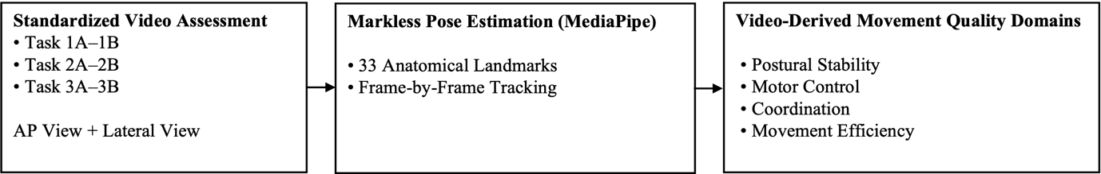
Supplementary Figure S1. Overview of the video-based movement quality assessment procedure. Standardized rehabilitation-task videos were recorded from anterior–posterior and lateral views and processed using markerless pose estimation. Four movement-quality metrics representing postural stability, motor control, coordination, and movement efficiency were subsequently derived and evaluated as complementary rehabilitation outcome measures.

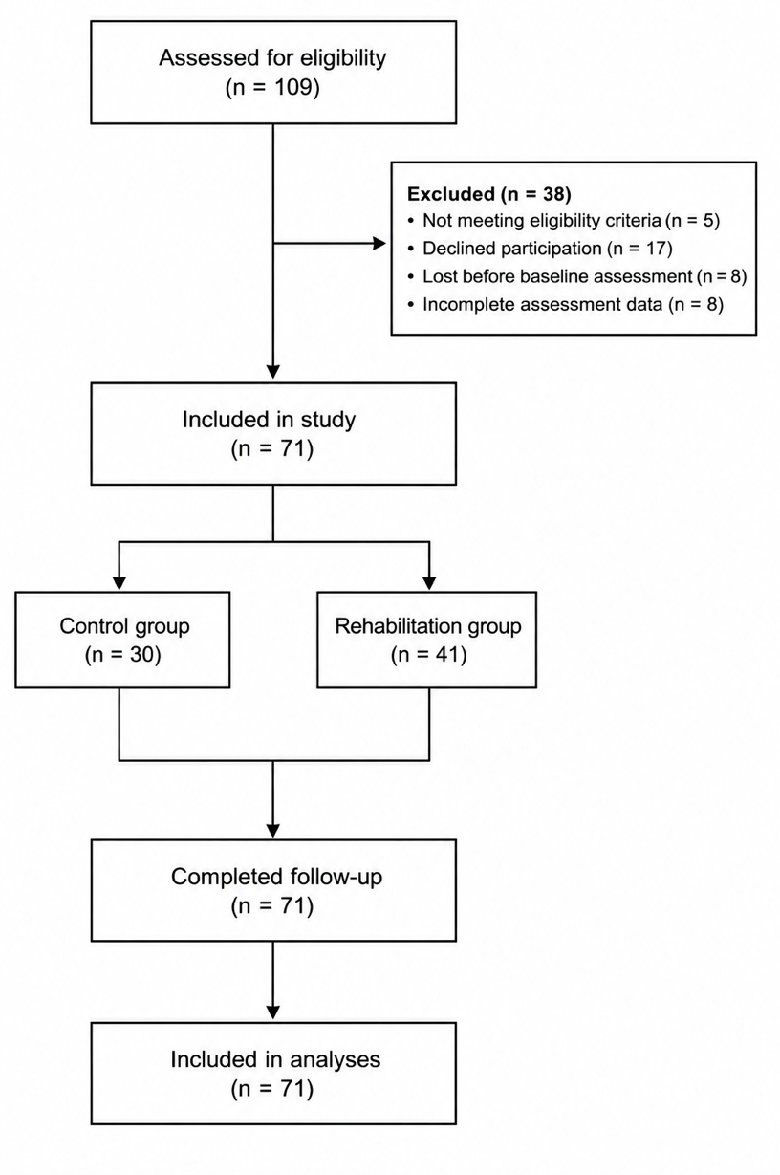
Supplementary Figure S2. Participant flow through screening, enrollment, follow-up, and analysis. Flow of participants through eligibility assessment, study inclusion, follow-up, and final analyses.

Supplementary Figure S2 Exploratory associations between movement-quality metrics and TUG performance. Standardized regression coefficients and 95% confidence intervals from exploratory models examining associations between movement-quality metrics and TUG performance at baseline and over time. These analyses were exploratory and not part of the primary study objectives.

