Supplementary Data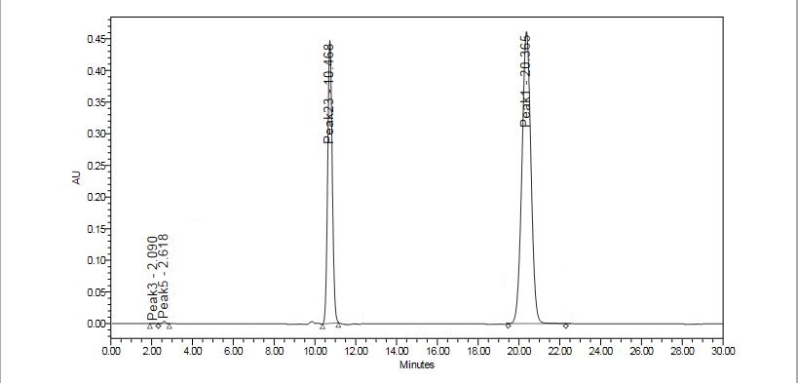
A)

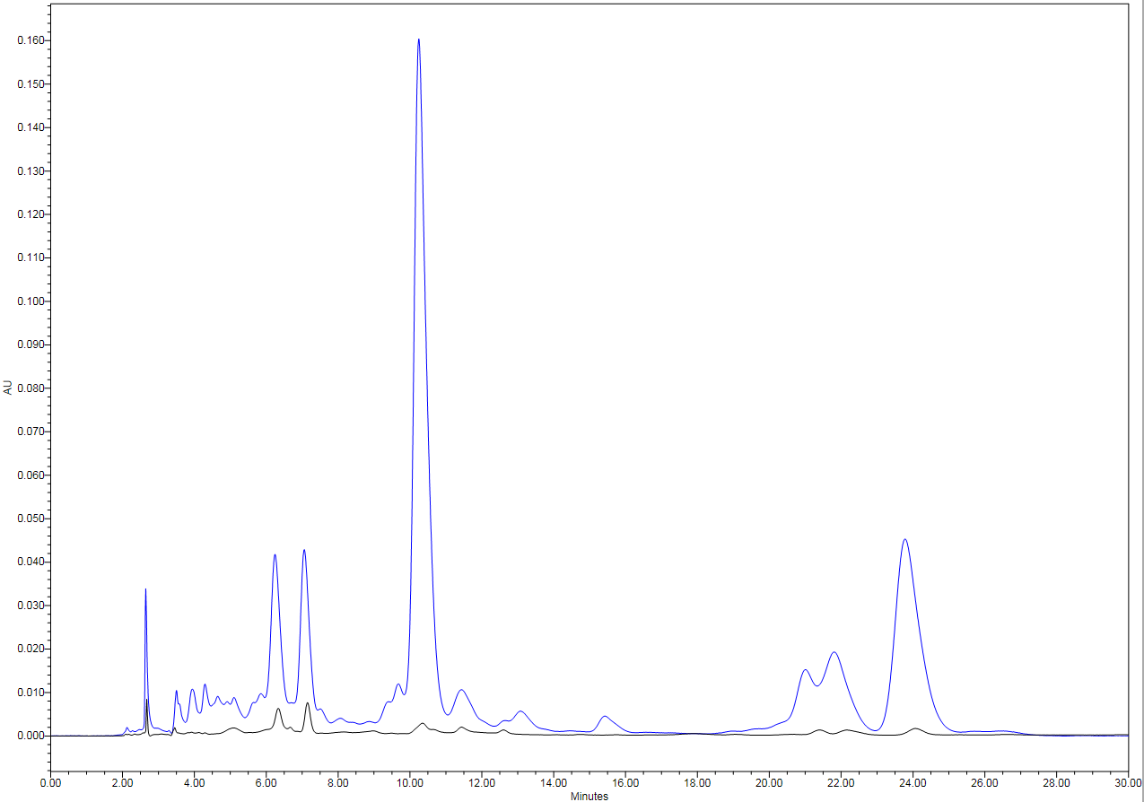
B)
P-II in PKR-31
P-II in PKR-84
Fig. S1 Chromatogram: A) Standards of Picroside-I and II, B) PKR-84 and PKR-31
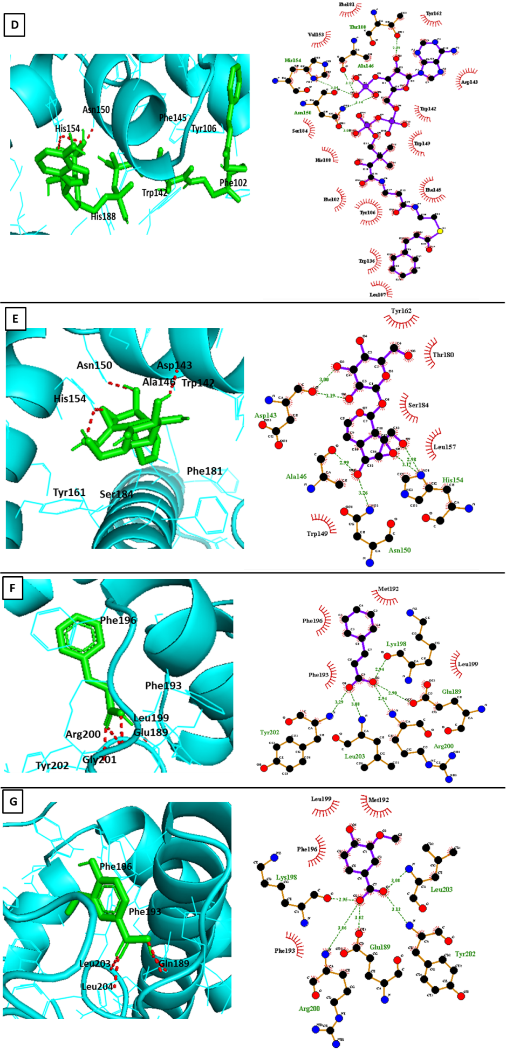
Fig. S2 Interactions of compounds with Acyltransferase (MBOAT, identifier Node_48592/618 bp (AT_PII-10)). 6-feruloylcatalpol(A) 6-cinnamoylcatalpol(B) 6-vanilloylcatalpol (C) Cinnamoyl CoA (D) Catalpol (E) Cinnamic Acid (F) Vanillic Acid (G)

