Supplementary material

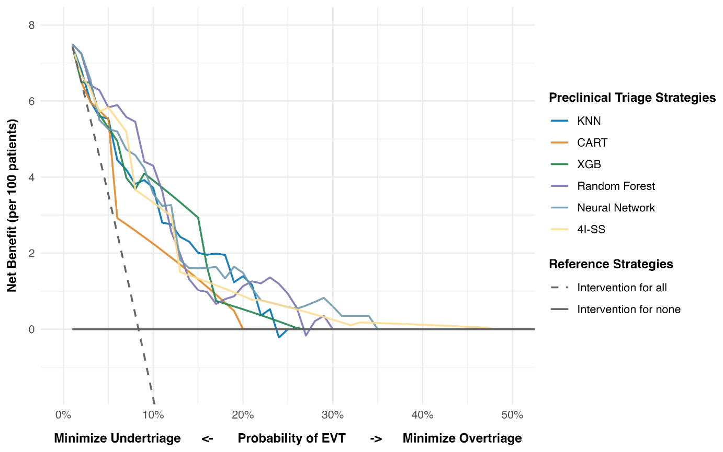
Fig S1 Decision curve analysis comparing the clinical utility (net benefit) of ML models, the 4I-SS, and reference strategies for preclinical identification of EVT candidates.

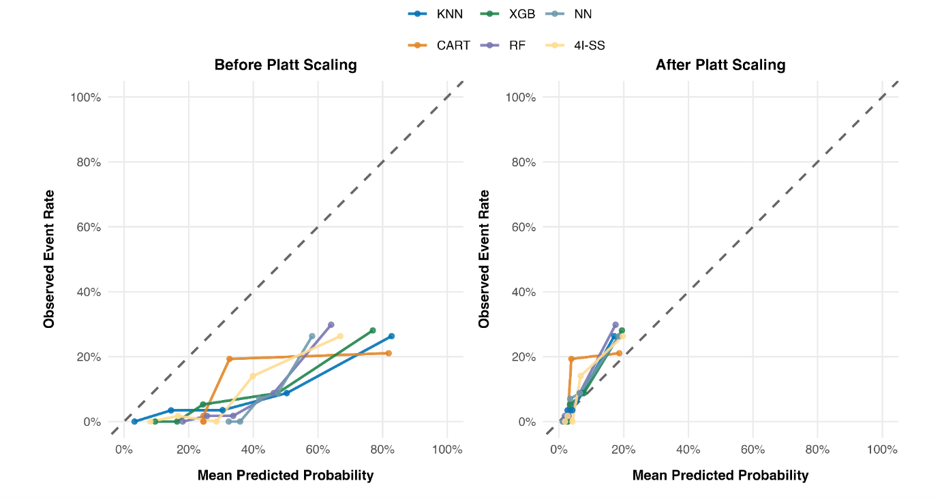
Fig. S2 Calibration plots before (left) and after (right) Platt scaling, showing the alignment of predicted probabilities with observed event rates with the diagonal line indicating perfect calibration.

Tab. S1 Predictive performance of machine learning classifiers and the 4I-SS for identifying endovascular thrombectomy candidates in the evaluation cohort
Model/ Metric | AUC  ROC | NCV  ±SD | AUP  RC | Acc | Sens  Recall | Spec | PPV  Precision | NNA | NPV | F1-  score | Brier score (%)
One R | 0.78  (0.68–0.86) | 0.75  ±0.066 | 0.22 (0.13–0.32) | 0.77 (0.72–0.82) | 0.79 (0.58–0.93) | 0.77 (0.72–0.82) | 0.24 (0.15–0.34) | 4.2 | 0.98 (0.95–0.99) | 0.37 (0.25–0.49) | NA
k Nearest Neighbor | 0.81 (0.71–0.88) | 0.77 ±0.063 | 0.28 (0.14–0.44) | 0.74 (0.69–0.78) | 0.75 (0.53–0.90) | 0.74 (0.69–0.79) | 0.21 (0.13–0.30) | 4.8 | 0.97 (0.94–0.99) | 0.33 (0.22–0.44) | 0.069 (0.047–0.097)
CART | 0.77 (0.69–0.88) | 0.76 ±0.082 | 0.20 (0.15–0.38) | 0.77  (0.72–0.82) | 0.79 (0.58–0.93) | 0.77 (0.72–0.82) | 0.24 (0.15–0.34) | 4.2 | 0.98 (0.95–0.99) | 0.37 (0.25–0.49) | 0.073 (0.050–0.10)
XGBoost | 0.82 (0.74–0.88) | 0.79  ±0.065 | 0.24 (0.14–0.38) | 0.67 (0.61–0.72) | 0.83 (0.62–0.95) | 0.65  (0.59–0.71) | 0.18 (0.12–0.26) | 5.5 | 0.98 (0.95–0.99) | 0.30 (0.20–0.40) | 0.069 (0.048–0.095)
Random Forest | 0.85 (0.78–0.90) | 0.80 ±0.047 | 0.32 (0.19–0.51) | 0.68 (0.62–0.73) | 0.92 (0.74–0.99) | 0.66 (0.60–0.72) | 0.20 (0.13–0.28) | 5.0 | 0.99 (0.96–1.00) | 0.32 (0.23–0.43) | 0.068 (0.047–0.096)
Neural Network | 0.83 (0.75–0.89) | 0.81 ±0.068 | 0.34 (0.17–0.50) | 0.71 (0.59–0.70) | 0.83 (0.62–0.95) | 0.63 (0.57–0.69) | 0.20 (0.11–0.25) | 5.0 | 0.98 (0.94–0.99) | 0.32 (0.22–0.43) | 0.068 (0.047–0.093)
Reference: 4I-SS | 0.82 (0.72–0.89) | 0.79 ±0.033 | 0.28 (0.15–0.45) | 0.71 (0.65–0.76) | 0.87 (0.67–0.96) | 0.69 (0.64–0.74) | 0.21 (0.13–0.29) | 4.8 | 0.98 (0.95–1.00) | 0.33 (0.23–0.44) | 0.069 (0.061-0.132)
Performance metrics included discrimination (area under the receiver operating characteristic curve [AUC-ROC] and mean ± SD from nested cross-validation [NCV], as well as area under the precision–recall curve [AUPRC]), overall accuracy (Acc), sensitivity (Sens, Recall), specificity (Spec), positive predictive value (PPV, Precision), negative predictive value (NPV), F1 score (F1), and probability estimates (Brier score). Values are reported as point estimates with 95% confidence intervals obtained using bias-corrected and accelerated (BCa) bootstrapping with 5,000 resamples from stratified 5-fold cross-validation. Abbreviations: k-NN, k-nearest neighbor; RF, random forest; NN, neural network; NNA, number needed to alert; 4I-SS, 4-item stroke scale; NA, not applicable. Best performing metrics compared to reference in each category are shown in bold. All values are presented with mean and 95% CI.

Sociodemographic subgroup analysis using ROC curves and AUROC
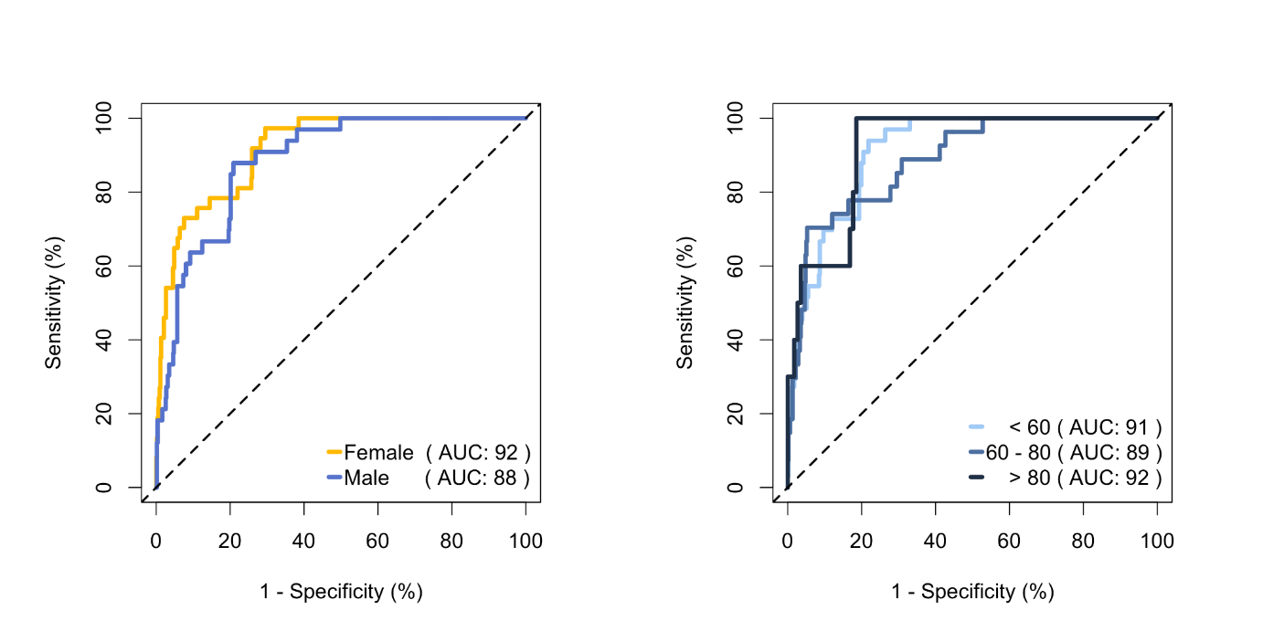
Fig. S3 Sociodemographic Subgroup Analysis Using ROC Curves and AUROC. Display of ROC curves stratified by sex a and age group b, derived from ensemble-level mean predicted probabilities on training data.

The literature illustrates substantial heterogeneity in sociodemographic subgroups. Women have been shown to face a higher risk of misdiagnosis and delayed treatment compared to men, and older ages are associated with undertriage. We analysed whether our models discriminate in any way across these groups. Exploratory subgroup analyses were performed to characterise potential fairness-related disparities in discriminative performance. An ensemble score was computed as the mean predicted probability across all ML classifiers and applied as a unified discriminative index across age (below 60, 60 to 80, and above 80 years) and sex (female vs. male) strata. Due to insufficient EVT event counts within subgroups of the holdout test set, analyses were conducted on training data, where a higher absolute number of EVT events permitted more stable subgroup-specific ROC estimation, with results presented in Supplementary Figure S3. Comparable ensemble discrimination was observed across both sex (AUROC 0.92 female vs. 0.88 male) and age strata (AUROC 0.91 for below 60, 0.89 for 60 to 80, and 0.92 for above 80 years), with no systematic pattern of performance degradation identified in any prespecified stratum. The observed AUROC variation of 0.88 to 0.92 across subgroups is small and likely attributable to sampling variability, given the low number of EVT events per subgroup and the use of training rather than held-out data. Reported AUROC estimates are therefore overestimated and should be interpreted as preliminary indicators of relative algorithmic fairness rather than as definitive measures of subgroup-specific predictive accuracy.

