Supplementary Methods
Egger-Regression
We propose a PCA-MR-Egger extension, however we did not perform a dedicated simulation study to evaluate its performance. MR-Egger has much lower statistical power compared to IVW and ML [1] it is not practical with exposure sample sizes less than 500. MR-Egger is robust to uncorrelated horizontal pleiotropy wherein a genetic variant(s) has an effect on Y that is not mediated by X [2,3]. We considered the following linear model:
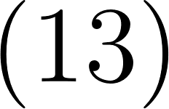
where  is the pleiotropic effect of the i-th PC. With the inclusion of an intercept and overdispersion, generalized linear regression can provide accurate causal estimates in the presence of both uncorrelated horizontal pleiotropy and balanced horizontal pleiotropy. When using correlated instruments, the causal estimate and its precision are characterized by the following equations:
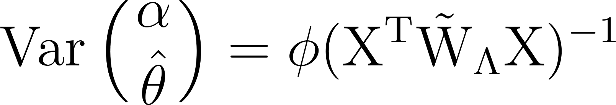 | 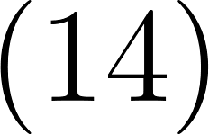
where 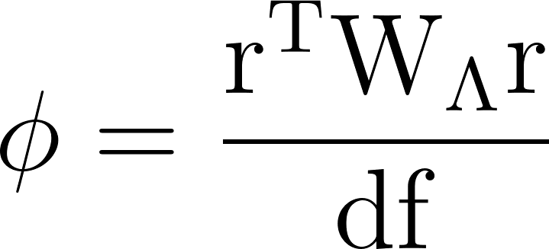.
Supplementary Results
The alternative weight matrix outperforms precision weighting alone
We evaluated PCA-MR extensions with and without the alternative precision matrix in the first and second simulation study regimes (See methods). Additionally, we analyzed the utility of the F-statistic truncation. For the first simulation scenarios with 10 valid IVs and high LD (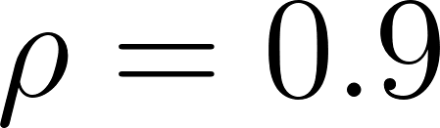), the alternative weight matrix substantially improved both power and coverage, with significantly lower RMSE and precision compared to precision-weighting alone (Supplementary Figures 1 & 2).
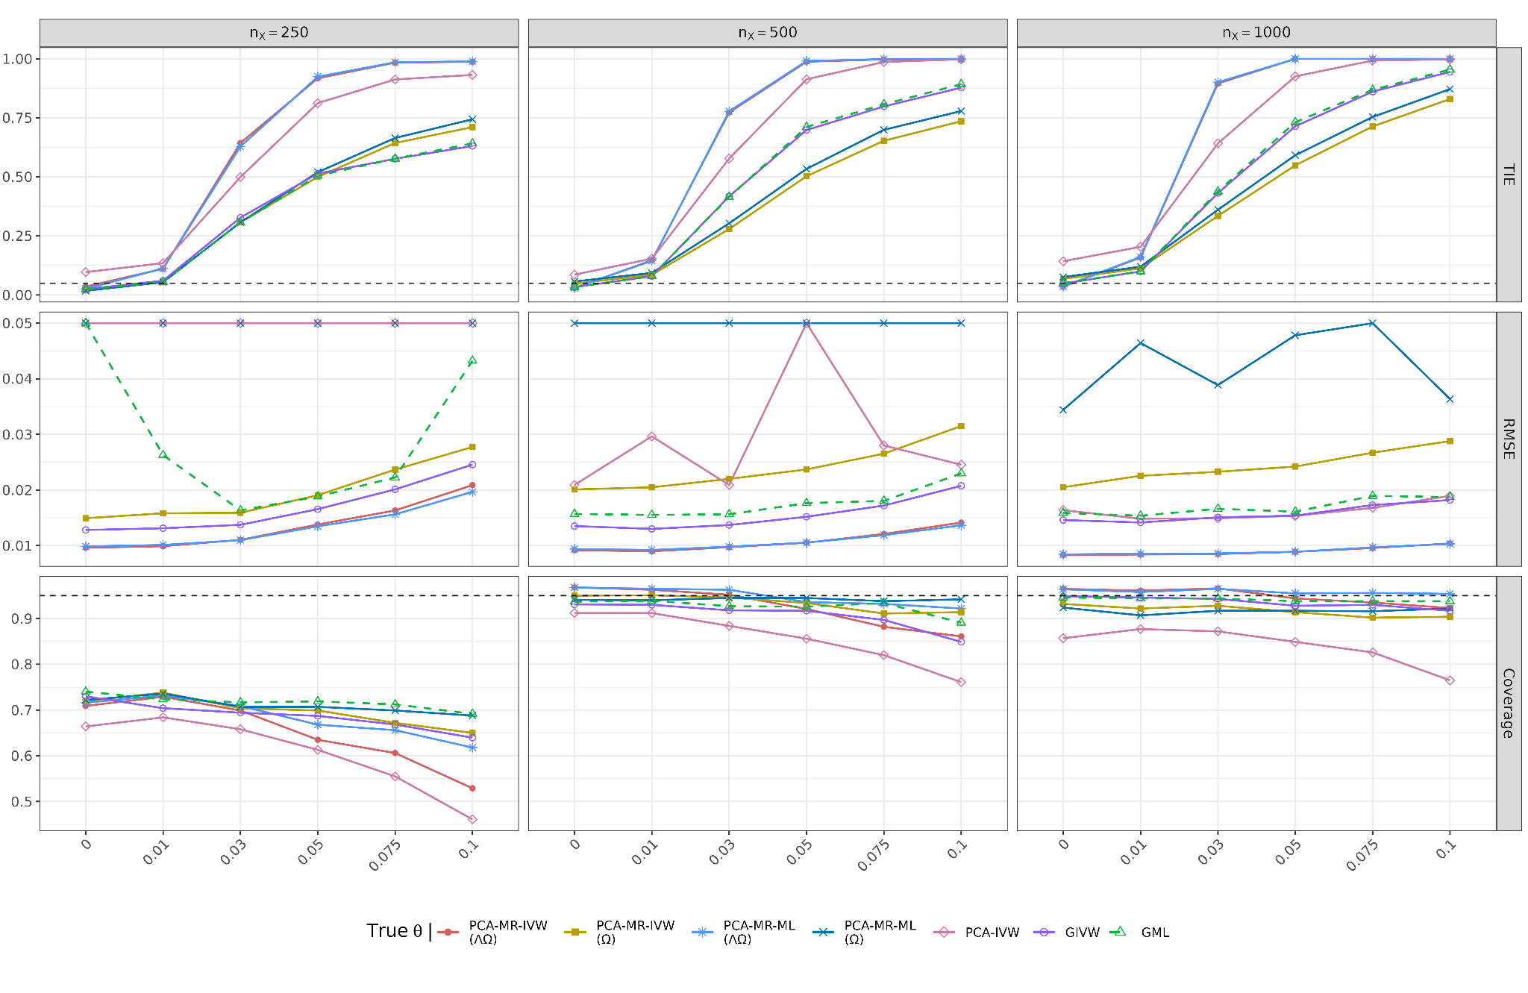
Supplementary Figure 1. TIE (), RMSE, and 95% confidence interval coverage across simulation replicates of PCA-MR-IVW and ML (With and without the alternative weight matrix,  and  respectively), PCA-IVW, GIVW, and GML for the first scenario regime with all valid IVs in high LD (). Results are shown across exposure sample sizes as a function of the true . Dashed lines represent the nominal TIE rate and nominal coverage (0.95), respectively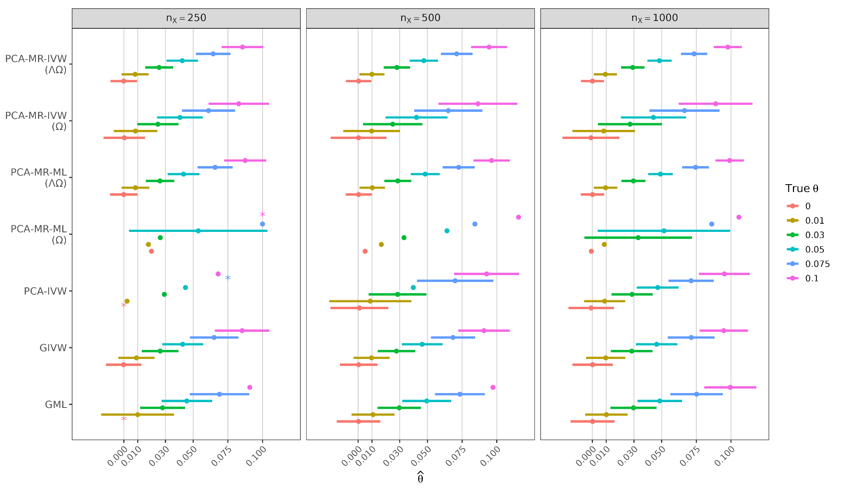
Supplementary Figure 2. Mean  estimates and standard deviation intervals across replicates for PCA-MR-IVW and ML (With and without the alternative weight matrix, and respectively), PCA-IVW, GIVW, and GML for the first scenario regime with all valid IVs in high LD (). Extreme standard deviation intervals were omitted, and extreme estimates are denoted by “”.
Assessing the efficacy of the alternative weight matrix using weak instruments
In the second set of simulations with weak-IVs, the alternative weight matrix substantially decreased weak-instrument bias towards null association. PCA-MR-IVW and ML showed higher power, precision, and RMSE compared to PCA-IVW, GIVW, and GML. Additionally, PCA-MR exhibited controlled TIE under null association, while the existing frameworks were inflated.
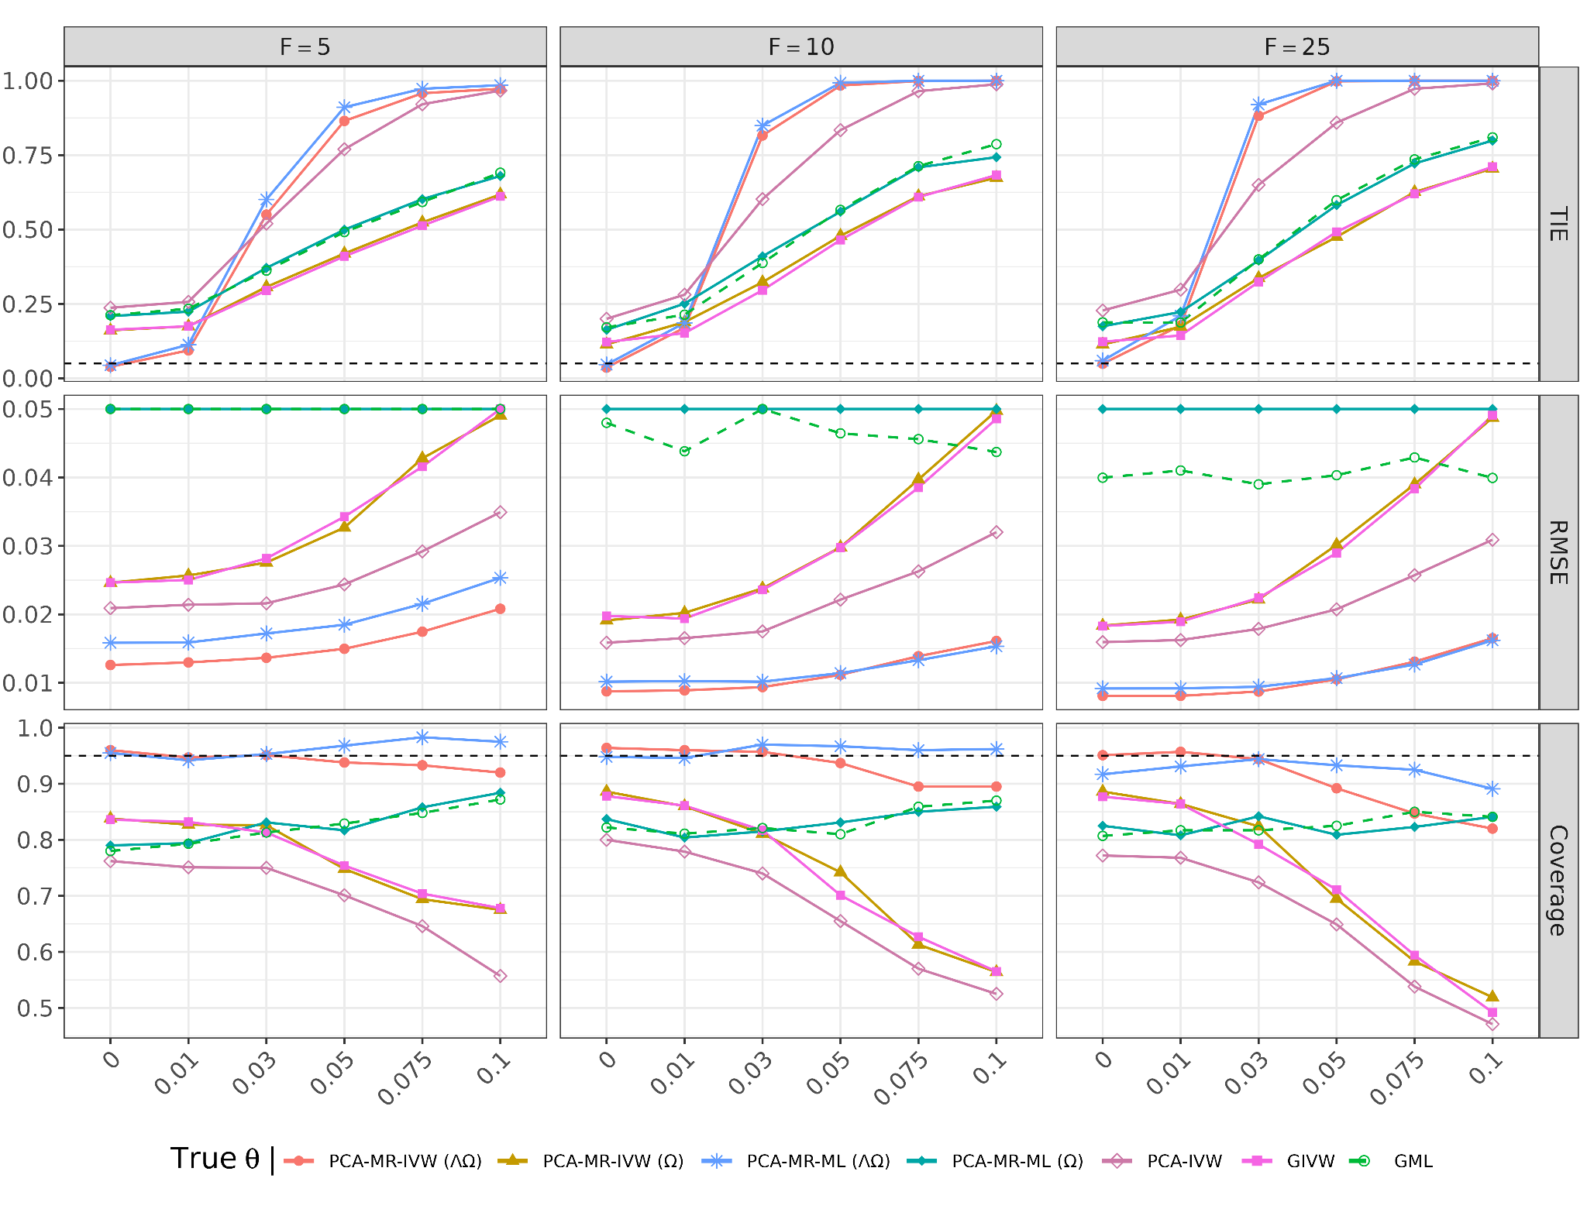
Supplementary Figure 3. TIE (), RMSE, and 95% confidence interval coverage across simulation replicates of PCA-MR-IVW and ML (With and without the alternative weight matrix, and respectively), PCA-IVW, GIVW, and GML for the first scenario regime with weak-IVs (all valid) in high LD (). Results are shown across exposure sample sizes as a function of the true . Dashed lines represent the nominal TIE rate and nominal coverage (0.95), respectively.
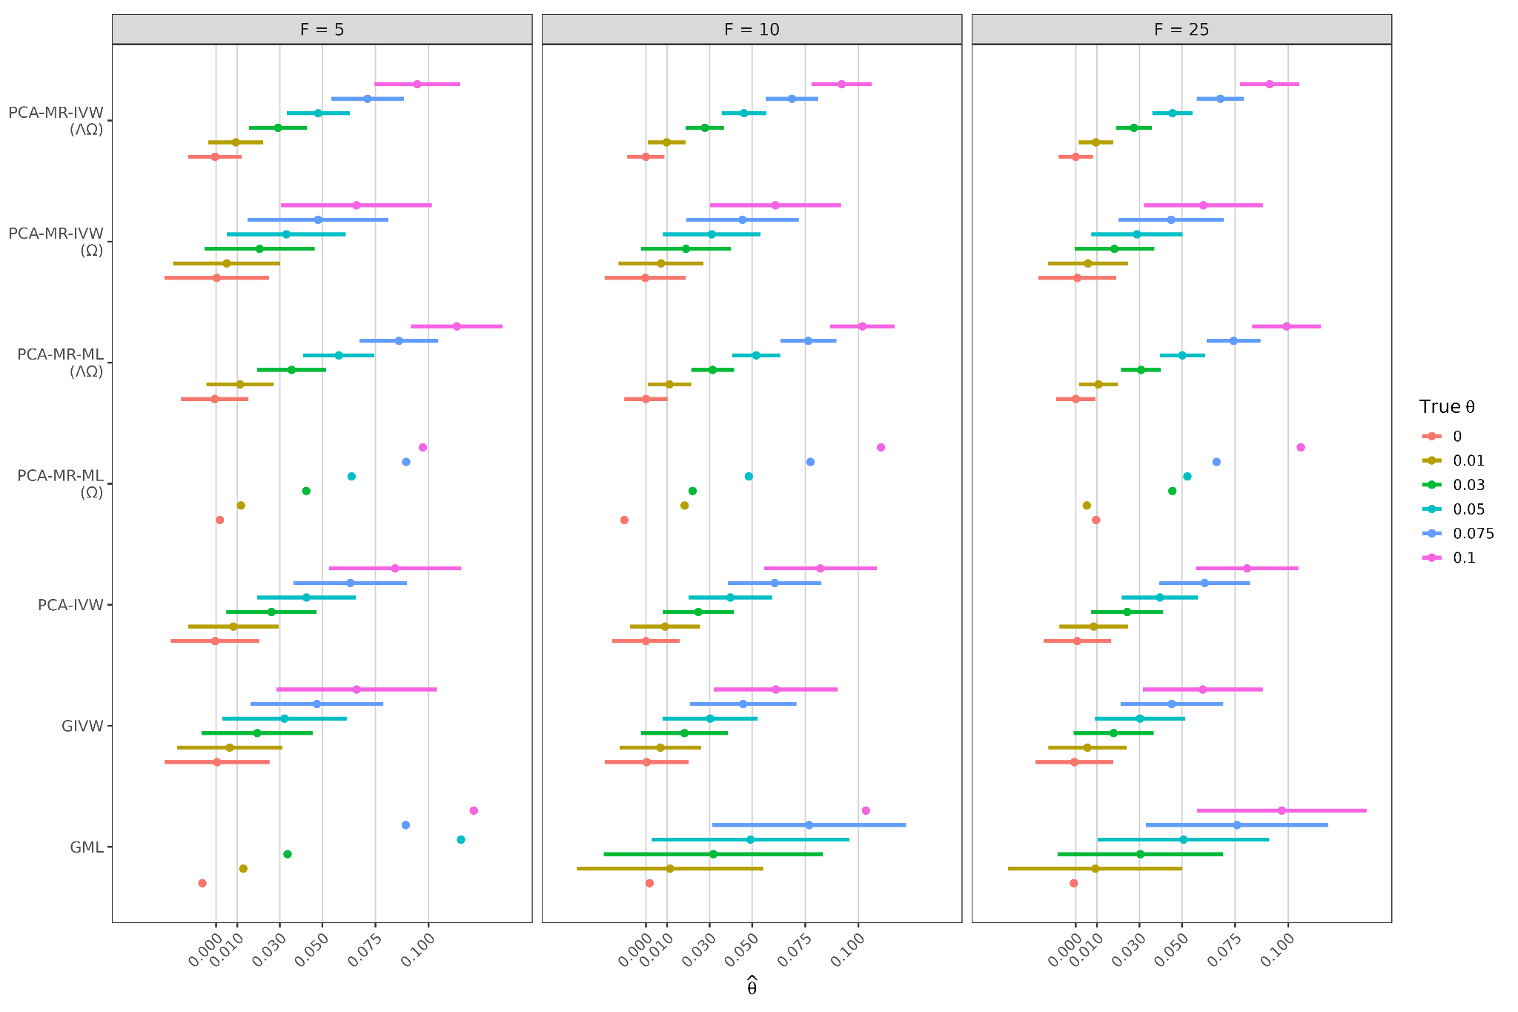
Supplementary Figure 4. Mean estimates and standard deviation intervals across replicates for PCA-MR-IVW and ML (With and without the alternative weight matrix, and respectively), PCA-IVW, GIVW, and GML for the first scenario regime with all valid IVs in high LD () in the first scenario regime with weak-IVs (all valid) in high LD (). Extreme standard deviation intervals were omitted, and extreme estimates are denoted by “”.
Supplementary Note 1.
The alternative weight matrix extends standard precision weighting by incorporating the amount of genetic variance explained by PCs, using  as a heuristic proxy for instrument relevance. PCA-MR implementations that incorporated the relevance-aware weighting scheme outperformed precision-based weighting alone, significantly reducing weak-instrument bias, increasing power, and lowering RMSE and numerical instabilities.
References
1. Hemani G, Bowden J, Davey Smith G. Evaluating the potential role of pleiotropy in Mendelian randomization studies. Hum Mol Genet [Internet]. 2018 [cited 2025 Nov 16];27:R195–208. https://doi.org/10.1093/hmg/ddy163
2. Bowden J, Davey Smith G, Burgess S. Mendelian randomization with invalid instruments: effect estimation and bias detection through Egger regression. Int J Epidemiol [Internet]. 2015 [cited 2025 Nov 16];44:512–25. https://doi.org/10.1093/ije/dyv080
3. Lin Z, Deng Y, Pan W. Combining the strengths of inverse-variance weighting and Egger regression in Mendelian randomization using a mixture of regressions model. PLoS Genet [Internet]. 2021 [cited 2025 Nov 14];17:e1009922. https://doi.org/10.1371/journal.pgen.1009922

