Supplementary Material
Supplementary Figures 1 – 12
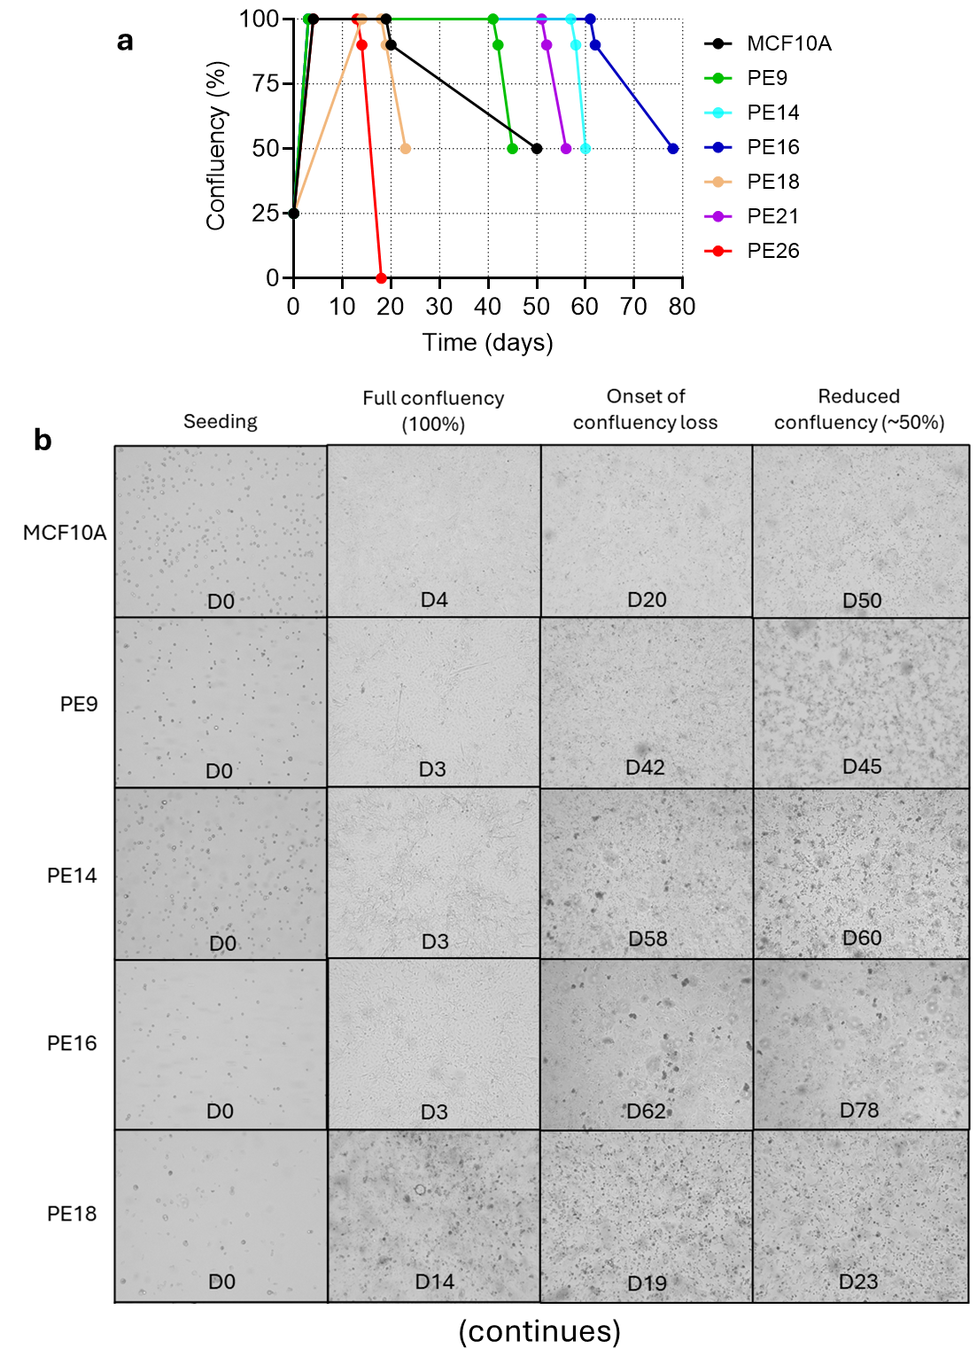
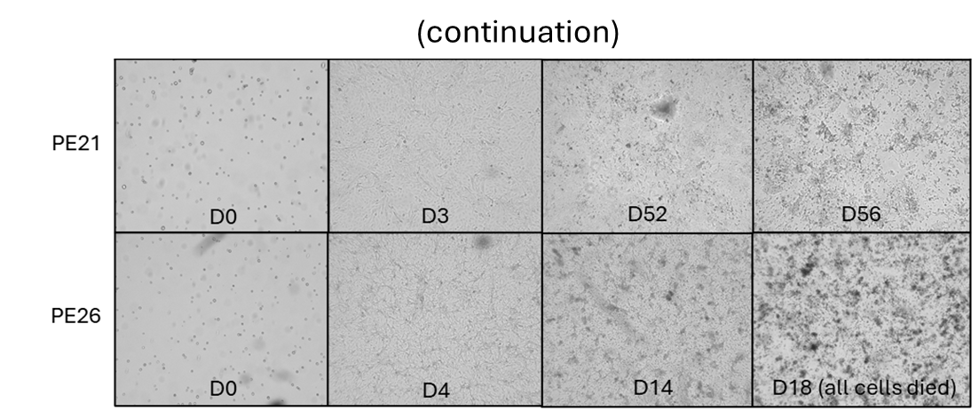Supplementary Figure 1. Parental and WP clone confluency and morphology during one selection cycle. (a) Confluency of MCF10A and WP clones over time . Culture media was not refreshed throughout the experiment. (b) MCF10A parental cells exhibited an epithelial-like morphology, whereas WP clones showed a mixture of epithelial- and mesenchymal-like cells in varying proportions. Days post-seeding are indicated in each image.
Variant Classification | Hugo Symbol | aaChange | Reference Allele | Tumor Seq Allele2
Missense_Mutation | ACAN | p.T1403A | A | G
Missense_Mutation | ADAM7 | p.R282P | G | C
Nonsense_Mutation | ALK | p.Q180X | G | A
Missense_Mutation | ANKRA2 | p.L156F | C | A
Splice_Site | ANXA9 |  | A | C
Missense_Mutation | APP | p.S310T | A | T
Missense_Mutation | ATXN2 | p.Y204H | A | G
Missense_Mutation | BASP1 | p.K210N | G | T
Missense_Mutation | BRAF | p.P523L | G | A
Missense_Mutation | C19orf35 | p.L374P | A | G
Missense_Mutation | C8orf89 | p.V3G | A | C
Missense_Mutation | CCDC144A | p.V1179A | T | C
Missense_Mutation | CCNI | p.L63F | C | A
Missense_Mutation | CD109 | p.P1231T | C | A
Missense_Mutation | CD2AP | p.G213A | G | C
Missense_Mutation | CD5 | p.A132S | G | T
Missense_Mutation | CDH23 | p.S570I | G | T
Missense_Mutation | CLCA1 | p.Q464H | G | C
Missense_Mutation | CNBD2 | p.G420R | G | A
Missense_Mutation | CNTN6 | p.S813Y | C | A
Missense_Mutation | COL19A1 | p.Q284H | G | C
Missense_Mutation | COL7A1 | p.R1915H | C | T
Missense_Mutation | CSMD1 | p.N2609K | G | T
Missense_Mutation | CYP4B1 | p.M1T | T | C
Missense_Mutation | DDX51 | p.A171S | C | A
Missense_Mutation | DEPDC1B | p.L112M | G | T
Missense_Mutation | DHTKD1 | p.P706Q | C | A
Missense_Mutation | EHMT1 | p.R523Q | G | A
Nonsense_Mutation | EXOSC3 | p.E255X | C | A
Missense_Mutation | FAM13C | p.G387A | C | G
Missense_Mutation | FAM193A | p.N537D | A | G
Missense_Mutation | FAM69A | p.F79L | A | T
Missense_Mutation | FBXO8 | p.T145A | T | C
Missense_Mutation | FOXB2 | p.E45Q | G | C
Missense_Mutation | FSTL5 | p.T754I | G | A
Frame_Shift_Ins | GGT6 | p.W119fs | - | A
Nonsense_Mutation | GNL2 | p.S90X | G | T
Missense_Mutation | GOLGA3 | p.P1483S | G | A
Missense_Mutation | GRK4 | p.F305L | C | G
Missense_Mutation | GZMB | p.G127E | C | T
Missense_Mutation | HIVEP3 | p.E275K | C | T
Missense_Mutation | HRAS | p.G12V | C | A
Missense_Mutation | IL24 | p.Q153K | C | A
Missense_Mutation | ILF3 | p.N859H | A | C
Missense_Mutation | INTS1 | p.P726S | G | A
Missense_Mutation | INVS | p.S693Y | C | A
Splice_Site | ITGA4 |  | G | A
(continues)

(continuation)
Variant Classification | Hugo Symbol | aaChange | Reference Allele | Tumor Seq Allele2
Nonsense_Mutation | KIF13A | p.E984X | C | A
Missense_Mutation | KRT16 | p.S434Y | G | T
Missense_Mutation | LIPF | p.V168I | G | A
Splice_Site | LOC644145 |  | A | T
Missense_Mutation | LRRIQ4 | p.D335N | G | A
Missense_Mutation | MAATS1 | p.A310E | C | A
Missense_Mutation | MAP1LC3B2 | p.P2L | C | T
Missense_Mutation | MKI67 | p.S518Y | G | T
Missense_Mutation | MUC16 | p.W4118C | C | A
Missense_Mutation | MYBL1 | p.S289L | G | A
Missense_Mutation | MYH14 | p.D1887H | G | C
Missense_Mutation | NCR3LG1 | p.Q368K | C | A
Missense_Mutation | NECTIN3 | p.D437N | G | A
Missense_Mutation | NLRP13 | p.T384A | T | C
Missense_Mutation | NYAP2 | p.P314T | C | A
Missense_Mutation | OAS1 | p.P129T | C | A
Missense_Mutation | OR5M9 | p.E109D | C | A
Missense_Mutation | PCDHB3 | p.S631C | A | T
Missense_Mutation | PFAS | p.R604L | G | T
Missense_Mutation | PHC1 | p.A318S | G | T
Missense_Mutation | PI4KA | p.F1562L | A | C
Splice_Site | PIGR |  | A | G
Missense_Mutation | PLS1 | p.I95V | A | G
Splice_Site | PLS1 |  | T | C
Missense_Mutation | PMS1 | p.I103V | A | G
Missense_Mutation | PPM1K | p.V294F | C | A
Missense_Mutation | PTPRJ | p.P284T | C | A
Nonsense_Mutation | PTPRO | p.W300X | G | A
Frame_Shift_Ins | RAPGEF5 | p.K366fs | - | T
Missense_Mutation | RNF123 | p.D1252Y | G | T
Missense_Mutation | RPL27A | p.Q67H | G | C
Missense_Mutation | SH3PXD2A | p.C101F | C | A
Splice_Site | SNCA |  | C | T
Missense_Mutation | SPHK2 | p.Q162K | C | A
Missense_Mutation | SPTBN4 | p.M544T | T | C
Missense_Mutation | SPTLC3 | p.D552Y | G | T
Missense_Mutation | STPG3 | p.S151I | G | T
Missense_Mutation | TEX33 | p.K218R | T | C
Missense_Mutation | TMCO3 | p.K207E | A | G
Missense_Mutation | TP53BP2 | p.T967R | G | C
Missense_Mutation | USP43 | p.H1103N | C | A
Missense_Mutation | XPO4 | p.E989D | C | A
Missense_Mutation | ZFHX4 | p.Q2242R | A | G
Missense_Mutation | ZNF761 | p.T293S | C | G
Missense_Mutation | ZNF800 | p.H305P | T | G
Missense_Mutation | ZNF85 | p.F287L | T | A
Supplementary Figure 2. Non-synonymous mutations shared among all six WP clones.

Variant_Classification | Hugo_Symbol | aaChange | Reference_Allele | Tumor_Seq_Allele2
Missense_Mutation | ANKRA2 | p.L156F | C | A
Splice_Site | ANXA9 |  | A | C
Missense_Mutation | APP | p.S310T | A | T
Missense_Mutation | ATXN2 | p.Y204H | A | G
Missense_Mutation | CD109 | p.P1231T | C | A
Missense_Mutation | CD2AP | p.G213A | G | C
Missense_Mutation | CLCA1 | p.Q464H | G | C
Missense_Mutation | COL19A1 | p.Q284H | G | C
Missense_Mutation | DDX1 | p.Q402H | G | T
Missense_Mutation | DHTKD1 | p.P706Q | C | A
Missense_Mutation | EHMT1 | p.R523Q | G | A
Missense_Mutation | FBXO8 | p.T145A | T | C
Nonsense_Mutation | GNL2 | p.S90X | G | T
Missense_Mutation | GZMB | p.G127E | C | T
Missense_Mutation | HRAS | p.G12V | C | A
Missense_Mutation | INTS1 | p.P726S | G | A
Splice_Site | ITGA4 |  | G | A
Nonsense_Mutation | KIF13A | p.E984X | C | A
Missense_Mutation | LIPF | p.V168I | G | A
Missense_Mutation | MAATS1 | p.A310E | C | A
Missense_Mutation | MAP1LC3B2 | p.P2L | C | T
Missense_Mutation | NLRP13 | p.T384A | T | C
Missense_Mutation | OR5M9 | p.E109D | C | A
Splice_Site | PLS1 |  | T | C
Missense_Mutation | PTPRJ | p.P284T | C | A
Missense_Mutation | SH3PXD2A | p.C101F | C | A
Splice_Site | SNCA |  | C | T
Missense_Mutation | SPHK2 | p.Q162K | C | A
Missense_Mutation | TEX33 | p.K218R | T | C
Missense_Mutation | USP43 | p.H1103N | C | A
Missense_Mutation | XPO4 | p.E989D | C | A

Supplementary Figure 3. Overlap of non-synonymous mutations between WP clones and HRAS-transformed MCF10A models. Table listing the 31 non-synonymous mutations shared between the six WP clones and a well-established family of tumorigenic HRAS-transformed MCF10A cell lines that were subsequently passaged extensively in vivo (Soule, Maloney et al., 1990; Qu, Han et al., 2015; Maguire, Peck et al., 2016). These shared mutations represent a subset of the 340 non-synonymous mutations identified across the WP clones and overlap with a reference dataset containing 196 non-synonymous mutations.
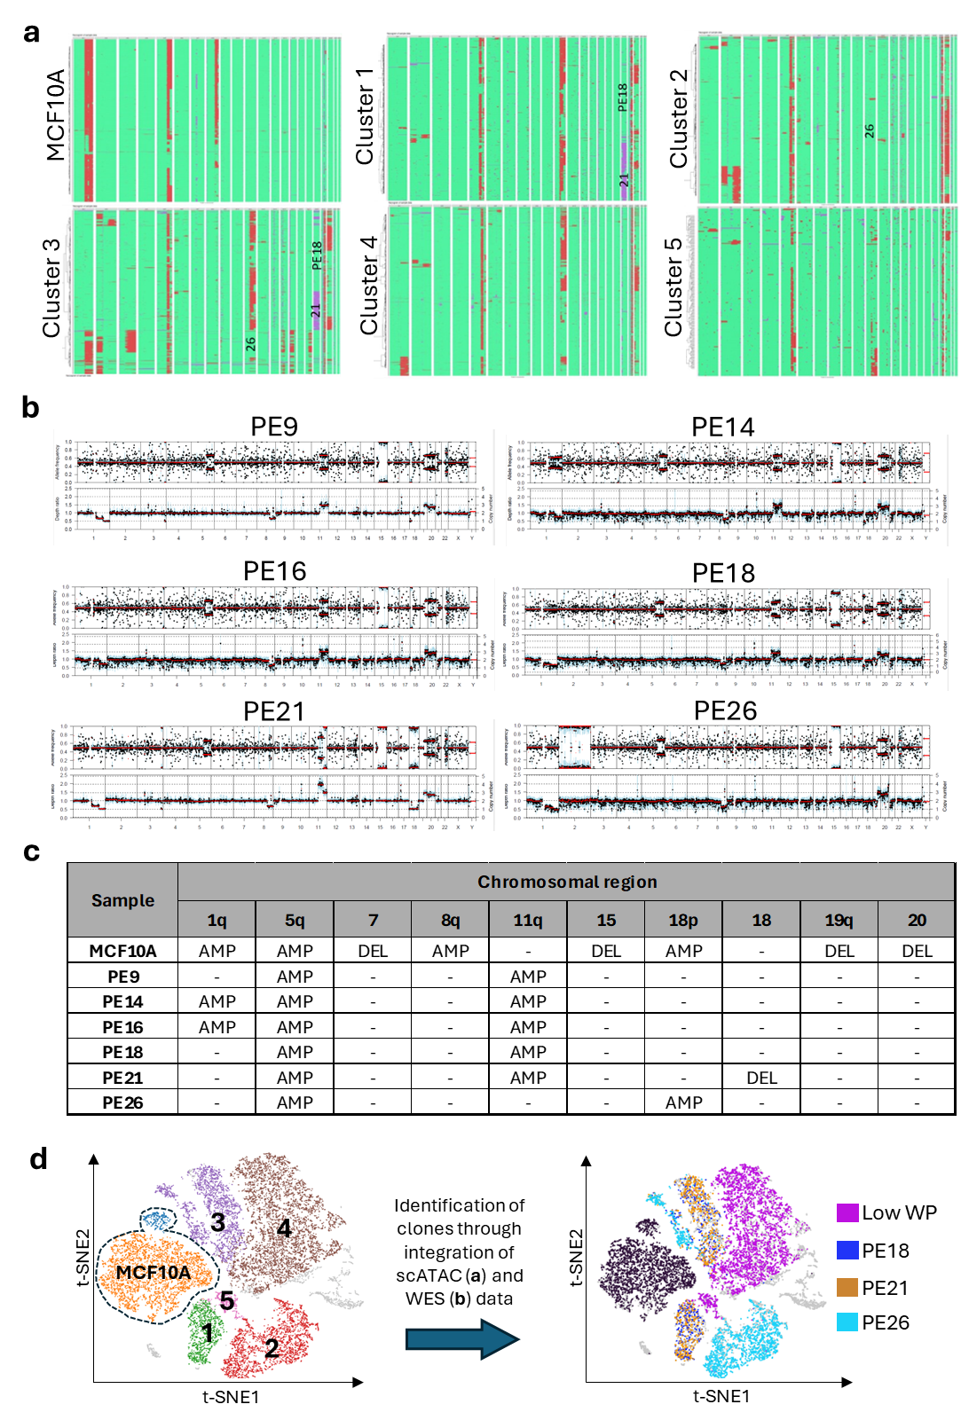
Cluster numbers in (a) correspond to t-SNE plot clusters in (d)
Supplementary Figure 4. Identification of WP clones on t-SNE plot through copy number alterations (CNAs) inferred from ATAC and WES data. (a) Analysis of the ATAC compartment of the scMultiome dataset using epiAneufinder revealed pre-existing cytogenetic abnormalities in MCF10A, including amplifications on chromosomes 1q, 5q, and 8q, as well as deletions in small regions of chromosomes 7, 8, 15, and 19. CNA events for cells located in t-SNE clusters 1–5 (see item (d)) were determined using MCF10A as the reference. (b) Allele frequencies (top) and copy-number profiles (bottom) of the WP clones, relative to parental MCF10A, as calculated with SEQUENZA on WES data, identified both shared events (e.g., Del1q [3 copies → 2 copies]) and unique alterations (e.g., Del(2) + Amp(2) in clone PE26). (c) Summary of the main chromosomal abnormalities identified in MCF10A and WP clones based on combined analyses of scMultiome and WES datasets. (d) t-SNE plot of gene expression showing that the 6 WP clones clustered into five main groups. Integration of single-cell CNAs inferred from ATAC (b) and WES (c) data enabled the identification of clonal composition within scMultiome-defined clusters: cluster 1 contains cells from PE21 and PE18; cluster 2 includes exclusively PE26 cells; and cluster 3 comprises cells from all three High WP clones. Low WP clones could not be resolved due to high genomic similarity among them.
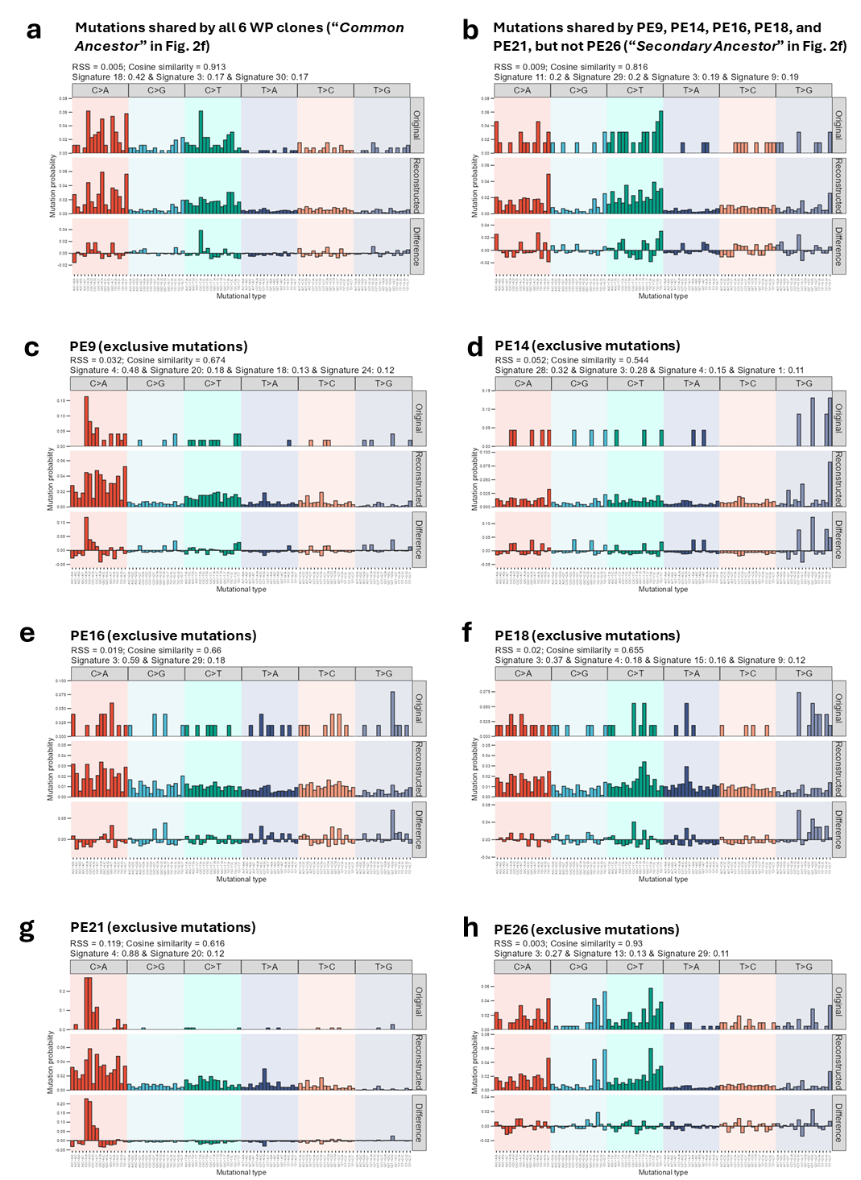
Supplementary Figure 5. Phylogenetic and mutational signature analysis suggests ROS as a dominant mutagenic in the origin of the WP clones. COSMIC mutational signature analysis on the: (a) hypothetical “Common Ancestor” (see Fig. 2f) of all the WP clones (estimated based on the mutations shared by all the clones); (b) hypothetical “Secondary Ancestor” of 5 of the WP clones (except PE26; see Fig. 2f); and (c-h) individual WP clones. ROS (signature 18) emerges as a dominant mutagenesis driver in common ancestors, but not in individual clones.
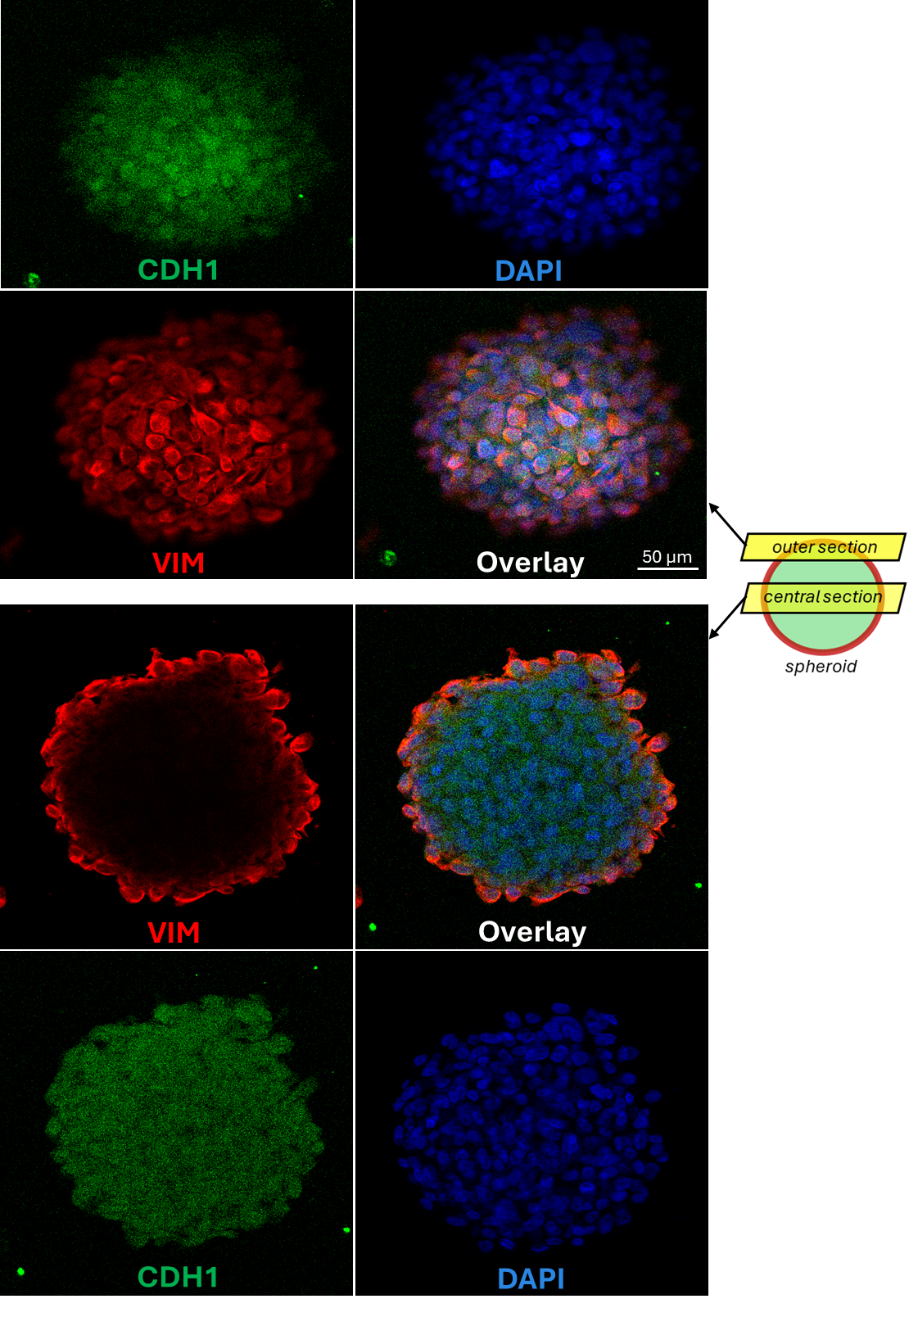Supplementary Figure 6. Confocal microscope imaging depicting the epithelial core and mesenchymal surroundings of an PE26 spheroid sectioned along its outer and central planes. Magnification: 160X.
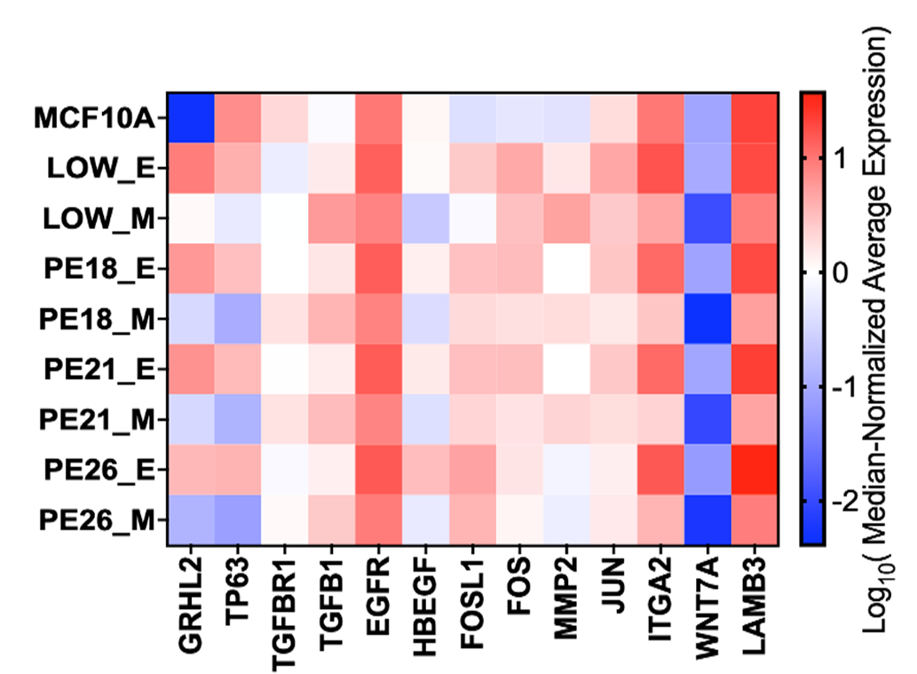 Supplementary Figure 7. Increased expression of downstream targets of the EGF–TP63/GRHL2 axis, as well as collagen-invasion–associated genes, in the epithelial (E) compartments.
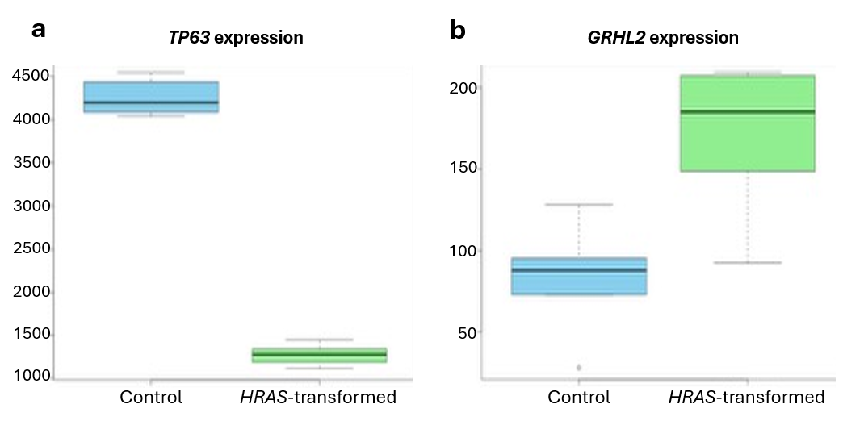
Supplementary Figure 8. Effect of HRAS mutation on GRHL2 expression. (a-b) Effect of HRAS-activating mutation on TP63 and GRHL2 expression. Analysis based on transcriptomic data from Stinson et al., 2011.
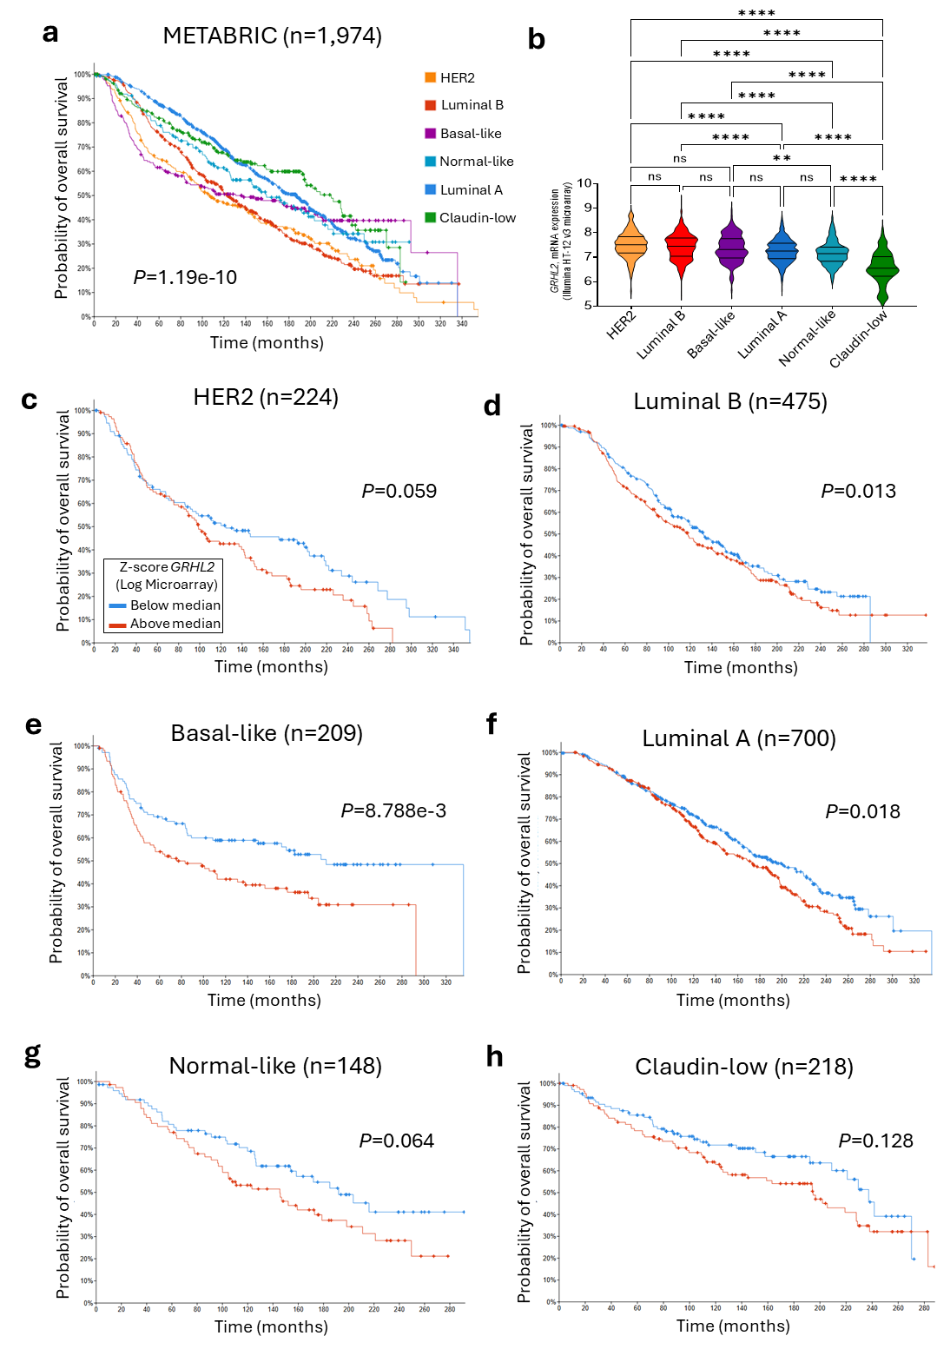
Supplementary Figure 9. GRHL2 expression and subtype-specific overall survival in the METABRIC breast cancer cohort. (a) Kaplan–Meier overall survival curves for patients stratified according to the major molecular breast cancer subtypes. P value indicate significance based on the log-rank test. (b) GRHL2 expression levels across molecular breast cancer subtypes. Subtypes characterized by higher GRHL2 expression—such as HER2-positive, Luminal B, and basal-like tumors—displayed markedly shorter overall survival (in a) compared with subtypes with lower GRHL2 expression, including normal-like, Luminal A, and claudin-low tumors. Statistical analysis was performed using one-way ANOVA followed by Tukey’s multiple comparisons test. **** indicates P<0.0001 and ** indicates P<0.01. (c-h) Overall survival stratified by GRHL2 expression across individual molecular subtypes, with patients dichotomized using the median expression value as the cut-off (blue curve: below median; red curve: above median). Survival differences were assessed using the log-rank test.
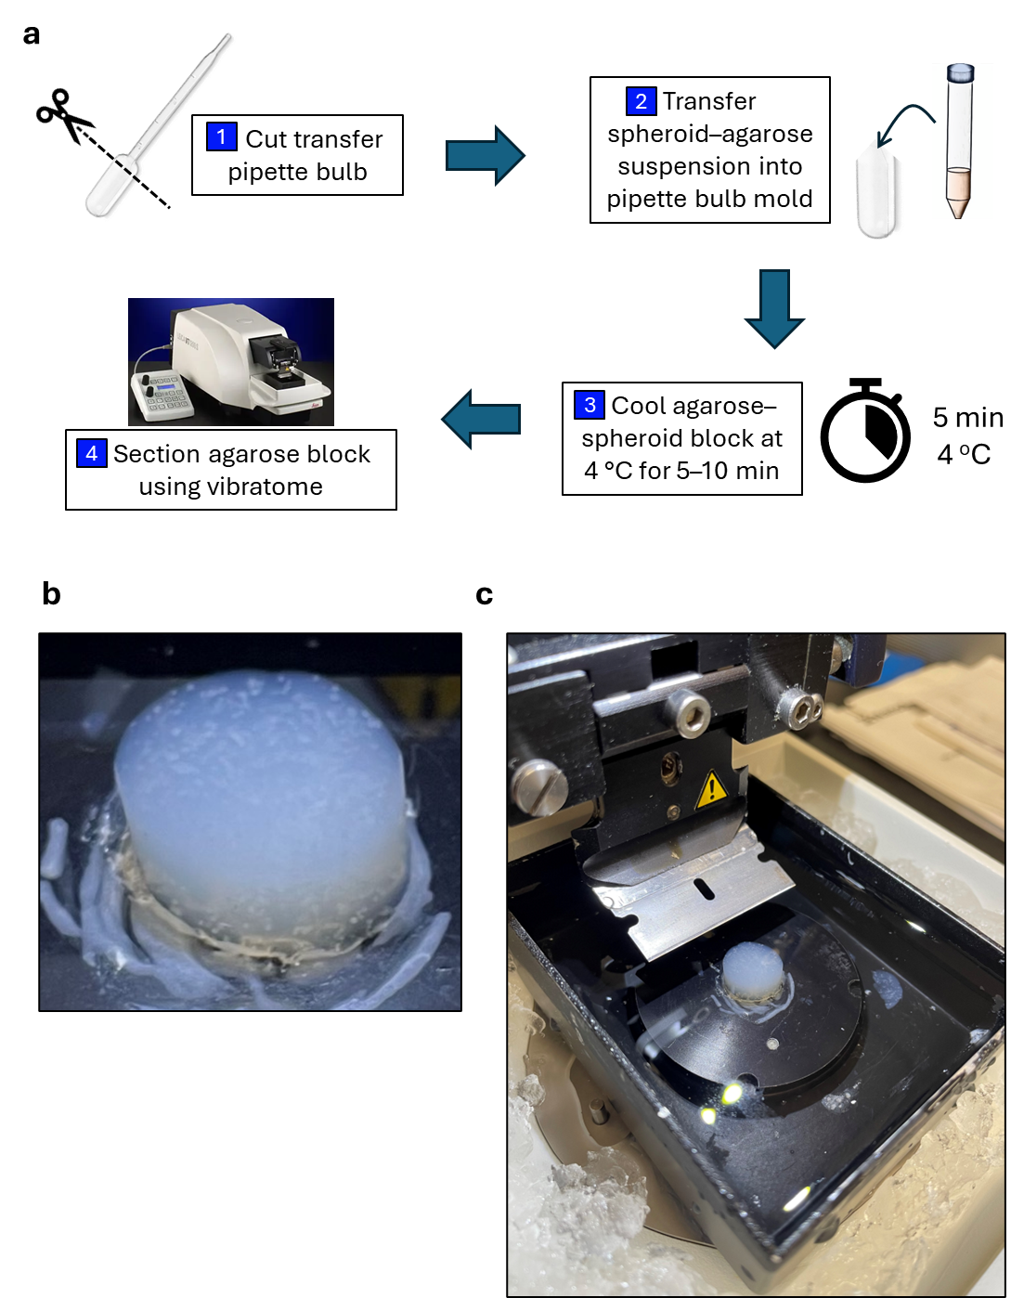
Supplementary Figure 10. Preparation of PE26 spheroid agarose blocks for sectioning. (a) Schematic illustration of the main steps for embedding floating PE26 spheroids into low-melting-point agarose prior to vibratome sectioning. (b) Representative photograph of an agarose block containing PE26 spheroids (visible as white dots distributed throughout the gel). (c) Setup of the agarose block mounted on the vibratome stage, surrounded by ice-cold PBS, immediately before sectioning.

