Extended Data

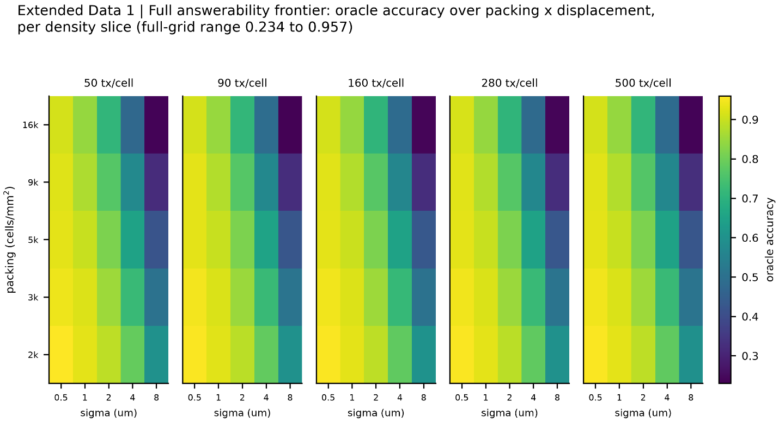

Extended Data Fig. 1 | Full answerability frontier. Oracle accuracy across the complete generative grid of transcript density, cell packing, and displacement, with one-dimensional slices along each axis. Across all 125 grid points oracle accuracy ranges from 0.234 to 0.957, falling with tighter packing and larger displacement and rising with transcript abundance.
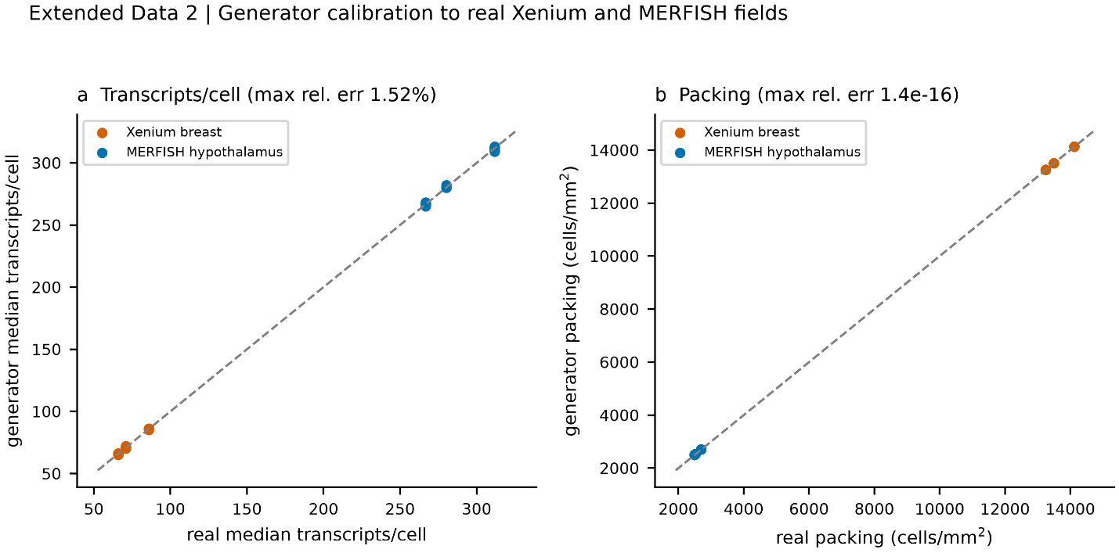

Extended Data Fig. 2 | Generator calibration to real tissue. Per-statistic comparison of the synthetic generator with public Xenium and MERFISH fields: median transcripts per cell match within 1.52% and cell packing matches exactly (difference 1.4e-16). The oracle equals or exceeds the naive nearest-center baseline at all 125 grid points, with a minimum margin of +0.006.

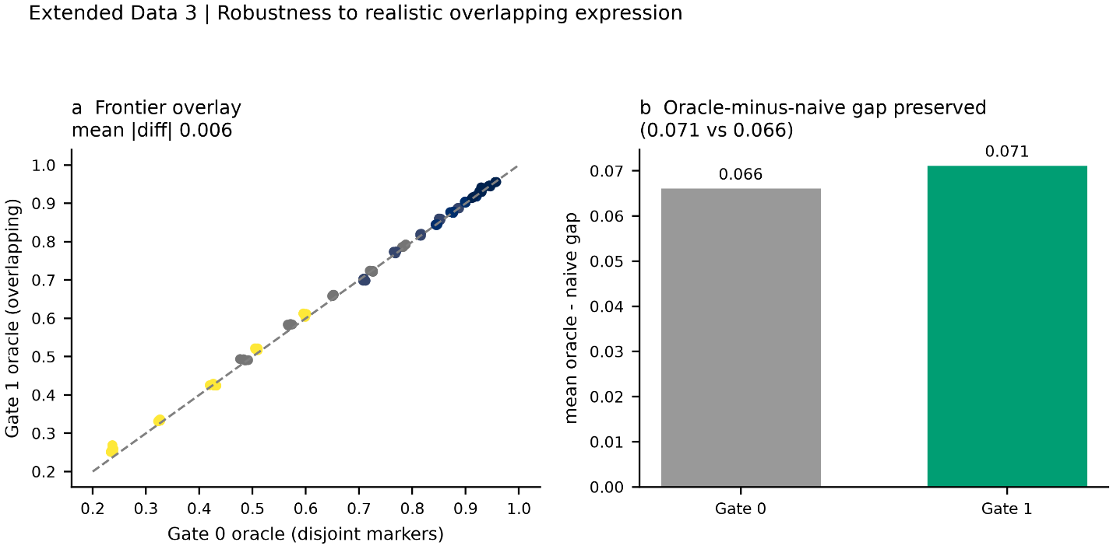
Extended Data Fig. 3 | Robustness to realistic overlapping expression. Answerability frontier under idealized versus realistic overlapping per-type expression. The frontier is essentially unchanged, with an assignment-frontier mean absolute difference of 0.006, and the oracle-minus-naive gap is preserved at 0.071 against 0.066.
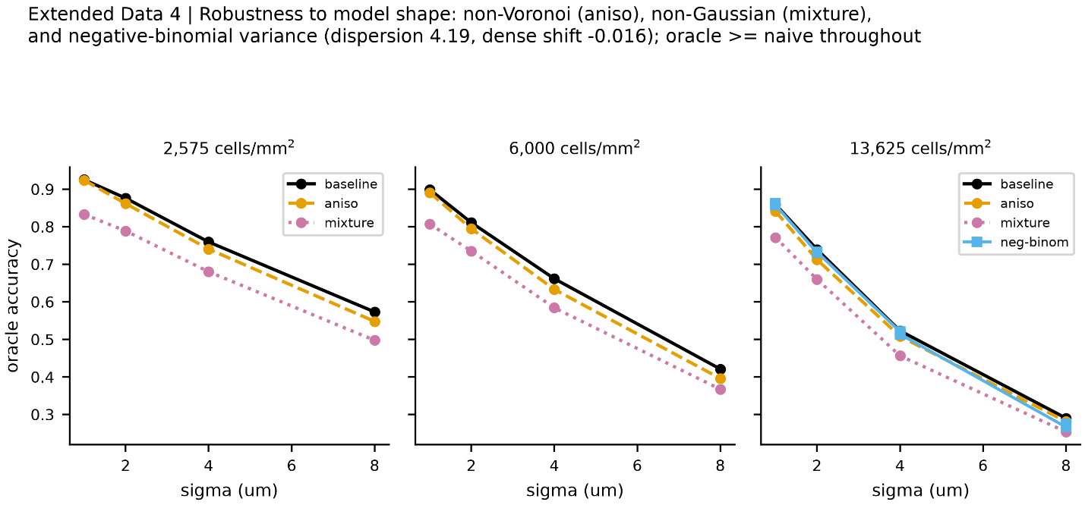

Extended Data Fig. 4 | Robustness to model shape. The dense-tissue bound under negative-binomial within-type expression variance (dispersion near 4.19; dense-accuracy shift -0.016), non-Voronoi cell geometry, and non-Gaussian displacement. The bound holds under each departure from the idealized model.
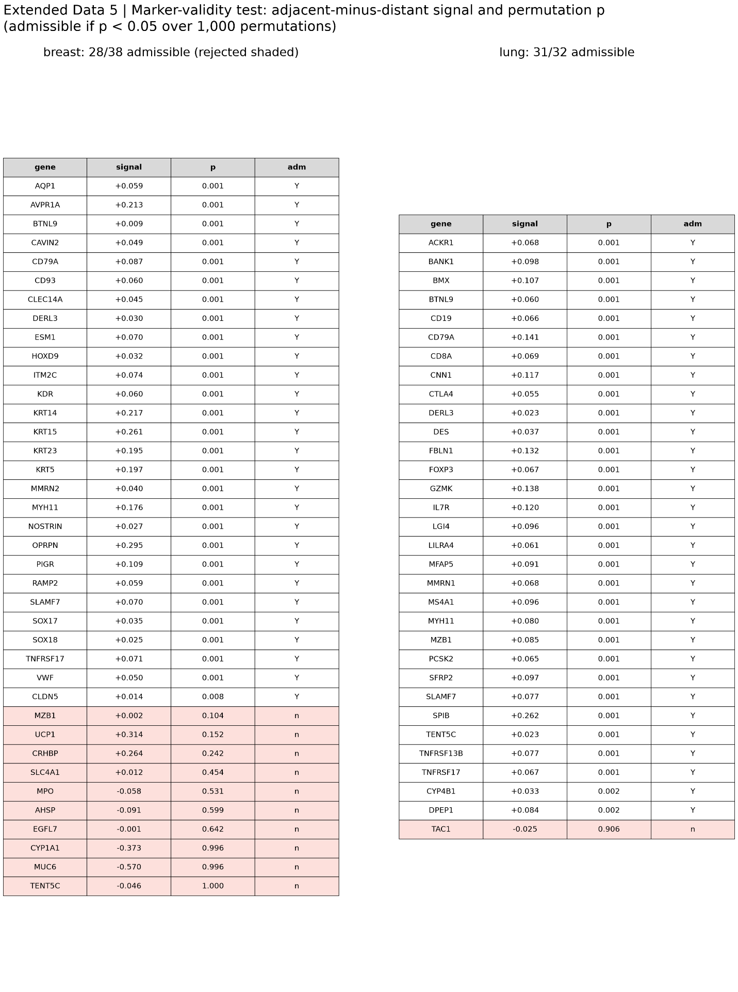

Extended Data Fig. 5 | Marker-validity test, per-marker detail (table). For each candidate marker, the adjacent-minus-distant expression signal and its position-permutation P value over 1,000 permutations, for breast (28 of 38 markers admissible) and lung (31 of 32 admissible). Markers that fail the test are listed explicitly; admissibility is determined without reference to the displacement a marker implies, which is what makes the estimate non-circular.

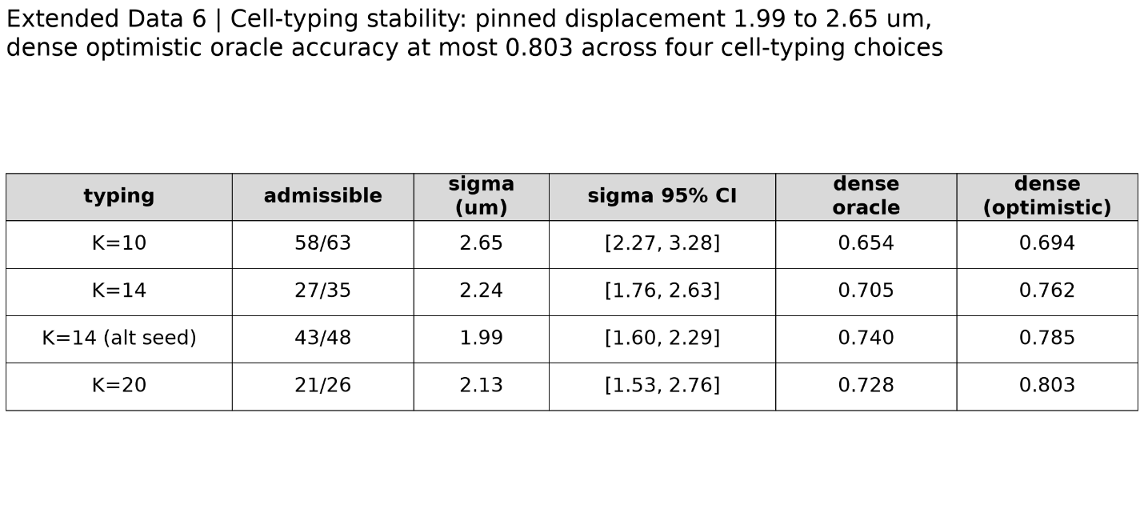

Extended Data Fig. 6 | Cell-typing stability. Pinned displacement and dense-tissue oracle accuracy across alternative cell-typing choices. Pinned displacement ranges over 1.99 to 2.65 micrometres and dense accuracy never exceeds 0.803, so the bound is stable to how cell types are defined.

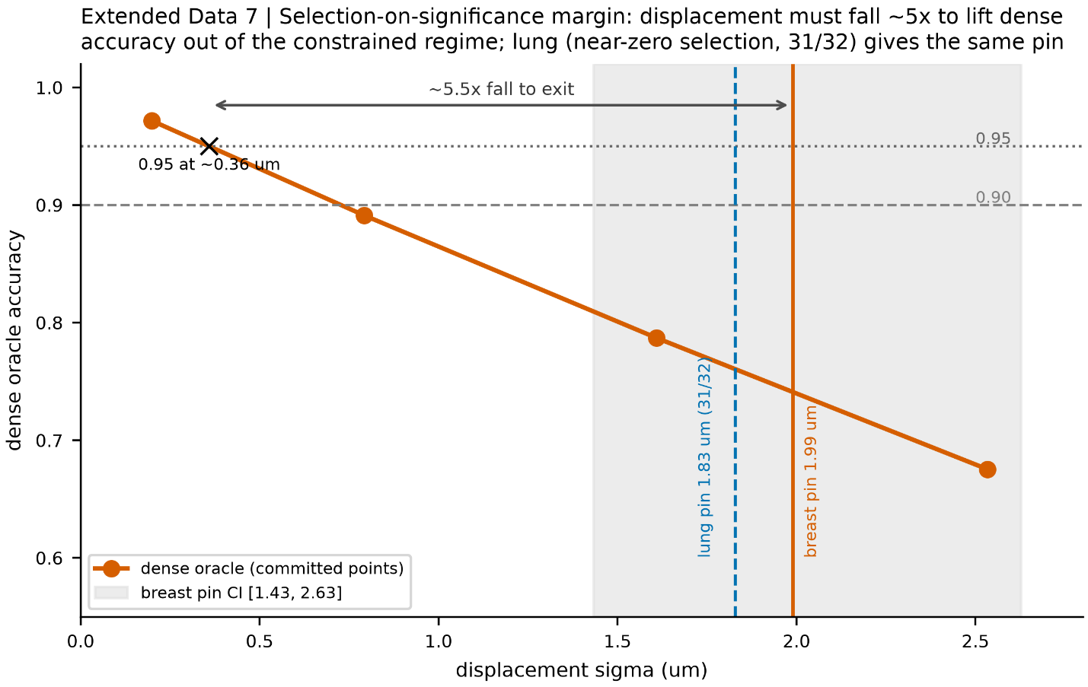

Extended Data Fig. 7 | Selection-on-significance sensitivity. Dense-tissue oracle accuracy as a function of assumed displacement, showing that displacement would have to fall roughly fivefold below the pinned value to lift dense accuracy out of the constrained regime. The lung dataset, in which only 1 of 32 markers was rejected, serves as a near-zero-selection control and yields a consistent displacement.
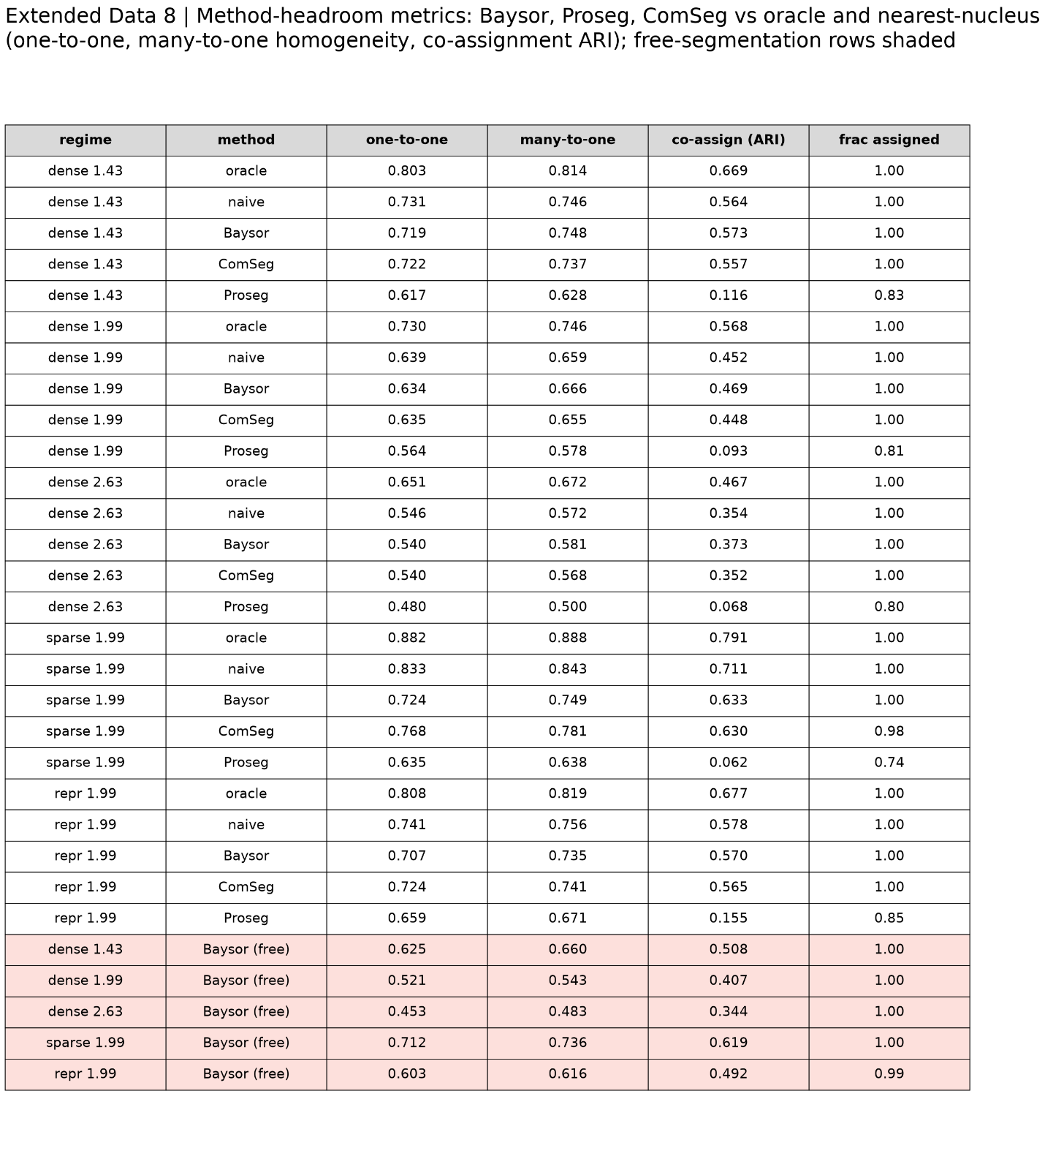
Extended Data Fig. 8 | Method-headroom metrics (table). One-to-one matched accuracy, many-to-one homogeneity, and co-assignment metrics for Baysor (0.7.1), Proseg (3.1.1), and ComSeg (1.8.5), against the oracle and the nearest-nucleus baseline in dense tissue, given true nuclei. The best fairly configured method remains 0.066 to 0.110 below the oracle. Against nearest-nucleus the comparison is metric-dependent and within run-to-run noise (about 0.012): one-to-one -0.009 to -0.004, many-to-one up to +0.009, co-assignment up to +0.019. Without a nuclei prior, only Baysor runs de novo, at 0.521 against nearest-nucleus 0.639.
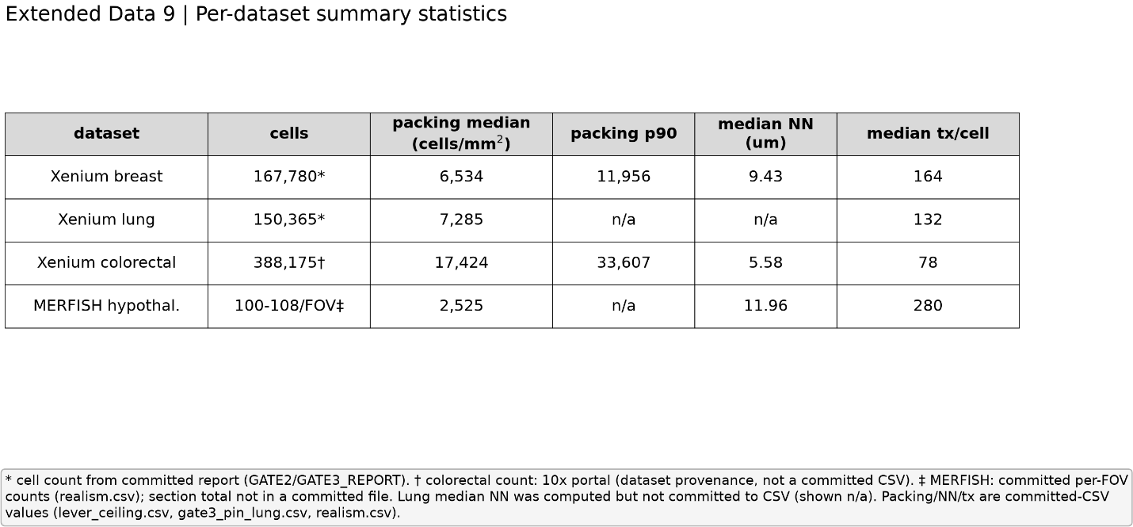

Extended Data Fig. 9 | Per-dataset summary statistics (table). Cell counts, cell packing, and nearest-neighbor distances for the four datasets: Xenium breast (167,780 cells; section median packing 6,534 cells/mm2), Xenium lung (150,365 cells), Xenium colorectal (388,175 cells; median packing 17,424 cells/mm2), and MERFISH hypothalamus. The colorectal and hypothalamus cell counts are the published dataset sizes, cited via their accessions.
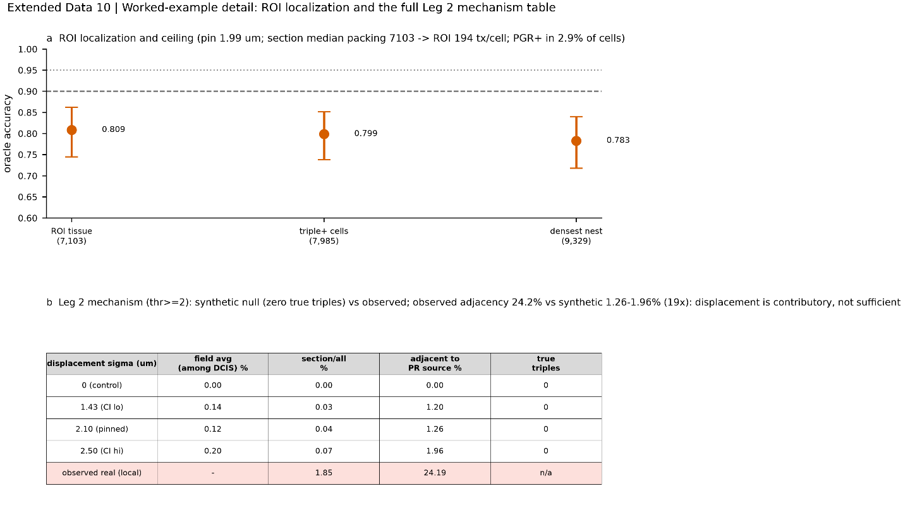

Extended Data Fig. 10 | Worked-example detail. Region-of-interest localization (local packing 7,985 against a section median of 6,534 cells/mm2; densest tumor nest 9,329 cells/mm2) and the full Leg 2 mechanism table: apparent triple-positive rate under a displacement sweep, with field-average, adjacency-conditioned, and local rates, and the zero-displacement control. Pure displacement produces 0% spurious apparent triple-positives at zero displacement and 1.26%, rising to 1.96% at the upper displacement interval, among cells adjacent to a progesterone-receptor source, against 24.2% observed in the same adjacency condition, a roughly nineteenfold under-production. Oracle accuracy in the region is 0.799 (optimistic interval end 0.86) and 0.783 at the densest nest; PGR is detected in 2.9% of cells; the 165 apparent triple-positives represent 0.098% of the section.

