ONLINE SUPPLEMENTARY MATERIALS
Title: Machine learning-based derivation and external validation of a tool to predict death and development of organ failure in hospitalized patients with COVID-19

Authors: Xu, Y.; Trivedi, A.; Becker N.; et al

Table of Contents

Figure S1. Calibration plots for prediction models.
Figure S2. Variable importance plots.
Table S1. Elastic net LR model for in-hospital mortality prediction
Table S2. Lasso LR model for ICU transfer prediction
Table S3. Elastic net LR model for shock prediction
Table S4. Lasso LR model for dialysis prediction
List of Variables

Figure S1. Calibration plots for prediction models. A. 28-days mortality in the internal validation. B. 28-days mortality in the external validation. C. 28-day ICU transfer in the internal validation D. 28-day shock in the internal validation. 28-day receipt of RRT in the internal validation.
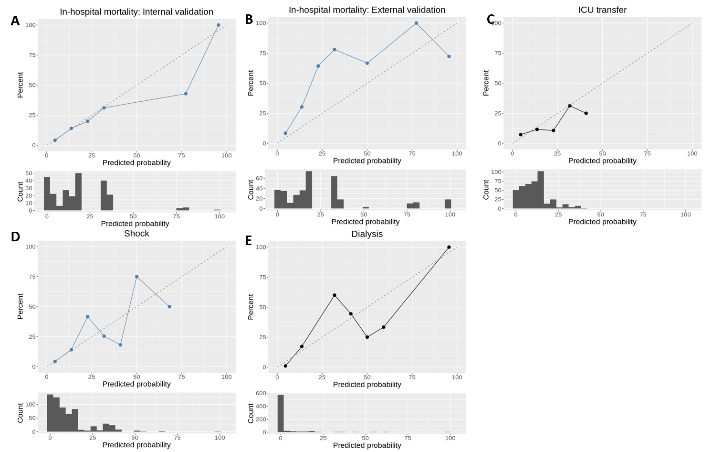
Figure S2. Variable importance plots. (B) 28-day shock (C) and 28-day dialysis (D) prediction models by SHAP
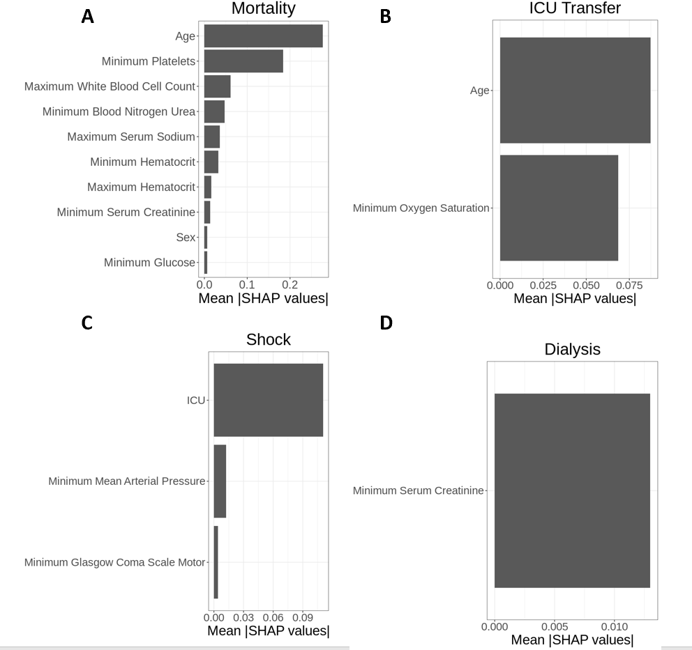

Table S1. Elastic net LR model for in-hospital mortality prediction
Variable name | Coefficient
Intercept | -2.02165
Age | 0.019197
Sex | 0.013532
Minimum Serum Creatinine | 0.016108
Maximum White Blood Cell Count | 0.01365
Minimum Glucose | 0.000193
Minimum Platelets | -0.00259
Maximum Serum Sodium | 0.010451
Maximum Hematocrit | -0.00328
Minimum Hematocrit | -0.00665
Minimum Blood Nitrogen Urea | 0.004135

Table S2. Lasso LR model for ICU transfer prediction
Variable name | Coefficient
Intercept | 2.249323
Age | 0.005735
Minimum oxygen saturation | -0.02782

Table S3. Elastic net LR model for shock prediction
Variable name | Coefficient
Intercept | -0.00931
Minimum Mean Arterial Pressure | -0.00121
Minimum Glasgow Coma Scale Motor | -0.00588
ICU | 0.254973

Table S4. Lasso LR model for dialysis prediction
Variable name | Coefficient
Intercept | -0.05697268
Minimum Serum Creatinine | 0.02231206

List of Variables
The full list of variables for mortality prediction using the overlapping features:
Age, Maximum Blood Nitrogen Urea, Maximum Glucose, Maximum Hematocrit, Maximum Platelets, Maximum Serum Chloride, Maximum Serum Creatinine, Maximum Serum Potassium, Maximum Serum Sodium, Maximum White Blood Cell Count, Minimum Blood Nitrogen Urea, Minimum Glucose, Minimum Hematocrit, Minimum Platelets, Minimum Serum Chloride, Minimum Serum Creatinine, Minimum Serum Potassium, Minimum Serum Sodium, Minimum White Blood Cell Count, Sex.
The full list of variables for ICU transfer prediction:
Age, Dialysis, Ethnicity, Height, Maximum Anion Gap, Maximum Blood Nitrogen Urea, Maximum Glasgow Coma Scale Motor, Maximum Glasgow Coma Scale Total, Maximum Glasgow Coma Scale Verbal, Maximum Glasgow Coma Scale Visual, Maximum Glucose, Maximum Hematocrit, Maximum Mean Arterial Pressure, Maximum Platelets, Maximum Pulse, Maximum Respiratory Rate, Maximum Serum Bicarb, Maximum Serum Chloride, Maximum Serum Creatinine, Maximum Serum Potassium, Maximum Serum Sodium, Maximum Systolic Blood Pressure, Maximum Temperature, Maximum White Blood Cell Count, Minimum Anion Gap, Minimum Blood Nitrogen Urea, Minimum Glasgow Coma Scale Motor, Minimum Glasgow Coma Scale Total, Minimum Glasgow Coma Scale Verbal, Minimum Glasgow Coma Scale Visual, Minimum Glucose, Minimum Hematocrit, Minimum Mean Arterial Pressure, Minimum oxygen saturation, Minimum Platelets, Minimum Pulse, Minimum Respiratory Rate, Minimum Serum Bicarb, Minimum Serum Chloride, Minimum Serum Creatinine, Minimum Serum Potassium, Minimum Serum Sodium, Minimum Systolic Blood Pressure, Minimum Temperature, Minimum White Blood Cell Count, Race, Sex.
The full list of variables for shock prediction:
Age, Blood Product - FFP Day 1, CAM ICU, Daily Net Fluid Balance Day 1, Dialysis, Ethnicity, Height, ICU, Intubatated, Maximum Anion Gap, Maximum Blood Nitrogen Urea, Maximum Glasgow Coma Scale Motor, Maximum Glasgow Coma Scale Total, Maximum Glasgow Coma Scale Verbal, Maximum Glasgow Coma Scale Visual, Maximum Glucose, Maximum Hematocrit, Maximum Mean Arterial Pressure, Maximum Platelets, Maximum Pulse, Maximum Respiratory Rate, Maximum Serum Bicarb, Maximum Serum Chloride, Maximum Serum Creatinine, Maximum Serum Potassium, Maximum Serum Sodium, Maximum Temperature, Maximum White Blood Cell Count, Minimum Anion Gap, Minimum Blood Nitrogen Urea, Minimum Glasgow Coma Scale Motor, Minimum Glasgow Coma Scale Total, Minimum Glasgow Coma Scale Verbal, Minimum Glasgow Coma Scale Visual, Minimum Glucose, Minimum Hematocrit, Minimum Mean Arterial Pressure, Minimum oxygen saturation, Minimum Platelets, Minimum Pulse, Minimum Respiratory Rate, Minimum Serum Bicarb, Minimum Serum Chloride, Minimum Serum Creatinine, Minimum Serum Potassium, Minimum Serum Sodium, Minimum Temperature, Minimum White Blood Cell Count, Race, Sex.
The full list of variables for dialysis prediction:
Age, Blood Product - FFP Day 0, Blood Product - FFP Day 1, CAM ICU, Daily Ins Day 1, Daily Net Fluid Balance Day 1, Ethnicity, Height, ICU, Intubatated, Maximum Anion Gap, Maximum Blood Nitrogen Urea, Maximum Glasgow Coma Scale Motor, Maximum Glasgow Coma Scale Total, Maximum Glasgow Coma Scale Verbal, Maximum Glasgow Coma Scale Visual, Maximum Glucose, Maximum Hematocrit, Maximum Mean Arterial Pressure, Maximum Platelets, Maximum Pulse, Maximum Respiratory Rate, Maximum Serum Bicarb, Maximum Serum Chloride, Maximum Serum Creatinine, Maximum Serum Potassium, Maximum Serum Sodium, Maximum Systolic Blood Pressure, Maximum Temperature, Maximum White Blood Cell Count, Minimum Anion Gap, Minimum Blood Nitrogen Urea, Minimum Glasgow Coma Scale Motor, Minimum Glasgow Coma Scale Total, Minimum Glasgow Coma Scale Verbal, Minimum Glasgow Coma Scale Visual, Minimum Glucose, Minimum Hematocrit, Minimum Mean Arterial Pressure, Minimum oxygen saturation, Minimum Platelets, Minimum Pulse, Minimum Respiratory Rate, Minimum Serum Bicarb, Minimum Serum Chloride, Minimum Serum Creatinine, Minimum Serum Potassium, Minimum Serum Sodium, Minimum Systolic Blood Pressure, Minimum Temperature, Minimum White Blood Cell Count, Race, Sex, Shock.

