Supplementary Table 1:

Sequences of the primers used for the qRT-PCR experiments
Gene | Primers
OCT4 | For- CATTTGTGGGTAGGTTATTTC
OCT4 | Rev- AAGGAATAGTCTGTAGAAGTG
PAX6 | For- CCTGGCTAGCGAAAAGCAAC
PAX6 | Rev- TTCTCTCCCCCTCCTTCCTG
CUX1 | For- AGAACCAAGCCGAAACCATAG
CUX1 | Rev- TTTCCAGGGCTGTTTGTAGG
SOX1 | For- AGGTCCAAGCACTTACAAG
 | Rev- TATAACTCCGCCGTCTGA
18S | For- GGATGTAAAGGATGGAAAATACA
 | Rev- TCCAGGTCTTCACGGAGCTTGTT
PSD95 | For- CTCCGATGAAGTCAGAGCCC
 | Rev- CCCGTTCACCTGCAACTCA

Supplementary table 2:

Summary of the main patient’s derived cells features, as tissue of origin, gender and age of the individuals and the presence of mutation /disease.
Name | Primary tissue | Sex/age | Disease | Mutation
CTRL 1 | Skin fibroblasts | XY 59 | Healthy individual | -
CTRL 2 | Skin fibroblasts | XY 12 | Healthy individual | -
jHD | Skin fibroblasts | XX 8 | Juvenile Huntington's disease | HTT 85 CAG repeat expansion

Supplementary Table 3:
Outline of the internal statistical significance of jHD qRTPCR experiments (One-way ANOVA Tukey’s multiple comparisons)
jHD | OCT4 | PAX6 | SOX1 | CUX1 | PSD95
0 vs 6 | *** | ns | ns | ns | ns
0 vs 16 | *** | ns | ns | ns | ns
0 vs 30 | *** | ns | *** | ns | ns
0 vs 60 | *** | ns | ns | ns | ns
0 vs 80 | *** | ns | ns | ** | ns
6 vs 16 | ns | ns | ns | ns | ns
6 vs 30 | ns | ns | *** | ns | ns
6 vs 60 | ns | ns | ns | ns | ns
6 vs 80 | ns | ns | ns | ** | ns
16 vs 30 | ns | ns | *** | ns | ns
16 vs 60 | ns | ns | ns | ns | ns
16 vs 80 | ns | ns | ns | ** | ns
30 vs 60 | ns | ns | *** | ns | ns
80 vs 30 | ns | ns | ns | ** | ns
80 vs 60 | ns | ns | ns | ** | ns

Supplementary Figure 1:
Validation of the healthy controls’ hiPSC generation. Panel a) display the embryoid bodies (EB) formation for both control iPSCs. Panel b) shows the in vivo teratoma formation, demonstated by the presence of the three germ layers, for both control iPSCs.

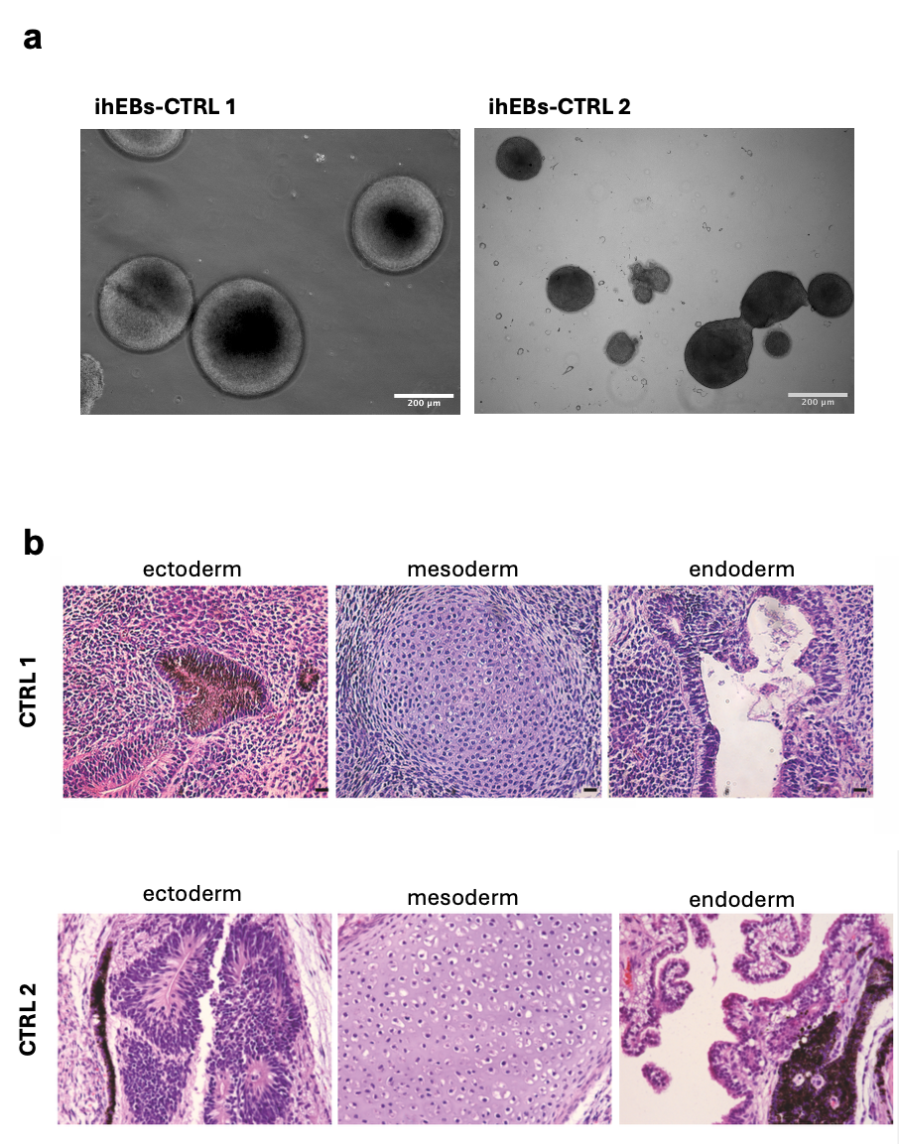

Supplementary Figure 2:
3D cultures from neural sphere (NS) stage (day30) to endpoint maturation (day80) and three intermediate growth stages (day35, 45, 60). Three representative images coming from three independent differentiation batches are given for each stage for both control and jHD cultures. These and other images were used for the organoid’s surface measurement (Scale bar: 200μm).

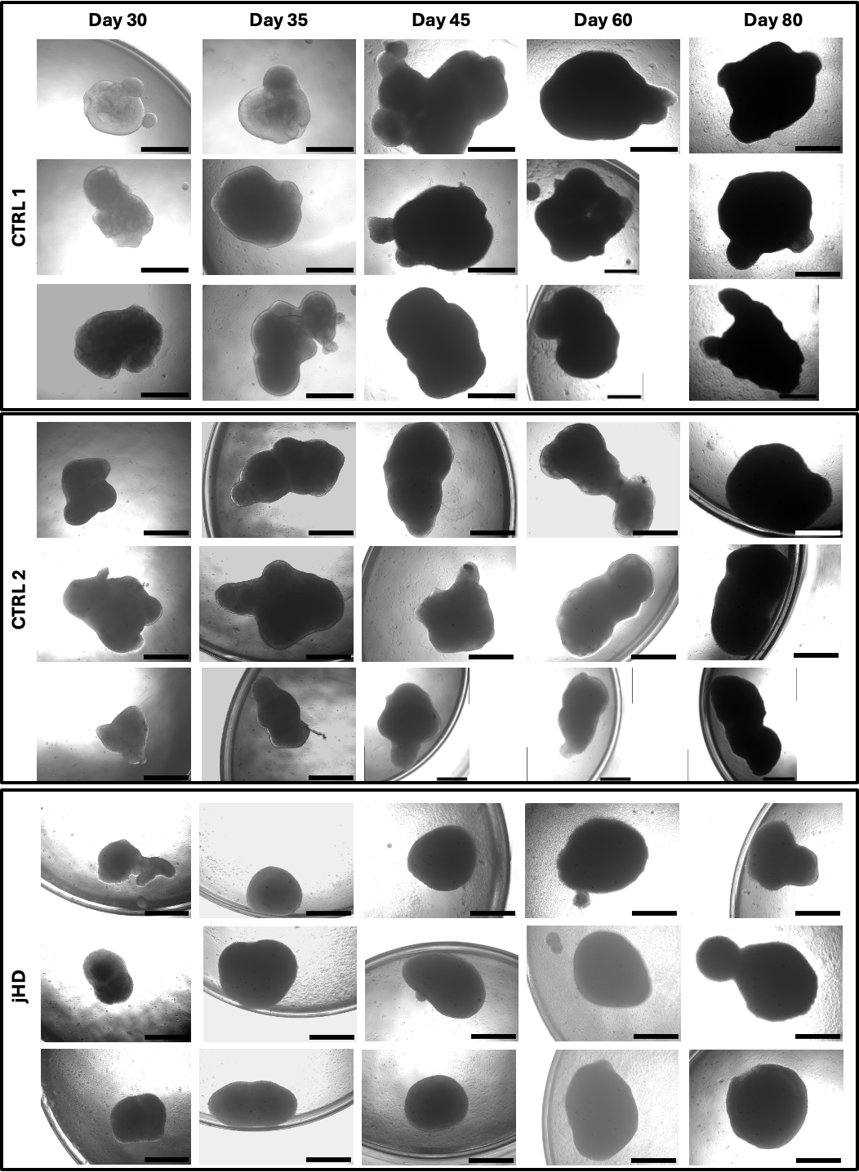
Supplementary Figure 3:
Expression fold changes of stemness marker OCT4, NS marker PAX6 and neural epithelium (NE) marker SOX1 for the jHD cultures, both 2D and 3D (day 60 and day80 respectively). The internal statistical significance are listed in supplementary Table 3.

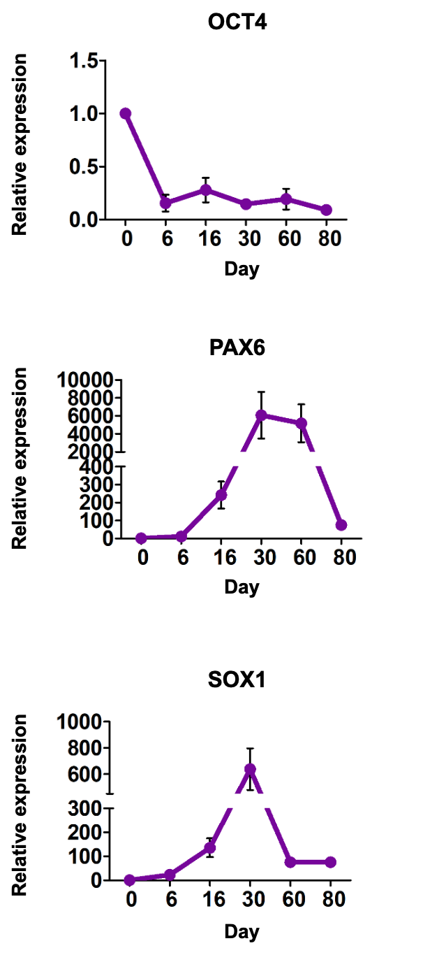

Supplementary Figure 4:
Immunofluorescence staining of jHD cortical neurons (a) and cortical organoids (b) expressing Cajal-Retzius marker Relin (RLN) (a. Scale bar 100μm; b. scale bar 100μm).

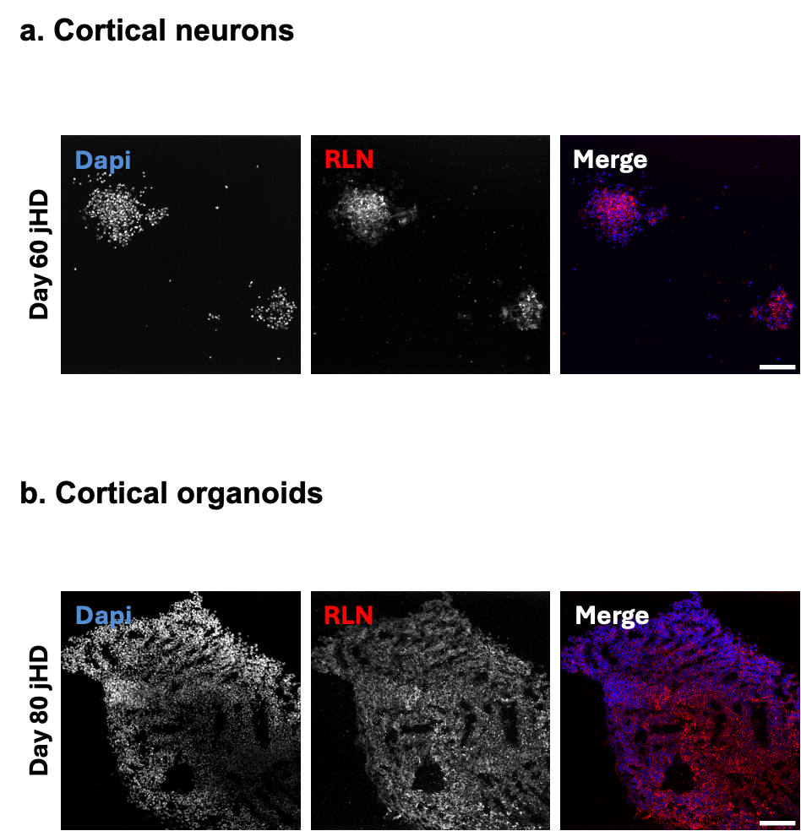

Supplementary Figure 5:
Immunofluorescence staining of jHD cortical neurons (a) and cortical organoids (b) expressing mutant aggregated Huntingtin (aggHtt) at day 45 of maturation in both culture conditions (a. Scale bar 20μm; b. scale bar 10μm).

