Supplementary Tables (S2)

Table S2.1. Sustainable Development Goals and their respective description adapted to the CG context (Katila et al., 2019).

SDG | Potential CG contributions | Examples of indicators
SDG1: No Poverty  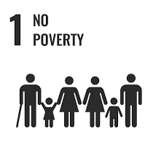 | Strengthening of social support networks and engagement with relevant political and community actors to promote socio-economic inclusion and change. | 1a. Number of partnerships with social support institutions/associations (partnerships/year)  1b. Number of actions implemented in vulnerable neighbourhoods (actions/year)
SDG2: Zero Hunger  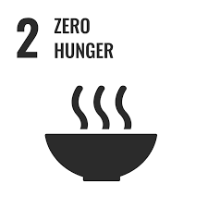 | Alleviation of food and nutritional insecurity; increase in the availability of fresh produce to local communities; promotion of agroecological practices . | 2a. Amount of vegetables/fruits harvested per unit area (kg/m²/year or kg/ha/year)  2b. Amount of food donated to vulnerable communities (kg/year)  2c. Number of meals prepared with garden-grown and/or organic ingredients (meals/year)  2d. Number of people participating in shared meals (persons/year)  2e. Crop agrobiodiversity (number of cultivated species and/or varieties/year)
SDG3: Good Health and Well-Being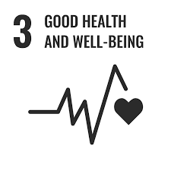 | Promotion of physical and mental health through hands-on activities; encouragement of healthy dietary habits; strengthening of social cohesion and inclusion. | 3a. Number of volunteers engaged in practical gardening and maintenance activities (persons/year)  3b. Number of health- and well-being-related activities organized (activities/year)  3c. Self-reported well-being of participants (mean score from survey; e.g. Likert scale 1–5)
SDG4: Quality Education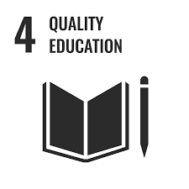 | Provision of educational activities with schools and institutions; promotion of outdoor and experiential learning opportunities. | 4a. Number of schools and educational institutions supported by the project (institutions/year)  4b. Number of students participating in project activities (students/year)  4c. Number of educational visits/workshops hosted by the project (activities/year)
SDG5: Gender Equality  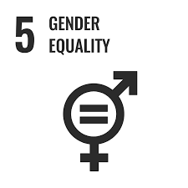 | Empowerment of women and girls; promotion of gender-balanced decision-making; support for inclusive participation and gender equality. | 5a. Gender ratio among community members (female:male or % by gender category)  5b. Number of sub-projects or initiatives led by women (projects/year)  5c. Gender ratio among volunteers (female:male or % by gender category)
SDG6: Clean Water and Sanitation  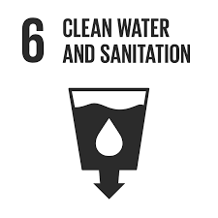 | Promotion of rainwater harvesting and storage; implementation of water-efficient irrigation and watering practices. | 6a. Amount of rainwater harvested and reused in the garden (L/year or m³/year)  6b. Water consumption per kilogram of vegetables produced (L/kg)
SDG7: Affordable and Clean Energy  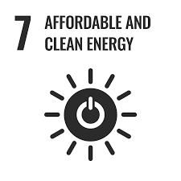 | Promotion of local energy communities and autonomous energy production; encouragement of non-fossil-fuel-based energy use. | 7a. Share of renewable energy generated locally by the project (% of total energy use/year)  7b. Energy consumption per member (kWh/member/year)  7c. Total renewable energy produced on-site (kWh/year)
SDG8: Decent Work and Economic Growth  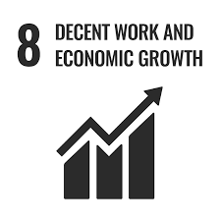 | Creation of qualified jobs in nature restoration, food production, social support, and education; provision of internships and opportunities for alternative economic models and local livelihoods. | 8a. Number of paid jobs generated by the project (jobs/year)  8b. Number of internships hosted by the project (internships/year)  8c. Number of training or skill-development opportunities provided (opportunities/year)
SDG9: Industry, Innovation, and Infrastructure  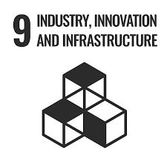 | Promotion of innovation through the development of new or reused technologies and strategies; support for action-research and experimental practices. | 9a. Number of innovative technological or methodological outputs developed (outputs/year)  9b. Number of academic works or research projects linked to the garden (works/year)  9c. Number of new or improved infrastructures created using sustainable approaches (infrastructure units/year)
SDG10: Reduced Inequality  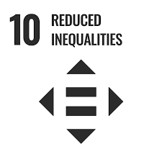 | Promotion of social inclusion of minorities and marginalized communities; empowerment of vulnerable groups; valorization of ancestral, traditional, and culturally diverse practices (Malberg et al., 2020). | 10a. Representation of LGBTQIA+ participants among members/participants (% of total participants)  10b. Representation of low-income participants in the project (% of total participants)  10c. Representation of participants under 30 years old (% of total participants or persons/year)
SDG11: Sustainable Cities and Communities  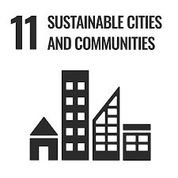 | Improvement of urban public space; promotion of sustainable mobility; strengthening of social cohesion; enhancement of resilience to climate change and extreme events. | 11a. Share of members using sustainable commuting modes to access the garden (% of members)  11b. Proportion of permeable  surface area within the project area (% of total area)  11c. Tree canopy cover (% of total area)  11d. Vegetation index (e.g. NDVI) (unitless index)  11e. Surface or air temperature difference compared with surrounding urban areas (°C)
SDG12: Responsible Consumption and Production  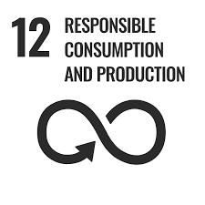 | Promotion of sustainable material consumption; valorization of organic residues; application of upcycling practices; use of local material sources. | 12a. Amount of compost produced (kg/year)  12b. Amount of organic residues reused as biomass or compost feedstock (kg/year)  12c. Amount of upcycled materials used to build or maintain infrastructure (kg/year)  12d. Share of locally sourced materials used in project activities (% of total materials/year)
SDG13: Climate Action  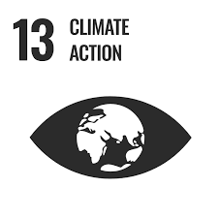 | Implementation of climate adaptation techniques; provision of environmental education; promotion of strategies to reduce the carbon footprint of food production and urban green spaces. | 13a. Amount of carbon sequestered in biomass and/or soil (kg C/year or t CO₂e/year)  13b. Soil organic matter content (% dry weight)  13c. Permeable surface area (m² or % of total area)  13d. Number of climate adaptation practices implemented (practices/year)
SDG14: Life Below Water  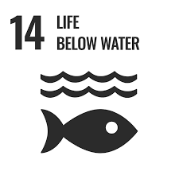 | Reduction of plastic waste leakage and promotion of waste prevention through reuse and upcycling practices | 14a. Amount of plastic waste avoided or reused through project activities (kg/year)
SDG15: Life on Land  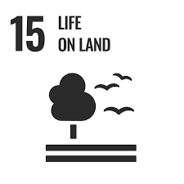 | Promotion of biodiversity; improvement of soil health; restoration of degraded urban land. | 15a. Biodiversity indices across multiple taxa (index values/year; e.g. Shannon, Simpson, richness)  15b. Soil biological activity or metabolism (e.g. mg CO₂-C/kg soil/day)  15c. Number of native plant species established (species/year)  15d. Area of restored or ecologically managed habitat (m²/year)
SDG16: Peace, Justice, and Strong Institutions  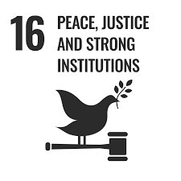 | Promotion of participatory and alternative decision-making models; strengthening of inclusive organizational systems; enhancement of community trust and empowerment. | 16a. Number of active members (persons/year)  16b. Number of meetings held (meetings/year)  16c. Number of participants actively involved in meetings (persons/year)  16d. Transparency index (index score; define scale/methodology)
SDG17: Partnerships for the Goals  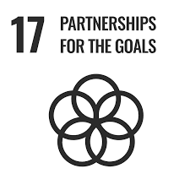 | Establishment of cross-sectoral partnerships between local actors and public institutions; promotion of support, knowledge exchange, and collaborative networks. | 17a. Number of partnerships with local projects and institutions (partnerships/year)  17b. Number of national and international networks in which the project participates (networks/year)  17c. Number of Erasmus+ or other exchange programmes linked to the project (programmes/year)  17d. Number of participants involved in exchange programmes (persons/year)

Table S2.2. Indicators selected to assess HortaFCUL’s contributions to the Sustainable Development Goals, their units of measure, framework of analysis and their source.

Sustainability dimension (P) | SDG | Indicator | Unit of measurement | Indicator framework | Data Source
People | SDG 2 – Zero Hunger | Number of meals prepared with locally produced organic food | Number of meals per year | Temporal sequence | Project activity records
 | SDG 4 – Quality Education | Number of educational events | Number of events per year | Temporal sequence | Event archives and communication platforms
 |  | Number of participants in educational events | Mean number of participants per event | Temporal sequence | Attendance records
Prosperity | SDG 8 – Decent Work and Economic Growth | Amount of funds raised by the project | Euros (€) per year | Temporal sequence | Financial reports
 | SDG 11 – Sustainable Cities and Communities | Percentage of permeable surface | Percentage | Temporal sequence | Infrastructure monitoring records
 |  | Tree and shrub canopy cover | Area (m²) or percentage of project area | Campus baseline comparison | Remote sensing data / spatial analysis
Planet | SDG 12 – Responsible Consumption and Production | Amount of compost produced | Metric tonnes per year | Temporal sequence | Composting station records
 | SDG 13 – Climate Action | Soil organic matter content | Percentage | Campus baseline comparison | Biomass estimates / ecological models
 | SDG 15 – Life on Land | Species richness across major taxonomic groups | Number of species | Campus baseline comparison | Citizen science platforms and biodiversity surveys
Peace | SDG 16 – Peace, Justice and Strong Institutions | Number of active project members | Number of members per year | Temporal sequence | Internal membership records
Partnerships | SDG 17 – Partnerships for the Goals | Number of local, national and international partnerships | Number of partnerships | Temporal sequence | Institutional mobility records

