Supplementary Figures (S3)

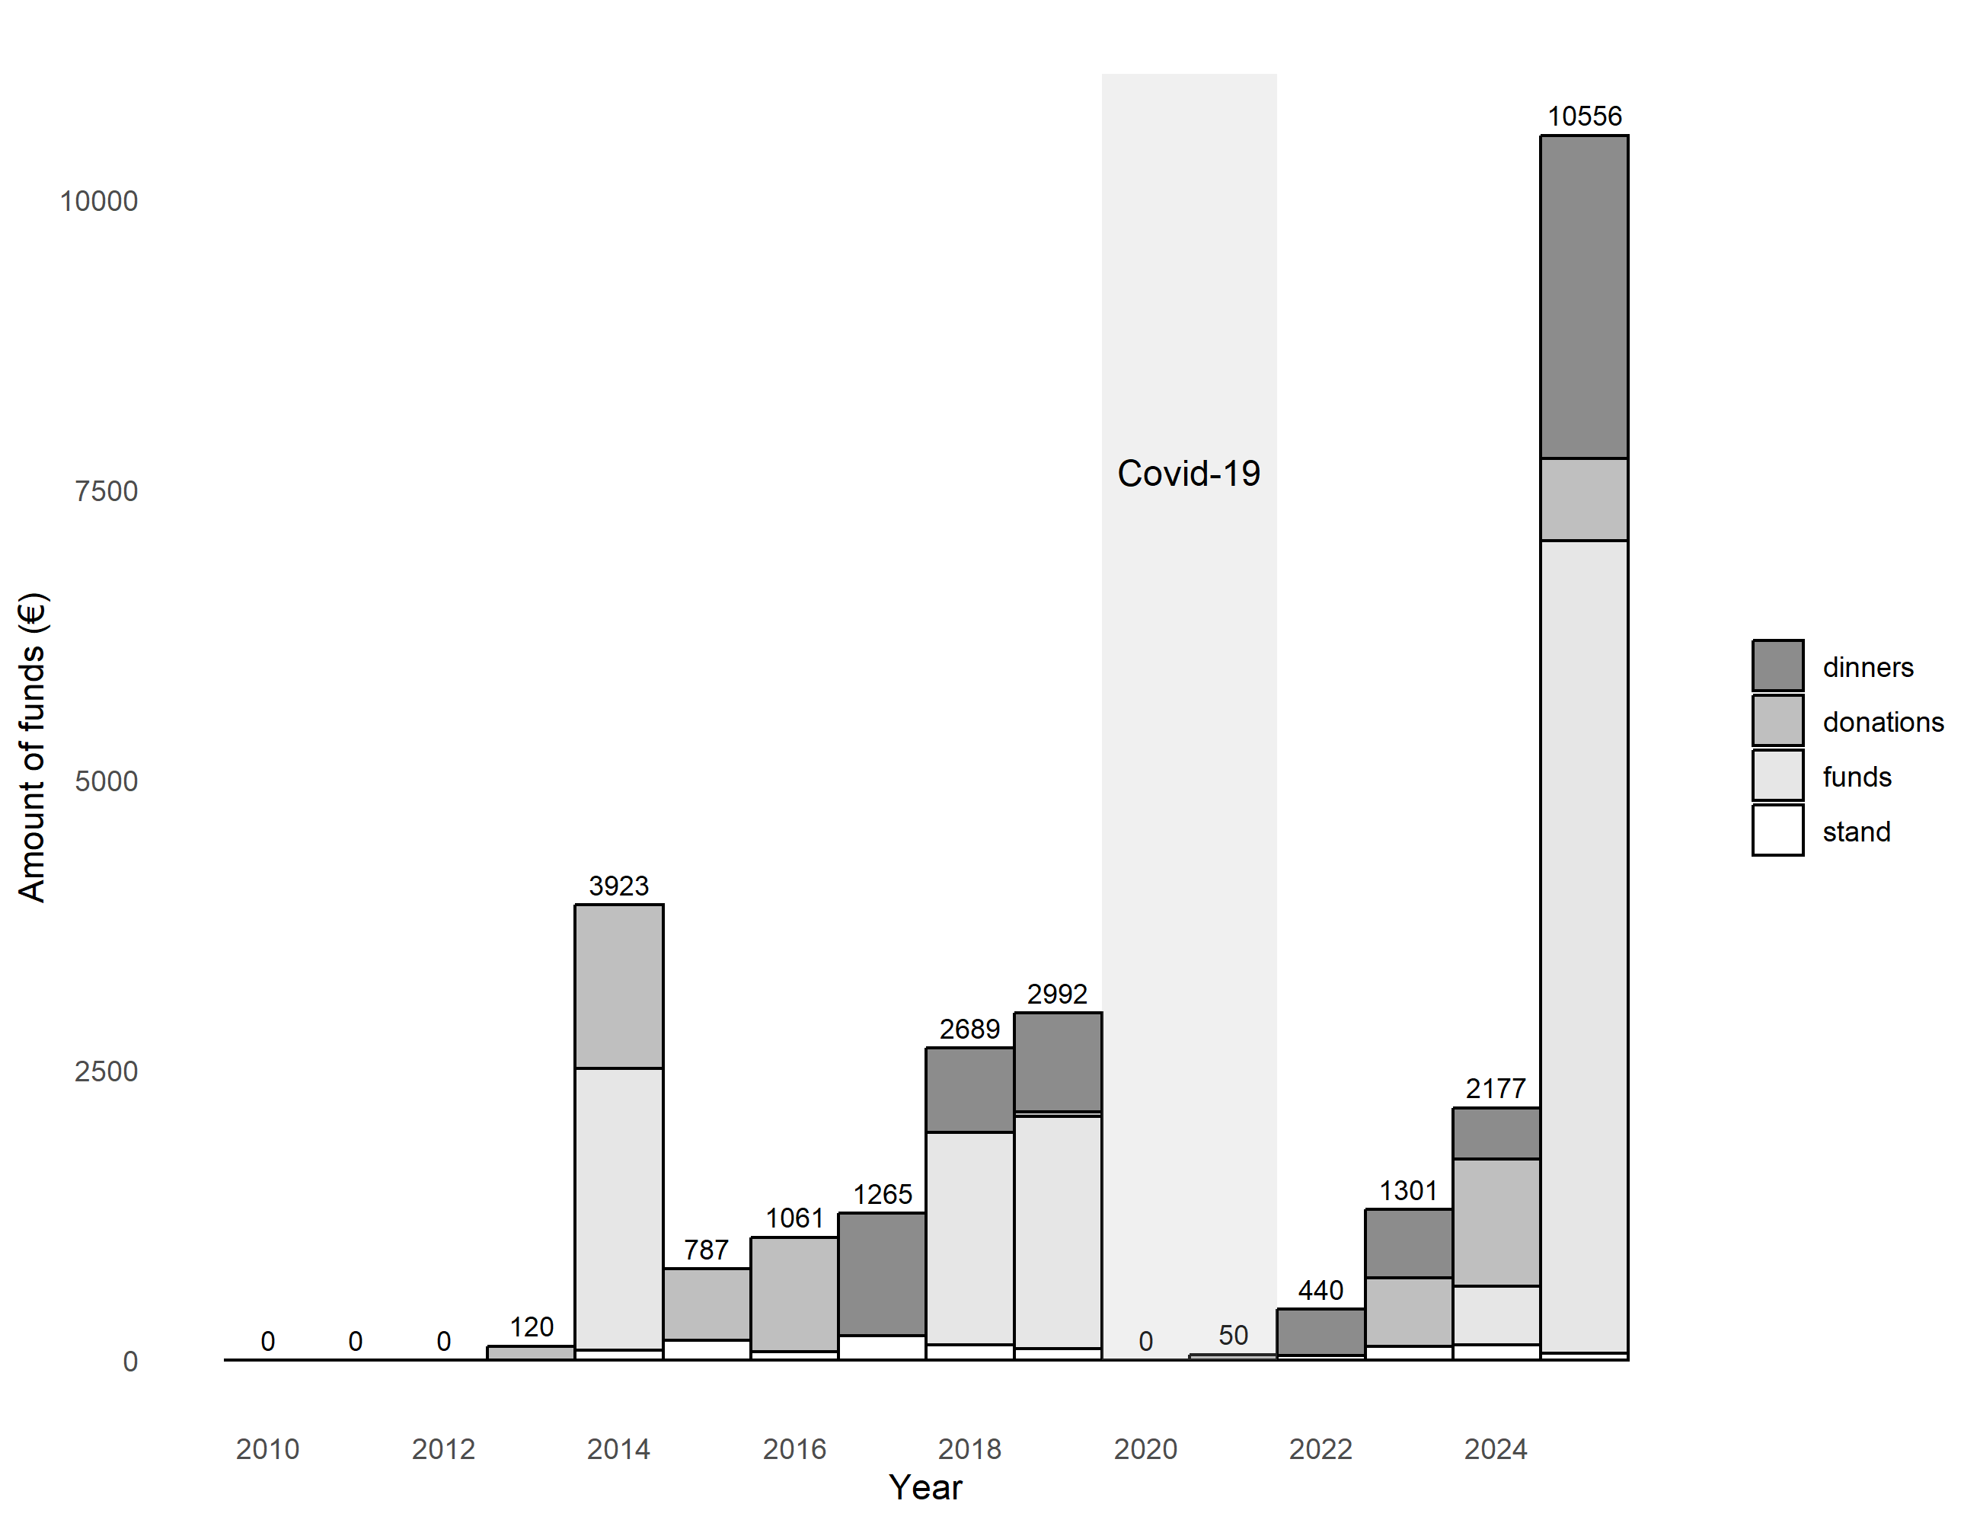

Fig. S3.1 Amount of funds (in euros) raised by the case study project between 2010 and 2012. Different sources of funds are highlighted with different shades of grey. Covid-19 pandemic period is also identified between 2020 and 2021.
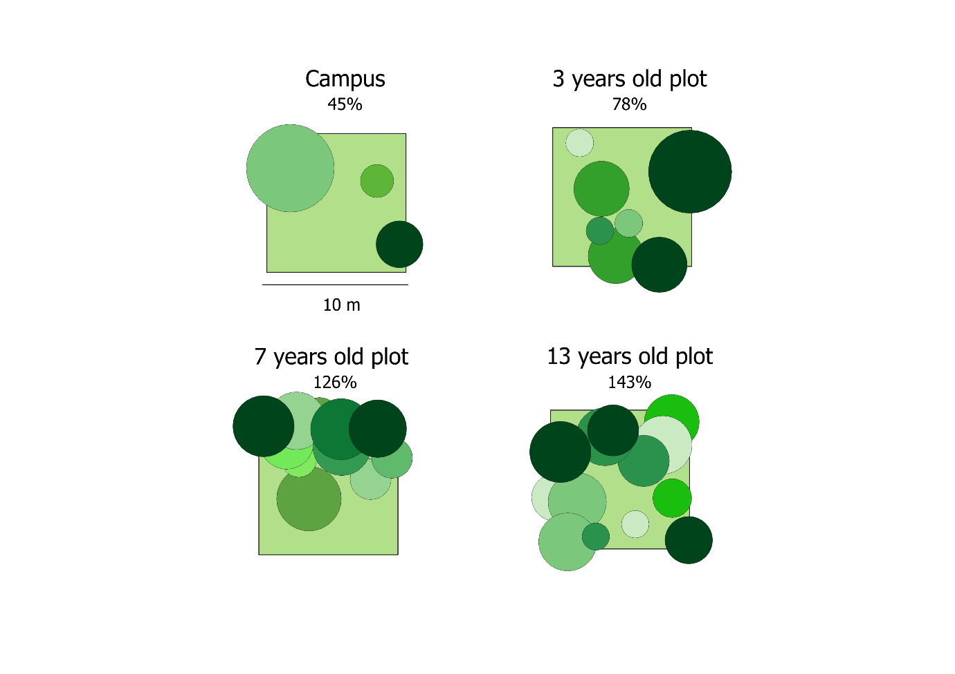
Fig S3.2. Schematic representation of both campus and Projects 1 (13 years old), 2 (7 years old) and 3 (3 years old) relative tree cover in 100m² squares. Each circle depicts an individual tree canopy. Both the number of trees and the summed canopy area correspond to the averages calculated for 100m². Tree layout and colors were randomly assigned.
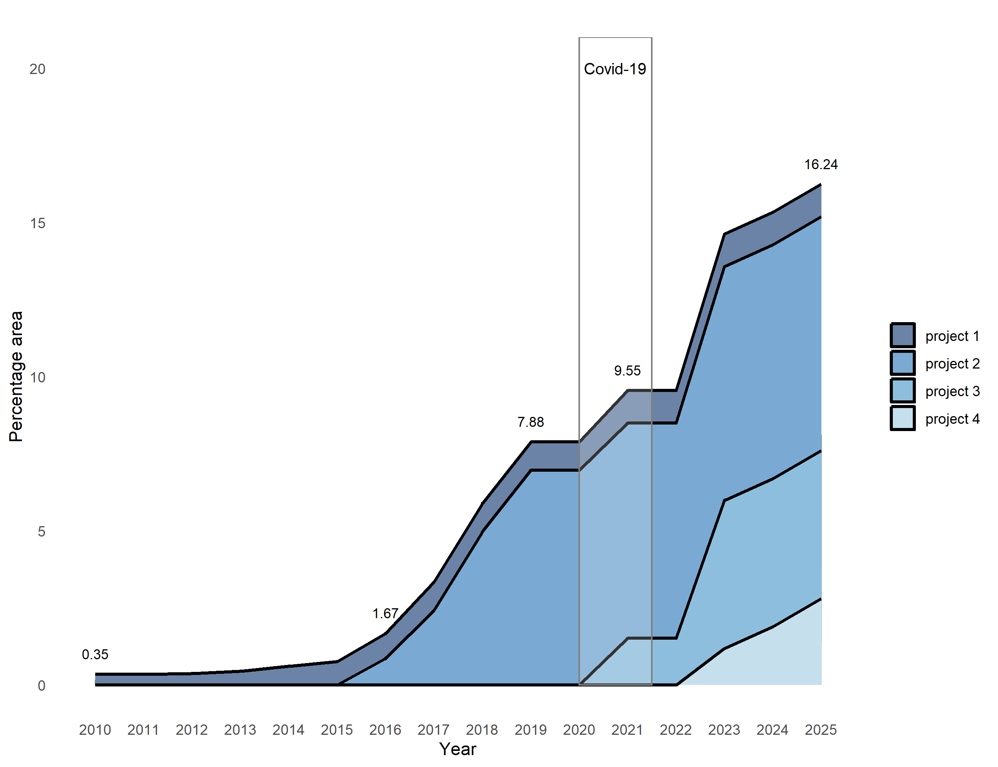
Fig. S3.3 Percentage of the case study’s permeable surface with time. Projects 1 to 4 areas are highlighted with different shades of blue. Covid-19 pandemic period is also identified between 2020 and 2021.
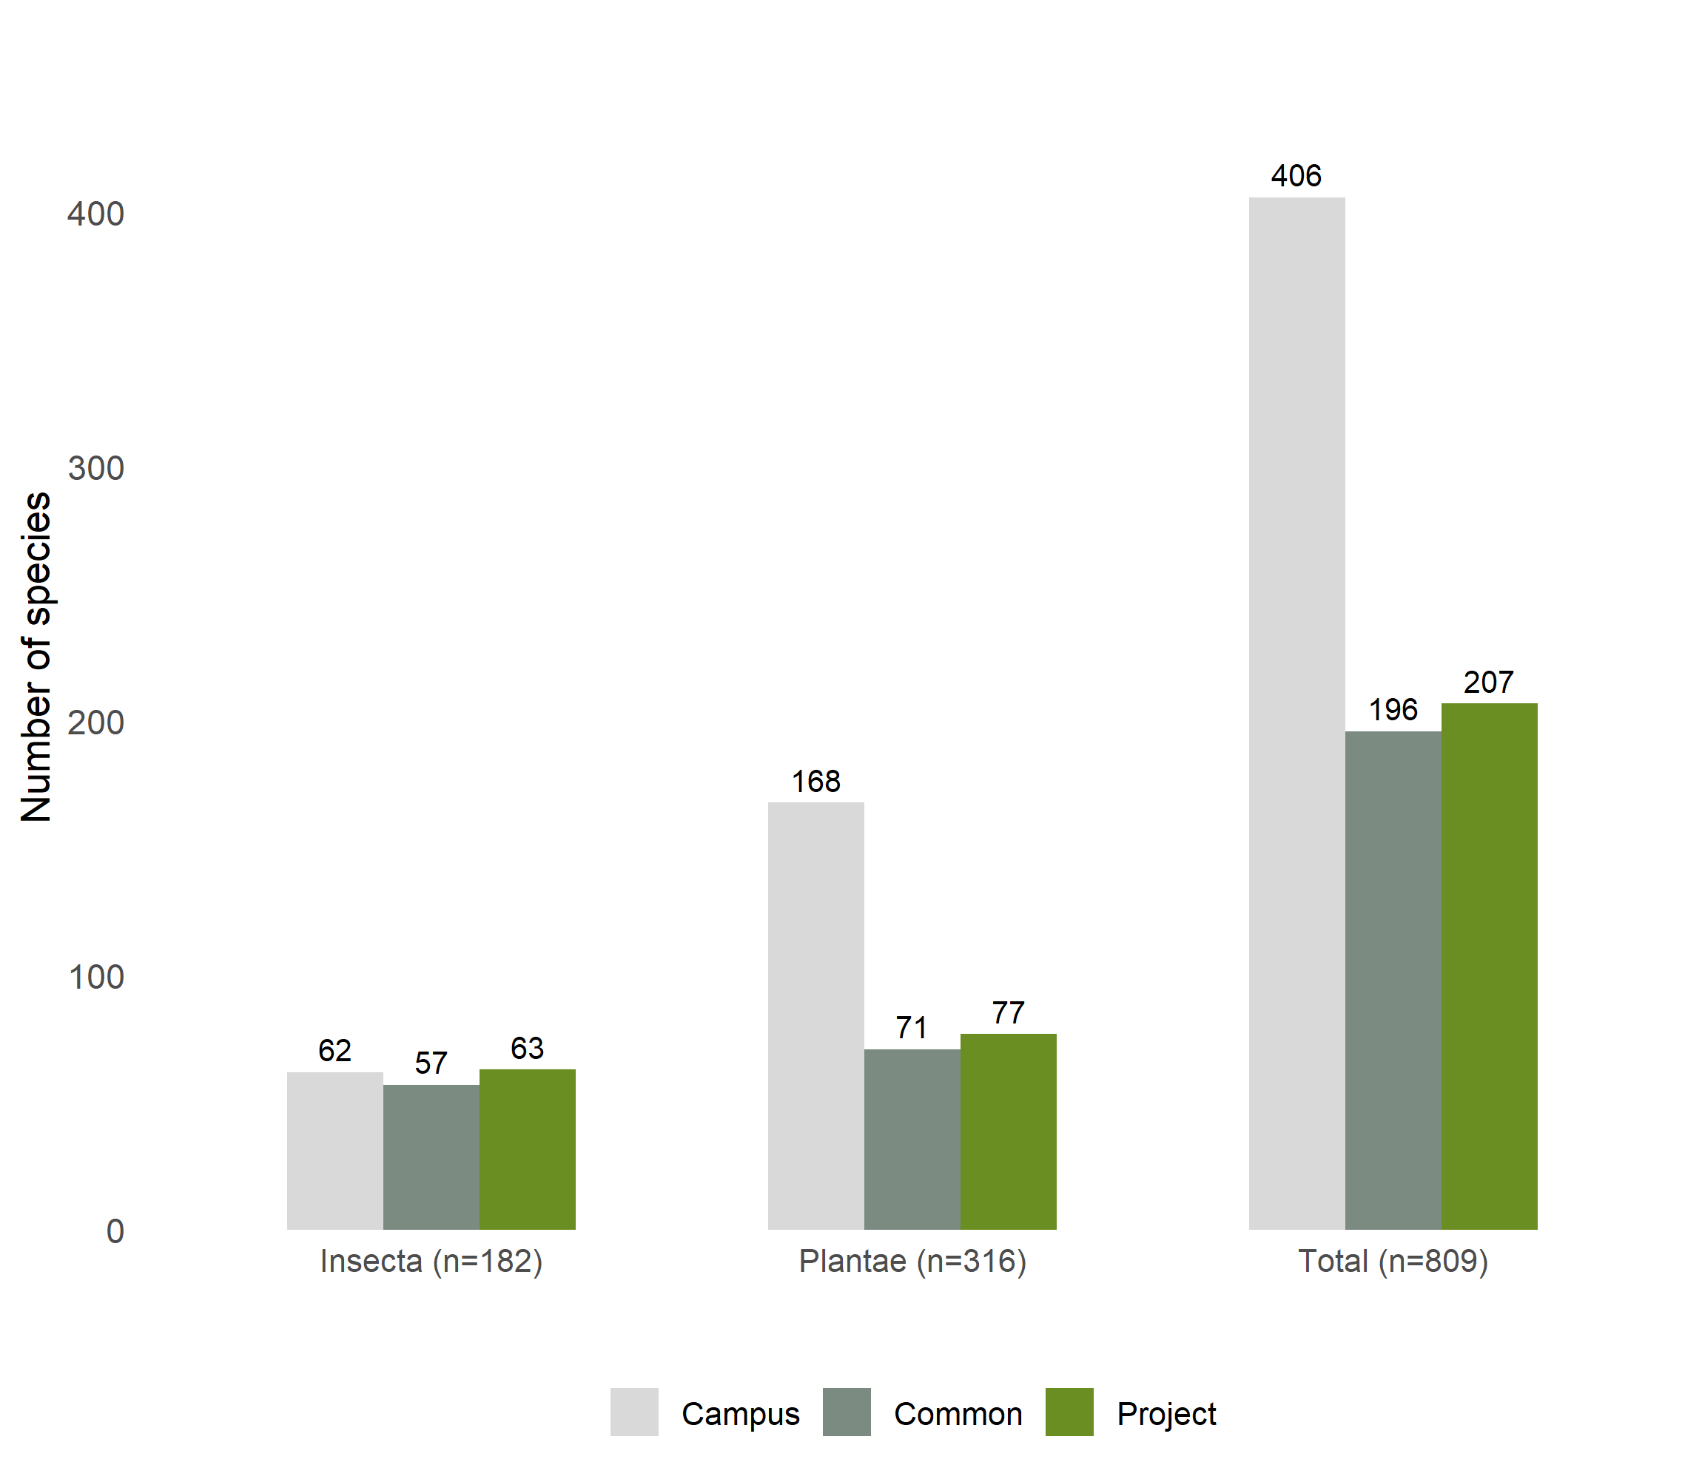
Fig. S3.4 Number of species exclusively observed in campus and project areas and common to both sites for Classe Insecta, Kingdom Plantae and All taxa (Total).

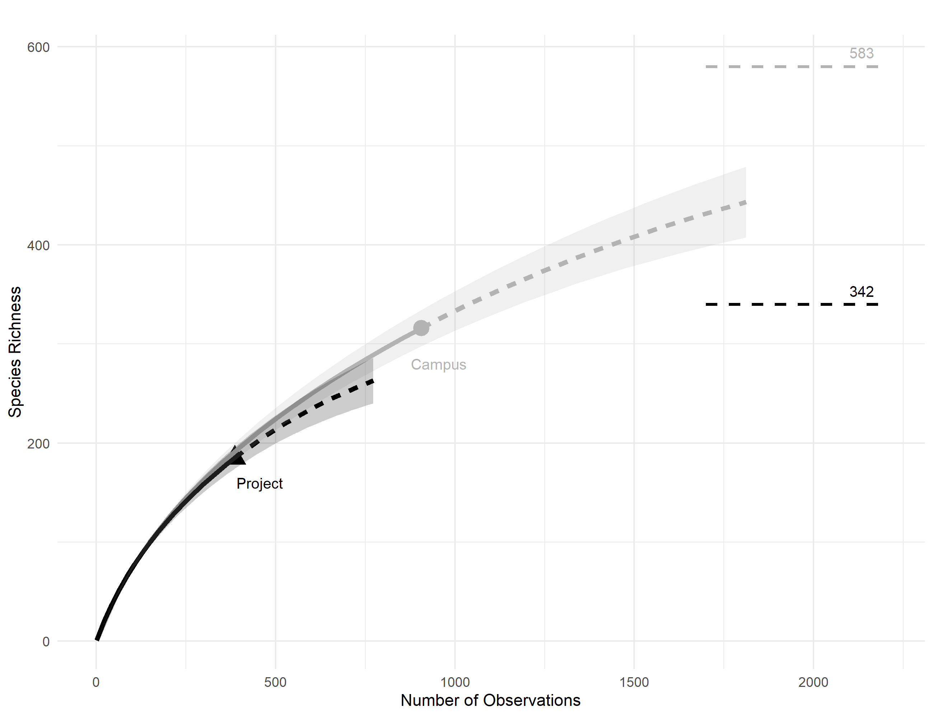
Fig. S3.5. Rarefaction and extrapolation curves (q=0) for Kingdom Plantae species in campus green areas (grey) and case study areas (black). Assymptote estimates for both curves were added at the right side of the plot.

