Supplementary

Table 1. Metabolites of E. cloacae S1 using different carbon sources. Data shown are averages of triplicate experiments with standard error.
Carbon source | Metabolites (g/L)
Carbon source | Ethylene glycol | Glycolic acid | Acetic acid | Acetoin | 2,3-butanediol
Xylonic acid | 2.67±0.26 | 0.46±0.08 | 0 | 0 | 0
Xylose | 0 | 0 | 0 | 0 | 1.18±0.13
Glucose | 0 | 0 | 1.15±0.02 | 0.05±0.05 | 2.14±0.18
Gluconic acid | 0 | 0 | 0.51±0.43 | 1.49±0.05 | 1.56±0.05
2-Ketogluconic acid | 0 | 0 | 1.76±0.21
Glycerol | 0 | 0 | 0. | 0.77±0.38 | 0.45±0.15

Table 2. Enzyme activity determination of purified putative glycolaldehyde DH expressed in E. coli (AlB, BetB, Ad1 and Ad2) compared with cell lysate of E. cloacae S1.
Cofactor used | Glycolaldehyde dehydrogenase activity (U/mg P)
Cofactor used | Cell lysate | AldB | BetB | Ad1 | Ad2
NAD | 0.0021± 0.0004 | 0.025±0.008 | 0.21± 0.12 | 0.024± 0.02 | 0.012± 0.005
NADP | 0±0.01 | 0.035±0.015 | 0.042±0.003 | 0.025±0.02 | 0.003±0.003

Table 3 Primers
Primer name | Sequence (5’-3’)
16sRNA-a | GGGAGCGAATCAGACGACG
16sRNA-s | GGTTACCTTGTTACGACTT
yhcH-a |  | GCTTCAGACACCTTCCAGTAGTAGGGGTTG
yhcH-s |  | TCATTTGCATGATTCGCATCAGATAATGATTA
yjhH-a | GGGAGCGAATCAGACGACG
yjhH-s | TCGGGCAAACACGACATCA
yjhG-a | GTCAGCAGAATGTAGGTTACGCAG
yjhG-s | ACCCCTACTACTGGAAGGTGTCTG
yagG-a |  | GCCCCCACGGACGATAGAG
yagG-s |  | CTGCGCGACAACGACATCA
xyL-a |  | CGGAGAACGGCAAGTATCG
xyL-s |  | ATCGTCGCCTACTCGCTGA
iclR-a |  | GATGGGCGAAGCCAAAGAG
iclR-s |  | GCTCTACGGCAACGACTCG
yqhD-a | TTAGCGCGCCGCCTCGTAGATA
yqhD-s | ATGAATAATTTTAATCTCCACACCCCAACCCGC
betB-a | ATGCACCACATCGAACAGATTTT
betB-s | CTTCCACCAGAAAATGCGCCTCAA
yhcH-FRT-a |  | TTACCCCACCAACATCTTAACAACCACTTTTCTGACCTTATTCCGGGGATCCGTCGACC
yhcH-FRT-s |  | TTGAATTCTCGTATAAAAGATAAAAATGAAACGGTGTTTTTGTAGGCTGGAGCTGCTTC
yjhH-FRT-a | TCAGCAGAGCTTGAGCTGTTGCAGCAGGGTTTTCAGCTGATTCCGGGGATCCGTCGACC
yjhH-FRT-s | ATGCCGCAGTCCGCGTTGTTCACGGGAATCATTCCCCCTGTGTAGGCTGGAGCTGCTTC
yjhG-FRT-a | TTAAAGTCCGAGTGCTTTTTTACCGGCGTTAATTACCTCATTCCGGGGATCCGTCGACC
yjhG-FRT-s | ATGACCATCGAGAAAATTTTCACCCCGCAGGATGATGCGTTGTAGGCTGGAGCTGCTTC
yjhG-FRT-s |  | ATGACCATCGAGAAAATTTTCACCCCGCAGGATGATGCGTTGTAGGCTGGAGCTGCTTC
yagG-FRT-a |  | TTACTGGGATGCGGCTGTCGCGGCGTCGGGAAGGGCCTCATTCCGGGGATCCGTCGACC
xyL-FRT-a |  | CACGCGCGCTGGGCTACCCGGCCTGAGCCGTTAAATCGGATTCCGGGGATCCGTCGACC
xyL-FRT-s |  | ATGGAAATCACCAACCCAATACTCACCGGCTTCAACCCGGTGTAGGCTGGAGCTGCTTC
iclR- FRT-a |  | ATGCCGATTATTCAGTCTGTTGAACGTGCGTTGCAGATCATTCCGGGGATCCGTCGACC
iclR- FRT-s |  | TCAGGCCGGGTAGCCCAGCGCGCGTGAGAGCTGGAGCCCGTGTAGGCTGGAGCTGCTTC
yqhD- FRT-a | ATTTTGGCATCCACCGGATAAGTCACGTACTGCTCAACGATTCCGGGGATCCGTCGACC
yqhD- FRT-s | TCCGGTGTACACCTACACCCTGCCCGCGCGTCAGGTCGCGTGTAGGCTGGAGCTGCTTC
betB- FRT-a | TGCCGCATTGCCAGCGGGCGTGTTTAATATCATCACCGGGATTCCGGGGATCCGTCGACC
betB- FRT-s | TTTTTGTAGGCCCGGTAAGCGTAGCGCCACCGGGCAGGGTTGTAGGCTGGAGCTGCTTCGAA
Test773-s | ATGACGAGCGTCCCTCCC
Test 778 | AGAATCTCGCTCTCTCCAGGGGAAG
yqhD-a2 | CATGCCATGGTTAGCGCGCCGCCTCGTAGA
yqhD-s2 | CGCGGATCCATGAATAATTTTAATCTCCACACCCCAACC
aldB-a |  | CCCAAGCTTGGGCTAGAACAGCCCCAGCGGT
aldB-s |  | CCGGAATTCCGGATGACAAACAATCCTCCCTCTTCA
betB-a2 |  | CCCAAGCTTGGGTTAACCCACAATCGACTTCGG
betB-s2 |  | CGCGGATCCGCGATGCACCACATCGAACAGATTT
ad1-a |  | CCGGAATTCCGGTTACTTACGCACCACCACCAGC
ad1-s |  | CGCGGATCCGCGATGGCTTATCAGACAGTAAATCCTGC
ad2-a | CCGGAATTCCGGTCAGTCGCACCAGTGGTTGA
ad2-s | CGCGGATCCGCGATGGACGATCTGAAGATATTTATCG

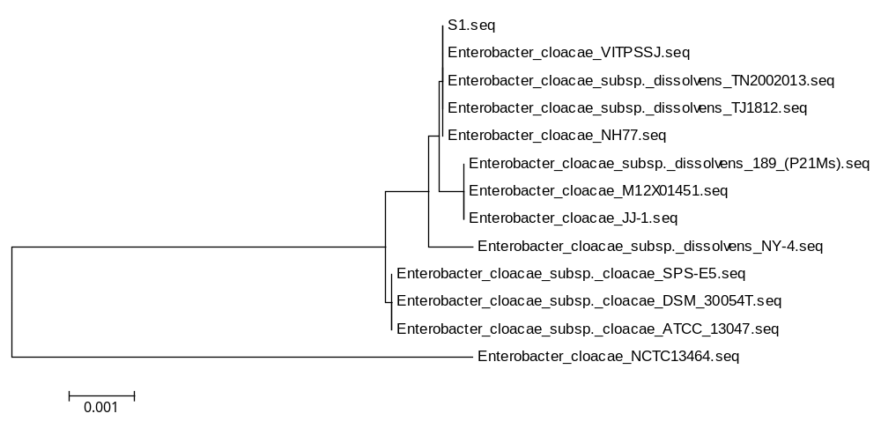
Figure 1 Phylogenetic tree of the16S rRNA genes of E. cloacae S1 and other E. cloacae strains

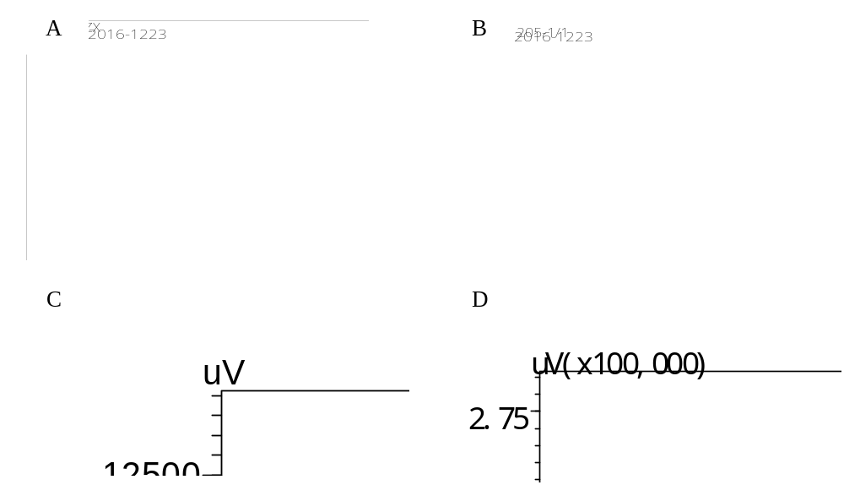
Figure 2. Ethylene glycol and glycolic acid identification. A: ¹H NMR spectra of glycolic acid; B: ¹³C NMR spectra of glycolic acid; C: HPLC chromatograms of ethylene glycol; D GC chromatograms of ethylene glycol. Pink lines are standard chemicals, blue lines are samples.

