Supplementary material for:

Metabarcoding reveals high diversity of benthic foraminifera driven by atlantification of coastal Svalbard
Ngoc-Loi Nguyen^{1*}, Joanna Pawłowska¹, Inès Barrenechea Angeles^{2,3}, Marek Zajaczkowski¹, Jan Pawłowski^{1,3}
¹ Institute of Oceanology Polish Academy of Sciences, Powstancow Warszawy 55 81-712 Sopot, Poland
² Department of Earth Sciences, University of Geneva, Rue des Maraîchers 13, 1205 Geneva, Switzerland
³ Department of Genetics and Evolution, University of Geneva, Boulevard d’Yvoy 4, 1205 Geneva, Switzerland

* Correspondence to: loinguyen@iopan.pl, Tel.: +48 (58) 7311 661
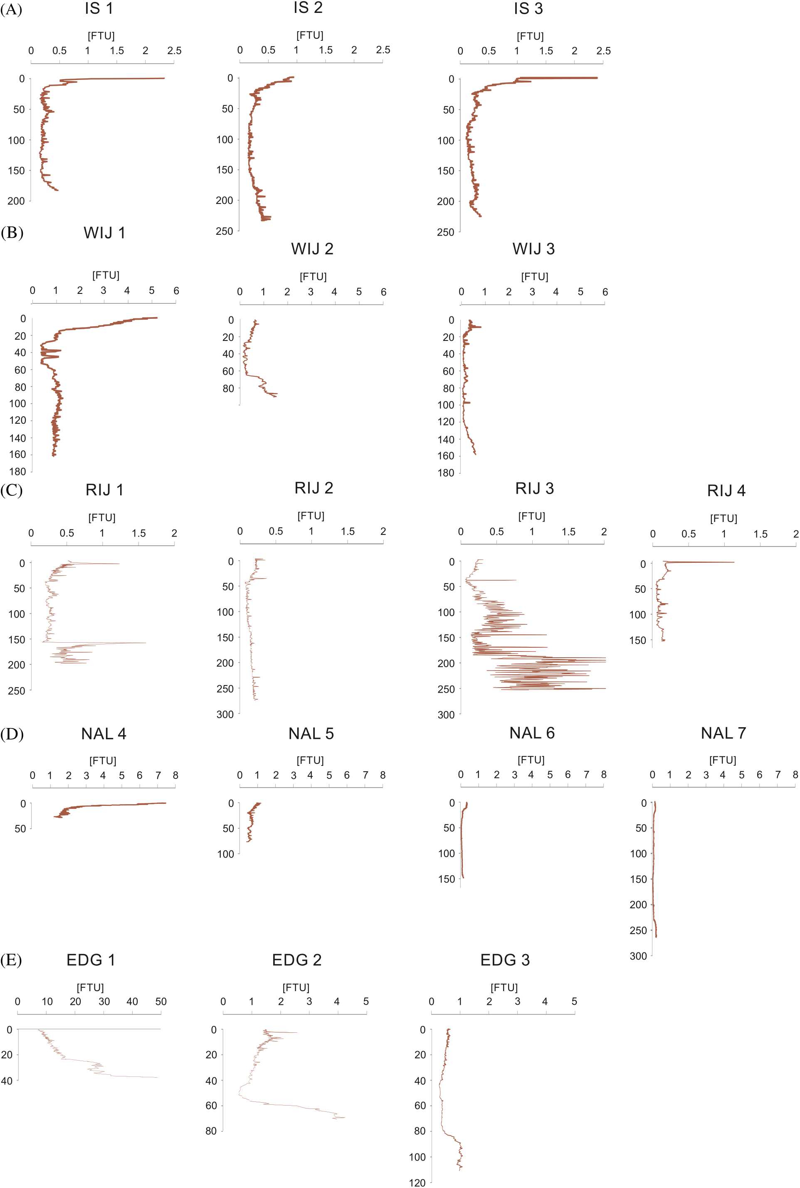
Figure S1. The vertical distributions of turbidity at 17 stations. (A) IS – Isfjorden, (B) WIJ – Wijdefjorden, (C) RIJ – Rijpfjorden, (D) NAL – Nordaustlandet, and (E) EDG – Edgeoya.

Figure S2. Taxonomic composition of unique and shared foraminiferal ASVs in different size fractions. Bar plots represent the proportion of reads assigned to the taxonomic composition of each fraction by order/clade.
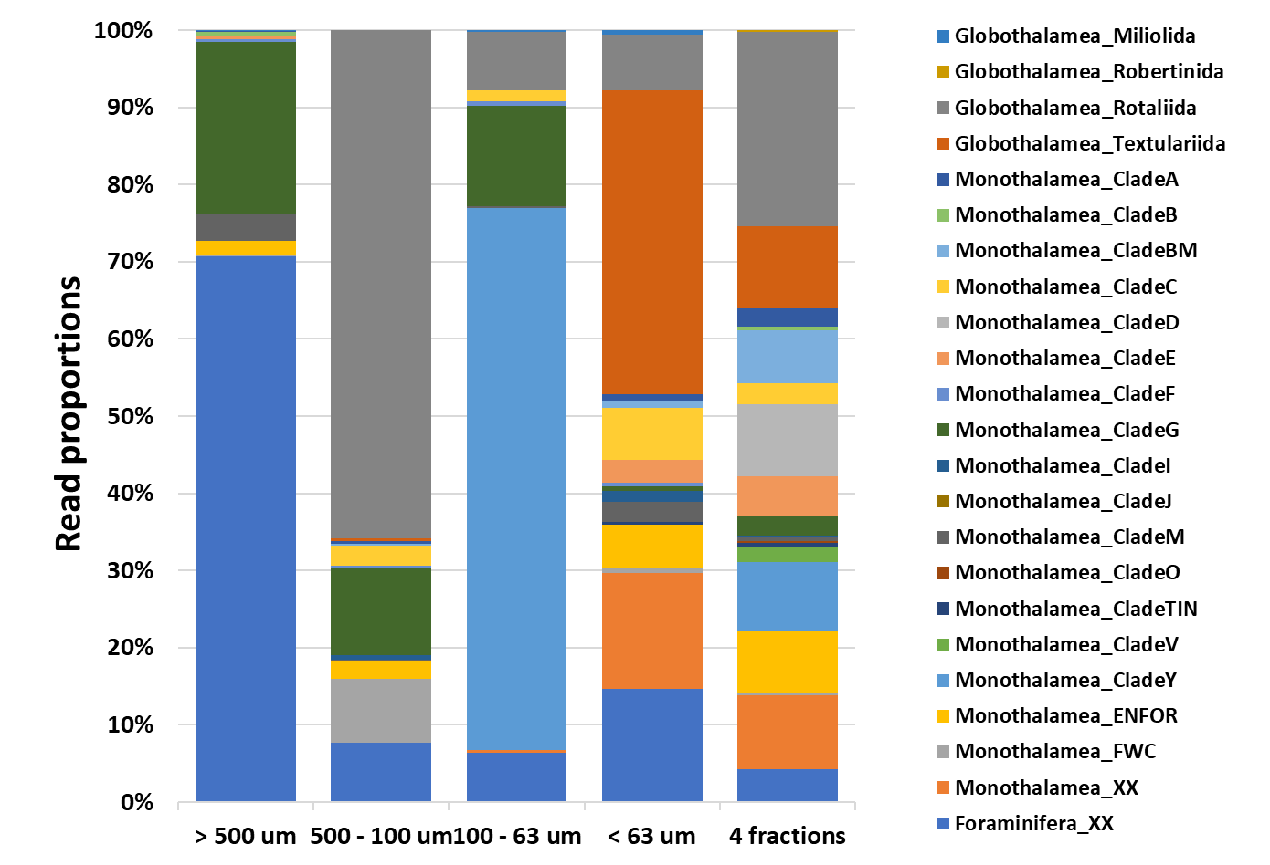

Table S1. Location of the sampling stations.
Station | Depth (m) | Latitude | Longitude
Edgeoya 1 | 41 | 77°42'55.5"N | 24°12'51.2"E
Edgeoya 2 | 71 | 77°41'08.8"N | 24°39'23.0"E
Edgeoya 3 | 114 | 77°39'45.1"N | 25°00'09.7"E
Isfjorden 1 | 191 | 78°24'00.0"N | 15°35'41.4"E
Isfjorden 2 | 240 | 78°15'53.4"N | 14°51'12.0"E
Isfjorden 3 | 230 | 78°09'48.0"N | 14°07'06.0"E
Nordaustlandet 4 | 42 | 79°42'43.6"N | 26°34'57.3"E
Nordaustlandet 5 | 82 | 79°40'30.4"N | 26°48'57.1"E
Nordaustlandet 6 | 147 | 79°36'14.5"N | 27°30'11.8"E
Nordaustlandet 7 | 275 | 79°33'11.1"N | 28°00'20.8"E
Rijpfjorden 1 | 202 | 80°05'22.4"N | 22°12'59.8"E
Rijpfjorden 2 | 260 | 80°18'27.8"N | 22°10'57.1"E
Rijpfjorden 3 | 260 | 80°22'21.2"N | 22°05'44.2"E
Rijpfjorden 4 | 155 | 80°30'17.3"N | 22°02'59.8"E
Wijdefjorden 1 | 160 | 79°09'27.8"N | 16°00'05.1"E
Wijdefjorden 2 | 100 | 79°29'21.5"N | 15°33'28.5"E
Wijdefjorden 3 | 154 | 79°53'48.9"N | 15°19'04.0"E

Table S2. Definition of water masses in Svalbard according to Cottier, et al. ¹.
Water masses |  | Temperature (°C) | Salinity
Atlantic water | AW | > 3.0 | > 34.65
Arctic water | ArW | -2.5 | 34.3 - 34.8
Transformed Atlantic water | TAW | 1.0 - 3.0 | > 34.65
Winter Cooled Water | WCW | < -0.5 | 34.4 - 35.0
Surface water | SW | > 1.0 | < 34.0
Local water | LW | -1.5 | 34.3 - 34.85
Intermediate water | IW | > 1.0 | 34.0- 34.65

Table S3: Primers and PCR thermal cycling profile ^{2,3} used in this study.
Target gene and amplicon size | 37f SSU rDNA, 68 - 196 bp
Primer name and sequence | s14F1 (5′- XXXXXAAGGGCACCACAAGAACGC-3′)
Primer name and sequence | s15 (5'- XXXXXCCTATCACATAATCATGAAAG-3')
Thermal cycling | 1 cycle | 94°C | 1 min
Thermal cycling | 60 cycles | 94°C | 30 sec
Thermal cycling |  | 52°C | 30 sec
Thermal cycling |  | 72°C | 30 sec
Thermal cycling | 1 cycle | 72°C | 2 min

Table S4. Sequencing data statistics and quality control results
Name | Method | Raw paired-end reads | Raw reads | ASVs | Retained reads | Retained ASVs
EDG1 | Sieved | 199,663 | 195,196 | 192 | 185,515 | 141
EDG2 | Sieved | 377,126 | 358,537 | 365 | 358,023 | 330
EDG3 | Sieved | 403,247 | 385,467 | 538 | 384,588 | 497
IS1 | Sieved | 358,591 | 340,383 | 460 | 331,059 | 422
IS2 | Sieved | 403,475 | 381,449 | 586 | 375,557 | 483
NAL4 | Sieved | 266,984 | 259,027 | 225 | 256,796 | 189
NAL5 | Sieved | 334,649 | 319,765 | 460 | 314,457 | 390
NAL6 | Sieved | 273,959 | 256,110 | 573 | 249,021 | 490
NAL7 | Sieved | 411,847 | 353,112 | 644 | 338,512 | 493
RIJ1 | Sieved | 404,865 | 372,858 | 510 | 371,198 | 475
RIJ2 | Sieved | 364,483 | 346,437 | 529 | 343,541 | 477
RIJ3 | Sieved | 381,675 | 362,406 | 519 | 359,640 | 493
RIJ4 | Sieved | 424,620 | 383,727 | 669 | 379,638 | 579
WIJ1 | Sieved | 209,741 | 192,331 | 329 | 190,445 | 267
WIJ3 | Sieved | 342,889 | 329,614 | 461 | 323,280 | 381
Mean of Sieved |  | 343,854 | 322,427 | 471 | 317,418 | 407
EDG1 | Unsieved | 56,411 | 54,912 | 108 | 50,894 | 84
EDG2 | Unsieved | 44,506 | 41,057 | 188 | 41,038 | 186
EDG3 | Unsieved | 93,269 | 86,133 | 395 | 85,632 | 382
IS1 | Unsieved | 44,606 | 42,066 | 332 | 41,788 | 322
IS2 | Unsieved | 101 | 53 | 20 | 53 | 20
NAL4 | Unsieved | 42,053 | 37,505 | 227 | 36,735 | 215
NAL5 | Unsieved | 63,713 | 54,901 | 333 | 54,172 | 311
NAL6 | Unsieved | 49,556 | 46,896 | 441 | 45,918 | 424
NAL7 | Unsieved | 58,636 | 52,677 | 428 | 41,462 | 388
RIJ1 | Unsieved | 50,276 | 45,392 | 414 | 45,071 | 405
RIJ2 | Unsieved | 66,043 | 61,872 | 304 | 61,778 | 300
RIJ3 | Unsieved | 69,189 | 64,669 | 412 | 64,050 | 403
RIJ4 | Unsieved | 44,368 | 41,456 | 439 | 40,956 | 411
WIJ1 | Unsieved | 67,597 | 56,299 | 228 | 56,241 | 219
WIJ3 | Unsieved | 60,648 | 56,948 | 330 | 56,442 | 311
Mean of Unsieved |  | 57,919 | 53,056 | 327 | 51,584 | 312

Table S5: Total number of ASVs and sequence read abundance identified within the foraminiferal 37f dataset.

Table S6. Permutational multivariate analysis of variance (PERMANOVA) results based on Bray-Curtis dissimilarities using abundance data for showing the effects of method, site, depth and their interaction on the foraminiferal community structure.

Source of variation | Df | Sum of Sqs | R2 | pseudo-F | Pr(>F)
Method | 1 | 0.2276 | 0.02533 | 0.8691 | 0.692
Site | 4 | 2.7089 | 0.30154 | 2.5861 | 0.001
Depth | 1 | 0.5618 | 0.06253 | 2.1452 | 0.003
Method × Site | 4 | 0.6051 | 0.06736 | 0.5777 | 1
Method × Depth | 1 | 0.1784 | 0.01986 | 0.6814 | 0.905
Site × Depth | 4 | 1.6354 | 0.18205 | 1.5613 | 0.001
Method × Site × Depth | 3 | 0.4475 | 0.04981 | 0.5696 | 0.999
Residual | 10 | 2.6187 | 0.2915
Total | 28 | 8.9834 | 1
Df: degrees of freedom; Sum of Sqs —sum of squares; R2: the effect size; pseudoF - F value by permutation, Pr(>F): level of significance based on 999 random permutations.

Table S7. Correlation of environmental variables with foraminiferal community compositions following envfit procedure. Pr (>r) indicates the level of significance based on 999 random permutations.
Variables | r2 | Pr(>r)
Vectors
Depth | 0.6918 | 0.001
Temperature surface | 0.5219 | 0.002
Temperature bottom | 0.1638 | 0.096
Salinity surface | 0.0893 | 0.285
Salinity bottom | 0.8619 | 0.001
Turbidity surface | 0.6057 | 0.001
Turbidity bottom | 0.672 | 0.001
Factors
Method | 0.0055 | 0.798
Site | 0.4497 | 0.007

Table S8. Foraminiferal ASVs and their correlations as computed using sparse PLS regression (sPLS). Correlations between foraminiferal ASVs and environmental parameters are revealed using standard methods for regression-based modelling of high dimensional data. Environmental parameters correspond to Depth, Bottom Salinity, Surface Temperature, Surface Salinity, Bottom Temperature, Bottom Turbidity, Surface Turbidity.

Reference

1 Cottier, F. et al. Water mass modification in an Arctic fjord through cross-shelf exchange: The seasonal hydrography of Kongsfjorden, Svalbard. Journal of Geophysical Research: Oceans 110, doi:https://doi.org/10.1029/2004JC002757 (2005).
2 Lejzerowicz, F., Esling, P. & Pawlowski, J. Patchiness of deep-sea benthic Foraminifera across the Southern Ocean: Insights from high-throughput DNA sequencing. Deep Sea Research Part II: Topical Studies in Oceanography 108, 17-26, doi:https://doi.org/10.1016/j.dsr2.2014.07.018 (2014).
3 Barrenechea Angeles, I. et al. Planktonic foraminifera eDNA signature deposited on the seafloor remains preserved after burial in marine sediments. Sci Rep 10, 20351, doi:10.1038/s41598-020-77179-8 (2020).

