Supplementary Evidence
Prototype RAiA user-interface screenshot series: The screenshots show the HTML user interface of the non-operational RAiA v2 prototype using synthetic or non-confidential demonstration data. The sequence illustrates the main assessor-facing and administrative screens supporting dossier navigation, CTD mapping, findings review, evidence capture, governance oversight, report export and auditability. These screenshots demonstrate interface structure and workflow logic only.
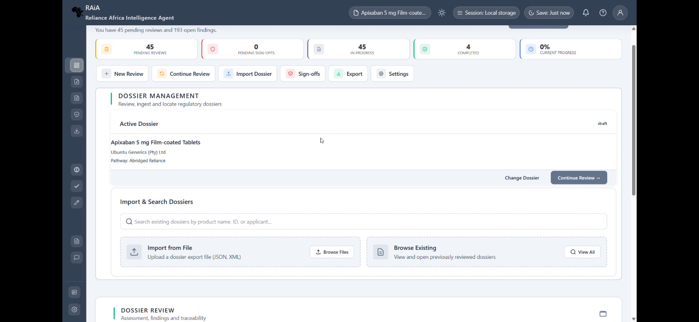

Supplementary Fig. S1. Dashboard: Dashboard view of the RAiA v2 prototype user interface, showing the entry point for monitoring dossier-review activity, review status and navigation to key workflow areas. The dashboard supports assessor orientation within the non-operational review-support environment.
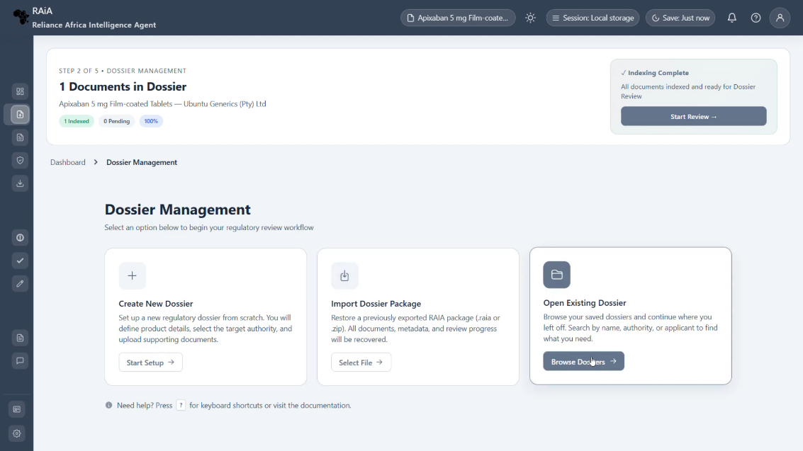
Supplementary Fig. S2. Dossier management: Dossier-management view showing how uploaded or registered dossier files are organised for review. The screen illustrates the prototype’s support for dossier tracking, document access and workflow continuity before detailed CTD-aligned analysis.
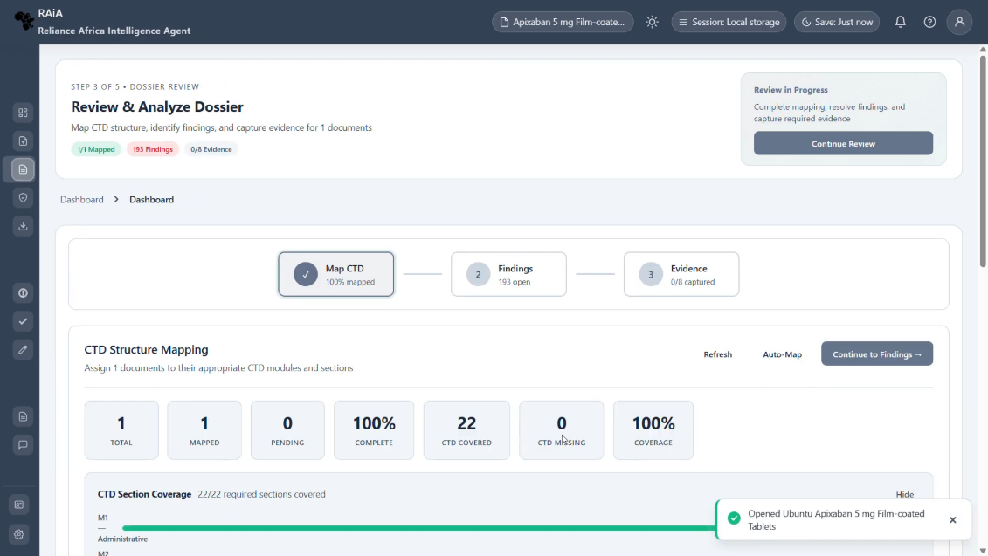
Supplementary Fig. S3. Dossier review: CTD mapping: CTD-mapping view showing how dossier content is organised against Common Technical Document sections for structured review. The screen demonstrates the interface logic for linking uploaded material to regulatory dossier sections, supporting navigation and assessor verification
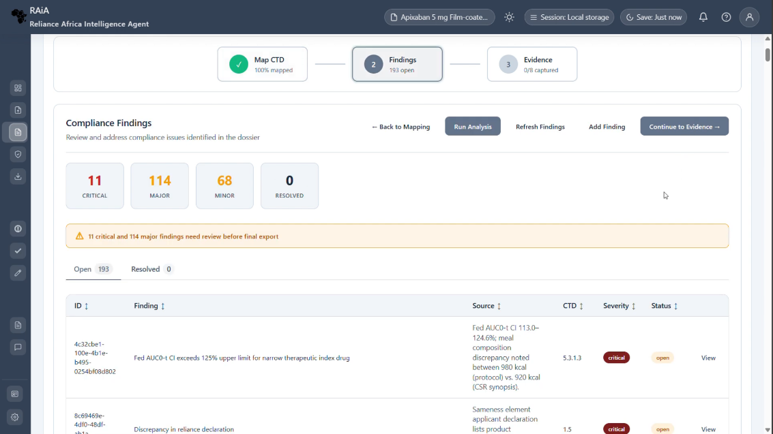
Supplementary Fig. S4. Dossier review: findings analysis: Findings-analysis view showing candidate review findings generated or organised within the prototype for assessor inspection. The screen illustrates how findings are presented for human review, including review status and actionability, without implying autonomous regulatory decision-making.
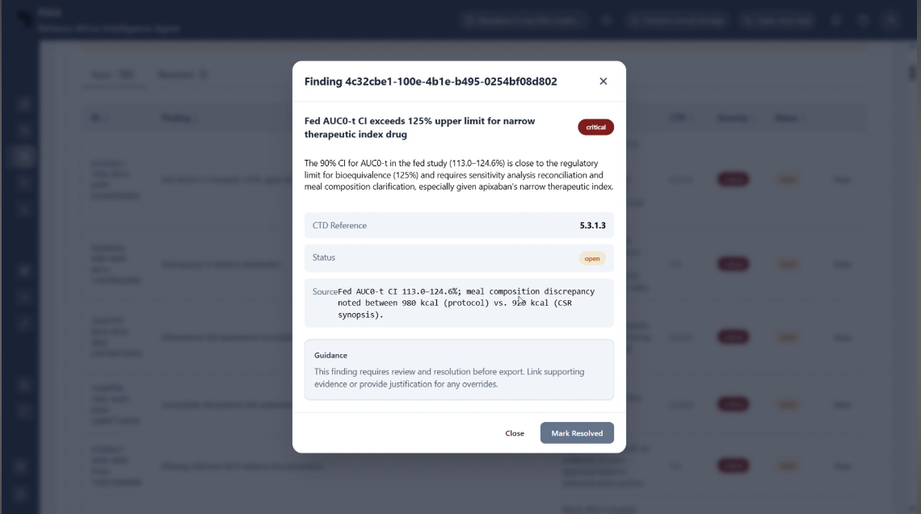
Supplementary Fig. S5. Dossier review: findings analysis, mark/resolve finding modal: Modal window for marking or resolving a candidate finding. The interface demonstrates how assessor actions can be captured at finding level, supporting acceptance, resolution, deferral or other status changes with traceable human input.
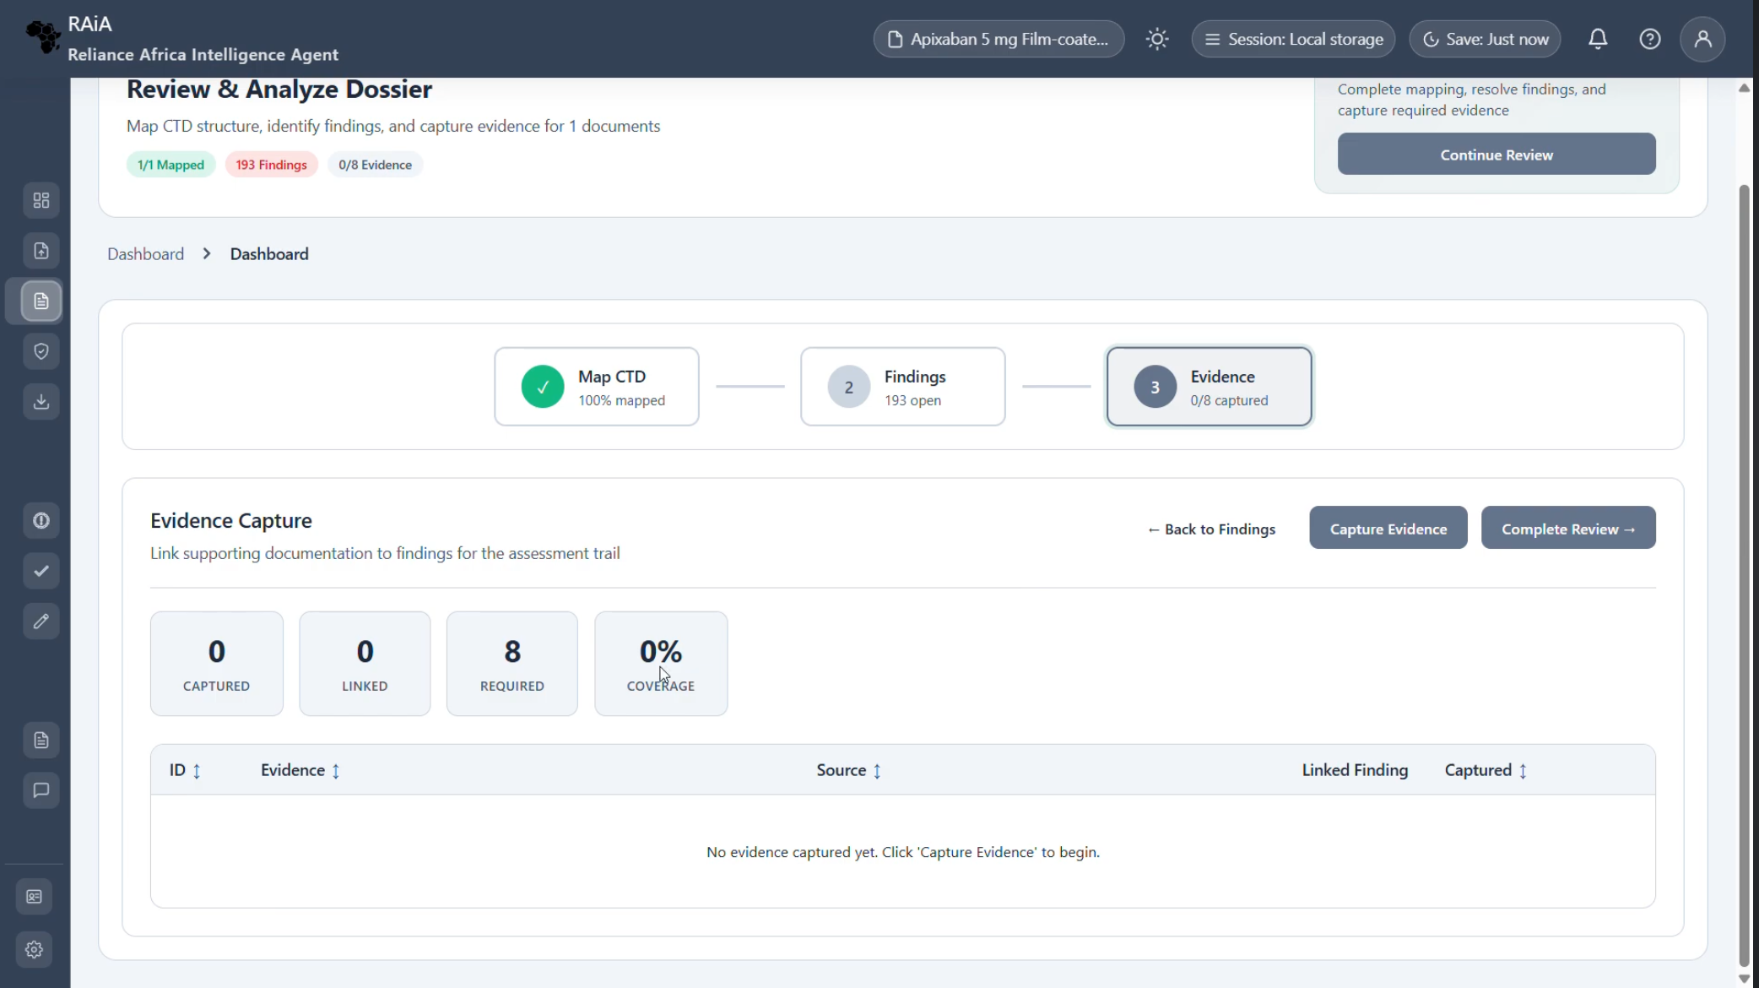
Supplementary Fig. S6. Dossier review: Evidence. Evidence view showing source-linked material associated with review findings. The screen illustrates the prototype’s evidence-trace function, allowing assessors to inspect supporting material rather than relying on unsupported AI-generated synthesis.
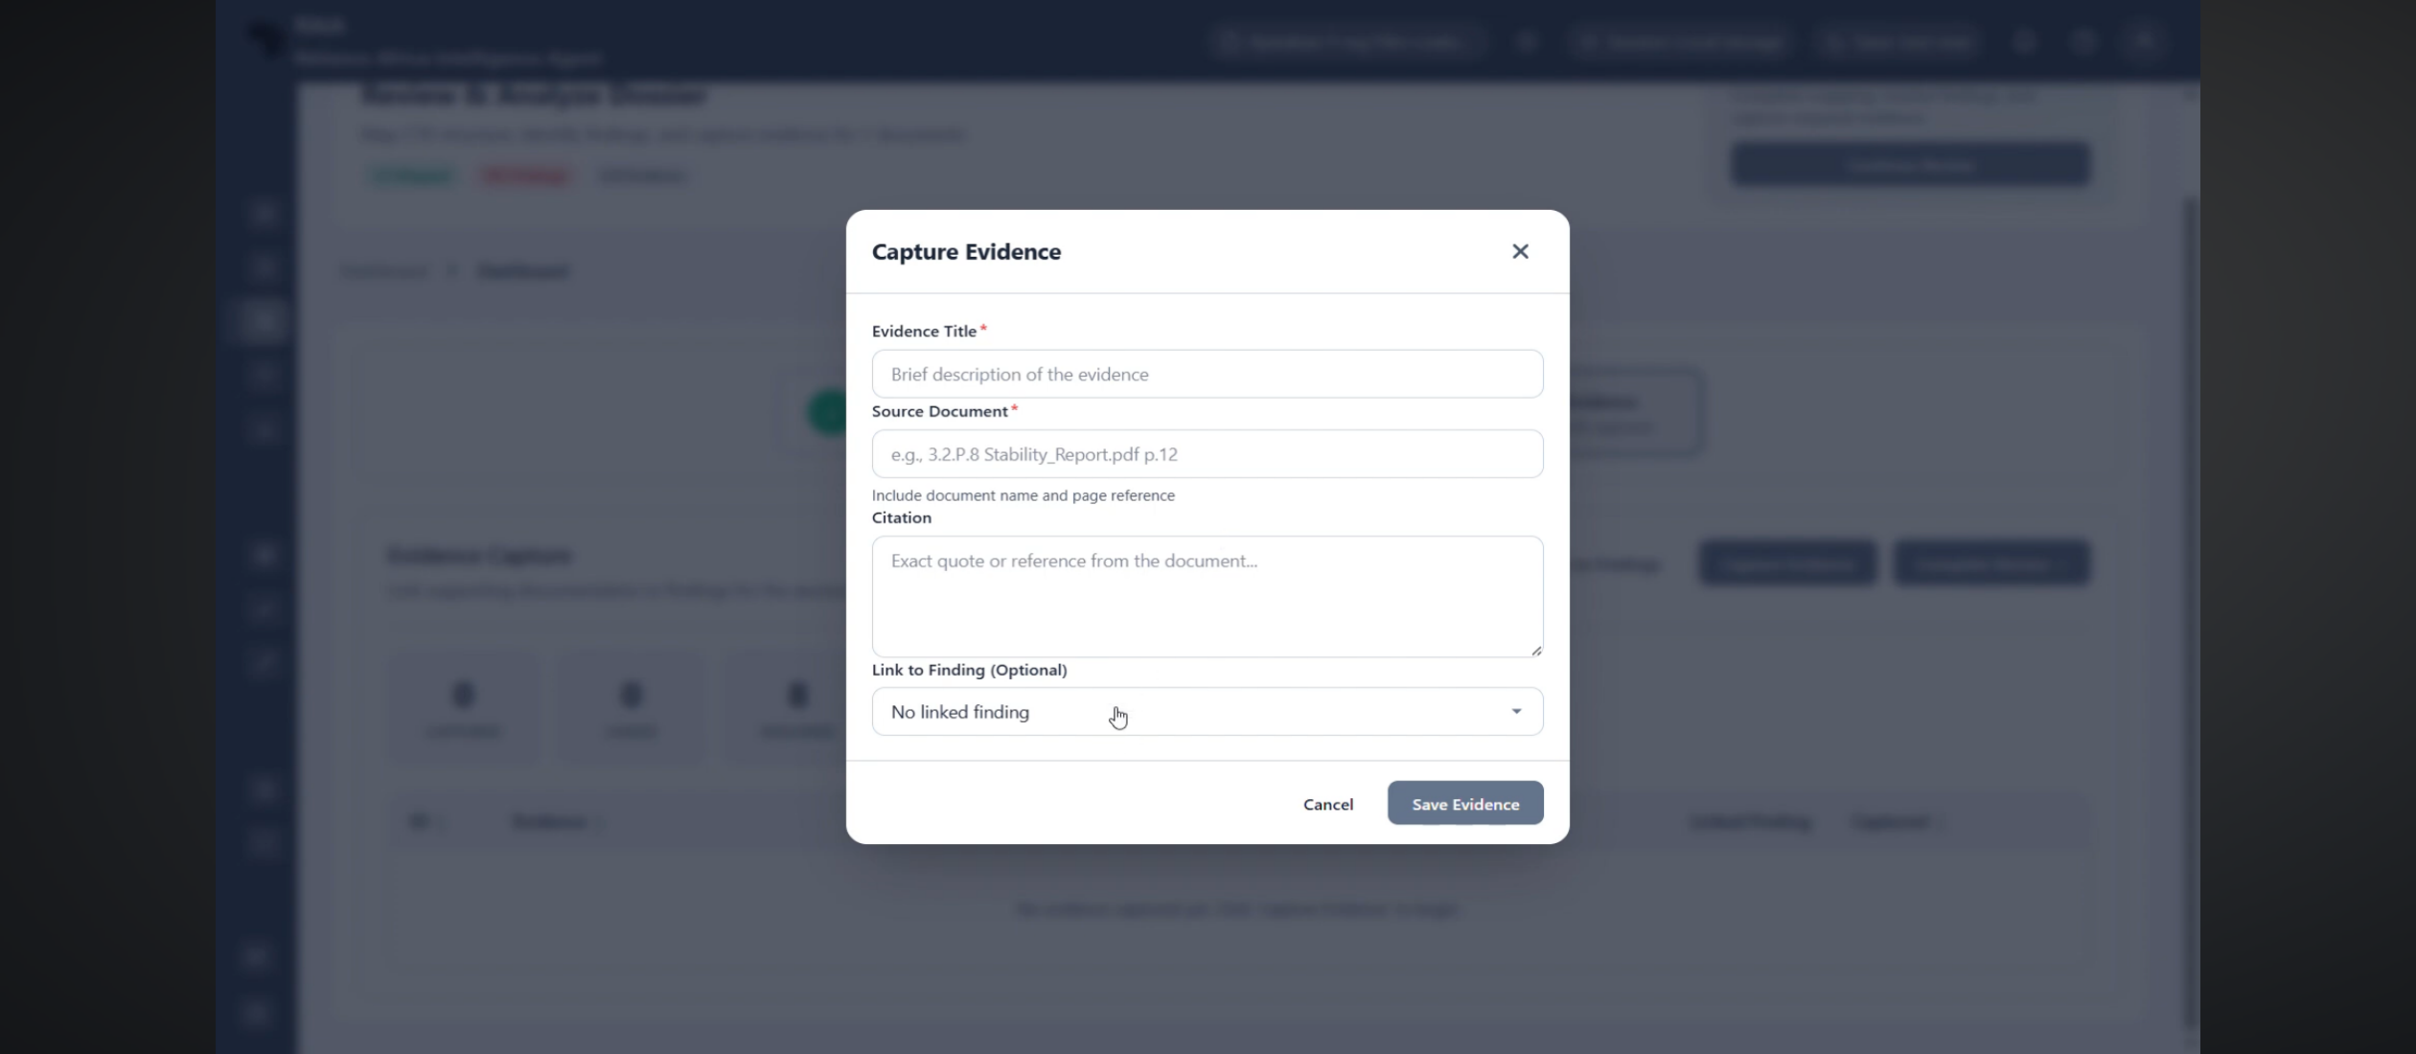
Supplementary Fig. S7. Dossier review: evidence capture modal: Evidence-capture modal showing the structured entry or confirmation of evidence linked to a finding. The modal demonstrates how the interface supports provenance capture, source linkage and assessor review of evidence objects
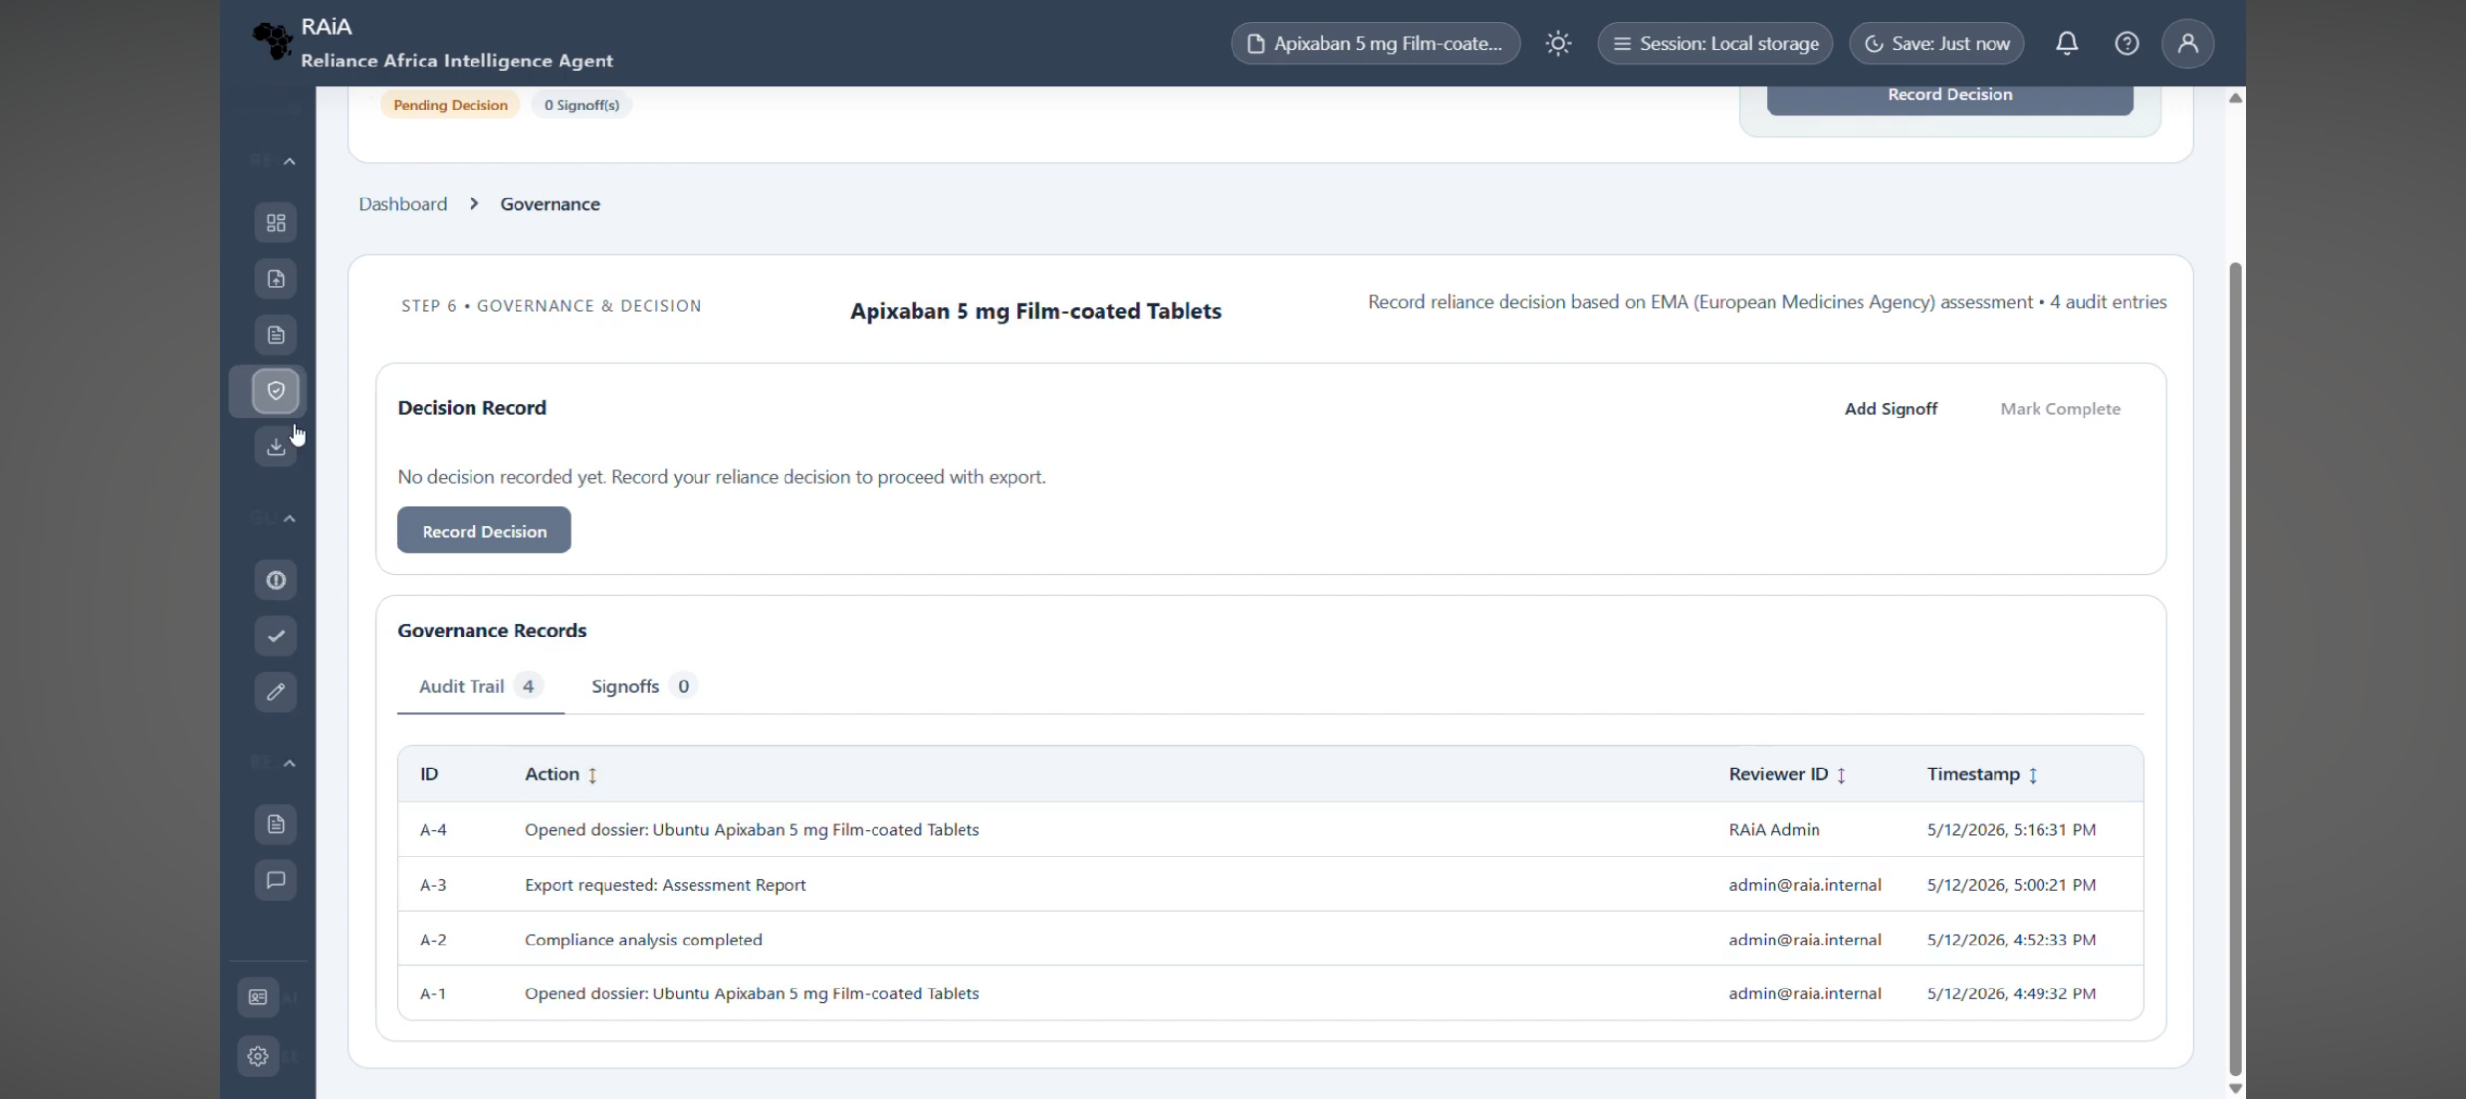
Supplementary Fig. S8. Governance: Governance view showing prototype controls relevant to accountable use, including review boundaries, oversight functions or governance-related configuration. The screen illustrates how the interface operationalises governance as part of the system workflow rather than as an external statement.
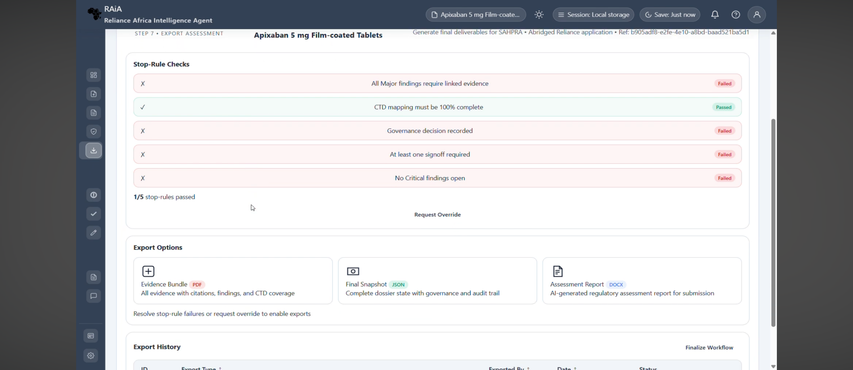
Supplementary Fig. S9. Export: Export view showing the interface for generating or preparing review-support outputs from validated findings and associated evidence. The screen demonstrates report-output functionality while preserving the boundary that exported materials are review-support artifacts and not autonomous regulatory decisions.
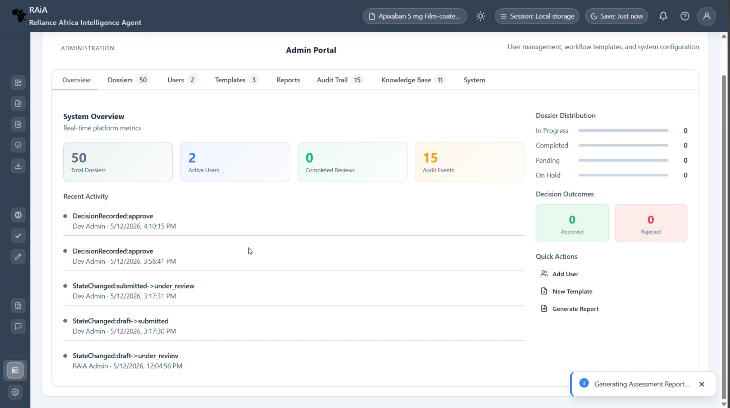
Supplementary Fig. S10. Admin portal: overview: Administrative overview showing system-level management functions for the RAiA prototype. The screen illustrates administrator-facing controls relevant to system configuration, user management or monitoring within the non-operational environment.
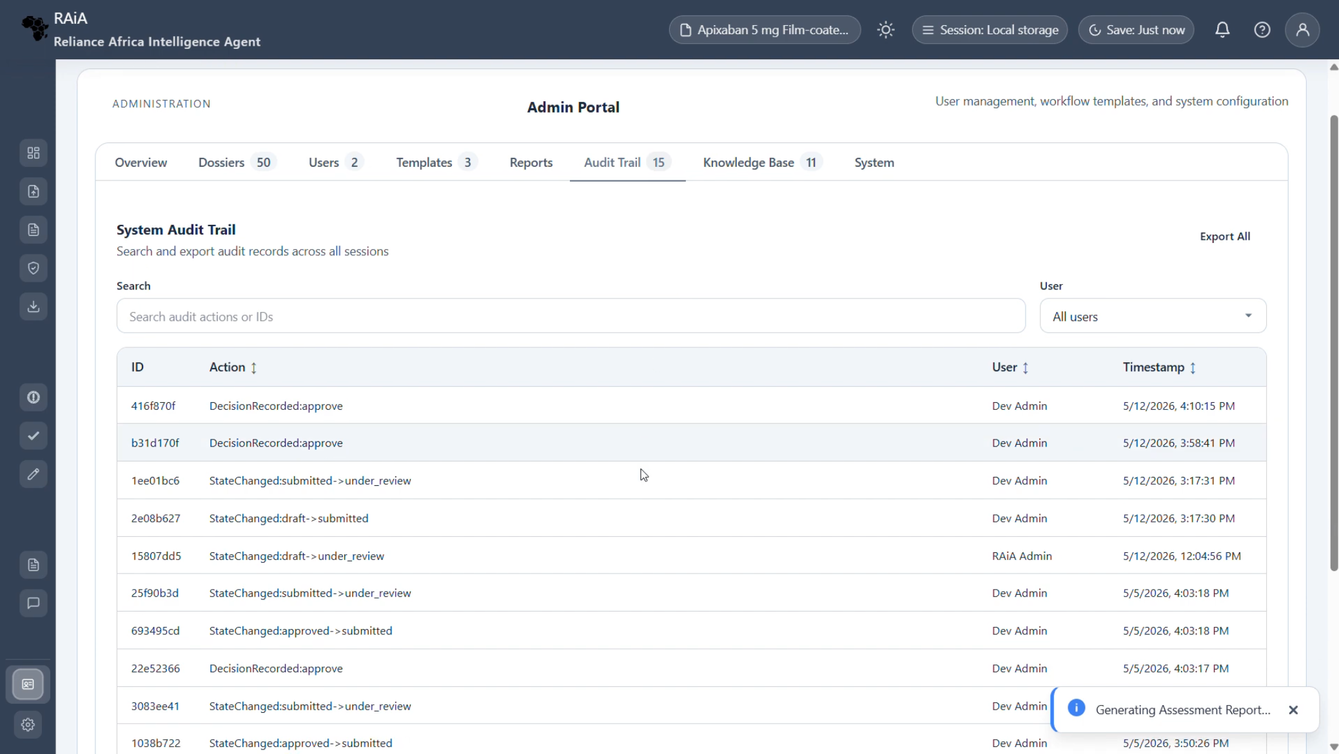
Supplementary Fig. S11. Admin portal: audit trail: Audit-trail view showing logged system or user actions within the prototype. The screen demonstrates the auditability logic required for traceable review support, including the capacity to record actions, changes or review events for later inspection.

Supplementary S12. RAiA Proof of Concept (PoC) v2 Demo Video YouTube Link: https://youtu.be/NzvO2gRWZPU

