Supplementary Material
Clinical Readiness of Machine-Learning Risk Models in Non-Variceal Upper Gastrointestinal Bleeding:
A Systematic Review and Network Meta-Analysis — Supplementary Materials

Table of Contents
Supplementary Table S1: Study Records (26 included studies)
Supplementary Table S2: Direct ML-versus-CCS AUROC contrasts contributing to the S2 network
Supplementary Table S3: Per-Comparison GRADE Certainty Assessment
Supplementary Figure S1: GRADE Certainty Domain Heatmap
Supplementary Table S4: PROBAST per Study (Domain-Level Risk-of-Bias)
Supplementary Table S5: TRIPOD+AI Completeness per ML Model
Supplementary Table S6: Clinical Readiness Score (CRS) Domain Definitions
Supplementary Table S7: Excluded Studies with Reasons
Supplementary Table S8: Companion-Pair Resolution Records
Supplementary Table S9: Sensitivity Analyses (12 pre-specified)
Supplementary Figure S2: Prediction Interval Plot for All-ML vs GBS Pool
Supplementary Figure S3: Doi Plot + LFK Index for All-ML vs GBS Pool
Supplementary Table S10: Node-Splitting Inconsistency Tests
Supplementary Figure S4: Node-Splitting Forest Plot (S2 closed loops)
Supplementary Table S11: Meta-Regression on Heterogeneity Sources
Supplementary Table S12: Comparator Balance Transparency (Per-Scenario)
Supplementary Table S13: PRISMA-NMA 2015 Checklist (33 items)

Supplementary Table S1. Included Study Records (26 studies meeting inclusion criteria for systematic review)
Per-study extraction records including AUGIB ID, citation, country, population, sample size, outcome events, tool class, ML algorithm, validation type, PROBAST overall, TRIPOD+AI completeness, era, and primary scenario(s).
Study | Country | Population / setting | N | Outcome events | Tool class | Outcome family | Validation | PROBAST | TRIPOD+AI | Scenario
Lu 2026 | USA | 30d mortality ICU | 10654 | 910 | Tree-ensemble (NVUPreM) | Mortality | External(eICU) | MODERATE | 68% | S2
Boros 2025 | Hungary | inhospital mortality | 1021 | 108 | Tree-ensemble (XGBoost+CatBoost) | Mortality | Internal 5-fold CV | MODERATE | 72% | S2
Rotondano 2011 | Italy | 30d mortality | 2380 | 165 | ANN (TWIST Semeion) | Mortality | Split 5x2 CV | HIGH | 38% | S2
Seo 2020 | Korea | 30d mortality + rebleed | 1439 | 17 | Voting+RF (LR+RF+GB Voting) | Mortality + rebleeding composite | Internal 5-fold CV | HIGH | 71% | S2
Zhao 2024 | USA | inhospital mortality ICU | 2716 | 485 | Tree-ensemble (GBDT) | ICU mortality | Internal 80:20 | HIGH | 64% | S4
Das 2008 | USA | mortality + rebleed | 387 | 65 | ANN (ANN) | Mortality | Split+External | HIGH | 42% | S2
Shung 2024 (2024) | USA | composite outcome | 4322 | N/A | ML EHR-based (GBM-EHR) | Composite high-risk outcome | External(3rd hosp) | LOW | 82% | S2
Nazarian 2024 | UK | hemostatic therapy | 970 | N/A | Tree-ensemble (Random Forest) | Major intervention-related (hemostatic therapy) | Internal CV | MODERATE | 72% | S2
Raghareutai 2025 | Thailand | endoscopic intervention | 1389 | 615 | Multi-ML (15 ML models) | Major intervention-related (endoscopic intervention) | Internal 80:20 | MODERATE | 70% | S2
In 2024 | Korea | mortality+rebleed+interv | 1241 | N/A | Conventional risk score | Mortality + rebleeding + intervention (CCS-only) | Internal retrospective | MODERATE | — | S2
Chen 2025 | China | 7d rebleeding | 965 | 88 | Tree-ensemble (XGBoost web) | Rebleeding | Internal bootstrap | MODERATE | 73% | S3
Chen 2025 | China | rebleeding | 279 | 45 | Nomogram-LASSO (LASSO+Nomogram) | Rebleeding | Internal 7:3 | MODERATE | 76% | S3
Zang 2025 | China | rebleeding | 254 | N/A | Deep (Transformer+KAN) | Rebleeding | Internal 5-fold CV | MODERATE | 74% | S3
Li 2026 | China | short-term rebleed | 204 | 25 | Tree-ensemble (CatBoost+SHAP) | Rebleeding (PUB) | Internal 7:3 | MODERATE | 74% | S3
Zhang 2025 | China | 1yr rebleed | 575 | N/A | Logistic+RF (LR+RF) | Long-term rebleeding | Internal 7:3 | MODERATE | 68% | S3
Deng 2025 | USA | major bleeding | 2604 | N/A | Deep (Residual-LSTM) | Major bleeding (ICU) | External(eICU) | MODERATE | 70% | S4
Huang 2025 | USA | inhospital mortality | 19834 | 231 | Multi-ML (LR+LASSO+XGB+RF) | Major intervention-related (endoscopic) | External(NIS+37) | MODERATE | 65% | S2
Li 2025 | China | transfusion | 1,386 total / 1,177 analytic | 475 | Multi-task deep (HGBVE) | Multi-outcome (mortality/rebleed/transfusion) | External(Fenyang n=209) | MODERATE | 89% | S5
Lin 2026 | China | massive transfusion | 700 | N/A | Tree-ensemble (Explainable ML) | Massive transfusion | Internal | MODERATE | 74% | S5
Thiebaud 2025 | France | composite intervention | 990 | 755 | Conventional risk score | Mortality + transfusion (CCS-only) | Internal retrospective | LOW | — | S1
Alomari 2026 | USA | 30d mortality | 12,619 total / 7,166 analytic | N/A | Cluster-ML (RF cluster ensemble) | Mortality | External(Jefferson) | MODERATE | 76% | S2
Yildirim 2026 | Turkey | inhospital mortality | 178 | 36 | Conventional risk score | Mortality (CCS-only ED) | Prospective ED | MODERATE | — | S2
Isik 2025 | Turkey | intervention+mortality | 795 | N/A | Conventional risk score | Mortality + rebleeding (CCS-only) | Internal retrospective | MODERATE | — | S2
Aydin 2025 | Turkey | inhospital mortality | 315 | 25 | Conventional risk score | Mortality (geriatric, CCS-only) | Internal retrospective | MODERATE | — | S2
Tan 2018 | HongKong | PUB mortality | N/A | N/A | Deep (ResNet+LSTM) | Mortality (PUB) | Split | HIGH | 58% | S2
Park 2018 | Korea | mortality+rebleed+interv | 1796 | N/A | Multi-ML (RF+XGB+LR) | Composite high-risk outcome | Internal 5-fold CV | HIGH | 58% | S2
Abbreviations: NV-UGIB, non-variceal upper gastrointestinal bleeding; AUGIB, acute upper gastrointestinal bleeding; PUB, peptic ulcer bleeding; ICU, intensive care unit; ML, machine learning; CCS, conventional clinical risk score; GBS, Glasgow-Blatchford Score; ANN, artificial neural network. PROBAST overall risk-of-bias: LOW (blue), MODERATE (orange), HIGH (red). TRIPOD+AI completeness reported only for studies that developed or validated an ML model; CCS-only studies marked as "—". Scenarios: S1 ED triage, S2 high-risk adverse outcome (mortality, composite high-risk outcome, or major intervention-related outcome), S3 rebleeding, S4 ICU mortality, S5 transfusion. Companion-pair records (Park 2018 companion, Das 2000, Das 2001) are not counted as independent included studies and are tabulated separately in Supplementary Table S8.

Supplementary Table S2. Direct ML-versus-CCS AUROC contrasts contributing to the S2 network
ΔAUROC is reported as the discrimination advantage of A over B (positive values favor A). Direct contrasts use inverse-variance pooling across studies within each comparison. Bucher indirect estimates are not listed as rows in this table and are shown separately in Figure 4 where applicable. k indicates the number of contributing studies for direct contrasts.
Comparison (A vs B) | ΔAUROC | 95% CI | Evidence type | k (direct)
ANN vs AIMS65 | +0.270 | [+0.233, +0.307] | direct | 1
ANN vs Rockall | +0.170 | [+0.107, +0.233] | direct | 1
Cluster-ML vs AIMS65 | +0.162 | [+0.149, +0.175] | direct | 1
Cluster-ML vs GBS | +0.142 | [+0.129, +0.155] | direct | 1
ML EHR-based vs GBS | +0.030 | [+0.013, +0.047] | direct | 1
Multi-ML vs GBS | +0.130 | [+0.108, +0.152] | direct | 1
Tree-ensemble vs ABC | +0.070 | [+0.024, +0.116] | direct | 1
Tree-ensemble vs AIMS65 | +0.183 | [+0.167, +0.199] | direct | 1
Tree-ensemble vs GBS | +0.269 | [+0.254, +0.283] | direct | 3
Tree-ensemble vs Rockall | +0.241 | [+0.225, +0.256] | direct | 2
Voting+RF vs GBS | +0.194 | [+0.082, +0.306] | direct | 1
Voting+RF vs Rockall | +0.215 | [+0.102, +0.328] | direct | 1

Supplementary Table S3. Per-Comparison GRADE Certainty Assessment
Adapted CINeMA + GRADE-NMA + GRADE-DTA framework. Adapted for AUROC-difference contrasts; not formally validated. Downgrade columns: 0 = no downgrade; 1 = serious; 2 = very serious. Imprecision uses an extended 0–3 scale where 3 = extremely serious (95% CI crosses both zero and the pre-specified MCID anchor, ΔAUROC ±0.10). Total_DG = sum of downgrades; Certainty = final certainty rating from starting High.
Comparison | Scenario | ΔAUROC (95% CI) | I² | k | Downgrade summary  (Bias / Rep / Ind / Imp / Het) | Certainty | Rationale
Tree-ensemble vs GBS | S2 | +0.185 [-0.083, +0.453] | 98% | 3 | 1/1/1/3/2 | Very Low | Mixed outcomes (mortality + hemostatic therapy via Nazarian); high heterogeneity; CI crosses zero and MCID
Tree-ensemble vs AIMS65 | S2 | +0.183 [+0.167, +0.199] | 0% | 1 | 1/1/0/0/0 | Low | Single direct contrast (Lu); no observed heterogeneity; consistent direction
Tree-ensemble vs Rockall | S2 | +0.241 [+0.153, +0.329] | 0% | 2 | 1/1/0/0/0 | Low | Two direct contrasts (Lu, Boros); no observed heterogeneity; consistent direction
Tree-ensemble vs ABC | S2 | +0.070 [+0.024, +0.116] | 0% | 1 | 1/1/0/2/0 | Very Low | Single direct Tree-ensemble vs ABC contrast; ABC was used as a contextual node in the expanded ranking set; CI near MCID threshold
ANN vs AIMS65 | S2 | +0.270 [+0.233, +0.307] | 0% | 1 | 1/1/0/0/0 | Low | Single direct contrast (Rotondano historical ANN anchor); CI entirely above MCID 0.10 anchor; consistent direction
ANN vs Rockall | S2 | +0.170 [+0.107, +0.233] | 0% | 1 | 1/1/0/0/0 | Low | Single direct contrast (Das 2008 historical ANN anchor); CI entirely above MCID 0.10 anchor
Voting+RF vs GBS | S2 | +0.194 [+0.082, +0.306] | 0% | 1 | 1/1/0/1/0 | Very Low | Single study (Seo); CI extends below MCID 0.10 anchor (lower bound +0.082); serious imprecision
Voting+RF vs Rockall | S2 | +0.215 [+0.102, +0.328] | 0% | 1 | 1/1/0/0/0 | Low | Single direct contrast (Seo); CI entirely above MCID anchor
ML EHR-based vs GBS | S2 | +0.030 [+0.013, +0.047] | 0% | 1 | 1/1/1/2/0 | Very Low | Single external validation study (Shung); composite outcome indirectness; small ΔAUROC below MCID
Multi-ML vs GBS | S2 | +0.130 [+0.108, +0.152] | 0% | 1 | 1/1/1/0/0 | Low | Single study (Raghareutai); endoscopic intervention outcome indirectness; CI narrowly above MCID 0.10 anchor (lower bound +0.108), but endpoint indirectness limits interpretation
Cluster-ML vs GBS | S2 | +0.142 [+0.129, +0.155] | 0% | 1 | 1/1/0/0/0 | Low | Single direct contrast (Alomari); CI entirely above MCID anchor
Cluster-ML vs AIMS65 | S2 | +0.162 [+0.149, +0.175] | 0% | 1 | 1/1/0/0/0 | Low | Single direct contrast (Alomari); CI entirely above MCID anchor
Downgrade summary column reports the per-domain downgrade level for: Bias (within-study risk of bias, PROBAST), Reporting (TRIPOD+AI completeness and selective-reporting concerns), Indirectness, Imprecision, and Heterogeneity. Each domain uses a 0–2 scale (0 = no downgrade; 1 = serious; 2 = very serious); Imprecision uses an extended 0–3 scale where 3 = extremely serious (95% CI crosses both zero and the pre-specified MCID anchor of ΔAUROC ±0.10).

Supplementary Figure S1. GRADE Certainty Domain Heatmap
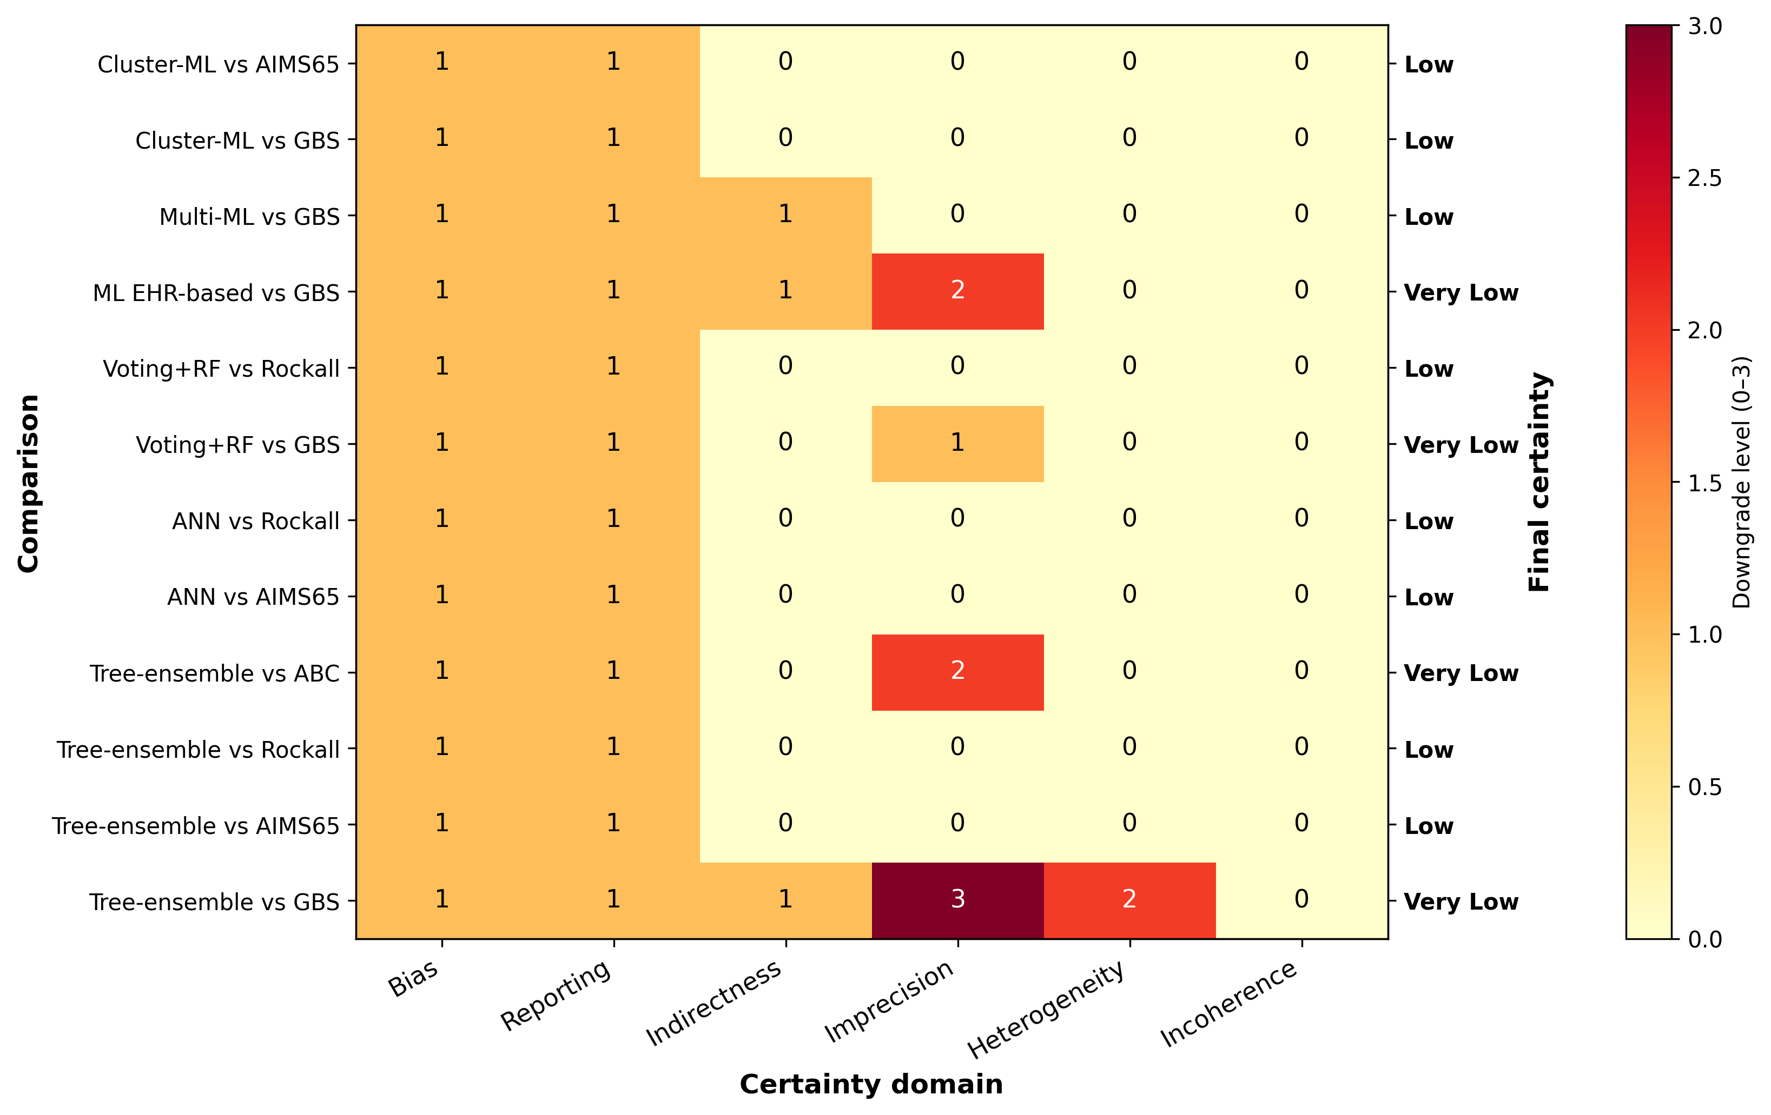
Heatmap of GRADE certainty for the twelve S2 ML-versus-CCS contrasts. Rows are comparisons; columns are domains (bias, reporting, indirectness, imprecision, heterogeneity, incoherence); cell color shows the downgrade level.

Supplementary Table S4. PROBAST per Study (Domain-Level Risk-of-Bias)
Per-study PROBAST domain ratings (Participants, Predictors, Outcome, Analysis) and overall risk-of-bias rating.
Study | Participants | Predictors | Outcome | Analysis | Overall | Key issues
Alomari 2026 | MODERATE | MODERATE | MODERATE | MODERATE | MODERATE | Mixed GIB indirectness
Aydin 2025 | LOW | MODERATE | LOW | MODERATE | MODERATE | CCS-only study
Boros 2025 | MODERATE | MODERATE | LOW | MODERATE | MODERATE | UGIB subgroup analysis indirectness
Chen 2025 | LOW | MODERATE | LOW | MODERATE | MODERATE | PUB-only population; no head-to-head ML vs CCS
Chen 2025 | MODERATE | LOW | LOW | LOW | MODERATE | Web deployment positive; internal validation only
Das 2008 | HIGH | HIGH | LOW | HIGH | HIGH | Pre-2015; SRH surrogate endpoint
Deng 2025 | LOW | MODERATE | LOW | MODERATE | MODERATE | Reports external validation cohort
Huang 2025 | LOW | MODERATE | LOW | MODERATE | MODERATE | Reports external validation cohort
In 2024 | LOW | MODERATE | LOW | MODERATE | MODERATE | CCS-only study
Isik 2025 | LOW | MODERATE | LOW | MODERATE | MODERATE | CCS-only study
Li 2025 | LOW | LOW | LOW | MODERATE | MODERATE | External validation positive; large effect
Li 2026 | LOW | MODERATE | LOW | MODERATE | MODERATE | PUB-only post-endoscopy; interpretable ML
Lin 2026 | LOW | MODERATE | LOW | MODERATE | MODERATE | Internal validation only; massive transfusion endpoint
Lu 2026 | MODERATE | MODERATE | LOW | LOW | MODERATE | —
Nazarian 2024 | LOW | MODERATE | LOW | MODERATE | MODERATE | Internal validation only; intervention outcome indirectness
Park 2018 | LOW | MODERATE | LOW | HIGH | HIGH | Retrospective development; calibration not reported
Raghareutai 2025 | LOW | MODERATE | LOW | MODERATE | MODERATE | Internal split; mixed UGIB population
Rotondano 2011 | HIGH | HIGH | LOW | HIGH | HIGH | Pre-2015 retrospective; small EPV
Seo 2020 | LOW | MODERATE | LOW | HIGH | HIGH | Mortality EPV < 1 — D+36 consensus split-handling
Shung 2024 | LOW | LOW | LOW | LOW | LOW | Reports external validation cohort
Tan 2018 | LOW | MODERATE | LOW | HIGH | HIGH | See manuscript Methods for assessment rationale
Thiebaud 2025 | LOW | LOW | LOW | LOW | LOW | Multi-center French; CCS gold standard
Yildirim 2026 | LOW | MODERATE | LOW | MODERATE | MODERATE | CCS-only study
Zang 2025 | LOW | MODERATE | LOW | MODERATE | MODERATE | Internal validation only; limited calibration reporting
Zhang 2025 | LOW | MODERATE | LOW | MODERATE | MODERATE | Long-term rebleeding endpoint; serology-based subset
Zhao 2024 | HIGH | MODERATE | LOW | MODERATE | HIGH | ICU subset; events estimated
PROBAST domain-level risk-of-bias ratings: LOW, MODERATE, HIGH, or UNCLEAR. PROBAST domains: Participants (data sources, inclusion criteria), Predictors (definition and assessment), Outcome (definition and timing), Analysis (sample size, missing data, performance, overfitting controls). We applied a pragmatic three-level adaptation (LOW/MODERATE/HIGH) in which the overall rating reflected the highest domain-level concern.

Supplementary Table S5. TRIPOD+AI Completeness per ML Model Report
TRIPOD+AI completeness as % of applicable items reported, with key strengths and gaps.
Study | TRIPOD+AI completeness | Reporting strengths | Reporting gaps
Li 2025 | 89% | External validation; SHAP; deployment workflow; calibration plot | Sample size justification absent
Alomari 2026 | 76% | External validation (Jefferson); Clustering rationale; sensitivity | Calibration sparse
Li 2026 | 74% | SHAP; PROBAST self-report | External validation incomplete
Chen 2025 | 73% | Web deployment; calibration | External validation absent
Zang 2025 | 74% | Architecture description detailed | Calibration sparse
Boros 2025 | 72% | Subgroup analysis; sensitivity | TRIPOD+AI AI-specific items partial
Seo 2020 | 71% | Internal cross-validation; multi-outcome | Imbalance handling unclear
Chen 2025 | 76% | Nomogram interpretability | External absent
Lu 2026 | 68% | External validation using eICU; large MIMIC/eICU cohort | —
Zhao 2024 | 64% | ICU subset | Calibration absent; HIGH PROBAST
Deng 2025 | 70% | LSTM architecture | No CCS comparator
Huang 2025 | 65% | Renal subgroup specific | TRIPOD+AI AI items partial
Tan 2018 | 58% | Pre-2020 reporting | AI training detail sparse
Rotondano 2011 | 38% | Historical anchor | Pre-TRIPOD+AI era; sparse reporting
Das 2008 | 42% | Pre-TRIPOD+AI era | Sparse reporting
Shung 2024 | 82% | External validation cohort; full model documentation; calibration plot | Sample size justification for subgroup
Nazarian 2024 | 72% | Random Forest with feature importance | External validation absent; small sample
Raghareutai 2025 | 70% | 15-ML model comparison with CV | Calibration plots sparse; no external validation
Park 2018 | 58% | Multi-ML ensemble; ensemble rationale | No external validation; calibration absent
Lin 2026 | 74% | Explainable ML + SHAP; calibration | Internal validation only; small sample
TRIPOD+AI completeness reported as the percentage of applicable items reported per study (denominator varies by model type and reporting scope). Strengths and Gaps columns indicate items reported well or incompletely.

Supplementary Table S6. CRS Domain Definitions
Clinical Readiness Score (CRS) — exploratory 7-domain composite developed for this review. Each domain scored 0–10 with equal weighting; not externally validated as a measurement instrument.
Domain | Definition | Scoring guidance (0–10) | Weighting
1. Discrimination | AUROC magnitude relative to the CRS readiness anchor (ΔAUROC 0.05). This CRS scoring anchor was used only for readiness scoring and was separate from the GRADE imprecision rules. | 10 = ΔAUROC > 0.20; 8 = 0.10–0.20; 6 = 0.05–0.10; 4 = 0–0.05; 0 = ≤ 0 | Equal
2. Calibration | Calibration plot + slope + intercept reporting quality | 10 = all reported + visual plot + slope ≈ 1; 5 = partial; 0 = none | Equal
3. Validation rigor | Internal split vs bootstrap vs temporal vs external | 10 = prospective external validation; 8 = retrospective external or temporal validation; 6 = internal bootstrap/cross-validation; 4 = simple split; 0 = none | Equal
4. Data accessibility | Whether input variables are routinely available at presentation | 10 = all routinely available; 5 = some require additional acquisition; 0 = research-only variables | Equal
5. Computational requirements | Bedside computability vs server requirement | 10 = bedside calculator possible; 6 = web service; 3 = local server; 0 = HPC required | Equal
6. Interpretability | Decision rule transparency / SHAP / model interpretability | 10 = transparent decision rule; 7 = SHAP/interpretable; 4 = post-hoc; 0 = black-box | Equal
7. TRIPOD+AI completeness | % of TRIPOD+AI items reported | Direct % score (e.g., 89% → 8.9 points) | Equal
CRS limitation statement | Exploratory composite, not externally validated as measurement instrument | Equal weighting used for transparency and reproducibility | —
Clinical Readiness Score (CRS) — exploratory composite score developed for this review. Each domain scored 0–10 against the criteria shown; equal weighting used in the main analysis. CRS has not been externally validated as a measurement instrument.

Supplementary Table S7. Excluded Studies with Reasons
Studies excluded at full-text or post-eligibility check, with category and detail. Eight conference-proceedings records could not be retrieved as full reports (PRISMA 2020) and are listed as Reports not retrieved. Two (Yang 2024 APDW, Kozma 2025 UEG Week) are documented individually; the remaining six lacked retrievable full text and are listed collectively. CCS-only studies (e.g., Işık 2025, Yildirim 2026, In 2024, Thiebaud 2025) appear in Supplementary Table S1 rather than here, as they are included (narrative) rather than excluded records.
Study (AUGIB ID) | Exclusion category | Detail / reason
Wei 2024 | Wrong outcome (AKI primary) | AKI primary outcome; UGIB secondary
Liu 2025 | Wrong outcome (AKI primary) | AKI in UGIB cohort
Kozma 2025 | Abstract only (UEG) | No full text; insufficient detail
ClinicalTrials.gov A | CT.gov no-results | Trial registered, no results posted
ClinicalTrials.gov B | CT.gov no-results | Trial registered, no results posted
Bai 2025 | Variceal-dominant cirrhotic population | Cirrhotic AGIB n=2,467; variceal bleeding 60.48%; ulcer 2.96%; NV-UGIB outcome subgroup not separately reported; CCS comparators (CAGIB/Child-Pugh/MELD/D'Amico/Augustin) cirrhosis-specific and not aligned with eligible NV-UGIB CCS set (GBS/AIMS65/Rockall/PNED/ABC). Authors explicitly note non-comparison with GBS/AIMS65/Rockall as a limitation. Retained as 'related-work' citation in Discussion; not included in meta-analytic synthesis.
Yang 2024 (APDW abstract) | China (Tianjin) | Conference abstract — Asian Pacific Digestive Week 2024

Supplementary Table S8. Companion-Pair Resolution Records
Per-pair resolution rules for companion studies (multiple records from the same cohort).
Pair ID | Studies | Issue | Resolution rule
Pair 1 | Rotondano 2011 + Marmo 2009 | Marmo 2009 PNED development; Rotondano 2011 ANN/TWIST validation in same PNED Italian cohort | Include Rotondano 2011 as primary; Marmo 2009 cited as PNED definition source only
Pair 2 | Zhang 2023a + Zhang 2023b (duplicate) | Same cohort, two journals | Include earliest publication only; exclude duplicate
Pair 3 | Seo 2020 + Park 2018 | Same Korean cohort | Use Seo 2020 as primary; Park 2018 cited as cohort description
Pair 4 | Das 2000 + Das 2001 + Das 2008 | Same author group, overlapping cohort, sequential reporting | Use Das 2008 as primary (most complete); Das 2000/2001 cited
Companion records are multiple publications from the same underlying study cohort or model. The resolution rule indicates which publication was retained as the primary record and which were retained as companion documentation. Companion records do not contribute as independent studies to the main NMA pool.

Supplementary Table S9. Sensitivity Analyses (12 pre-specified)
Pre-specified sensitivity analyses for the S2 high-risk adverse outcome primary network. The contemporary-evidence sensitivity row reflects Shung, Nazarian, and Raghareutai; Shung composite outcome, Nazarian hemostatic therapy, Raghareutai endoscopic intervention.
Sensitivity analysis | k | ΔAUROC | 95% CI | I² | Contributing studies
Primary all-ML vs GBS | 7 | +0.148 | [+0.069, +0.228] | 99% | Lu 2026; Boros 2025; Seo 2020; Shung 2024; Nazarian 2024; Raghareutai 2025; Alomari 2026
Tree-ensemble class vs GBS | 3 | +0.185 | [-0.083, +0.453] | 98% | Lu 2026; Boros 2025; Nazarian 2024
ANN class vs all CCS | 2 | +0.223 | [-0.411, +0.857] | 86% | Rotondano 2011; Das 2008
Voting+RF vs GBS | 1 | +0.194 | [+0.082, +0.306] | 0% | Seo 2020
Externally validated ML vs GBS | 3 | +0.158 | [-0.180, +0.496] | 100% | Lu 2026; Shung 2024; Alomari 2026
Ext Tree-ensemble vs GBS | 1 | +0.301 | [+0.285, +0.317] | 0% | Lu 2026
Ext multi-ML pool vs GBS | 2 | +0.086 | [-0.626, +0.798] | 99% | Shung 2024; Alomari 2026
Strict NV-UGIB vs GBS | 2 | +0.262 | [-0.391, +0.916] | 71% | Lu 2026; Seo 2020
Ext + strict NV-UGIB vs GBS | 1 | +0.301 | [+0.285, +0.317] | 0% | Lu 2026
Network-structure sensitivity: historical ANN anchor exclusion (Rotondano did not contribute to all-ML vs GBS direct pool; effect unchanged by definition) | 7 | +0.148 | [+0.069, +0.228] | 99% | Lu 2026; Boros 2025; Seo 2020; Shung 2024; Nazarian 2024; Raghareutai 2025; Alomari 2026
Peer-reviewed-only ML vs GBS (identical to primary; no preprint/unpublished study contributed to S2) | 7 | +0.148 | [+0.069, +0.228] | 99% | Lu 2026; Boros 2025; Seo 2020; Shung 2024; Nazarian 2024; Raghareutai 2025; Alomari 2026
Contemporary ML-vs-CCS sensitivity (Shung/Nazarian/Raghareutai mixed outcomes) | 3 | +0.083 | [-0.045, +0.210] | 96% | Shung 2024; Nazarian 2024; Raghareutai 2025
Exploratory mortality-only outcome subgroup vs GBS (all-ML direct pool) | 3 | +0.202 | [-0.016, +0.419] | 99% | Lu 2026, Boros 2025, Alomari 2026
Exploratory composite/intervention-related outcome subgroup vs GBS (all-ML direct pool) | 4 | +0.101 | [-0.002, +0.205] | 94% | Seo 2020, Shung 2024, Nazarian 2024, Raghareutai 2025
Pre-specified sensitivity analyses for the S2 high-risk adverse outcome primary network. (a) Primary all-ML versus GBS pool is the headline contrast. (e) Externally validated ML versus GBS is the key sensitivity. (m) is a post-hoc contemporary mixed-outcome sensitivity restricted to Shung 2024, Nazarian 2024, and Raghareutai 2025, which evaluated composite or intervention-related outcomes.

Supplementary Figure S2. Prediction interval for the all-ML versus GBS direct pool (k=7).

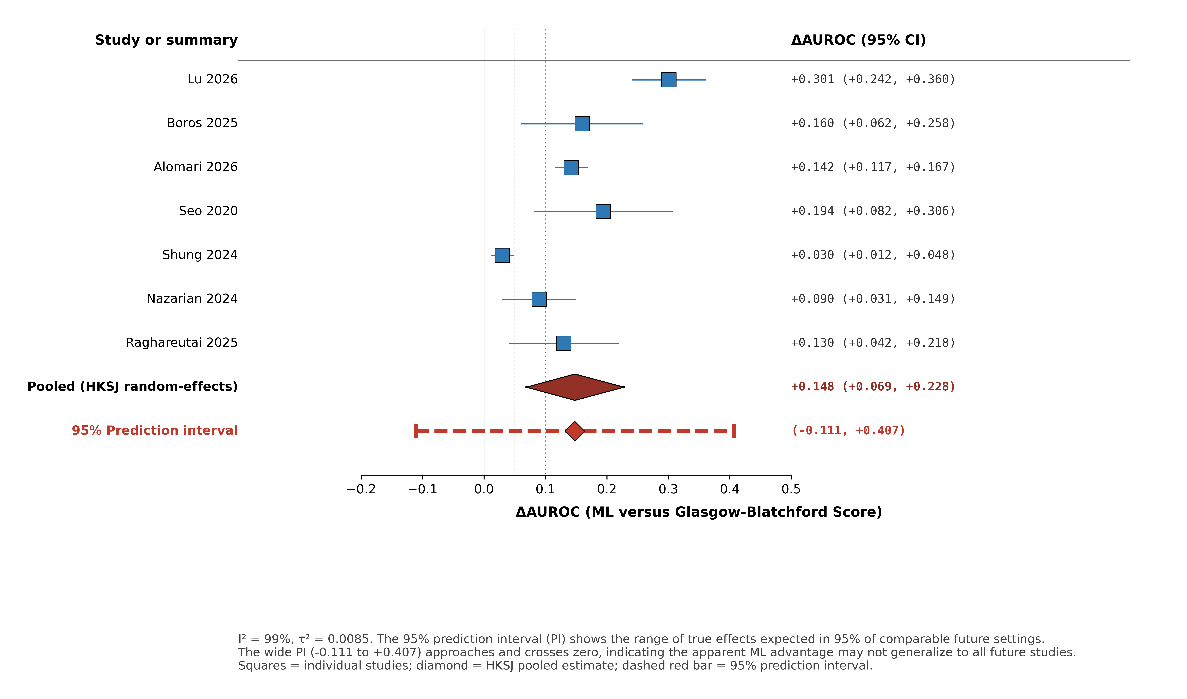

Individual studies (blue squares) with 95% CIs, HKSJ pooled estimate (red diamond, 95% CI), and 95% prediction interval (dashed red bar). The wide PI (−0.111 to +0.407) approaches and crosses zero, indicating that with I²=99% heterogeneity, the apparent ML discrimination advantage may not generalize to all future studies.

Supplementary Figure S3. Doi plot with LFK index for the all-ML versus GBS direct pool (k=7).

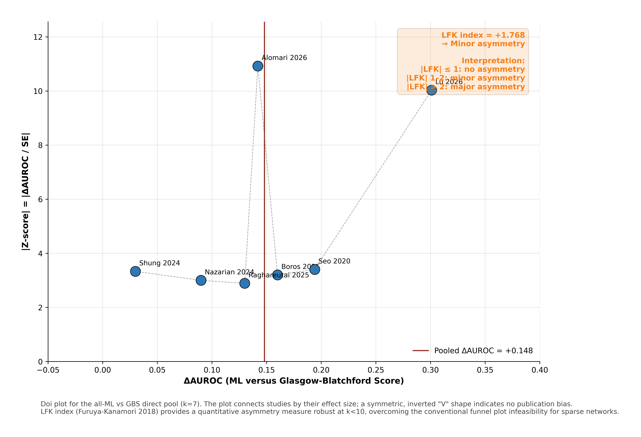

Doi plot (Furuya-Kanamori 2018) showing each study by ΔAUROC (x-axis) and |Z-score| (y-axis). The LFK index of +1.768 indicates minor asymmetry (|LFK| 1–2), suggesting some publication-bias or small-study-effect risk in the sparse all-ML vs GBS pool. The LFK index provides a quantitative asymmetry measure robust at k<10, addressing the conventional funnel-plot infeasibility for sparse networks.

Supplementary Table S10. Node-Splitting Inconsistency Tests
Direct vs indirect comparison consistency tests at each edge of the S2 network. p > 0.10 = consistent; p ≤ 0.10 flagged.
Scenario | Edge (A vs B) | Direct ΔAUROC | Indirect ΔAUROC | Difference | z | p (inconsistency) | Flag
S2 | GBS vs Tree-ensemble | -0.128 | -0.133 | +0.0048 | +0.113 | +0.910 | Consistent
S2 | AIMS65 vs Tree-ensemble | -0.102 | -0.097 | -0.0048 | -0.113 | +0.910 | Consistent
S2 | ANN vs Complete Rockall | +0.090 | +0.090 | 0.000 | 0.000 | +1.000 | Consistent
S2 | ANN vs GBS | +0.120 | +0.126 | -0.0064 | -0.174 | +0.862 | Consistent
S2 | AIMS65 vs ANN | -0.100 | -0.094 | -0.0063 | -0.173 | +0.863 | Consistent
S2 | AIMS65 vs GBS | +0.031 | +0.022 | +0.0088 | +0.301 | +0.764 | Consistent
S2 | Complete Rockall vs GBS | +0.030 | +0.036 | -0.0061 | -0.161 | +0.872 | Consistent
S2 | AIMS65 vs Complete Rockall | -0.010 | -0.004 | -0.0060 | -0.160 | +0.873 | Consistent
Direct versus indirect comparison consistency tests at each edge of the S2 network. Difference = (direct ΔAUROC) − (indirect ΔAUROC). p > 0.10 indicates statistical consistency between direct and indirect evidence; p ≤ 0.10 would flag inconsistency. All edges in the present S2 network were consistent.

Supplementary Figure S4. Node-splitting consistency assessment for the S2 closed loops.

For each closed loop, the direct estimate (blue square), indirect estimate via Bucher (orange circle), and combined network estimate (black diamond) are shown with 95% CIs. All eight comparisons yielded p > 0.10 (Wald-type z-test for Direct − Indirect), indicating no detected inconsistency between direct and indirect evidence.

Supplementary Table S11. Meta-Regression on Heterogeneity Sources
Random-effects meta-regression of ΔAUROC against pre-specified study-level covariates.
Covariate | k | β | SE | t | p | R² | Interpretation
Era (0=pre-2015, 1=post-2015, 2=post-2020) | 5 | -0.0089 | +0.0174 | -0.513 | +0.644 | +0.081 | No significant effect
ML class (0=ANN, 1=tree-ensemble, 2=hybrid) | 5 | +0.0143 | +0.0194 | +0.739 | +0.514 | +0.154 | No significant effect
Validation type (0=split, 1=bootstrap, 2=temporal, 3=external) | 5 | -0.0035 | +0.0112 | -0.313 | +0.775 | +0.032 | No significant effect
Random-effects meta-regression of pairwise ΔAUROC against pre-specified study-level covariates. β = regression coefficient; R² = proportion of between-study variance explained. p > 0.05 indicates no statistically significant moderator effect at the conventional threshold.

Supplementary Table S12. Comparator Balance Transparency (Per-Scenario)
Per-scenario count and percentage of direct edges using each conventional clinical risk score (CCS) as comparator. GBS appears as the most frequent comparator in S2.
Scenario | Comparator | k (direct edges) | % of direct edges | Dominance flag | Indirect coverage | Manuscript caveat
S2 | GBS | 7 | 70% | HIGH | All other nodes via shared comparator | Apparent ML advantage may partly reflect GBS over-representation
S2 | AIMS65 | 3 | 30% | Moderate | Via GBS shared path | Sparse direct; indirect-dominant
S2 | Complete Rockall | 2 | 20% | Low | Via GBS + AIMS65 | Historical ANN anchor only (Rotondano)
S3 | GBS | 2 | 50% | Moderate | All via GBS | Window heterogeneity (7-day strict)
S3 | AIMS65 | 1 | 25% | Low | Via GBS | Single direct (Chen 2025)
S3 | Pre-endoscopic Rockall | 1 | 25% | Low | Via GBS / AIMS65 | Single direct (Seo 2020)
S4 | AIMS65 + GBS | 1 | 100% | N/A single-study | N/A | Single ICU cohort
S5 | Composite CCS | 1 | 100% | N/A single-study | Thiebaud 2025 CCS anchor only | Variceal mix indirectness; external positive
Per-scenario count and percentage of direct edges using each conventional clinical risk score (CCS) as comparator. Dominance flag: HIGH if a single comparator accounts for ≥50% of direct edges. GBS dominates S2 direct evidence; this is flagged in the main text as a comparator-balance caveat.

Supplementary Table S13. PRISMA-NMA 2015 Checklist
Item-by-item compliance with the PRISMA extension for Network Meta-Analyses (Hutton 2015).
# | Item (PRISMA-NMA 2015) | Location in manuscript / supplement | Status
1 | Title — identify as systematic review with network meta-analysis | Title page | ✓
2 | Structured summary / abstract | Abstract (250 words) | ✓
3 | Rationale | Introduction paragraphs 1-3 | ✓
4 | Objectives — PICOS / framework | Introduction last paragraph | ✓
5 | Registration and protocol | Methods (PROSPERO CRD420261405871) | ✓
6 | Eligibility criteria | Methods — Scenario hierarchy and eligibility | ✓
7 | Information sources | Methods — Search and selection (5 databases) | ✓
8 | Search strategy | Supplementary §S14 (search date 31 May 2026) | ✓
9 | Study selection process | Methods + Cohen's κ 0.835 | ✓
10 | Data collection process | Methods | ✓
11 | Data items | Methods + Supp S1 study characteristics | ✓
12 | Geometry of the network | Figure 2 + Supp S2 league table; S3 star-shape noted | ✓
13 | Risk of bias in individual studies | Methods + Supp S4 PROBAST (LOW 5/MODERATE 16/HIGH 5) | ✓
14 | Summary measures | Methods — Statistical synthesis (ΔAUROC + 95% CI) | ✓
15 | Planned methods of analysis | Methods — Statistical synthesis | ✓
16 | Assessment of inconsistency | Methods + Supp S9 node-splitting (S2 only — S3 no closed loop) | ✓
17 | Risk of bias across studies (publication bias) | Methods — 'not formally assessed; conservatively downgraded' | ✓
18 | Additional analyses (subgroups, meta-regression, sensitivity) | Table 3 + Supplementary S8 | ✓
19 | Study selection results | Results — Study selection + Figure 1 PRISMA | ✓
20 | Presentation of network structure | Figure 2 + Supp S2 | ✓
21 | Summary of network geometry | Results — Network structure and comparator balance | ✓
22 | Study characteristics | Supp S1 | ✓
23 | Risk of bias within studies | Supp S4 + Supp S5 | ✓
24 | Results of individual studies | Supp S1 + Supp S2 | ✓
25 | Synthesis of results | Results + Table 3 + Figure 3 (S3 caveat embedded) | ✓
26 | Exploration for inconsistency | Supp S9 | ✓
27 | Risk of bias across studies | Methods + GRADE reporting bias | ✓
28 | Results of additional analyses | Table 3 + Supplementary S8 + Supplementary S10 | ✓
29 | Summary of evidence (per comparison certainty) | Table 3 + Figure 4 + Supplementary S3 | ✓
30 | Limitations | Discussion ¶6 — Limitations (includes CRS exploratory caveat) | ✓
31 | Conclusions | Conclusion section (reviewer §20 calibrated adoption) | ✓
32 | Funding | Title page (KNIH RS-2024-00437038) | ✓
Item-by-item compliance with the PRISMA extension for Network Meta-Analyses (PRISMA-NMA 2015; Hutton et al., Ann Intern Med 2015). ✓ = item reported as required; ◐ = item partially reported with caveats; ✗ = item not reported.

Supplementary Methods §S14. Database-Specific Search Strategies
Search strategies are provided as copy-paste ready Boolean strings with database-specific syntax, date ranges, and field tags. Searches were run on 2024-06-15 and updated on 10 June 2026.

S14.1 PubMed/MEDLINE (via NCBI E-Utilities)
("upper gastrointestinal hemorrhage"[MeSH] OR "upper gastrointestinal bleeding"[Title/Abstract] OR "non-variceal"[Title/Abstract] OR "NVUGIB"[Title/Abstract] OR "AUGIB"[Title/Abstract]) AND ("machine learning"[MeSH] OR "artificial intelligence"[MeSH] OR "deep learning"[Title/Abstract] OR "neural network*"[Title/Abstract] OR "random forest"[Title/Abstract] OR "XGBoost"[Title/Abstract] OR "gradient boost*"[Title/Abstract] OR "ensemble model"[Title/Abstract] OR "Glasgow-Blatchford"[Title/Abstract] OR "AIMS65"[Title/Abstract] OR "Rockall"[Title/Abstract] OR "ABC score"[Title/Abstract] OR "risk score"[Title/Abstract] OR "prognostic model"[Title/Abstract]) AND ("mortality"[Title/Abstract] OR "rebleeding"[Title/Abstract] OR "transfusion"[Title/Abstract] OR "endoscopic intervention"[Title/Abstract] OR "AUROC"[Title/Abstract] OR "C-statistic"[Title/Abstract] OR "prediction"[Title/Abstract]) AND ("2000/01/01"[Date - Publication] : "2026/06/10"[Date - Publication])

S14.2 EMBASE (via Ovid)
1. exp upper gastrointestinal hemorrhage/ OR ("upper gastrointestinal bleed*" OR "non-variceal upper GI bleed*" OR "NVUGIB" OR "AUGIB" OR "peptic ulcer bleeding").ti,ab,kw.
2. exp machine learning/ OR exp artificial intelligence/ OR (machine learning OR deep learning OR artificial intelligence OR neural network* OR random forest OR XGBoost OR "extreme gradient boost*" OR ensemble OR clustering ML).ti,ab,kw.
3. ("Glasgow Blatchford" OR "Glasgow-Blatchford" OR AIMS65 OR Rockall OR "ABC score" OR PNED OR "NEWS-2" OR "MAP-ASH" OR Oakland).ti,ab,kw.
4. 2 OR 3
5. (mortality OR death OR rebleed* OR transfusion OR intervention OR AUROC OR "C-statistic" OR discriminat* OR predict*).ti,ab,kw.
6. 1 AND 4 AND 5
7. limit 6 to (yr="2000-2026")

S14.3 Cochrane Central Register of Controlled Trials (CENTRAL)
#1 MeSH descriptor: [Upper Gastrointestinal Hemorrhage] explode all trees
#2 ("upper gastrointestinal bleed*" OR "non-variceal" OR "NVUGIB" OR "AUGIB"):ti,ab,kw
#3 #1 OR #2
#4 MeSH descriptor: [Artificial Intelligence] explode all trees
#5 ("machine learning" OR "deep learning" OR "neural network" OR "random forest" OR XGBoost OR "Glasgow-Blatchford" OR AIMS65 OR Rockall):ti,ab,kw
#6 #4 OR #5
#7 #3 AND #6 in Trials
#8 #7 with Publication Year from 2000 to 2026

S14.4 Web of Science (Core Collection)
TS=("upper gastrointestinal hemorrhage" OR "upper gastrointestinal bleed*" OR "non-variceal" OR "NVUGIB" OR "AUGIB") AND TS=("machine learning" OR "artificial intelligence" OR "deep learning" OR "neural network*" OR "random forest" OR XGBoost OR "ensemble" OR "Glasgow-Blatchford" OR AIMS65 OR Rockall OR "ABC score") AND TS=(mortality OR rebleed* OR transfusion OR "endoscopic intervention" OR AUROC OR predict*) AND PY=(2000-2026)

S14.5 KoreaMed
Query 1: ("non-variceal" OR "NVUGIB" OR "AUGIB" OR "상부 위장관 출혈") AND ("machine learning" OR "deep learning" OR "AI" OR "기계학습" OR "인공지능")
Query 2: ("Glasgow-Blatchford" OR AIMS65 OR Rockall OR "위장관 출혈 점수") AND ("validation" OR "검증" OR "predict*")
Date range: 2000-01-01 to 2026-06-10
Field: TI, AB, KW
Language: English + Korean

S14.6 Citation tracking
Forward citation tracking (cited-by) and backward citation tracking (references) were performed on all included studies and recent (2024–2026) NV-UGIB / AUGIB systematic reviews and editorials. Eighteen additional records were identified through this process (see Figure 1 PRISMA flow).

Notes on Supplementary Material Format
Per the submission format, all supplementary tables and figures are embedded directly in this Word document. No separate spreadsheet file is provided.
All analyses are reproducible from the reviewer-access OSF repository at submission; the repository will be made public with DOI-bearing records upon acceptance (input data, analysis scripts, this supplementary file); reviewer-access at submission, public at acceptance.

