SUPPLEMENTARY INFORMATION
A Proteomic Atlas of Human Milk: Uncovering Milk Functional Components
Authors
Harris Zaverdas^{a,f*}, Syed Taimoor Hussain Shah^{b*}, Filip Stojceski^{c}, Konstantinos Panagiotopoulos^{b}, Konstantina Liontouª, Seferina Mavroudi^{f}, Ma Carmen Durán-Ruiz^{d,e}, Foteini Kiskiraª, Athanasios Kalogeras^{g}, Christos Alexakos^{g}, Gianvito Grasso^{c}, Konstantinos Theofilatosª, Marco Agostino Deriu^{b}
Affiliations
ª InSyBio PC, Patras, 265 04, Greece
^{b} PolitoBIOMed Lab, Department of Mechanical and Aerospace Engineering, Politecnico di Torino, 10129 Turin, Italy
^{c} Dalle Molle Institute for Artificial Intelligence USI-SUPSI, Polo universitario Lugano-Campus Est, Lugano, Switzerland.
^{d} Biomedicine, Biotechnology and Public Health Department, Medicine Faculty, Cádiz University, 11002, Cádiz, Spain
^{e} Biomedical Research and Innovation Institute of Cadiz (INiBICA), Cadiz, Spain
^{f} Department of Nursing, School of Health Rehabilitation Sciences, University of Patras, 26500, Patras, Greece
^{g} Industrial Systems Institute, Athena Research Center, 265 04, Patras, Greece
* These authors contributed equally: Harris Zaverdas, Syed Taimoor Hussain Shah.
Keywords: Human Milk, Proteomics, Protein-Protein Interactions, Protein Regulatory Networks Cardiovascular Diseases

Supplementary Tables
Supplementary Table 1: Mined Proteomics Datasets of Human Milk. Columns indicate the ProteomeXchange Dataset ID of the Human Milk (HM) Datasets identified. Rows indicate the information retrieved from the corresponding publications. Row Abbreviations: Samples Used (RAW)- Samples used in the proteomics analysis (RAW files contained in PRIDE DB), Mod. Res. – Modification Residues, Var. Mods – Variable Modifications, Fixed Mods – Fixed Modifications, P. Enzyme -Proteolytic Enzyme, PIT – Protein Ion Tolerance, FIT – Fragment Ion Tolerance. Other Abbreviations: IDR - Iodoacetamide Derivatized Residue, MR - Monohydroxylated Residue, AcR - Acylated Residue, DR- Deamidated Residue, A (N-Term) - Acetylation of the peptide N-term, D (NQ) - Deamidation of the side chains of Asparagine and Glutamine,O (M) – Oxidation of Methionine, C (C) - Cystein Carbamidomethylation, P (ST) - Phosphorylation of Serine and Threonine, (max. X mc) – (max X missed cleavages), RQ/ IbL-TMT - Relative Quantification with Isobaric Labeling- Tandem Mass Tag for evaluation of isobaric labeling, IsL – Isotope Labeling, LFQ – Label Free Quantification. NaN – Information unable to be retrieved from publication. UniProt (2020/ Human/ 20,368 or 20,367 seqs) – Database Used (Year/ Organism/ Number of Sequences used from each organism).
Dataset ID | PXD021974 | PXD003465 | PXD036477 | PXD013764 | PXD033473 | PXD034806 | PXD028280 | PXD014917
Sample Type | HM | HM | HM | HM | HM + Bovine Formula | HM | HM | HM
Samples Used (RAW) | 6 (93) | 28 (28) | 297 (358) | 9 (171) | 9 (20) | 367 (367) | 29 (30) | 108 (108)
Mod. Res. | TMT6plex-126 reporter+balance, reagent AcR, IDR | MR, IDR, DR | MR, AcR, DR | NaN | Phosphorylated residue, AcR, biotinylated residue, IDR | MR, AcR, S-carboxamidoethyl-L-cysteine, DR | MR,AcR,S-carboxamidoethyl-L-cysteine | NaN
Var. Mods | O (M), D (NQ), 6-plex TMT | NaN | A (N-Term), D (NQ), O (M) | NaN | O (M) | A (N-Term), D (NQ), O (M) | A (N-Term), D (NQ), O (M), P (ST) | For tryptic: O (M) For non-tryptic: A (N-Term), O (M), P (ST)
Fixed Mods | 6-plex TMT, C (C) | C (C) | Proteomics: P (C), Peptidomics: None | C (C) | NaN | P (C) | Acrlylamide (C) | For tryptic: C (C). For non-tryptic: None
P. Enzyme | Trypsin (max. 2 mc) | Trypsin (using FASP) | Trypsin /P(max. 2 mc) | Trypsin (max. 2 mc) | Trypsin | Trypsin /P(max. 2 mc) | Trypsin (max. 2 mc) | Trypsin (For tryptic: max. 2 mc. For non-tryptic: max. 12 mc)
PIT | 10 ppm | NaN | 20 ppm | 10 ppm | NaN | 20 ppm | 20 ppm | 50 ppm
FIT | 0.02 Da | NaN | NaN | 0.05 Da | NaN | 0.5 Da | 0.5 Da | 0.5 Da
Peptide FDR maximum | 0.01 | 0.01 | 0.01 | 0.01 | 0.01 | 0.01 | 0.01 | 0.01
Protein FDR maximum | 0.01 | 0.01 | 0.01 | 0.01 | 0.01 | 0.01 | 0.01 | 0.01
Quantification Method | RQ/ IbL-TMT | MS1- based IsL | LFQ | LFQ | LFQ | MS1 Intensity-based LFQ | LFQ | LFQ
Search Database | UniProt (2020/ Human/ 20,368 or 20,367 seqs) | UniProt (2014/ Human) | UniProt (2021/ Human+Bovine+Allergens/ 24,175+1,006+721 seqs) | UniProt (2017/ Human+Glycopeptides/ 20,172+1,259 seqs) | University of Nebraska Allergens database (2019/ Human/ 2209 seqs)+ UniProt (Unknown Date/Human) | UniProt (2021/ Human+Bovine+Allergens/ 24,175+1,006+721 seqs) | Custom Database (Unknown Date/ Human+Bovine+Allergens/ 4296 total seqs) | UniProt (2018/ Human/ 20,417 seqs)
Instrument Used | Orbitrap Fusion Lumos | LTQ Orbitrap | Q Exactive HF-X | Orbitrap Fusion Lumos, Q Exactive | Orbitrap Fusion Lumos | Q Exactive HF-X | LTQ Orbitrap | HPLC system/Q-Exactive Plus HQ-Orbitrap MS or Orbitrap Fusion Tribrid MS
Software Used | Mascot, Scaffold, ProteoWizard | Andromeda, MaxQuant | Andromeda, MaxQuant | Proteome Discoverer, Mascot | Peaks Studio | Andromeda, MaxQuant | Andromeda, MaxQuant | Proteome Discoverer, Mascot
DOI | 10.1021/acs.jproteome.0c00816 | 10.1016/j.dib.2016.02.046 | 10.1038/s41598-024-58127-2 | 10.1021/acs.jproteome.9b00753 | 10.1089/bfm.2022.0115 | 10.3389/FIMMU.2022.977470 | 10.1021/acs.jproteome.1c00879 | 10.1007/s00216-021-03468-4#citeas

Supplementary Table 2: Clustering Assessment metrics for the clustering algorithms used in the PPI Network Analysis. MCODE DC 2 is for the MCODE algorithm with Degree Coefficient 2, and Leiden Res 0.1 and 05 are for Leiden algorithm metrics with resolution 0.1 and 0.5, respectively. Density was computed with network reconstruction using Python’s NetworkX library, and the Silhouette Coefficient was calculated with Node2Vec embeddings and Python’s NetworkX library. The rest were computed with ClusterMaker2 Network Analytics.
Metric | MCODE DC 2 | Leiden Res 0.1 | Leiden Res 0.5
Density | 0.45 | 0.22 | 0.42
Silhouette Coefficient | -0.035 | -0.047 | -0.043

Supplementary Table 3: Clustering Analytics for the PPI Network clustering using the MCODE algorithm with Degree Coefficient 2. For each cluster the number of edges and nodes is presented along with the per-cluster Density, Inertia and Silhouette Coefficient. Per-cluster metrics were calculated from subgraphs using NetworkX for density and topological features, with standardized node attributes used to compute silhouette scores and intra-cluster inertia.
MCODE Cluster | Nodes | Edges | Density | Inertia | Silhouette
2 | 62 | 511 | 0.270227 | 122.8021 | 0.128593
3 | 10 | 44 | 0.977778 | 21.99452 | 0.063286
6 | 30 | 78 | 0.17931 | 131.4932 | -0.021
10 | 5 | 6 | 0.6 | 11.08885 | -0.13767
1 | 98 | 1890 | 0.397644 | 663.829 | -0.18392
11 | 6 | 7 | 0.466667 | 15.6845 | -0.19408
8 | 5 | 7 | 0.7 | 36.43472 | -0.23472
7 | 15 | 27 | 0.257143 | 86.83023 | -0.2736
12 | 9 | 11 | 0.305556 | 92.63984 | -0.32478
9 | 12 | 17 | 0.257576 | 175.8384 | -0.34888
5 | 27 | 75 | 0.213675 | 189.906 | -0.36313
13 | 4 | 4 | 0.666667 | 19.48195 | -0.4019
4 | 12 | 37 | 0.560606 | 834.264 | -0.46915

Supplementary Table 4: List of the top-20 scoring milk-specific Human Milk PPIs predicted to interact using the ML EOA pipeline. Interactions were ranked using the mean of the classifier’s confidence and the computationally predicted affinity (‘Prb_Aff’ column). Other abbreviations used: ‘uidA/B’: UniProt ID of interactor A/B, ‘Prb’: the classifier’s confidence for this interaction, ‘Aff’: the computationally predicted affinity for this interaction, ‘GeneA/B’: The official Gene Name corresponding to A & B interactors, ‘category_A/B’: the functional categories of the A/B proteins, and ‘disA/B’: the intrinsic disorder predictions for A/B proteins
uidA | uidB | Prb | Aff | Prb_Aff | GeneA | GeneB | category_A | category_B | disA | disB
P49327 | P63104 | 0.882927 | 0.401306 | 0.642117 | FASN | YWHAZ | Milk-specific proteins | Other_Cellular_Proteins | 0 | 0.065
P02788 | P19835 | 0.834146 | 0.401744 | 0.617945 | LTF | CEL | Serum_Proteins | Milk-specific proteins | 0.03 | 0.232
P01857 | P49327 | 0.834146 | 0.401306 | 0.617726 | IGHG1 | FASN | Immunoglobulins | Milk-specific proteins | 0.025 | 0
P07195 | Q6EEV6 | 0.834146 | 0.401035 | 0.617591 | LDHB | SUMO4 | Milk-specific proteins | Other_Cellular_Proteins | 0.003 | 0.684
P07195 | Q71U36 | 0.829268 | 0.401037 | 0.615153 | LDHB | TUBA1A | Milk-specific proteins | Other_Cellular_Proteins | 0.003 | 0.029
P49327 | P28799 | 0.829268 | 0.401035 | 0.615151 | FASN | GRN | Milk-specific proteins | Secreted_Factors | 0 | 0.002
P49327 | Q71U36 | 0.829268 | 0.401034 | 0.615151 | FASN | TUBA1A | Milk-specific proteins | Other_Cellular_Proteins | 0 | 0.029
P07195 | P63104 | 0.804878 | 0.401308 | 0.603093 | LDHB | YWHAZ | Milk-specific proteins | Other_Cellular_Proteins | 0.003 | 0.065
P49327 | P08238 | 0.804878 | 0.401034 | 0.602956 | FASN | HSP90AB1 | Milk-specific proteins | Other_Cellular_Proteins | 0 | 0.115
P07195 | P14618 | 0.785366 | 0.402434 | 0.5939 | LDHB | PKM | Milk-specific proteins | Other_Cellular_Proteins | 0.003 | 0.004
P07195 | P07339 | 0.765854 | 0.401381 | 0.583617 | LDHB | CTSD | Milk-specific proteins | ECM_Enzymes | 0.003 | 0
P07195 | P08754 | 0.75122 | 0.401328 | 0.576274 | LDHB | GNAI3 | Milk-specific proteins | Other_Cellular_Proteins | 0.003 | 0
P07195 | P22392 | 0.741463 | 0.402209 | 0.571836 | LDHB | NME2 | Milk-specific proteins | Other_Cellular_Proteins | 0.003 | 0
P07195 | P36871 | 0.736585 | 0.401518 | 0.569052 | LDHB | PGM1 | Milk-specific proteins | Cellular Enzymes | 0.003 | 0
P07195 | Q06210 | 0.731707 | 0.401026 | 0.566367 | LDHB | GFPT1 | Milk-specific proteins | Other_Cellular_Proteins | 0.003 | 0.01
P07195 | P40925 | 0.726829 | 0.401904 | 0.564367 | LDHB | MDH1 | Milk-specific proteins | Cellular Enzymes | 0.003 | 0
O14745 | P07195 | 0.726829 | 0.401744 | 0.564287 | NHERF1 | LDHB | Other_Cellular_Proteins | Milk-specific proteins | 0.025 | 0.003
O00560 | P07195 | 0.726829 | 0.401645 | 0.564237 | SDCBP | LDHB | Other_Cellular_Proteins | Milk-specific proteins | 0.003 | 0.003
P07195 | Q99497 | 0.726829 | 0.401372 | 0.5641 | LDHB | PARK7 | Milk-specific proteins | Cellular Enzymes | 0.003 | 0
P07195 | P37837 | 0.726829 | 0.401338 | 0.564083 | LDHB | TALDO1 | Milk-specific proteins | Other_Cellular_Proteins | 0.003 | 0.039
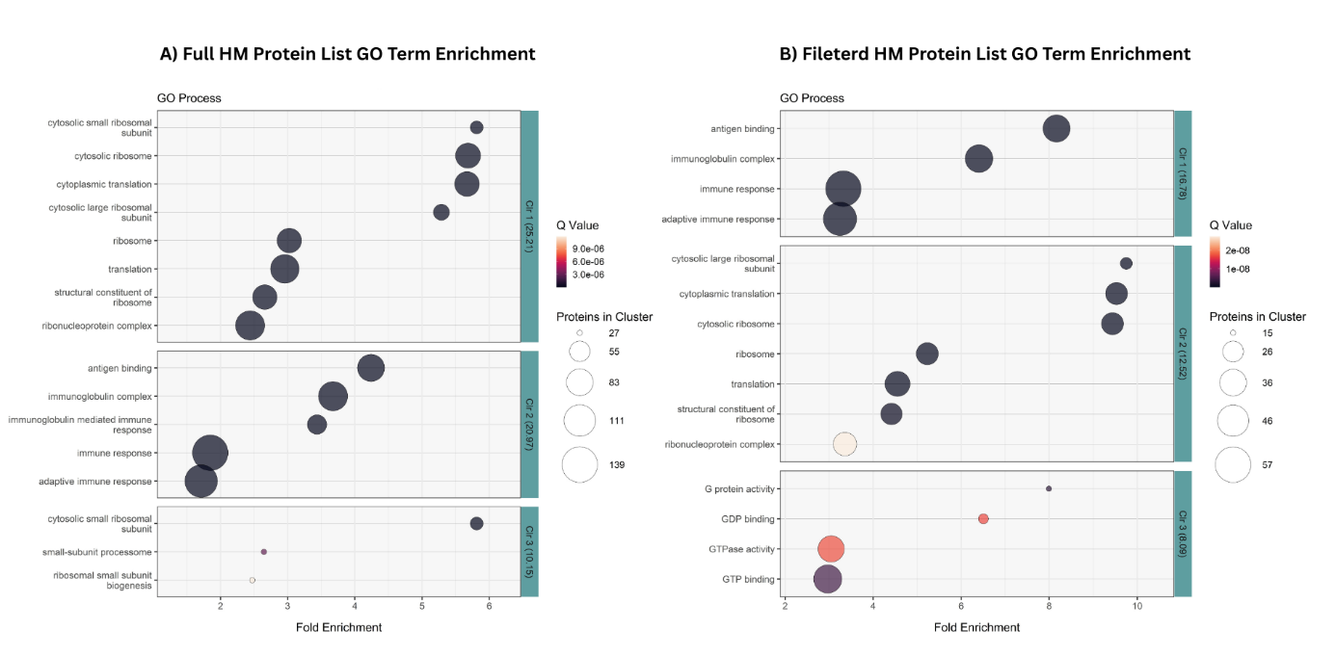
Supplementary Figure 1: GO Term Enrichment results for A) The full list of 2,911 proteins identified in ProteomeXchange dataset analysis, and B) The filtered list of 645 proteins used for the network analysis. GO Term enrichments were performed against the human genome, keeping only the top 3 enrichment clusters with the highest Enrichment Score and the GO Terms with adjusted p-value<0.05. Classification stringency was set to Medium as default. Y-axis represents the GO term clusters that formed, grouped by each taste receptor’s interactors. X-axis represents each cluster’s Fold Enrichment value, the colour gradient represents its q-value, and each dot’s size represents the number of proteins involved in the cluster.

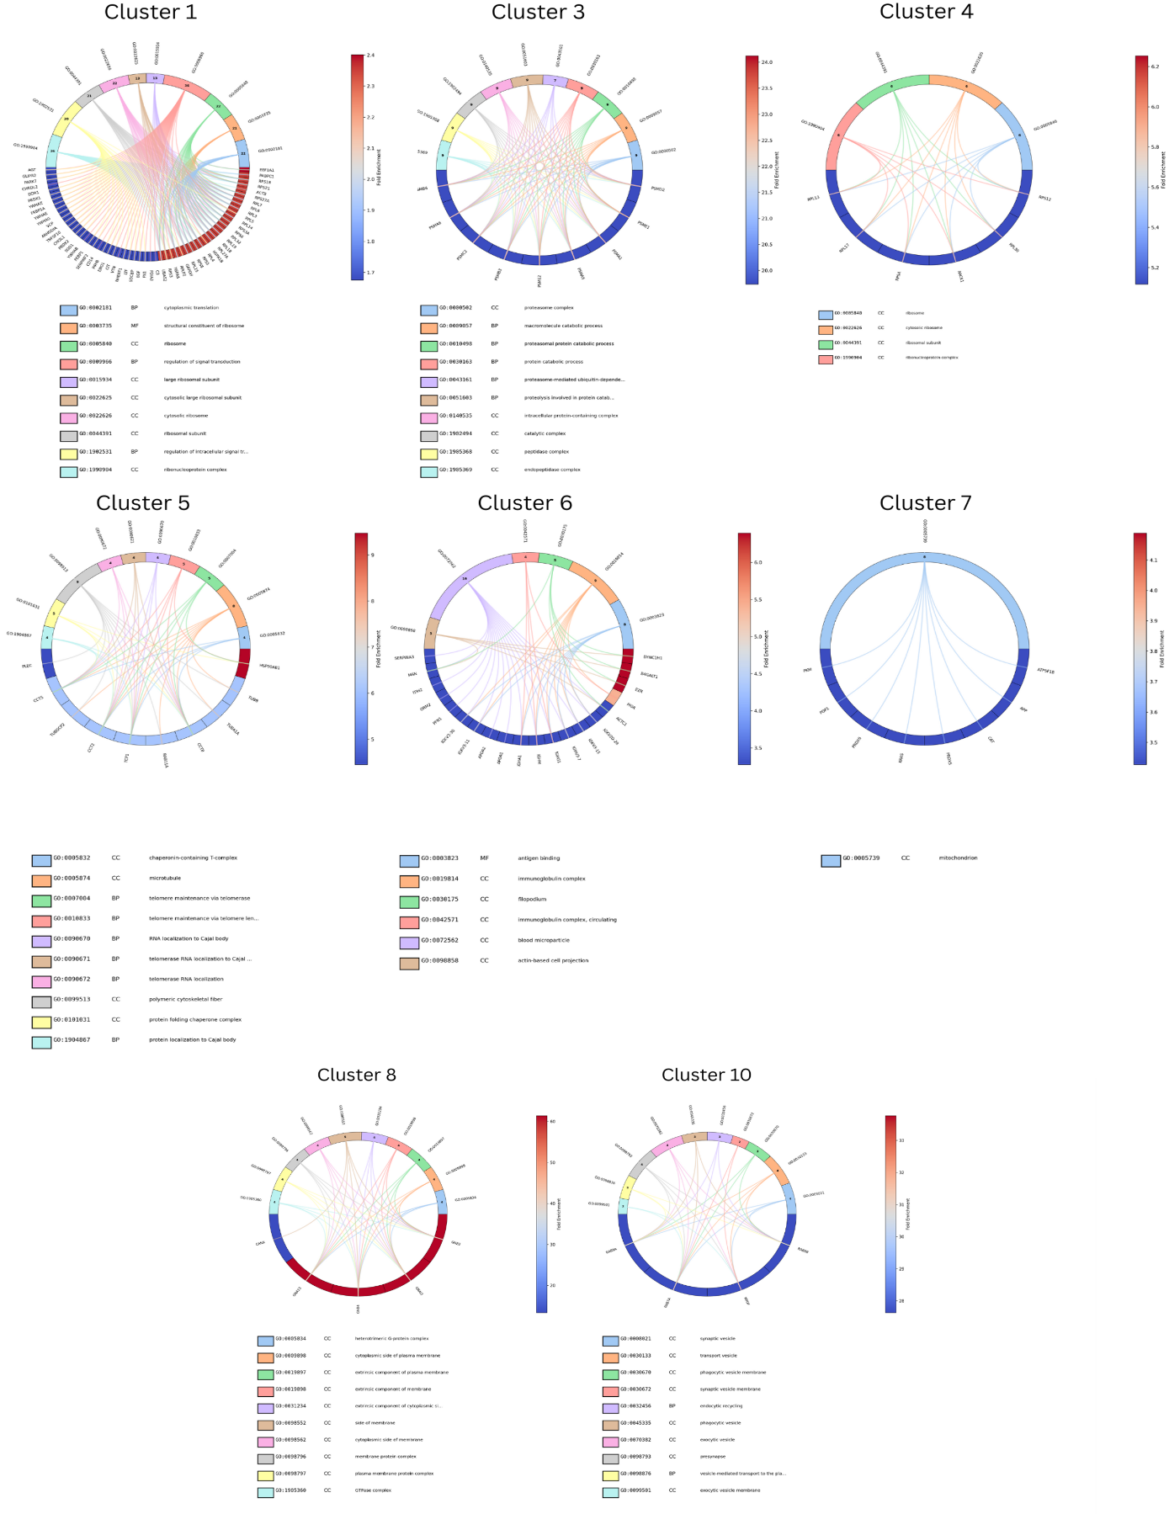
Supplementary Figure 2: Circular graphs of the Protein Groups enrichment analysis results of all the clusters of the reconstructed Human Milk (HM) PPI Network, using MCODE Algorithm with Degree Coefficient 2 that had at least one significantly enriched (adjusted p-value<0.05) GO Term cluster. On the bottom half of each circle are present the significantly enriched Genes of each cluster, ranked from left to right with ascending Fold Enrichment values (also colored from blue to red respectively). Only Genes with adjusted p-value<0.05 are depicted in the graphs. Protein Group clusters are present on the top half of the circle with distinct colors . Inside each Protein Group cluster cell is noted the number of Genes involved in the cluster.
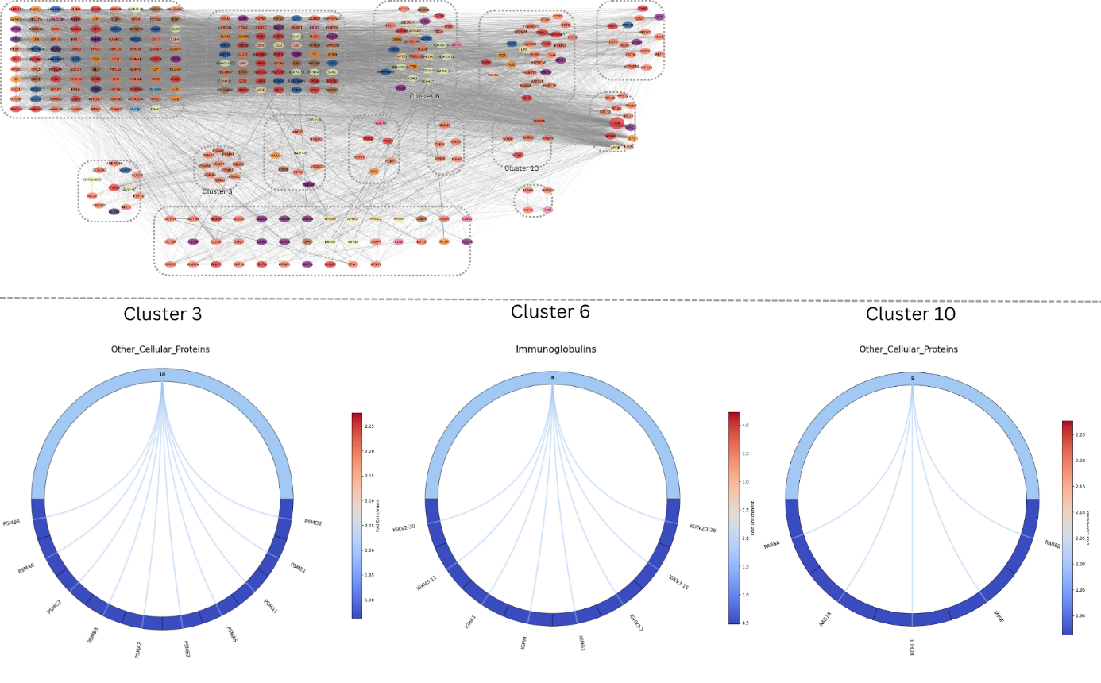
Supplementary Figure 3: Circular graphs of the Protein Groups enrichment analysis results of the 3 top-ranked clusters of the reconstructed Human Milk (HM) PPI Network, using MCODE Algorithm with Degree Coefficient 2. On the bottom half of each circle are present the significantly enriched Genes of each cluster, ranked from left to right with ascending Fold Enrichment values (also colored from blue to red respectively). Only Genes with adjusted p-value<0.05 are depicted in the graphs. Protein Group clusters are present on the top half of the circle with distinct colors . Inside each Protein Group cluster cell is noted the number of Genes involved in the cluster.
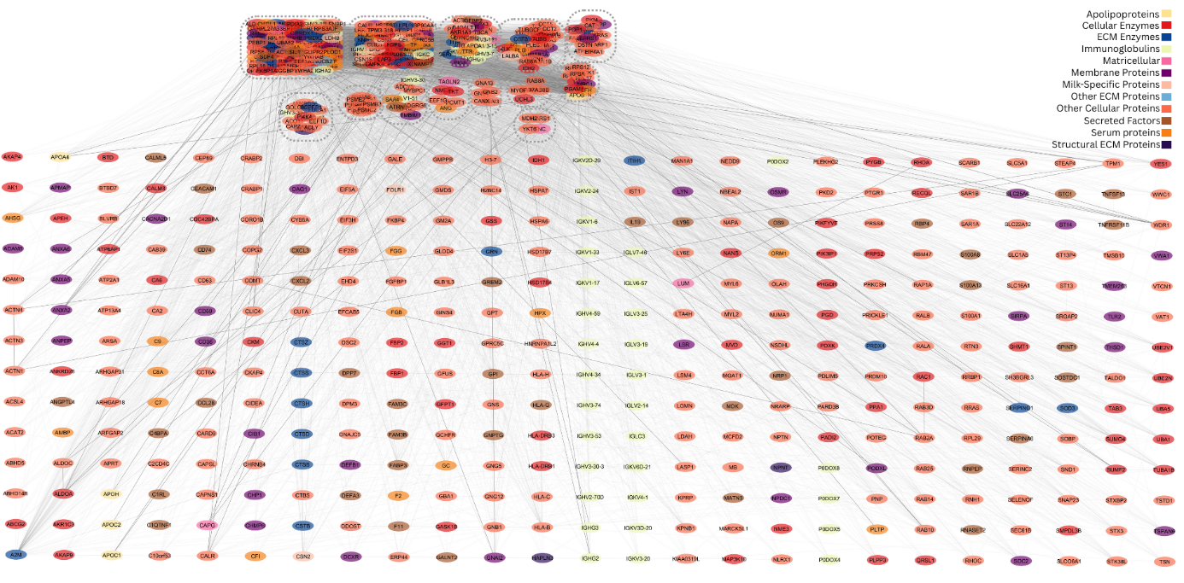
Supplementary Figure 4: All unclustered nodes of the reconstructed Human Milk (HM) PPI Network, using MCODE Algorithm with Degree Coefficient 2. On the top of the graph there is present the smaller version of the Network Clustering figure with the distinct clusters enclosed in dotted lines.

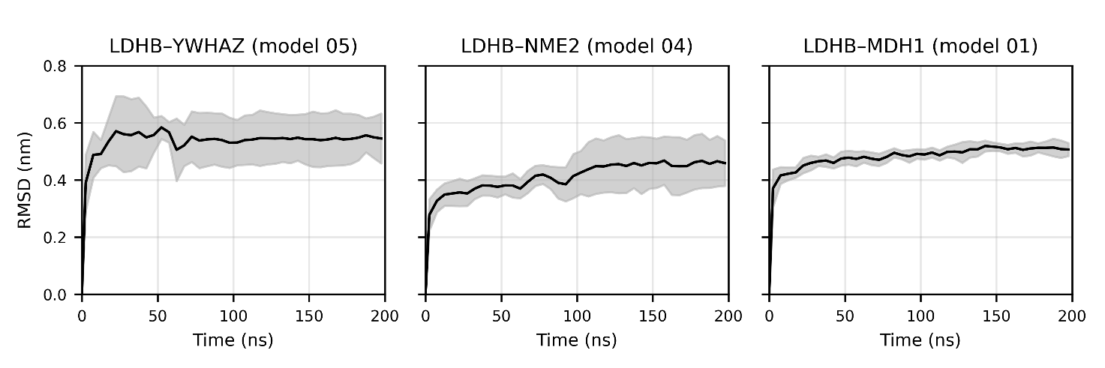
Supplementary Figure 5: Root-mean-square deviation analysis (RMSD) analysis of the best protein-protein complexes (LDHB-YWHAZ model 05; LDHB-NME2 model 04; LDHB-MDH1 model 01;). The RMSD analyses are presented as the average (black line) with the corresponding standard deviation (grey shaded area) between the 3 replicas, calculated using 5 ns time windows.

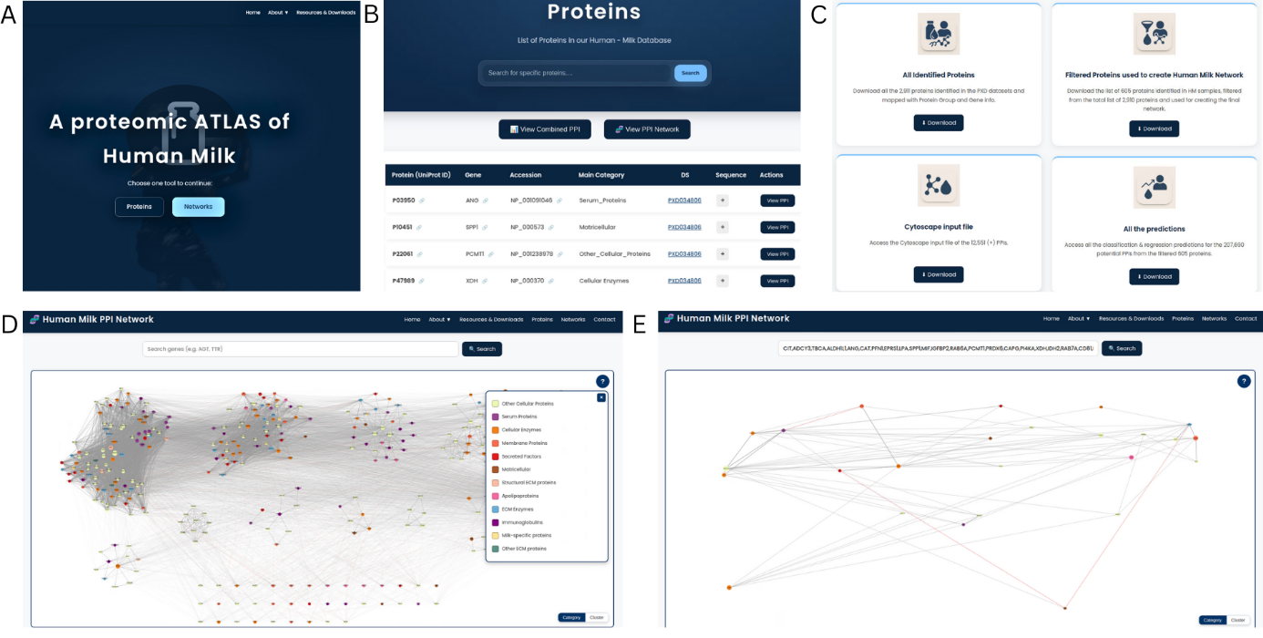
Supplementary Figure 6: Web interface and functionalities of Proteomic Atlas of Human (A) Home page of the Human Milk Proteomic Atlas, where users can directly search for proteins and explore their PPI and regulatory networks derived from the atlas. (B) Protein search interface, used for queries for individual proteins identified in human milk. For each protein, detailed information is provided, including gene name, accession number, functional category, detected datasets, amino acid sequence, and direct links to external resources such as the UniProt database. (C) Resources and Downloads page, allowing users to access curated outputs of the study, such as the complete list of identified human milk proteins, filtered protein sets used for network reconstruction, and the corresponding MaxQuant-processed raw datasets. (D) Human Milk PPI Network page, providing the global human milk PPI network reconstructed from the identified HM proteins from the proteomics analysis, with all the information on functional protein groups and network clusters, for further exploration of system-level organization. (E) Subnetwork visualization showing the PPI network for a user-defined subset of proteins selected through the protein search function, enabling focused analysis of local interaction neighbourhoods within the broader atlas.

Supplementary Discussion 1

By further analyzing the milk-specific top-scoring PPIs with MD analysis, we aimed to validate the interactions of highly prevalent HM proteins and characterize them. A notable interaction is between LDBH and YWHAZ. The selected pairs that were described were LDBH (P07195) - YWHAZ (P63104), LDBH - NME2 (P22392), and LDBH - MDH1 (P40925). At the core of these selected interactions stands L-lactate Dehydrogenase B chain (LDHB), while also being a part of the majority of the top 20 scoring milk-specific PPIs (13 out of 20 include LDHB- Supplementary Table 4). LDHB has been characterized as a significant protein in human milk as one of the low-abundance proteins present in its whey fraction, with a role in energy production, and specifically glycolysis[1]. Lactate Dehydrogenase, in general, is considered an important marker, with its activity (along with other measured milk parameters) associated with maternal lifestyle characteristics, such as vegetable consumption, place of living, age, and former smoking[2], and in other studies, it is found (along with LDHB specifically) to be downregulated in human breast cancer cell lines and tumor tissues[3]. Concerning the observed interactions, experimental evidence from reciprocal co-immunoprecipitation studies argues that the heart form of lactate dehydrogenase (H-LDH or LDH-B) is physically associated with local nucleoside diphosphate kinase B (NDPK-B/ UID: P22392), which is coded by the NME2 gene, further confirming the MD findings[4]. The identification of a stable complex between LDHB and YWHAZ is particularly compelling. While LDHB is classically viewed as a glycolytic enzyme catalyzing the conversion of pyruvate to lactate[5, 6], 14-3-3 proteins are ubiquitous regulators that bind to phospho-serine/phospho-threonine motifs to modulate the activity, localization, and stability of their targets[7, 8]. The high number of hydrogen bonds and the significant buried surface area observed in the LDHB-YWHAZ model suggest that 14-3-3 zeta/delta may play a regulatory role in lactate metabolism within the mammary gland. Indeed, recent literature has demonstrated that 14-3-3 zeta/delta upregulates LDHA activity, providing a strong indication that LDHB may similarly serve as a potential target for 14-3-3 zeta/delta[9]. As for the LDHB-NADH1 interaction, to the authors’ knowledge, no experimental or computational evidence exists yet to verify this interaction. Indirect evidence links these two proteins/genes in a functional manner. For example, it was shown that the LDHB-generated NADH is subsequently channelled through the malate-aspartate shuttle (MAS) and the glycerol-3-phosphate shuttle (G3PS) to support mitochondrial electron transport, linking LDHB activity to MDH1 function within the MAS pathway[10]. The lack of reports about these interactions, and especially about contextualizing them in the broader HM function, opens new avenues of research on their importance in regulating energy production and glycolysis. Especially considering the critical role of LDHB as a marker in pathological states (such as breast cancer), further delving into the role of these interactions and unravelling the downstream pathways they affect may be of therapeutic benefit.

Supplementary Notes 1
Silhouette Coefficient is used as the primary metric for assessing the clustering results and is commonly preferred as a standard metric in many clustering methodologies [11–13] due to its ability to identify clusters of similar characteristics. Essentially, the Silhouette coefficient is a measure of how similar an object is to its own cluster (cohesion) compared to other clusters (separation) by calculating the average distance between a node and all other nodes in the same cluster (intra-cluster distance) and the lowest average distance between the node and all nodes in any other cluster (nearest-cluster distance) [14]. Density is also a widely used metric for clustering evaluation and is computed by averaging the ratio of existing to possible edges per cluster. It is used for measuring the overall compactness and cohesion of the detected clusters [15, 16].
Supplementary References
[1] Liao Y, Alvarado R, Phinney B, et al. Proteomic Characterization of Human Milk Whey Proteins during a Twelve-Month Lactation Period. J Proteome Res 2011; 10: 1746–1754.
[2] Poniedziałek B, Rzymski P, Pięt M, et al. Relation between polyphenols, malondialdehyde, antioxidant capacity, lactate dehydrogenase and toxic elements in human colostrum milk. Chemosphere 2018; 191: 548–554.
[3] Aslebagh R, Channaveerappa D, Arcaro KF, et al. Proteomics analysis of human breast milk to assess breast cancer risk. Electrophoresis 2018; 39: 653–665.
[4] Jovanović S, Jovanović A, Crawford RM. M-LDH Serves as a Regulatory Subunit of the Cytosolic Substrate-channelling Complex in Vivo. Journal of Molecular Biology 2007; 371: 349–361.
[5] Everse J, Kaplan NO. Lactate Dehydrogenases: Structure and Function. In: Meister A (ed) Advances in Enzymology - and Related Areas of Molecular Biology. Wiley, pp. 61–133.
[6] Cuozzo F, Viloria K, Shilleh AH, et al. LDHB contributes to the regulation of lactate levels and basal insulin secretion in human pancreatic β cells. Cell Reports 2024; 43: 114047.
[7] Aitken A. 14-3-3 proteins: A historic overview. Seminars in Cancer Biology 2006; 16: 162–172.
[8] Tzivion G, Avruch J. 14-3-3 Proteins: Active Cofactors in Cellular Regulation by Serine/Threonine Phosphorylation. Journal of Biological Chemistry 2002; 277: 3061–3064.
[9] Chang C-C, Zhang C, Zhang Q, et al. Upregulation of lactate dehydrogenase a by 14-3-3ζ leads to increased glycolysis critical for breast cancer initiation and progression. Oncotarget 2016; 7: 35270–35283.
[10] Liu M, Cheng A, You W, et al. CDK1-mediated phosphorylation of LDHA fuels mitosis through LDHB-dependent lactate oxidation. EMBO Rep 2025; 26: 4923–4949.
[11] Nidheesh N, Nazeer KAA, Ameer PM. A Hierarchical Clustering algorithm based on Silhouette Index for cancer subtype discovery from genomic data. Neural Comput & Applic 2020; 32: 11459–11476.
[12] Lengyel A, Botta‐Dukát Z. Silhouette width using generalized mean—A flexible method for assessing clustering efficiency. Ecology and Evolution 2019; 9: 13231–13243.
[13] Vardakas G, Papakostas I, Likas A. Deep Clustering Using the Soft Silhouette Score: Towards Compact and Well-Separated Clusters. Epub ahead of print 2024. DOI: 10.48550/ARXIV.2402.00608.
[14] Shutaywi M, Kachouie NN. Silhouette Analysis for Performance Evaluation in Machine Learning with Applications to Clustering. Entropy 2021; 23: 759.
[15] Newman MEJ, Girvan M. Finding and evaluating community structure in networks. Phys Rev E; 69. Epub ahead of print 26 February 2004. DOI: 10.1103/physreve.69.026113.
[16] Barabási A-L, Oltvai ZN. Network biology: understanding the cell’s functional organization. Nat Rev Genet 2004; 5: 101–113.

