Extended Figures and Legends
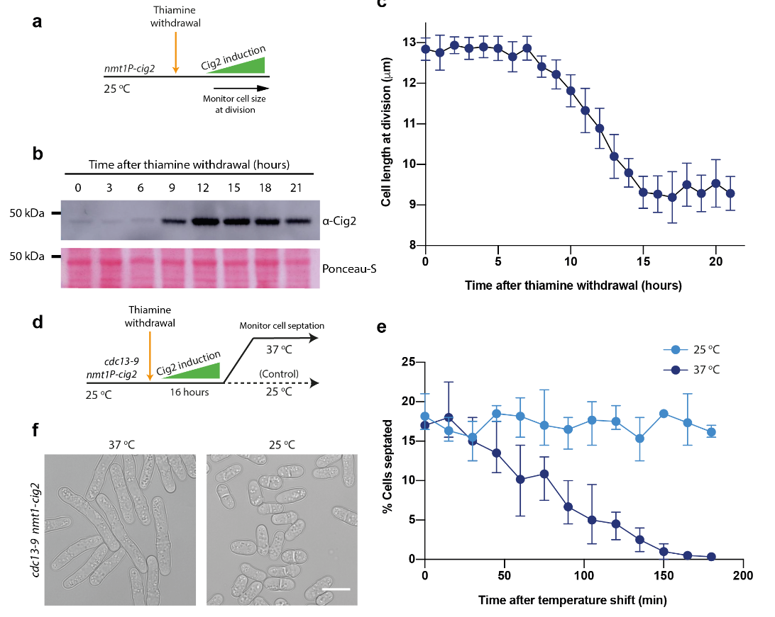Figure S1— Overexpression of Cig2 cannot drive cell division in the absence of Cdc13
a Experimental outline for panels (b) and (c). Thiamine was removed from the growth medium by washing cells into EMM.
b Western blots for Cig2 (upper) following thiamine withdrawal, with Ponceau-S staining (lower) of the same membrane region as the upper panel given as a loading control.
c Cell length at division measurements after thiamine withdrawal. Cell length at division was determined by visual inspection and measurement of cells with septa. 30 cells were measured per timepoint. Points shows the mean value of 30 cells, whiskers delimit SD.
d Experimental outline for panels (e) and (f). Thiamine was removed from media by washing cells into EMM. After 16 hours of thiamine withdrawal cells were shifted to 37 °C or held at 25 °C as a control.
e Percentage of cells with septa as determined by visual inspection. At least 50 cells were counted per time point following shift. Points indicate the mean value over three replicates, whiskers delimit the range of values.
f Example images of cdc13-9 nmt1-cig2 cells taken 19 hours after thiamine withdrawal and either shifted to 37 °C after 16 hours (left) or maintained at 25 °C (right). Scale bar = 10 µm.
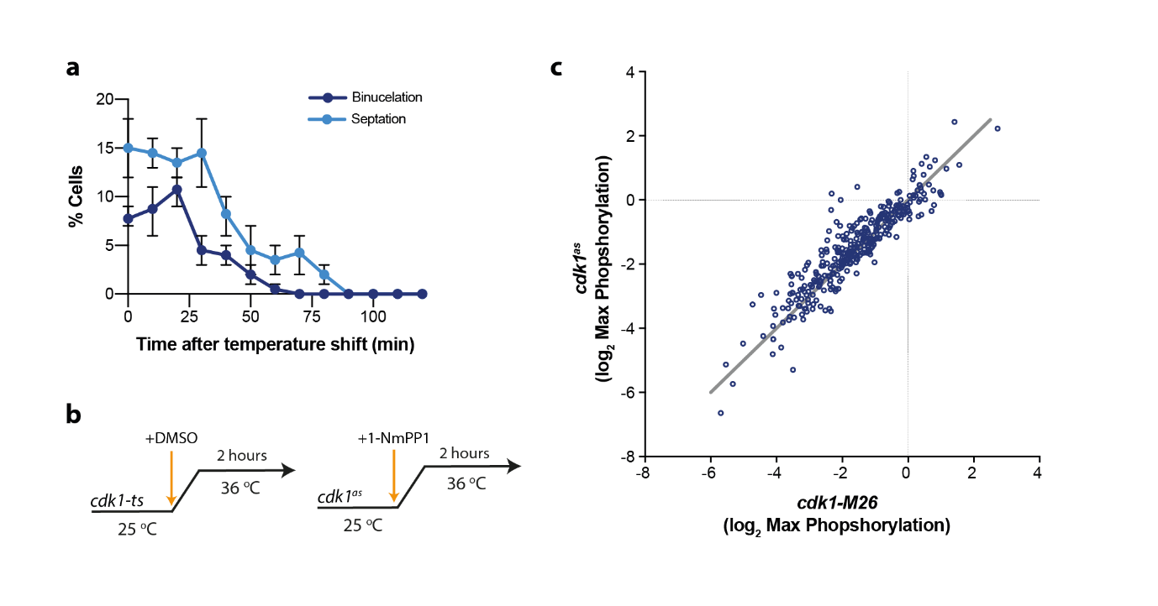Figure S2 — Using a Cdk1^{TS} allele to remove endogenous CDK activity
a Septation and binucleation indices of asynchronous Cdk1^{TS} (encoded by the cdc2-M26 allele) cells after shift to the restrictive temperature. 50 cells were counted per timepoint, points represent mean values, and error bars represent range of values over 3 biological repeats.
b Experimental schematic for compared conditions in panel (c). Samples for phosphoproteomics were taken 2 hours after temperature shift or addition of 10 µM 1-NmPP1.
c Phosphorylation values for 321 previously characterised CDK phosphosites, normalised to mitotic CDK phosphorylation. Sites that did not decrease below zero in both conditions were deemed to be non-genuine CDK phosphosites, and were removed from subsequent analysis. Grey line gives y=x.
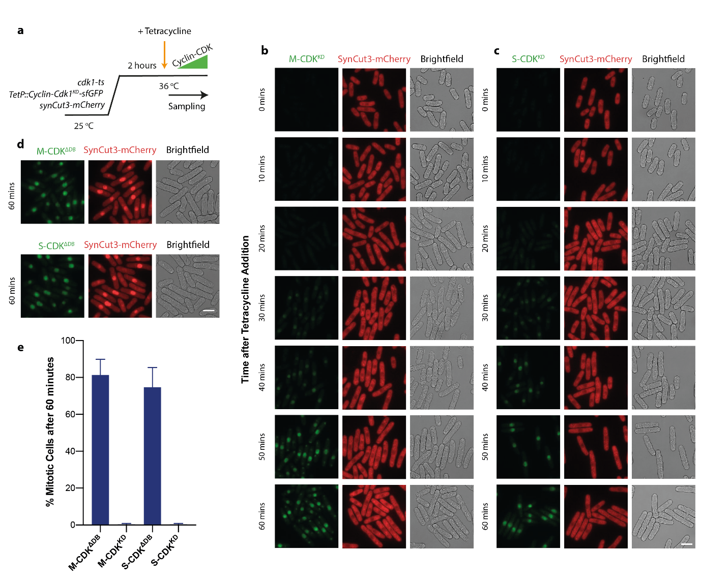Figure S3 - Mitotic progression is strictly dependent on induced S-CDK or M-CDK activity
a Experimental outline for panels (b)-(e). Endogenous CDK activity was removed by shifting Cdk1-ts expressing cells to 36 ºC for 2 hours.
b/c Representative images of cells following induction of either M-CDK^{KD}-sfGFP (b) or S-CDK^{KD}-sfGFP (c). CDK kinase activity is removed through the K33A mutation. Images represent a single Z-slice across the medial focal plane of cells. Images in the same channel are comparable. Scale bar = 10 μm.
d Representative images of cells following induction of either M-CDK^{ΔDB}-sfGFP (top) or S-CDK^{ΔDB}-sfGFP (bottom) 60 minutes after tetracycline addition. Images represent a single Z-slice across the medial focal plane of cells. Images in the same channel are comparable. Scale bar = 10 μm.
e Quantification of mitotic cells after 60 minutes of cyclin-CDK induction, as a percentage of all cells. Mitotic cells were classed as cells with nuclear synCut3-mCherry levels 1.5x more than mean cytoplasmic levels.
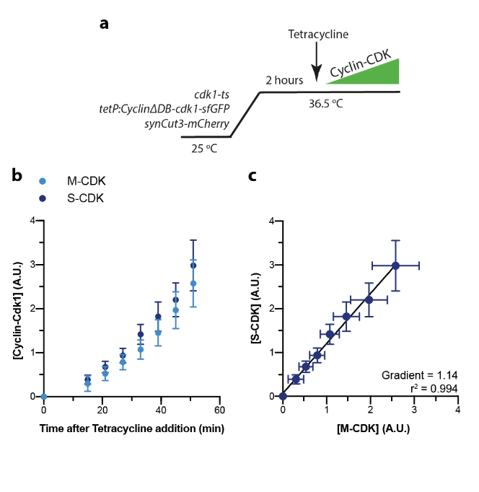

Figure S4 — Quantification of S-CDK^{ΔDB} and M-CDK^{ΔDB} expression
a Experimental schematic for the induction of truncated cyclin-CDK complexes lacking residues 1-80 of cyclin, which encompass the predicted APC/C recognition degron box sequences of both Cig2 and Cdc13.
b Proteomic quantification of cyclin-CDK expression after tetracycline induction. n=15 peptide reporters for M-CDK. n=12 reporters for S-CDK. Error bars give SEM.
c S-CDK^{ΔDB} expression plotted against M-CDK^{ΔDB} expression. Error bars give SEM.
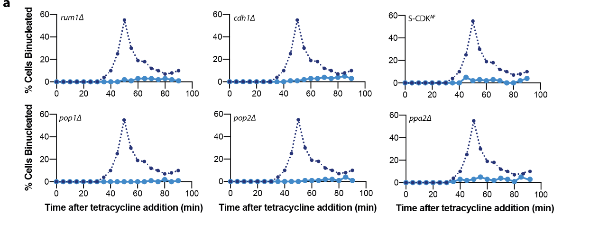
Figure S5 — Other negative regulators of CDK activity do not restrict S-CDK from executing mitosis
a Binucleation index after induction of S-CDK in the absence of the labelled negative regulators of CDK activity. Instead of the deletion of Wee1, S-CDK^{AF} was expressed carrying unphosphorylatable T14A Y15F mutations on Cdk1, thus mimicking Wee1 kinase loss. Dashed line gives M-CDK induction profile, all reproduced from Figure 3b.
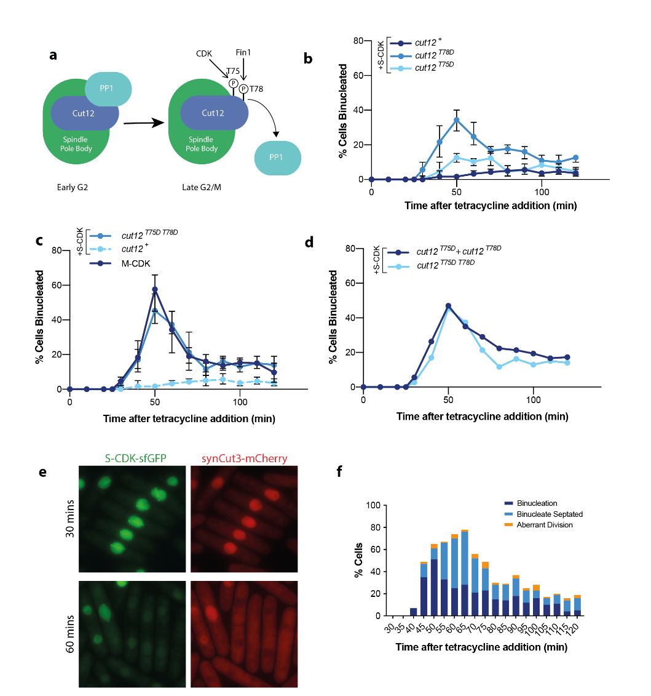
Figure S6 — Removal of SPB-bound PP1 through mitotic phosphomimetics also allows S-CDK to drive mitosis
a PP1 regulation through Cut12 phosphorylation by cell cycle kinases.
b Binucleation index after induction of S-CDK-sfGFP in backgrounds with either wild-type Cut12 or Cut12 mutants with phosphomimetic mutations. Binucleation was measured through DAPI and Calcofluor staining of fixed cells. Septated cells were not included in this measure. 100 cells counted per timepoint. Datapoints represent mean of three biological replicates, and error bars represent SEM.
c As in (b), but including induction of M-CDK in an otherwise wild-type background. Dashed blue line reproduces S-CDK data from panel (b). M-CDK-sfGFP data is reproduced from Figure 4F
d As in (b), but Cut12^{T75D} + Cut12^{T78D} curve gives summed mean values from S-CDK inductions in backgrounds with Cut12^{T75D} and Cut12^{T78D} from panel (b). Cut12^{T75DT78D} data is directly reproduced from panel (c).
e Example maximum projection images of S-CDK-sfGFP induced in the presence of the mutant cut12 allele.
f Quantitation of mitotic and post-mitotic events during a longer expression of S-CDK induced in the presence of the mutant Cut12^{T75D T78D} allele. 100 cells were counted per timepoint.

