Supplementary information
Table S1 Effects of larvicide treatments on tadpole survival based on Cox proportional hazards models. Hazard ratios are shown relative to the control treatment. Bold indicates significant treatments.
Larvicide | β | Hazard ratio | SE | z | P
Bti | -0.64 | 0.53 | 0.56 | -1.15 | 0.25
Larvicidal oil | 2.13 | 8.44 | 0.41 | 5.18 | <0.001
Temephos | -0.58 | 0.56 | 0.54 | -1.09 | 0.28

Table S2 Results of the linear mixed-effects model examining the effects of three larvicide treatments (Bacillus thuringiensis israelensis [Bti], larvicidal oil, and temephos), days since treatment, and their interaction on Liuixalus romeri tadpole body length at minimum recommended rates. Control is set as the default reference treatment. Bold indicates significant factors.
Factors | Estimate | SE | t | P
Bti | -0.005 | 0.069 | -0.073 | 0.942
Larvicidal oil | -0.083 | 0.069 | -1.147 | 0.253
Temephos | -0.105 | 0.072 | -1.532 | 0.128
Time | 0.013 | 0.002 | 6.158 | <0.001
Bti x Time | 0.004 | 0.003 | 1.363 | 0.175
Larvicidal oil x Time | -0.010 | 0.004 | -2.647 | 0.009
Temephos x Time | 0.002 | 0.003 | 0.819 | 0.414

Table S3 Pairwise comparisons of daily proportional growth rates of Liuixalus romeri tadpoles among mosquito larvicide treatments under exposure to minimum recommended rates, estimated using marginal trends from the linear mixed-effects model. Bold indicates significant comparisons.
Comparison | Estimate | SE | t | P
Control vs Bti | -0.004 | 0.003 | -1.356 | 0.529
Control vs Larvicidal oil | 0.010 | 0.004 | 2.615 | 0.048
Control vs Temephos | -0.002 | 0.003 | -0.817 | 0.846
Bti vs Larvicidal oil | 0.014 | 0.004 | 3.721 | 0.002
Bti vs Temephos | 0.002 | 0.003 | 0.592 | 0.934
Larvicidal oil vs Temephos | -0.012 | 0.004 | -3.339 | 0.006

Table S4 Results of mixed-effects models testing the effects of mosquito larvicide treatment, time, and their interaction on movement parameters of Liuixalus romeri tadpoles during early (day 4–11) and full (day 4–32) exposure periods.
Parameter | Factors | F or χ² | P
Early period
Average speed | Larvicide | 3.943 | 0.013
 | Time | 2.782 | 0.101
 | Larvicide x Time | 4.828 | 0.005
Mobile average speed | Larvicide | 5.147 | 0.003
 | Time | 2.499 | 0.119
 | Larvicide x Time | 4.715 | 0.005
Average acceleration | Larvicide | 6.051 | 0.001
 | Time | 0.387 | 0.538
 | Larvicide x Time | 4.359 | 0.008
Mobility rate | Larvicide | 4.210 | 0.240
 | Time | 1.809 | 0.179
 | Larvicide x Time | 7.492 | 0.058
Exploration rate | Larvicide | 6.039 | 0.110
 | Time | 1.042 | 0.307
 | Larvicide x Time | 15.966 | 0.001
Frozen events | Larvicide | 0.951 | 0.460
 | Time | 0.087 | 0.770
 | Larvicide x Time | 1.480 | 0.231
Full period
Average speed | Larvicide | 1.054 | 0.352
 | Time | 7.812 | <0.001
 | Larvicide x Time | 2.180 | 0.035
Mobile average speed | Larvicide | 1.647 | 0.264
 | Time | 4.870 | 0.001
 | Larvicide x Time | 2.353 | 0.023
Average acceleration | Larvicide | 0.758 | 0.471
 | Time | 7.726 | <0.001
 | Larvicide x Time | 2.402 | 0.020
Mobility rate | Larvicide | 0.935 | 0.627
 | Time | 8.106 | 0.088
 | Larvicide x Time | 14.938 | 0.060
Exploration rate | Larvicide | 11.659 | 0.003
 | Time | 19.129 | 0.001
 | Larvicide x Time | 28.056 | <0.001
Frozen events | Larvicide | 1.046 | 0.355
 | Time | 11.002 | <0.001
 | Larvicide x Time | 1.002 | 0.439

Table S5 Results of post-hoc pairwise comparisons derived from mixed-effects models examining the effects of larvicide treatment on movement parameters of Liuixalus romeri tadpoles across time. Only statistically significant comparisons (p < 0.05) are presented. Analyses were conducted separately for the early period (Day 4–11) and the full period (Day 4–32). *For proportional parameters, estimates are odds ratios from beta regression models with a logit link. For continuous parameters, estimates are pairwise differences on the log-transformed response scale.
Parameter | Comparison | Day since treatment | Estimate* | SE | t or z | P
Early period
Average acceleration | Oil vs Bti | 11 | -2.187 | 0.451 | -4.851 | <0.001
Average acceleration | Temephos vs Oil | 11 | 1.463 | 0.437 | 3.335 | 0.013
Average speed | Oil vs Bti | 11 | -2.265 | 0.497 | -4.557 | <0.001
Average speed | Temephos vs Oil | 11 | 1.634 | 0.482 | 3.390 | 0.011
Mobile average speed | Oil vs Control | 11 | -1.429 | 0.523 | -2.734 | 0.048
Mobile average speed | Oil vs Bti | 11 | -2.312 | 0.481 | -4.809 | <0.001
Mobile average speed | Temephos vs Oil | 11 | 1.621 | 0.466 | 3.476 | 0.009
Exploration rate | Bti vs Control | 11 | 2.765 | 1.063 | 2.645 | 0.041
Exploration rate | Oil vs Bti | 11 | 0.124 | 0.050 | -5.150 | <0.001
Exploration rate | Temephos vs Oil | 11 | 4.589 | 1.883 | 3.715 | 0.001
Mobility rate | Bti vs Control | 11 | 2.335 | 0.709 | 2.793 | 0.027
Mobility rate | Temephos vs Control | 11 | 2.575 | 0.765 | 3.186 | 0.008
Full period
Average acceleration | Temephos vs Bti | 18 | 1.289 | 0.492 | 2.622 | 0.029
Mobile average speed | Temephos vs Bti | 18 | 1.344 | 0.546 | 2.463 | 0.043
Mobile average speed | Bti vs Control | 25 | -1.44 | 0.563 | -2.56 | 0.034
Exploration rate | Bti vs Control | 18 | 0.364 | 0.143 | -2.565 | 0.028
Exploration rate | Temephos vs Control | 18 | 3.197 | 1.324 | 2.806 | 0.014
Exploration rate | Temephos vs Bti | 18 | 3.163 | 1.263 | 2.884 | 0.011

Table S6 Results of mixed-effects models, with and without body size included as a fixed effect, testing the effects of mosquito larvicide treatment, time, and their interaction on movement parameters of Liuixalus romeri tadpoles during the early exposure period (Days 4–11) and full exposure period (Days 4–32). Bold text indicates statistically significant effects.
Parameter | Factors | P (without body size) | P (with body size)
Early period
Average speed | Larvicide | 0.013 | 0.053
Average speed | Larvicide x Time | 0.005 | 0.002
Mobile average speed | Larvicide | 0.003 | 0.039
Mobile average speed | Larvicide x Time | 0.005 | 0.003
Average acceleration | Larvicide | 0.001 | 0.038
Average acceleration | Larvicide x Time | 0.008 | 0.005
Frozen events | Larvicide | 0.460 | 0.503
Frozen events | Larvicide x Time | 0.231 | 0.239
Mobility rate | Larvicide | 0.240 | 0.287
Mobility rate | Larvicide x Time | 0.058 | 0.058
Exploration rate | Larvicide | 0.110 | 0.149
Exploration rate | Larvicide x Time | 0.001 | 0.001
Full period
Average speed | Larvicide | 0.352 | 0.461
Average speed | Larvicide x Time | 0.035 | 0.044
Mobile average speed | Larvicide | 0.264 | 0.154
Mobile average speed | Larvicide x Time | 0.023 | 0.019
Average acceleration | Larvicide | 0.471 | 0.521
Average acceleration | Larvicide x Time | 0.020 | 0.025
Frozen events | Larvicide | 0.355 | 0.371
Frozen events | Larvicide x Time | 0.439 | 0.682
Mobility rate | Larvicide | 0.627 | 0.932
Mobility rate | Larvicide x Time | 0.060 | 0.125
Exploration rate | Larvicide | 0.003 | 0.004
Exploration rate | Larvicide x Time | <0.001 | <0.001

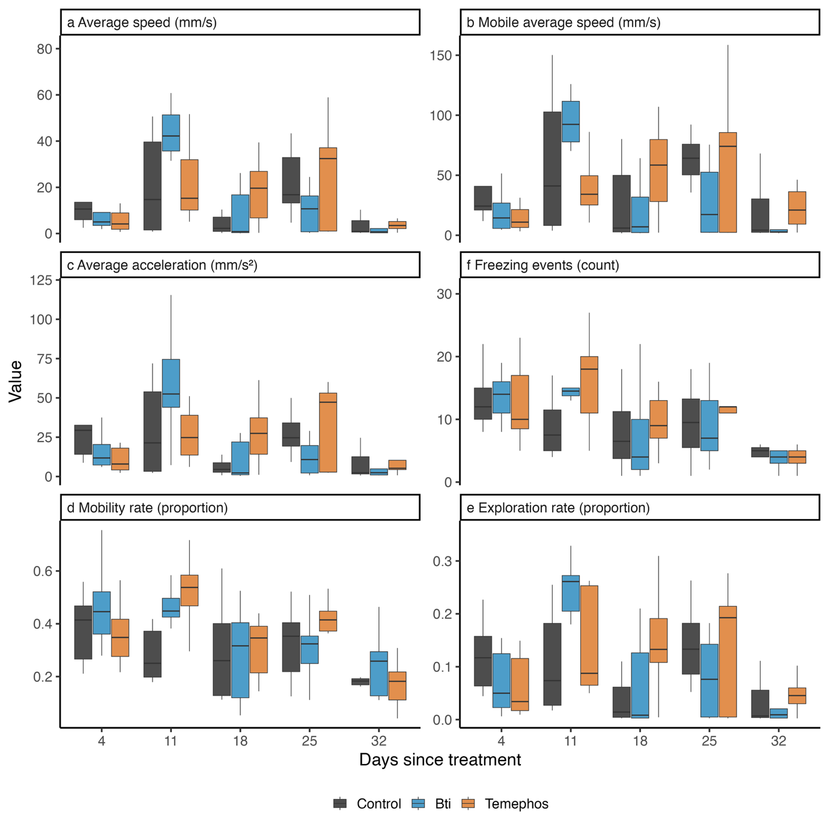
Fig. S1. Impacts of mosquito larvicides at minimum recommended rates on movement parameters (average acceleration, average speed, exploration rate, freezing events, mobile average speed, and mobility rate) of Liuixalus romeri tadpoles at 4, 11, 18, 25, and 32 days since exposure. Treatments include Bacillus thuringiensis israelensis (Bti), temephos, and a control. Movement was analysed using ToxTrac.

