Supplementary Methods

Classification

TropWet Classification System
The original TropWet system is largely based on linear spectral unmixing (LSU) of Landsat image composites applied to vegetation, water and soil spectral endmembers automatically generated from band indices. A ruleset is applied to the resulting fractional images (i.e. pixel-level fractions of vegetation, water, soil), alongside auxiliary data (e.g. Height Above Nearest Drainage Network to extract wetland land cover classes, including both open water and inundated vegetation ¹. For application to the Sahel, important modifications were made to TropWet to improve the transferability and robustness of the approach, as well as addressing sources of error.
To enable processing over a large area, like the Sahel, TropWet was applied in a tiled workflow. With the original version of TropWet (TropWet.V1) this led to artefacts occurring at the edge of tiles as neighbouring tiles would use different, automatically generated, endmembers to drive the spectral unmixing process. For the modified version, TropWet.V2, single endmembers were generated to ensure consistency across the study area. The endmember for open water was taken from a point in the centre of a permanent lake located in the Sudd Wetlands, South Sudan (7°25.26'N 30°34.61'E). Its permanence was confirmed by cross-checking against the Global Surface Water (GSW) project’s water occurrence layer ², which indicated 100% occurrence over the period 1984-2021. The vegetation (photosynthetic “green” vegetation) endmember was defined in a forested area in Ethiopia (7°53.98'N 35°8.20'E), where the Global Forest Change Layer ³ indicates no change in forest cover since 2000. The endmember for bare earth was based on a location in South Sudan (14°36.34'N 29°52.40'E) for which historical Google Satellite Imagery indicated an absence of any vegetation or evidence of surface water over the period 1984 to present. For each endmember type (water, vegetation and bare earth), the spectral values (i.e. blue, green, red, near infrared, shortwave infrared bands 1 and 2) for the final endmember were based on the mean reflectance from all valid cloud free Landsat scenes from LS5, LS7, LS8 and LS9.
Initial iterations of TropWet.V2 within the Sahel region indicated spectrally similarity between open water and areas that have recently been burnt, a potentially significant source of error given that burning is a common agricultural practice across the region. As such, a “burnt” endmember was introduced. The MODIS Fire_cci Burned Area product (version 5.1) was used to identify significant burn events. Landsat composites were then generated that coincide with those events. A total of six Landsat images were generated between 2015 and 2020. Spectral data from within the burnt area for each of the six scenes was compiled, and the mean spectral response was used as the final endmember.
Median composites were generated in Google Earth Engine (GEE) using Landsat 8 and 9, which were processed to surface reflectance using the Land Surface Reflectance Code (LaSRC). Individual images were cloud masked using the QA and RA bitmask bands stored within the GEE dataset structure. Due to cloud cover, it was not possible to generate monthly composites for the Sahel region. Rather, serial bi-monthly composites were generated for the period 2014 to the end of 2023. Constrained, non-negative, spectral unmixing was applied to the Landsat image composites over 50 2.5 x 2.5 degree tiles distributed across the Sahel region.
TropWet.V1 applied a set of rules to the unmixed image, together with the terrain metrics slope angle and Height Above Nearest Drainage Network (HAND), to map wetland classes, including open water, inundated vegetation and aquatic vegetation. However, this approach did not adequately represent transition areas, particularly the transition between inundated vegetation and non-inundated areas. To resolve this, a fuzzy-based approach was introduced whereby class membership was considered within ± 5% of the original hard ruleset (largely applied to combinations of the water, vegetation, and bare earth fractions). Thresholds for the fuzzy classification were defined via Bayesian optimisation using a pseudo ground truth dataset. The target classes were open water, turbid water, inundated vegetation and non-inundated. A turbid water class was introduced following initial iterations of the classification approach, which revealed confusion between open water with high sediment content and bare earth.
The pseudo ground truth dataset used in the Bayesian optimisation procedure was based on visual interpretation of land cover type at a series of reference points. These points were generated through the stratified random distribution of 25 3 x 3 km grid squares across the extent of the Sahel and from randomly selected bi-monthly time steps within the 2014-2023 period. Stratification was based on the classification result of the original TropWet.V1 approach to ensure that samples would be taken from a range of land cover types. Each grid square was populated with 200 random points and interrogated against Landsat image composites, concurrent PlanetLabs monthly basemap data and Google Earth imagery to label them as either open water, turbid water, inundated vegetation or non-inundated.
Bayesian optimisation of fuzzy membership for each class was performed by testing combinations of fuzzy classification thresholds, comparing the resulting classification with the pseudo ground truth dataset, and extracting accuracy scores for each combination. The combinations that returned the highest classification accuracy (macro F1 score) were used for final classification, which was then applied to the serial bi-monthly Landsat data from 2014 to the end of 2023.
A summary of the overall classification approach can be found in Figure S1.
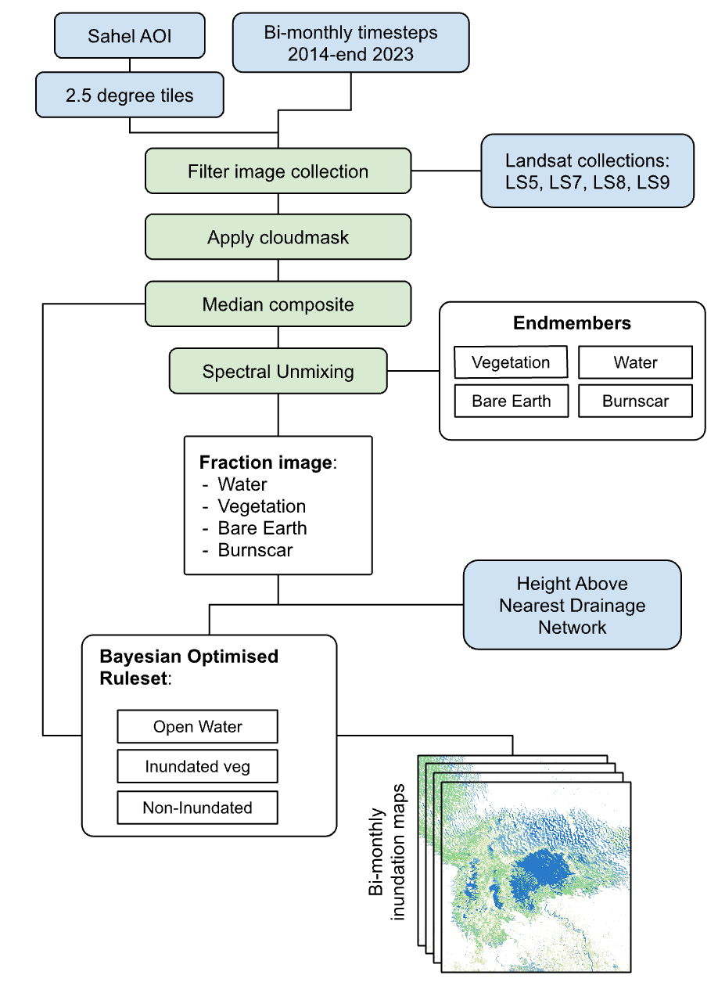
- Flow diagram summarising the overall TropWet.V2 classification approach.

Post-classification refinements
In some instances, wet soils were confused with turbid water, leading to an overestimation of turbid water, particularly in agricultural areas along the Nile Valley with extensive tilled soils. Equally, the relatively dark spectral response of exposed volcanic rock in Kenya and Ethiopia was sometimes misclassified as turbid water. Turbid water is assumed to occur in areas with permanent or semi-permanent open water. As such, we introduced a refinement whereby turbid water would be relabelled as non-inundated when the GSW dataset ² indicated no open water, or when the TropWet frequency of open water was zero, i.e., either dataset indicated that the pixel was unlikely to be inundated. Turbid water was not a class of interest and therefore was relabelled as open water for the final classification.
Small, isolated, non-inundated areas were sometimes misclassified as inundated vegetation. This is likely to be the result of shadowing, resulting in a spectral response that is similar to a mixed vegetation-water pixel. In some instances, this may be due to a failure in the LaSRC approach to adequately mask cloud shadow. For the main part, however, it is likely that higher vegetation canopies, particularly forests, cast shadows, again exhibiting a spectral response similar to that of a mixed vegetation-water pixel. This effect was reduced by relabelling inundated vegetation pixels as non-inundated where the Hansen Global Forest Change v1.11 forest cover for 2000 was greater than 50% coverage ³. Analysis of this dataset indicated a negligible change in forest cover across the Sahel region for the study period.
Remaining isolated areas of inundated vegetation were assumed to be erroneous or the result of temporal flooding caused by localised rainfall events. To account for this, each serial classified image was clumped to join neighbouring pixels with the same class value. These images are then used to generate a binary image indicating pixels mapped as inundated vegetation for more than 20% of the time. In this respect, these areas are assumed to be “hydrologically active”. Inundated vegetation pixels were relabelled as non-inundated where they are >100 m from a hydrologically active area.
A summary of the post-classification refinement steps is shown in Figure S2.
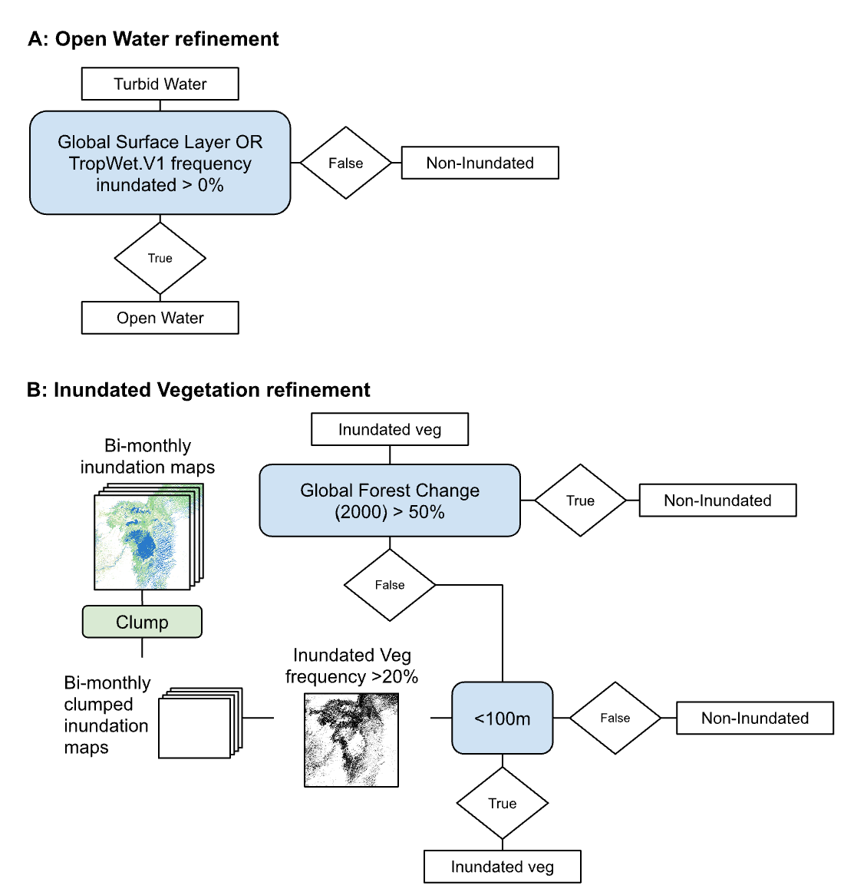
- Flow diagram summarising the overall post-classification refinement steps used in TropWet.V2.

Ground-Truth Observations
Ground truth data collection campaigns were carried out in two locations: 1. Within the Inner Niger Delta, Mali from 17-26 October 2025 and 2. The area around Lake Olbolosat, Kenya from 11-17 October 2025 (Figure S3).
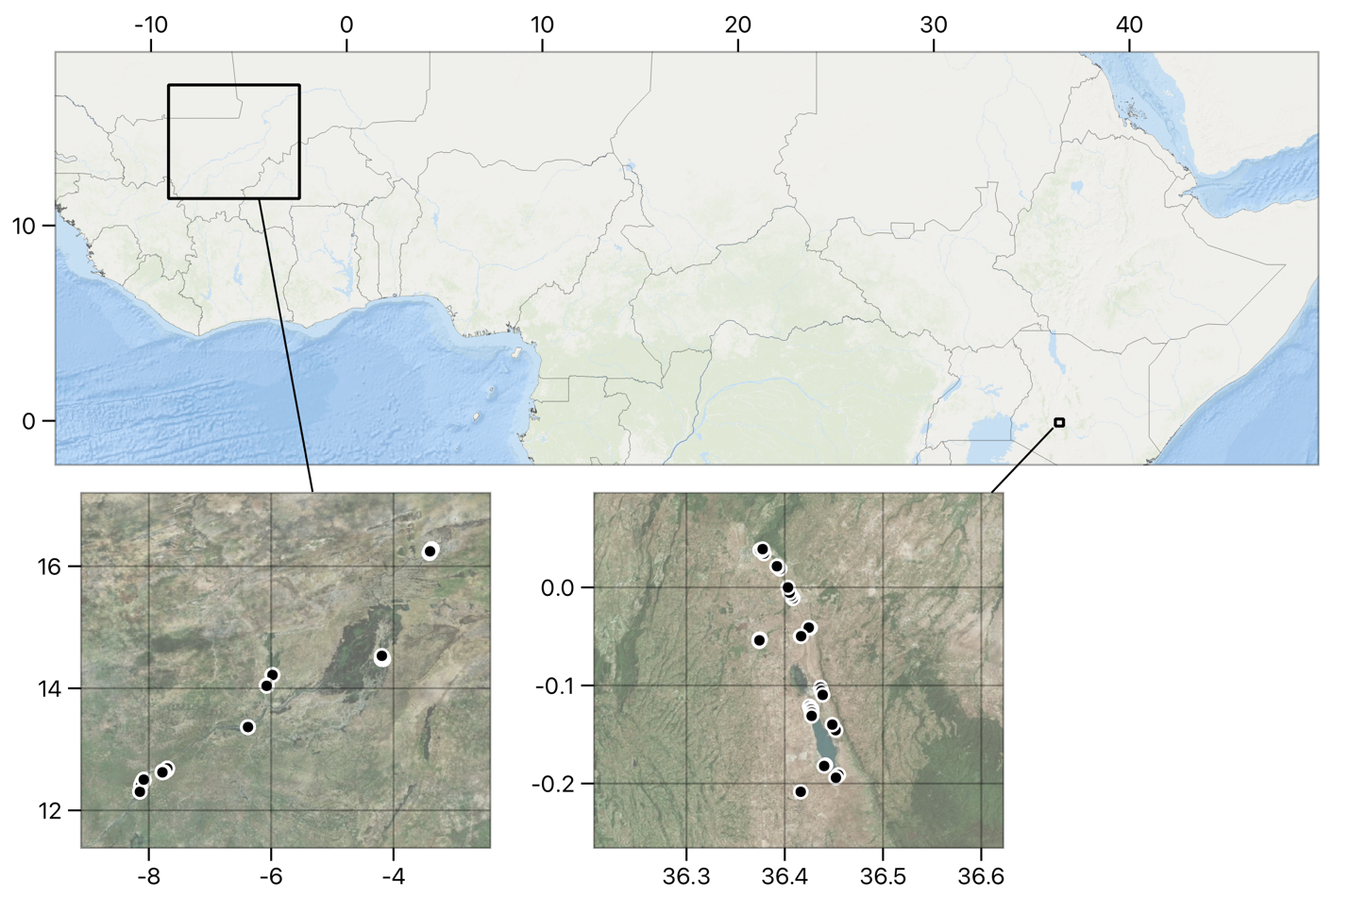
- Location of ground-truth sites in Mali and Kenya. Basemap imagery provided by Bing Imagery and ESRI Ocean Basemap.
At each location, field teams were tasked with making observation within a variety of inundation conditions, e.g. open water, water with emergent herbaceous vegetation (ranging from tall grasses to low grasses), wet soils, floating vegetation, cloudy/clear water, small/large extent water bodies, emergent vegetation with taller shrubs and/or trees, as well as recording observations where no water was present.
At each sampling point a record of the time, photo(s), xy coordinate and characterisation of inundation and land cover conditions was made (see the summary table below). Observations were made within a 30 x 30 m area, assuming the field surveyor was positioned at the centre of the area. Data was recorded using a bespoke EpiCollect (https://five.epicollect.net/) data collection form.
- List of the data recorded at each sample point
Question
Date
Time
Site ID
Mobile coordinates
Photo North
Photo East
Photo South
Photo West
Land cover type
Waterbody
Marsh
Grassland/pasture
Artificial
Crops: rice
Crops: other
Bare sand/soil
Other
Standing water?
Yes
No
Waterbody type
River
Pond
Stream
Spring
Floodplain
Rain-fed temporary
Other
Size of waterbody
﹤5m
5-10m
10-30m
﹥30m
Multiple small (﹤5m)
Multiple large (﹥5m)
Depth of water
Shallow (less than ankle depth)
Deep
Wet soil
Turbidity/cloudiness
Fully clear
Partially clear
Fully cloudy/muddy
Presence of flooded vegetation?
Yes
No
Flooded vegetation type
Grasses
Shrubs/trees
Marsh/reeds
Floating
% cover of flooded vegetation
0-20 %
20-40 %
40-60 %
60-80%
80-100%
Flooded vegetation canopy height
﹤20 cm
20-50 cm
50-100 cm
1-2 m
2-5 m
﹥ 5 m
Photo(s) of dominant flooded vegetation type
Evidence of previous standing water?
Yes
No
Maybe
Presence of non-flooded vegetation?
Yes
No
Dominant Vegetation (non-flooded)
Grass
Shrubs
Trees
Crops
Photo of Dominant vegetation
Leaf moisture
Low (dry/brown grass)
Medium (grass green & brown mixed)
High (grass is green)
Evidence of burning (i.e. charred ground/burnt vegetation)
Yes
No
Wetland position (e.g. edge of floodplain, non-wetland escarpment, lake shore etc.)
Addition comments?

References
1. Hardy, A., Oakes, G. & Ettritch, G. Tropical wetland (tropwet) mapping tool: the automatic detection of open and vegetated waterbodies in google earth engine for tropical wetlands. Remote Sens (Basel) 12, 1182 (2020).
2. Pekel, J.-F., Cottam, A., Gorelick, N. & Belward, A. S. High-resolution mapping of global surface water and its long-term changes. Nature 540, 418–422 (2016).
3. Hansen, M. C. et al. High-resolution global maps of 21st-century forest cover change. Science 342, 850–853 (2013).

