Supplementary Information of:
Quantum Tunnelling based Ultra-compact and Energy Efficient Spiking Neuron in 45nm Silicon-on-Insulator Technology enables Hardware Liquid State Machine
Ajay K. Singh, Vivek Saraswat, Udayan Ganguly, Maryam Shojaei Baghini
Department of Electrical Engineering, Indian Institute of Technology Bombay, Mumbai-400076, India
Supplementary Information 1: Measurement Setup
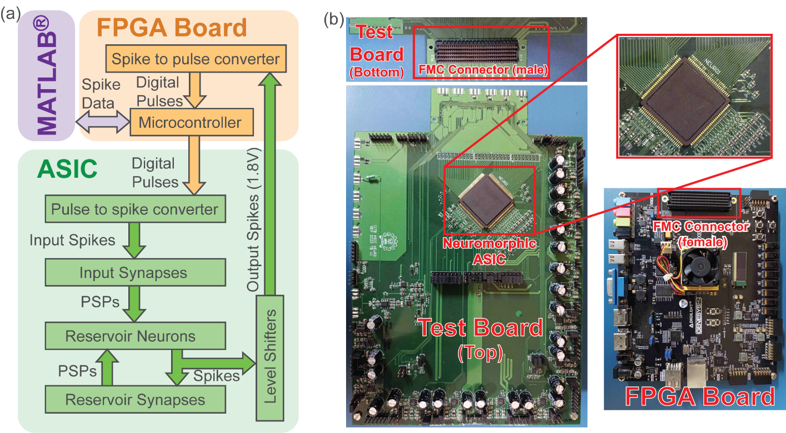
Fig. S.1 Measurement Setup. (a) Block diagram of measurement setup used. (b) Photo of FPGA board and custom made test board used for the measurement.
The Block diagram of the measurement setup used is shown in Fig. S.1(a). MATLAB® is used to generate input spikes data for the reservoir. An FPGA is used to send/receive generated spike data from the computer to the ASIC chip. A soft microcontroller is implemented in FPGA to facilitate data communication between the computer and the ASIC. The data communication between the computer and microcontroller is done using Universal Asynchronous Receiver/Transmitter (UART) protocol. The spike data received from the computer is converted to digital pulse format. A pulse means a spike and no pulse means no spike. The FPGA board is connected to the custom made test board using a high-pin count (HPC) FPGA Mezzanine Card (FMC) connector. The ASIC contains a pulse to spike converter stage which converter the digital pulses received from the FPGA to spike signal. These input spike signals are then converted to postsynaptic pulses (PSPs) by input synapses which are then applied to LSM neurons. The output spikes generated by the LSM reservoir are level shifted to 1.8V using level shifters and then sent to FPGA. Since the spikes generated by the LSM reservoir are very narrow, a microcontroller operating at a very high clock frequency (clock period less than spike duration) is required to detect spikes. Therefore, to avoid the high-frequency requirement, a spike to pulse converter is used to elongate the spike duration to be able to read the output spikes. These pulses are then sent back to the computer via the microcontroller. Fig S.1(b) shows the photo of the test board and the FPGA board used for the measurement. The test board contains the ASIC (Neuromorphic test chip), voltage regulators to supply the test chip and multichannel digital-to-analog (DAC) to generate bias voltages.

Supplementary Information 2: BTBT Neuron Static Power
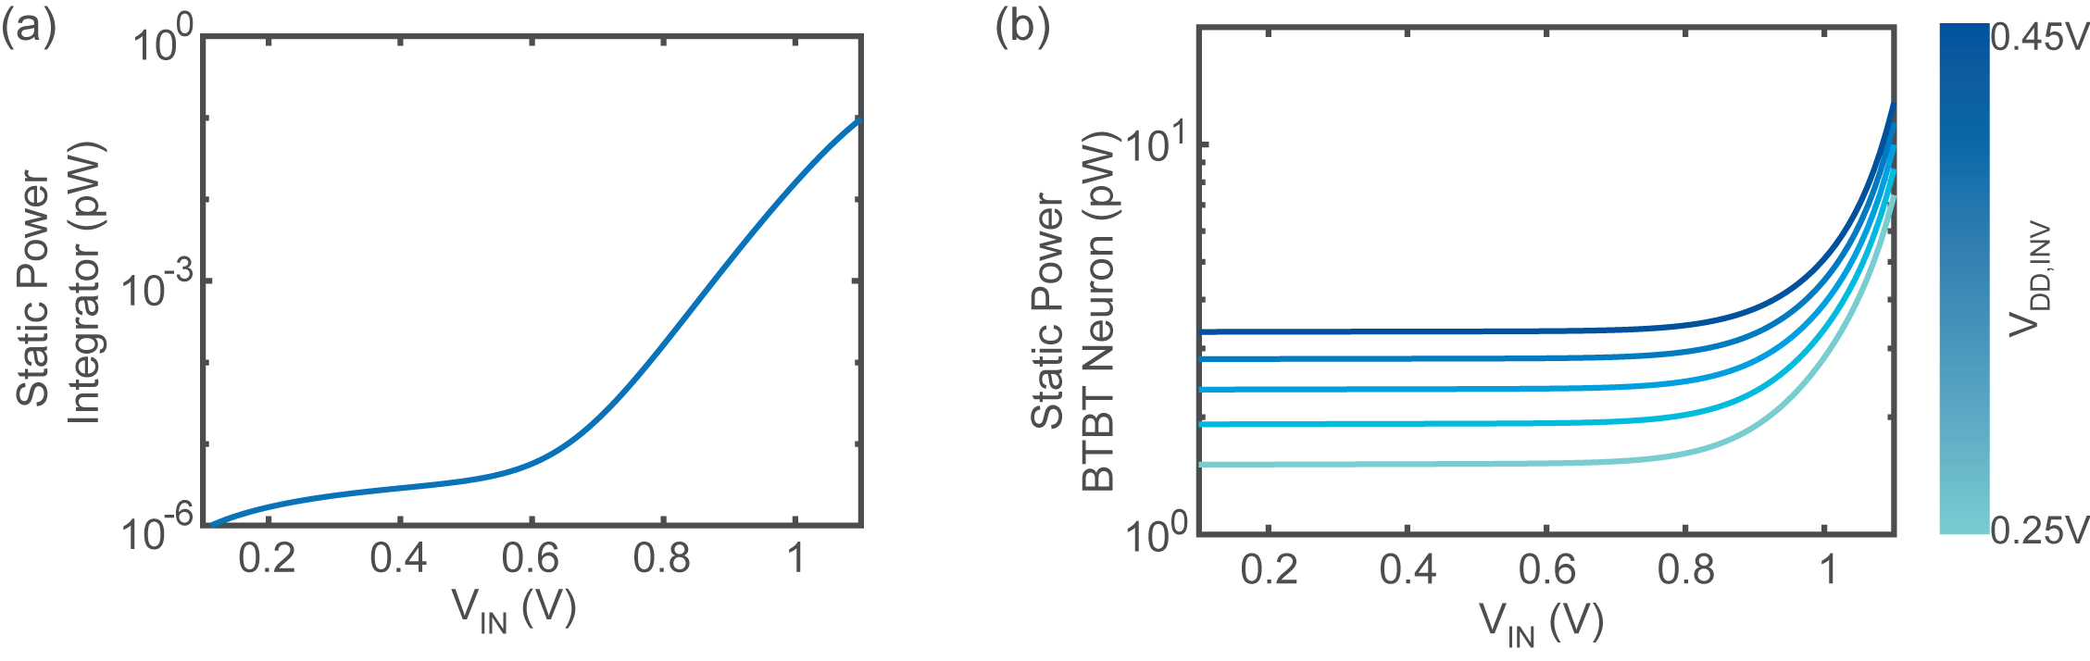
Fig. S.2 Static power of BTBT neuron. (a) Static power of the integrator versus input voltage V_{IN}. (b) Total static power of the BTBT neuron versus input voltage V_{IN} for various inverter supply levels (V_{DD,INV}). Inverter static power is the dominant contributor to the total static power of the neuron.

