Additional file 2
1. Additional Figure 1: Comparison of TKI-related adverse event occurrence in the pre-TKI HU and direct TKI subgroups according to first-line 2G-TKI (nilotinib, bosutinib or dasatinib). Percentage of patients with adverse events that occurred within the first 12 months of TKI treatment in the direct TKI group (blue bars) and the pre-TKI HU group (red bars), according to the prescribed first-line TKI: A. Nilotinib, B. Bosutinib C. Dasatinib. Direct TKI group = 430 patients including 74 nilotinib, 45 bosutinib, and 16 dasatinib, and pre-TKI HU group = 370 patients including 111 nilotinib, 35 bosutinib, and 24 dasatinib. *p < 0.05 (Pearson’s chi-square test).

A
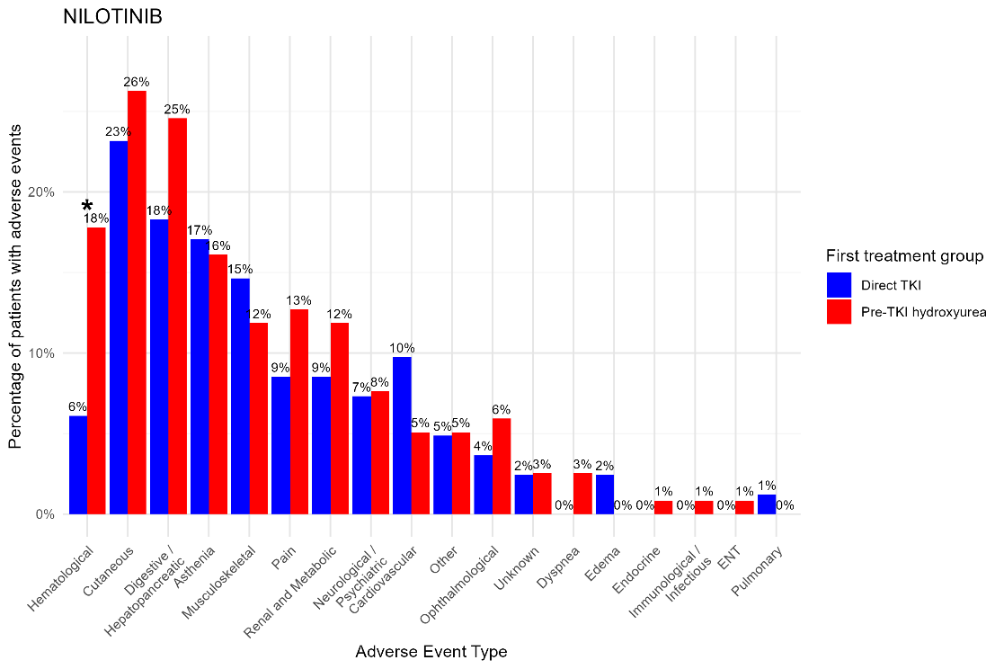
B
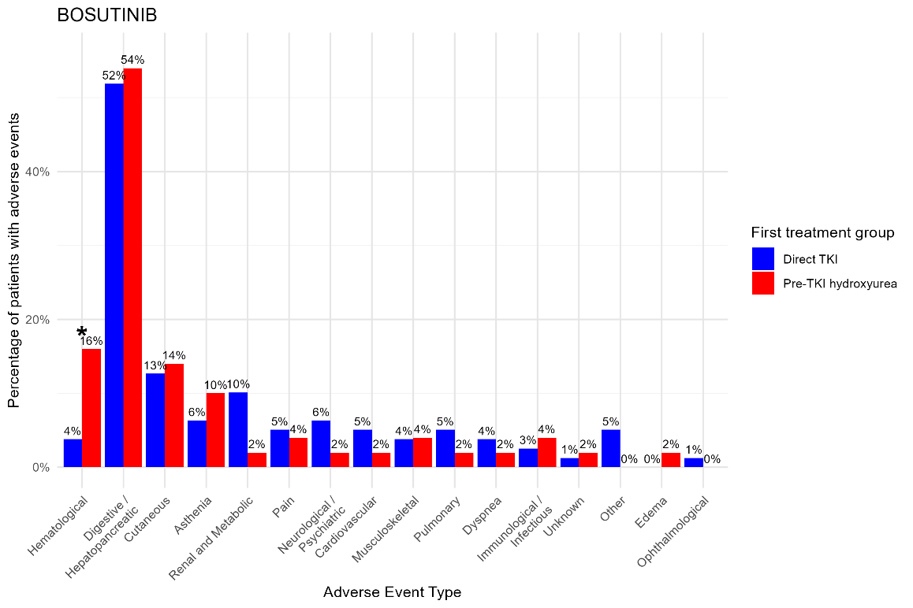
C
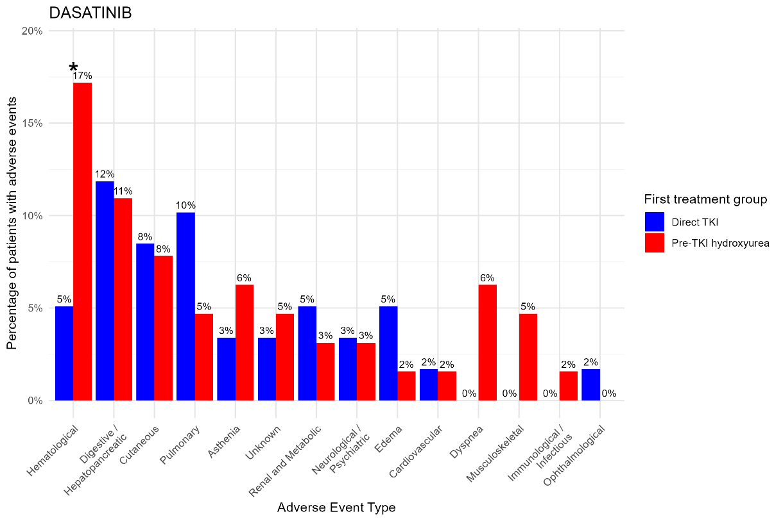

2. Additional Figure 2: Unweighted Kaplan-Meier curves of the indicated molecular milestones in the direct TKI and pre-TKI hydroxyurea (HU) groups in the whole cohort (A-C), in imatinib-treated patients (D-F) and 2G-TKI-treated patients (G-I) (see flowchart in Figure 3).
Imatinib
All TKIs
2G-TKIs
A
G
D
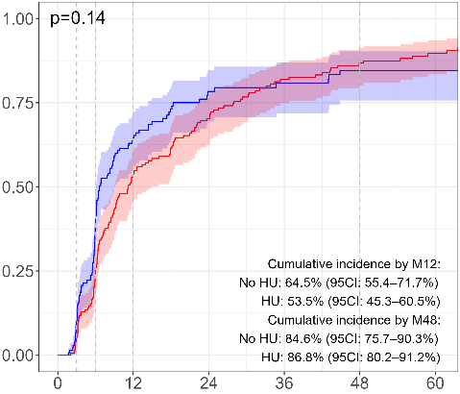
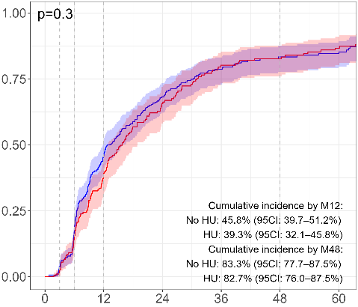
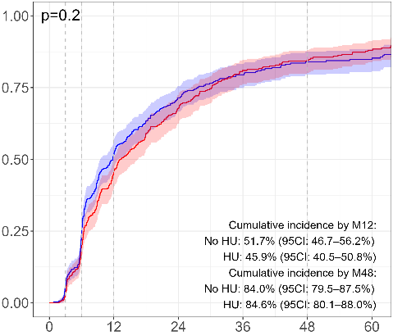
MR3

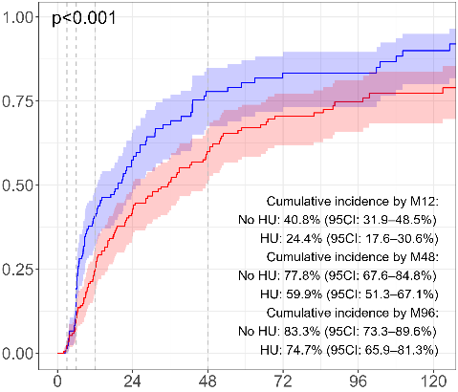
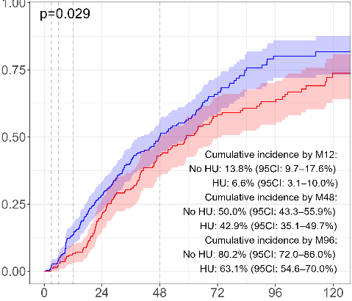
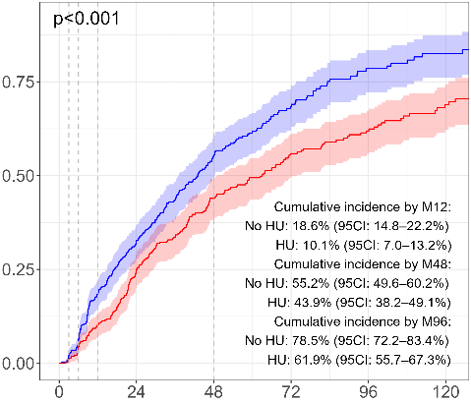
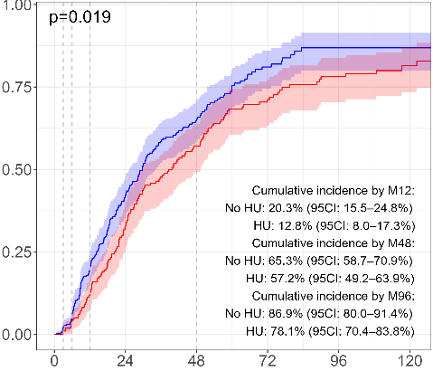
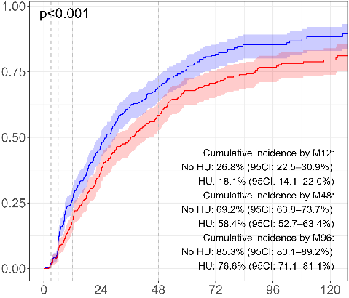
Red: Hydroxyurea pretreatment; Blue: Direct TKI without hydroxyurea pretreatment
H
I
F
E
C
B
MR4.5
MR4
Months since first-line TKI treatment initiation
3. Additional Figure 3: Cumulative incidence of first TKI switches during the 60 months of follow-up according to the reason in the pre-TKI HU group (red) and direct TKI group (blue) from the whole cohort. Switches were classified as due to intolerance (A) and resistance (B). These reasons were considered as competing risks with other switch types and death. (C) Percentages (and 95% Confidence Interval) of patients in the two groups who switched TKI at months 12, 24, 36, and 60.
A
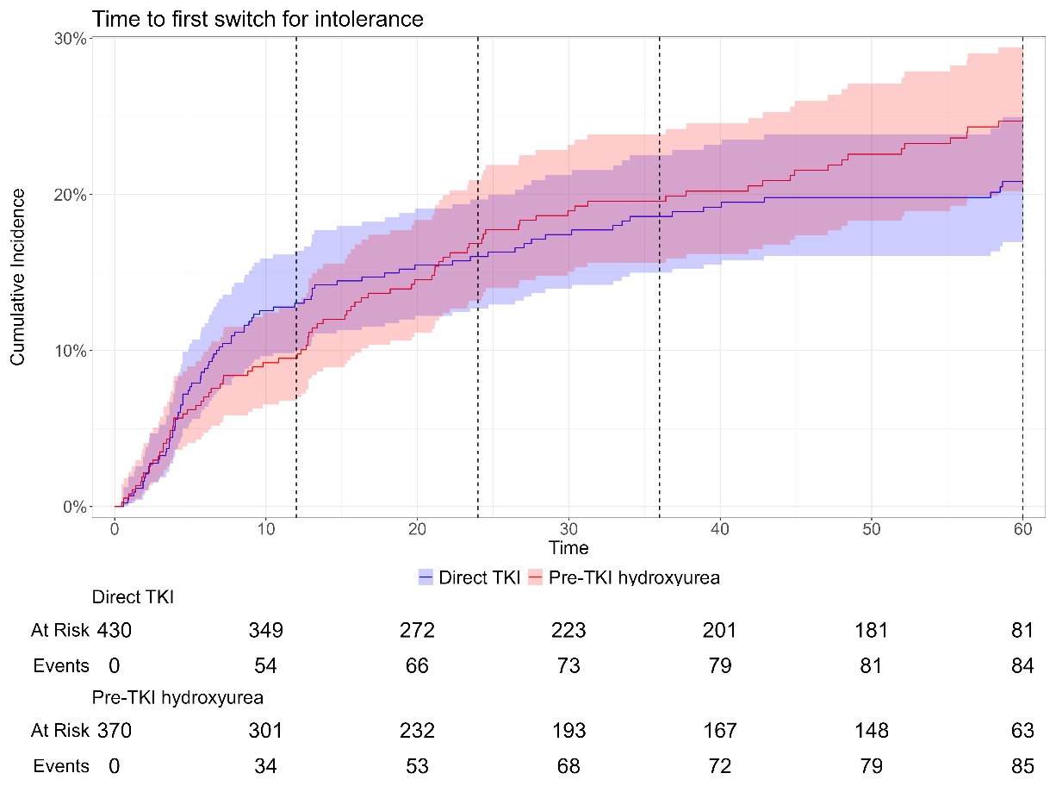

B
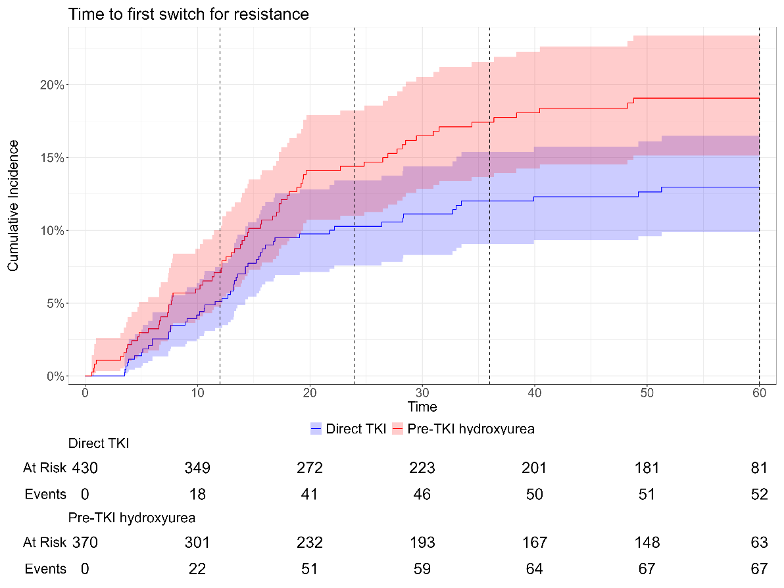

C
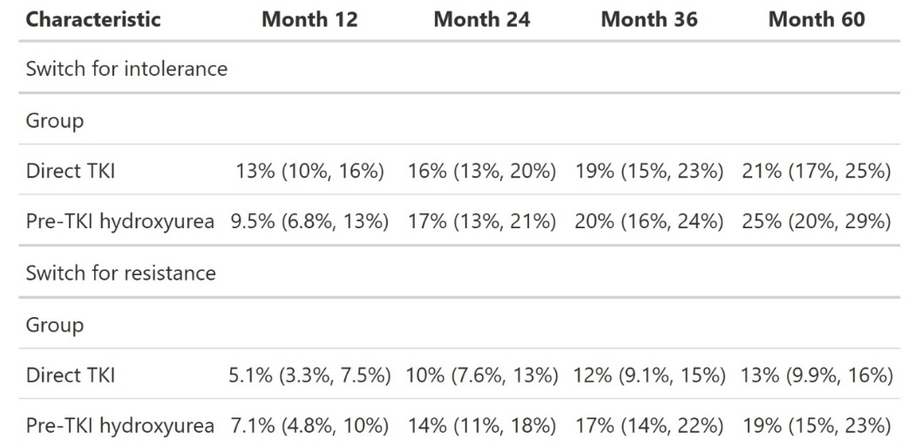

4. Additional Figure 4: Individual white blood cell count kinetics during the first 60 days of treatment.
Leukocytosis was quantified from day 0 to day 60 after initiation of the first treatment (TKI or HU) for each patient (dots and pale lines). Thick curves and their confidence intervals correspond to the mean value predicted for each group. The vertical red line corresponds to the median duration of HU pretreatment (16 days).
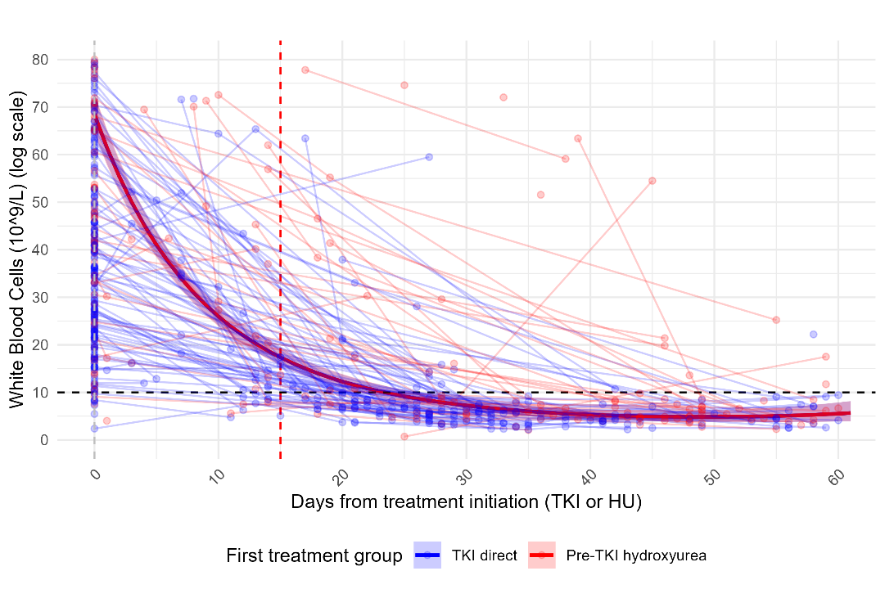
5. Additional Figure 5: Change in the percentage of patients who received HU before TKI initiation from 2010 to 2025.