Supplementary Information

Quantum dots based in-vitro co-culture cancer model for identification of rare cancer cell heterogeneity

Satyanarayana Swamy Vyshnava¹, Gayathri Pandluru¹, Kanderi Dileep Kumar², Shiva Prasad Panjala³, Swathi Banapuram³, Kameshpandian Paramasivam⁴, Kothamunireddy Varalakshmi Devi⁵, Roja Rani Anupalli³ and Muralidhara Rao Dowlatabad*¹

¹Department of Biotechnology, Sri Krishnadevaraya University, Anantapuramu, A.P, India.
²Department of Microbiology, Sri Krishnadevaraya University, Anantapuramu, A.P, India.
³Department of Genetics and Biotechnology, Osmania University, Hyderabad, T.S, India.
⁴Department of Forensic science, Ultra arts, and science college, Madurai, T.N, India.
⁵College of Pharmaceutical Sciences, Sri Krishnadevaraya University, Anantapuramu, A.P, India.

*Corresponding author
Dr. Muralidhara Rao Dowlatabad,
Department of Biotechnology,
Sri Krishnadevaraya University,
Anantapuramu, A.P, India. 515 003,
Email id: rao.muralidhara@gmail.com

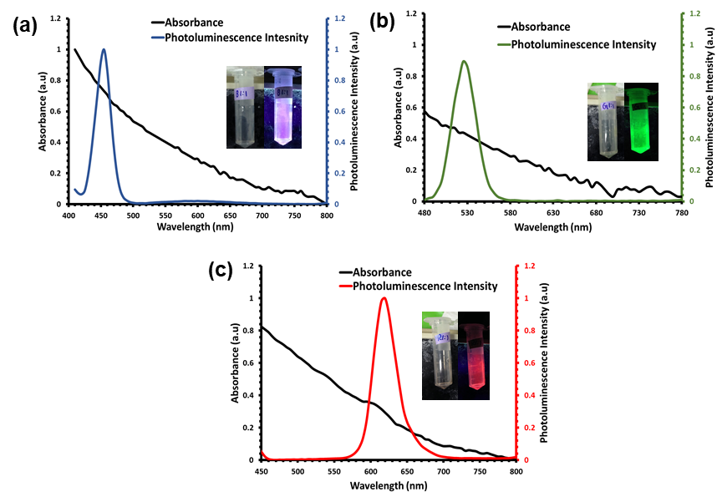

Fig S1. Quantum dots conjugated with amine-polyethylene glycol-propionic acid (nPEGc) and streptavidin moieties which are ready to bind with biotin based anti-EpCAM, anti-CD45 and anti-CD44 antibodies by strong biotin streptavidin reaction, which shows the fluorescence intensities when measured with UV-Visible fluorescence spectroscopy (a) QD⁴⁵⁰ showing fluorescence at 450 nm and strong absorbance 410nm, insight shows the blue fluorescence (b) QD⁵²⁵ showing fluorescence at 525nm and strong absorbance 480nm, insight shows the green fluorescence (c) QD⁶¹⁵ showing fluorescence at 615nm and strong absorbance 580nm, insight shows the red fluorescence

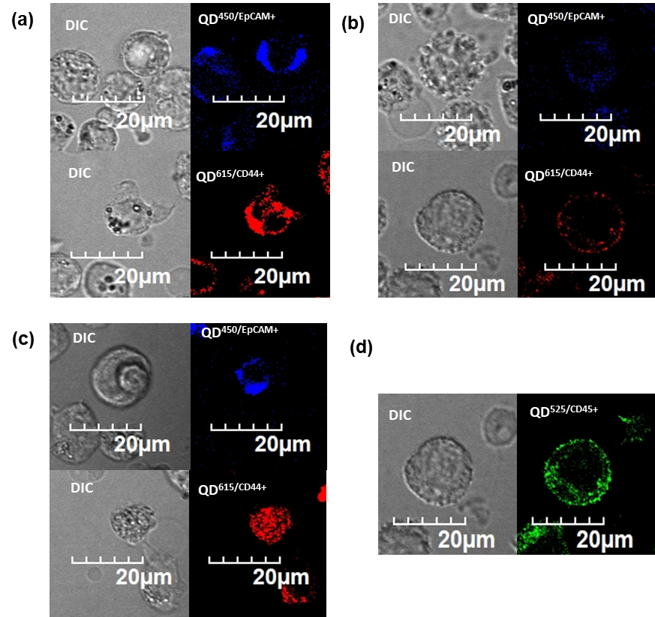

Fig S2. Confocal Microscopy imaging of the quantum dots conjugated with anti-EpCAM, anti-CD45 and anti-CD44 antibodies (a) MCF-7 cell lines with respective fluorescence emission for anti-EpCAM and anti-CD44 (b) HeLa cell lines with respective fluorescence emission for anti-EpCAM and anti-CD44 (c) HEK-293 cell lines with respective fluorescence emission for anti-EpCAM and anti-CD44 (d) THP-1 cell lines with respective fluorescence emission for anti-CD45

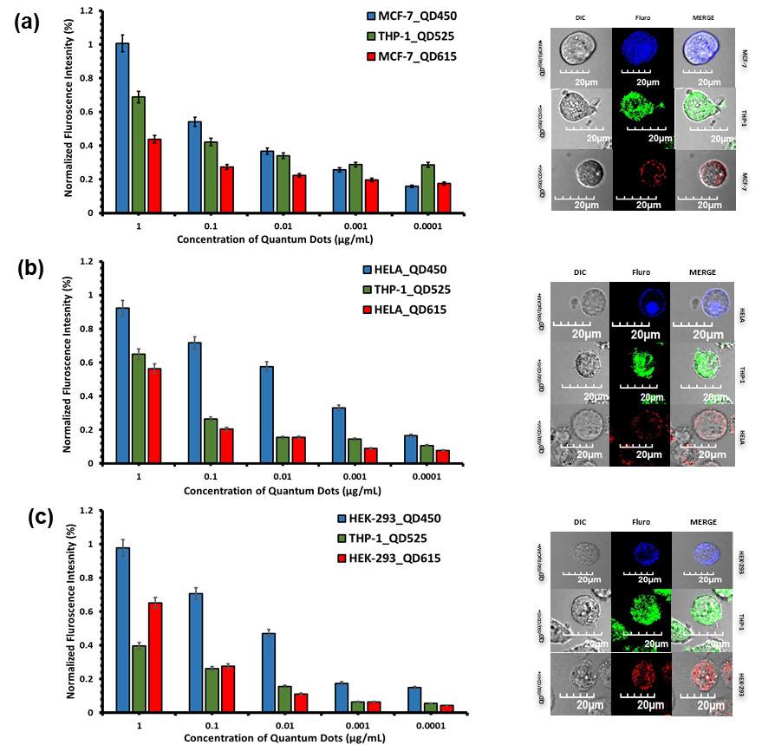

Fig S3. Binding efficacy of the quantum dots conjugated with anti-EpCAM, anti-CD45 and anti-CD44 cells in-vitro incubated with concentrations from 0.0001, 0.001, 0.01, 0.1 and 1.0 μg/mL in DMEM media incubated for 15 minutes (a) MCF-7 and THP-1 cancer cell lines co-cultures with higher fluorescence at 1.0 μg/mL concentration and insight shows the confocal images with respective Quantum dots binding (b) HeLa and THP-1 cancer cell lines co-cultures with higher fluorescence at 1.0 μg/mL concentration and insight shows the confocal images with respective Quantum dots binding (c) HEK-293 and THP-1 cancer cell lines co-cultures with higher fluorescence at 1.0 μg/mL concentration and insight shows the confocal images with respective Quantum dots binding

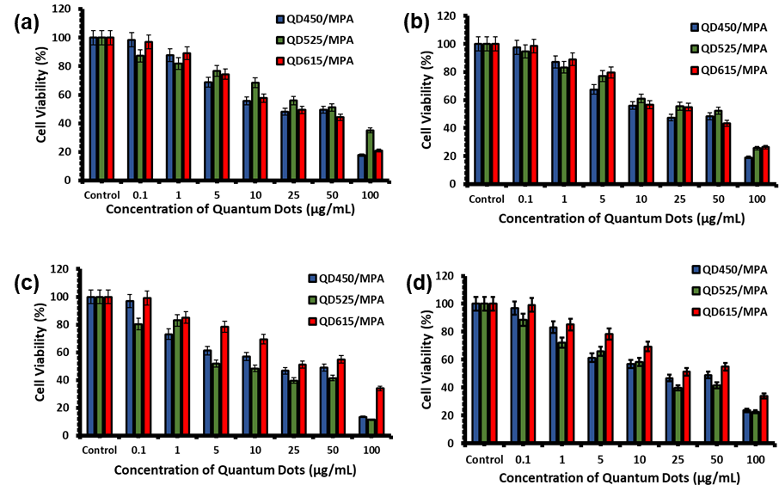

Fig S4. Cytotoxicity of the quantum dots incubated with concentrations from 0.1, 1.0, 5.0,10.0, 25.0, 50, and 100 μg/mL in DMEM media incubated for 24 hours (a) MCF-7 cytotoxicity was initiated at 5 μg/mL (b) HeLa cytotoxicity was initiated at 5 μg/mL (c) HEK-293 cytotoxicity was initiated at 5 μg/mL (d) THP-1 cytotoxicity was initiated at 5 μg/mL , the working concentrations of these quantum dots will be at 1 μg/mL

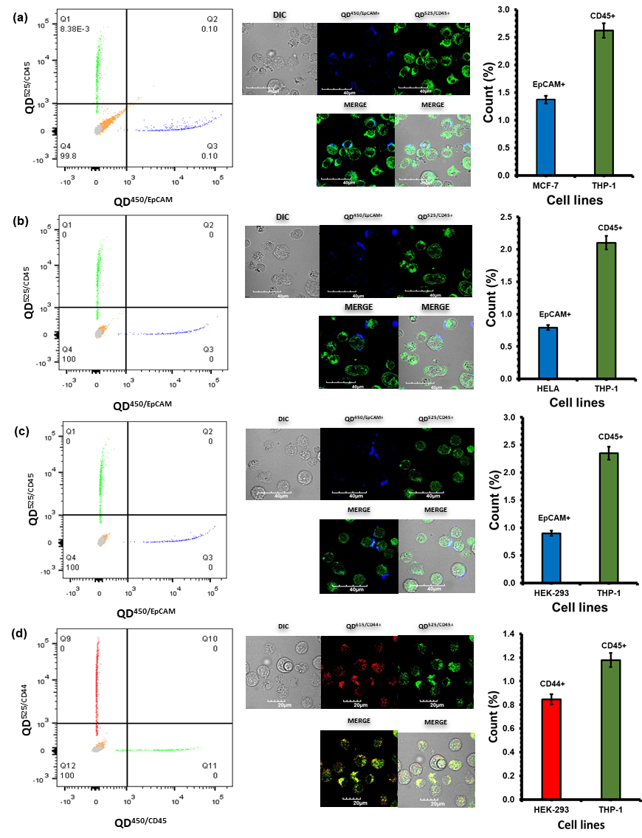
Fig S5. Optimization of quantum dots conjugated with anti-EpCAM, anti-CD45 and anti-CD44 cells in in-vitro with incubated with concentrations at 1μg/mL in DMEM media incubated for 15 minutes when flow in the Flowcytometry followed by exited at 405, 495nm and 590nm lasers (a) MCF-7 and THP-1 (b) HeLa and THP-1 (c) HEK-293 and THP-1 (d) HEK-293 and THP-1 cancer cell lines co-cultures with respective fluorescence emission and insight shows the confocal images with respective Quantum dots binding

Table S1: Quantum dots with specific fluorescence wavelength s coupled with specific antibodies, based on the requirement of the targeted cell lines
Quantum dots | Fluorescence wavelength (nm) | Antibodies bind to QD | Cell lines
QD⁴⁵⁰ | 450 | EpCAM | MCF-7  HeLa  HEK-298
QD⁵²⁵ | 525 | CD45 | THP-1
QD⁶¹⁵ | 615 | CD44 | MCF-7  HeLa  HEK-298

Table S2: Aliquots of specific cell line groups for Quantum dots binding studies
Trails | Cell lines | QD specificity | Number of cells seeded for co-cultures | Mean cell count percentage sorted from flow cytometry
I | MCF-7 | QD^{450/EpCAM} | 2x10⁻³ | 76
I | MCF-7 | QD^{615/CD44} | 2x10⁻³ | 54
I | THP-1 | QD^{525/CD45} | 6x10⁻³ | 78
II | HeLa | QD^{450/EpCAM} | 2x10⁻³ | 62
II | HeLa | QD^{615/CD44} | 2x10⁻³ | 68
II | THP-1 | QD^{525/CD45} | 6x10⁻³ | 82
III | HEK-293 | QD^{450/EpCAM} | 2x10⁻³ | 72
III | HEK-293 | QD^{615/CD44} | 2x10⁻³ | 54
III | THP-1 | QD^{525/CD45} | 6x10⁻³ | 82

