Title
Residual cancer cells in re-excision after breast-conserving surgery: association to invasive lobular breast carcinoma and locoregional recurrence (ISRCTN12077301)

Authors
Anna Allfelt^{1,2}, Pär-Ola Bendahl^{3,4}, Sara Alkner^{3,4,5}, Ulrik Narbe^{3,5}, Kim Gulis^{2,6} Sergio Mosquim Junior³, Lisa Rydén^{1,2,4}, Julia Ellbrant^{1,2}
1. Department of Surgery and Gastroenterology, Skåne University Hospital, Malmö, Sweden.
2. Department of Clinical Sciences, Division of Surgery, Lund University, Lund, Sweden.
3. Department of Clinical Sciences, Division of Oncology, Lund University, Lund, Sweden.
4. Lund University Cancer Center, Lund University, Lund, Sweden.
5. Department of Hematology, Oncology and Radiation Physics, Skåne University Hospital, Malmö and Lund, Sweden.
6. Department of Surgery, Kristianstad Central Hospital, Kristianstad, Sweden.

Corresponding author
Anna Allfelt, Department of Clinical Sciences, Division of Surgery, Lund University, Medicon Village, 223 81, Lund, Sweden (anna.allfelt@med.lu.se). ORCID ID https://orcid.org/0009-0002-7889-9821
Supplementary Materials - Index

Supplementary Figures:

Figure S1. Patterns of locoregional recurrence and histological subtypes at primary surgery and recurrence | page. 10

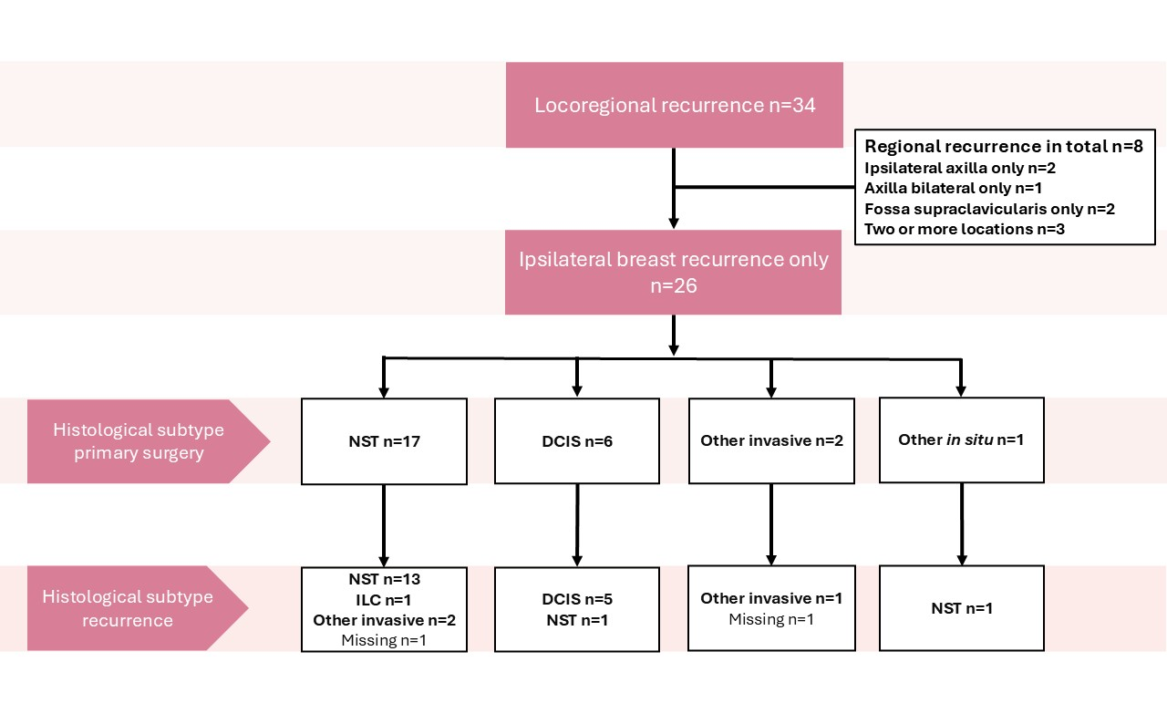
Location of locoregional recurrence and histological subtype at primary surgery and at recurrence. NST, invasive carcinoma of no special type; DCIS, ductal cancer in situ.

Figure S2. Cumulative incidence of locoregional recurrence by ILC and DCIS at primary surgery | page. 10
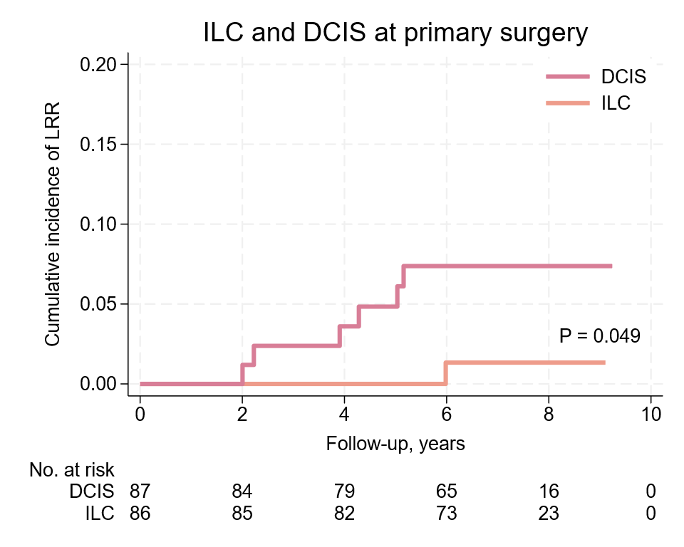
Cumulative incidence curves visualizing locoregional recurrence-free interval (LRFi) by ILC, invasive lobular carcinoma and DCIS, ductal cancer in situ including at-risk patients.

Figure S3. Cumulative incidence of locoregional recurrence by molecular surrogate subtype | page. 10

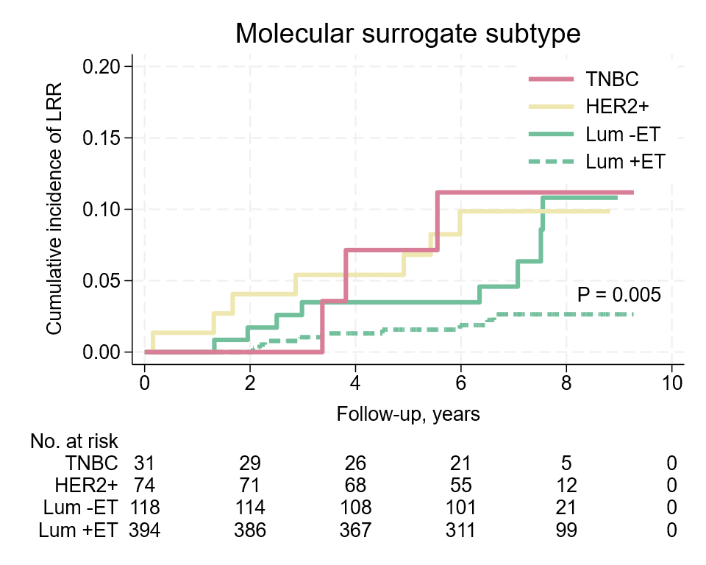

Cumulative incidence curves visualizing locoregional recurrence-free interval (LRFi) by molecular surrogate subtype in four categories: triple-negative breast cancer (TNBC), HER2-positive breast cancer (HER2+), and luminal tumours (ER+/HER2-) with or without endocrine therapy (Lum +/-ET). LRR; locoregional recurrence.

