Appendix A. Preliminary Thin-Film Deposition Attempts
Subsequent presentations and public disclosures related to LK-99 highlighted thin-film transport characteristics, including flat-voltage-like responses, as notable features of the material. Motivated by these reports, high-purity LK-99 samples were reproduced in the present study based on the synthesis procedures described in the original publications and related patents, and preliminary thin-film deposition experiments were subsequently carried out.
However, XRD and grazing-incidence X-ray diffraction (GIXRD) analyses did not provide clear evidence for the formation of the Pb₁₀₋ₓCuₓ(PO₄)₆O apatite phase in the deposited thin films. Nevertheless, electrical measurements revealed voltage–current characteristics qualitatively similar to the flat-voltage-like responses reported in previous LK-99-related presentations.
These observations indicate that transport characteristics alone are insufficient to establish the structural identity of LK-99-related thin films. The results further emphasize that structural characterization, including XRD, GIXRD, transmission electron microscopy (TEM), and compositional analysis, should accompany any interpretation of electrical transport behavior in such thin-film systems.
In addition, nonlinear transport behavior was observed in several thin-film samples deposited on copper substrates. However, such responses may originate from grain-boundary effects associated with polycrystalline multiphase structures, interfacial oxide layers formed between the film and substrate, or other interface-related phenomena. Consequently, these observations were not interpreted as intrinsic thin-film properties and were not included in the main results of this work.
More quantitative and reproducible evaluation of thin-film properties will require the application of controlled deposition techniques such as sputtering, pulsed laser deposition (PLD), or electron-beam evaporation. Additional studies will also be necessary to systematically verify compositional control and structural stability during thin-film growth.

Figure 5. High-Resolution XRD Pattern of the Thin Film Deposited on a Silicon Wafer
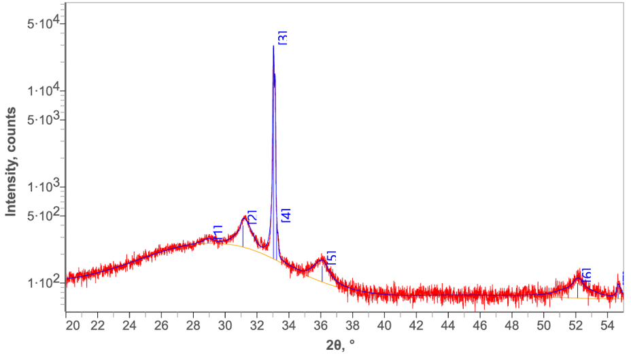
The diffraction peaks are dominated by reflections originating from the Si substrate, while no clear evidence for the formation of the Pb₁₀₋ₓCuₓ(PO₄)₆O apatite phase was identified.

Table 2. Peak positions identified from the thin-film XRD pattern 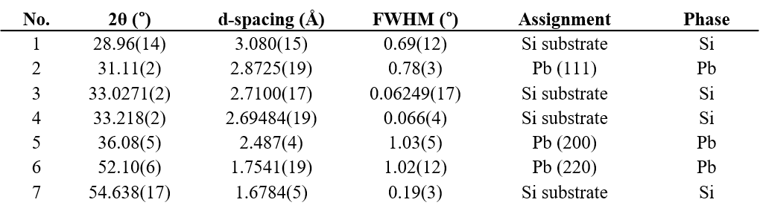
Table 2. Major diffraction peaks identified from the thin-film XRD pattern. The peaks assigned to Pb are consistent with metallic lead (PDF 04-016-5377), while all other diffraction peaks are attributed to the silicon wafer substrate.

Figure 6. Grazing-Incidence X-Ray Diffraction (GIXRD) Patterns of Thin Films Deposited on Cu Substrates
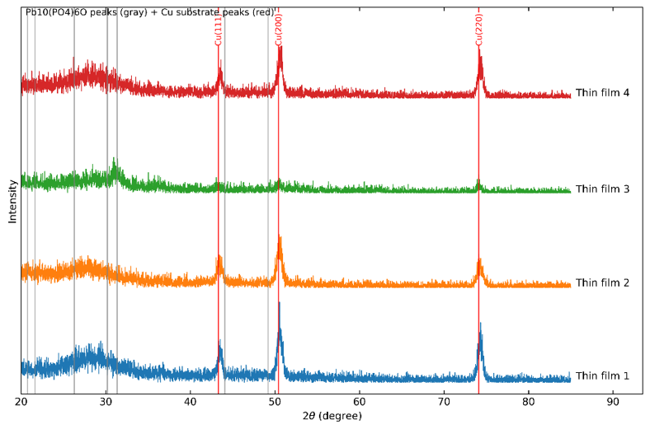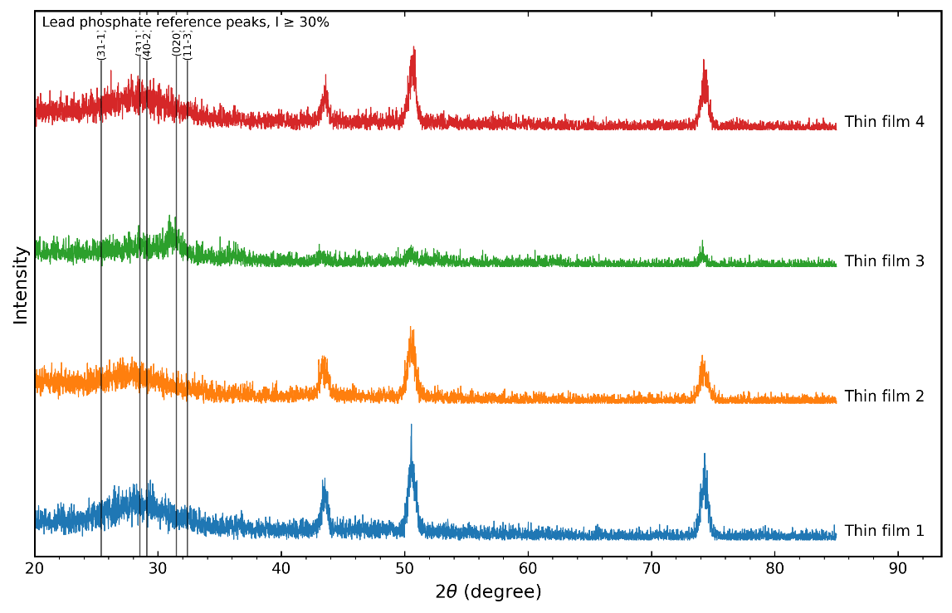
The broad diffuse scattering band observed in the 25–33° 2θ range of the thin-film XRD pattern did not coincide with the principal diffraction peaks expected for Pb₁₀(PO₄)₆O apatite. Instead, the scattering feature overlapped more closely with diffraction regions commonly associated with lead-phosphate-related phases. These observations suggest that the films produced under the present thermal evaporation conditions did not retain a well-defined oxide lead apatite structure. Rather, the deposited films are more consistent with a poorly crystalline Pb-phosphate-based multiphase material and/or an amorphous phase assemblage.

Figure 7. Thin-Film Delta I–V Response on Cu Substrate
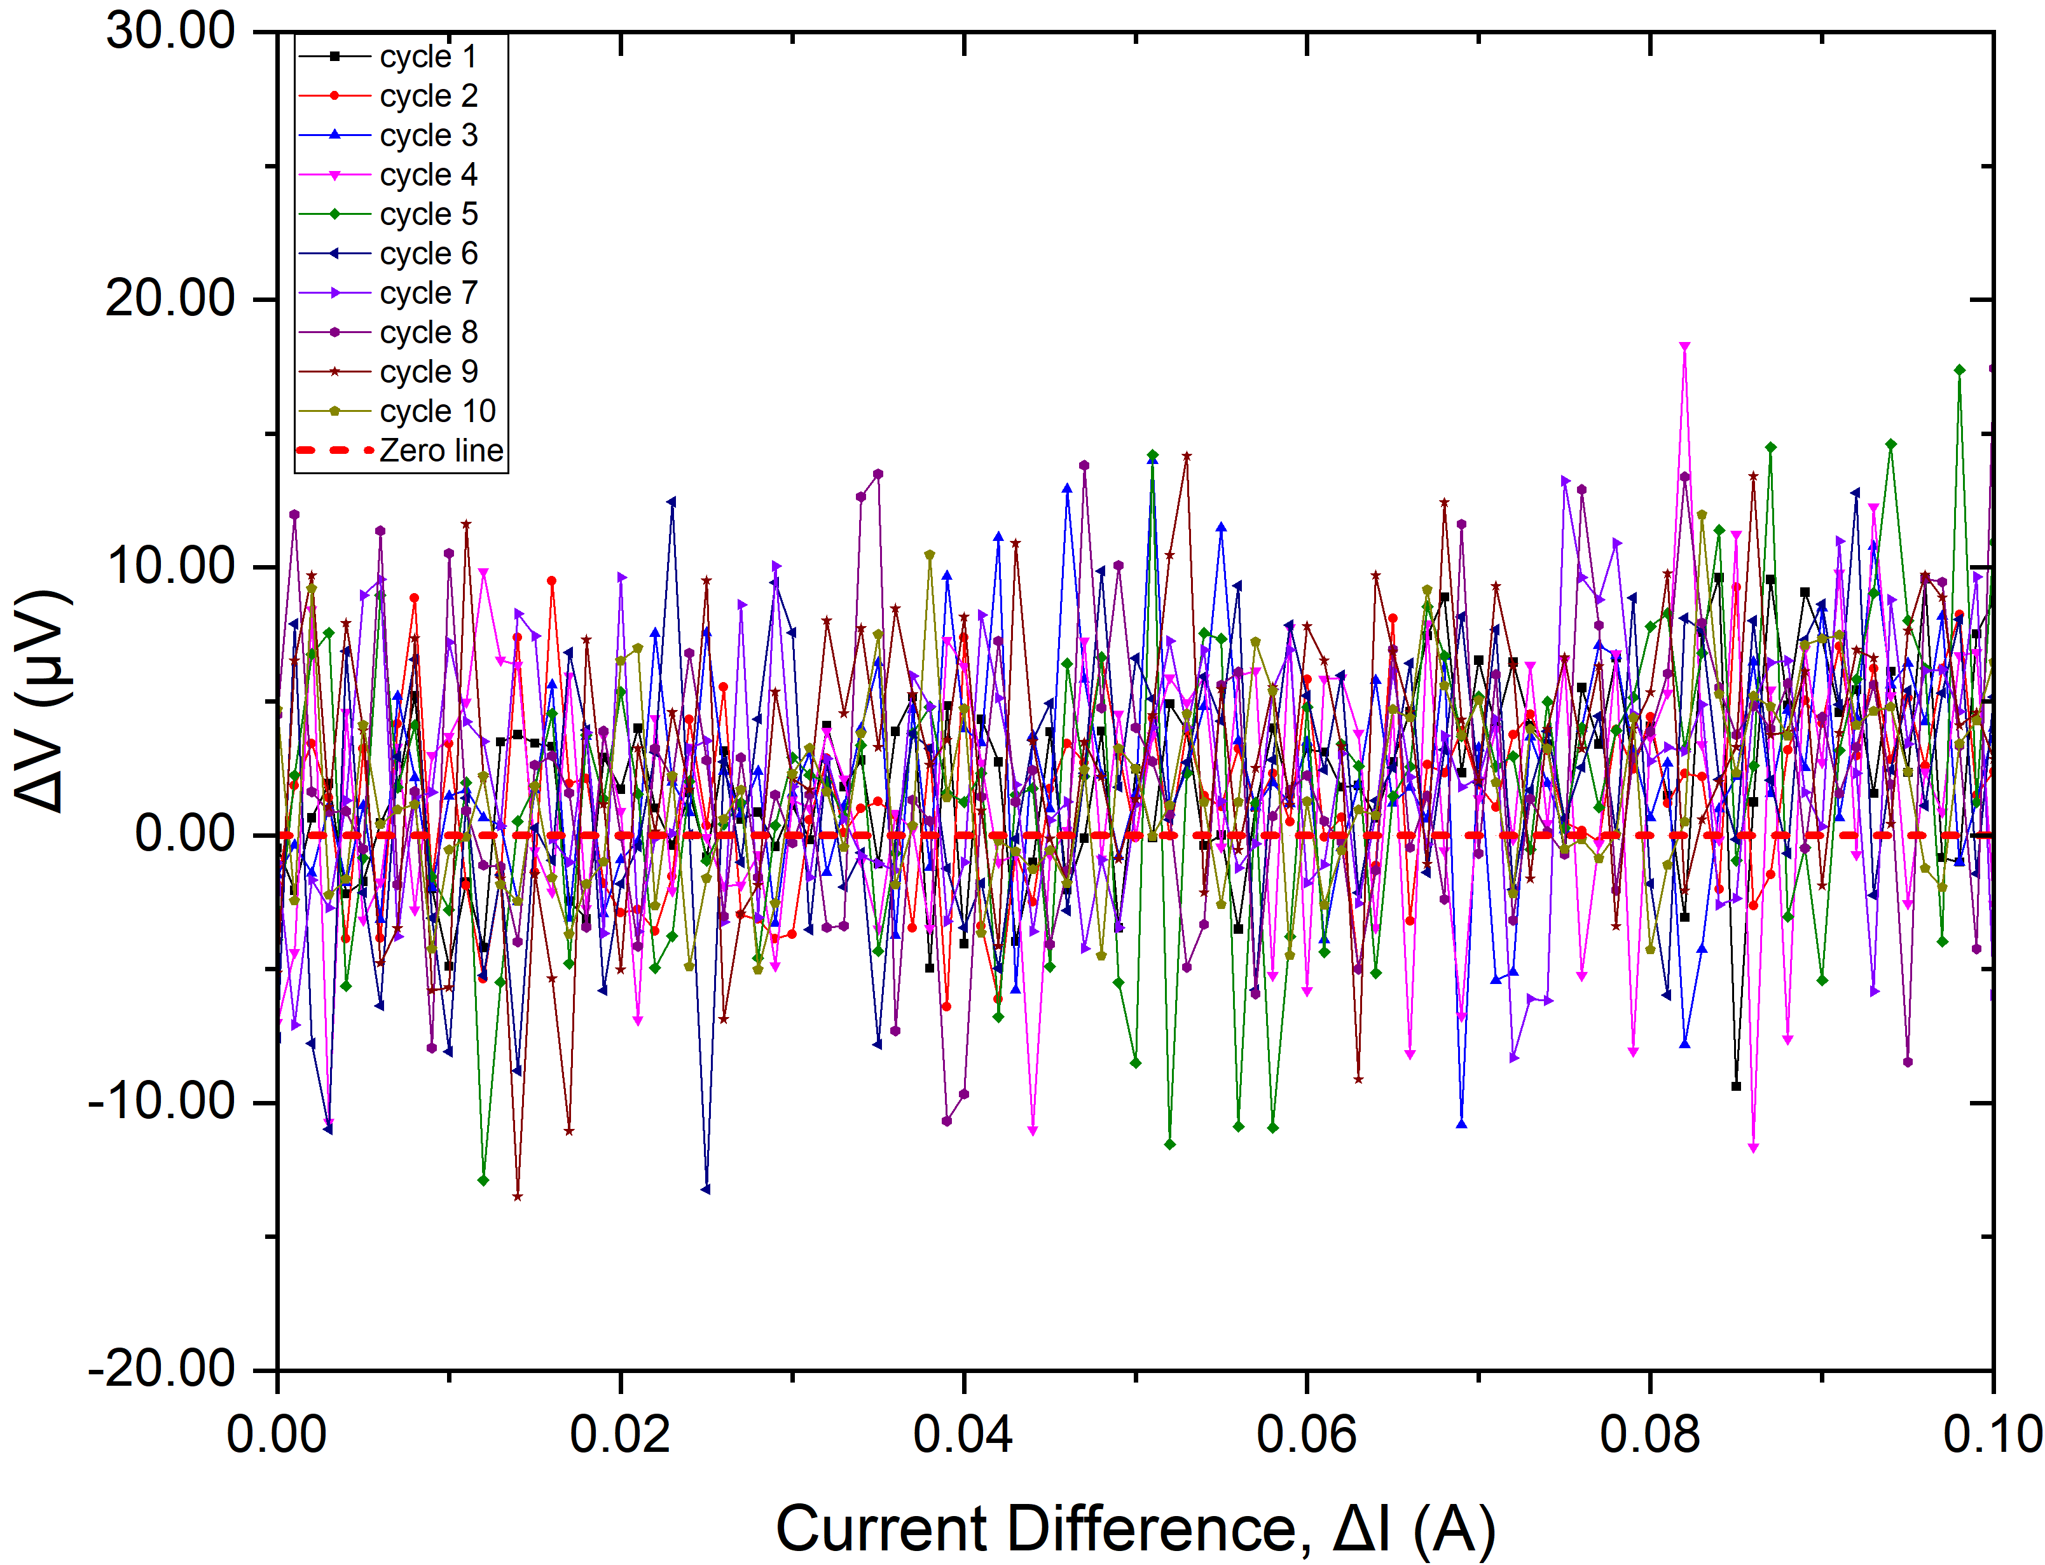
Delta-mode current–voltage (ΔI–ΔV) response measured for a thin film deposited on a copper substrate. A nonlinear transport response was observed. However, XRD and GIXRD analyses did not provide clear evidence for the formation of a Pb₁₀₋ₓCuₓ(PO₄)₆O apatite phase, highlighting the importance of structural characterization when interpreting thin-film transport behavior.
Figure 8. Thin-Film Linear I–V Response on Cu Substrate
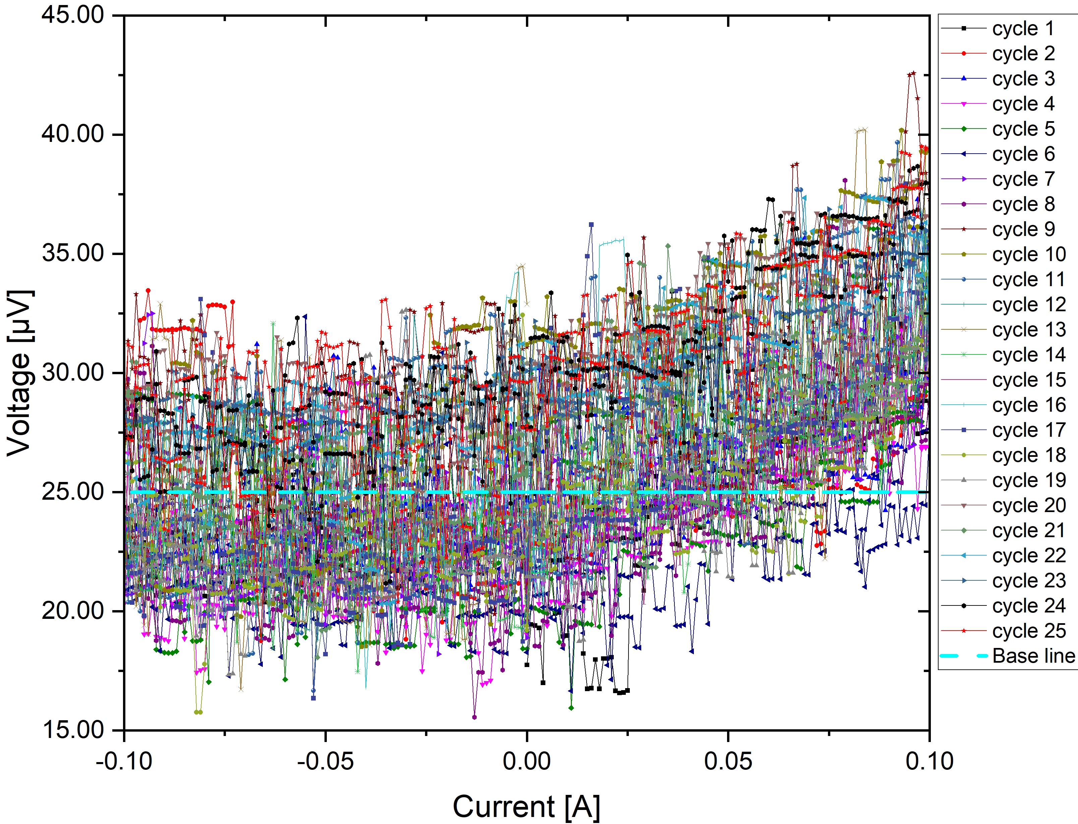
Linear current–voltage (I–V) response measured for a thin film deposited on a copper substrate. The observed transport characteristics differed from those of the bulk pellet samples and may be influenced by grain-boundary effects, interfacial oxide layers, substrate-related effects, or other microstructural factors.

Author's Note
The samples investigated in this study were synthesized on a laboratory scale for research purposes, and only a limited quantity remains available. Nevertheless, a small number of additional samples may be available for independent verification and reproducibility studies. The authors welcome scientific collaboration aimed at objective validation of the present results and encourage independent replication efforts by interested researchers.

