Supporting Information

Direct valorization of real acid mine drainage into MgAlFe-LDHs: structural evolution, sulfate fixation, and anionic pollutant removal
Jierong Wang ^{a#}, Junyu Ren ^{a#}, Dong Zhang^{b}, Meng Zhang ª, Ruijie Guo ^{a,c}, Peide Han ª, Hong Yan ^{a,c∗}
ª College of Materials Science and Engineering, Taiyuan University of Technology, Taiyuan, P.R. 030024, China
^{b} Taiyuan Bilan Hydralic Engineering Design Co., LTD., Taiyuan, Shanxi 030024, P.R. China
^{c} Key Laboratory of Interface Science and Engineering in Advanced Materials (Taiyuan University of Technology), Ministry of Education, Taiyuan 030024, P.R. China

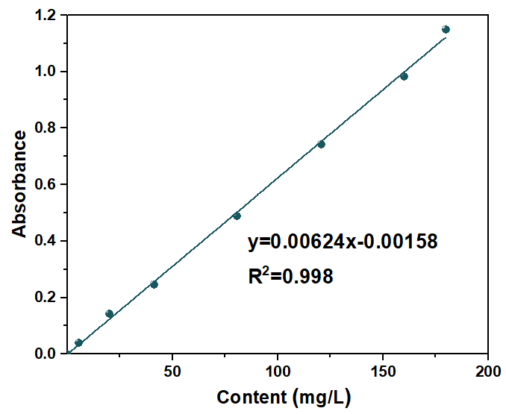
Figure S1 Calibration curve for SO2− 4 concentration determination
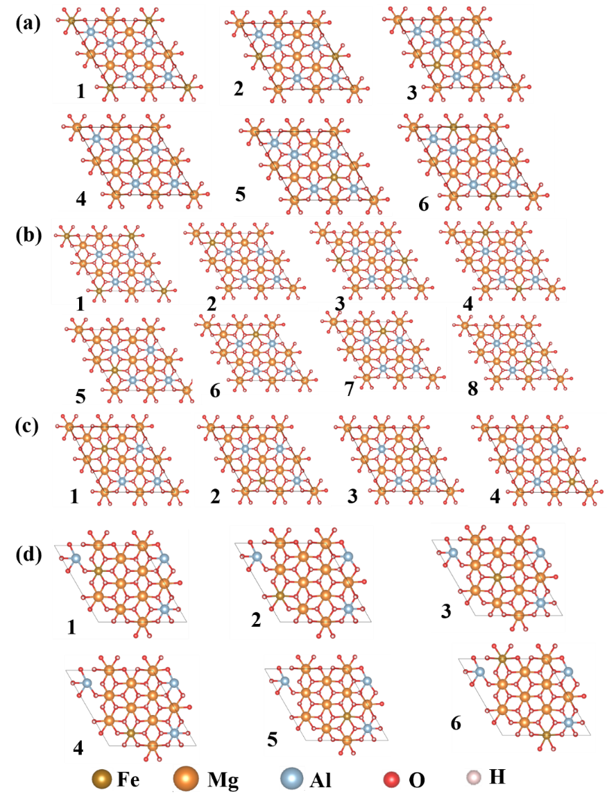
Figure S2 Possible atomic arrangements in the single-layer structure of LDHs at M²⁺/M³⁺=1 (a), 1.5 (b), 2 (c), and 2.5 (d)
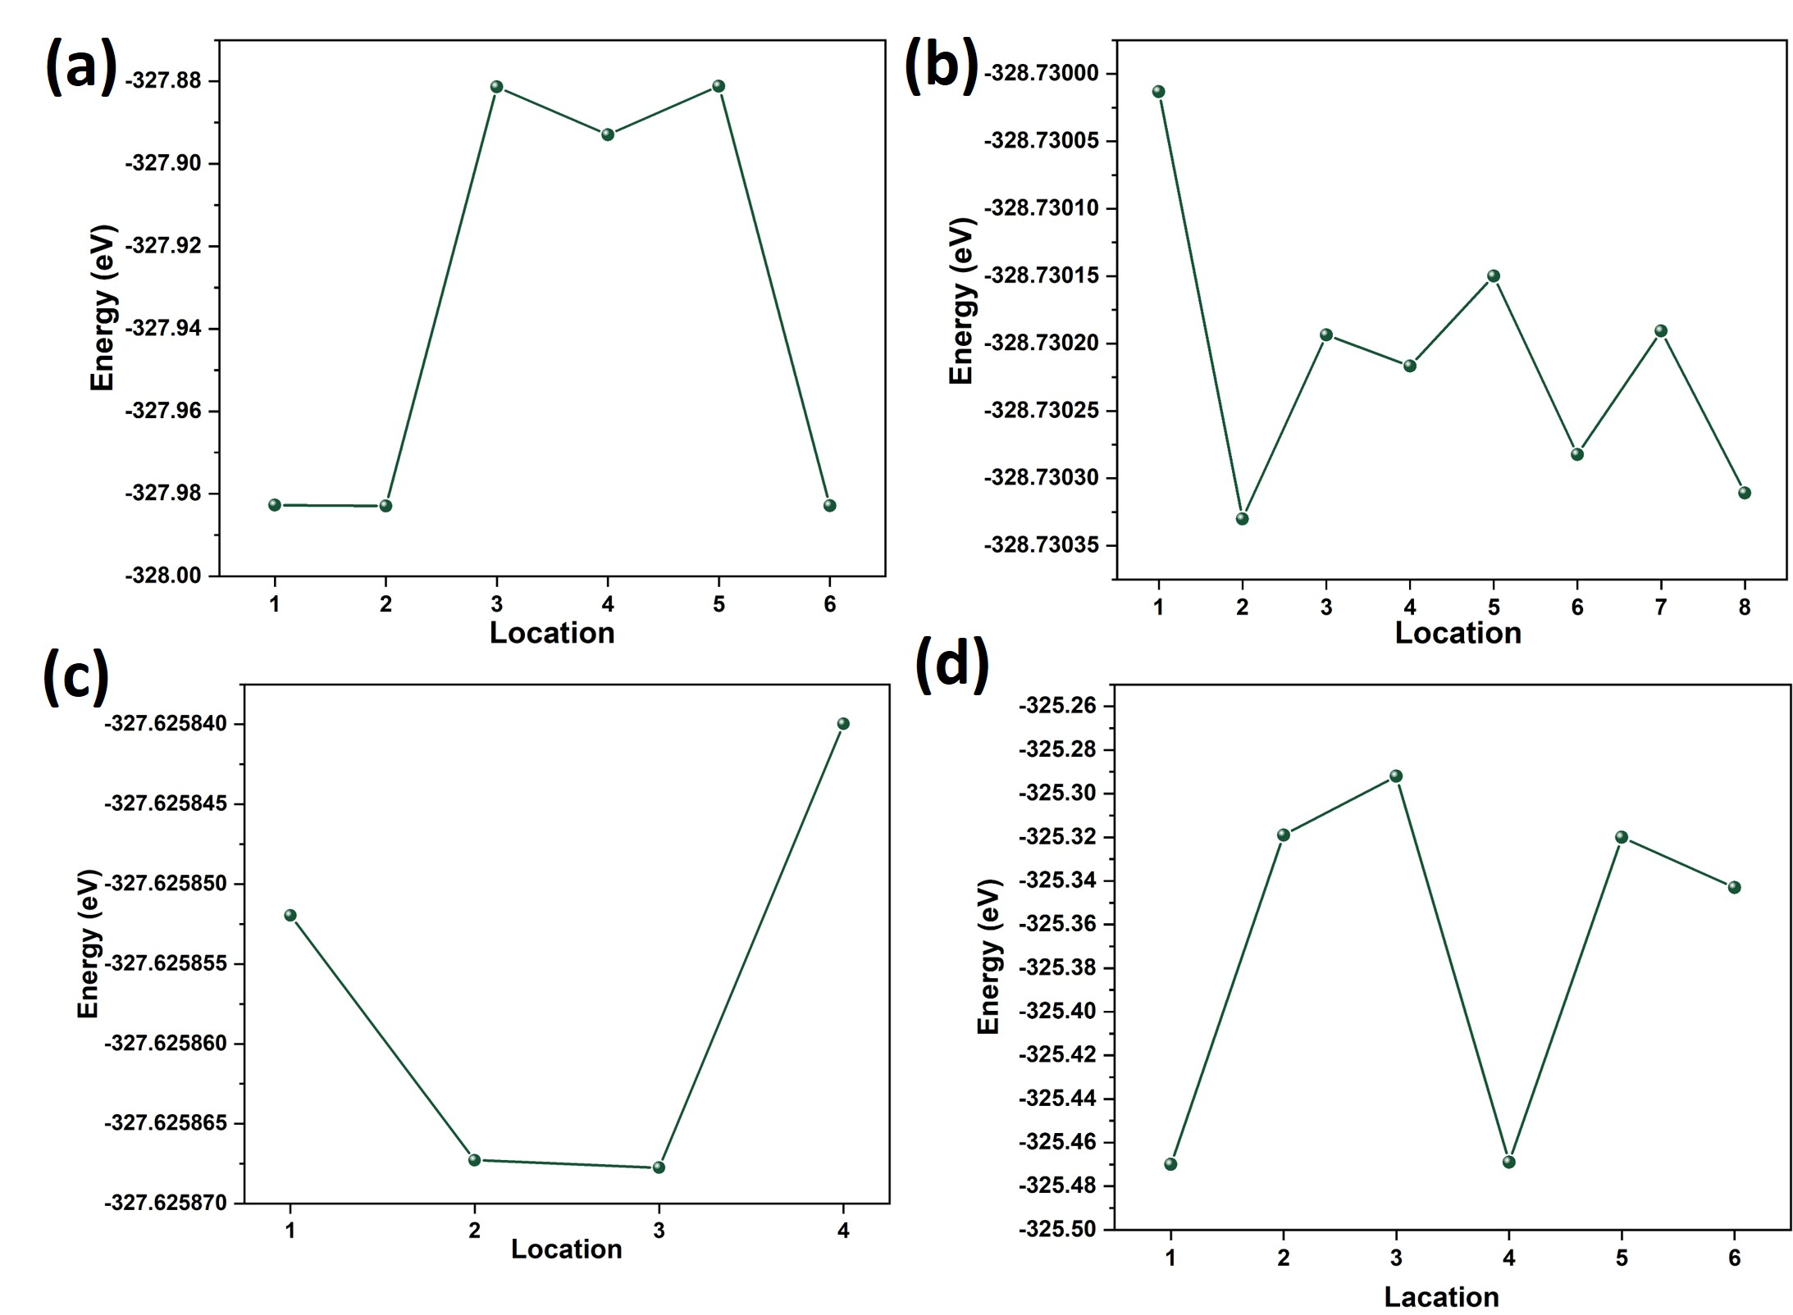
Figure S3 Calculated energies corresponding to the possible single-layer atomic arrangements of LDHs at M²⁺/M³⁺=1 (a), 1.5 (b), 2 (c), and 2.5 (d)

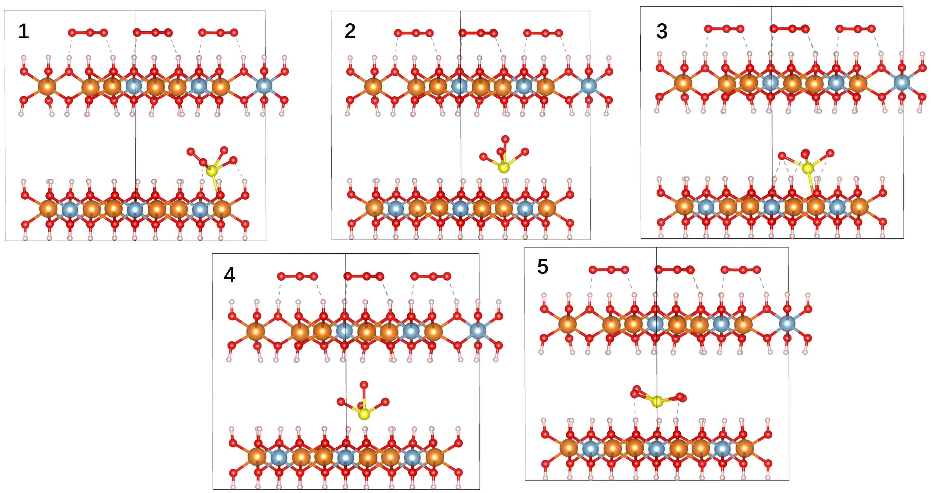
Figure S4 Potential adsorption sites of SO2− 4within the interlayer region of LDHs

Table S1 Removal ratio of metal ions from AMD during LDH formation at different M²⁺/M³⁺ ratios
pH | M²⁺/M³⁺ | Removal ratio (%)
pH | M²⁺/M³⁺ | Fe³⁺ | Al³⁺ | Zn²⁺ | Mn²⁺ | Ca²⁺
8.5 | 1 | 99.96 | 99.89 | 97.76 | 98.45 | 21.68
8.5 | 2.5 | 99.97 | 99.96 | 98.54 | 98.78 | 22.31
9 | 1 | 99.96 | 99.34 | 98.76 | 99.77 | 22.75
9 | 2.5 | 99.97 | 99.96 | 99.19 | 99.80 | 26.01
9.5 | 1 | 99.97 | 98.51 | 99.52 | 99.86 | 26.71
9.5 | 2.5 | 99.99 | 99.99 | 99.83 | 99.92 | 31.91
10 | 1 | 99.78 | 98.96 | 99.74 | 99.98 | 22.53
10 | 2.5 | 99.98 | 99.94 | 99.87 | 99.99 | 31.47

Table S2 Experimental factors and levels for response surface optimization of MO adsorption
Factor | Unit | Code | Code level
Factor | Unit | Code | −1 | 0 | 1
LDHs dosage | g | A | 0.1 | 0.2 | 0.3
pH |  | B | 6 | 7 | 8
adsorption time | min | C | 30 | 135 | 240
Table S3 Box–Behnken design and results
Standard order | Run order | Factor level |  |  | Removal ratio (%)
Standard order | Run order | A | B | C | Removal ratio (%)
1 | 15 | 0.1 | 6 | 135 | 72.2
2 | 5 | 0.3 | 6 | 135 | 81
3 | 2 | 0.1 | 8 | 135 | 70.3
4 | 12 | 0.3 | 8 | 135 | 81
5 | 13 | 0.1 | 7 | 30 | 68.8
6 | 6 | 0.3 | 7 | 30 | 77.6
7 | 4 | 0.1 | 7 | 240 | 83
8 | 9 | 0.3 | 7 | 240 | 92.4
9 | 10 | 0.2 | 6 | 30 | 74.1
10 | 3 | 0.2 | 8 | 30 | 77.5
11 | 8 | 0.2 | 6 | 240 | 88
12 | 7 | 0.2 | 8 | 240 | 87.2
13 | 11 | 0.2 | 7 | 135 | 85.3
14 | 14 | 0.2 | 7 | 135 | 84.9
15 | 1 | 0.2 | 7 | 135 | 83.8

Table S4 ANOVA for the response surface model of MO adsorption
Source | Sum of squares | df | Mean square | F-value | P-value
Model | 663.38 | 9 | 73.71 | 48.53 | 0.0002
A-LDHs dosage | 177.66 | 1 | 177.66 | 116.97 | 0.0001
B-pH | 0.0612 | 1 | 0.0612 | 0.0403 | 0.8488
C-adsorption time | 345.85 | 1 | 345.85 | 227.70 | <0.0001
AB | 0.9025 | 1 | 0.9025 | 0.5942 | 0.4756
AC | 0.0900 | 1 | 0.0900 | 0.0593 | 0.8173
BC | 4.41 | 1 | 4.41 | 2.90 | 0.1491
A² | 88.50 | 1 | 88.50 | 58.27 | 0.0006
B² | 49.08 | 1 | 49.08 | 32.31 | 0.0023
C² | 1.70 | 1 | 1.70 | 1.12 | 0.3381
Residual | 7.59 | 5 | 1.52
Lack of fit | 6.39 | 3 | 2.13 | 3.53 | 0.2286
Pure error | 1.21 | 2 | 0.6033
Total | 670.97 | 14

Figure S5 Comparison between the predicted and actual values of MO removal
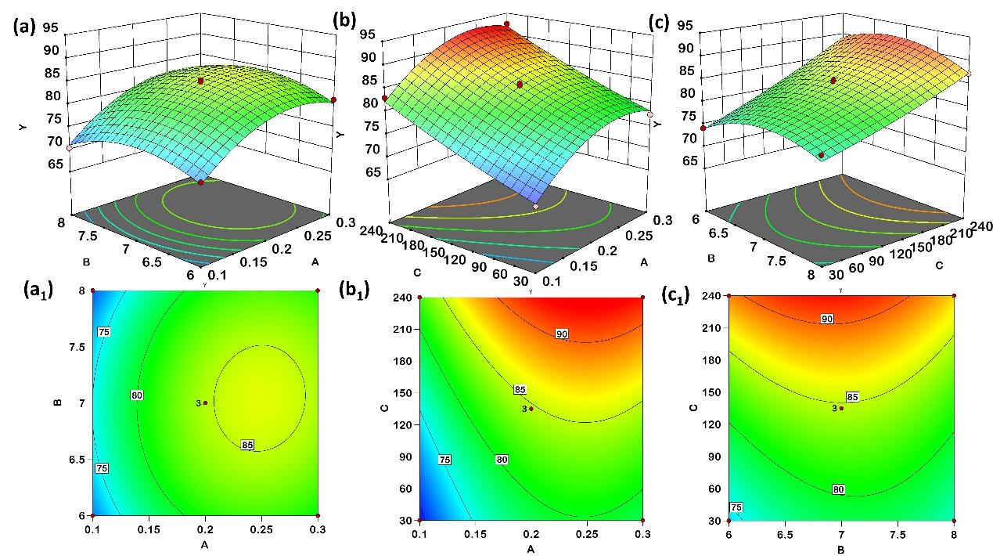
Figure S6 Three-dimensional surface plots and contour plots for the interactive effects of LDHs dosage and pH (a, a₁), LDHs dosage and adsorption time (b, b₁), and adsorption time and pH (c, c₁) on MO removal
Table S5 Experimental factors and levels for response surface optimization of Cr(VI) adsorption
Factor | Unit | Code | Code level
Factor | Unit | Code | −1 | 0 | 1
LDHs dosage | g | A | 0.1 | 0.15 | 0.2
pH |  | B | 5 | 6 | 7
adsorption time | min | C | 30 | 45 | 60
Table S6 Box–Behnken design and experimental results for Cr(VI) removal
Standard order | Run order | Factor level |  |  | Removal ratio (%)
Standard order | Run order | A | B | C | Removal ratio (%)
1 | 15 | 0.1 | 5 | 45 | 83.6
2 | 8 | 0.2 | 5 | 45 | 89.8
3 | 7 | 0.1 | 7 | 45 | 81.3
4 | 10 | 0.2 | 7 | 45 | 87
5 | 13 | 0.1 | 6 | 30 | 79.1
6 | 4 | 0.2 | 6 | 30 | 85.4
7 | 5 | 0.1 | 6 | 60 | 83.1
8 | 14 | 0.2 | 6 | 60 | 90.7
9 | 9 | 0.15 | 5 | 30 | 85.1
10 | 2 | 0.15 | 7 | 30 | 79.9
11 | 6 | 0.15 | 5 | 60 | 88.6
12 | 3 | 0.15 | 7 | 60 | 86.3
13 | 12 | 0.15 | 6 | 45 | 87.7
14 | 1 | 0.15 | 6 | 45 | 86.9
15 | 11 | 0.15 | 6 | 45 | 87.8
Table S7 ANOVA for the response surface model of Cr(VI) adsorption
Source | Sum of squares | df | Mean square | F-value | P-value
Model | 200.05 | 9 | 22.23 | 45.38 | 0.0003
A-LDHs dosage | 105.85 | 1 | 105.85 | 216.10 | <0.0001
B-pH | 19.53 | 1 | 19.53 | 39.87 | 0.0015
C-adsorption time | 59.40 | 1 | 59.40 | 121.28 | 0.0001
AB | 0.3600 | 1 | 0.3600 | 0.7349 | 0.4304
AC | 2.72 | 1 | 2.72 | 5.56 | 0.0649
BC | 1.56 | 1 | 1.56 | 3.19 | 0.1342
A² | 0.6933 | 1 | 0.6933 | 1.42 | 0.2876
B² | 3.22 | 1 | 3.22 | 6.57 | 0.0505
C² | 7.85 | 1 | 7.85 | 16.03 | 0.0103
Residual | 2.45 | 5 | 0.4898
Lack of fit | 1.00 | 3 | 0.3342 | 0.4620 | 0.7381
Pure error | 1.45 | 2 | 0.7233
Total | 202.50 | 14
Figure S7 Comparison between the predicted and actual values of Cr(VI) removal

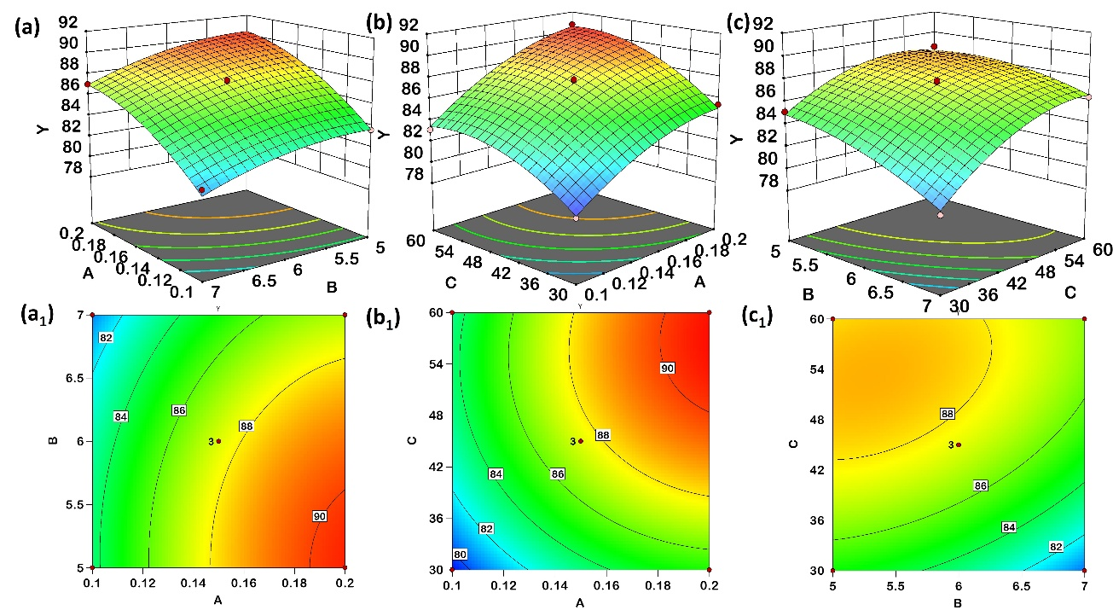
Figure S8 Three-dimensional surface plots and contour plots for the interactive effects of LDHs dosage and pH (a, a₁), LDHs dosage and adsorption time (b, b₁), and adsorption time and pH (c, c₁) on Cr(VI) removal

# These authors contributed equally to this work and should be considered co-first authors. ∗ Corresponding author. College of Materials Science and Engineering, Taiyuan University of Technology, Taiyuan 030024, P.R. China E-mail address: yanhong@tyut.edu.cn (H. Yan).

