Supplementary Information
Table of contents
Supplementary Note 1. DFT calculations, GeNNIP4MD workflow and MLIP training details
Supplementary Note 2. Validation and computational performance of the Fe–C MLIP
Supplementary Note 3. Determination of carbon chemical potential and GCMC/MD settings
Supplementary Note 4. Additional crack-propagation results
Supplementary Note 5. Static Rice–Wang evaluation structures
Supplementary Note 6. Additional analysis of carbon displacement and DBR
Supplementary Figs. 1–13
Supplementary Tables 1–2

Supplementary Video 1. Crack propagation in a carbon-segregated general grain boundary during tensile loading corresponding to Fig. 3a.
Supplementary Video 2. Dynamic bond reconfiguration during crack propagation corresponding to Fig. 4b.
Supplementary References

Supplementary Note 1
DFT calculations, GeNNIP4MD workflow and MLIP training details
DFT calculations used for labelling the MLIP training dataset and validating the MLIP accuracy were performed using the Vienna Ab initio Simulation Package (VASP)^{1,2}. The exchange–correlation functional was described using GGA-PBE³. For the Fe pseudopotential, the 4s and 3d electrons were treated as valence electrons, as in previous MLIP studies for Fe-based systems^{4,5}. The plane-wave cutoff energy was set to 520 eV. The k-point mesh for each atomic structure was generated using the Monkhorst–Pack scheme⁶ and set to be equivalent to an 18 × 18 × 18 mesh for the conventional α-Fe unit cell. Methfessel–Paxton smearing⁷ with a width of 0.1 eV was used to improve convergence. Structural optimizations were performed until the total energy and atomic forces converged to below 10⁻⁶ eV and 10⁻² eV Å⁻¹, respectively. These settings were identical to those used in previous MLIP studies for Fe-based systems^{4,5}. Interatomic-potential calculations were performed using LAMMPS⁸.
The training dataset for the Fe–C MLIP was constructed using the GeNNIP4MD workflow (Supplementary Fig. 1)⁹. GeNNIP4MD is an iterative workflow consisting of training, exploration, screening and labelling steps. In this workflow, poorly learned structures are detected using uncertainty estimates from multiple preliminary MLIPs, and a second screening based on structural features reduces redundancy while incorporating diverse atomic environments into the training dataset.
The initial training dataset was designed for the Fe–C system by following the dataset-construction strategy used in previous Fe–H MLIP work⁴. It consisted of (1) strained α-Fe containing solute carbon, (2) α-Fe containing C–vacancy clusters, (3) strained Fe carbides, including cementite and ε-carbide, (4) cementite containing point defects, (5) ε-carbide with various vacancy configurations, (6) strained diamond and graphene and (7) Fe–Fe, Fe–C and C–C dimers.
The exploration targets included (1) strained α-Fe containing solute carbon, (2) α-Fe containing self-interstitial atoms (SIAs), (3) α-Fe containing vacancy clusters, small voids and multiple carbon atoms, (4) low-index surfaces of α-Fe containing solute carbon, (5) strained symmetric tilt grain boundaries containing solute carbon, (6) generalized stacking faults in α-Fe containing solute carbon, (7) screw dislocations with segregated carbon, (8) cementite containing point defects, (9) low-index cementite surfaces, (10) generalized stacking faults in cementite and (11) cementite/α-Fe interfaces. Exploration calculations were performed at 300–1500 K and 0–5 GPa using the preliminary MLIPs obtained in each iteration cycle. MD simulations and structural relaxations were performed using LAMMPS.
For strained symmetric tilt grain boundaries containing solute carbon, Σ3(111), Σ3(112), Σ9(114), Σ9(221), Σ11(113), Σ11(332), Σ5(210) and Σ5(310) grain boundaries were considered. For each grain-boundary structure, diverse atomic environments corresponding to stressed grain boundaries and general grain boundaries were generated by applying cell strains of up to 5%, random atomic displacements of up to 0.5 Å, insertion of 1–5 carbon atoms near the grain boundary and rigid-body translations of 0.5–10 Å normal to the grain-boundary plane.
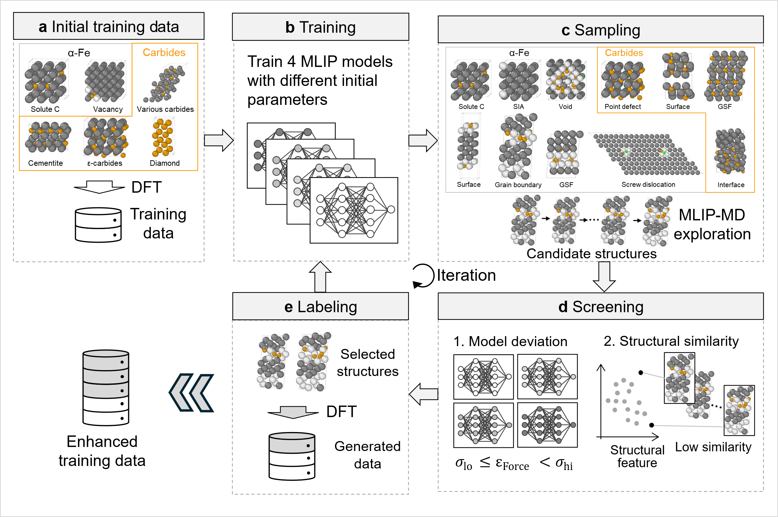
Supplementary Fig. 1: Workflow for constructing the Fe–C MLIP training dataset using GeNNIP4MD.
a, Initial training dataset, consisting of C-containing α-Fe, C–vacancy clusters, Fe carbides, defect-containing cementite, ε-carbide, diamond and graphene.
b, Training step. Multiple preliminary Deep Potential (DP) models are trained from the initial or updated training dataset using different random seeds.
c, Sampling/exploration step. Diverse Fe–C atomic structures, including grain boundaries, surfaces, dislocations, generalized stacking faults, carbides and Fe/carbide interfaces, are generated by MD and structural relaxation using the preliminary DP models.
d, Screening step. Candidate poorly learned structures are extracted based on force deviations among multiple DP models, and low-redundancy representative structures are then selected by a second screening based on structural similarity.
e, Labelling step. DFT calculations are performed for the selected structures to obtain energies, atomic forces and virial tensors, which are added to the training dataset. Repeating this cycle over relevant configurational spaces efficiently incorporates Fe–C atomic environments associated with segregation, deformation and fracture at general grain boundaries.
Deep Potential (DP) models¹⁰ were used as preliminary MLIPs in each GeNNIP4MD iteration cycle. This choice enabled efficient execution of many iteration cycles by using data-parallel training with DeePMD-kit¹⁰. DP models were trained using DeePMD-kit v2.2.89. A two-body embedding descriptor (se_e2_a) was used as the DP descriptor. The cutoff radius was 6.5 Å, the embedding network was set to (20, 40, 80), and the number of axis neurons was 16. The fitting network was set to (240, 240, 240), with 240 neurons in each of the three hidden layers. A hyperbolic tangent function was used as the activation function for each hidden layer. The initial and final learning rates were 10⁻³ and 1.0 × 10⁻⁸, respectively, and the number of training steps was 800,000. These settings were identical to those used in previous studies employing the iterative workflow for Fe–H systems^{4,11}.
In each exploration cycle, four DP models trained with identical hyperparameters but different random seeds were used. The maximum deviation in atomic forces among the four models was evaluated, and structures with maximum deviations of 0.15–0.35 eV Å⁻¹ were selected as labelling candidates. Structural similarity between the candidate structures and the existing training dataset was then evaluated, and low-redundancy structures were selected for DFT labelling.
Structural similarity was evaluated using multidimensional features extracted from the hidden layers of the DP models. These features were projected onto a two-dimensional space using densMAP¹², and pairwise Euclidean distances between candidate structures were calculated in this space. In each screening round, structures located close to other structures, that is, highly redundant structures, were sequentially removed until the prescribed number of representative structures remained. In this study, up to 500 structures were selected as DFT-labelling candidates in each cycle.
Spin-polarized DFT calculations were performed for the selected structures to obtain energies, atomic forces and virial tensors. After 75 iterations, the final training dataset contained 27,723 structures and 1,394,289 local atomic environments.
For the final production model, an MLIP in the performant implementation of the atomic cluster expansion (PACE)^{13,14} format was constructed. In PACE, the local energy of each atom is expressed as an expansion of rotationally, inversion and permutation invariant basis functions based on the local atomic density. In this study, a nonlinear expansion of the local density was used, with 544 basis functions and 4,982 fitting parameters in total. Bessel functions were used as the radial basis. The cutoff radius was 6.0 Å for Fe–Fe interactions and 4.5 Å for the other interactions. The PACE model was trained using Pacemaker¹³. The weights for energy and forces were set using the Auto option in Pacemaker, and the optimized weight was 0.019. The parameters were optimized using the BFGS algorithm. The root-mean-square errors (RMSEs) for the full training dataset were 3.46 meV atom⁻¹ for energy and 112.99 meV Å⁻¹ for atomic forces.

Supplementary Note 2
Validation and computational performance of the Fe–C MLIP
In Fig. 1 of the main text, we present performance tests directly relevant to the GCMC/MD segregation calculations and crack-propagation simulations in this study, including C segregation energies at general grain boundaries, C–C interactions, cohesive energies of C-segregated grain boundaries, computational speed and extrapolation grades during crack propagation. Here, we provide additional validation results to assess the broader transferability of the constructed PACE model. For comparison, the same calculations were performed using empirical interatomic potentials, including the bond-order potential (BOP)¹⁵ and modified embedded-atom method (MEAM) ¹⁶, as well as previously reported MLIPs^{17,18}.
PACE reproduced the basic properties of α-Fe and lattice-defect formation energies with accuracy comparable to that of DFT and the previously reported BNNP (Supplementary Table 1). PACE also reproduced experimental values¹⁹⁻²¹ with DFT-level accuracy. Generalized stacking fault energies and dislocation-core-related energies were also reproduced with accuracy comparable to previously reported MLIPs^{17,18}, relative to the DFT results obtained in this study and those reported in previous studies^{22,23} (Supplementary Fig. 2).
For carbon-containing α-Fe, we validated the accuracy for C solution energies, C–C interactions, vacancy–C interactions and dislocation–C interactions. PACE reproduced the C solution energy at octahedral sites, the repulsive interaction between neighbouring C atoms and vacancy–C interaction energies in good agreement with DFT (Supplementary Fig. 3). For C–C interactions, PACE reproduced the repulsive interaction at neighbouring sites consistently with DFT. By contrast, the reference BNNP showed nonphysical attractive interactions for some distant C configurations. Such errors could substantially affect simulations of structures in which high local carbon concentrations appear, such as grain boundaries, dislocations and crack-tip regions.
For C segregation energies at symmetric tilt grain boundaries, the RMSE was 0.107 eV for PACE and 0.145 eV for BNNP, indicating higher accuracy for PACE (Supplementary Fig. 5). Moreover, for general grain boundaries, that is, high-angle random grain boundaries that were not explicitly included in the exploration structures, PACE achieved an RMSE of 0.104 eV, maintaining accuracy comparable to that for symmetric tilt grain boundaries (Supplementary Fig. 6). This result demonstrates the high transferability of the constructed PACE model to general grain boundaries that were not explicitly included during training.
For carbide systems, PACE reproduced the formation energies of ε-carbide, cementite and other Fe–C carbides in good agreement with DFT (Supplementary Fig. 7). PACE also showed high accuracy for point-defect formation energies in cementite (Supplementary Fig. 8) and generalized stacking fault energies in cementite²⁴ (Supplementary Fig. 9). These results show that PACE consistently describes a wide range of Fe–C chemical environments, from dilute carbon solution states to carbide phases containing high carbon concentrations.

Supplementary Table 1: Accuracy of the constructed PACE-based MLIP for physical properties of α-Fe and defect formation energies in α-Fe. The self-interstitial energy represents the formation energies of crowdion<111>, dumbbell<110>, dumbbell<100>, tetrahedral, and octahedral configurations, in order of top to bottom. In vacancy formation energy E_{mV-nNN}, m is the number of vacancies, and n indicates that the vacancies are in the n-th nearest neighbor configuration. For comparison, values calculated using DFT and values calculated using BNNP, BOP, and MEAM constructed in previous studies are also shown. In addition, previous DFT¹⁸ and experimental¹⁹⁻²¹ values were shown.

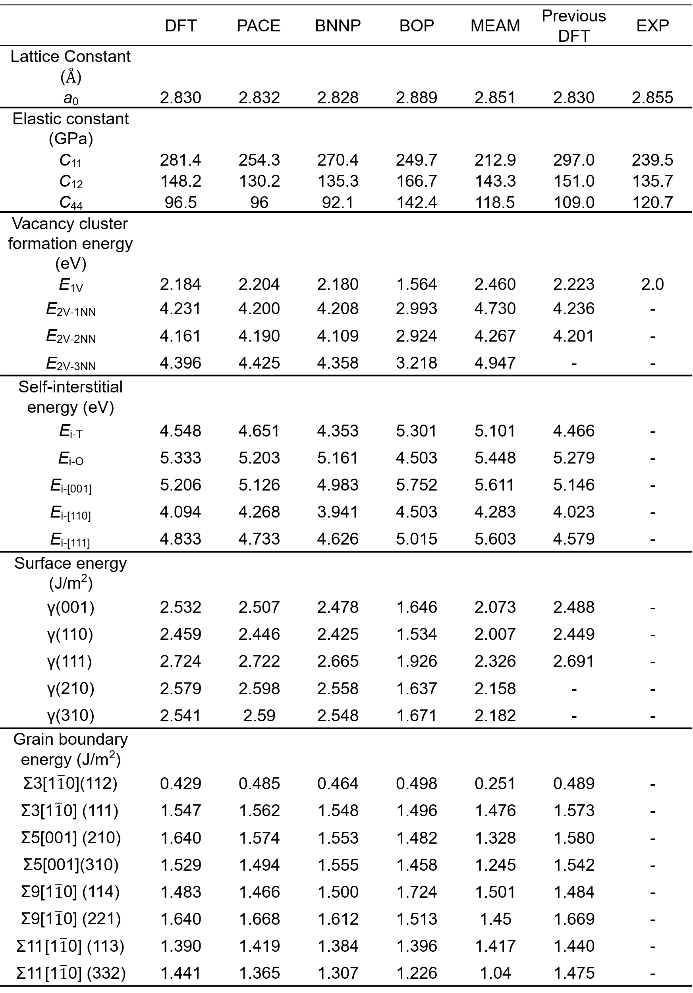
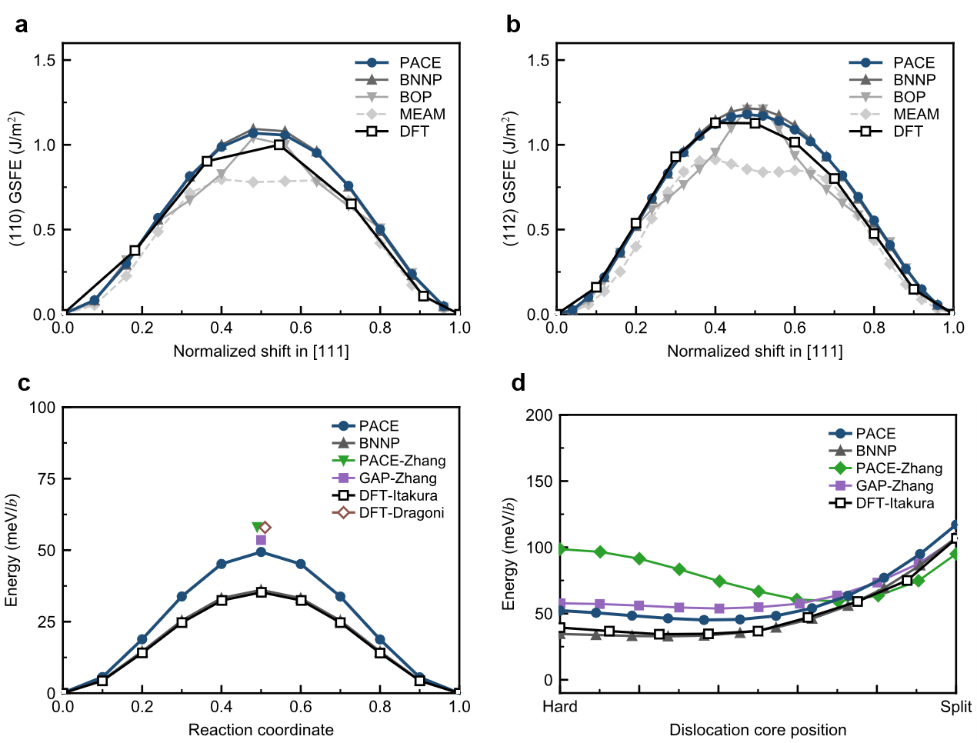
Supplementary Fig. 2: Accuracy of each interatomic potential for generalized stacking fault energies and Peierls potentials.
a,b, Comparison with DFT of generalized stacking fault energies (GSFEs) on the a, (110) and b, (112) planes.
c, One-dimensional Peierls potential for the transition between equivalent easy cores of a ½⟨111⟩ screw dislocation.
d, Two-dimensional Peierls potential for the transition from the hard core to the split core of a ½⟨111⟩ screw dislocation.
For comparison, results from DFT and previously reported BNNP, BOP, MEAM, PACE-Zhang and GAP-Zhang models are also shown. The DFT data in c and d are taken from refs. ^{22,23}. PACE reproduces the GSFEs and energy barriers for dislocation-core transitions consistently with DFT.
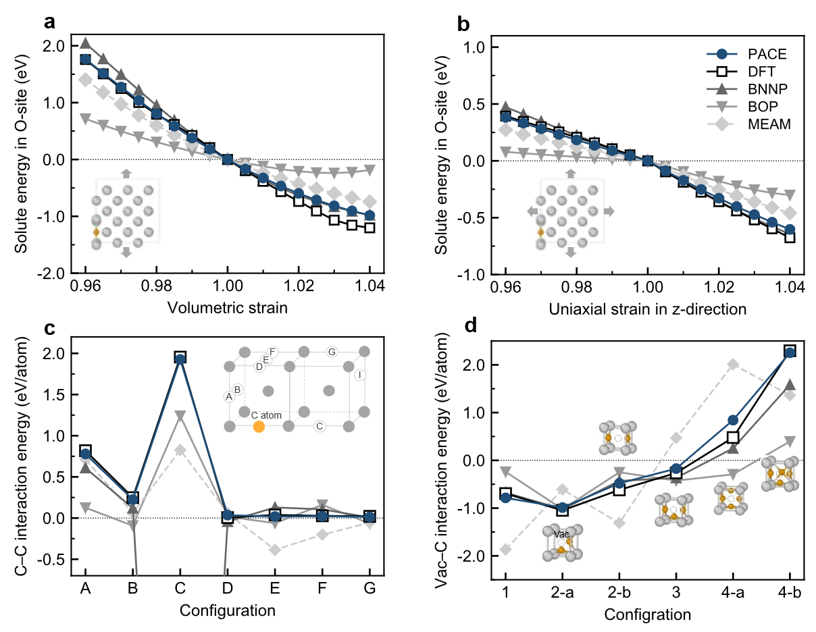
Supplementary Fig. 3: Accuracy of each interatomic potential for C solution and C–defect interactions in α-Fe.
a,b, C solution energies at octahedral sites (O-sites) in strained α-Fe. a, Isotropic volumetric strain. b, Uniaxial strain along the $z$direction.
c, C–C interaction energies in α-Fe. The inset shows the relative configuration of the reference C atom and the second C atom.
d, Vacancy–C interaction energies in α-Fe. The inset shows the C atom configuration relative to the vacancy. PACE reproduces the DFT trends for C solution, C–C interactions and vacancy–C interactions.

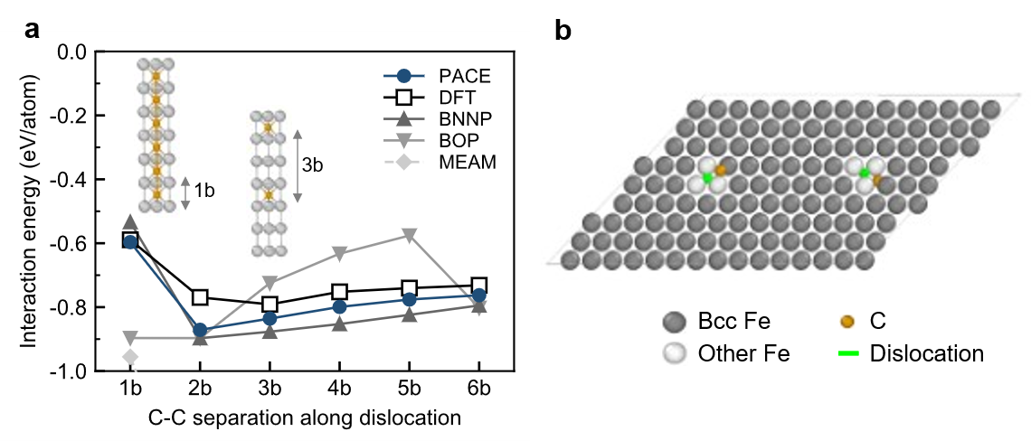
Supplementary Fig. 4: Accuracy of each interatomic potential for C segregation to screw dislocations.
a, Interaction energy as a function of the C–C distance along a screw-dislocation core. The interaction energies for each configuration are compared among DFT, PACE, BNNP, BOP and MEAM.
b, Atomic structure of the screw dislocation and C atom configurations used in the calculations. C atoms are placed at stable sites near the dislocation core, and the configurations shown in a correspond to different C–C spacings along the dislocation-line direction.
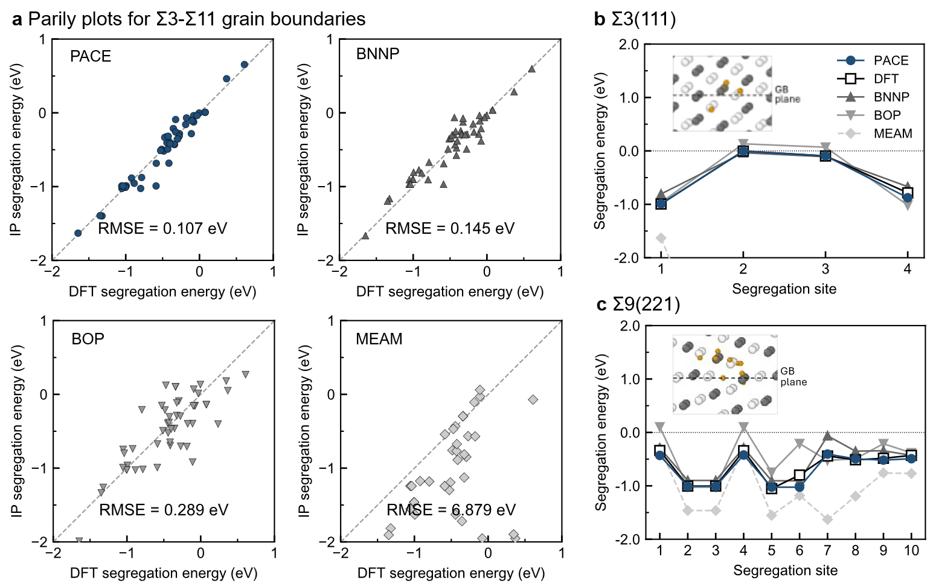

Supplementary Fig. 5: Accuracy of each interatomic potential for C segregation energies at symmetric tilt grain boundaries.
a, Comparison with DFT of C segregation energies at eight symmetric tilt grain boundaries. PACE shows good agreement with DFT and lower RMSE than BNNP, BOP and MEAM.
b,c, Site dependence of C segregation energies at representative b, Σ3(111) and c, Σ9(221) grain boundaries. Insets show the C segregation sites at each grain boundary. Segregation-site numbers are assigned in ascending order of distance from the grain-boundary centre. PACE reproduces the energy differences among different segregation sites near the grain boundary consistently with DFT.
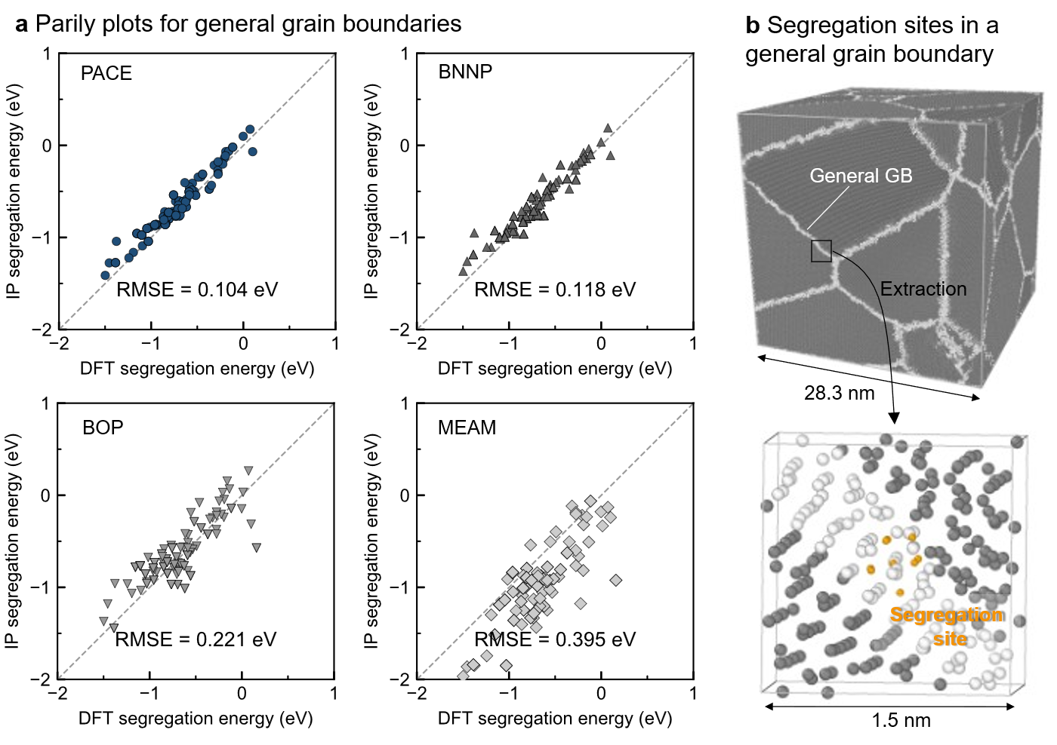

Supplementary Fig. 6: Accuracy of each interatomic potential for C segregation energies at general grain boundaries.
a, Comparison with DFT of C segregation energies at ten general grain-boundary regions extracted from a nanopolycrystalline model. PACE shows the highest accuracy and gives lower RMSE than BNNP, BOP and MEAM.
b, Procedure for constructing the atomic structures used to evaluate segregation energies at general grain boundaries, together with a representative example. Local regions near general grain boundaries were extracted from a nanopolycrystalline model with random grain orientations to construct atomic models of a size tractable for DFT calculations. The lower panel shows a representative example of C segregation sites in an extracted region.

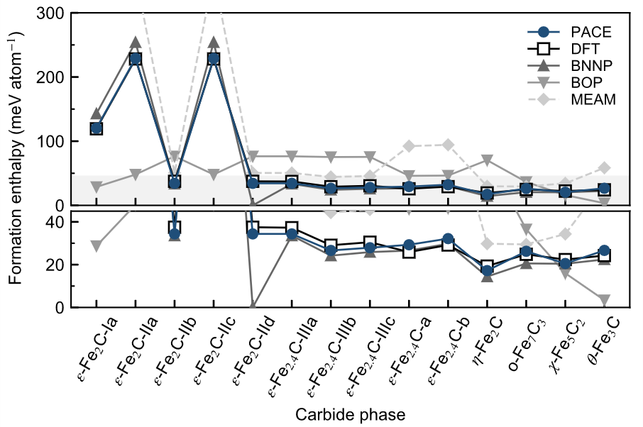
Supplementary Fig. 7: Accuracy of each interatomic potential for the formation enthalpies of Fe carbides.
Formation enthalpies of each carbide phase calculated by DFT, PACE, BNNP, BOP and MEAM. The upper panel shows the results for all carbide phases, and the lower panel shows an enlarged view of the low-formation-enthalpy region.

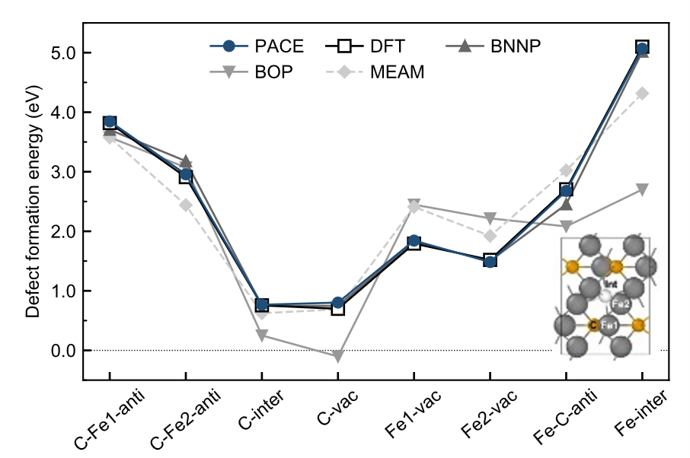
Supplementary Fig. 8: Accuracy of each interatomic potential for point-defect formation energies in cementite.
Formation energies of C antisite defects, C interstitial defects, C vacancies, Fe vacancies, Fe–C complex defects and Fe interstitial defects in cementite, compared among DFT, PACE, BNNP, BOP and MEAM. The inset shows representative defect sites in cementite. PACE reproduces the DFT trends well for a wide variety of point defects in cementite.
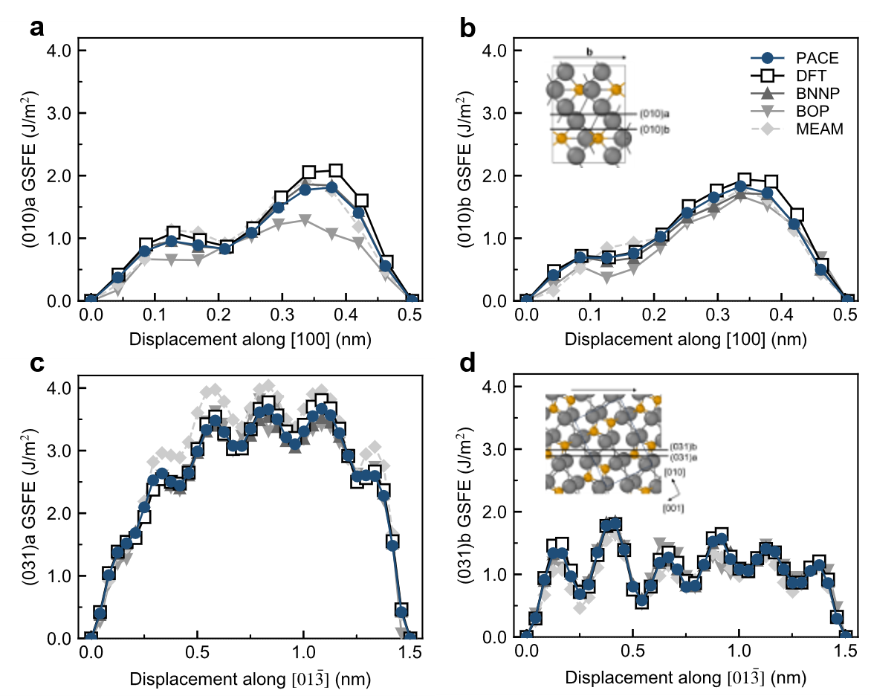

Supplementary Fig. 9: Accuracy of each interatomic potential for generalized stacking fault energies in cementite.
Generalized stacking fault energies (GSFEs) of cementite for each slip system, compared among DFT, PACE, BNNP, BOP and MEAM.
a, GSFE for displacement along the [100] direction on the ${\left(010\right)}_{a}$plane.
b, GSFE for displacement along the [100] direction on the ${\left(010\right)}_{b}$plane.
c, GSFE for displacement along the [01$\overline{3}$] direction on the ${\left(031\right)}_{a}$plane.
d, GSFE for displacement along the [01$\overline{3}$] direction on the ${\left(031\right)}_{b}$plane.
Insets show the slip plane and displacement direction used in each GSFE calculation. PACE reproduces the overall DFT energy curves well for all slip systems.
Supplementary Note 3
Determination of carbon chemical potential and GCMC/MD settings
For grain-boundary segregation calculations, the chemical potential corresponding to the target bulk carbon concentration must be determined. In general, this relationship between chemical potential and bulk carbon concentration can be obtained directly by performing GCMC/MD for bulk α-Fe. In the Fe–C system, however, the energy difference between the state immediately after inserting carbon into an octahedral site, which is the stable site for carbon, and the MD-relaxed state was large, making it difficult to reach equilibrium within practical simulation times. Therefore, in this study, the free energy for inserting one carbon atom into α-Fe was evaluated by nonequilibrium thermodynamic integration along the Frenkel–Ladd path²⁵. Supplementary Fig. 10 shows the relationship between the carbon chemical potential and bulk carbon concentration at 373 K. The chemical potentials corresponding to 20 and 60 wt ppm were determined from this relationship. We confirmed that $μ_{C}$ was sufficiently converged with respect to system size for α-Fe supercells larger than $10×10×10$.

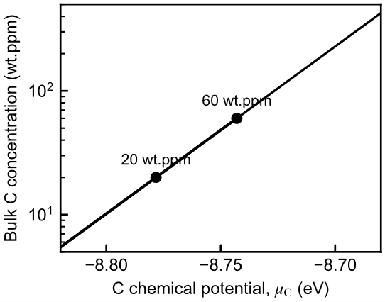

Supplementary Fig. 10: Relationship between bulk carbon concentration and carbon chemical potential.
Relationship between bulk carbon concentration and carbon chemical potential $μ_{C}$ at 373 K, evaluated from the carbon insertion free energy along the Frenkel–Ladd path and the ideal lattice-gas approximation. Black circles indicate the conditions corresponding to 20 wt ppm, used for crack-propagation simulations, and 60 wt ppm, used for comparison of grain-boundary segregation amounts with experiment.
Supplementary Note 4
Additional crack-propagation results
In the main text, stress–strain curves and the relationship between internal energy and crack area were shown for a representative grain boundary exhibiting average behaviour among the 12 grain boundaries. Supplementary Table 2 summarizes the analysis results for all 12 grain boundaries. As additional crack-propagation results, Supplementary Fig. 11 shows the stress–strain curves and the relationship between internal energy and crack area for the two grain boundaries with the minimum and maximum crack-growth resistance under the clean condition. Both grain boundaries exhibited qualitatively similar behaviour to the representative grain boundary shown in the main text.

Supplementary Table 2: General grain-boundary models used for crack-propagation analysis and their crack-growth resistance.
Misorientation angle, grain-boundary energy, interfacial excess in the C-segregated state corresponding to a bulk carbon concentration of 20 wt ppm, and crack-growth resistance $dU/dA$ for clean and C-segregated conditions are shown for the 12 general grain boundaries. The interfacial excess was evaluated from equilibrium segregation states obtained by GCMC/MD. $dU/dA$ was determined from the slope of the linear region in the relationship between internal energy $U$ and one-sided crack area $A$ during crack-propagation simulations.

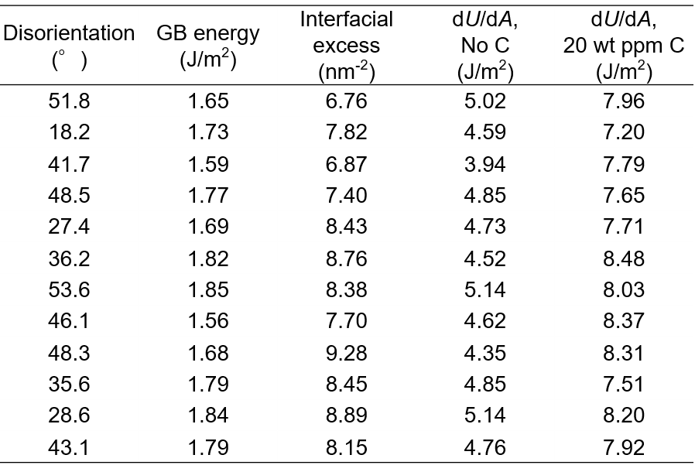

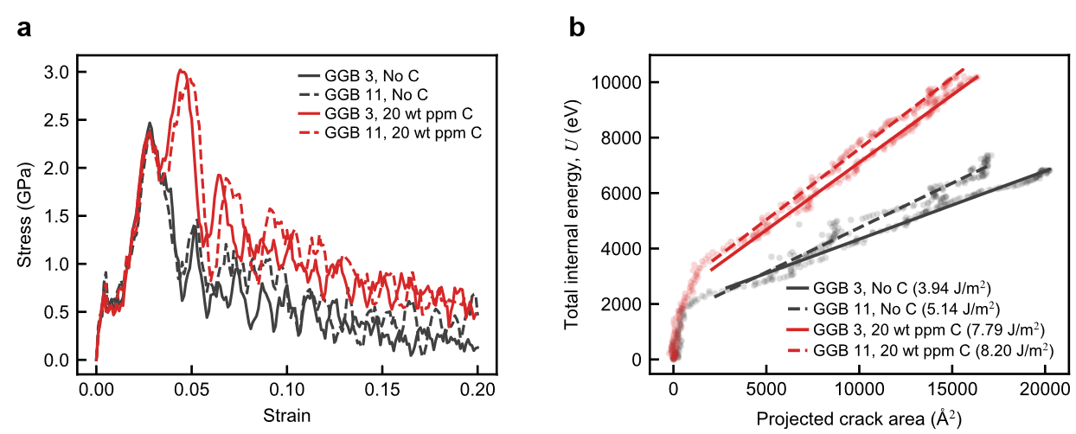

Supplementary Fig. 11: Crack-propagation behaviour of the grain boundaries with the minimum and maximum crack-growth resistance under the clean condition among the 12 grain boundaries.
a, Stress–strain curves for the two grain boundaries, GGB 3 and GGB 11, which showed the minimum and maximum crack-growth resistance $dU/dA$ under the clean condition, respectively.
b, Relationship between internal energy $U$ and one-sided crack area $A$ for the same two grain boundaries. Solid and dashed lines represent GGB 3 and GGB 11, respectively. Black and red indicate the clean and 20 wt ppm bulk-carbon conditions, respectively. Values in parentheses denote the crack-growth resistance $dU/dA$ evaluated from the slope of the linear region.
Supplementary Note 5
Static Rice–Wang evaluation structures
The static Rice–Wang-type contribution²⁶ described in the Methods was evaluated using atomic structures corresponding to the regions that actually fractured during the crack-propagation simulations. Specifically, for each grain boundary, we compared (i) the initial atomic structure before strain loading and (ii) the post-fracture atomic structure in which the corresponding region had separated after crack propagation, and evaluated the energy difference between them. A representative example is shown in Supplementary Fig. 12.

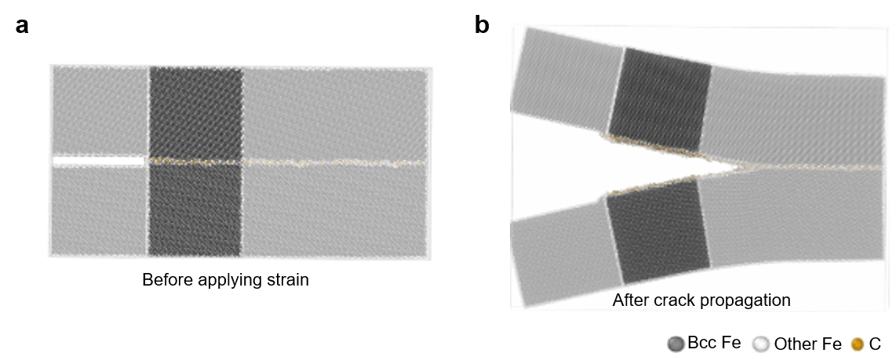
Supplementary Fig. 12: Pre- and post-fracture structures used to evaluate the static Rice–Wang-type contribution.
a, Initial C-segregated general grain-boundary structure before strain loading.
b, Post-fracture structure in which the corresponding region has separated into two free surfaces after crack propagation. Atoms used for the energy evaluation are shown in normal colours, whereas atoms outside the evaluation region are shown as transparent. For clean and C-segregated grain boundaries, the work of separation was evaluated from the energy difference between the pre- and post-fracture structures corresponding to the same fractured region, normalized by the one-sided crack area. The difference in the work of separation between the C-segregated and clean grain boundaries was defined as the static Rice–Wang-type contribution of carbon. This evaluation is a static comparison based on atomic structures before and after fracture and does not include dynamic contributions during crack propagation.

Supplementary Note 6
Additional analysis of carbon displacement and DBR
In the main text, we focused on two representative carbon atoms at a representative grain boundary and showed their coordination numbers, Voronoi volumes and local atomic-structure changes during crack propagation. Here, to further assess the generality of DBR, we provide an additional analysis of the displacement distribution of carbon atoms that were present in the crack-propagation region.
Specifically, we analysed the positional changes before and after crack propagation for each carbon atom that was present before strain loading within the fully fractured region used for the crack-growth-resistance evaluation, corresponding to positions 20–120 Å ahead of the initial crack tip. The displacement component along the crack-propagation direction was then calculated for each carbon atom.
As shown in Supplementary Fig. 13, the displacement distribution of carbon atoms is biased in the crack-propagation direction, with approximately 60% of the carbon atoms moving preferentially in that direction. Some carbon atoms showed large displacements of about 20.0 Å, and the average displacement was approximately 2.08 Å.

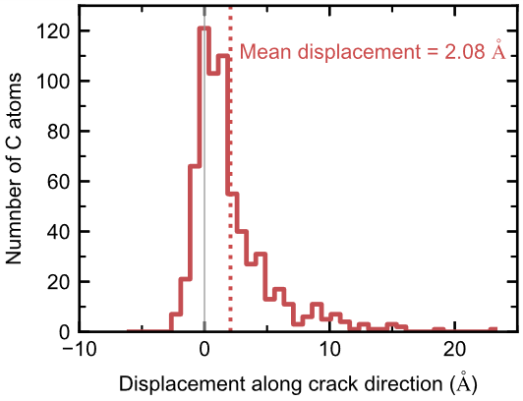
Supplementary Fig. 13: Distribution of carbon-atom displacements along the crack-propagation direction.
The displacement component along the crack-propagation direction is shown for carbon atoms that were present before strain loading within the fully fractured region used for the crack-growth-resistance evaluation, corresponding to 20–120 Å from the initial crack tip. The black dashed line indicates zero displacement, and the red dotted line indicates the average displacement of 2.08 Å. The maximum displacement was 23.0 Å. The positive mean displacement and the asymmetric distribution with a positive tail indicate that carbon atoms moved preferentially in the crack-propagation direction.
Legends for Supplementary Videos
Supplementary Video 1. Crack propagation in a carbon-segregated general grain boundary during tensile loading.
Carbon atoms are shown in orange.

Supplementary Video 2. Dynamic bond reconfiguration during crack propagation corresponding to Fig. 4b.
The video shows the crack-propagation process over the strain range of approximately 0.04–0.10. The red carbon atom, corresponding to C2 in Fig. 4b, follows the advancing crack tip through repeated bond breaking and reforming, whereas the blue carbon atom remains on the fracture surface after bond rupture, consistent with the Rice–Wang-type picture.
Supplementary References
1 Kresse, G. & Joubert, D. From ultrasoft pseudopotentials to the projector augmented-wave method. Phys. Rev. B 59, 1758-1775 (1999). https://doi.org/10.1103/PhysRevB.59.1758
2 Kresse, G. & Furthmüller, J. Efficient iterative schemes for ab initio total-energy calculations using a plane-wave basis set. Phys. Rev. B 54, 11169-11186 (1996). https://doi.org/10.1103/PhysRevB.54.11169
3 Perdew, J. P., Burke, K. & Ernzerhof, M. Generalized gradient approximation made simple. Phys. Rev. Lett. 77, 3865 (1996).
4 Ito, K., Otaki, T., Yokoi, T., Hyodo, K. & Mori, H. Machine learning interatomic potential reveals hydrogen embrittlement origins at general grain boundaries in α-iron. Commun. Mater. 7, 30 (2025). https://doi.org/10.1038/s43246-025-01042-4
5 Ito, K., Yokoi, T., Hyodo, K. & Mori, H. Machine learning interatomic potential with DFT accuracy for general grain boundaries in α-Fe. npj Comput. Mater. 10, 255 (2024). https://doi.org/10.1038/s41524-024-01451-y
6 Monkhorst, H. J. & Pack, J. D. Special points for Brillouin-zone integrations. Phys. Rev. B 13, 5188 (1976).
7 Methfessel, M. & Paxton, A. T. High-precision sampling for Brillouin-zone integration in metals. Phys. Rev. B 40, 3616-3621 (1989). https://doi.org/10.1103/PhysRevB.40.3616
8 Plimpton, S. Fast Parallel Algorithms for Short-Range Molecular Dynamics. J. Comput. Phys. 117, 1-19 (1995). https://doi.org/10.1006/jcph.1995.1039
9 Matsumura, N. et al. Generator of Neural Network Potential for Molecular Dynamics: Constructing Robust and Accurate Potentials with Active Learning for Nanosecond-Scale Simulations. Journal of Chemical Theory and Computation 21, 3832-3846 (2025). https://doi.org/10.1021/acs.jctc.4c01613
10 Zeng, J. et al. DeePMD-kit v2: A software package for deep potential models. The Journal of Chemical Physics 159 (2023). https://doi.org/10.1063/5.0155600
11 Ito, K. et al. Predicting hydrogen diffusion in nickel–manganese random alloys using machine learning interatomic potentials. Commun. Mater. 6, 195 (2025). https://doi.org/10.1038/s43246-025-00924-x
12 Narayan, A., Berger, B. & Cho, H. Assessing single-cell transcriptomic variability through density-preserving data visualization. Nature Biotechnology 39, 765-774 (2021). https://doi.org/10.1038/s41587-020-00801-7
13 Bochkarev, A. et al. Efficient parametrization of the atomic cluster expansion. Phys. Rev. Mater. 6, 013804 (2022). https://doi.org/10.1103/PhysRevMaterials.6.013804
14 Lysogorskiy, Y. et al. Performant implementation of the atomic cluster expansion (PACE) and application to copper and silicon. npj Comput. Mater. 7, 97 (2021). https://doi.org/10.1038/s41524-021-00559-9
15 Zhou, X., Foster, M. E., Ronevich, J. A. & San Marchi, C. W. Review and construction of interatomic potentials for molecular dynamics studies of hydrogen embrittlement in Fe─C based steels. J Comput Chem 41, 1299-1309 (2020). https://doi.org/10.1002/jcc.26176
16 Liyanage, L. S. I. et al. Structural, elastic, and thermal properties of cementite (${\mathrm{Fe}}_{3}C$) calculated using a modified embedded atom method. Phys. Rev. B 89, 094102 (2014). https://doi.org/10.1103/PhysRevB.89.094102
17 Zhang, S., Meng, F., Fu, R. & Ogata, S. Highly efficient and transferable interatomic potentials for α-iron and α-iron/hydrogen binary systems using deep neural networks. Comput. Mater. Sci. 235, 112843 (2024). https://doi.org/10.1016/j.commatsci.2024.112843
18 Meng, F.-S. et al. A highly transferable and efficient machine learning interatomic potentials study of α-Fe–C binary system. Acta Mater. 281, 120408 (2024). https://doi.org/10.1016/j.actamat.2024.120408
19 Basinski, Z. S., Hume-Rothery, W. & Sutton, A. L. The lattice expansion of iron. Proceedings of the Royal Society of London. Series A. Mathematical and Physical Sciences 229, 459-467 (1997). https://doi.org/10.1098/rspa.1955.0102
20 Adams, J. J., Agosta, D. S., Leisure, R. G. & Ledbetter, H. Elastic constants of monocrystal iron from 3to500K. J. Appl. Phys. 100, 113530 (2006). https://doi.org/10.1063/1.2365714
21 De Schepper, L. et al. Positron annihilation on pure and carbon-doped $\ensuremath{\alpha}$-iron in thermal equilibrium. Phys. Rev. B 27, 5257-5269 (1983). https://doi.org/10.1103/PhysRevB.27.5257
22 Dragoni, D., Daff, T. D., Csányi, G. & Marzari, N. Achieving DFT accuracy with a machine-learning interatomic potential: Thermomechanics and defects in bcc ferromagnetic iron. Phys. Rev. Mater. 2, 013808 (2018). 10.1103/PhysRevMaterials.2.013808
23 Itakura, M., Kaburaki, H. & Yamaguchi, M. First-principles study on the mobility of screw dislocations in bcc iron. Acta Mater. 60, 3698-3710 (2012). https://doi.org/10.1016/j.actamat.2012.03.033
24 Kadota, N. et al. Room-temperature plastic deformation of single crystals of cementite investigated by micropillar compression. Acta Mater. 304, 121759 (2026). https://doi.org/10.1016/j.actamat.2025.121759
25 Frenkel, D. & Smit, B. Understanding molecular simulation: from algorithms to applications. (elsevier, 2023).
26 Rice, J. R. & Wang, J.-S. Embrittlement of interfaces by solute segregation. Mater. Sci. Eng., A 107, 23-40 (1989). https://doi.org/10.1016/0921-5093(89)90372-9

