Supplementary table 1: GAM Parametric Coefficients for Ae. Aegypti and Ae. albopictus
|Predictor-
Ae. Aegypti | Estimate| Std. Error| z value| Pr(>&#124;z&#124;)|
|:-------------------|--------:|----------:|-------:|------------------:|
|(Intercept) | 4.989| 0.047| 105.767| 0.000|
|SeasonRainy | 1.189| 0.033| 36.179| 0.000|
|LandscapeRice_field | -0.364| 0.062| -5.848| 0.000|
|LandscapeRiver | 0.206| 0.054| 3.839| 0.000|
|LandscapeUrban | 0.863| 0.048| 18.153| 0.000|
|LandscapeWetland | 0.562| 0.050| 11.241| 0.000|
|LandscapeWooded | 0.161| 0.054| 2.971| 0.003|
|Predictor-
Ae. albopictus | Estimate| Std. Error| z value| Pr(>&#124;z&#124;)|
|:-------------------|--------:|----------:|-------:|------------------:|
|(Intercept) | 3.201| 0.128| 24.958| 0.000|
|SeasonRainy | 1.281| 0.111| 11.506| 0.000|
|LandscapeRice_field | -0.966| 0.179| -5.392| 0.000|
|LandscapeRiver | -0.569| 0.156| -3.634| 0.000|
|LandscapeUrban | -2.530| 0.346| -7.305| 0.000|
|LandscapeWetland | -0.479| 0.152| -3.148| 0.002|
|LandscapeWooded | 0.437| 0.121| 3.624| 0.000|

Supplementary figure 1: The high-resolution satellite images illustrate representative 20 m × 20 m
or 25 m × 25 m sampling plots within each habitat type.

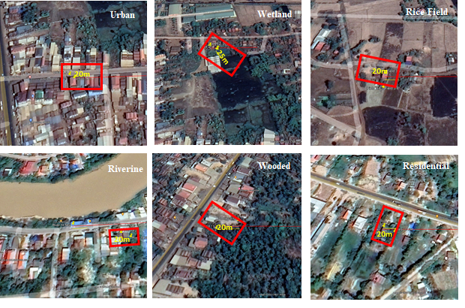

Supplementary figure 2: Climate variable trends in Kampong Thom Province, Cambodia, from 2021 to 2024. (A) Monthly time series plots of temperature (°C), humidity (%), rainfall (cm), and wind speed (m/s) illustrating seasonal and inter-annual variation. (B) Decomposed line graphs showing separate seasonal patterns for humidity, rainfall, temperature, and wind speed.

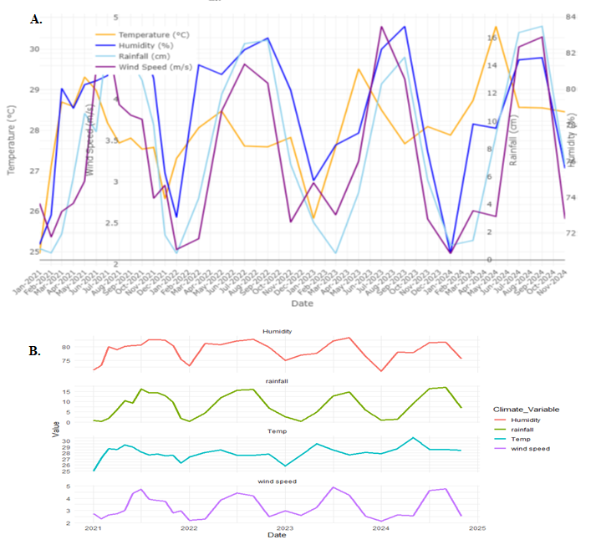

Supplementary Figure 3: Diagnostic plots for the generalized linear models of Ae.aegypti and Ae. albopictus

