Appendices

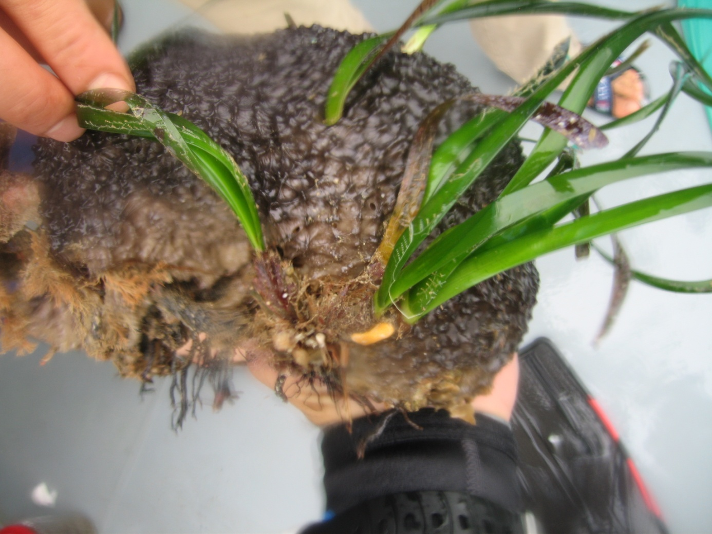
Appendix 1 Through an unusual habitat, a sponge stuck to the rocks, Hydrolithon boreale on the tips of leaves of Posidonia oceanica.

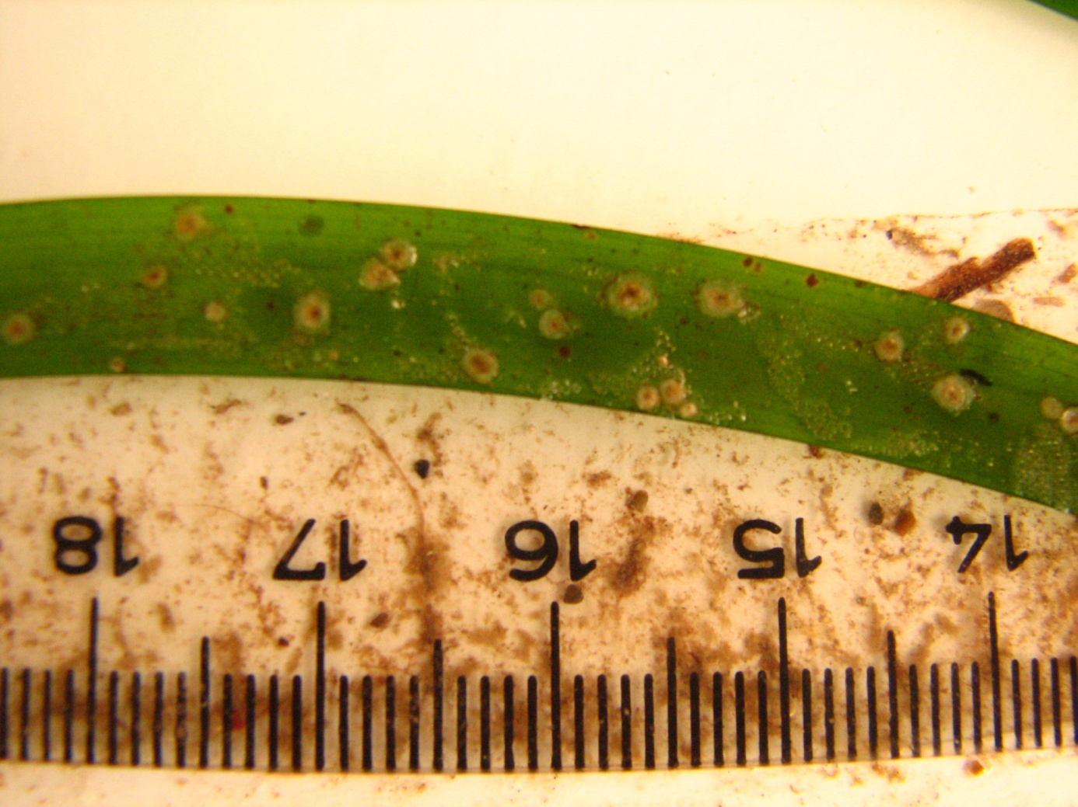
Appendix 2 A leaf of Posidonia oceanica, invaded by Hydrolithon boreale preserved in the formalin solution.

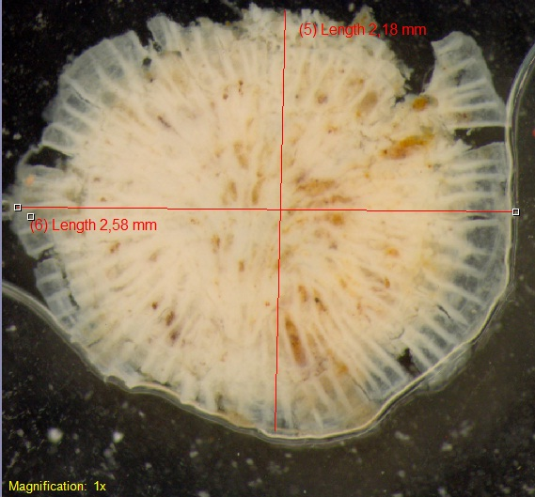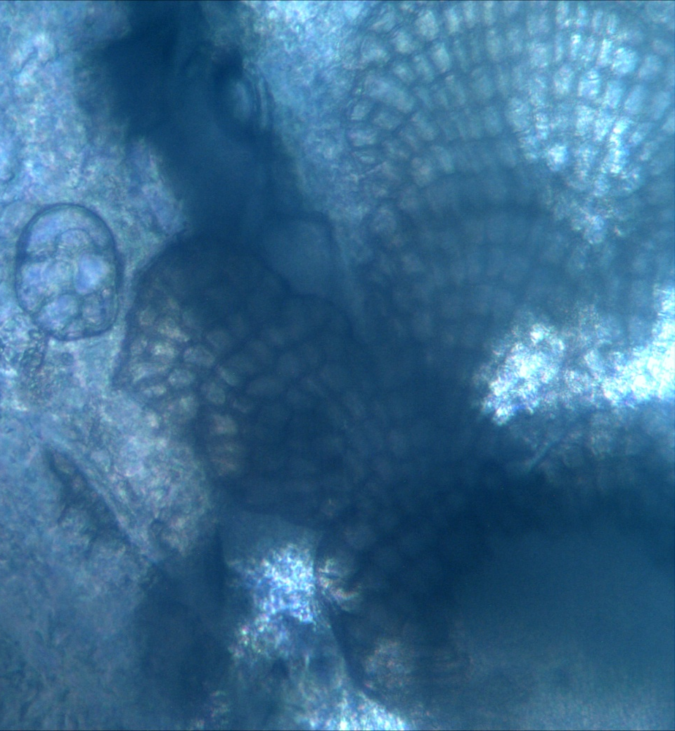
b
a
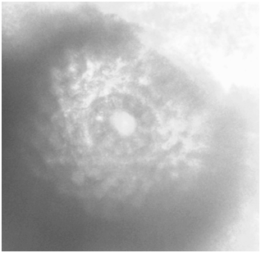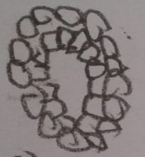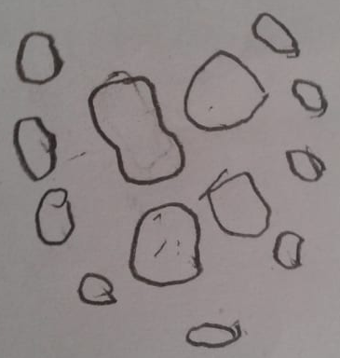
e
d
c
Appendix 3 Hydrolithon boreale: its crust preserved in the formalin solution (a), surface view of thallus (b), carposporangial conceptacles surrounded by superficial vegetative cells (c), details draft- drawings of inner and outer ring of pore filaments with uncounted cells sequence (d), and spore germination disc with an 4-celled central element and 4-celled laterally (8 cells) (e). Brief description: specimen preserved in the formalin is pinkish creamy in color (a), a disc with centre in thicker than the margin of the crust in shape. A thin and flat germination disc with cells sequenced curly perpendicular to the centre (b). Carposporangial conceptacles surrounded by superficial vegetative cells with 11 cells of outer ring (c). Spore germination disc; four central cells in semi-rectangle or square in shape; two larger than other two, surrounded by 4 small cells on each lateral of the central cells (e) (Reyes and Afonso-Carrillo 1995). Remarks to differentiate the other similar and common species in the Mediterranean Sea: Pneophyllum fragile has 8-celled central element on spore germination disc (Reyes and Afonso-Carrillo 1995; Kjøsterud, 1997). Hydrolithon farinosum with spore germination discs consisting of a 4-celled central element in quarter oval-shaped, surrounded by 12 cells; central and lateral cells almost in same size (Penrose and Chamberlain 1993). Hydrolithon cruciatum; spore germination disc consisting of a 4-celled central element in quarter oval-shaped, surrounded by 8 cells; central and lateral cells almost in same size (Reyes and Afonso-Carrillo 1995; Kjøsterud 1997).

Appendix 4 Average essential nutrients (µM) distribution between a period of 2011-2012 in the Antalya Gulf (a) and 2019 in the present area (PSA) and Antalya Gulf (AG).
a | SNO₃+NO₂ | SNH₄ | SPO₄ | NNO₃+NO₂ | NNH₄ | NPO₄
Dec-2011 | 22.87 | 174.07 | 2.00 | 21.20 | 170.75 | 2.00
Jan-2012 | 18.61 | 210.66 | 1.90 | 12.59 | 215.65 | 1.79
Jul-2011 | 17.59 | 71.51 | 0.95 | 15.46 | 71.51 | 1.26
Aug-2012 | 5.74 | 516.12 | 3.26 | 5.74 | 455.14 | 3.37
b | SNO₂+NO₃ | SNH₄ | SPO₄ | NNO₂+NO₃ | NNH₄ | NPO₄ | Ssi | NSi
PSA | 2.39 | 137.83 | 8.77 | 1.81 | 185.94 | 7.51 | 61.47 | 34.85
AG | 2.19 | 125.50 | 8.35 | 1.51 | 108.12 | 4.59 | 75.23 | 33.50

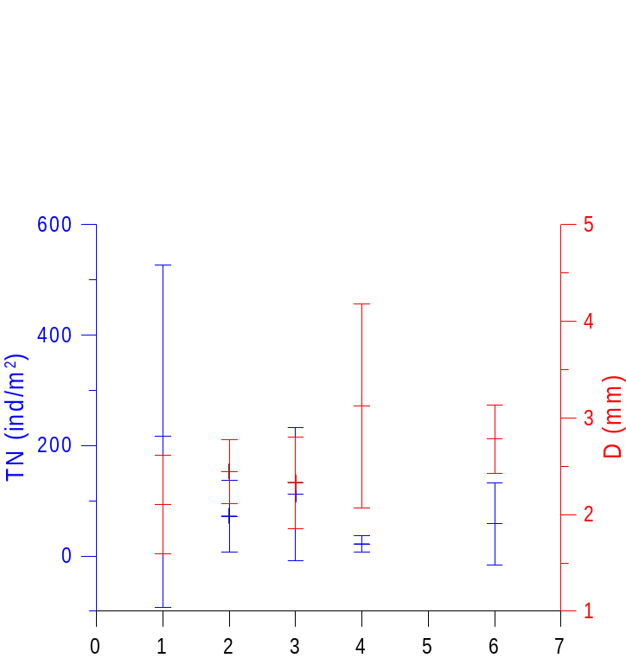
Appendix 5 Abundance (TN) and diameter (D) of the crust of Hydrolithon boreale on leaves of Posidonia oceanica found on the different bottom types (1; rock, 2; sand, 3; matte, 4; mud, 5; coastal sandy mud, organically loaded; 6; white sand in summer (see Figure 1 for the locations).

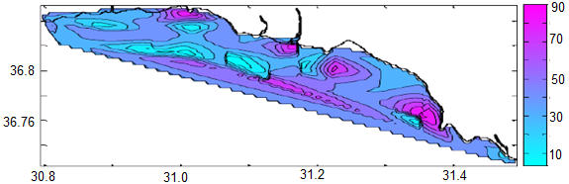
Antalya in December
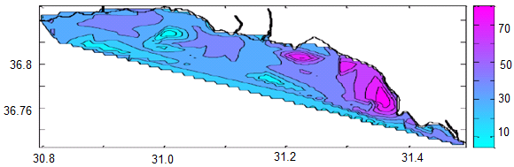
January
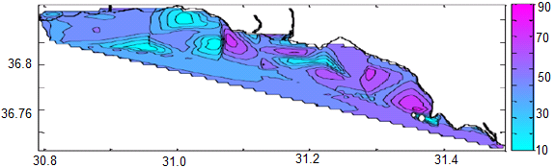
July
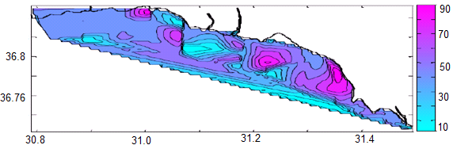
September
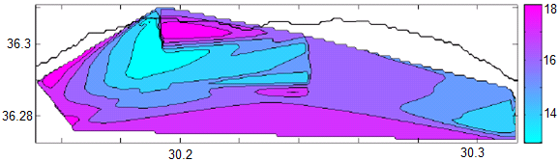
Finike in August
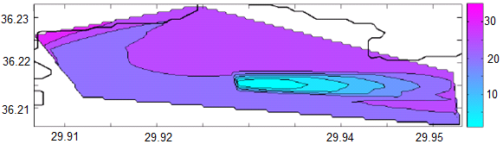
Kekova in August
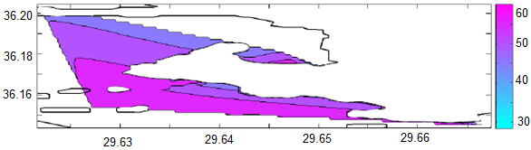
Kaş in August
Appendix 6 Temporal total carbonate content (% on scale bar) of the surface sediment in Antalya Gulf and westerly adjacent bays found within the present study area (Mutlu et al., 2014) (see Figure 1 for the locations).

