Supplementary Information

Supplementary Table S1. Information on specimens used for study including the species, family, experiment ID assigned to that specimen, the original collection the specimen belongs to, the original collection ID number, stain used on examined pereopods (coomassie brilliant blue, bromophenol blue, hoechst DAPI & phalloidine, the examination method, and which pereopods were examined. Examination methods: Light-light microscopy on Olympus BX51 and/or Olympus BX60, Confocal-Confocal Scanning Laser Microscope, Leica SP8, and Stereo-Stereo Microscope. Pereopods examined: R-right, L-left, number corresponding to which pereopod. Collection identifier information: SM-Siena McKim Collection (California Department of Fish and Wildlife Scientific Collecting Permit S-220460007-25002-001), BC-Brittany Cummings Collection, SBMNH-Santa Barbara Museum of Natural History (Vanessa Delnavaz curator), IM - Inez Mangino Collection, NHMLA-Natural History Museum of Los Angeles (Adam Wall and Regina Wetzer curators), FLMNH-Florida Museum of Natural History (Gustav Paulay curator), MCM-From Dr. Andrew Thurber Lab UCSB, collected at Turtle Rock, McMurdo, Antarctica in 2023 (loaned by Dexter Davis), ALMNH-Alabama Museum of Natural History collected by Dr. Kevin Kocot, NOAA-Collected by Elyse Wurster & Kerri Danil at Southwest Fisheries Science Center National Marine Fisheries Service (off of gray whale; Marine Mammal Stranding Report number: SW-2025-1284562).

Species | Family | Experiment ID | Collection | Collection ID | Stain | Examination Method | Pereopods Examined
Aoroides secunda Gurjanova, 1938 | Aoridae | SM247A | SM |  | coomassie blue | Light | LP3,4,5,6
Aoroides secunda | Aoridae | SM237 | SM |  | hoechst & phalloidine | Confocal | LP3,5
Aoroides secunda | Aoridae | SM247B | SM |  | bromophenol | Light | RP3,4, 5, 6
Aoroides secunda | Aoridae | SM247C | SM |  | bromophenol | Light | RP4,5,6
Aoroides secunda | Aoridae | SM247E | SM |  | none | Confocal | RP3
Aoroides secunda | Aoridae | SM247D | SM |  | none | SEM | RP3,4
Bemlos audbettius, J.L. Barnard, 1962 | Aoridae | SM531A | SBNHM | 693714 | bromophenol | Light | LP2, 3
Bemlos audbettius | Aoridae | SM531B | SBMNH | 693714 | bromophenol | Light | LP3,4
Grandidierella japonica Stephensen, 1938 | Aoridae | SM329A | SM |  | bromophenol | Light | LP3,4,5,6
Grandidierella japonica | Aoridae | SM329B | SM |  | bromophenol | Light | RP3,4,5,6
Acuminodeutopus periculosus J.L. Barnard, 1969 | Unciolidae | SM602A | NHMLA | 289690 | bromophenol | Light | RP2,3,4
Acuminodeutopus periculosus | Unciolidae | SM603A | NHMLA | 233394 | none | Confocal | RP2,3
Microprotopus reneyi Wigley, 1966 | Microdeutopidae | SM460A | FLMNH | 48033 | bromophenol | Light | LP3,4,5,6
Microprotopus reneyi | Microdeutopidae | SM460B | FLMNH | 48033 | bromophenol | Light | LP3,4,5,6
Americorophium stimpsoni Shoemaker, 1941 | Corophiidae | SM244 | SM |  | bromophenol | Light | LP3,4,6, RP6,7
Americorophium stimpsoni | Corophiidae | SM234 | SM |  | hoechst & phalloidine | Confocal | LP4,6
Americorophium stimpsoni | Corophiidae | SM243 | SM |  | none | Light | LP3,5,6,7
Americorophium stimpsoni | Corophiidae | SM245A | SM |  | coomassie blue | Light | LP3,4,5
Americorophium stimpsoni | Corophiidae | SM245B | SM |  | bromophenol | Light | RP4, 5
Americorophium stimpsoni | Corophiidae | SM444A | SM |  | none | Confocal | RP4
Protomedeia articulata J.L. Barnard, 1962 | Corophiidae | SM343A | NHMLA | 235211 | bromophenol | Light | RP3,4, 5,6
Protomedeia articulata | Corophiidae | SM343A | NHMLA | 235211 | NONE | Confocal | LP3,4
Haplocheira  balssi Schellenberg, 1931 | Corophiidae | SM433 | MCM | MCM23_TR_BJ_010_01 | bromophenol | Light | RP3,4,5,6
Haplocheira  balssi | Corophiidae | SM434 | MCM | MCM23_TR_BJ_010_02 | bromophenol | Light | LP3,5,6, 7
Monocorophium acherusicum A. Costa, 1953 | Corophiidae | SM532A | SM |  | bromophenol | Light | RP3,4,5,6
Monocorophium acherusicum | Corophiidae | SM532B | SM |  | bromophenol | Light | LP4,6
Sunamphitoe humeralis Stimpson, 1864 | Ampithoidae | SM277 | SM |  | bromophenol | Light | LP3,4,5,6
Sunamphitoe humeralis | Ampithoidae | SM278 | SM |  | bromophenol | Light | RP3,4,6 LP5
Sunamphitoe humeralis | Ampithoidae | SM281 | SM |  | coomassie blue | Light | RP3,4,5,6
Sunamphitoe humeralis | Ampithoidae | SM281A | SM |  | none | Confocal | LP3,4 RP5
Sunamphitoe humeralis | Ampithoidae | SM279 | SM |  | none | SEM | RP3,4
Ampithoe valida S.I. Smith, 1873 | Ampithoidae | SM328A | SM |  | bromophenol | Light | RP3,4 RP5
Ampithoe valida | Ampithoidae | SM328A | SM |  | none | Confocal | LP3
Ampithoe valida | Ampithoidae | SM328B | SM |  | bromophenol | Light | LP3,4,5,6
Ampithoe valida | Ampithoidae | SM328C | SM |  | bromophenol | Light | RP3,4,5,6
Jassa carltoni Conlan, 1990 | Ischyroceridae | SM194A | SM |  | bromophenol | Light | RP3,4,6
Jassa carltoni | Ischyroceridae | SM194D | SM |  | bromophenol | Light | LP3,4,5,6
Jassa carltoni | Ischyroceridae | SM194D | SM |  | coomassie blue | Light | RP3,4,5,6
Jassa carltoni | Ischyroceridae | SM194F | SM |  | coomassie blue | Light | RP3,4,6,7
Jassa carltoni | Ischyroceridae | SM181A | SM |  | bromophenol | Light | RP3,4,5
Jassa carltoni | Ischyroceridae | SM194B | SM |  | hoechst & phalloidine | Confocal | RP4,6
Jassa carltoni | Ischyroceridae | SM194F | SM |  | coomassie blue | Light | RP3,4,6,7
Jassa carltoni | Ischyroceridae | SM194E | SM |  | none | SEM | RP4, LP4
Jassa marmorata Holmes, 1905 | Ischyroceridae | SM178 | SM |  | coomassie blue | Light | RP3,4,5,6
Jassa marmorata | Ischyrocerida | SM178 | SM |  | bromophenol | Light | RP2, LP2
Microjassa litotes J.L. Barnard, 1954 | Ischyroceridae | SM462A | SM |  | bromophenol | Light | LP3,4,5,6
Microjassa litotes | Ischyroceridae | SM462B | SM |  | bromophenol | Light | LP3,4,5,6
Microjassa litotes | Ischyroceridae | SM581A | SM |  | none | Confocal | RP2,3,5
Microjassa litotes | Ischyroceridae | SM582A | SM |  | bromophenol | Light | LP2,3,4,5
Ischyrocerus anguipes Krøyer, 1838 | Ischyroceridae | SM623A | SM |  | bromophenol | Light | RP2,3,4,6
Ischyrocerus anguipes | Ischyroceridae | SM623A | SM |  | none | Confocal | LP2,3
Ericthonius rubricornis Stimpson, 1853 | Ischyroceridae | SM228A | SM |  | bromophenol | Light | LP3,4,5,6
Ericthonius rubricornis | Ischyroceridae | SM228B | SM |  | bromophenol | Light | LP3,4,5,6
Ericthonius rubricornis | Ischyroceridae | SM228C | SM |  | coomassie blue | Light | RP3,4,5,6
Ericthonius rubricornis | Ischyroceridae | SM228D | SM |  | coomassie blue | Light | RP3,4,5,6
Ericthonius rubricornis | Ischyroceridae | SM228E | SM |  | none | SEM | RP3,5 LP4
Notopoma sp. A | Ischyroceridae | SM114A | SM |  | coomassie blue | Light | LP3,4,6
Notopoma sp. A | Ischyroceridae | SM114B | SM |  | bromophenol | Light | LP3,4,5,6
Notopoma sp. A | Ischyroceridae | SM114C | SM |  | bromophenol | Light | LP3,4,5
Notopoma sp. A | Ischyroceridae | SM479 | SM |  | hoechst & phalloidine | Confocal | LP4
Notopoma sp. A | Ischyroceridae | SM114D |  |  | none | SEM | LP3,4
Ampelisciphotis podophthalma | Photidae | SM578 | NHMLA | 261811 | bromophenol | Light | RP2,3,4,5
Photis lacia Barnard, 1962 | Photidae | SM222A | SM |  | coomassie blue | Light | LP3,4,5,7
Photis lacia | Photidae | SM222B | SM |  | coomassie blue | Light | LP3,4,5,6
Photis lacia | Photidae | SM222C | SM |  | bromophenol | Light | RP3,4,5,6
Photis conchicola Alderman, 1936 | Photidae | SM274A | SM |  | bromophenol | Light | RP3,4,5
Photis conchicola | Photidae | SM274B | SM |  | bromophenol | Light | LP3,4,5
Photis conchicola | Photidae | SM480 | SM |  | hoechst & phalloidine | Light | RP4
Gammaropsis thompsoni Walker, 1898 | Photidae | SM271 | SM |  | bromophenol | Light | LP3,4,5,6
Gammaropsis thompsoni | Photidae | SM75 | SM |  | bromophenol | Light | RP3,4,5,6
Gammaropsis thompsoni | Photidae | SM272 | SM |  | coomassie blue | Light | LP4,5,6
Amphideutopus oculatus J.L. Barnard in J.L. Barnard & Reish, 1959 | Kamakidae | SM344 | NHMLA | 220250 | bromophenol | Light | LP3,5
Chevalia anomala Souza-Filho, Souza & Valério-Berardo, 2010 | Chevaliidae | SM209A | NHMLA | BDT-1041 | bromophenol | Light | LPP3,4,5,6
Chevalia anomala | Chevaliidae | SM209B | NHMLA | BDT-1041 | bromophenol | Light | LP3,4,5,6
Podocerus brasiliensis Dana, 1853 | Podoceridae | SM38 | SM |  | bromophenol | Light | RP3,4,5,6
Podocerus brasiliensis | Podoceridae | SM88 | SM |  | coomassie blue | Light | LP3,4,5,6
Podocerus brasiliensis | Podoceridae | SM86 | SM |  | coomassie blue | Light | LP3,4,5,6
Podocerus brasiliensis | Podoceridae | SM38 | SM |  | none | SEM | LP3,4,5
Podocerus brasiliensis | Podoceridae | SM235 | SM |  | none | SEM | LP7
Podocerus cristatus Thomson, 1879 | Podoceridae | SM267 | BC | BCPD-0446 | coomassie blue | Light | RP3,4,5,6,7 RP3,4,5,6,7
Podocerus cristatus | Podoceridae | SM268 | BC | BCPD-0337 | bromophenol | Light | LP3,4,5,6,7  RP3,4,5,6,7
Podocerus cristatus | Podoceridae | SM270 | BC | BCPD-0233 | coomassie blue | Light | RP3,4,5,6
Podocerus cristatus | Podoceridae | SM269 | BC | BCPD-0233 | none | SEM | RP3,4
Podocerus septemcarinatus Schellenberg, 1926 | Podoceridae | SM264 | ALMNH | ALMNH:Inv:24305 | bromophenol | Light | RP3,4,5,6
Podocerus septemcarinatus | Podoceridae | SM264 | ALMNH | ALMNH:Inv:24305 | none | Confocal | LP3
Podocerus septemcarinatus | Podoceridae | SM265 | ALMNH | ALMNH:Inv:24305 | bromophenol | Light | RP2,3,4,7
Neoxenodice sp. | Podoceridae | SM266A | ALMNH | ALMNH:Inv:25114 | bromophenol | Light | RP3,4,5,6,7
Neoxenodice sp. | Podoceridae | SM266B | ALMNH | ALMNH:Inv:25114 | bromophenol | Light | LP4,5,6
Neoxenodice sp. | Podoceridae | SM266C | ALMNH | ALMNH:Inv:25114 | coomassie blue | Light | RP3,4,5,6,7
Neoxenodice sp. | Podoceridae | SM266D | ALMNH | ALMNH:Inv:25114 | none | SEM | RP2,3,4
Dulichia sp. | Dulichiidae | SM148A | SM |  | bromophenol | Light | LP3,4,5,6
Dyopedos monacanthus Metzger, 1875 | Dulichiidae | SM529A | SBMNH | 459879 | bromophenol | Light | RP1,2,3,4
Caprella sp. | Caprellidae | SM50A | SM |  | bromophenol | Light | RP5,6,7
Caprella mutica Schurin, 1935 | Caprellidae | SM261A | SM |  | coomassie blue 1/4 | Light | LP5,6,7
Caprella mutica | Caprellidae | SM2261B | SM |  | none | confocal | LP2, RP2
Caprella mutica | Caprellidae | SM261C | SM |  | bromophenol | Light | RP2, LP2
Caprella mutica | Caprellidae | SM261D | SM |  | none | Stereo & Light | RP2, LP2
Caprella mutica | Caprellidae | SM261E | SM |  | none | Stereo & Light | LP2
Caprella californica Stimpson, 1856 | Caprellidae | SM569A | SM |  | none | Stereo | LP2,5 RP2,5
Metacaprella kennerlyi Stimpson, 1864 | Caprellidae | SM539A | SBMNH | 697039 | none | Confocal | RP2, LP2
Metacaprella kennerlyi | Caprellidae | SM539B | SBMNH | 697039 | none | Confocal | LP2
Metacaprella kennerlyi | Caprellidae | SM539C | SBMNH | 697039 | none | Confocal | RP2, LP2
Tritella laevis Mayer, 1903 | Caprellidae | SM620A | NHMLA | 471329 | none | Confocal | RP2, 3,4
Tritella laevis | Caprellidae | SM622A | NHMLA | 445240 | bromophenol | Light | RP2, 3, 4
Tritella pilimana Mayer, 1890 | Caprellidae | SM634A | IM | 362 | bromophenol | Light | RP2, 3, 4 LP2
Mayerella banksia Laubitz, 1970 | Caprellidae | SM535 | SBMNH | 693490 | none | Light | RP2,3,4,5
Deutella californica Mayer, 1890 | Caprellidae | SM648 | NHMLA | 218238 | bromophenol | Light | LP2
Hemiproto sp. McCain, 1968 | Caprellidae | SM600 | NHMLA | 274126 | bromophenol | Light | RP2, 3, 4
Perotripus brevis LaFollette, 1915 | Caprellidae | SM538 | SBMNH | 694172 | none | Light & Confocal | RP2,3,4
Cyamus boopis Lütken, 1870 | Cyamidae | SM250A | BC | PSU19-05-03Er | coomassie blue | Light | LP5,6,7
Cyamus boopis | Cyamidae | SM250A | BC | PSU19-05-03Er | coomassie blue | Light | RP2,5,6,7 LP1
Cyamus boopis | Cyamidae | SM330 | NOAA |  | NONE | Stereo & Confocal | LP2,5,6
Cyamus boopis | Cyamidae | SM331 | NOAA |  | NONE | Stereo & Confocal | LP2,5,7

Supplementary Table S2. Corophiidan pereopod 3 and 4 silk-spinning system characters. NA = pereopods 3 and 4 missing or reduced. Proximal glands: yes (present), no (absent). Distal gland: simple (simple lateral duct), expanded (expanded lateral duct). Chamber type: simple (no modification), modified (chamber with double walls, ribcage outer wall, and/or entire chamber structure with a constriction). Slit location: typical (slit located on the same side as the sensillum groove) or opposite (slit located on the opposite side of sensillum groove).

Species | Superfamily | Family | Proximal gland | Distal gland | Chamber type | Slit location
Aoroides secunda | Aoroidea | Aoridae | yes | simple | simple | typical
Bemlos audbettius | Aoroidea | Aoridae | yes | simple | simple | typical
Grandidierella japonica | Aoroidea | Aoridae | yes | simple | simple | typical
Acuminodeutopus periculosus | Aoroidea | Unciolidae | yes | simple | simple | typical
Micropotopus reneyi | Aoroidea | Microdeutopidae | yes | simple | simple | typical
Americorophium stimpsoni | Corophioidea | Corophiidae | yes | simple | simple | typical
Protomedeia articulata | Corophioidea | Corophiidae | yes | simple | simple | typical
Haplocheira  balssi | Corophioidea | Corophiidae | yes | simple | simple | typical
Monocorophium acherusicum | Corophioidea | Corophiidae | yes | simple | simple | typical
Sunamphitoe humeralis | Corophioidea | Ampithoidae | yes | simple | modified | typical
Ampithoe valida | Corophioidea | Ampithoidae | yes | simple | modified | typical
Jassa carltoni | Photoidea | Ischyroceridae | yes | expanded | simple | opposite
Jassa marmorata | Photoidea | Ischyroceridae | yes | expanded | simple | opposite
Microjassa litotes | Photoidea | Ischyroceridae | yes | expanded | simple | opposite
Ischyrocerus anguipes | Photoidea | Ischyroceridae | yes | expanded | simple | opposite
Ericthonius rubricornis | Photoidea | Ischyroceridae | yes | expanded | simple | opposite
Notopoma sp. A | Photoidea | Ischyroceridae | yes | simple | modified | typical
Ampelisciphotis podophthalma | Photoidea | Photidae | yes | simple | modified | typical
Photis lacia | Photoidea | Photidae | yes | simple | modified | typical
Photis conchicola | Photoidea | Photidae | yes | simple | modified | typical
Gammaropsis thompsoni | Photoidea | Photidae | yes | simple | simple | typical
Amphideutopus oculatus | Photoidea | Kamakidae | yes | simple | simple | typical
Chevalia anomala | Chevalioidea | Chevaliidae | yes | simple | modified | typical
Podocerus brasiliensis | Caprelloidea | Podoceridae | no | expanded | simple | opposite
Podocerus cristatus | Caprelloidea | Podoceridae | no | expanded | simple | opposite
Podocerus septemcarinatus | Caprelloidea | Podoceridae | no | expanded | simple | opposite
Neoxenodice sp. | Caprelloidea | Podoceridae | no | expanded | simple | opposite
Dulichia sp. | Caprelloidea | Dulichiidae | yes | simple | modified | typical
Dyopedos monacanthus | Caprelloidea | Dulichiidae | yes | simple | modified | typical
Caprella sp. | Caprelloidea | Caprellidae | NA | NA | NA | NA
Caprella mutica | Caprelloidea | Caprellidae | NA | NA | NA | NA
Caprella californica | Caprelloidea | Caprellidae | NA | NA | NA | NA
Metacaprella kennerlyi | Caprelloidea | Caprellidae | NA | NA | NA | NA
Tritella laevis | Caprelloidea | Caprellidae | no | no | no | NA
Tritella pilmana | Caprelloidea | Caprellidae | no | no | no | NA
Mayerella banksia | Caprelloidea | Caprellidae | no | no | no | NA
Deutella californica | Caprelloidea | Caprellidae | NA | NA | NA | NA
Hemiproto sp. | Caprelloidea | Caprellidae | no | no | no | NA
Perotripus brevis | Caprelloidea | Caprellidae | no | no | no | NA
Cyamus boopis | Caprelloidea | Cyamidae | NA | NA | NA | NA

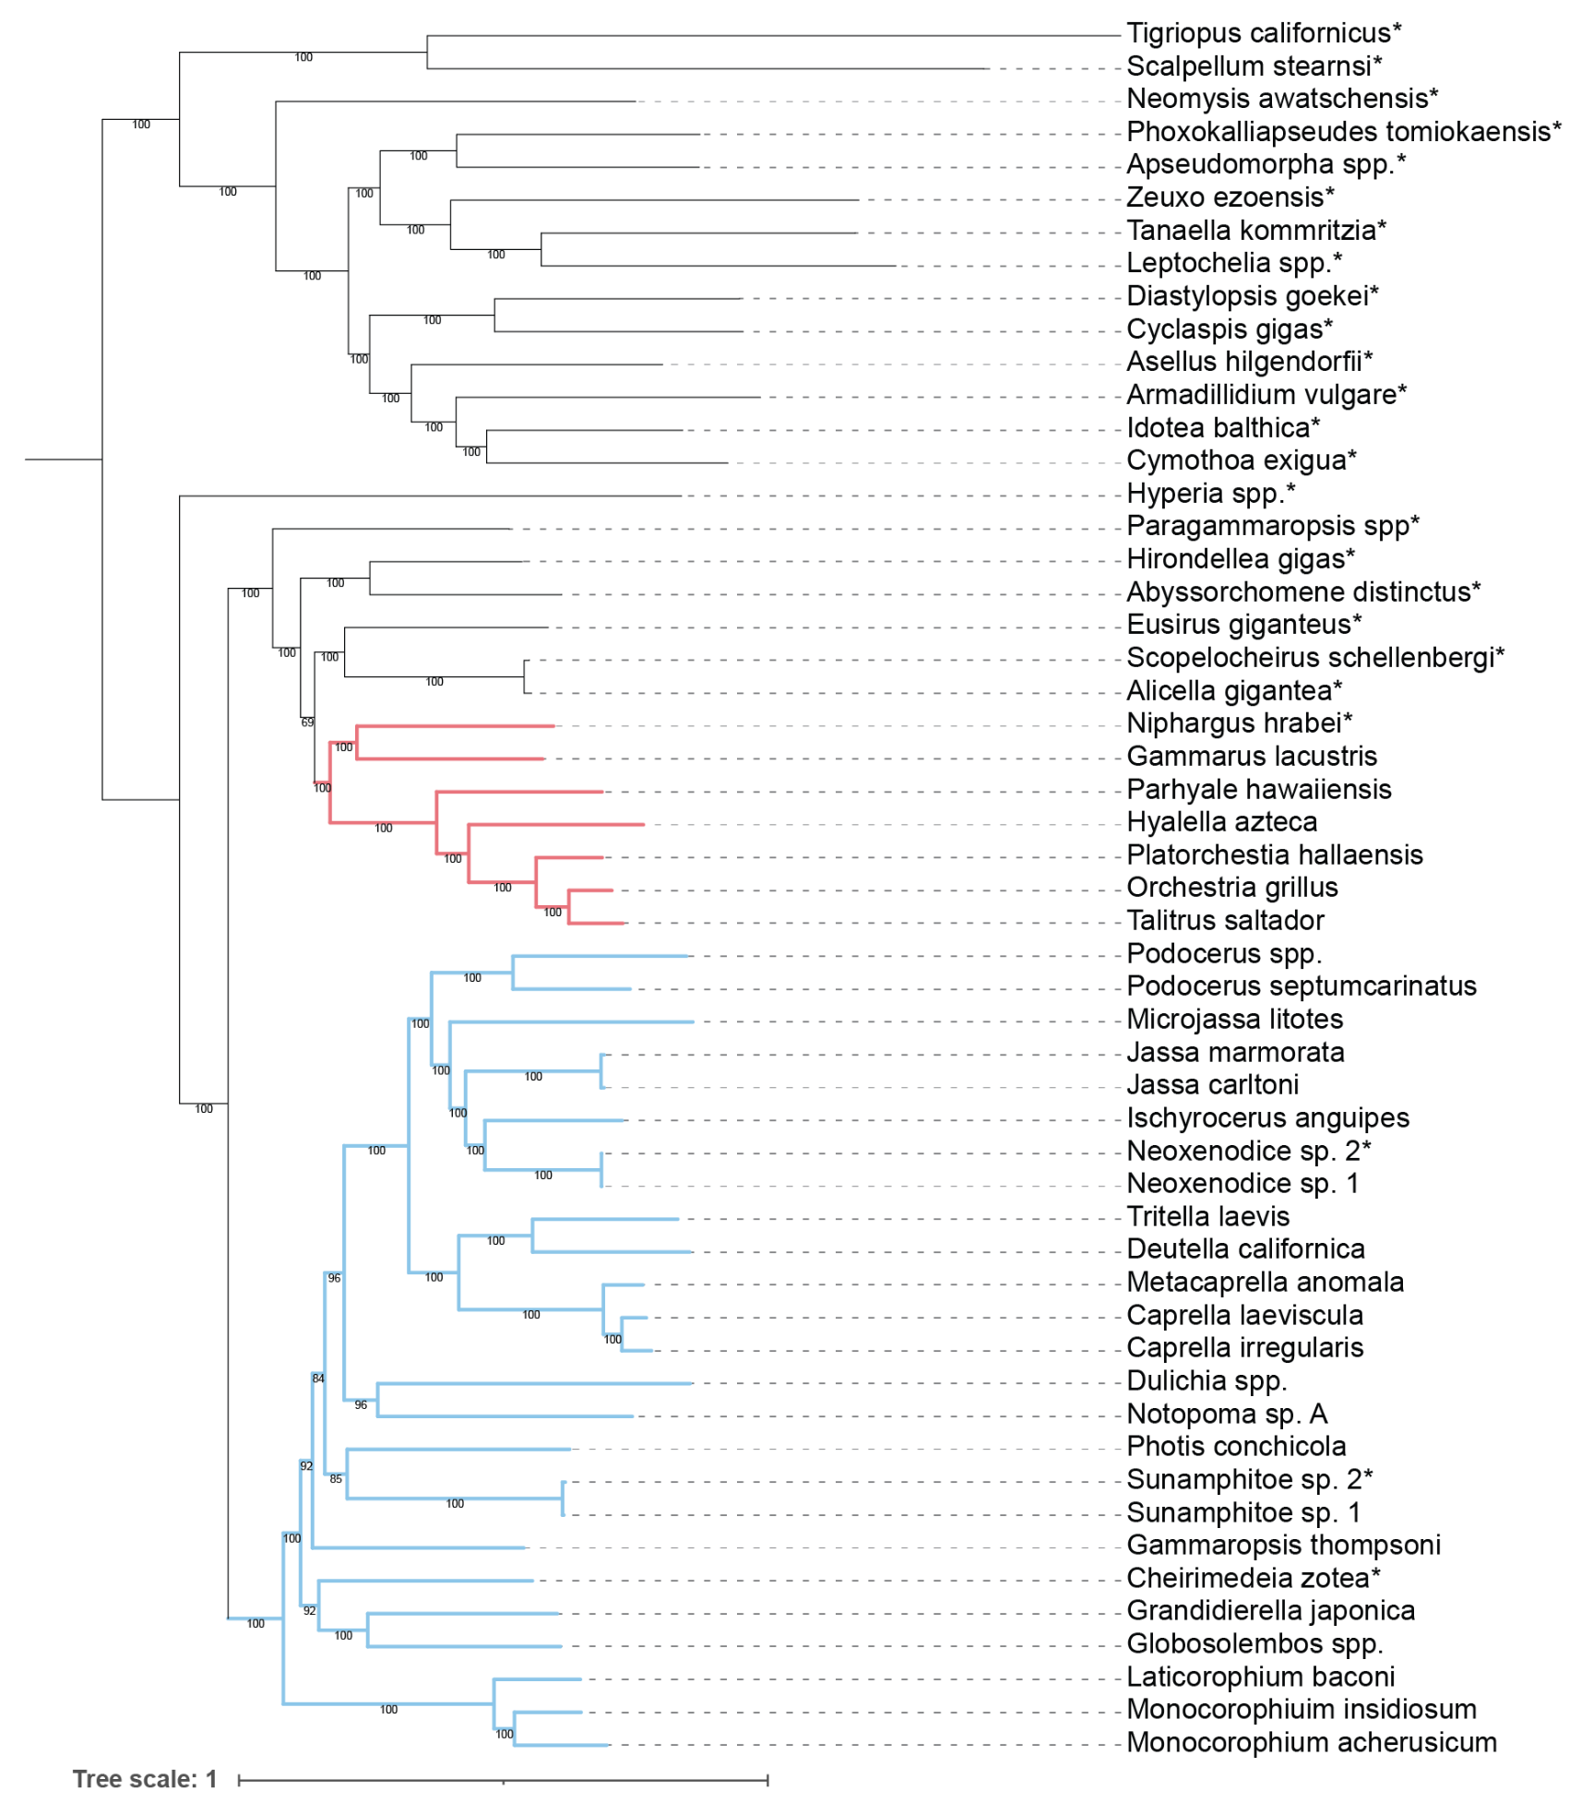
Supplementary Figure S4. Phylogeny used for ancestral state reconstruction and correlative evolution analyses. Taxa with asterisks were removed prior to analyses. Corophiida (Blue clade) and non-Corophiida outgroups (red clade). Accessibility caption: Phylogeny of corophiidans, other amphipods, and peracarid crustaceans and other crustaceans. Blue clade include corophiidans and red clad include non-corophiidan amphipods as an outgroup.
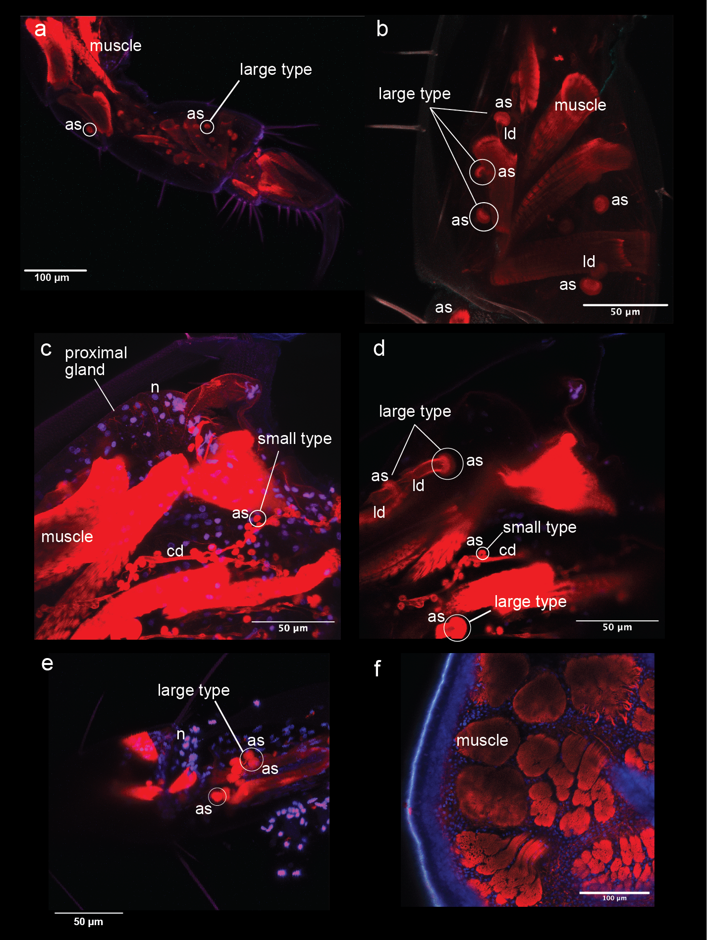
Supplementary Figure S5. Corophiidan pereopods stained with hoechst DAPI (blue) and phalloidin (red) imaged on a confocal laser microscope. Secretory cells of distal gland stain prominently with phalloidin, showing small and large type secretory cell (sc) and accumulation site (as) labeled; cd = central duct, ld = lateral duct. Nucleus (n) stained with DAPI. Some spherical accumulation sites of distal glands circled. a Americorophium stimpsoni (Corophiidae) pereopod 3 entire leg. b A. stimpsoni pereopod 4 merus. c A. stimpsoni pereopod 4 basis z projection. d A. stimpsoni pereopod 4 basis single slice. e Aoroides secundus (Aoridae) pereopod 3 merus and carpus. f Cyamus boopis (Cyamidae) pereopod 2 propodus palm, no glands. Accessibility caption: composite figure of confocal images of corophiidan pereopods stained red with phallodine and blue with hoechst DAPI.

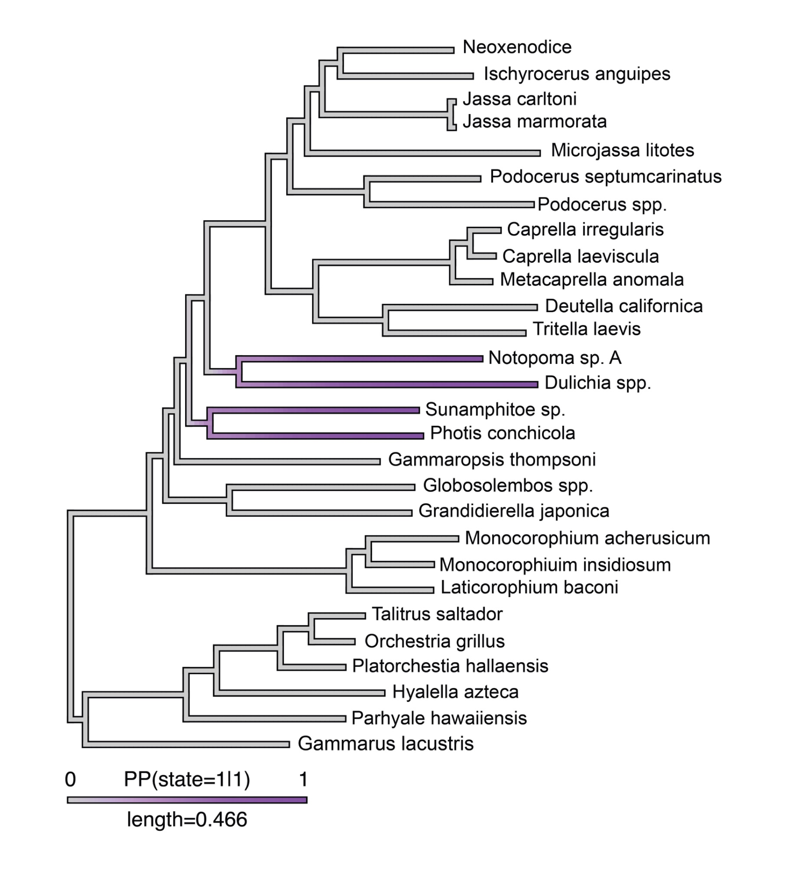
Supplementary Figure S6. Correlative evolution modeling, summarized state transitions from 100 simulations of ARD stochastic character mapping. Joint states: 0|0 no modified reservoir chamber|no attachment silk and 1|1 modified reservoir chamber|attachment silk. Legend “length” is branch length. Accessibility caption: phylogeny with gray and purple branches and nodes representing state transitions.

