Supplemental Material to the paper:

SOX9 is a target of miR-134-3p and miR-224-3p in breast cancer cell lines
by Tsu-Yang Chao*, Theresa Kordaß*, Wolfram Osen, and Stefan B. Eichmüller

Supplementary Materials and Methods

XTT proliferation assay and luciferase assay conditions

Cells were seeded in 96-well transparent culture plates to achieve 70-80 % confluence on the day of transfection. After 24 hours, cells were transfected with 50 nM miRNAs or siRNAs (mimic control-1, miR-134-3p, miR-224-3p, miR-6859-3p, SOX9 siRNA pool). Proliferation assays were performed using XTT dye. Cells were washed and incubated with XTT reagent in the incubator for 6 hours. The spectro-photometrical absorbance of the samples was measured using a microplate (ELISA) reader. The wavelength to measure the absorbance of the formazan product is 450 nm.

Supplementary Tables
Table S1. Antibodies used for FACS and Western blot analysis.
Antibody | Type | Manufacturer
Anti-Actin clone C4 human | Mouse monoclonal | MP Biomedicals, Illkirch,  France
Goat anti-mouse sc2005 | IgG-HRP | Santa Cruz Biotechnology,  Heidelberg, Germany
Goat anti-rabbit sc2004 | IgG-HRP | Santa Cruz Biotechnology,  Heidelberg, Germany
Anti-SOX9 AB5535 | Rabbit polyclonal | Sigma-Aldrich, St. Louis, USA

Table S2. Sequence of miRNAs and siRNAs used in this study.
miRNA | Sequence 5’-3’ | Purpose
hsa-miR-134-3p | CCUGUGGGCCACCUAGUCACCAA | candidate miRNA
hsa-miR-224-3p | AAAAUGGUGCCCUAGUGACUACA | candidate miRNA
hsa-miR-6859-3p | UGACCCCCAUGUCGCCUCUGUAG | candidate miRNA
mimic control-1 | GGUUCGUACGUACACUGUUCA | non-targeting control miRNA
SOX9 siRNA pool ON Target plus SMARTpool | GGAACAACCCGUCUACACA GAACAAGCCGCACGUCAAG GACCUUCGAUGUCAACGAG GGAAGUCGGUGAAGAACGG | GE Healthcare Dharmacon, Freiburg, Germany

Table S3. Primers used in this study. BS = binding site in SOX9 3’-UTR.
miRNA | Sequence 5’-3’ | Purpose
RPL19_fwd | GGCACATGGGCATAGGTAAG | qPCR
RPL19_rev | CCATGAGAATCCGCTTGTTT | qPCR
SOX9_fwd | AGCGAACGCACATCAAGAC | qPCR
SOX9_rev | CTGTAGGCGATCTGTTGGGG | qPCR
del_1484_fwd | TTTGCAGTGTTTTCTGCACAGACCTTTGGGCTGC | mutation miR-134-3p BS
del_1484_rev | GCAGCCCAAAGGTCTGTGCAGAAAACACTGCAAA | mutation miR-134-3p BS
del_1485_fwd | GCAGTGTTTTCTGCCCAGACCTTTGGGCTG | mutation miR-134-3p BS
del_1485_rev | CAGCCCAAAGGTCTGGGCAGAAAACACTGC | mutation miR-134-3p BS
del_1486_fwd | GTCATTTGCAGTGTTTTCTGCCAAGACCTTTGGGCT | mutation miR-134-3p BS
del_1486_rev | AGCCCAAAGGTCTTGGCAGAAAACACTGCAAATGAC | mutation miR-134-3p BS
del_474_fwd | TTTTAGTATGTACTGTGTATGATTCATTACATTTTGAGGGGATTTATACATATTTTTAG | mutation miR-224-3p BS
del_474_rev | CTAAAAATATGTATAAATCCCCTCAAAATGTAATGAATCATACACAGTACATACTAAAA | mutation miR-224-3p BS
del_475_fwd | GTATGTACTGTGTATGATTCATTACCTTTTGAGGGGATTTATACATATTTTT | mutation miR-224-3p BS
del_475_rev | AAAAATATGTATAAATCCCCTCAAAAGGTAATGAATCATACACAGTACATAC | mutation miR-224-3p BS
del_476_fwd | GTATGTACTGTGTATGATTCATTACCATTTGAGGGGATTTATACATATTTTTAG | mutation miR-224-3p BS
del_476_rev | CTAAAAATATGTATAAATCCCCTCAAATGGTAATGAATCATACACAGTACATAC | mutation miR-224-3p BS
del_683_fwd | TGTGTTATGTGATCAGTTTTGGGGTTAACTTTGCTTAATTCCTC | mutation miR-6859-3p BS
del_683_rev | GAGGAATTAAGCAAAGTTAACCCCAAAACTGATCACATAACACA | mutation miR-6859-3p BS
del_684_fwd | GTGTTATGTGATCAGTTTTGGGGTTAACTTTGCTTAATTCCTCA | mutation miR-6859-3p BS
del_684_rev | TGAGGAATTAAGCAAAGTTAACCCCAAAACTGATCACATAACAC | mutation miR-6859-3p BS
del_685_fwd | TGTTATGTGATCAGTTTTGGGGTTAACTTTGCTTAATTCCTCAG | mutation miR-6859-3p BS
del_685_rev | CTGAGGAATTAAGCAAAGTTAACCCCAAAACTGATCACATAACA | mutation miR-6859-3p BS

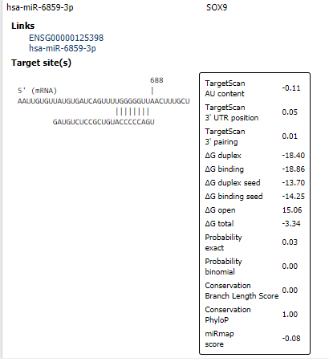
Supplementary Figures
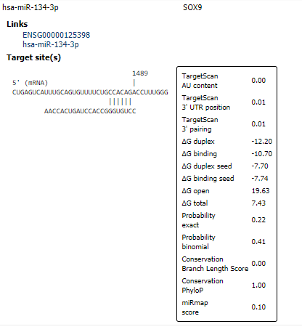
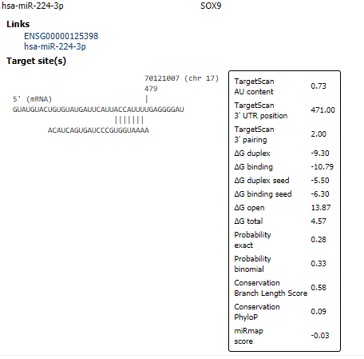

Fig. S1: miRNA binding sites within SOX9 3’-UTR. Binding sites were retrieved with miRmap tool (https://mirmap.ezlab.org/app/).
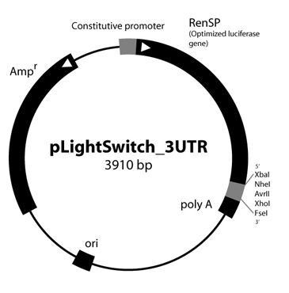
Fig S2. The structure of the SOX9 3’UTR encoding reporter plasmid. The SOX9 3’UTR sequence was cloned into pLightSwitch (pLS) plasmid via NheI/XhoI digestion. The resulting reporter plasmid was then used to verify direct interactions between the miRNAs under investigation and the SOX9 3’UTR via luciferase assay.

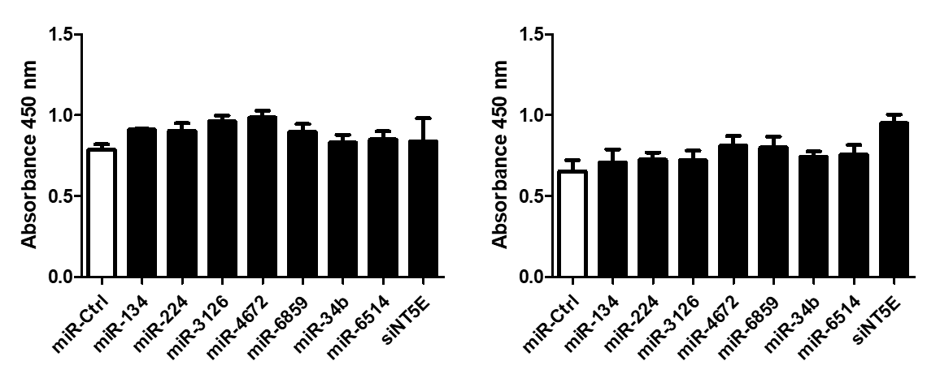
A B
Fig. S3: XTT assay for MDA-MB-231 (A) and MCF-7 (B) cells. Cell Viability was monitored with XTT assay using the same conditions as applied during the luciferase reporter assay to exclude potential interference of results caused by miRNA mediated changes in cell viability. Four individual transfections were performed per condition. No significant changes in viability were observed for the condition used for the reporter assays.

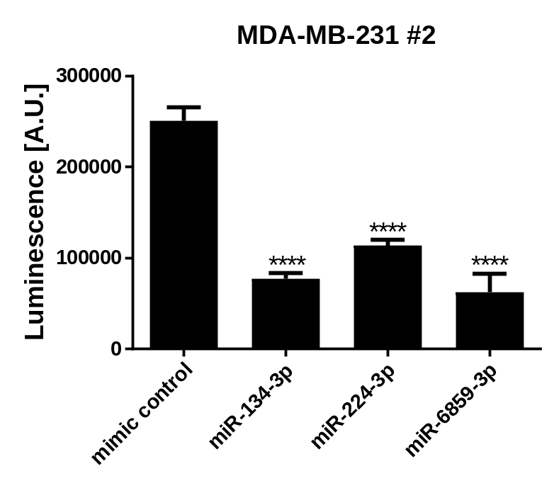
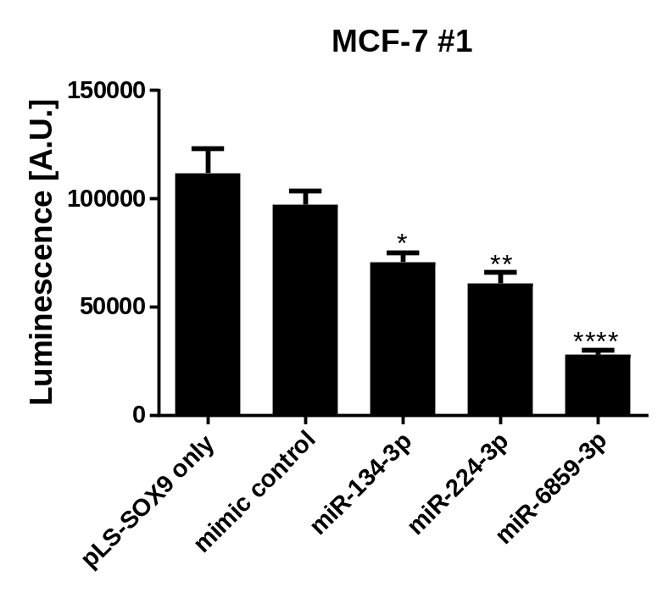
Fig S4. Independent repetitions of luciferase SOX9 3’-UTR reporter assay. MDA-MB-231 or MCF-7 cells were transfected with 50 nM miRNA and 24 h luciferase activity was assessed by luminescence measurement. Per condition five individual transfections were performed. Significance was assessed by one-way ANOVA using Dunnett’s multiple comparison test. All samples were compared to mimic control-1 samples. *: p < 0.05; **: p < 0.01; ***: p < 0.001; ****: p < 0.0001.

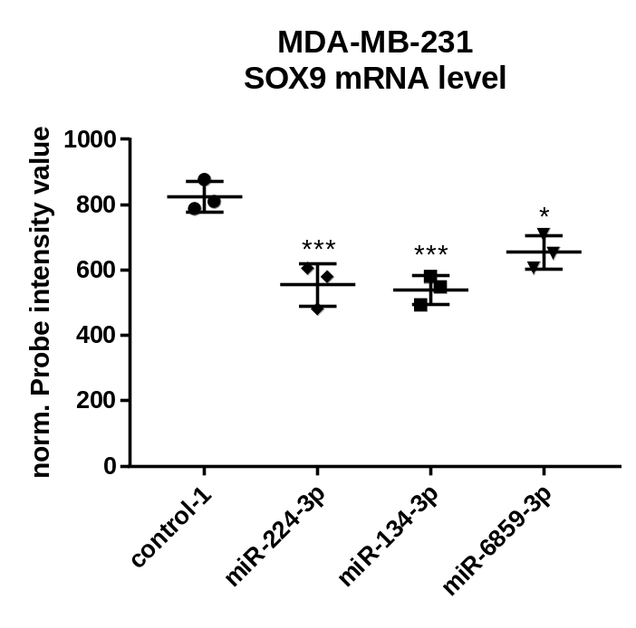
Fig S5. miRNA mediated effects on SOX9 expression in MDA-MB-231 cells determined by microarray analysis. MDA-MB-231 cells were transfected with 50 nM miRNA and 48 h post transfection cells were harvested and used for subsequent gene expression profiling. Per condition three transfections were performed. Significance was assessed by one-way ANOVA using Dunnett’s multiple comparison test. All samples were compared to mimic control-1 samples. *: p < 0.05; **: p < 0.01; ***: p < 0.001; ****: p < 0.0001.

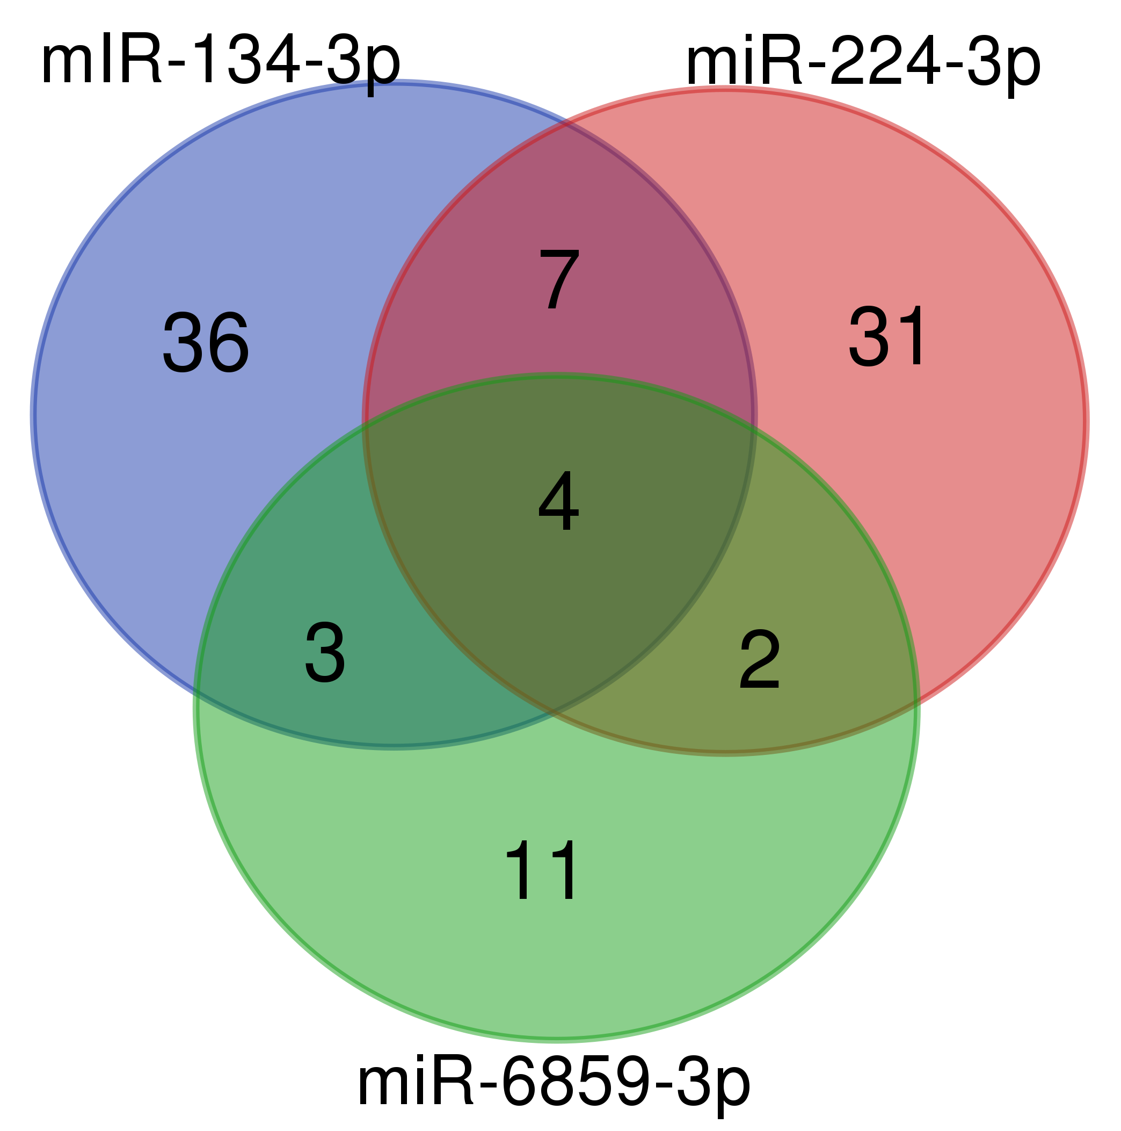
Fig S6. Venn diagram of significantly enhanced genes. MDA-MB-231 cells were transfected with 50 nM miRNA and subsequent gene expression profiling was performed. All significantly enhanced genes compared to mimic control-1 transfections with a fold change > 2 were considered.
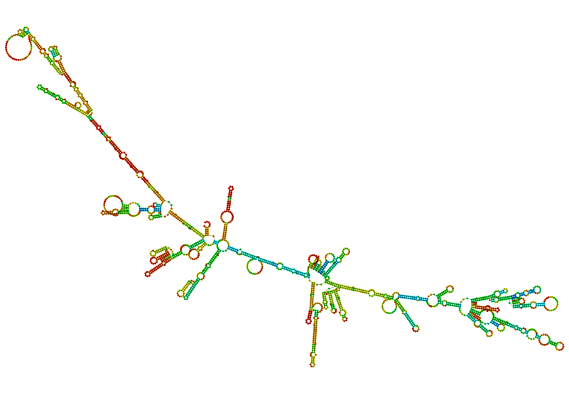
Fig S7. RNA fold prediction of SOX9 3’-UTR sequence. The Minimum Free Energy (MFE) structure of SOX9 3’-UTR sequence was retrieved with RNAfold WebServer (http://rna.tbi.univie.ac.at/cgi-bin/RNAWebSuite/RNAfold.cgi). As input sequence we used the provided DNA sequence of the SOX9 3’-UTR within the pLS plasmid converted to mRNA sequence by Nucleic Acid Converter tool (https://skaminsky115.github.io/nac/index.html).
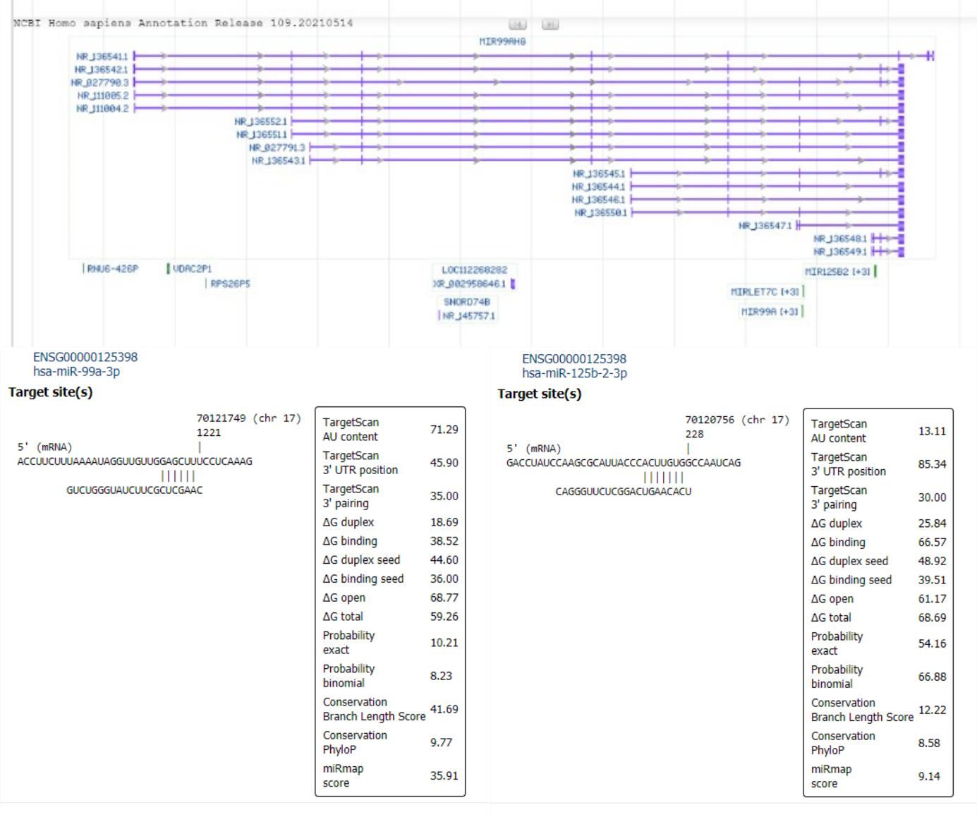
Fig S8. MIR99AHG was significantly enhanced upon miR-6859-3p transfection in MDA-MB-231 cells. MIR99AHG was among the significantly up-regulated genes (FC = 1.61, p = 0.009) based on Microarray gene expression profiling in MDA-MB-231 cells transfected with miR-6859-3p compared to mimic control-1 transfection. This gene encodes for miR-let-7c, miR-99a and miR-125b-2 miRNAs. miR-99a-3p and miR-125b-2-3p are both predicted to likely bind to SOX9 3’-UTR. Gene information was retrieved from NCBI (https://www.ncbi.nlm.nih.gov/gene/388815) and miRNA binding information was retrieved from miRmap tool (https://mirmap.ezlab.org/app/).

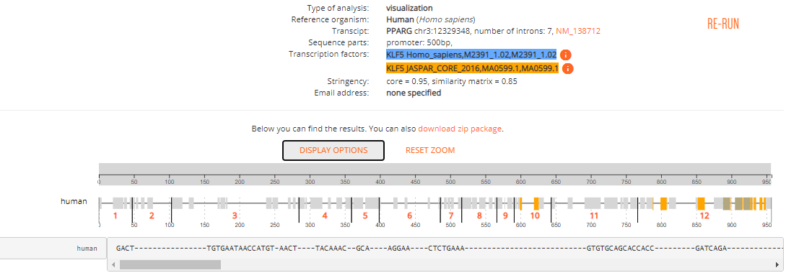
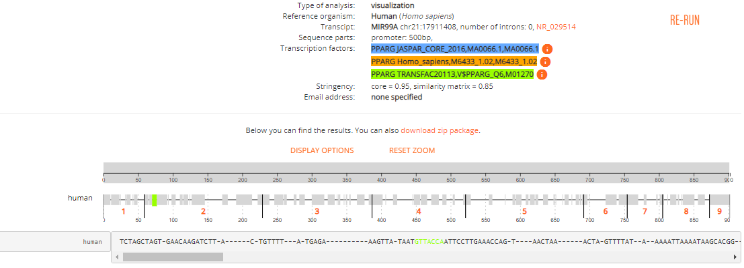
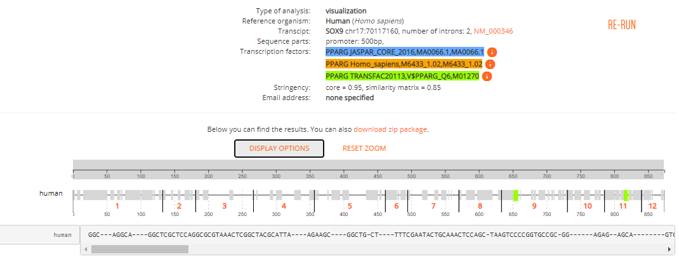
Fig S9. PPARG is negatively correlated with MIR99AHG mRNA levels but positively correlated with SOX9 mRNA levels. To find a possible explanation for observed MIR99AHG up-regulation upon miR-6859-3p transfection, we searched for transcription factors that are significantly negatively correlated with MIR99AHG mRNA levels within NCI-60 data set [1] (PCC < - 0.35) and that were inhibited by miR-6859-3p transfection in our MDA-MB-231 Microarray data (FC < 0.7, p < 0.05). We found PPARG to be negatively correlated with MIR99AHG mRNA levels (PCC = -0.39, p = 0.0022) and interestingly positively correlated with SOX9 mRNA levels (PCC = 0.40, p = 0.0015). For both genes, PPARG exhibit binding sites within the respective promoter. Furthermore, PPARG expression level was significantly reduced upon miR-6859-3p transfection (FC = 0.70, p = 0.03). miR-6859-3p is not predicted to bind to PPARG 3’-UTR, but we found that miR-6859-3p has a potential binding site within KLF5 3’-UTR. KLF5 is a known transcriptional activator of PPARG and has several binding sites within the PPARG promoter [2, 3].

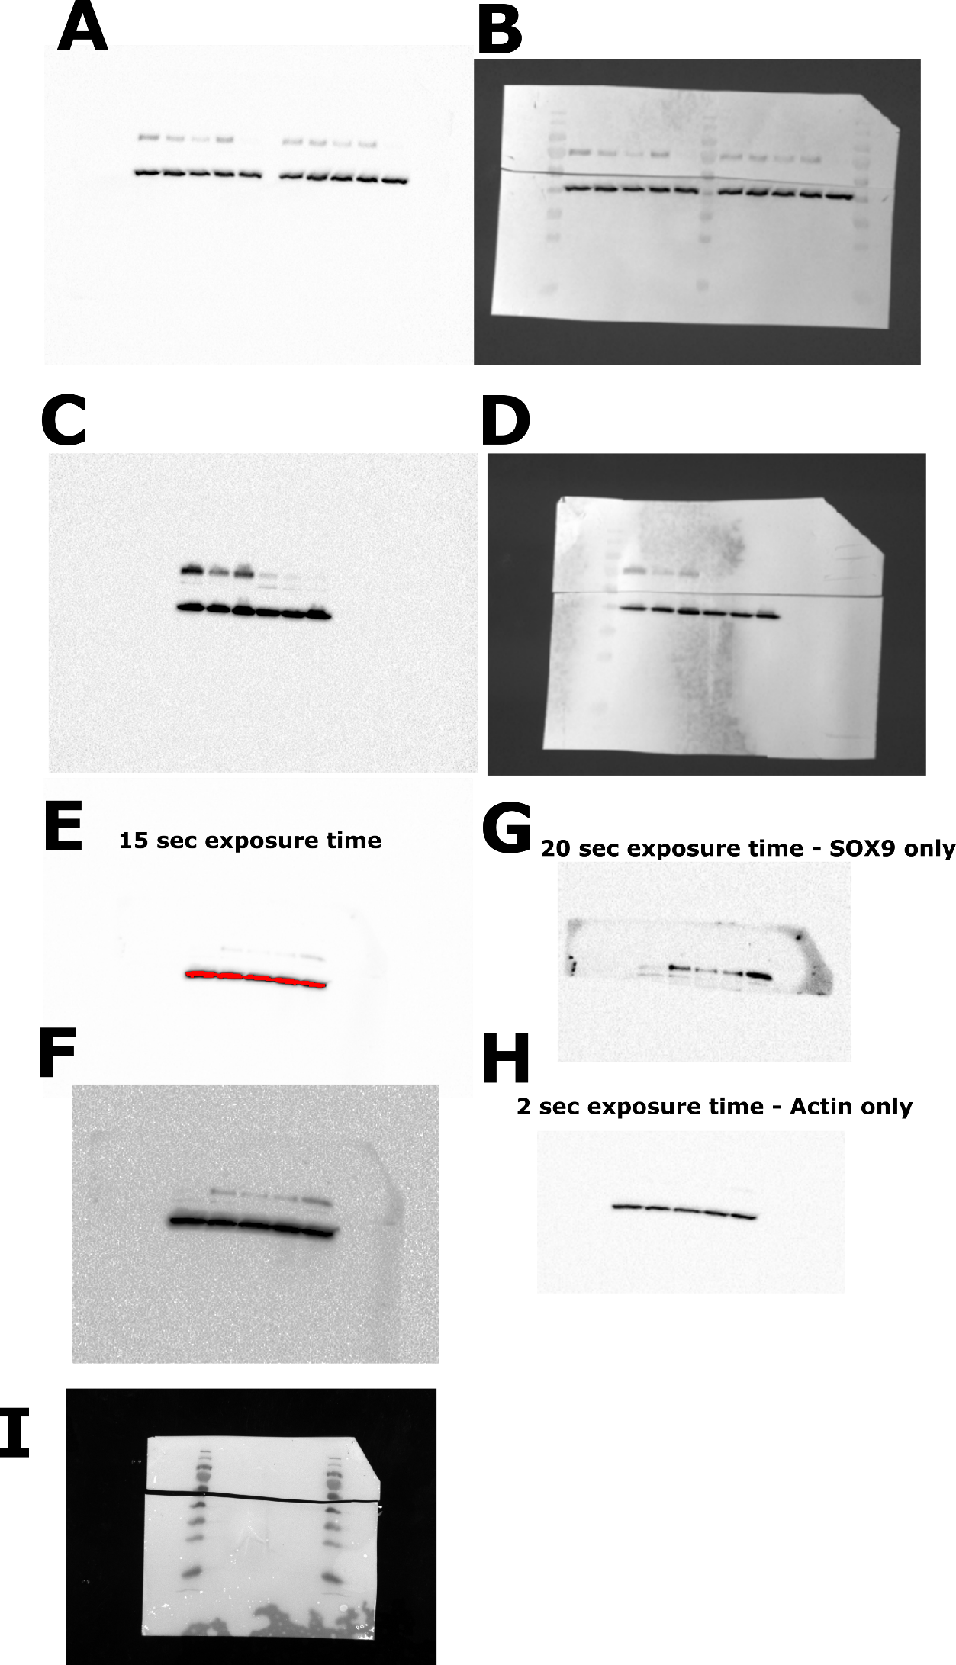

Fig S10. Full-size images of Western blots used in this study. Procedure: After blotting, membranes were cut into two pieces according to the size markers, enabling independent incubation of the upper and the lower part of the membrane with SOX9 and β-actin specific antibodies, respectively. Subsequently, both blots were positioned and aligned in the imager, a photograph was taken to identify markers, chemiluminescence was measured, and both pictures were overlaid. (A, B) Full-size image of the Western blot shown in Figure 1C. Sample order is as indicated in Figure 1C. Chemiluminescence detection (A) was performed with an exposition time of 0.5 seconds and merged with a photograph of the blot (B). (C, D) Full-size image of the Western blot used to quantify changes in SOX9 protein levels after miRNA transfection as depicted in Figure 1B. Chemiluminescence detection (C) was performed with an exposition time of 0.5 seconds followed by overlay with the corresponding photograph (D). Sample order: mimic control-1, miR-134-3p, miR-6514-3p, SOX9 siRNA 12.5 nM, SOX9 siRNA 25 nM and SOX9 siRNA 50 nM. (E-I) Full-size images of an independent Western blot replicate used for quantification shown in Figure 1B. Simultaneous detection of SOX9 and β-actin with an exposition time of 15 seconds resulted in oversaturated β-actin signals (E). Membrane contours became visible after altering the high, low and gamma settings (F). Subsequently, the SOX9-specific signal was measured separately at an exposition time of 20 seconds (G) or of 2 seconds in case of β-actin (H) for quantification. Sample order: SOX9 siRNA, miR-6859-3p, miR-224-3p, miR-134-3p and mimic control-1. As the camera for the colorimetric photograph was broken at the time of the experiment, a later picture was taken from the cut plots (I), which could not be used for an overlay.

References
1. Reinhold WC, Sunshine M, Liu H, Varma S, Kohn KW, Morris J, Doroshow J, Pommier Y: CellMiner: a web-based suite of genomic and pharmacologic tools to explore transcript and drug patterns in the NCI-60 cell line set. Cancer Res 2012, 72(14):3499-3511.
2. Lee JE, Ge K: Transcriptional and epigenetic regulation of PPARgamma expression during adipogenesis. Cell Biosci 2014, 4:29.
3. Oishi Y, Manabe I, Tobe K, Tsushima K, Shindo T, Fujiu K, Nishimura G, Maemura K, Yamauchi T, Kubota N et al: Kruppel-like transcription factor KLF5 is a key regulator of adipocyte differentiation. Cell Metab 2005, 1(1):27-39.

