Supporting Information

Wood quality and material integrity of wildfire-exposed Cryptomeria japonica evaluated by mechanical grading and multi-scale characterization

Yuta Nakayasu^{a,}*, Kosuke Yamaguchi^{b,**}, Kayoko Kobayashi^{c}, Yuka Nakagawa^{d,e}, Keisho Ri^{a,f},Keito Mineo^{d,e}, Takaaki Tomaiª, Hironori Taniuchi^{b}, Yoshiya Touge^{g, h,***}

a Frontier Research Institute for Interdisciplinary Sciences, Tohoku University, 6-3 Aoba, Aza, Aramaki, Aoba-ku, Sendai, Miyagi 980-8578, Japan.
b Iwate Prefectural Forestry Technology Center, 560-11 Kemuyama, Dai-3-chiwari
Yahaba Town, Shiwa-gun, Iwate 028-3623, Japan
c Division of Forest and Biomaterials Science, Graduate School of Agriculture, Kyoto University, Sakyo-ku, Kyoto 606-8502, Japan
d Institute for Chemical Research, Kyoto University, Gokasho, Uji, Kyoto, 611-0011, Japan
e Biomass Product Tree Industry-Academia Collaborative Research Laboratory, Kyoto University, Gokasho, Uji, Kyoto 611-0011, Japan
f School of Engineering, Tohoku University, 6-6 Aoba, Aza, Aramaki, Aoba-ku, Sendai, Miyagi 980-8579, Japan.
g Institute for Advanced Academic Research, Chiba University, 1-33 Yayoi-cho, Inage-ku, Chiba, Chiba 263-8522, Japan
h Disaster Prevention Research Institute, Kyoto University, Gokasho, Uji, Kyoto, 611-0011, Japan

*Correspondence to: Frontier Research Institute for Interdisciplinary Sciences, Tohoku University, 6-3 Aoba, Aza, Aramaki, Aoba-ku, Sendai, Miyagi 980-8578, Japan. E-mail addresses: nakayasu@tohoku.ac.jp (Y. Nakayasu)
** Correspondence to: Iwate Prefectural Forestry Technology Center, 560-11 Kemuyama, Dai-3-chiwari Yahaba Town, Shiwa-gun, Iwate 028-3623, Japan. E-mail addresses: kousuke-yamaguchi@pref.iwate.jp (K. Yamaguchi)
*** Correspondence to: Institute for Advanced Academic Research, Chiba University, 1-33 Yayoi-cho, Inage-ku, Chiba, Chiba 263-8522, Japan. E-mail addresses: touge@chiba-u.jp (Y. Touge)

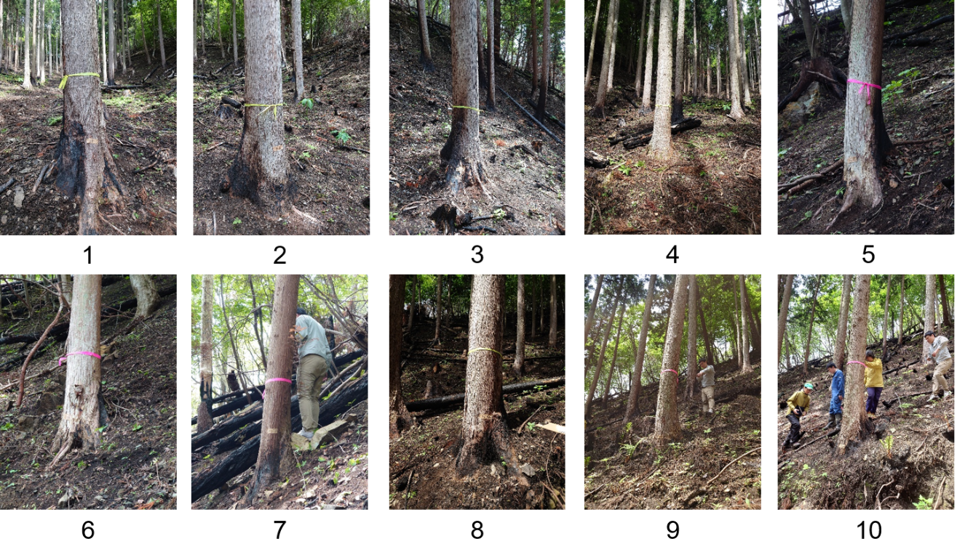
Fig. S1 Photographs of ten trees classified into low severity.
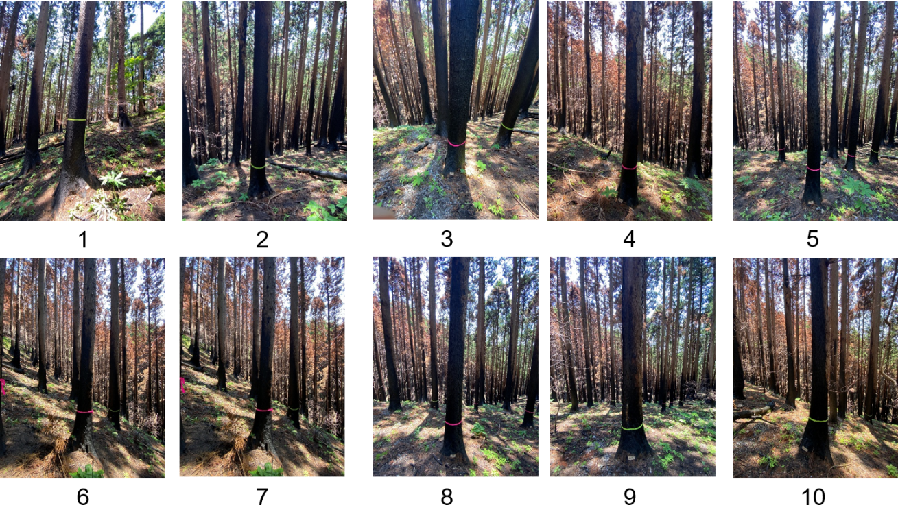
Fig. S2 Photographs of ten trees classified into moderate severity.

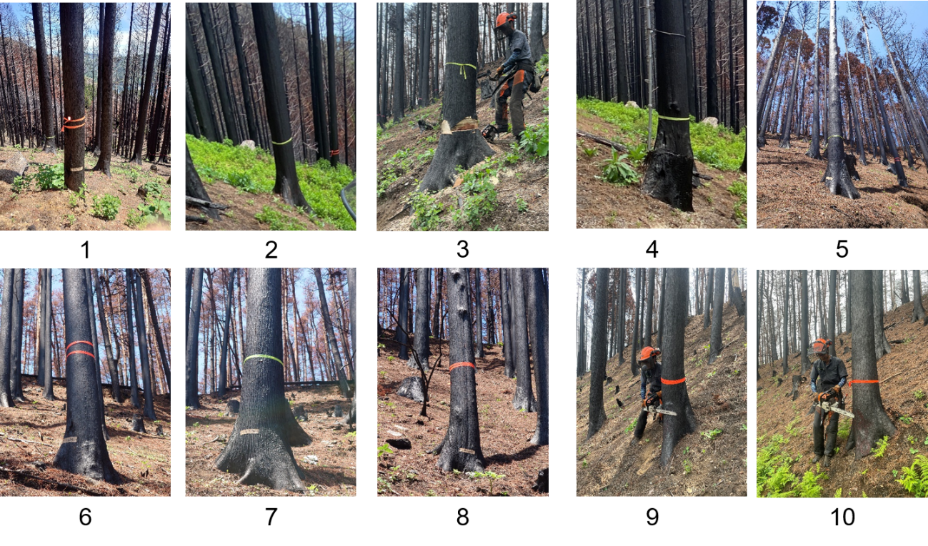Fig. S3 Photographs of ten trees classified into severe severity.

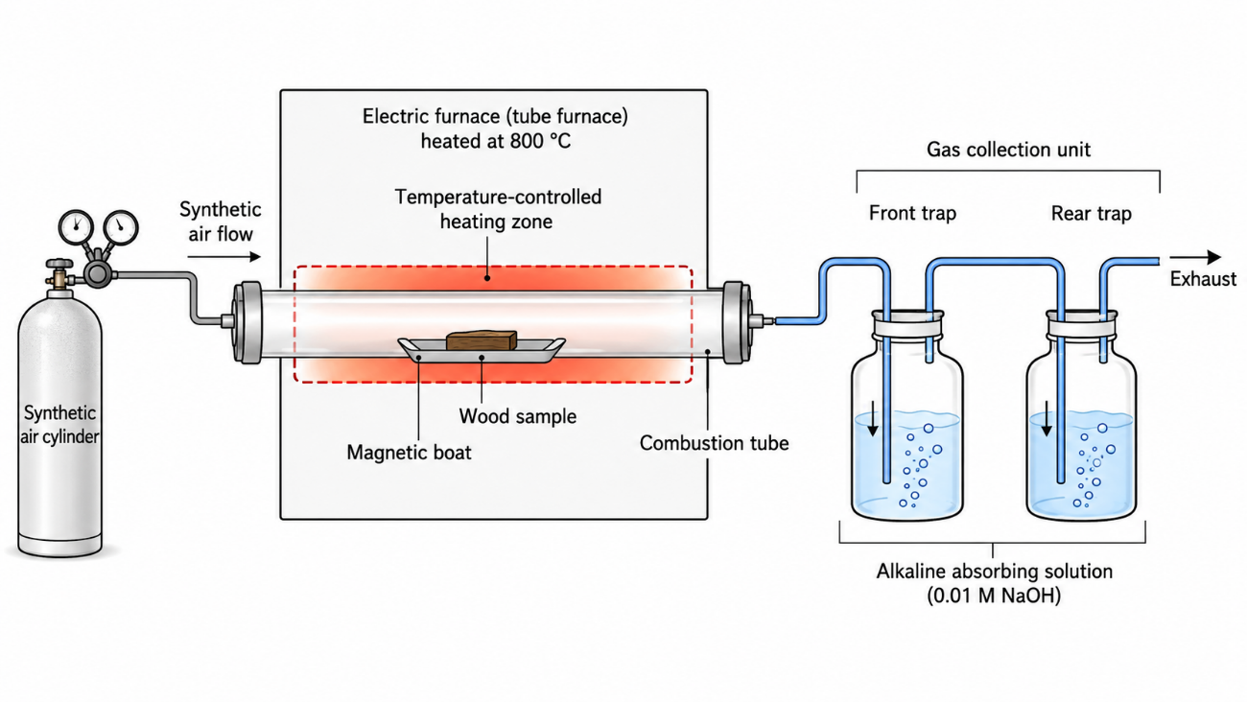
Fig. S4 Schematic representation of the procedure used to determine the total chlorine concentration.

Table S1. Descriptive comparison between severely burned wood and control
Component | Severely burned  mean ± SD (%) | Severely burned  range (%) | Control  mean ± SD (%) | Control  range (%) | Mean difference  (burned − control)
Glucose | 43.75 ± 2.63 | 41–46 | 45.00 ± 1.41 | 44–46 | -1.25
Xylose | 4.50 ± 0.58 | 4–5 | 5.00 ± 0.00 | 5–5 | -0.50
Galactose | 0.25 ± 0.50 | 0–1 | 0.00 ± 0.00 | 0–0 | +0.25
Arabinose | 1.00 ± 0.00 | 1–1 | 1.00 ± 0.00 | 1–1 | +0.00
Mannose | 6.50 ± 0.58 | 6–7 | 7.00 ± 1.41 | 6–8 | -0.50
Lignin | 39.50 ± 1.91 | 37–41 | 36.00 ± 1.41 | 35–37 | +3.50
Total | 95.50 ± 2.52 | 93–99 | 94.50 ± 0.71 | 94–95 | +1.00
Note: Values are descriptive statistics only. Because each ring position is represented by a single value and the sample size is small, the manuscript should avoid the expression “no statistically significant difference” unless additional replicate-based statistical tests are performed.

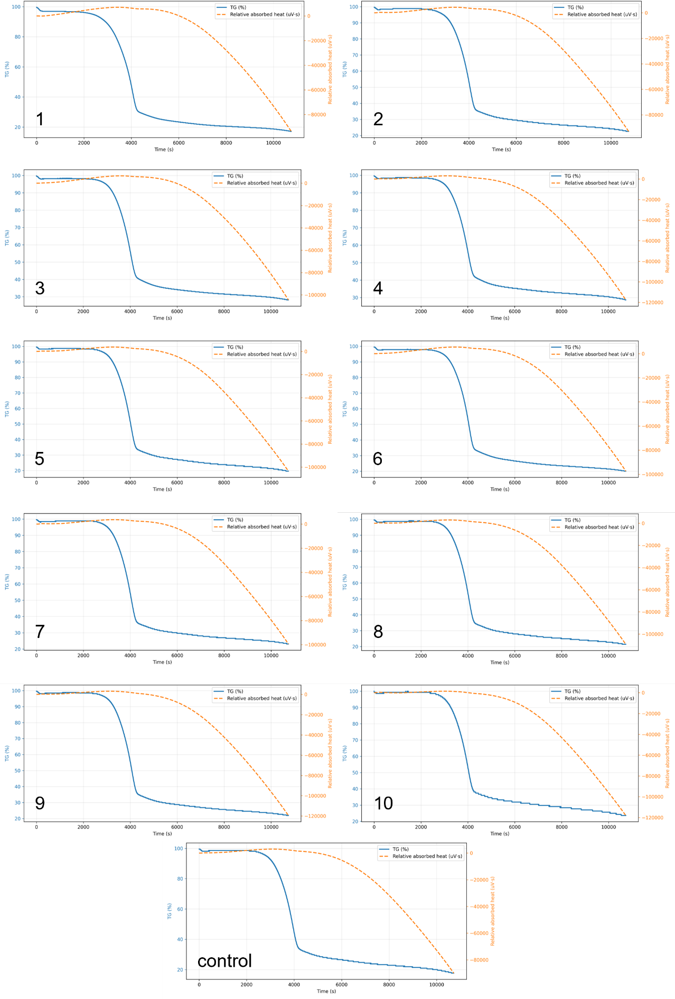
Fig. S5. Thermogravimetric analysis of the outer annual rings of severely burned wood.

