Supporting Information
Utilizing 4D-STEM to Characterize Diffusion-Induced Grain Boundary Migration in NiCr Alloys
Eitan Hershkovitz¹, Karen Kruska², Pauline Simmonnin², Konnor Walter³, Emmanuelle Marquis^{2,3}, Daniel Schreiber^{2*}, and Chongmin Wang^{1*}
¹Environmental Molecular Sciences Laboratory, Pacific Northwest National Laboratory, Richland, WA, USA.
²Energy and Environment Directorate, Pacific Northwest National Laboratory, Richland, WA, USA.
³Department of Materials Science and Engineering, University of Michigan, Ann Arbor, MI, USA.
*Corresponding authors: chongmin.wang@pnnl.gov Daniel.Schreiber@pnnl.gov

Opposite Grain DIGM-zone Strain Maps
To confirm that DIGM-induced strain is confined exclusively to the compositionally altered DIGM-zone, 4D-STEM strain maps were acquired from the adjacent grain on the opposite side of the grain boundary (the grain not swept by boundary migration) for all three samples. In each case, neither ε₁₁ (perpendicular to the grain boundary) nor ε₂₂ (parallel to the grain boundary) reveals measurable strain in the region immediately bordering the boundary. This holds regardless of initial alloy composition or exposure conditions. In parts of the Ni5Cr-Water sample and the Ni30Cr-Air sample, apparent strain is visible immediately bordering the boundary; however, upon closer inspection of the respective diffraction patterns in those areas, these regions contain slight overlap from the neighboring grain. It is important to note that the TEM lamella is aligned to the zone axis of the grain being analyzed and not to be edge-on with the grain boundary, meaning that it is possible for a small section of the opposing grain to have partial overlap, obscuring the diffraction pattern and producing an erroneous strain measurement. This explains why no such artifact appears in the Ni30Cr-Water sample and only manifests in the Ni5Cr-Water sample maps and the Ni30Cr-Air sample on the ε₂₂ map. In both (b) and (i), an example diffraction pattern is presented as an inset outlined in green, taken from the location marked by the green dot at the edge of the grain boundary where apparent strain is observed. The green arrows in those patterns point to reflections associated with the off-zone-axis grain on the other side of the boundary, confirming that these additional reflections obfuscate the main pattern and produce an incorrect strain measurement rather than reflecting true strain in the adjacent grain. A log-scale intensity image of the average diffraction pattern from each scan is shown as an inset in (a), (d), and (g)

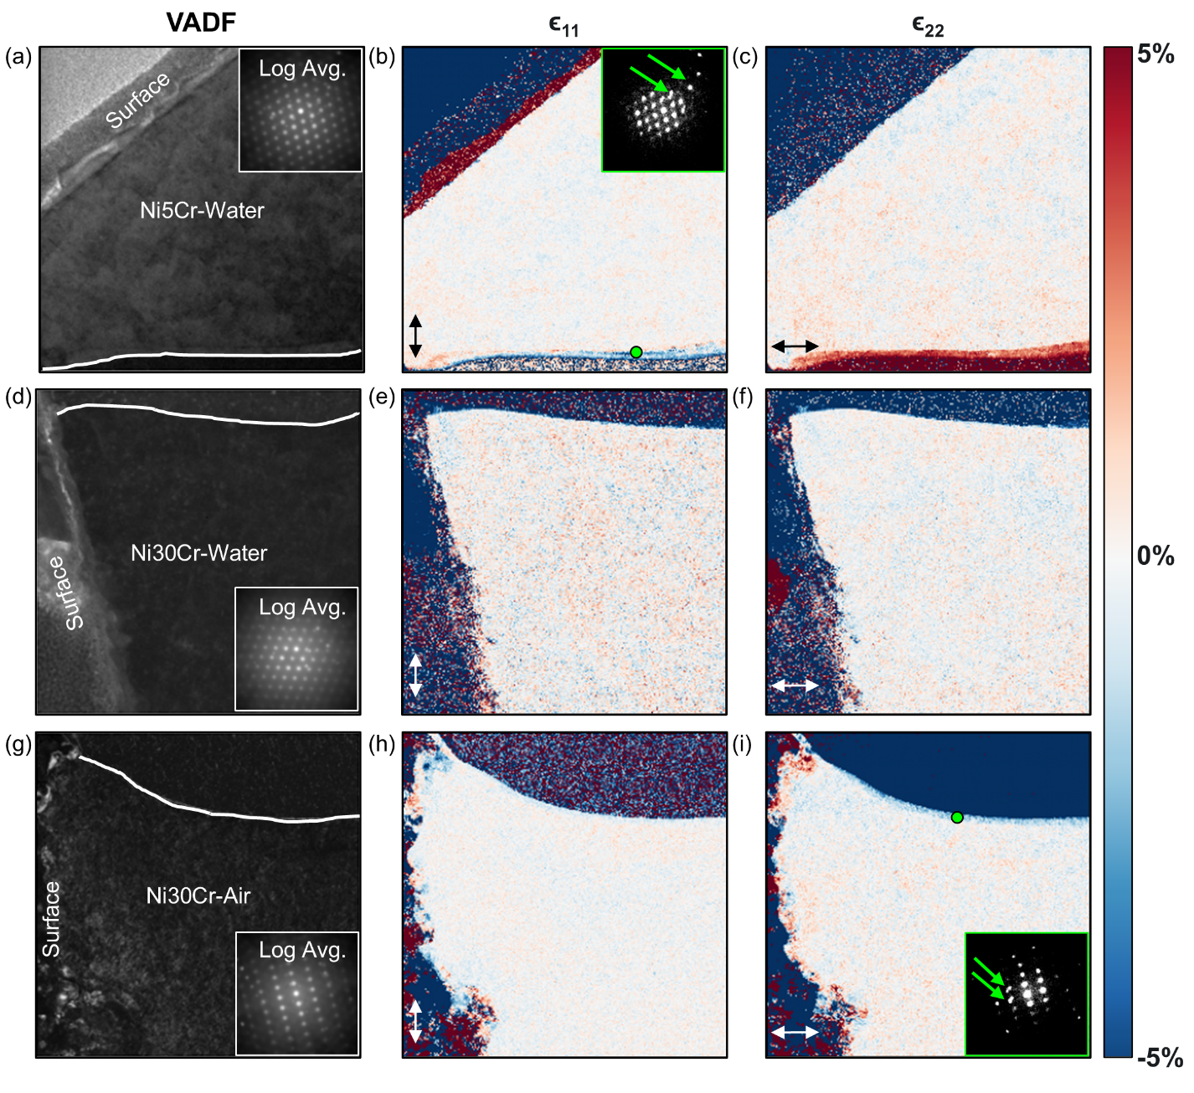
Supplementary Figure S1. 4D-STEM strain mapping of the grain adjacent to (opposite side of) the grain boundary for all three samples. (a, d, g) Virtual annular dark filed (VADF) images showing the region analyzed on the opposite side of the grain boundary for the Ni5Cr-Water, Ni30Cr-Water, and Ni30Cr-Air samples, respectively; insets show log-scale intensity of the average diffraction pattern from each scan. (b, e, h) Corresponding ε₁₁ strain maps (perpendicular to the grain boundary). (c, f, i) Corresponding ε₂₂ strain maps (parallel to the grain boundary). Insets in (b) and (i) show diffraction patterns (outlined in green) acquired from the locations marked by green dots near the grain boundary edge where apparent strain is observed; green arrows indicate reflections from the off-zone-axis grain across the boundary, confirming that the apparent strain in these localized regions is an artifact of diffraction pattern overlap rather than true strain in the adjacent grain.

