Supplementary Table 1. Cell-specific gene signature
Gene | Origin
POU5F1 | Stem/ progenitor cells
SOX9 | Stem/ progenitor cells
CD44 | Stem/ progenitor cells
CD24 | Stem/ progenitor cells
PAX2 | Stem/ progenitor cells
PAX8 | Stem/ progenitor cells
CITED1 | Stem/ progenitor cells
NOTCH2 | Stem/ progenitor cells
SIX2 | Stem/ progenitor cells
LGR5 | Stem/ progenitor cells
PROM1 | Stem/ progenitor cells
PODXL | Podocytes
WT1 | Podocytes
CD2AP | Podocytes
NPHS1 | Podocytes
ABCC1 | Proximal tubule
ABCC3 | Proximal tubule
ABCC4 | Proximal tubule
ATP11A | Proximal tubule
CLCN5 | Proximal tubule
LRP2 | Proximal tubule
SLC22A6 | Proximal tubule
SLC22A8 | Proximal tubule
SLC22A2 | Proximal tubule
SLC5A2 | Proximal tubule
SLC22A3 | Proximal tubule
SLC40A1 | Proximal tubule
UMOD | Loop of Henle
CLDN10 | Loop of Henle
CLDN14 | Loop of Henle
SLC12A1 | Loop of Henle
PCBD1 | Distal tubule cells
CALB1 | Distal tubule cells
ATP1A1 | Distal tubule cells
SLC12A3 | Distal tubule cells
SLC41A3 | Distal tubule cells
CDH1 | Collecting duct
AQP3 | Collecting duct
AQP2 | Collecting duct
GATA3 | Collecting duct
SLC12A2 | Collecting duct
PECAM1 | Endothelium
CDH5 | Endothelium
FLT1 | Endothelium
EPCAM | Epithelium
PAX8 | Epithelium

Supplementary Table 2. Primer sequences commercially available (IDT) for all genes analyzed by qPCR.
Gene | Reference sequence | Assay ID (IDT)
RPLP0 | NM_001002 | Hs.PT.39a.22214824
PRKAA1 (AMPKa1) | NM_206907 | Hs.PT.58.700639
AMPKa2 | NM_006252 | Hs.PT.58.3219579
GAPDH | NM_002046 | Hs.PT.39a.22214836
mTOR | NM_004958 | Hs.PT.58.45414861
SLC22A6 (OAT1) | NM_153278 | Hs.PT.58.447346
OAT3 | NM_004254 | Hs.PT.58.40750585
SLC22A1 (OCT1) | NM_153187 | Hs.PT.58.4286019
OCT2 | NM_003058 | Hs.PT.58.2629312
SLC5A2 (SGLT2) | NM_003041 | Hs.PT.58.38756530
AQP1 | NM_001185060 | Hs.PT.56a.27098577.g
ACTA2 (α-SMA) | NM_001141945 | Hs.PT.56a.2542642
B2M | NM_004048 | Hs.PT.58v.18759587
FANK 1 (Fibronectin) | NM_145235 | Hs.PT.58.27951369
HIF1A | NM_181054 | Hs.PT.58.534274
EPAS1 (HIF2A) | NM_001430 | Hs.PT.58.2273374
HO1 | NM_002133 | Hs.PT.58.45340055
PROM1 | NM_001145847 | Hs.PT.58.28257943
VMAC (Vimentin) | NM_001017921 | Hs.PT.58.3448582
ACTb | NM_001101 | Hs.PT.39a.22214847
KIM1 | NM_012206 | Hs.PT.58.3472
NCC | NM_000339 | Hs.PT.58.40684907
NGAL | NM_005564 | Hs.PT.58.27617685
NKCC1 | NM_001046 | Hs.PT.58.25217590
NKCC2 | NM_000338 | Hs.PT.58.41074963
PAX8 | NM_003466 | Hs.PT.58.1610472
SOX9 | NM_000346 | Hs.PT.58.38984663

Supplementary Table 3. Cohort characteristics description
Sample ID | Age | Sex | Anatomophatological diagnosis | Histological grade | Tumoral paired PDOs | Fresh/Frozen
TU22002 | 76 | Male | Oncocytoma | - | Yes | Fresh
TU22012 | 75 | Female | Clear cell renal cell carcinoma (ccRCC) | G4 | Yes | Fresh/Frozen
TU22032 | 46 | Male | Xp11 translocation-associated renal cell carcinoma | G3 | No | Fresh
TU22043 | 62 | Male | Chromophobe renal cell carcinoma (chRCC) | G3 | Yes | Fresh
TU22051 | 56 | Male | Clear cell renal cell carcinoma (ccRCC) | G3 | Yes | Fresh
TU23001 | 50 | Male | Clear cell renal cell carcinoma (ccRCC) | G1 | Yes | Frozen
TU23002 | 47 | Female | Xp11 translocation-associated renal cell carcinoma | G4 | Yes | Fresh
TU23004 | 59 | Male | Clear cell renal cell carcinoma (ccRCC) | G3 | Yes | Frozen
TU23005 | 47 | Female | Clear cell renal cell carcinoma (ccRCC) | G2 | Yes | Frozen
TU23013 | 61 | Male | Clear cell renal cell carcinoma (ccRCC) | G2 | No | Frozen
TU23016 | 51 | Male | Clear cell renal cell carcinoma (ccRCC) | G3 | Yes | Frozen
TU23017 | 73 | Female | Clear cell renal cell carcinoma (ccRCC) | G4 | Yes | Fresh
TU23018 | 51 | Male | Clear cell renal cell carcinoma (ccRCC) | G2 | Yes | Frozen
TU23025 | 70 | Male | Clear cell renal cell carcinoma (ccRCC) | G3 | Yes | Frozen
TU23034 | 49 | Male | Clear cell renal cell carcinoma (ccRCC) | G3 | Yes | Frozen
TU23038 | 60 | Male | Clear cell renal cell carcinoma (ccRCC) | G3 | Yes | Frozen
TU23043 | 74 | Male | Clear cell renal cell carcinoma (ccRCC) | G4 | Yes | Frozen
TU24003 | 81 | Female | Clear cell renal cell carcinoma (ccRCC) | G3 | Yes | Frozen
TU24017 | 77 | Male | Clear cell renal cell carcinoma (ccRCC) | G2 | Yes | Fresh
TU24018 | 83 | Male | Oncocytoma | - | Yes | Fresh
TU25002 | 74 | Male | Clear cell renal cell carcinoma (ccRCC) | G2 | No | Fresh
TU25003 | 71 | Male | Clear cell renal cell carcinoma (ccRCC) | G3 | No | Fresh

Supplementary Table 4. Tissue and tubuloids STRs analysis
 | D8S1179 | D21S11 | D7S820 | CSP1PO | D3S1358 | TH01 | D13S317 | D16S539 | D2S1338 | D19S433 | vWA | TPOX | D18S51 | AMEL | D5S818 | FGA
Tissue 1 | 12, 15 | 30 | 8, 12 | 11, 13 | 16, 18 | 6, 9.3 | 11 | 9, 12 | 19, 20 | 12, 14 | 15, 17 | 8, 9 | 13, 21 | X, X | 12 | 21, 24
Tubuloid1 | 12, 15 | 30 | 8, 12 | 11, 13 | 16, 18 | 6, 9.3 | 11 | 9, 12 | 19, 20 | 12, 14 | 15, 17 | 8, 9 | 13, 21 | X, X | 12 | 21, 24
Tissue 2 | 13, 14 | 29, 30 | 9, 12 | 10, 11 | 15 | 9.3 | 8, 12 | 10, 13 | 19, 24 | 13, 14 | 15, 16 | 8, 10 | 13, 15 | X, Y | 11, 12 | 19
Tubuloid 2 | 13, 14 | 29, 30 | 9, 12 | 10, 11 | 15 | 9.3 | 8, 12 | 10, 13 | 19, 24 | 13, 14 | 15, 16 | 8, 10 | 13, 15 | X, Y | 11, 12 | 19
Tissue 3 | 12, 15 | 29, 30.2 | 8, 9 | 11, 12 | 17, 18 | 8 | 11 | 12, 13 | 20, 24 | 14, 16 | 16, 19 | 8, 11 | 12, 17 | X, X | 12, 13 | 22, 24
Tubuloid 3 (Fresh) | 12, 15 | 29, 30.2 | 8, 9 | 11, 12 | 17, 18 | 8 | 11 | 12, 13 | 20, 24 | 14, 16 | 16, 19 | 8, 11 | 12, 17 | X, X | 12, 13 | 22, 24
Tubuloid 3 (Frozen) | 12, 15 | 29, 30.2 | 8, 9 | 11, 12 | 17, 18 | 8 | 11 | 12, 13 | 20, 24 | 14, 16 | 16, 19 | 8, 11 | 12, 17 | X, X | 12, 13 | 22, 24
Tissue 4 | 13, 14 | 28, 32.2 | 8, 12 | 10 | 15,17 | 6, 9 | 10, 11 | 12, 13 | 17, 24 | 14, 15 | 14, 17 | 12 | 14 | X, Y | 11, 13 | 20, 21
Tubuloid 4 | 13, 14 | 28, 32.2 | 8, 12 | 10 | 15,17 | 6, 9 | 10, 11 | 12, 13 | 17, 24 | 14, 15 | 14, 17 | 12 | 14 | X, Y | 11, 13 | 20, 21
Tissue 5 | 13, 15 | 29 | 8, 12 | 11, 13 | 15, 16 | 9.3 | 11 | 9, 11 | 23, 24 | 14, 15 | 17, 18 | 8, 9 | 13, 14 | X, Y | 11, 13 | 22, 25
Tubuloid 5 | 13, 15 | 29 | 8, 12 | 11, 13 | 15, 16 | 9.3 | 11 | 9, 11 | 23, 24 | 14, 15 | 17, 18 | 8, 9 | 13, 14 | X, Y | 11, 13 | 22, 25
Tissue 6 | 10, 14 | 30 | 8, 13 | 11, 13 | 16, 18 | 6, 9 | 11, 14 | 10, 11 | 19, 25 | 16, 16.2 | 14, 18 | 9, 11 | 14, 15 | X, Y | 11, 13 | 20, 22
Tubuloid 6 | 10, 14 | 30 | 8, 13 | 11, 13 | 16, 18 | 6, 9 | 11, 14 | 10, 11 | 19, 25 | 16, 16.2 | 14, 18 | 9, 11 | 14, 15 | X, Y | 11, 13 | 20, 22
Tissue 7 | 13 | 31.2 | 10, 12 | 12, 13 | 16 | 7 | 11, 13 | 12, 13 | 19 | 13, 14 | 14, 16 | 8, 9 | 15, 17 | X, Y | 12 | 20, 21
Tubuloid 7 | 13 | 31.2 | 10, 12 | 12, 13 | 16 | 7 | 11, 13 | 12, 13 | 19 | 13, 14 | 14, 16 | 8, 9 | 15, 17 | X, Y | 12 | 20, 21
Tissue 8 | 15 | 29, 32.2 | 9, 12 | 11, 12 | 14, 16 | 7, 8 | 12, 13 | 9, 11 | 24 | 13, 14 | 17, 19 | 8 | 14 | X, Y | 8, 11 | 21, 27
Tubuloid 8 | 15 | 29, 32.2 | 9, 12 | 11, 12 | 14, 16 | 7, 8 | 12, 13 | 9, 11 | 24 | 13, 14 | 17, 19 | 8 | 14 | X, Y | 8, 11 | 21, 27
Tissue 9 | 11, 16 | 29 | 9, 11 | 10, 11 | 15, 17 | 7, 9.3 | 10, 11 | 11, 12 | 16, 20 | 13, 15.2 | 15, 17 | 11, 12 | 14, 17 | X, Y | 12 | 19, 21
Tubuloid 9 | 11, 16 | 29 | 9, 11 | 10, 11 | 15, 17 | 7, 9.3 | 10, 11 | 11, 12 | 16, 20 | 13, 15.2 | 15, 17 | 11, 12 | 14, 17 | X, Y | 12 | 19, 21
Tissue 10 (Tumoral) | 12, 15 | 30 | 8, 12 | 11, 13 | 16, 18 | 6, 9.3 | 11 | 9, 12 | 19, 20 | 12, 14 | 15, 17 | 8, 9 | 13, 21 | X, X | 12 | 21, 24
Tubuloid 10 (Tumoral) | 12, 15 | 30 | 8, 12 | 11, 13 | 16, 18 | 6, 9.3 | 11 | 9, 12 | 19, 20 | 12, 14 | 15, 17 | 8, 9 | 13, 21 | X, X | 12 | 21, 24
Tissue 11 (Tumoral) | 13, 14 | 29, 30 | 9, 12 | 10, 11 | 15 | 9.3 | 8, 12 | 10, 13 | 19, 24 | 13, 14 | 15, 16 | 8, 10 | 13, 15 | X, Y | 11, 12 | 19
Tubuloid 11 (Tumoral) | 13, 14 | 29, 30 | 9, 12 | 10, 11 | 15 | 9.3 | 8, 12 | 10, 13 | 19, 24 | 13, 14 | 15, 16 | 8, 10 | 13, 15 | X, Y | 11, 12 | 19
Tissue 12 (Tumoral) | 13, 14 | 28, 32.2 | 8, 12 | 10 | 15,17 | 6 | 10, 11 | 12, 13 | 17, 24 | 14, 15 | 14 | 12 | 14 | X, Y | 11, 13 | 20, 21
Tubuloid 12 (Tumoral) | 13, 14 | 28, 32.2 | 8, 12 | 10 | 15,17 | 6 | 10, 11 | 12, 13 | 17, 24 | 14, 15 | 14 | 12 | 14 | X, Y | 11, 13 | 20, 21

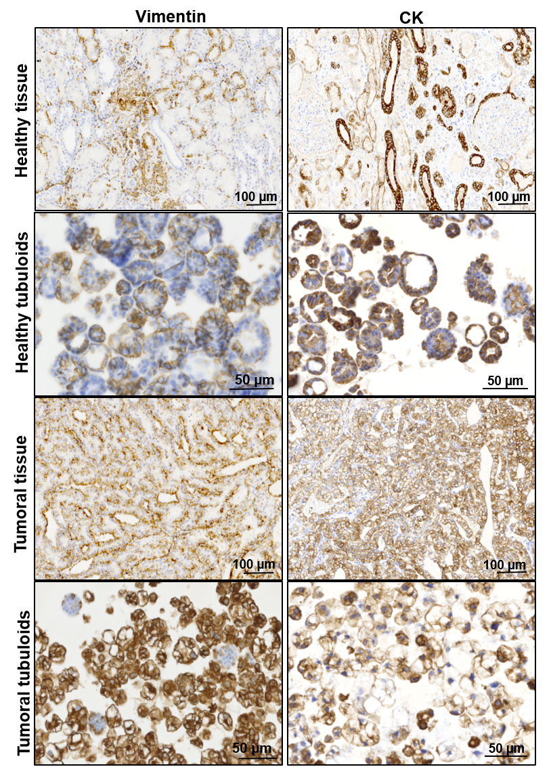
Supplementary Figure 1. Immunohistochemical staining for vimentin and CK AE1/AE3. The immunohistochemical staining was performed on both the original healthy and tumoral renal tissue and the corresponding tubuloid cultures. The images show positive expression of both markers in the tubuloids, comparable to that observed in their respective tissue of origin.
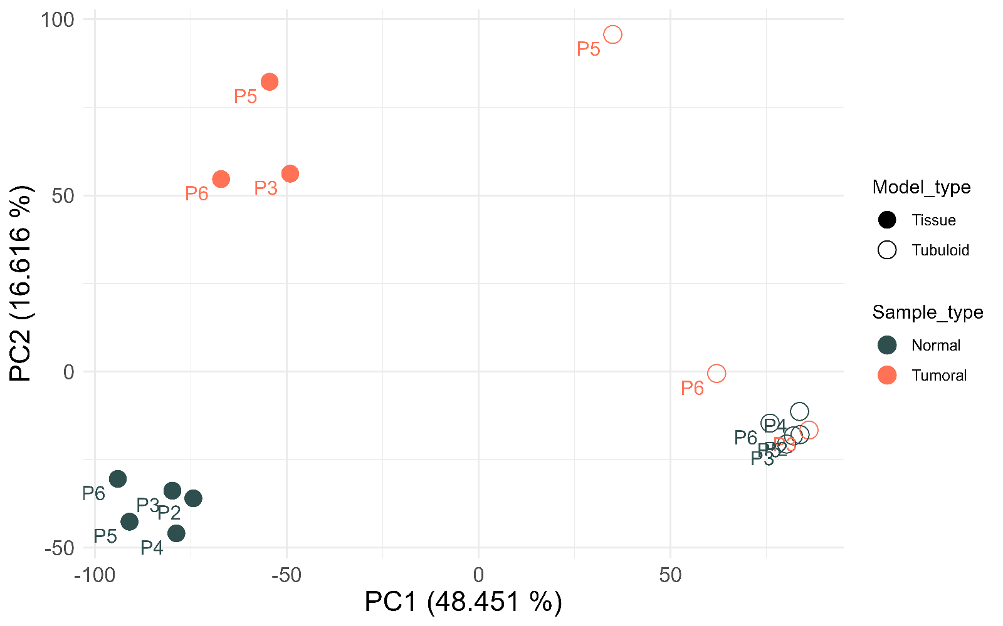
Supplementary Figure 2. Principal component analysis (PCA) of RNA expression in tubuloids and tissues of origin.
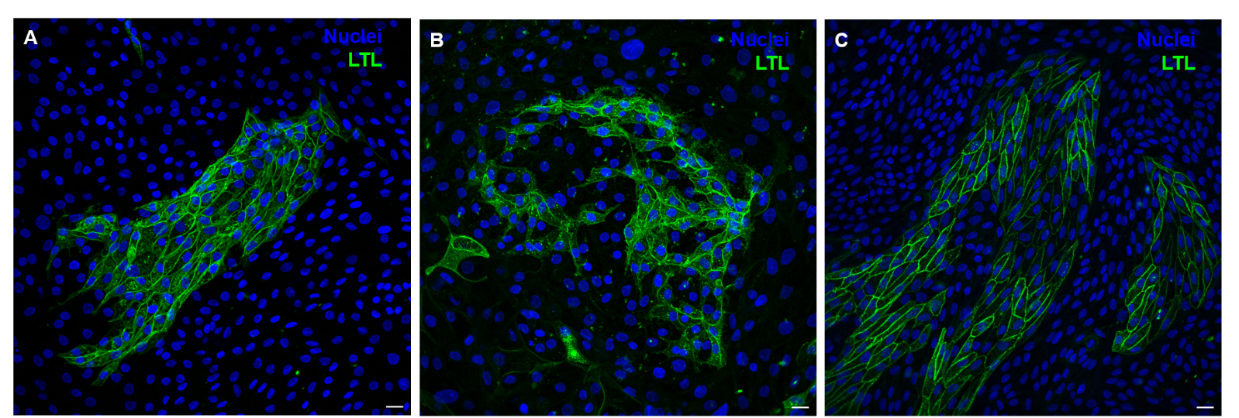
Supplementary Figure 3. LTL expression was observed across different serial passages derived from the same patient. Scale bar: 20 µm.

