Supplementary Information
Pre-existing Immunity to H1N1 Influenza Virus Improves Antibody Response to Vaccination through Germinal Center Regulation
Opeyemi E. Oludada^{1*}, Magen E. Francis^{2,8*}, Anuj Kumar², Gustavo S. Martinez², Mary K. Foley^{2,9}, Reema Singh³, Angela Rasmussen³, Melissa L. Rioux², Craig McCormick², Jayme Salsman⁴, Graham Dellaire⁴, Gregory K. Tharp⁵, Steven E. Bosinger ^{5, 6,7}, and Alyson A. Kelvin^{1#}
Affiliations:
^{1.} Faculty of Veterinary Medicine, University of Calgary, Calgary, Alberta, Canada.
² Department of Microbiology & Immunology, Dalhousie University, Halifax, Nova Scotia B3H 4R2, Canada.
³ Vaccine and Infectious Disease Organization - International Vaccine Centre (VIDO-InterVac), Saskatoon, Saskatchewan, Canada.
^{4.} Departments of Pathology and Biochemistry & Molecular Biology, Dalhousie University, Halifax, Nova Scotia, B3H 4R2 Canada.
^{5.} Emory Primate Center Genomics Core, Emory National Primate Research Center, Atlanta, Georgia 30329, USA.
^{6.} Division of Microbiology and Immunology, Emory National Primate Research Center, Atlanta, Georgia 30329, USA.
^{7.} Department of Pathology and Laboratory Medicine, Emory University, Atlanta, Georgia 30322, USA.
^{8.} Medical Research Development Office (MRDO), Faculty of Medicine, Dalhousie University, Halifax, Nova Scotia B3H 0A2, Canada.
^{9.} Present Address: Queen's University, Kingston, K7L3N6, Ontario, Canada.
*These authors contributed equally
#Corresponding Author
Alyson A. Kelvin, PhD
Foothills Medical Centre
University of Calgary
Calgary, AB, T2N 5A1
alyson.kelvin@ucalgary.ca
Supplementary Fig. 1: Infection with H1N1 influenza virus FM/47 leads to preimmunity development
Supplementary Fig. 2: Vaccination in both preimmune and naïve mice leads to minimal weight change and 100%
Supplementary Fig. 3: Challenge in preimmune-vaccinated mice shows a distinct antibody isotype profile compared to control mice.
Supplementary Fig. 4: Preimmunity alters transcriptional programs associated with disease, inflammation, and adaptive immunity.
Supplementary Fig. 5: RNA sequencing reveals distinct lymphocyte gene regulation in lymph nodes of preimmune mice.
Supplementary Fig. 6: Lung transcriptional responses show limited regulation of lymphocyte-associated genes in preimmune mice.
Supplementary Fig. 7: Preimmunity alters baseline lymphocyte-associated gene expression in lymph nodes prior to vaccination:

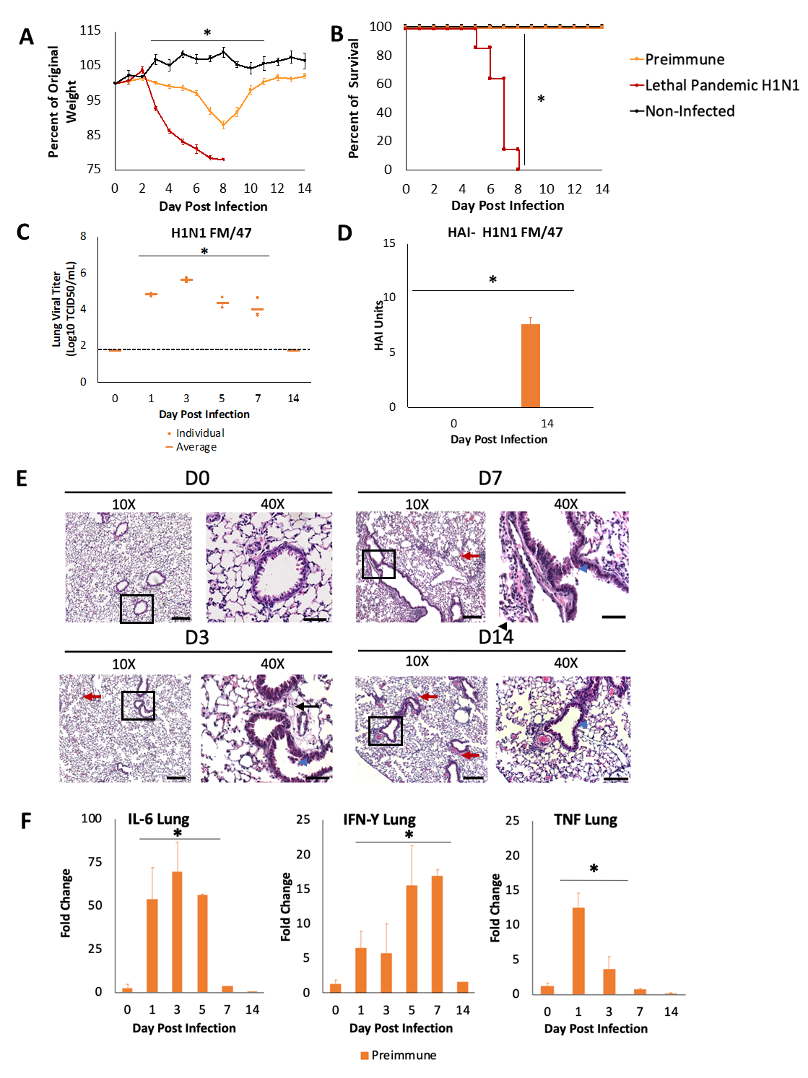
Supplementary Fig. 1. Infection with H1N1 influenza virus FM/47 leads to preimmunity development. (A) Body weight change following H1N1 imprinting is shown as a percentage of the original weight. (B) Survival following H1N1 imprinting, defined by reaching the humane endpoint of 80% baseline body weight and graphed for each group as Kaplan-Meier curves. (C) Live viral titer of the historic H1N1 virus in the lung as determined by calculating TCID₅₀ by the Reed and Muench method. (D) Antibodies represented in HAI units against historic H1N1 measured in RDE-treated sera collected on days 0 and 14 post-infection. (E) Representative lung histopathology of three mice per group, per time point. Hemorrhage (red arrow) at 10X and epithelial cell sloughing (blue arrowhead) and fibrin (black arrow) at 40X are evident. Scale bars represent 200 μm or 50 μm, respectively. (F) RNA from lung samples analyzed by RT-qPCR using IL-6-, IFN-γ-, and TNF-specific primers. Data are mean ± SD. * indicates a p-value ≤ 0.05 determined by unpaired, two-tailed Student’s t-test (two groups) or one-way ANOVA with Tukey’s multiple-comparisons test (three or more groups), comparing groups at the same time point; survival (B) was compared by the log-rank (Mantel-Cox) test. For (A and B), the same animals were followed longitudinally; for all other panels, independent animals were sampled at each time point. n = 3 mice for each group.

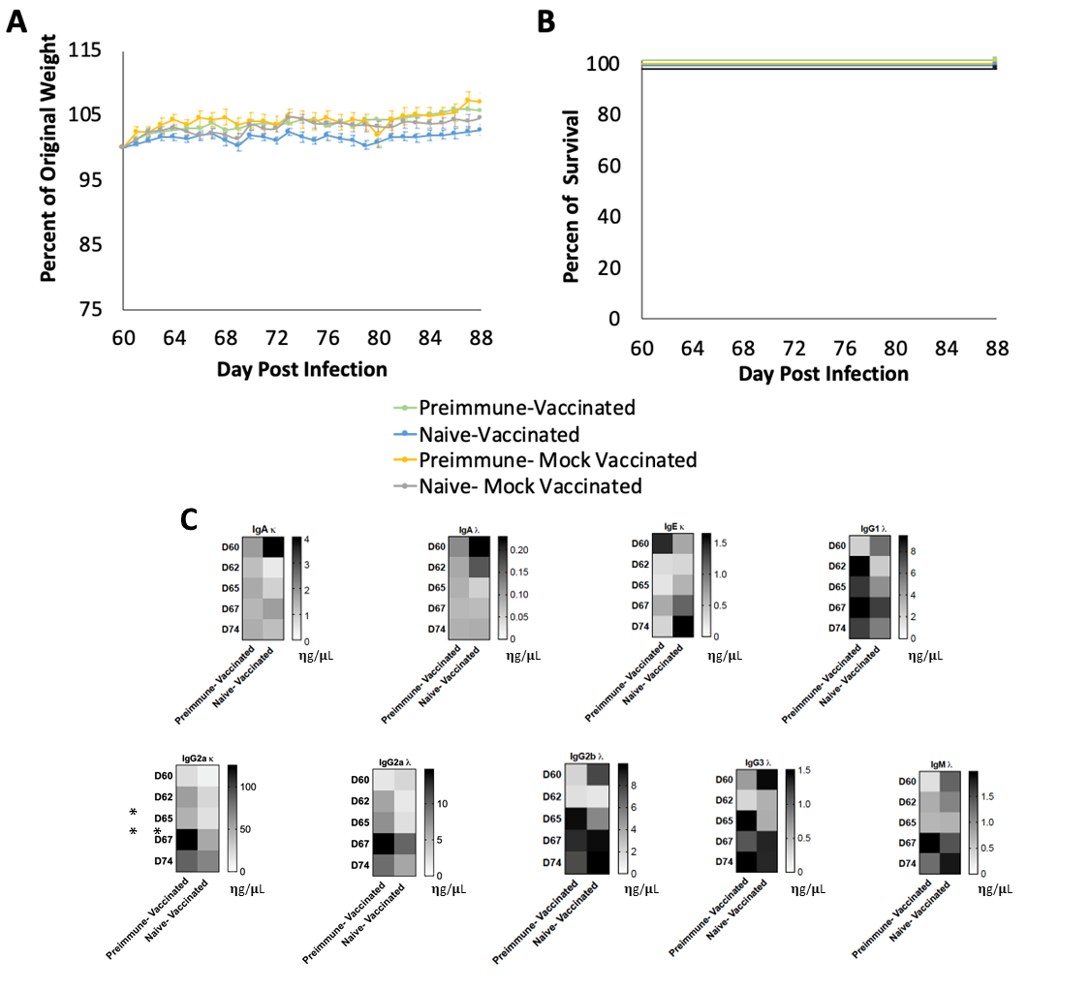
Supplementary Fig. 2. Vaccination in both preimmune and naïve mice leads to minimal weight change and 100% survival. (A) Body weight change following vaccination with FLUZONE quadrivalent (FLUZONE® QIV) influenza virus vaccine shown as percentage of the original weight. (B) Survival following FLUZONE Quadrivalent (FLUZONE® QIV) influenza virus vaccine, defined by reaching the humane endpoint of 80% baseline body weight and graphed for each group as Kaplan-Meier curves. (C) Post-vaccination serum antibody isotype concentrations (IgA κ, IgA λ, IgG1 λ, IgG3 λ, IgG2a λ, IgG2b λ, IgE κ, and IgM λ) in ng/µL, measured using a mouse antibody isotype CBA kit and analyzed by FACS. Data are mean ± SD. * indicates a p-value ≤ 0.05 determined by unpaired, two-tailed Student’s t-test (isotypes, C). For (A and B), the same animals were followed longitudinally, and groups were compared at each time point (n = 10); for all other panels, independent animals were sampled at each time point (n = 3 per group).

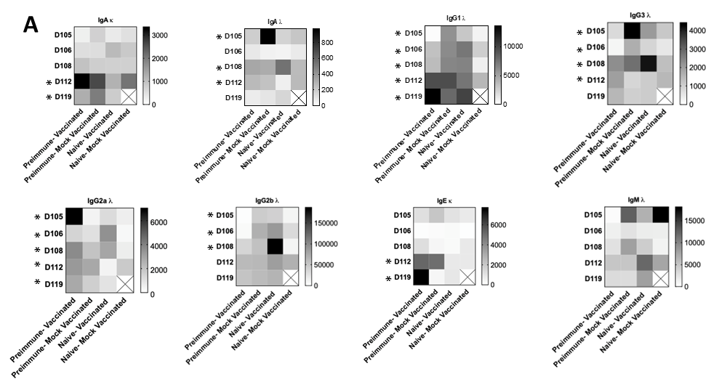
Supplementary Fig. 3: Challenge in preimmune-vaccinated mice shows a distinct antibody isotype profile compared to control mice. (A) Post-challenge serum antibody isotype concentrations (IgA κ, IgA λ, IgG1 λ, IgG3 λ, IgG2a λ, IgG2b λ, IgE κ, and IgM λ) in ng/µL, measured using a mouse antibody isotype CBA kit and analyzed by FACS. Data are mean ± SD. * indicates a p-value ≤ 0.05 as determined by one-way ANOVA with Tukey’s multiple-comparisons test, comparing groups at the same time point. n = 3 mice per group.
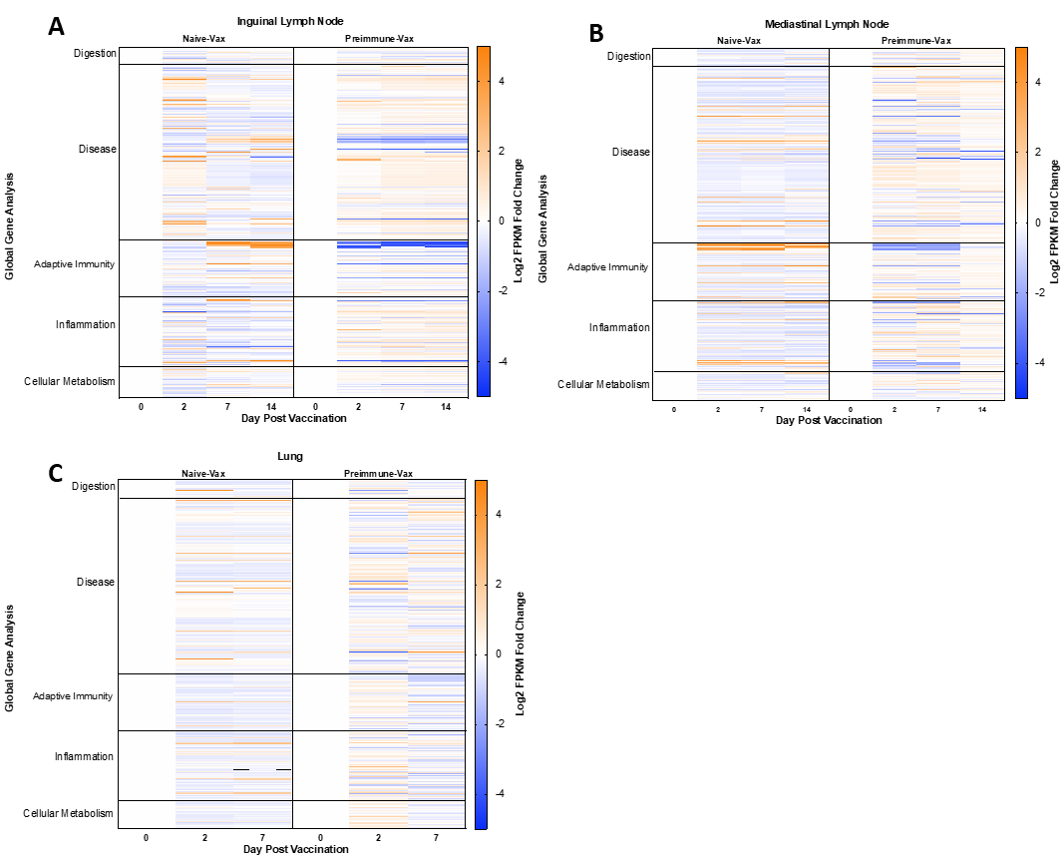
Supplementary Fig. 4: Preimmunity alters transcriptional programs associated with disease, inflammation, and adaptive immunity. (A-C) Total RNA isolated from inguinal lymph nodes (A), mediastinal lymph nodes (B), and lungs (C) using the RNeasy Mini Kit (Qiagen) following H1N1 imprinting. Libraries were sequenced on an Illumina platform and reads aligned to the mm10 reference genome. Global transcriptional profiles of naïve-vaccinated and preimmune-vaccinated mice were compared following vaccination. The top 300 differentially expressed genes were analyzed for pathway enrichment using the Database for Annotation, Visualization, and Integrated Discovery (DAVID) based on KEGG pathway annotations. Heatmaps display gene expression as log₂ fold change in FPKM values at each time point relative to the corresponding baseline (leftmost column), with values normalized to z-scores.
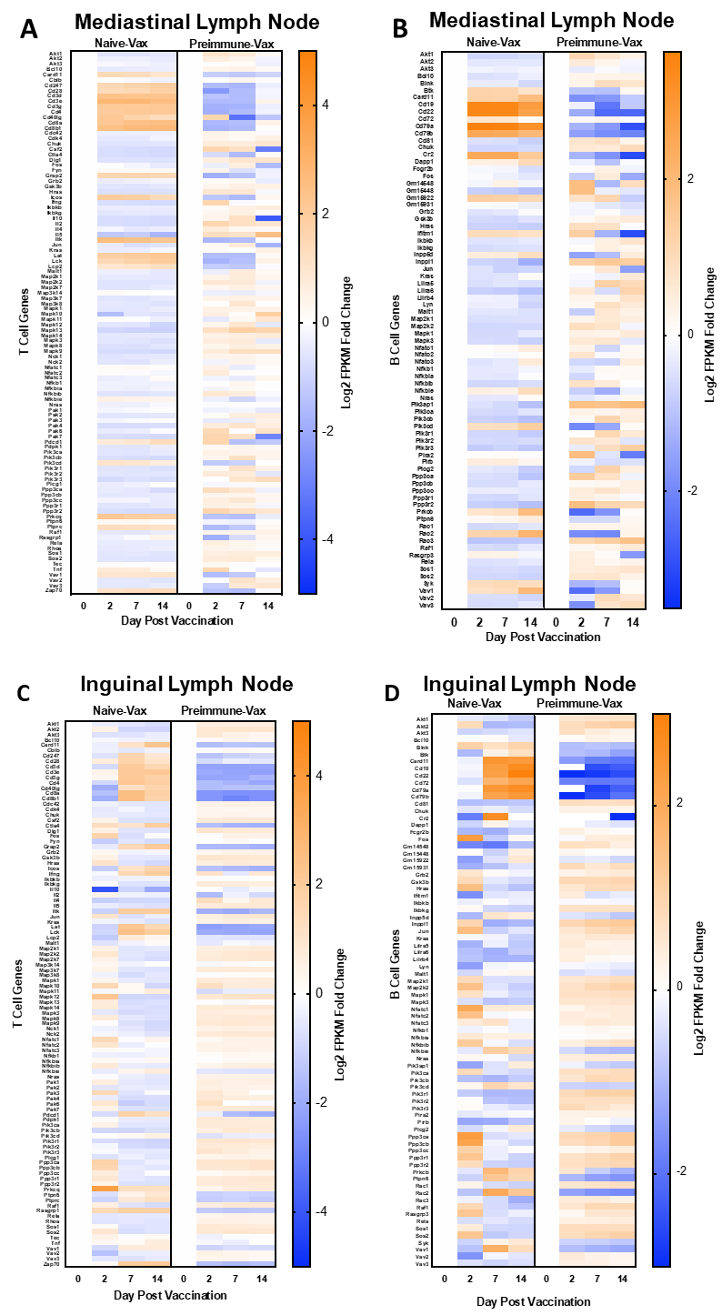
Supplementary Fig. 5. RNA sequencing reveals distinct lymphocyte gene regulation in lymph nodes of preimmune mice. Heatmaps showing differential expression of T cell-associated (A, C) and B cell-associated (B, D) genes in mediastinal (A, B) and inguinal (C, D) lymph nodes following vaccination. Gene expression is shown as the log₂ fold change in FPKM values at each time point relative to the baseline (day 0), normalized by z-score. Pathway-focused analyses were performed using curated KEGG T-cell and B-cell gene sets via the Database for Annotation, Visualization and Integrated Discovery (DAVID). n = 3 mice per group.

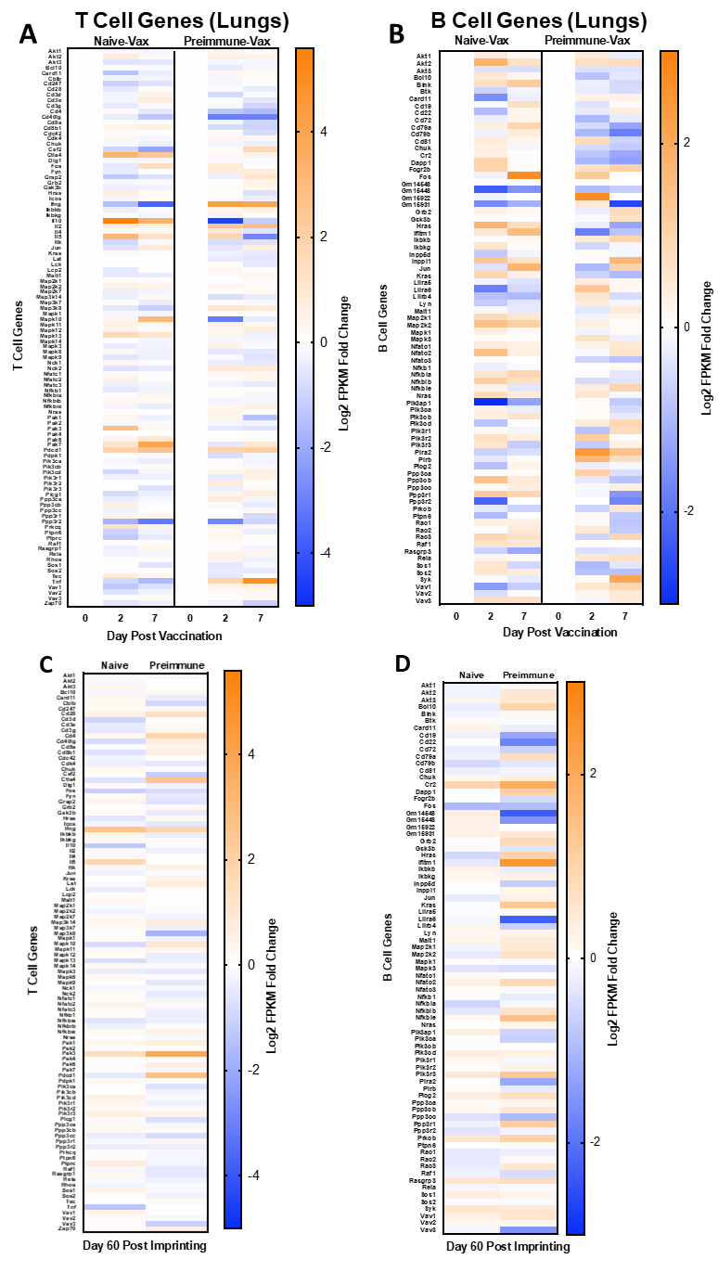
Supplementary Fig. 6. Lung transcriptional responses show limited regulation of lymphocyte-associated genes in preimmune mice. Heatmaps showing differential expression of T cell-associated (A, C) and B cell-associated (B, D) genes following vaccination. Comparisons include lungs from naïve-vaccinated and preimmune-vaccinated mice. Heatmaps display gene expression as log₂ fold change in FPKM values at each time point relative to the corresponding baseline (leftmost column), with values normalized to z-scores. Pathway-focused analyses were performed using curated KEGG T-cell and B-cell gene sets via the Database for Annotation, Visualization and Integrated Discovery (DAVID). n = 3 mice per group.

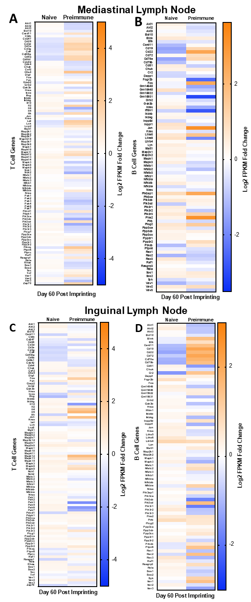

Supplementary Fig. 7. Preimmunity alters baseline lymphocyte-associated gene expression in lymph nodes prior to vaccination: Heatmaps showing differential expression of T cell-associated (A, C) and B cell-associated (B, D) genes in the mediastinal (A, B) and inguinal (C, D) lymph nodes harvested 60 days post imprinting, before vaccination. Total RNA was isolated using the RNeasy Mini Kit (Qiagen), sequenced on an Illumina platform, and aligned to the mm10 reference genome. Differential expressions of T cell-associated (A, C) and B cell-associated (B, D) genes was assessed by comparing naïve and preimmune mice in mediastinal (A, C) and inguinal (B, D) lymph nodes at day 60. Heatmaps display gene expression as log₂ fold change in FPKM relative to the baseline (leftmost column), with values normalized by z-score. Pathway-focused analyses were performed using curated KEGG T-cell and B-cell gene sets via the Database for Annotation, Visualization, and Integrated Discovery (DAVID). n = 3 mice per group.

