Online Resources (Supplementary Information)
Manuscript: Development and external validation of an AI pipeline for fully automated DMFT determination from panoramic radiographs.
Corresponding author: Babak Saravi (babak.saravi@med.uni-duesseldorf.de).
Online Resource 1
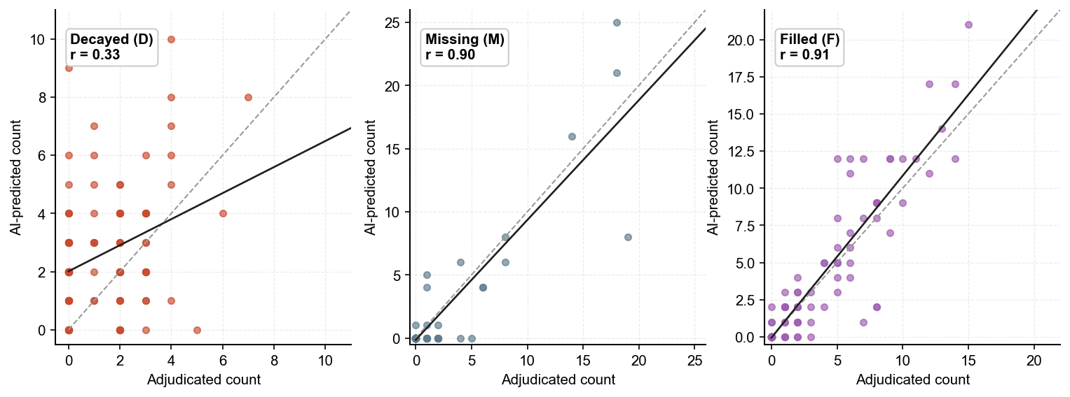
Fig. S1. Per-component agreement (Decayed, Missing and Filled) between AI predictions and the adjudicated rater reference on the external cohort (n = 100). Each panel shows the line of identity (grey dashed) and a least-squares regression fit (black solid); Pearson r is reported per component.

Online Resource 2
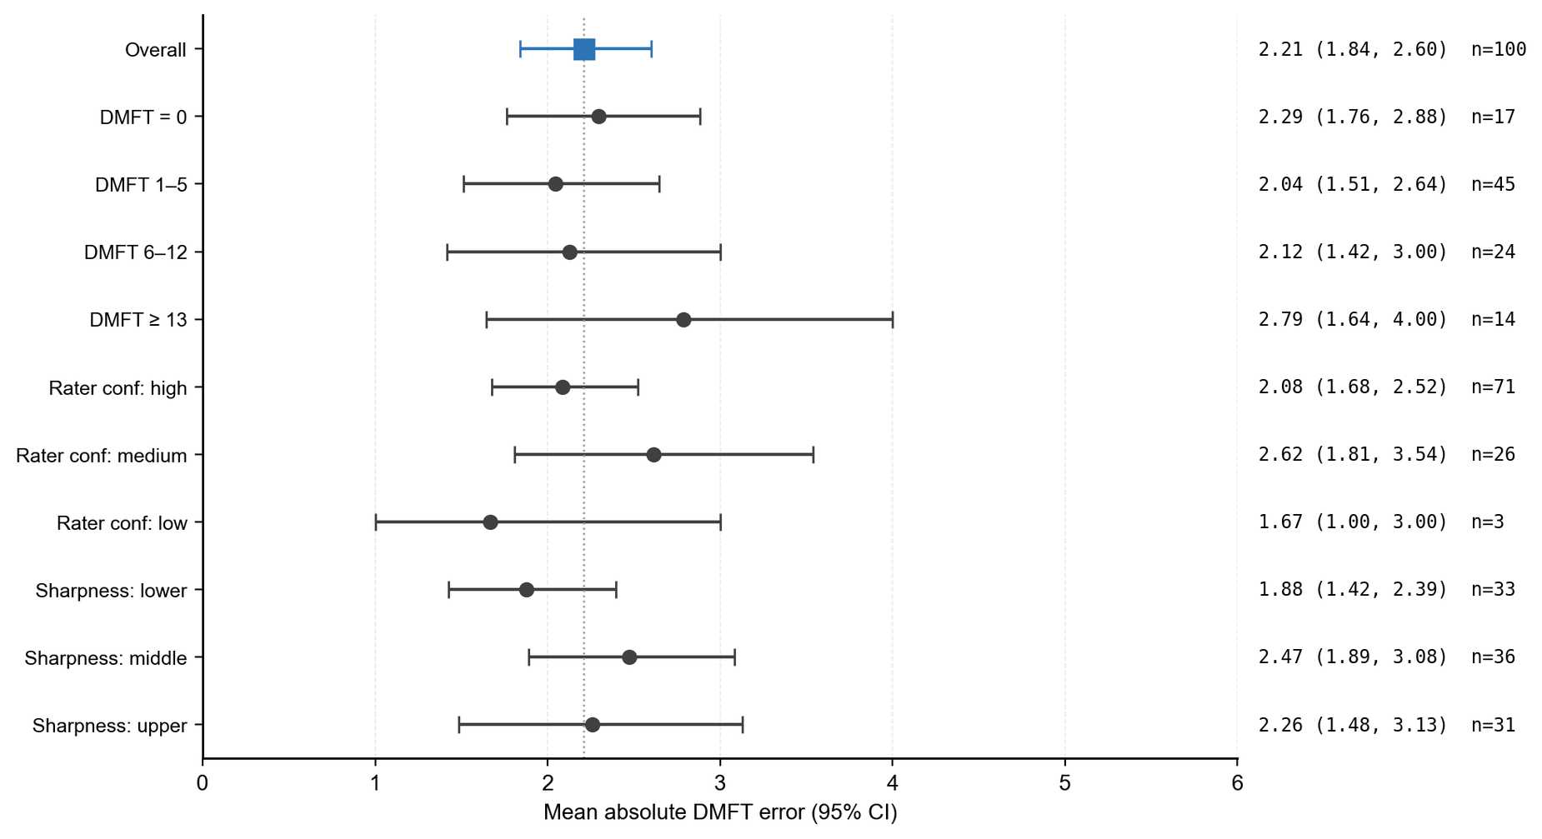
Fig. S2. Forest plot of the mean absolute error of the AI-predicted DMFT against the adjudicated reference on the external cohort, stratified by pre-specified subgroups (DMFT severity, rater self-reported confidence, image-sharpness tercile). Markers indicate the bootstrap mean; horizontal bars indicate 95% percentile-bootstrap confidence intervals (2,000 resamples); the dashed vertical line marks the overall point estimate.

Online Resource 3
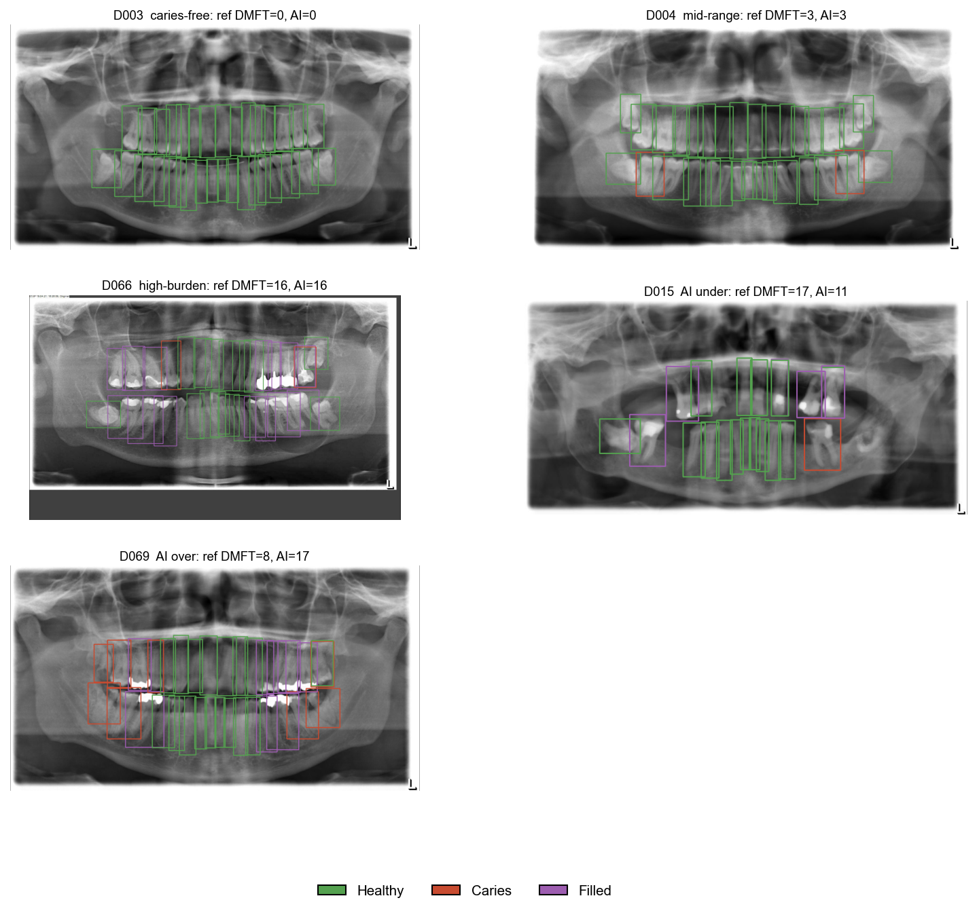
Fig. S3. Representative qualitative examples from the external cohort (n = 100). Per panel, the AI-predicted bounding boxes are overlaid on the original panoramic radiograph (green = Healthy, red = Caries, purple = Filled); the header reports the radiograph identifier, the adjudicated rater DMFT and the AI-predicted DMFT. Examples span the agreement spectrum.

Online Resource 4
Table S1. Held-out internal validation metrics (n = 141, disjoint from training): per-class detection performance (no test-time augmentation). Per-class AP is reported alongside overall AP, AP50, AP75, precision and recall (COCO convention).
Metric | Healthy | Caries | Filled
AP (IoU 0.50:0.95) | 0.711 | 0.434 | 0.625
Precision | 0.882 | 0.611 | 0.781
Recall | 0.926 | 0.540 | 0.889
Overall (all classes): mAP50–95 = 0.590; AP50 = 0.810; AP75 = 0.726; precision = 0.758; recall = 0.785

Online Resource 5
Table S2. Cumulative agreement of the AI pipeline with the adjudicated rater DMFT on the external cohort (n = 100). The third column gives the analogous cumulative agreement between the two dentists for comparison.
Tolerance |AI − reference| ≤ N | AI vs adjudicated (%) | Rater A vs Rater B (%)
0 | 15 | 42
1 | 42 | 57
2 | 68 | 66
3 | 84 | 74
4 | 86 | 80
5 | 90 | 84
6 | 97 | 95
7 | 98 | 95
8 | 99 | 95

Online Resource 6
Table S3. Checklist for Artificial Intelligence in Medical Imaging (CLAIM), completed for the present study. CLAIM items follow Mongan J, Moy L, Kahn CE. Checklist for Artificial Intelligence in Medical Imaging (CLAIM): A Guide for Authors and Reviewers. Radiol Artif Intell 2020;2(2):e200029. https://doi.org/10.1148/ryai.2020200029.
Section | CLAIM item | Reported | Location in manuscript
Title / Abstract | 1. Identification as a study of AI methodology, specifying the category of technology used (deep learning). | Yes | Title; Abstract
 | 2. Structured summary of study design, methods, results, and conclusions. | Yes | Abstract
Introduction | 3. Scientific and clinical background, including the intended use and clinical role of the AI approach. | Yes | Introduction
 | 4. Study objectives and hypotheses. | Yes | Introduction (final paragraph)
Methods — Study design | 5. Prospective or retrospective study. | Yes | Methods — Datasets (retrospective)
 | 6. Study goal (e.g., model creation, feasibility, external validation). | Yes | Introduction; Methods
Methods — Data | 7. Data sources. | Yes | Methods — Datasets (DENTEX 2023; University Hospital Düsseldorf)
 | 8. Eligibility criteria for inclusion of cases. | Yes | Methods — External validation cohort
 | 9. Data pre-processing steps. | Yes | Methods — Detection pipeline
 | 10. Selection of data subsets, if applicable. | Yes | Methods — 100 OPGs randomly selected from a consecutive series of 269
 | 11. Definitions of data elements (DMFT components; FDI numbering). | Yes | Methods — Reference standard
 | 12. De-identification methods. | Yes | Methods — Ethics (anonymised prior to analysis)
 | 13. How missing data were handled. | Yes | Methods — uninterpretable OPGs excluded; M inferred from absence of detection
Methods — Ground truth | 14. Definition of the reference standard, in sufficient detail to allow replication. | Yes | Methods — Reference standard (two-rater adjudicated DMFT)
 | 15. Rationale for choosing the reference standard. | Yes | Methods — Reference standard; Discussion
 | 16. Source of ground-truth annotations; qualifications and preparation of annotators. | Yes | Methods — two dentists, blinded
 | 17. Annotation tools. | Yes | Methods — structured spreadsheet, WHO DMFT-only convention
 | 18. Measurement of inter-/intra-rater variability; methods to resolve discrepancies. | Yes | Methods/Results — ICC (2,1), linear-weighted κ; component-wise averaging
Methods — Data partitions | 19. Intended sample size and how it was determined. | Partly | Methods — DENTEX split; external n = 100 (randomly selected from a consecutive series of 269; no formal power calculation)
 | 20. How data were assigned to partitions; proportions. | Yes | Methods — 80/20 internal (564 train / 141 validation, disjoint); external held-out
 | 21. Level at which partitions are disjoint. | Yes | Methods — institution-level (external cohort fully independent)
Methods — Model | 22. Detailed description of the model (inputs, outputs, architecture). | Yes | Methods — Detection pipeline; full code released (Data and code availability)
 | 23. Software libraries, frameworks and packages. | Yes | Methods (PyTorch, Ultralytics, Python)
 | 24. Initialization of model parameters (transfer learning). | Yes | Methods — COCO-pretrained, fine-tuned
Methods — Training | 25. Training approach: augmentation, hyperparameters, number of models. | Yes | Methods — Detection pipeline; Online Resource 4 (Table S1)
 | 26. Method of selecting the final model. | Yes | Methods — early stopping on validation mAP
 | 27. Details of ensembling techniques, if applicable. | Yes | Methods — four-fold TTA + Weighted-Box-Fusion
Methods — Evaluation | 28. Metrics of model performance. | Yes | Methods/Results — AP, AP50, AP75, AR, ICC, Pearson r, MAE, Bland–Altman
 | 29. Statistical measures of significance and uncertainty (e.g., CIs). | Yes | Methods — 10,000-resample bootstrap 95% CIs
 | 30. Robustness or sensitivity analysis. | Yes | Results — pre-specified subgroup analyses (Online Resource 2)
 | 31. Methods for explainability/interpretability and how validated. | No | Not performed; acknowledged as a limitation (Discussion)
 | 32. Validation or testing on external data. | Yes | External Düsseldorf cohort (n = 100)
Results | 33. Flow of cases, using a diagram for inclusion/exclusion. | Yes | Figure 1 (study flow diagram)
 | 34. Demographic and clinical characteristics of cases. | Partly | Image-level characteristics given; patient demographics not available under DMFT-only annotation (Discussion)
 | 35. Performance metrics for the optimal model on all partitions. | Yes | Results; Tables 1–2; Online Resource 4
 | 36. Estimates of diagnostic accuracy and their precision (95% CIs). | Yes | Results — bootstrap 95% CIs; Bland–Altman limits of agreement
 | 37. Failure analysis of incorrectly classified cases. | Yes | Results/Discussion; Online Resource 3 (over- and under-estimation examples)
Discussion | 38. Study limitations, including bias, uncertainty and generalizability. | Yes | Discussion (limitations paragraph)
 | 39. Implications for practice, including intended use/clinical role. | Yes | Discussion; Abstract — Clinical Relevance
Other information | 40. Registration number and name of registry. | N/A | Not a prospective clinical trial; no registration required
 | 41. Where the full study protocol/code can be accessed. | Yes | Data and code availability (GitHub repository)
 | 42. Sources of funding and support; role of funders. | Yes | Declarations — Funding

