Supplementary Tables
Supplementary Table S1. Complication and satisfactory-outcome associations by predictor (Fisher's exact test)
A. Complications by injury duration (≤6 wk, n = 20 vs >6 wk, n = 7)
Complication | ≤6 wk | >6 wk | p
Heterotopic ossification | 5 (25.0) | 2 (28.6) | 1.000
Fish-tail deformity | 4 (20.0) | 4 (57.1) | 0.145
Valgus deformity (any) | 10 (50.0) | 2 (28.6) | 0.408
Both cases of valgus ≥15° (n = 2) occurred in the ≤6-week group.
B. Complications by Milch type (I, n = 4 vs II, n = 23)
Complication | Milch I | Milch II | p
Heterotopic ossification | 1 (25.0) | 6 (26.1) | 1.000
Fish-tail deformity | 1 (25.0) | 7 (30.4) | 1.000
Valgus deformity (any) | 2 (50.0) | 10 (43.5) | 1.000
C. Satisfactory MEPI (≥75) by predictor (satisfactory vs unsatisfactory)
Predictor level | Satisfactory | Unsatisfactory | p
Duration >6 wk | 7 | 0 | 1.000
Milch II | 21 | 2 | 1.000
HO present | 6 | 1 | 0.459
Fish-tail present | 8 | 0 | 1.000
Deformity present | 11 | 1 | 1.000
Supplementary Table S2. Spearman correlations of functional outcomes (MEPI and Liverpool Elbow Score) with study variables (N = 27)
The full 13 × 13 inter-variable correlation matrix is provided in Supplementary Figure S4.
Variable | rho with MEPI | rho with Liverpool score
Final ROM arc | +0.61 | +0.89
Final flexion | +0.58 | +0.84
Final extension lag | −0.56 | −0.81
Valgus deformity | −0.51 | −0.58
HO grade (Hastings & Graham) | −0.51 | −0.66
MEPI / Liverpool score | +0.57 | (1.00)
Operative time | −0.36 | −0.09
Blood loss | −0.35 | −0.13
Song stage | −0.12 | −0.08
Injury delay (weeks) | −0.07 | 0.00
Age | −0.05 | −0.27
Supplementary Table S3. Distribution and normality of continuous variables (Shapiro–Wilk; N = 27)
Variable | Mean ± SD | Median (IQR) | Range | Shapiro–Wilk p | Distribution
Age, years | 6.0 ± 2.1 | 5 (4–7) | 4–12 | 0.002 | non-normal
Injury delay, weeks | 5.9 ± 5.1 | 3 (3–7) | 3–20 | <0.001 | non-normal
Pre-op ROM min, deg | 41.5 ± 11.7 | 40 (30–50) | 30–60 | <0.001 | non-normal
Pre-op ROM max, deg | 95.6 ± 17.2 | 100 (90–105) | 50–120 | 0.010 | non-normal
Pre-op arc, deg | 54.1 ± 13.4 | 60 (50–60) | 20–70 | 0.004 | non-normal
Operative time, min | 53.4 ± 13.7 | 53 (42–63) | 30–80 | 0.731 | normal
Blood loss, ml | 20.0 ± 8.4 | 19 (12–27.5) | 8–34 | 0.038 | non-normal
Final flexion, deg | 130.7 ± 16.4 | 140 (115–140) | 90–150 | 0.004 | non-normal
Final extension lag, deg | 11.9 ± 13.9 | 10 (0–20) | 0–50 | <0.001 | non-normal
Final ROM arc, deg | 118.9 ± 28.2 | 120 (100–140) | 40–150 | 0.011 | non-normal
Valgus deformity, deg | 3.5 ± 4.8 | 0 (0–5) | 0–15 | <0.001 | non-normal
Liverpool Elbow Score | 9.3 ± 0.6 | 9.6 (8.6–9.6) | 7.7–10 | 0.003 | non-normal
MEPI | 88.7 ± 10.1 | 90 (80–100) | 65–100 | 0.016 | non-normal

Supplementary Figures
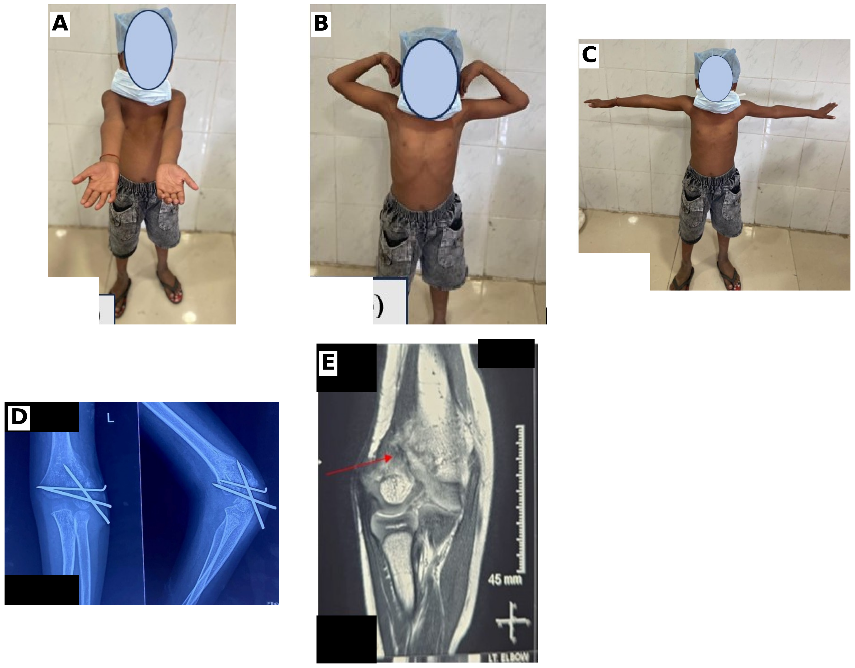
Supplementary Figure S1. Additional clinical and radiological findings. (A–C) Clinical range-of-motion photographs at final review (faces anonymised); (D) interim radiographs at two months with the Kirschner wires in situ; (E) MRI showing the united fracture line (red arrow).
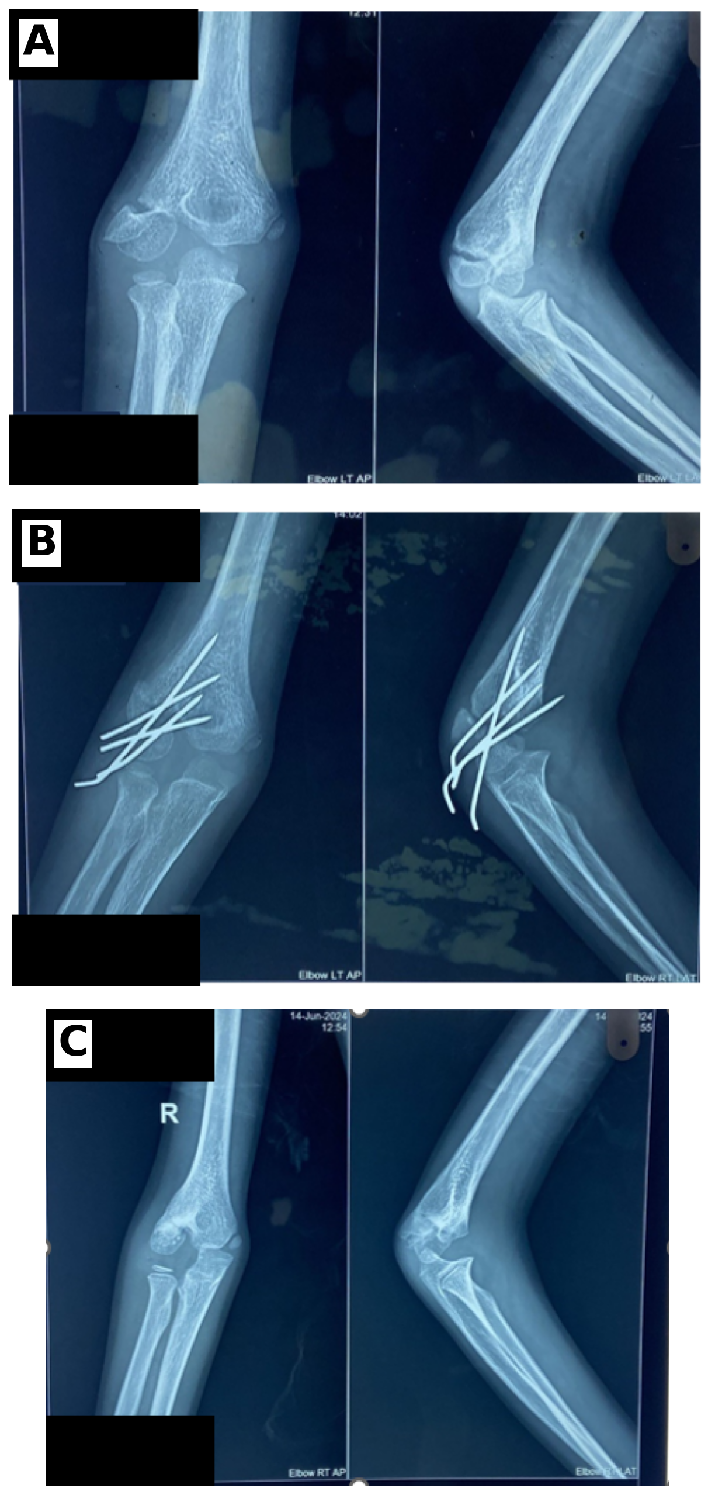
Supplementary Figure S2. Second representative case (right elbow). (A) Pre-operative, (B) immediate post-operative and (C) six-month radiographs showing union after open reduction and cross Kirschner-wire fixation.
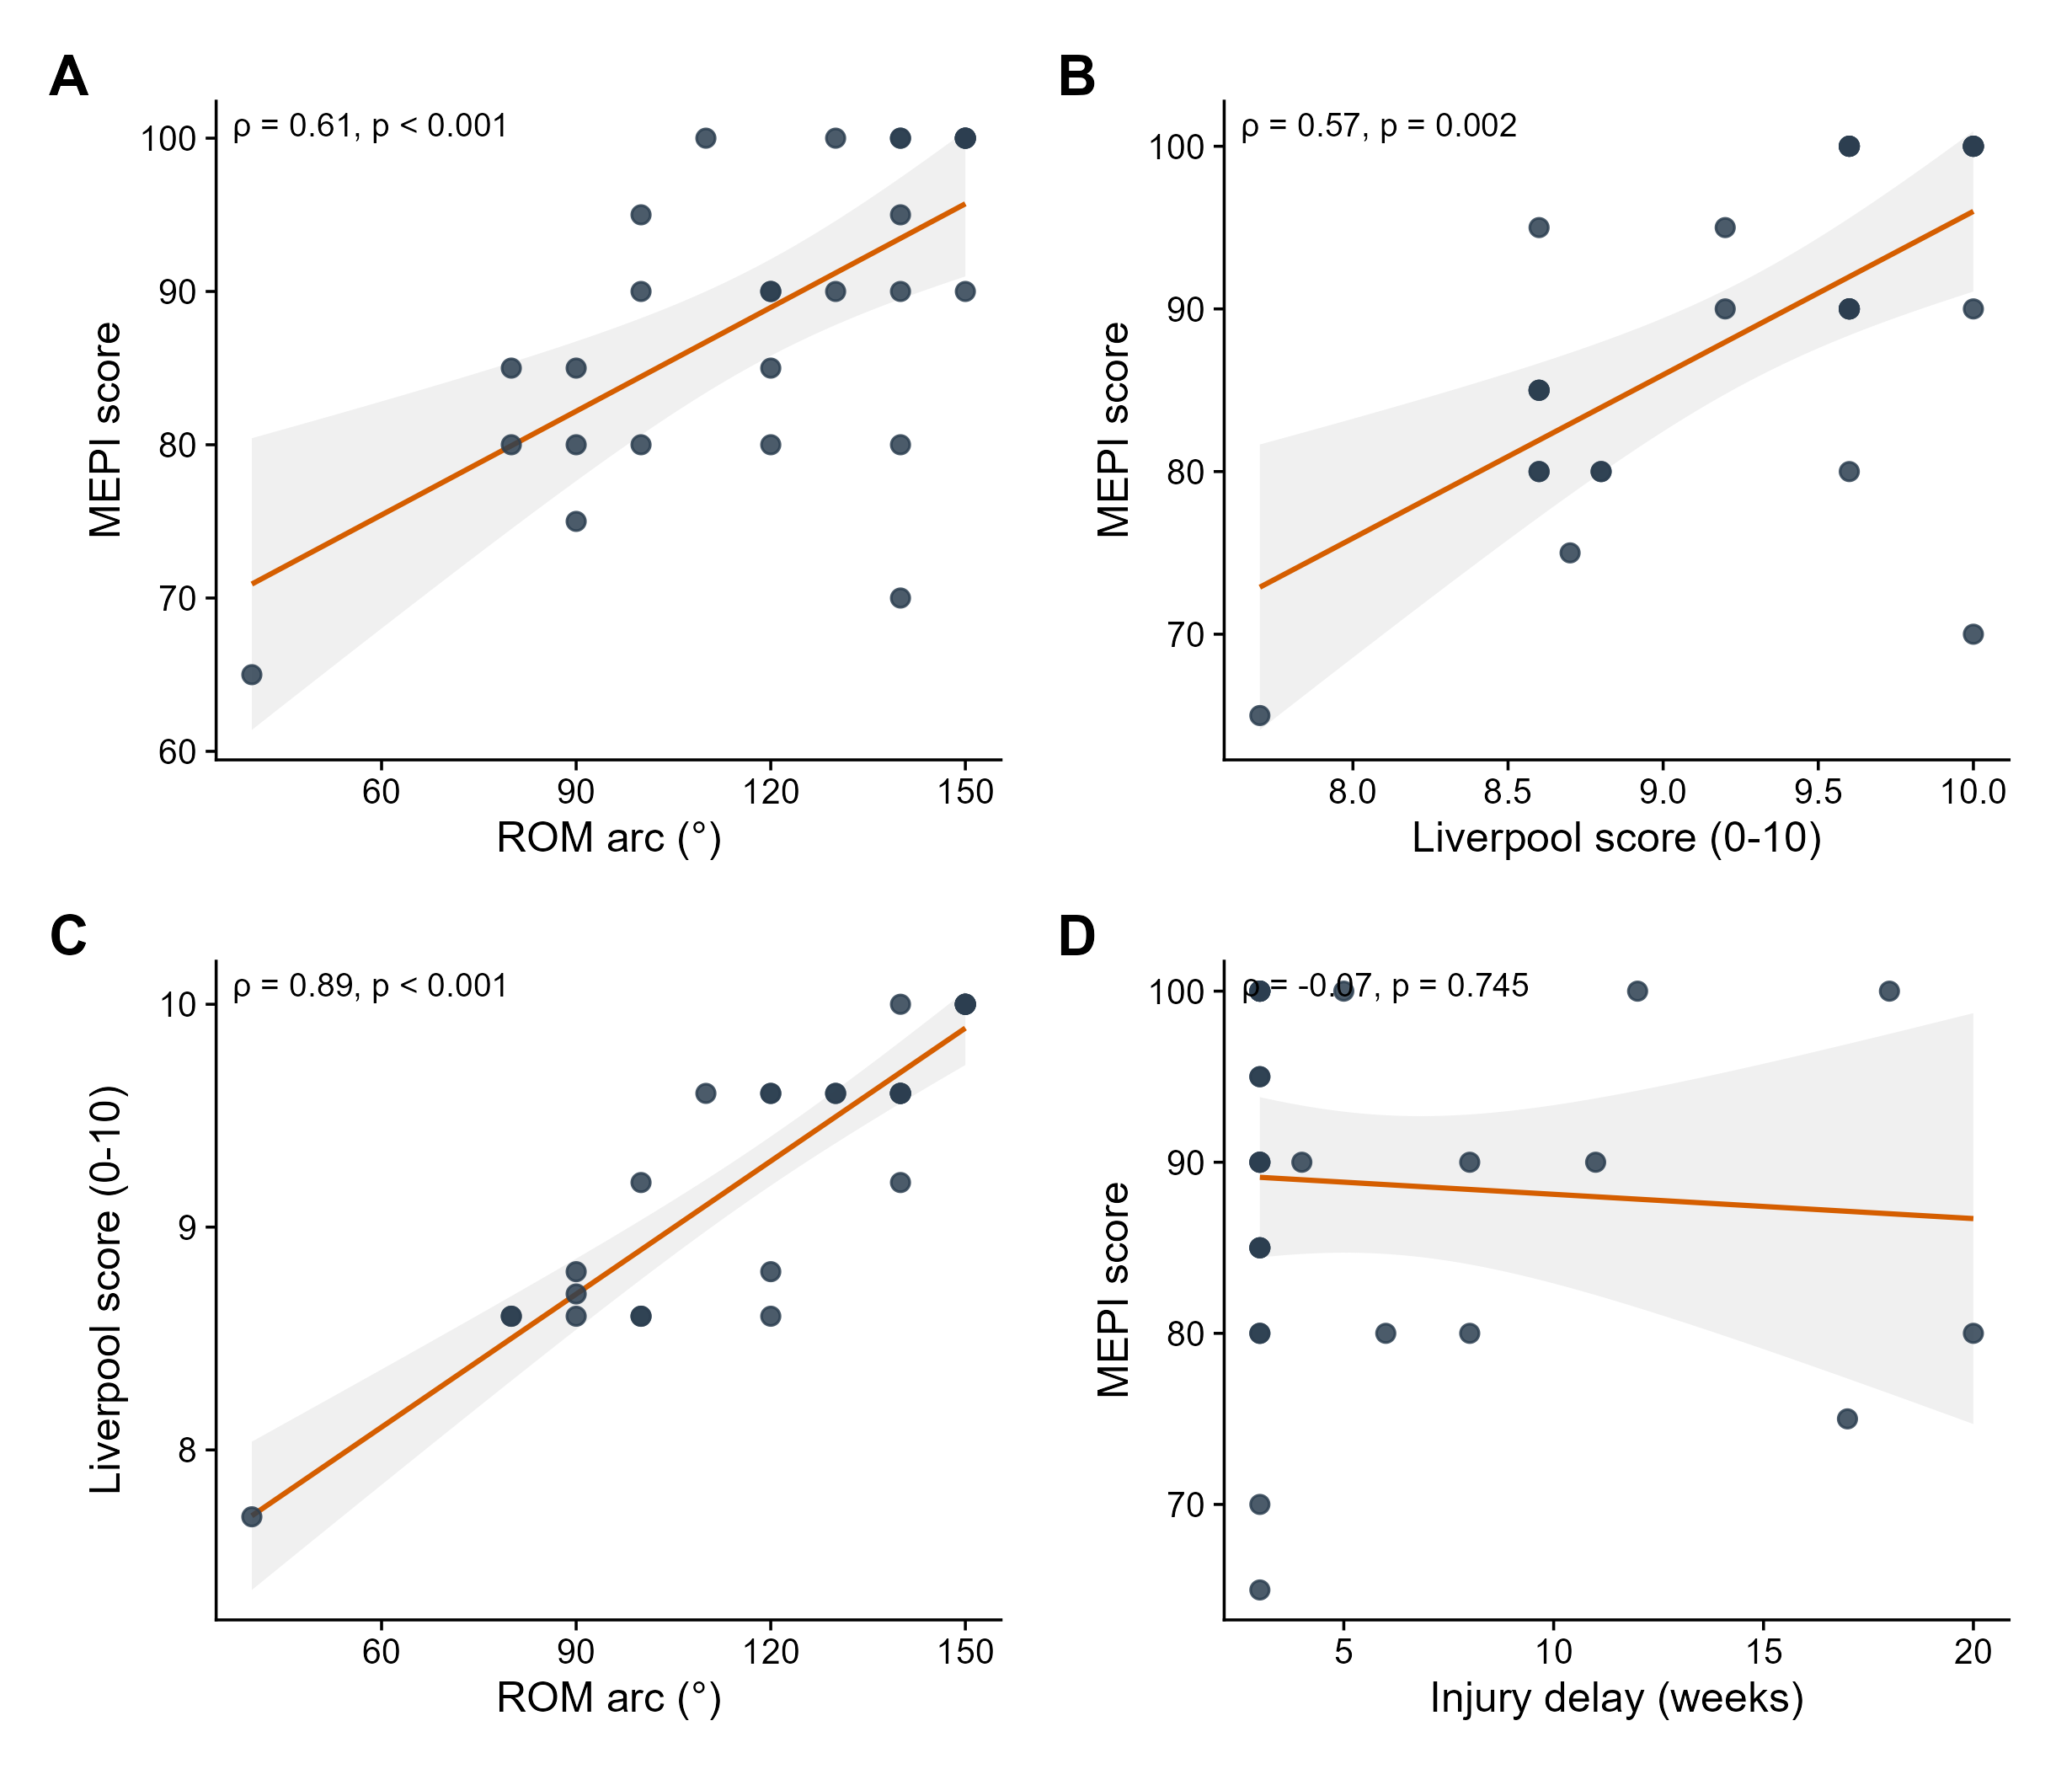
Supplementary Figure S3. Correlates of functional outcome and convergent validity. Scatter plots of (A) MEPI versus ROM arc, (B) MEPI versus Liverpool Elbow Score (convergent validity), (C) Liverpool Elbow Score versus ROM arc and (D) MEPI versus injury delay. Lines are linear fits with 95% confidence bands; ρ denotes the Spearman correlation coefficient. Functional outcome correlated with the mechanical state of the elbow (ROM arc, ρ = 0.61) but not with the delay before surgery (ρ = −0.07).
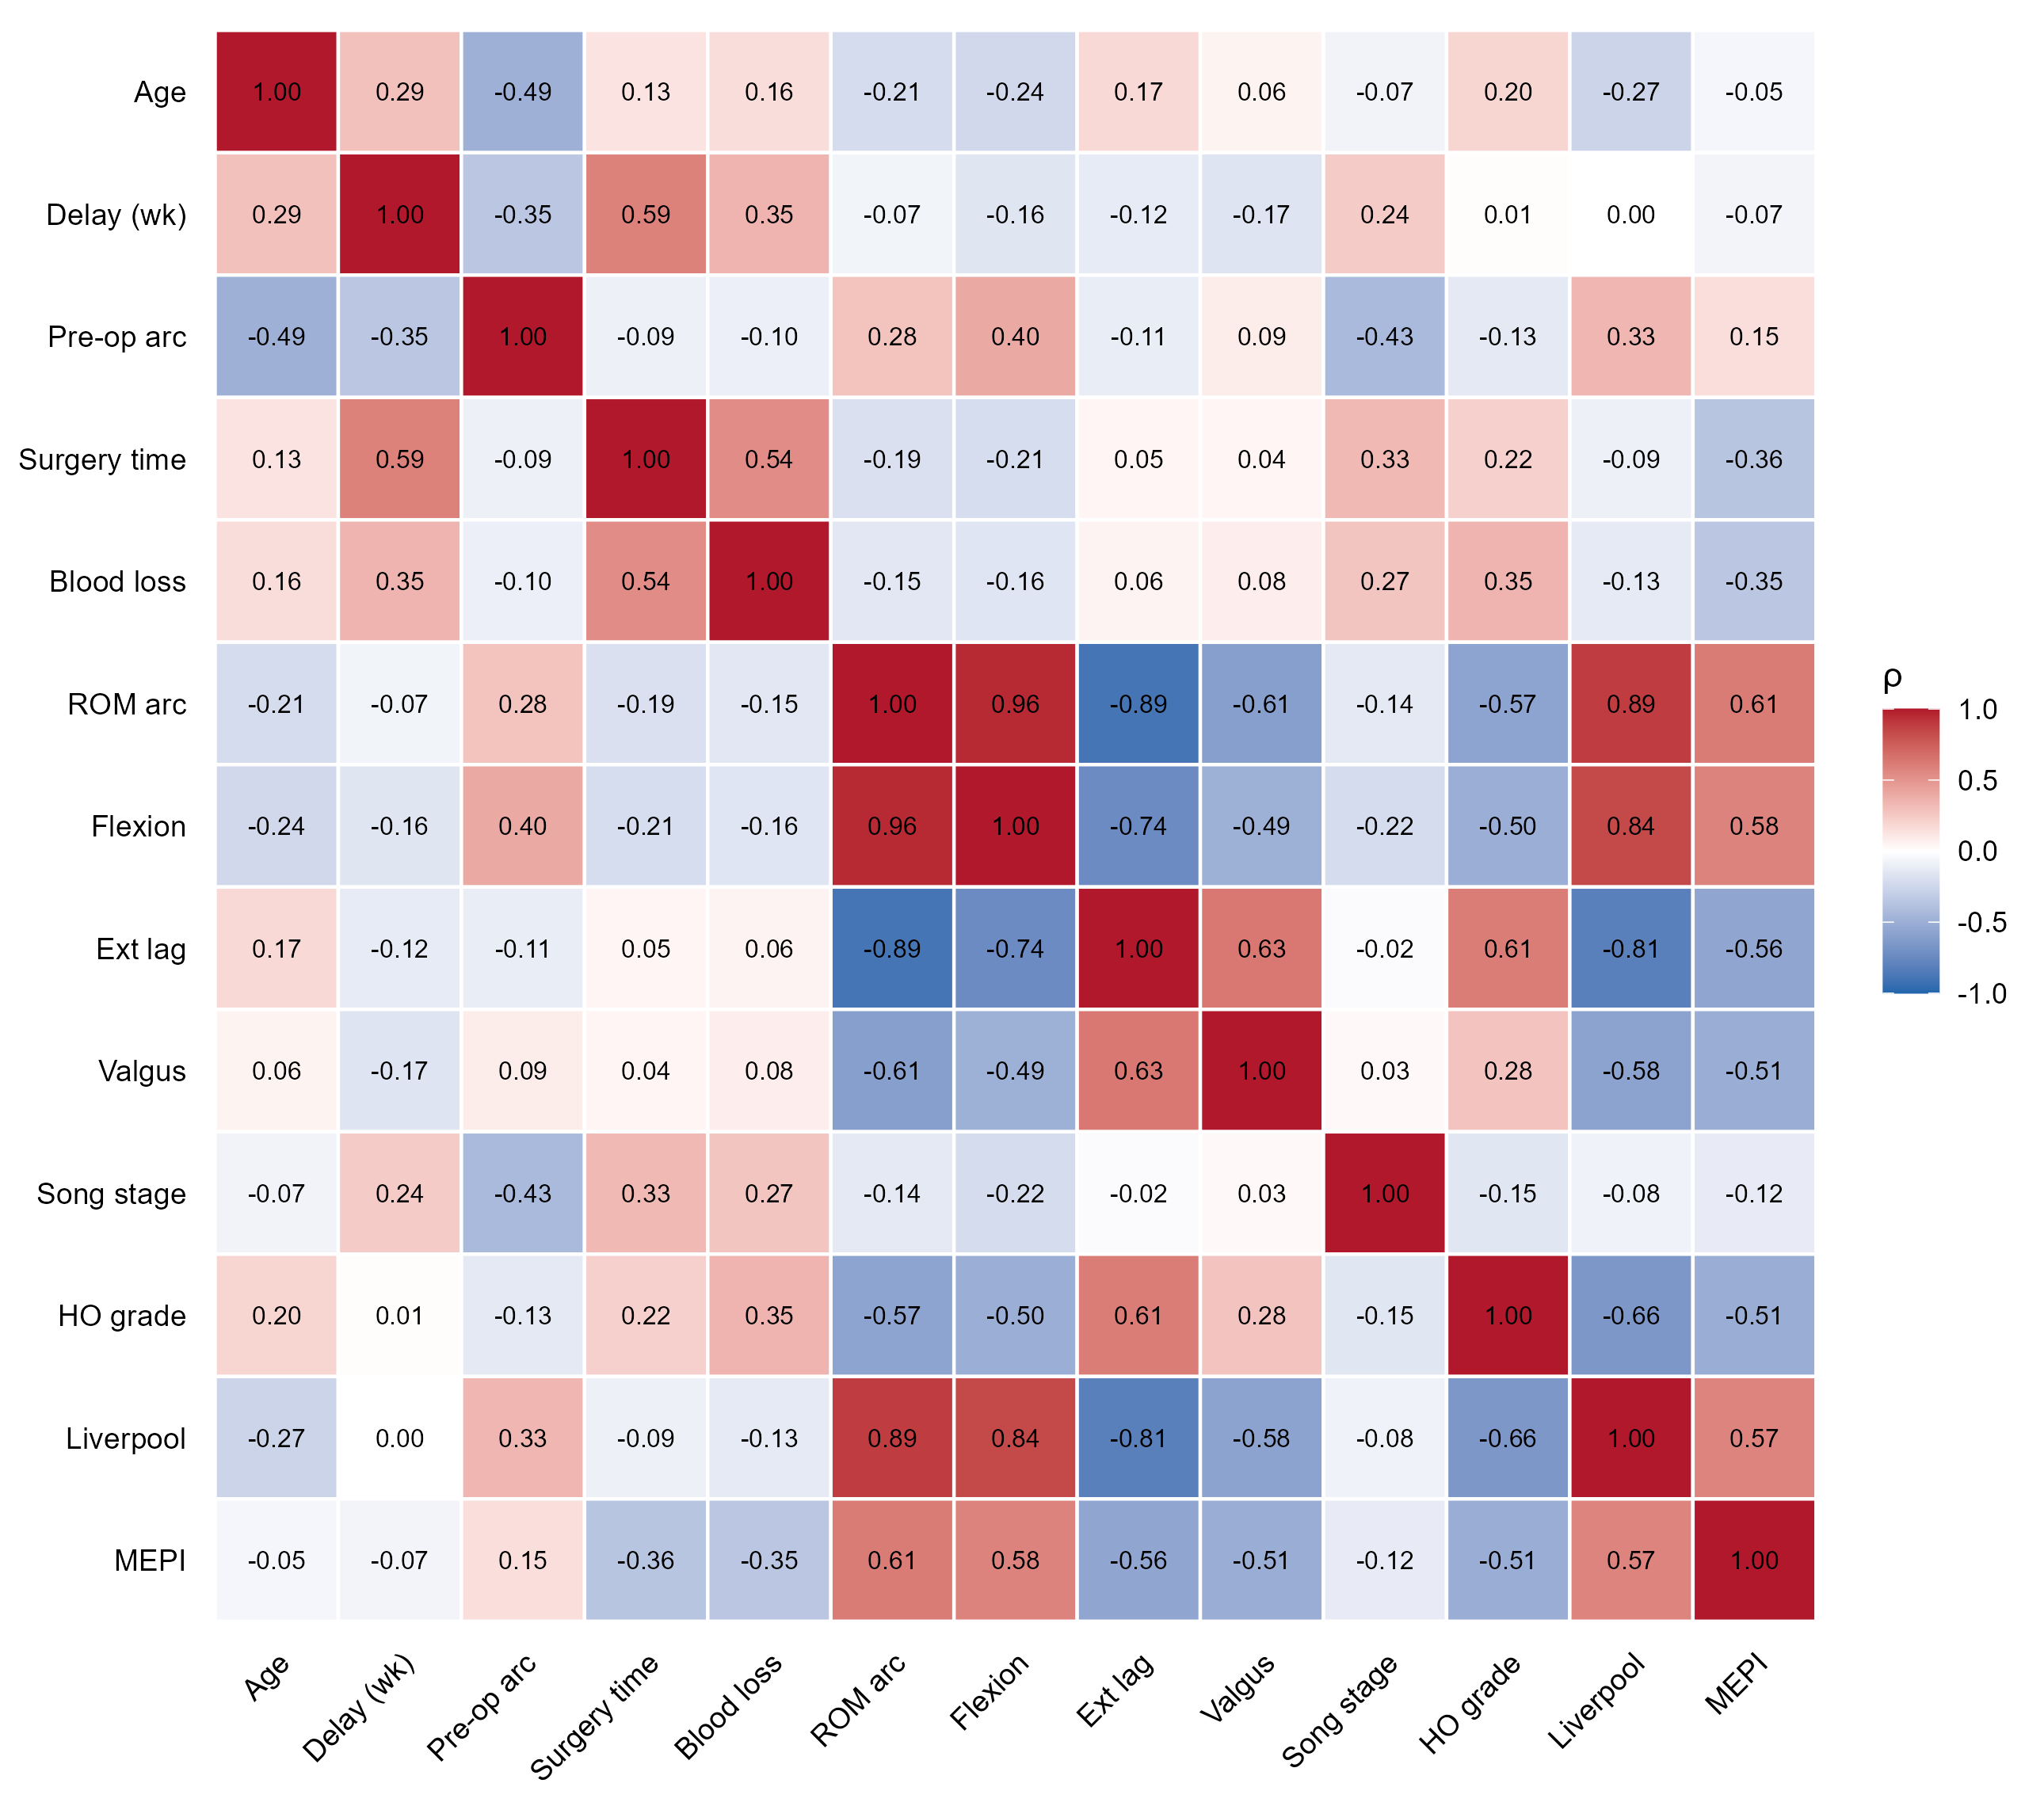
Supplementary Figure S4. Spearman correlation matrix of all study variables (n = 27). Cell colour and value indicate the Spearman correlation coefficient (ρ); red denotes positive and blue negative correlation.
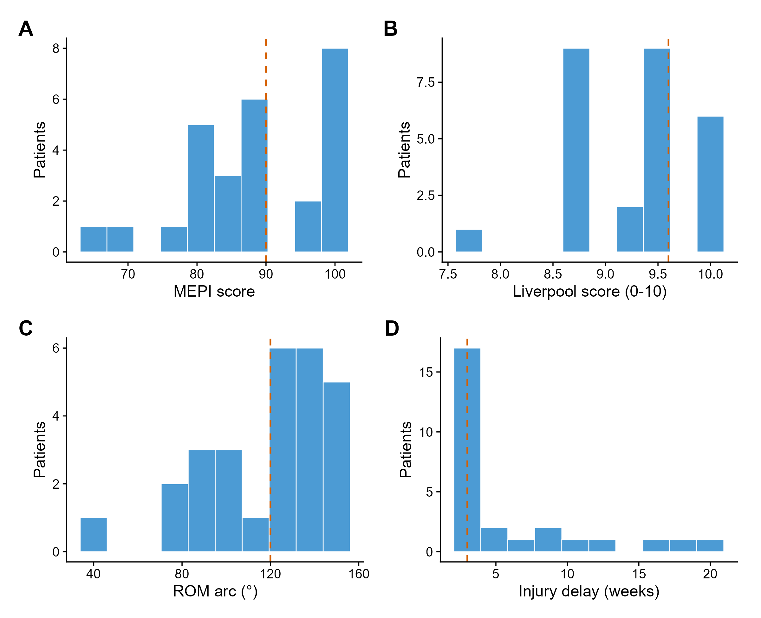
Supplementary Figure S5. Distribution of the principal continuous outcomes and injury delay (n = 27). Histograms of (A) MEPI, (B) Liverpool Elbow Score, (C) ROM arc and (D) injury delay; the dashed line marks the median.

