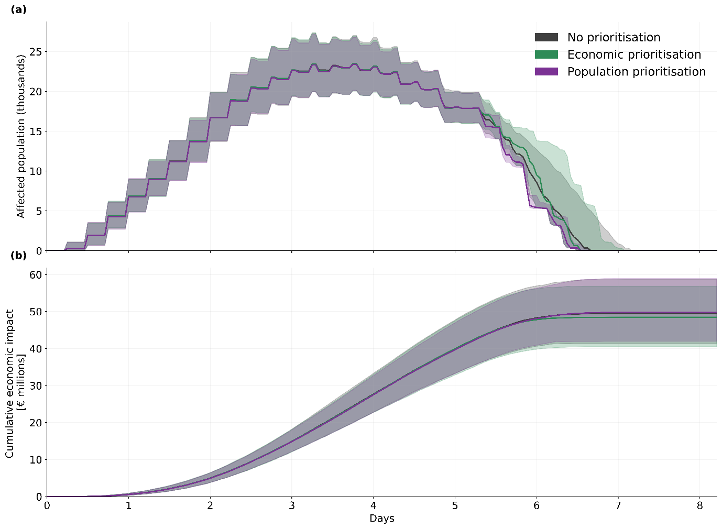
Figure S1. Affected population and cumulative economic impacts over time under three repair prioritisation schemes.

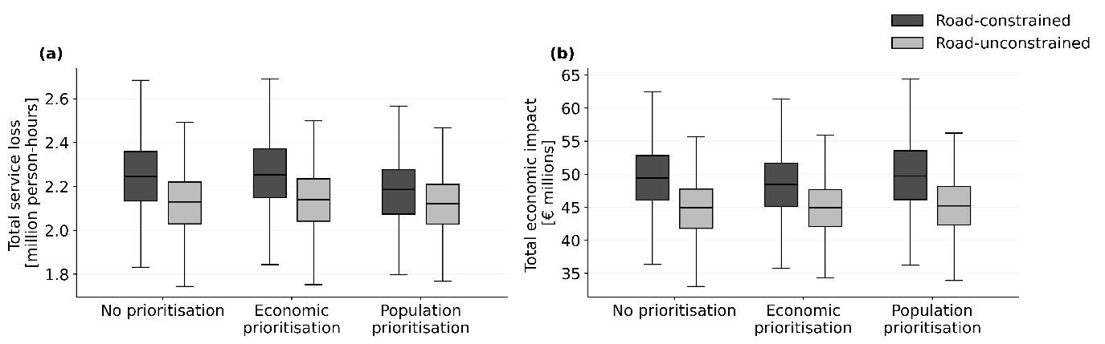
Figure S2. Box plots of economic and population service impacts under the three prioritisation schemes with road-constrained and road-unconstrained conditions.

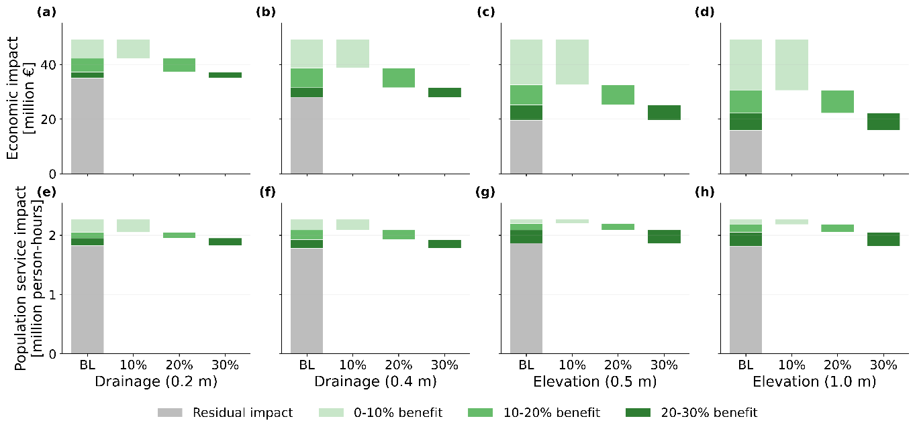
Figure S3. Median reductions in (a-d) economic impact and (e-h) population service impact from successive increases in the coverage of adaptation measures. Hazard-level area drainage (a,b,e,f) and asset-level elevation (c,d,g,h). Increasing coverage is ranked by economic impact. The BL column shows baseline impacts and the decomposition of avoided impacts into contributions from the top 10%, 20%, and 30% of drainage areas and assets under this ranking. Marginal economic benefits decrease with increasing coverage, unlike marginal population service benefits which show no clear trend.
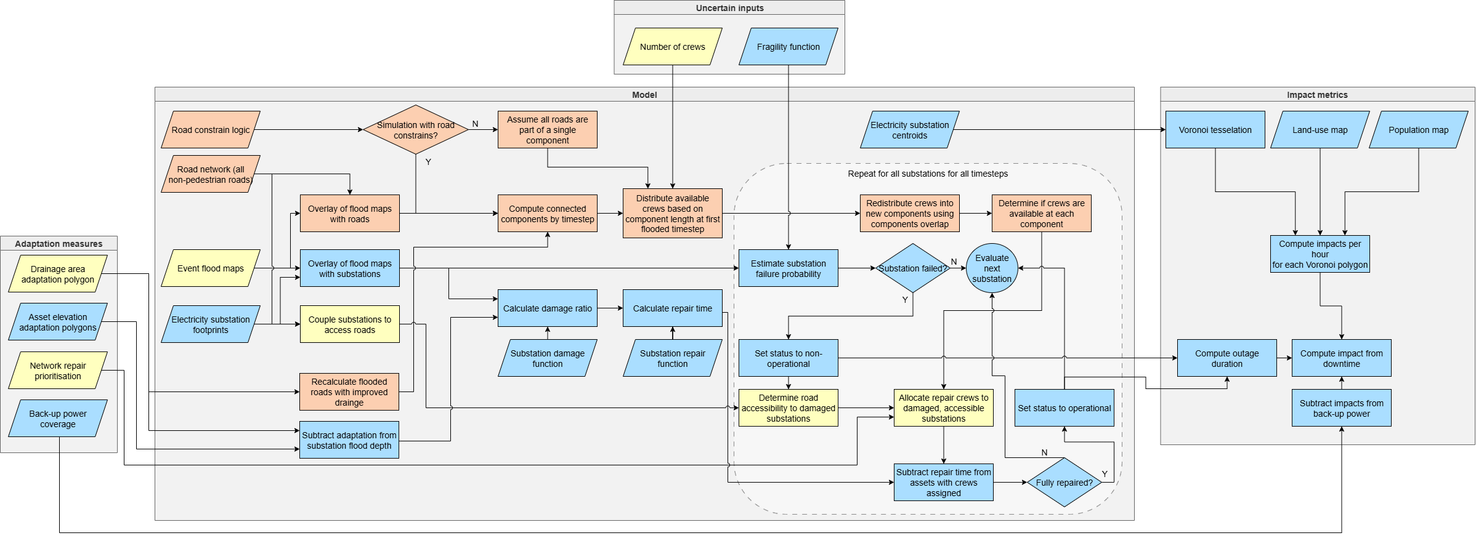

Figure S4. Coupled electricity-road model flowchart. Elements of the electricity system shaded blue, elements of the road system shaded red, shared elements shaded yellow. Flowchart shows the process to compute one realisation.
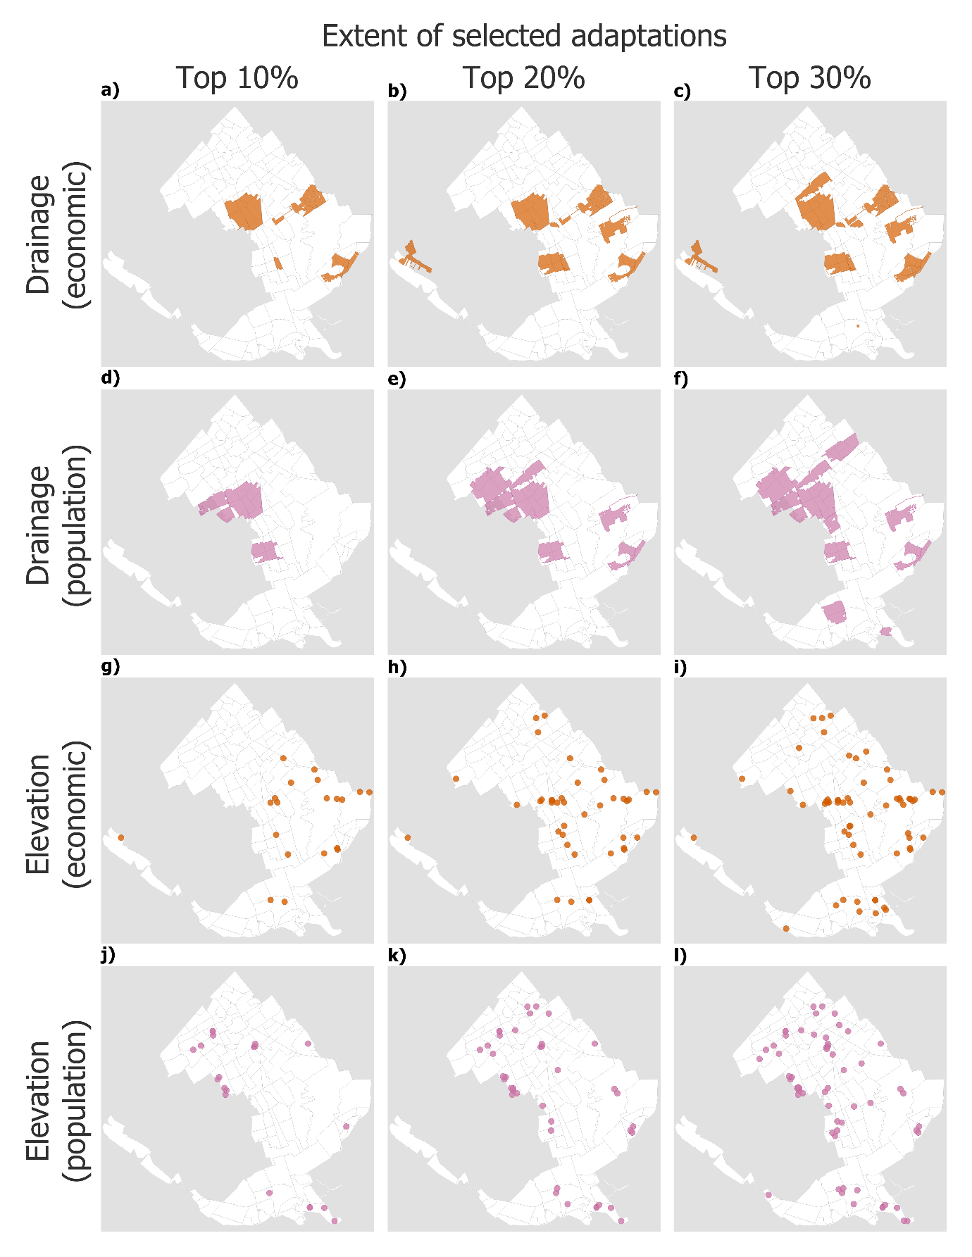
Figure S5. Layout of drainage and elevation adaptation measures. Columns indicate progressive extent of implementation, going from the 10% highest ranking areas to the top 30% highest ranking areas. Rows indicate the adaptation measure and ranking criterion used: (a-f) hazard-level drainage; (g-l) asset-level elevation. Orange (a-c,g-i) indicates economic ranking; purple (d-f, j-l) indicates population service ranking.
Table S1. Exposure, disruption, and impacts of electrical substation flooding during a large-scale pluvial flooding event under road-constrained and road-unconstrained recovery (10-20 repair crews). Exposure metrics are deterministic for the simulated event. Disruption and impact metrics are summarised across model realisations (n=1000) as median [25th-75th percentile].
Flood exposure and timing | Flood exposure peak | Hour 48
Flood exposure and timing | Flood fully receded (h) | Hour 143
Flood exposure and timing | Maximum flooded substations | 198 (5.3%)
Flood exposure and timing | Disruption peak | Hour 84 [78-90]
Flood exposure and timing | Peak non-operational substations | 80 (2.1%) [75-85]
Metric | Road-constrained recovery | Road-unconstrained recovery
Economic impact | 49.4 [46.1-52.8] M€ | 44.9 [41.8-47.7] M€
Population service impact | 2.24 [2.13-2.36] M person-h | 2.13 [2.03-2.22] M person-h
Peak affected population | 24.0 [22.5-25.5] thousand people | 23.4 [21.9-24.9] thousand people

Table S2. Benefits of individual adaptation measures under road-constrained recovery (10-20 repair crews). Structural measures are grouped by targeting criterion (minimising economic impact vs minimising population service impact), adaptation intensity (minor/major), and spatial coverage (top 10-30% of areas or assets ranked by the targeting criterion). Values are summarised across model realisations (n = 100) as median reduction relative to the baseline [25th-75th percentile]. Marginal reductions are reported as percentage-point (pp) increments in the median reduction relative to the previous coverage extent.
Targeting criterion and  measure |  | Intensity | Coverage | Economic impact  reduction (%) | Marginal reduction  (pp) | Population  service impact  reduction (%) | Marginal reduction  (pp)
Economic-impact targeted | Hazard-level  Improved drainage | 0.2 m | 10% | 14.1 [10.1-23.0] | + 14.1 | 9.8 [4.2-15.1] | + 9.8
Economic-impact targeted | Hazard-level  Improved drainage | 0.2 m | 20% | 26.0 [20.0-35.7] | + 11.9 | 13.5 [8.9-17.4] | + 3.7
Economic-impact targeted | Hazard-level  Improved drainage | 0.2 m | 30% | 32.7 [27.2-37.7] | + 6.7 | 20.9 [15.4-24.5] | + 7.4
Economic-impact targeted | Hazard-level  Improved drainage | 0.4 m | 10% | 21.5 [12.5-27.8] | + 21.5 | 8.0 [1.8-13.7] | + 8.0
Economic-impact targeted | Hazard-level  Improved drainage | 0.4 m | 20% | 34.8 [30.7-39.2] | + 13.3 | 15.8 [11.0-20.0] | + 7.8
Economic-impact targeted | Hazard-level  Improved drainage | 0.4 m | 30% | 43.1 [36.5-48.0] | + 8.3 | 22.7 [18.2-26.2] | + 6.9
Economic-impact targeted | Asset-level  Elevation | 0.5 m | 10% | 33.0 [26.6-38.6] | + 33.0 | 3.2 [-0.9-9.4] | + 3.2
Economic-impact targeted | Asset-level  Elevation | 0.5 m | 20% | 47.4 [43.0-52.4] | + 14.4 | 9.2 [4.1-13.9] | + 6.0
Economic-impact targeted | Asset-level  Elevation | 0.5 m | 30% | 59.5 [55.9-62.2] | + 12.1 | 19.4 [15.3-23.3] | + 10.2
Economic-impact targeted | Asset-level  Elevation | 1.0 m | 10% | 38.4 [33.3-42.2] | + 38.4 | 3.9 [0.2-8.6] | + 3.9
Economic-impact targeted | Asset-level  Elevation | 1.0 m | 20% | 54.7 [50.4-58.6] | + 16.3 | 10.9 [4.6-15.2] | + 7.0
Economic-impact targeted | Asset-level  Elevation | 1.0 m | 30% | 67.5 [64.2-69.8] | + 12.8 | 20.8 [16.2-24.3] | + 9.9
Population service-impact targeted | Hazard-level  Improved drainage | 0.2 m | 10% | 8.1 [1.0-17.2] | + 8.1 | 10.3 [5.3-17.2] | + 10.3
Population service-impact targeted | Hazard-level  Improved drainage | 0.2 m | 20% | 19.4 [14.5-26.3] | + 11.3 | 22.5 [17.4-27.9] | + 12.2
Population service-impact targeted | Hazard-level  Improved drainage | 0.2 m | 30% | 25.4 [19.0-32.0] | + 6.0 | 26.5 [21.5-30.5] | + 4.0
Population service-impact targeted | Hazard-level  Improved drainage | 0.4 m | 10% | 13.8 [1.4-20.4] | + 13.8 | 18.3 [12.6-22.9] | + 18.3
Population service-impact targeted | Hazard-level  Improved drainage | 0.4 m | 20% | 24.1 [17.9-30.8] | + 10.3 | 33.6 [29.3-37.2] | + 15.3
Population service-impact targeted | Hazard-level  Improved drainage | 0.4 m | 30% | 27.0 [20.4-34.0] | + 2.9 | 39.8 [34.7-43.9] | + 6.2
Population service-impact targeted | Asset-level  Elevation | 0.5 m | 10% | 7.5 [-0.5-15.1] | + 7.5 | 28.4 [24.1-33.4] | + 28.4
Population service-impact targeted | Asset-level  Elevation | 0.5 m | 20% | 17.4 [6.6-22.1] | + 9.9 | 40.8 [36.9-44.6] | + 12.4
Population service-impact targeted | Asset-level  Elevation | 0.5 m | 30% | 20.6 [13.7-26.4] | + 3.2 | 49.8 [45.9-52.1] | + 9.0
Population service-impact targeted | Asset-level  Elevation | 1.0 m | 10% | 8.7 [0.4-15.9] | + 8.7 | 40.4 [36.2-44.5] | + 40.4
Population service-impact targeted | Asset-level  Elevation | 1.0 m | 20% | 19.1 [12.6-26.2] | + 10.4 | 53.3 [49.9-56.0] | + 12.9
Population service-impact targeted | Asset-level  Elevation | 1.0 m | 30% | 23.3 [15.3-31.7] | + 4.2 | 62.1 [58.0-64.7] | + 8.8
Back-up  power |  | Industrial  users only |  | 54.1 [52.1-56.4] | N/A
 |  | Commercial  users only |  | 7.5 [6.7-8.5]
 |  | Industrial and  commercial users |  | 61.9 [59.8-63.8]

Table S3. Selected adaptation measures and combinations illustrating the effect on flooded and unreachable substations during recovery. Unreachable station-hours count non-flooded, non-operational substations that could be repaired if accessible by road. The road-unconstrained case isolates the effect of removing access constraints, while the adapted cases show how drainage, elevation, and their combination alter flooded and unreachable substations under road-constrained recovery.
Policy group | Policy | Flooded station-hours | Unreachable station-hours | Non-operational station-hours reduction [med]
Baseline | Baseline road-constrained | 14,382 | 2,028 | 0
No road constraints | Road-unconstrained | 14,382 | 0 | 658.5
Drainage only | Population-targeted, top 20%, 0.2 m | 11,532 | 1,014 | 1,532
Drainage only | Population-targeted, top 30%, 0.4 m | 9,936 | 864 | 2,370.5
Elevation only | Economic-targeted, top 30%, 1.0 m | 9,696 | 1,116 | 2,509.5
Elevation only | Population-targeted, top 30%, 1.0 m | 10,374 | 1,722 | 2,245.5
Combined drainage + elevation | Population-targeted drainage 30%, 0.4 m + economic-targeted elevation 30%, 1.0 m | 6,552 | 516 | 3,945.5

Table S4. Combined adaptation measures. Combinations are defined by drainage and elevation intensity, coverage, and targeting criterion (M: economic-impact targeted; P: population-service-impact targeted), with and without back-up power for industrial and commercial users (Ind+Com). Reductions are summarised across model realisations (n = 100) as median reduction relative to the baseline [25th-75th percentile].
Combination | Back-up  power | Drainage improvement |  |  | Substation elevation |  |  | Economic impact  reduction (%) | Population service impact reduction (%)
Combination | Back-up  power | Intensity | Coverage | Target | Intensity | Coverage | Target | Economic impact  reduction (%) | Population service impact reduction (%)
Frontier 1 | None | 0.4 m | 30% | M | 1.0 m | 30% | P | 58.5 [55.0-62.0] | 68.9 [67.0-71.0]
Frontier 1 | Ind+Com |  |  |  |  |  |  | 83.8 [81.7-85.3] | 68.9 [67.0-71.0]
Frontier 2 | None | 0.4 m | 30% | P | 1.0 m | 30% | M | 77.9 [75.3-79.6] | 46.1 [43.2-50.1]
Frontier 2 | Ind+Com |  |  |  |  |  |  | 85.8 [84.3-86.9] | 46.1 [43.2-50.1]
Frontier 3 | None | 0.4 m | 30% | P | 1.0 m | 30% | P | 38.5 [32.7-43.3] | 71.0 [69.3-73.2]
Frontier 3 | Ind+Com |  |  |  |  |  |  | 81.5 [79.6-83.2] | 71.0 [69.3-73.2]
Near-frontier 1 | None | 0.4 m | 20% | P | 1.0 m | 30% | P | 37.0 [31.6-42.1] | 68.8 [66.4-70.3]
Near-frontier 1 | Ind+Com |  |  |  |  |  |  | 80.2 [77.7-82.2] | 68.8 [66.4-70.3]
Near-frontier 2 | None | 0.4 m | 20% | M | 1.0 m | 30% | P | 52.4 [47.9-57.0] | 68.3 [66.8-70.2]
Near-frontier 2 | Ind+Com |  |  |  |  |  |  | 82.5 [80.7-84.2] | 68.3 [66.8-70.2]
Near-frontier 3 | None | 0.4 m | 30% | M | 0.5 m | 30% | P | 56.5 [53.0-60.5] | 62.9 [60.3-64.7]
Near-frontier 3 | Ind+Com |  |  |  |  |  |  | 82.7 [80.8-84.2] | 62.9 [60.3-64.7]
Near-frontier 4 | None | 0.4 m | 30% | P | 0.5 m | 30% | M | 71.5 [68.8-73.6] | 46.4 [42.8-49.3]
Near-frontier 4 | Ind+Com |  |  |  |  |  |  | 84.6 [83.1-85.7] | 46.4 [42.8-49.3]
Near-frontier 5 | None | 0.4 m | 30% | P | 1.0 m | 20% | M | 72.2 [68.8-74.4] | 45.3 [40.2-48.0]
Near-frontier 5 | Ind+Com |  |  |  |  |  |  | 84.8 [83.3-85.8] | 45.3 [40.2-48.0]
Near-frontier 6 | None | 0.4 m | 20% | P | 1.0 m | 30% | M | 75.2 [73.5-77.1] | 42.4 [37.3-45.5]
Near-frontier 6 | Ind+Com |  |  |  |  |  |  | 83.3 [81.9-84.3] | 42.4 [37.3-45.5]
Note. Back-up power affects economic impacts only; population service impact reductions are unchanged relative to the corresponding no-back-up combination. Underlined values indicate near-frontier combinations (i.e., combinations that do not use maximum coverage/intensity across both measures).

Table S5. BBG2017 land-use categories grouped into five VoLL subsectors for area-based impact estimation. Because BBG2017 classifies dominant land use rather than electricity-consuming sectors, this grouping is an analytical mapping used for impact calculation rather than an official BBG classification. Categories not assigned to one of the five subsectors were excluded from the economic impact calculation.
VoLL subsector | National hourly electricity consumption (MWh h⁻¹) | VoLL (€/MWh) | Assigned BBG2017 categories
Commercial | 1685 | 84,931.21 | 21 Retail and hospitality; 43 Day recreation
Industry and agriculture | 4681 | 77,162.20 | 24 Enterprises area; 30 Landfill; 31 Vehicle scrap storage; 33 Mineral extraction site; 34 Construction site; 50 Greenhouse horticulture; 51 Other agricultural land
Public sector | 1046 | 100,329.15 | 22 Public facilities; 23 Social and cultural facilities; 32 Cemetery / crematorium; 40 Park and public green space
Transport | 544 | 105,914.00 | 10 Rail infrastructure; 11 Main road; 12 Airport
Households | 4737 | 34,601.38 | 20 Residential area; 42 Allotment gardens

