A real-world disproportionality analysis of adverse events associated with lenvatinib in thyroid cancer patients based on the FAERS database
Supplementary Table S1. Formulas and criteria for the four disproportionality analysis algorithms used in signal detection
Algorithm | Abbreviation | Formula / Calculation Method | Signal Criterion
Reporting Odds Ratio | ROR | 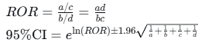 | Lower limit of 95% confidence interval (CI) > 1
Proportional Reporting Ratio | PRR | 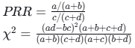 | PRR ≥ 2  χ2≥4
Bayesian Confidence Propagation Neural Network | BCPNN | 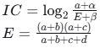  *Where α and β are prior parameters (default α = β = 1)* | IC025 > 0  *(IC025: the lower limit of the 95% two-sided credibility interval for the Information Component)*
Multi-item Gamma Poisson Shrinker | MGPS | 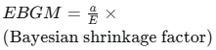  E is the expected count under the null hypothesis of no association | EBGM05 > 2  *(EBGM05: the lower limit of the 95% one-sided confidence interval for the Empirical Bayesian Geometric Mean)*
Notes to the table:
- The 2×2 contingency table is defined as: a = number of reports with target drug and target adverse event; b = reports with target drug and other events; c = reports with other drugs and target event; d = reports with other drugs and other events.
- A positive signal is declared only when all four algorithms simultaneously meet their respective signal criteria.
- This combined approach improves the robustness of signal detection by balancing the high sensitivity of frequentist methods (ROR, PRR) with the stability of Bayesian methods (BCPNN, MGPS), particularly for low-frequency events.

