Supplementary script Lycium

2025-12-17
#ITS sequences Lycium intricatum
##1- Dada2 - raw reads inspection, cleaning and taxonomy assignment
# Load required libraries
library(dada2)
# Define the path containing the raw ITS sequencing files
path <- "C:/your path/"
list.files(path)
# Import forward reads (primers and adapters already removed)
fnFs <- sort(list.files(path, pattern = "_R1_001.fastq.gz", full.names = TRUE))
# Primer sequences used for ITS amplification (reported for reference)
FWD <- "GTGARTCATCGAATCTTTG"
REV <- "TCCTCCGCTTATTGATATGC"
# Remove sequences containing ambiguous bases (Ns)
fnFs.filtN <- file.path(path, "filtN", basename(fnFs))
filterAndTrim(fnFs, fnFs.filtN, maxN = 0, multithread = TRUE)
# Ensure correct pairing and extract sample names from filenames
path.filt <- file.path(path, "filtN")
cutFs <- sort(list.files(path.filt, pattern = "_R1_001.fastq.gz", full.names = TRUE))
get.sample.name <- function(fname) strsplit(basename(fname), "_")[[1]][1]
sample.names <- unname(sapply(cutFs, get.sample.name))
# Inspect quality profiles of forward reads
plotQualityProfile(cutFs[1:18])
# Filter and trim reads based on quality thresholds
filtFs <- file.path(path.filt, "filtered", basename(cutFs))
out <- filterAndTrim(cutFs, filtFs, truncLen = 280, maxN = 0, maxEE = 2, truncQ = 2,
minLen = 50, rm.phix = TRUE, compress = TRUE, multithread = FALSE, trimLeft = 18)
# Inspect quality profiles after filtering
plotQualityProfile(filtFs[1:18])
# Learn the error rates from the filtered reads
errF <- learnErrors(filtFs, multithread = TRUE)
plotErrors(errF, nominalQ = TRUE)
# Perform sample inference using the DADA2 algorithm
dadaFs <- dada(filtFs, err = errF, multithread = TRUE)
# Construct the sequence table
seqtab <- makeSequenceTable(dadaFs)
# Remove chimeric sequences using the consensus method
seqtab.nochim <- removeBimeraDenovo(seqtab, method = "consensus", multithread = TRUE,
verbose = TRUE)
# Inspect sequence length distribution after chimera removal
table(nchar(getSequences(seqtab.nochim)))
# Export the final ASV table
write.csv(t(seqtab.nochim), "ITS_table_FINAL.csv")
# Track read counts through the pipeline
getN <- function(x) sum(getUniques(x))
track <- cbind(out, sapply(dadaFs, getN), rowSums(seqtab.nochim))
colnames(track) <- c("input", "filtered", "denoisedF", "nonchim")
rownames(track) <- sample.names
# Export read tracking table
write.csv(track, "track_table_ITS.csv")
# Assign taxonomy using the UNITE reference database
unite.ref <- "C:/Users/user/Desktop/Arianna/ERICA/ITS/sh_general_release_dynamic_19.02.2025.fasta"
taxa <- assignTaxonomy(seqtab.nochim, unite.ref, multithread = TRUE, tryRC = TRUE)
# Export taxonomy assignments
write.csv(taxa, "taxonomy.csv")
##2- Phyloseq
# -------------------------------------------------------------------------
# Construction and curation of the Phyloseq object for ITS amplicon data
# -------------------------------------------------------------------------
# Load required libraries
library(phyloseq)
library(ggplot2)
library(readxl)
library(dplyr)
library(tibble)
library(tidyverse)
library(vegan)
library(data.table)
library(stringr)
library(devtools)
library(ranacapa)
# -------------------------------------------------------------------------
# Import input data
# -------------------------------------------------------------------------
# ASV abundance table
asv16S <- read.table(
file = "C:/Users/Alber/Desktop/DOTTORATO/PROGETTO ERICA/ITS/phyloseq object 2/16S_table-FINAL.txt",
sep = "\t",
dec = ".",
header = TRUE,
check.names = FALSE
)
# Taxonomic assignment table
tax16S <- read.table(
file = "C:/Users/Alber/Desktop/DOTTORATO/PROGETTO ERICA/ITS/phyloseq object 2/taxonomy.txt",
sep = "\t",
dec = ".",
header = TRUE
)
# Experimental design / sample metadata
design <- read.table(
file = "C:/Users/Alber/Desktop/DOTTORATO/PROGETTO ERICA/ITS/phyloseq object 2/design.txt",
sep = "\t",
dec = ",",
header = TRUE,
stringsAsFactors = FALSE,
fill = TRUE,
fileEncoding = "latin1"
)
# -------------------------------------------------------------------------
# Data formatting for Phyloseq
# -------------------------------------------------------------------------
# Set ASV identifiers as row names
asv16S <- asv16S %>%
column_to_rownames("OTU.ID")
tax16S <- tax16S %>%
column_to_rownames("OTU.ID")
design <- design %>%
column_to_rownames("SAMPLE.ID")
# Clean taxonomy table (replace empty strings with NA)
tax16S[tax16S == ""] <- NA
tax16S[tax16S == " "] <- NA
# Convert data frames to matrices
OTU <- as.matrix(asv16S)
TAXA <- as.matrix(tax16S)
# -------------------------------------------------------------------------
# Phyloseq object construction
# -------------------------------------------------------------------------
ps16S_0 <- phyloseq(
otu_table(OTU, taxa_are_rows = TRUE),
tax_table(TAXA),
sample_data(design)
)
# -------------------------------------------------------------------------
# Removal of non-target and contaminant taxa
# -------------------------------------------------------------------------
# Number of taxa before filtering
num_taxa_before <- ntaxa(ps16S_0)
# Remove unassigned and non-target lineages
ps16S_1 <- ps16S_0 %>%
subset_taxa(!is.na(Phylum)) %>%
subset_taxa(!Phylum %in% "Unassigned") %>%
subset_taxa(!Order %in% "Chloroplast") %>%
subset_taxa(!Family %in% "Mitochondria") %>%
subset_taxa(!Kingdom %in% c("Eukaryota", "Archaea"))
# -------------------------------------------------------------------------
# ASV renaming and sample filtering
# -------------------------------------------------------------------------
# Rename ASVs with sequential identifiers
dna.16S <- taxa_names(ps16S_1)
names(dna.16S) <- taxa_names(ps16S_1)
ps16S_2 <- merge_phyloseq(ps16S_1, dna.16S)
taxa_names(ps16S_2) <- paste0("ASV", seq_len(ntaxa(ps16S_2)))
# Remove samples with insufficient sequencing depth (<100 reads)
ps16S_3 <- prune_samples(sample_sums(ps16S_2) >= 100, ps16S_2)
# Remove taxa with zero counts
ps16S_4 <- filter_taxa(ps16S_3, function(x) sum(x) > 0, prune = TRUE)
# -------------------------------------------------------------------------
# Low-abundance ASV filtering
# -------------------------------------------------------------------------
# Retain ASVs with relative abundance ≥0.01% in at least one sample
ps16S_5 <- transform_sample_counts(
ps16S_4,
function(x) ifelse((x / sum(x)) >= 0.0001, x, 0)
)
ps16S_6 <- filter_taxa(ps16S_5, function(x) sum(x) > 0, prune = TRUE)
# Save the curated Phyloseq object
saveRDS(ps16S_6, "ps16S_clean_ITS_ERICA.rds")
# -------------------------------------------------------------------------
# Sequencing depth assessment
# -------------------------------------------------------------------------
# Load cleaned dataset
dITS <- readRDS("ps16S_clean_ITS_ERICA.rds")
# Summarize sequencing depth per sample
sdtITS <- data.table(
as(sample_data(dITS), "data.frame"),
TotalReads = sample_sums(dITS),
keep.rownames = TRUE
)
###2.1- Rarefaction
# -------------------------------------------------------------------------
# Rarefaction analysis of ITS amplicon data
# -------------------------------------------------------------------------
# Load required libraries
library(phyloseq)
library(ggplot2)
library(vegan)
library(ranacapa)
# Determine the minimum sequencing depth across samples
min_depth <- min(colSums(otu_table(dITS))) # Example: 37855 reads; Fv: 54185
# Generate rarefaction curves for ITS data
rcurveITS <- ggrare(
dITS,
color = "SampleType",
step = 999,
se = FALSE
) +
labs(title = "ITS rRNA gene") +
geom_vline(xintercept = 54185)
## rarefying sample 170486
## rarefying sample 170487
## rarefying sample 170488
## rarefying sample 170489
## rarefying sample 170490
## rarefying sample 170491
## rarefying sample 170492
## rarefying sample 170493
## rarefying sample 170494
## rarefying sample 170495
## rarefying sample 170496
## rarefying sample 170497
## rarefying sample 170498
## rarefying sample 170499
## rarefying sample 170500
## rarefying sample 170501
## rarefying sample 170502
## rarefying sample 170503
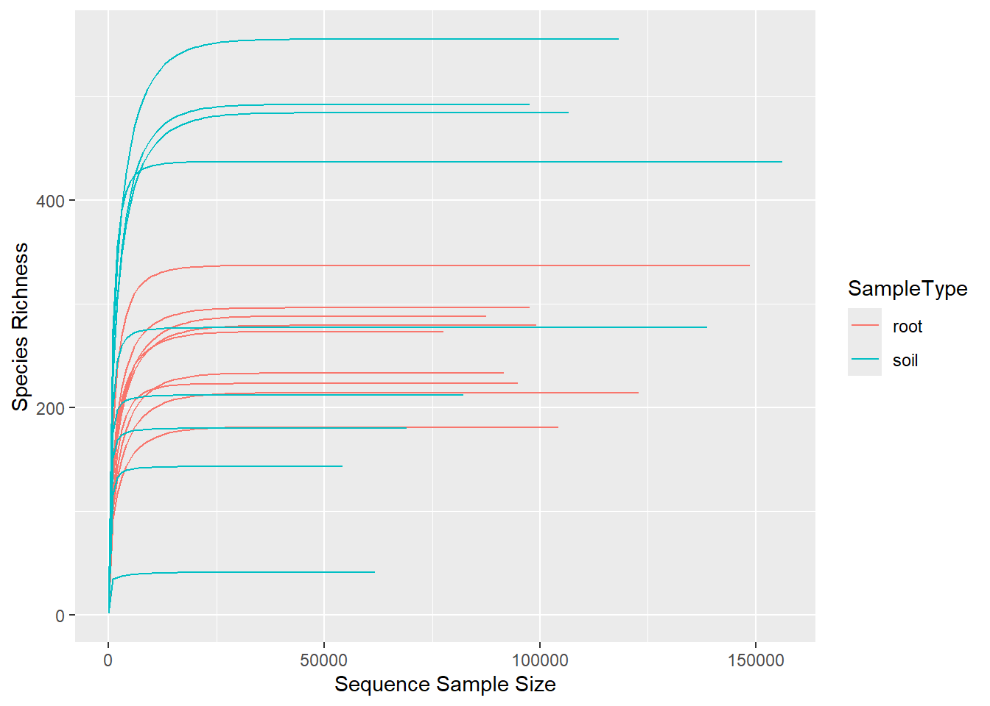
# Customize rarefaction curve appearance for publication
rcurveITSf <- rcurveITS +
theme(
strip.background = element_rect(color = "white", fill = "#585858", size = 1, linetype = "solid"),
strip.text.x = element_text(size = 12, color = "white"),
axis.title.x = element_text(size = 12, face = "bold"),
axis.title.y = element_text(size = 12, face = "bold"),
plot.title = element_text(size = 16),
axis.text.x = element_text(face = "bold"),
axis.text.y = element_text(face = "bold")
) +
ylab("Species richness") +
xlab("Sample size") +
ggtitle("ITS rRNA gene") +
facet_grid(~SampleType, scale = "free")
# Plot rarefaction curves
rcurveITSf
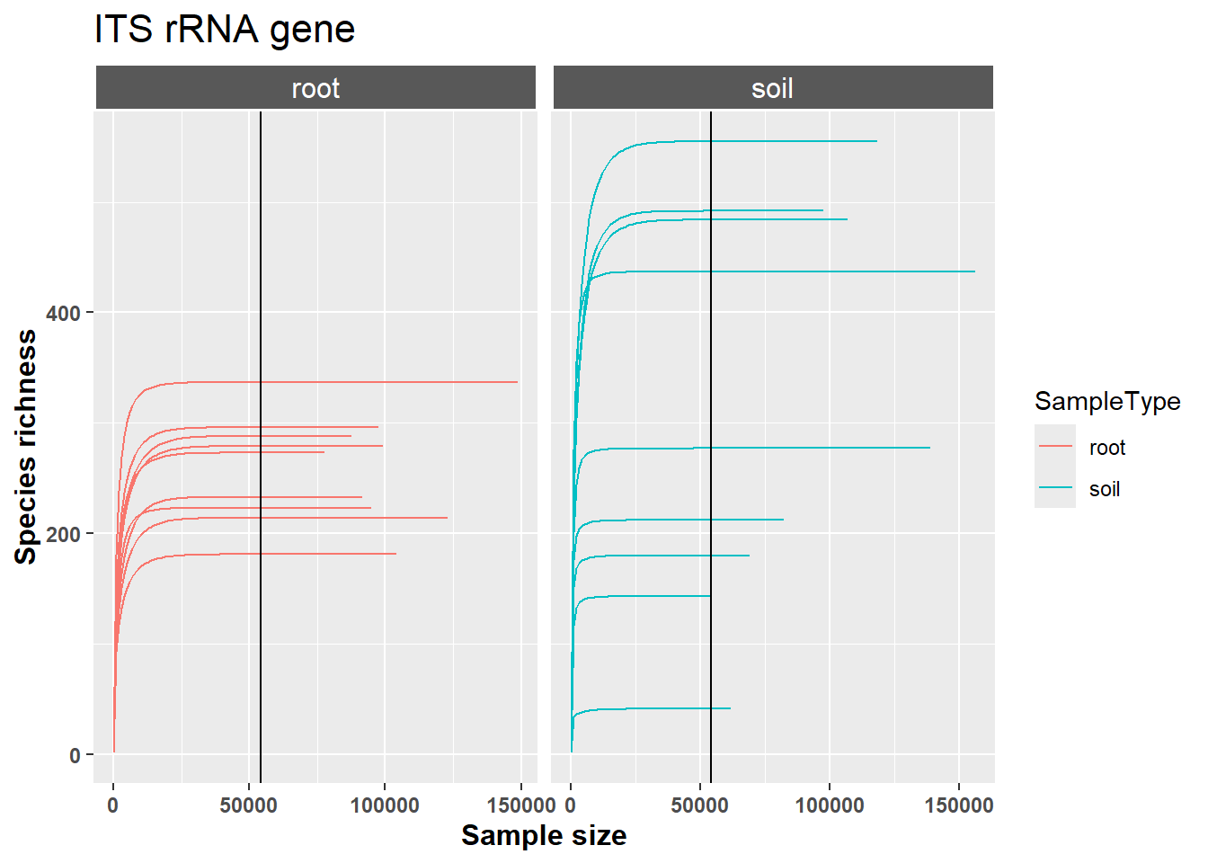
# Rarefy all samples to even depth for downstream diversity analyses
rITS <- rarefy_even_depth(
dITS,
sample.size = 54185,
rngseed = 900
)
# Generate rarefaction curves for rarefied dataset
rcurveITS_rarefied <- ggrare(
rITS,
color = "SampleType",
step = 999,
se = FALSE
) +
labs(title = "ITS rRNA gene (rarefied)") +
geom_vline(xintercept = 37855)
## rarefying sample 170486
## rarefying sample 170487
## rarefying sample 170488
## rarefying sample 170489
## rarefying sample 170490
## rarefying sample 170491
## rarefying sample 170492
## rarefying sample 170493
## rarefying sample 170494
## rarefying sample 170495
## rarefying sample 170496
## rarefying sample 170497
## rarefying sample 170498
## rarefying sample 170499
## rarefying sample 170500
## rarefying sample 170501
## rarefying sample 170502
## rarefying sample 170503
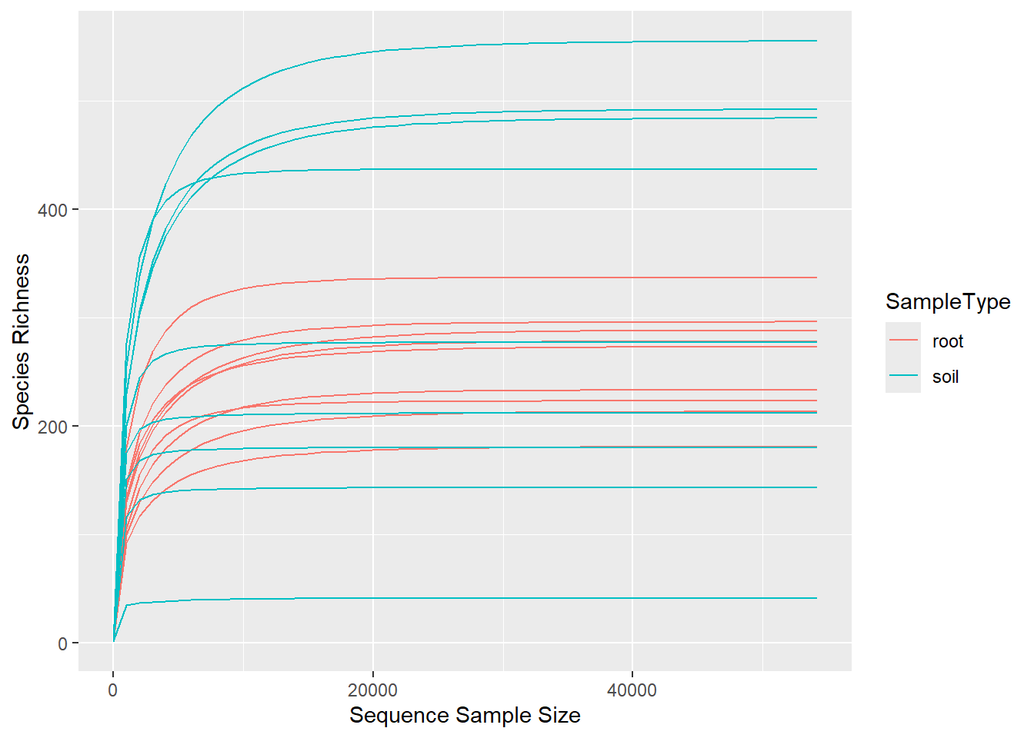
# Plot rarefied curves
rcurveITS_rarefied
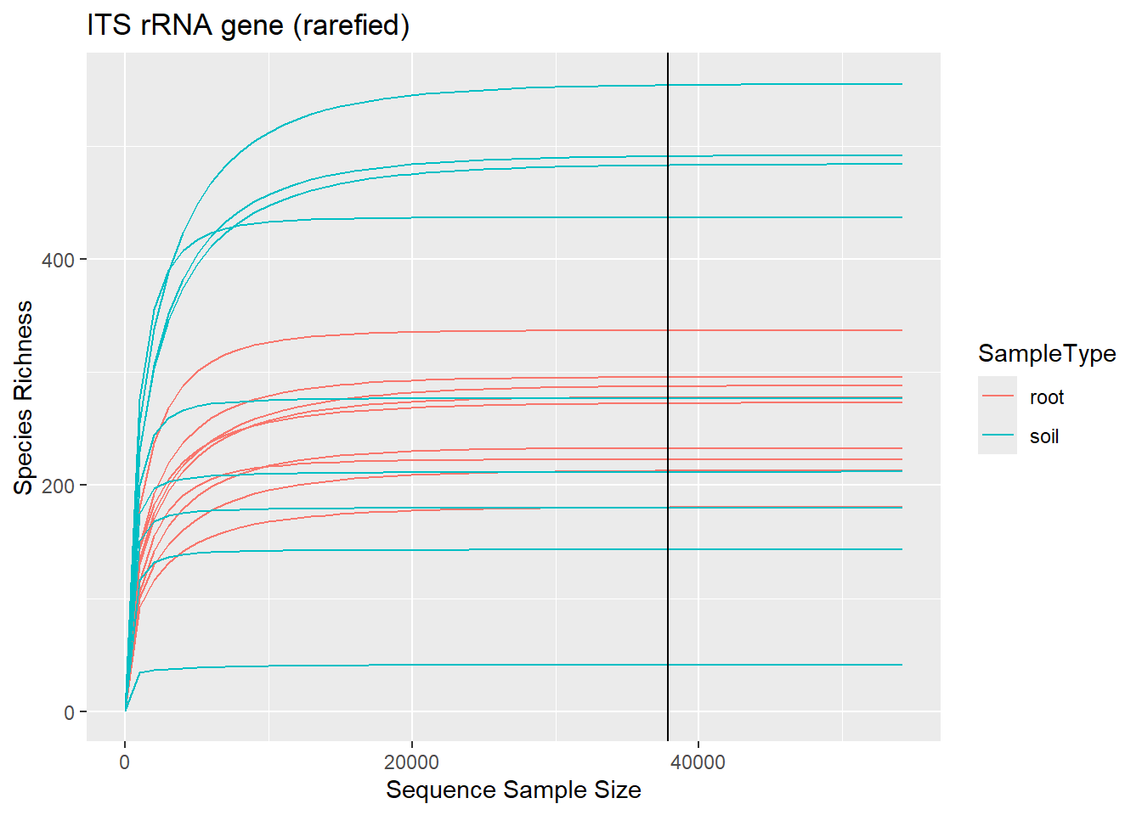
###2.2- Fig. 2A- Community composition
# -------------------------------------------------------------------------
# Phylum-Level Visualization of ITS Root-Associated Microbial Communities
# -------------------------------------------------------------------------
# Load required libraries
library(ggplot2)
library(phyloseq)
library(dplyr)
library(scales)
library(grid)
library(reshape2)
# Aggregate ITS Phyloseq object at Phylum level and calculate relative abundances
erie_phylum <- rITS%>%
tax_glom(taxrank = "Phylum")%>% # Agglomerate taxa at Phylum rank
transform_sample_counts(function(x) { x / sum(x) })%>% # Convert counts to relative abundances
psmelt() %>% # Convert to long-format data frame
arrange(Phylum) # Sort by Phylum
# Ensure proper factor levels for plotting
erie_phylum$Sampling.Label <- as.factor(erie_phylum$Sampling.Label)
erie_phylum$SampleType <- as.factor(erie_phylum$SampleType)
erie_phylum$Elevazione..masl. <- factor(
erie_phylum$Elevazione..masl.,
levels = c("65 m", "85 m", "92 m", "103 m"),
ordered = TRUE
)
# Define a publication-ready color palette for Phyla
phylum_colors <- c(
"#CBD588", "#5F7FC7", "orange", "#DA5724", "#508578", "#CD9BCD",
"#AD6F3B", "#673770", "#D14285", "#652926", "#C84248",
"#8569D5", "#5E738F", "#8A7C64", "#7CFC00", "#599861",
"#FF0000", "#00FF00", "#0000FF", "#FFFF00", "#00FFFF", "#FFC0CB",
"#008000", "#000080", "#808000", "#D1A33D", "#008080", "#FFD700",
"#800080", "#FF00FF", "#ADFF2F", "#32CD32", "#00FF7F", "#C0C0C0",
"#228B22", "#20B2AA", "#40E0D0", "#00BFFF", "#1E90FF", "#4IT9E1",
"#0000CD", "#8A2BE2", "#6A5ACD"
)
# Generate stacked bar plot of Phylum-level relative abundances
ggplot(erie_phylum, aes(x = Sampling.Label, y = Abundance, fill = Phylum)) +
facet_grid(SampleType ~ Elevazione..masl., scales = 'free_x', space = 'free', switch = 'both') + # Facet by sample type and elevation
geom_bar(stat = "identity") + # Stacked bar chart
scale_fill_manual(values = phylum_colors) + # Apply custom color palette
theme_minimal() + # Minimal theme
theme(
axis.title.x = element_text(size = 12, face = "bold", color = "black"),
axis.title.y = element_text(size = 12, face = "bold", color = "black"),
plot.title = element_text(size = 14, face = "bold", hjust = 0.5),
axis.text.x = element_text(angle = 45, hjust = 1, size = 10, color = "black"),
axis.text.y = element_text(size = 10, color = "black"),
strip.background = element_rect(fill = "lightblue", color = "black", size = 1),
strip.text = element_text(size = 12, face = "bold"),
strip.placement = "outside",
panel.spacing = unit(1, "lines"),
legend.position = "bottom",
legend.justification = "center",
legend.box.spacing = unit(0.5, "lines"),
legend.title = element_text(size = 10, face = "bold"),
legend.text = element_text(size = 9)
) +
guides(fill = guide_legend(reverse = FALSE, keywidth = 1, keyheight = 1, ncol = 7)) + # Customize legend
ylab("Relative Abundance (Phyla > 0.001%)") + # y-axis label
ggtitle("Lycius ITS Root-Associated Microbial Community") # Plot title
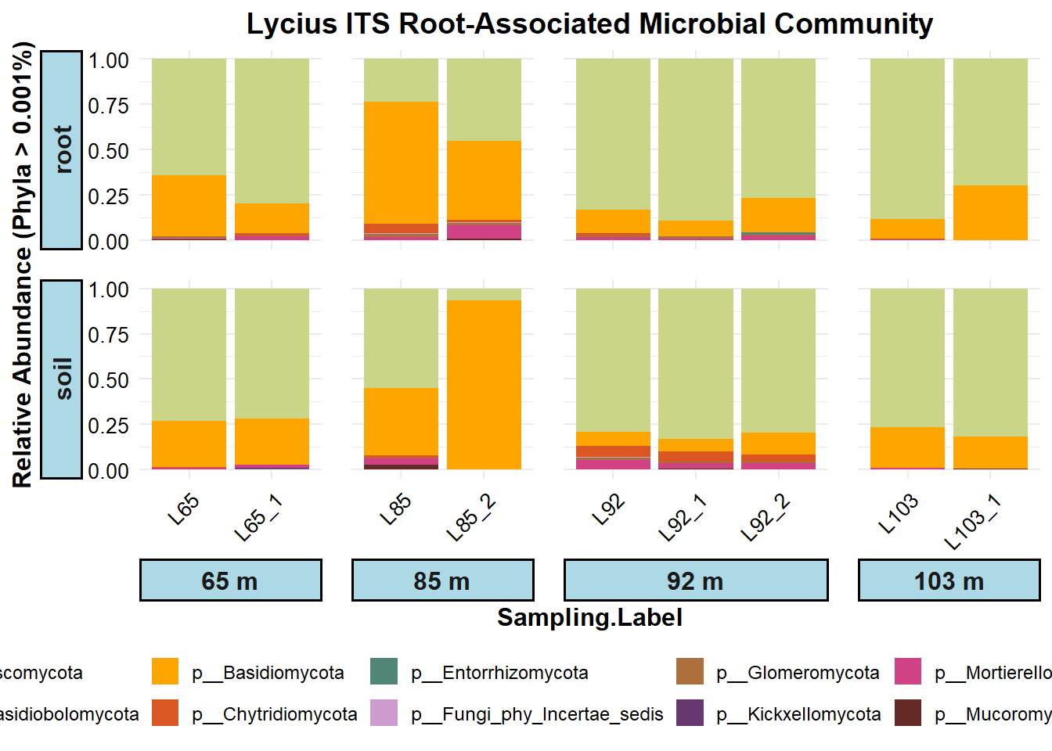
###2.3- Alpha diversity
# -------------------------------------------------------------------------
# Alpha Diversity Analysis for ITS Root-Associated Microbial Communities
# -------------------------------------------------------------------------
# Load required libraries
library(phyloseq)
library(picante)
library(tidyverse)
library(ggpubr)
library(rstatix)
library(ggthemes)
library(multcompView)
library(agricolae)
library(dplyr)
# -------------------------------------------------------------------------
# 1. Estimate Alpha Diversity Metrics
# -------------------------------------------------------------------------
# Compute alpha-diversity measures: Observed ASVs, Inverse Simpson, Shannon
table_rITS <- estimate_richness(rITS, split = TRUE, measures = c("Observed", "InvSimpson", "Shannon"))
# Combine alpha diversity metrics with sample metadata
sdrITS <- sample_data(rITS)
datarITS <- cbind(sample_data(sdrITS), table_rITS)
# Convert relevant columns to factors
datarITS$Sampling.Label <- as.factor(datarITS$Sampling.Label)
datarITS$SampleType <- as.factor(datarITS$SampleType)
datarITS$Elevazione..masl. <- as.factor(datarITS$Elevazione..masl.)
####2.3.1 - Fig. 2B (Upper)
# ------------------------------------------------------------------------- 2.
# Alpha Diversity by Sample Type (Observed and Shannon)
# -------------------------------------------------------------------------
# Set SampleType as ordered factor
datarITS$SampleType <- factor(datarITS$SampleType, levels = c("soil", "root"), ordered = TRUE)
# Define a color palette for plotting
paletteT <- c("#5a3b22", "#d2a679")
# Ensure factors for statistical testing
datarITS$Sampling.Label <- as.factor(datarITS$Sampling.Label)
datarITS$Elevazione..masl. <- as.factor(datarITS$Elevazione..masl.)
datarITS$SampleType <- as.factor(datarITS$SampleType)
# ------------------------------------------------------------------------- 2a.
# Observed ASV Richness
# -------------------------------------------------------------------------
# Perform Dunn's test for Observed ASVs between SampleTypes (FDR correction)
res_obs <- datarITS %>%
dunn_test(Observed ~ SampleType, p.adjust.method = "fdr")
# Add test results for plotting
stat.test_obs <- res_obs %>%
add_xy_position(x = "SampleType")
# Boxplot for Observed ASV richness
plot_16S_Observed_b <- ggplot(datarITS, aes(SampleType, Observed)) + geom_boxplot(aes(fill = SampleType),
show.legend = TRUE, outlier.shape = NA) + geom_jitter(size = 3) + labs(x = "Sample Type",
y = "Observed ASV Richness") + theme_bw() + theme(panel.grid.major = element_blank(),
panel.grid.minor = element_blank()) + stat_pvalue_manual(stat.test_obs, hide.ns = TRUE) +
scale_fill_manual(values = paletteT)
# Display plot
plot_16S_Observed_b
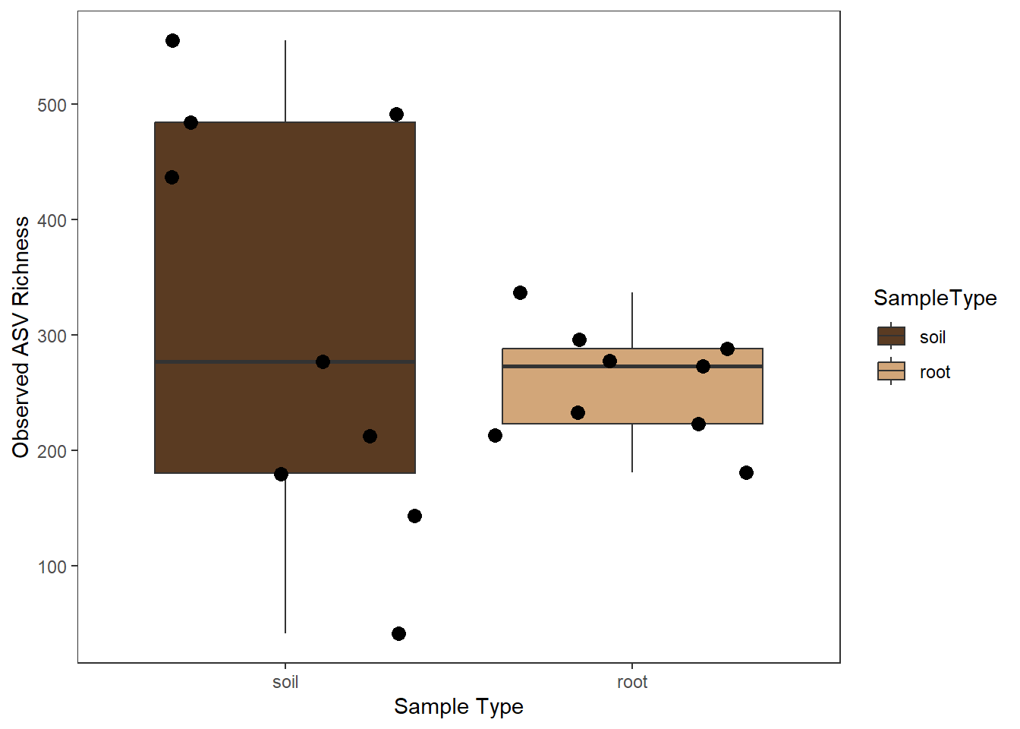
# ------------------------------------------------------------------------- 2b.
# Shannon Diversity Index
# -------------------------------------------------------------------------
# Perform Dunn's test for Shannon index between SampleTypes (FDR correction)
res_shan <- datarITS %>%
dunn_test(Shannon ~ SampleType, p.adjust.method = "fdr")
# Add test results for plotting
stat.test_sha <- res_shan %>%
add_xy_position(x = "SampleType")
# Boxplot for Shannon diversity
plot_16S_Shannon_b <- ggplot(datarITS, aes(SampleType, Shannon)) + geom_jitter(aes(color = SampleType),
size = 7) + labs(x = "Sample Type", y = "Shannon ASV Diversity") + theme_bw() +
theme(panel.grid.major = element_blank(), panel.grid.minor = element_blank()) +
stat_pvalue_manual(stat.test_sha, hide.ns = TRUE) + scale_color_manual(values = paletteT)
# Display plot
plot_16S_Shannon_b
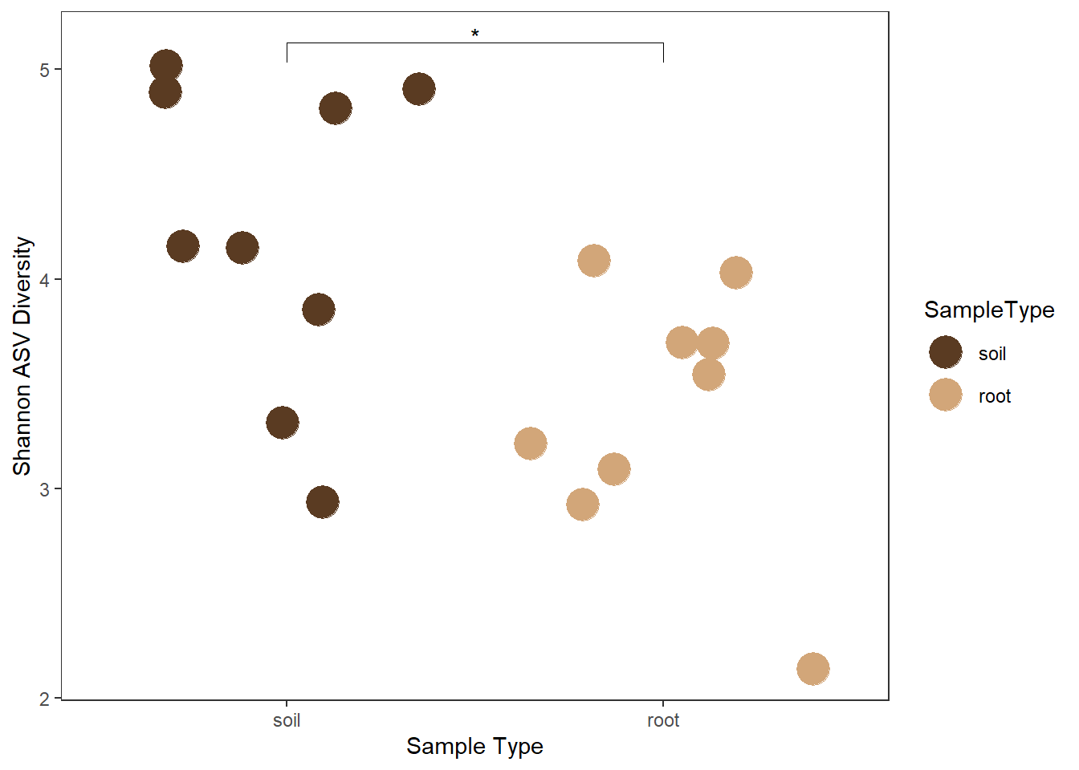
####2.3.1 - Fig. 3B
# -------------------------------------------------------------------------
# Alpha Diversity Analysis by Elevation for ITS Root-Associated Microbial Communities
# -------------------------------------------------------------------------
# Load required libraries
library(phyloseq)
library(tidyverse)
library(ggpubr)
library(rstatix)
# -------------------------------------------------------------------------
# 1. Set Factors and Color Palette
# -------------------------------------------------------------------------
# Ordered factor for Elevation
datarITS$Elevazione..masl. <- factor(datarITS$Elevazione..masl.,
levels = c("65 m", "85 m", "92 m", "103 m"),
ordered = TRUE)
# Convert other relevant variables to factors
datarITS$Sampling.Label <- as.factor(datarITS$Sampling.Label)
datarITS$SampleType <- as.factor(datarITS$SampleType)
# Define a color palette for elevations
paletteT <- c("#ece7f2","#b3e0f7", "#3690c0", "#003d6b")
# -------------------------------------------------------------------------
# 2. Observed ASV Richness by Elevation
# -------------------------------------------------------------------------
# Perform Dunn's test for Observed ASVs across Elevations with FDR correction
res_obs <- datarITS %>%
dunn_test(Observed ~ Elevazione..masl., p.adjust.method = "fdr")
# Add statistical test results for plotting
stat.test_obs <- res_obs %>% add_xy_position(x = "Elevazione..masl.")
# Create plot with jittered points colored by Elevation and shaped by SampleType
plot_16S_Observed_b <- ggplot(datarITS, aes(Elevazione..masl., Observed)) +
geom_jitter(aes(color = Elevazione..masl., shape = SampleType), size = 8, width = 0.2) +
labs(x = "Elevation (m a.s.l.)", y = "Observed ASV Richness") +
theme_bw() +
theme(panel.grid.major = element_blank(),
panel.grid.minor = element_blank(),
axis.title = element_text(size = 12, face = "bold"),
axis.text = element_text(size = 10),
legend.position = "right") +
stat_pvalue_manual(stat.test_obs, hide.ns = TRUE) +
scale_color_manual(values = paletteT) +
scale_fill_manual(values = paletteT)
# Display Observed ASV plot
plot_16S_Observed_b
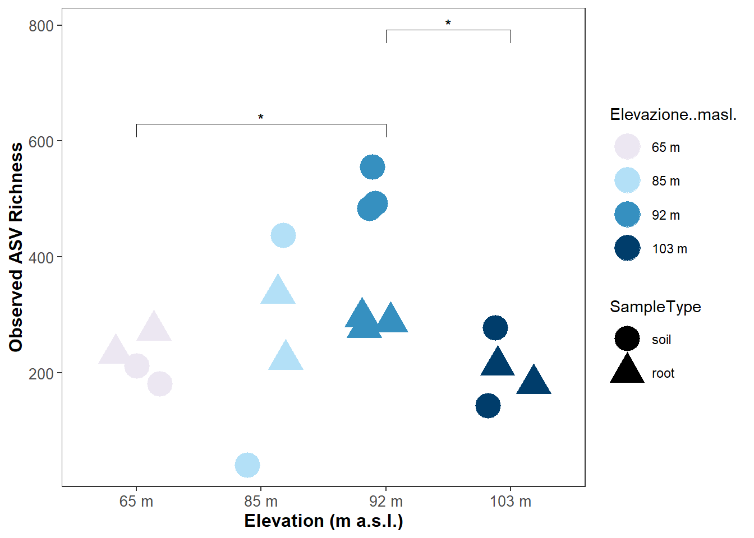
# -------------------------------------------------------------------------
# 3. Shannon Diversity by Elevation
# -------------------------------------------------------------------------
# Perform Dunn's test for Shannon diversity across Elevations with FDR correction
res_shan <- datarITS %>%
dunn_test(Shannon ~ Elevazione..masl., p.adjust.method = "fdr")
# Add statistical test results for plotting
stat.test_sha <- res_shan %>% add_xy_position(x = "Elevazione..masl.")
# Create plot with jittered points colored by Elevation and shaped by SampleType
plot_16S_Shannon_b <- ggplot(datarITS, aes(Elevazione..masl., Shannon)) +
geom_jitter(aes(color = Elevazione..masl., shape = SampleType), size = 8, width = 0.2) +
labs(x = "Elevation (m a.s.l.)", y = "Shannon ASV Diversity") +
theme_bw() +
theme(panel.grid.major = element_blank(),
panel.grid.minor = element_blank(),
axis.title = element_text(size = 12, face = "bold"),
axis.text = element_text(size = 10),
legend.position = "right") +
stat_pvalue_manual(stat.test_sha, hide.ns = TRUE) +
scale_color_manual(values = paletteT) +
scale_fill_manual(values = paletteT)
# Display Shannon Diversity plot
plot_16S_Shannon_b
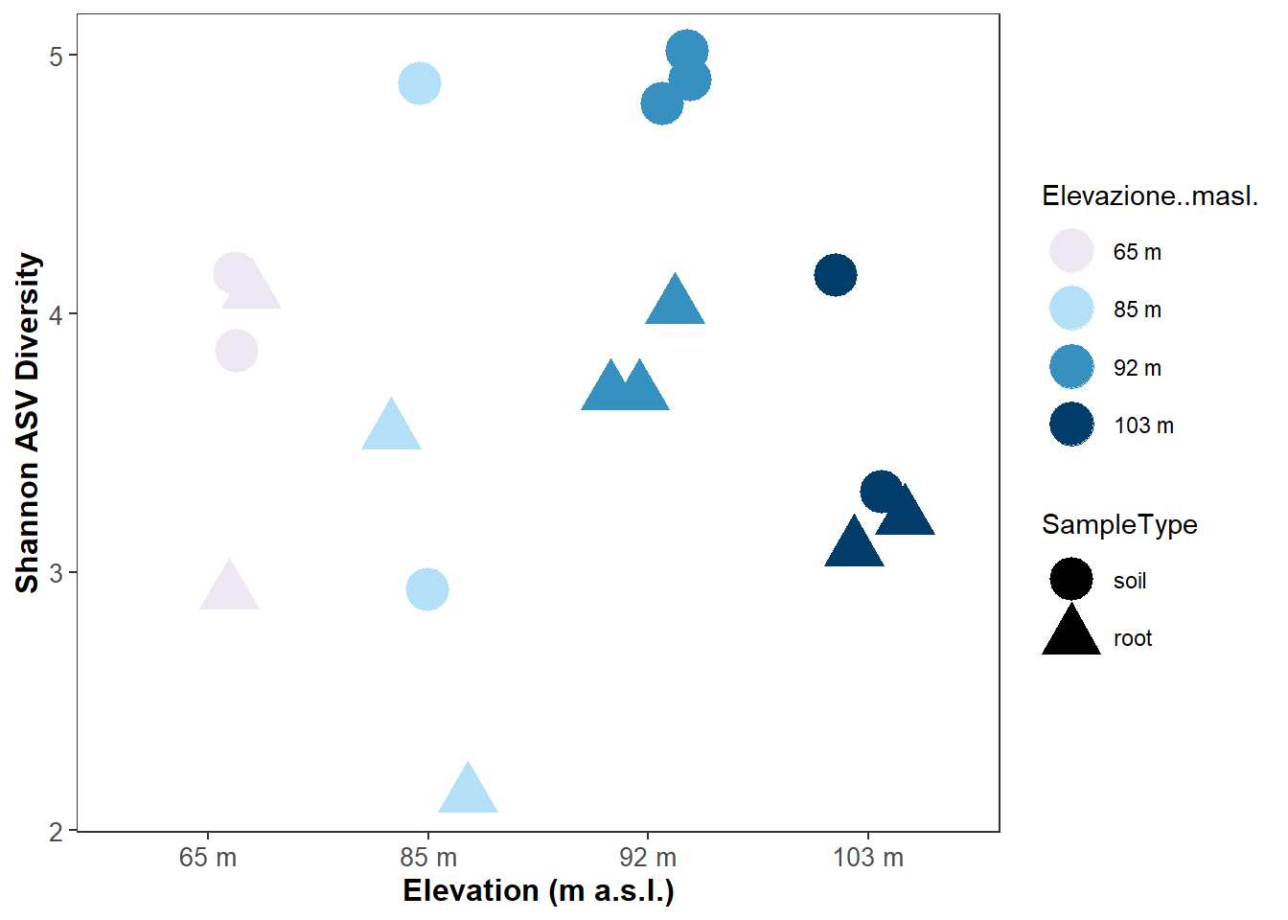
###2.4 - Beta diversity ####2.4.1 - Fig. 2B (Lower)
# -------------------------------------------------------------------------
# Beta Diversity Analysis by Tissue Type for ITS Root-Associated Communities
# -------------------------------------------------------------------------
# Load required libraries
library(phyloseq)
library(vegan)
library(ggplot2)
library(ggrepel)
library(dplyr)
# -------------------------------------------------------------------------
# 1. Prepare Data
# -------------------------------------------------------------------------
# Ensure SampleType is a factor with defined order
sample_data(rITS)$SampleType <- factor(sample_data(rITS)$SampleType,
levels = c("soil", "root"),
ordered = TRUE)
# Compute Bray-Curtis distance matrix
bray.16S <- phyloseq::distance(rITS, method = "bray")
# Convert sample data to data frame for adonis
mdat.16Sb <- as(sample_data(rITS), "data.frame")
# -------------------------------------------------------------------------
# 2. PERMANOVA test (adonis2)
# -------------------------------------------------------------------------
adonis.16Sbray <- adonis2(bray.16S ~ SampleType,
data = mdat.16Sb,
permutations = 20000,
by = "margin")
# Print results
print(adonis.16Sbray)
## Permutation test for adonis under reduced model
## Marginal effects of terms
## Permutation: free
## Number of permutations: 20000
##
## adonis2(formula = bray.16S ~ SampleType, data = mdat.16Sb, permutations = 20000, by = "margin")
## Df SumOfSqs R2 F Pr(>F)
## SampleType 1 1.0193 0.1469 2.7551 0.0011 **
## Residual 16 5.9194 0.8531
## Total 17 6.9386 1.0000
## ---
## Signif. codes: 0 '***' 0.001 '**' 0.01 '*' 0.05 '.' 0.1 ' ' 1
# -------------------------------------------------------------------------
# 3. PCoA ordination and plotting
# -------------------------------------------------------------------------
# Perform Principal Coordinate Analysis (PCoA) based on Bray-Curtis
bray.pcoa.16S <- ordinate(rITS, method = "PCoA", distance = "bray")
# Define custom color palette for SampleType
paletteT <- c("#5a3b22","#d2a679")
# Create PCoA plot
pcoa_plot <- plot_ordination(rITS, bray.pcoa.16S, type = "samples", color = "SampleType") +
geom_point(aes(color = SampleType), size = 8) + # Points with border
ggtitle("ITS rRNA Gene - Bray-Curtis PCoA") +
scale_color_manual(values = paletteT) + # Apply color palette
theme_bw() +
theme(panel.grid.major = element_blank(),
panel.grid.minor = element_blank(),
panel.background = element_blank(),
axis.title = element_text(size = 12, face = "bold"),
axis.text = element_text(size = 10),
legend.position = "right")
# Display PCoA plot
pcoa_plot
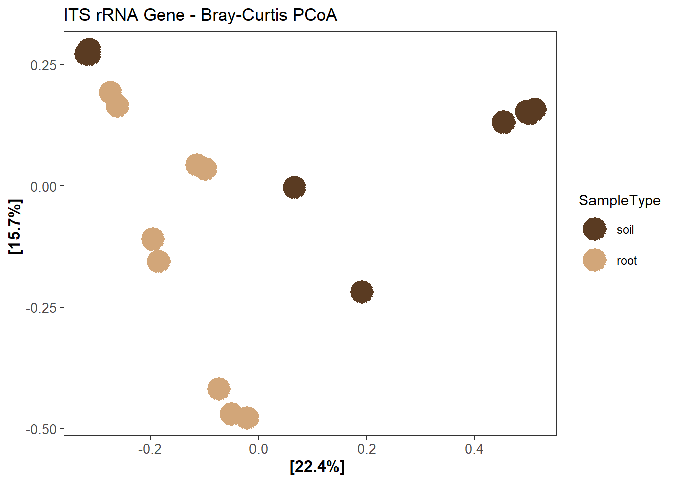
####2.4.2 - Fig. 3A
# -------------------------------------------------------------------------
# Beta Diversity Analysis by Elevation and Tissue Type for ITS Communities
# -------------------------------------------------------------------------
# Load required libraries
library(phyloseq)
library(vegan)
library(ggplot2)
library(ggrepel)
library(dplyr)
# -------------------------------------------------------------------------
# 1. Prepare Data
# -------------------------------------------------------------------------
# Ensure factors are correctly set
sample_data(rITS)$Elevazione..masl. <- factor(sample_data(rITS)$Elevazione..masl.,
levels = c("65 m", "85 m", "92 m", "103 m"),
ordered = TRUE)
sample_data(rITS)$SampleType <- factor(sample_data(rITS)$SampleType, levels = c("soil", "root"), ordered = TRUE)
# Compute Bray-Curtis distance matrix
bray.16S <- phyloseq::distance(rITS, method = "bray")
# Convert sample data to data frame for adonis2
mdat.16Sb <- as(sample_data(rITS), "data.frame")
# -------------------------------------------------------------------------
# 2. PERMANOVA (adonis2)
# -------------------------------------------------------------------------
adonis.16Sbray <- adonis2(bray.16S ~ Elevazione..masl. + SampleType,
data = mdat.16Sb,
permutations = 20000,
by = "margin")
# Print PERMANOVA results
print(adonis.16Sbray)
## Permutation test for adonis under reduced model
## Marginal effects of terms
## Permutation: free
## Number of permutations: 20000
##
## adonis2(formula = bray.16S ~ Elevazione..masl. + SampleType, data = mdat.16Sb, permutations = 20000, by = "margin")
## Df SumOfSqs R2 F Pr(>F)
## Elevazione..masl. 3 2.1352 0.30772 2.4450 0.00020 ***
## SampleType 1 1.0193 0.14690 3.5016 0.00015 ***
## Residual 13 3.7842 0.54538
## Total 17 6.9386 1.00000
## ---
## Signif. codes: 0 '***' 0.001 '**' 0.01 '*' 0.05 '.' 0.1 ' ' 1
# -------------------------------------------------------------------------
# 3. PCoA Ordination and Plot
# -------------------------------------------------------------------------
# Perform PCoA based on Bray-Curtis distance
bray.pcoa.16S <- ordinate(rITS, method = "PCoA", distance = "bray")
# Define a custom color palette for Elevation
palette_custom <- c("#ece7f2","#b3e0f7", "#3690c0", "#003d6b")
# Create PCoA plot
pcoa_plot <- plot_ordination(rITS, bray.pcoa.16S, type = "samples",
color = "Elevazione..masl.", shape = "SampleType") +
geom_point(aes(color = Elevazione..masl.), size = 6, stroke = 0.5, shape = 21, fill = NA) + # Border points
geom_point(aes(color = Elevazione..masl.), size = 5) + # Colored points on top
ggtitle("ITS rRNA Gene - Bray-Curtis PCoA") +
scale_color_manual(values = palette_custom) +
theme_bw() +
theme(panel.grid.major = element_blank(),
panel.grid.minor = element_blank(),
panel.background = element_blank(),
axis.title = element_text(size = 12, face = "bold"),
axis.text = element_text(size = 10),
legend.position = "right")
# Display the final PCoA plot
pcoa_plot
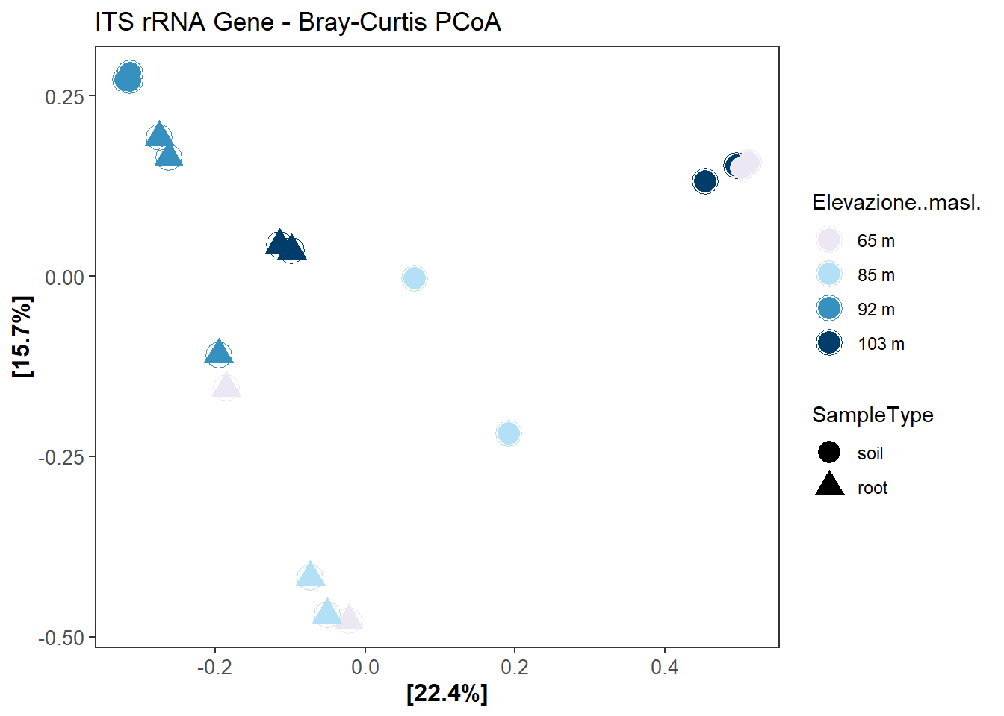
#18S sequences Lycium intricatum
##3- Dada2 - raw reads inspection, cleaning and taxonomy assignment
# ========================================================================= 1.
# DADA2 Workflow for 18S rRNA Sequencing Data
# =========================================================================
# ------------------------- 1.1 Load libraries -------------------------
library(dada2)
packageVersion("dada2")
# ------------------------- 1.2 Define path -------------------------
path <- "C:/Users/user/Desktop/Arianna/ERICA/18S/18Sseq/"
list.files(path)
# ------------------------- 1.3 Extract sample names -------------------------
fnFs <- sort(list.files(path, pattern = "_R1_001.fastq.gz", full.names = TRUE))
fnRs <- sort(list.files(path, pattern = "_R2_001.fastq.gz", full.names = TRUE))
sample.names <- sapply(strsplit(basename(fnFs), "_"), `[`, 1)
# ------------------------- 1.4 Quality profiles -------------------------
plotQualityProfile(fnFs)
plotQualityProfile(fnRs)
# ------------------------- 1.5 Filtering & Trimming -------------------------
filtFs <- file.path(path, "filtered", paste0(sample.names, "_F_filt.fastq.gz"))
filtRs <- file.path(path, "filtered", paste0(sample.names, "_R_filt.fastq.gz"))
names(filtFs) <- sample.names
names(filtRs) <- sample.names
out <- filterAndTrim(fnFs, filtFs, fnRs, filtRs, truncQ = 5, truncLen = c(250, 250),
maxEE = c(1, 1), matchIDs = TRUE, maxN = 0, rm.phix = TRUE, multithread = FALSE,
verbose = TRUE)
out
mean(out[, 2])/mean(out[, 1])
# Check filtered quality
plotQualityProfile(filtFs)
plotQualityProfile(filtRs)
# ------------------------- 1.6 Learn error rates -------------------------
set.seed(123)
errF <- learnErrors(filtFs, multithread = TRUE, verbose = TRUE, nbases = 2e+08, MAX_CONSIST = 15)
errR <- learnErrors(filtRs, multithread = TRUE, verbose = TRUE, nbases = 2e+08, MAX_CONSIST = 15)
plotErrors(errF, nominalQ = TRUE)
plotErrors(errR, nominalQ = TRUE)
# ------------------------- 1.7 Dereplication and Denoising
# -------------------------
dadaFs <- dada(filtFs, err = errF, pool = FALSE, multithread = TRUE)
dadaRs <- dada(filtRs, err = errR, pool = FALSE, multithread = TRUE)
# ------------------------- 1.8 Merge paired reads -------------------------
merged_reads <- mergePairs(dadaFs, filtFs, dadaRs, filtRs, verbose = TRUE, maxMismatch = 0)
length(merged_reads)
head(merged_reads[[1]])
# ------------------------- 1.9 Make sequence table -------------------------
seqtab <- makeSequenceTable(merged_reads)
dim(seqtab)
plot(table(nchar(getSequences(seqtab)))) # Inspect read lengths
# ------------------------- 1.10 Chimera removal -------------------------
seqtab.nochim <- removeBimeraDenovo(seqtab, method = "consensus", multithread = TRUE,
verbose = TRUE)
dim(seqtab.nochim)
sum(seqtab.nochim)/sum(seqtab) * 100 # % of non-chimeric reads
write.csv(t(seqtab.nochim), "18S_table-FINAL.csv")
# ------------------------- 1.11 Track reads through pipeline
# -------------------------
getN <- function(x) sum(getUniques(x))
track <- cbind(out, sapply(dadaFs, getN), sapply(dadaRs, getN), sapply(merged_reads,
getN), rowSums(seqtab.nochim))
colnames(track) <- c("input", "filtered", "denoisedF", "denoisedR", "merged", "nonchim")
rownames(track) <- sample.names
head(track)
# ------------------------- 1.12 Assign taxonomy -------------------------
## 1.12.1 Convert reference database to FASTA (if needed)
input_file <- "C:/your path" #Use supplementary Table N
output_file <- "output.fasta"
data <- read.table(input_file, header = TRUE, sep = "\t", stringsAsFactors = FALSE)
fasta_conn <- file(output_file, open = "w")
for (i in 1:nrow(data)) {
sequence <- data[i, 1]
taxonomy <- data[i, 2:ncol(data)]
taxonomy <- taxonomy[taxonomy != ""]
header <- paste0(">", paste(taxonomy, collapse = ";"), ";")
writeLines(c(header, sequence), fasta_conn)
}
close(fasta_conn)
cat("File FASTA generato in:", output_file, "\n")
## 1.12.2 Assign taxonomy using reference
ref.database <- "C:/your path/ref.database.fasta"
taxa <- assignTaxonomy(seqtab.nochim, ref.database, multithread = TRUE, tryRC = TRUE)
taxa.print <- taxa
rownames(taxa.print) <- NULL
head(taxa.print)
write.csv(taxa, "taxonomy.csv")
##4- Phyloseq
# ========================================================================= 2.
# Construct Phyloseq Object and Clean Data
# =========================================================================
# ------------------------- 2.1 Load libraries -------------------------
library("phyloseq")
library("ggplot2")
library("readxl")
library("dplyr")
library("tibble")
library("tidyverse")
library("vegan")
library("data.table")
library("stringr")
# ------------------------- 2.2 Load input data -------------------------
## ASV Table
asv16S <- read.table(file = "C:/Users/Alber/Desktop/DOTTORATO/PROGETTO ERICA/18S/phyloseq object/18S_table-FINAL.txt",
sep = "\t", header = TRUE, check.names = FALSE)
## Taxonomy Table
tax16S <- read.table(file = "C:/Users/Alber/Desktop/DOTTORATO/PROGETTO ERICA/18S/phyloseq object/taxonomy.txt",
sep = "\t", header = TRUE)
## Experimental Design
design <- read.table(file = "C:/Users/Alber/Desktop/DOTTORATO/PROGETTO ERICA/18S/phyloseq object/design.txt",
sep = "\t", header = TRUE, stringsAsFactors = FALSE, fill = TRUE, fileEncoding = "latin1")
# ------------------------- 2.3 Format tables for Phyloseq
# -------------------------
asv16S <- asv16S %>%
tibble::column_to_rownames("OTU.ID")
tax16S <- tax16S %>%
tibble::column_to_rownames("OTU.ID")
design <- design %>%
tibble::column_to_rownames("SAMPLE.ID")
# Clean taxonomy table
tax16S[tax16S == ""] <- NA
tax16S[tax16S == " "] <- NA
# Convert to matrices
OTU <- as.matrix(asv16S)
TAXA <- as.matrix(tax16S)
# ------------------------- 2.4 Create Phyloseq object
# -------------------------
ps18S_0 <- phyloseq(otu_table(OTU, taxa_are_rows = TRUE), tax_table(TAXA), sample_data(design))
# ------------------------- 2.5 Contamination removal -------------------------
ps18S_1 <- subset_taxa(ps18S_0, !is.na(Phylum) & !Phylum %in% c("Unassigned") & !Order %in%
c("Chloroplast") & !Family %in% c("Mitochondria") & !Kingdom %in% c("Eukaryota",
"Archaea"))
# ------------------------- 2.6 Rename ASVs -------------------------
dna.18S <- taxa_names(ps18S_1)
names(dna.18S) <- taxa_names(ps18S_1)
ps18S_2 <- merge_phyloseq(ps18S_1, dna.18S)
taxa_names(ps18S_2) <- paste0("ASV", seq(ntaxa(ps18S_2)))
# ------------------------- 2.7 Filter samples and low abundance ASVs
# ------------------------- Remove samples with <100 reads
ps18S_3 <- prune_samples(sample_sums(ps18S_2) >= 100, ps18S_2)
# Remove ASVs with zero counts across all samples
ps18S_4 <- filter_taxa(ps18S_3, function(x) sum(x) > 0, TRUE)
# Keep ASVs with >0.01% relative abundance per sample
ps18S_5 <- transform_sample_counts(ps18S_4, function(x) ifelse((x/sum(x)) >= 1e-04,
x, 0))
ps18S_6 <- filter_taxa(ps18S_5, function(x) sum(x) > 0, TRUE)
# ------------------------- 2.8 Save cleaned object -------------------------
saveRDS(ps18S_6, "ps18S_clean_18S_ERICA.rds")
# ------------------------- 2.9 Sequencing depth per sample
# -------------------------
d18S <- readRDS("ps18S_clean_18S_ERICA.rds")
sdt18S <- data.table(as(sample_data(d18S), "data.frame"), TotalReads = sample_sums(d18S),
keep.rownames = TRUE)
head(sdt18S)
## rn Sampling.Label Customer.label NAME Plate Primers
## <char> <char> <char> <char> <int> <char>
## 1: 170476 L103 _ID3325_191 1R 2 AMADf /AMDGR*
## 2: 170477 L103_1 _ID3325_192 2R 2 AMADf /AMDGR*
## 3: 170478 L92 _ID3325_193 3R 3 AMADf /AMDGR*
## 4: 170479 L92_1 _ID3325_194 4R 3 AMADf /AMDGR*
## 5: 170480 L92_2 _ID3325_195 5R 3 AMADf /AMDGR*
## 6: 170481 L65 _ID3325_196 6R 3 AMADf /AMDGR*
## position.on.plate SampleType Elevazione..masl. GPS
## <char> <char> <char> <char>
## 1: G12 root 103 m 37°6'0.04'', 14°8'19.82''
## 2: H12 root 103 m 37°6'0.04'', 14°8'19.82''
## 3: A01 root 92 m 37°5'59.4'', 14°8'21.45''
## 4: B01 root 92 m 37°5'59.4'', 14°8'21.45''
## 5: C01 root 92 m 37°5'59.4'', 14°8'21.45''
## 6: D01 root 65 m 37°5'55.71'', 14°8'25.13''
## Collecting.site TotalReads
## <char> <num>
## 1: Torre Manfria, Gela 93012 CL, Italy 14771
## 2: Torre Manfria, Gela 93012 CL, Italy 11654
## 3: Torre Manfria, Gela 93012 CL, Italy 18375
## 4: Torre Manfria, Gela 93012 CL, Italy 23649
## 5: Torre Manfria, Gela 93012 CL, Italy 20690
## 6: Torre Manfria, Gela 93012 CL, Italy 7466
###4.1- Rarefaction
library(phyloseq)
library(ggplot2)
library(vegan)
# ---------------------------------------------------
# 1. Controllare la profondità minima di sequenziamento
# ---------------------------------------------------
depth <- min(colSums(otu_table(d18S)))
depth
## [1] 7466
# Ad esempio: 37855 letture (alcune volte può variare per dataset diversi)
# ---------------------------------------------------
# 2. Curva di rarefazione (non rarefatta)
# ---------------------------------------------------
rcurve18S <- ggrare(d18S,
color = "SampleType",
step = 999,
se = FALSE) +
geom_vline(xintercept = 7466, linetype = "dashed", color = "red") +
labs(title = "18S rRNA gene")
## rarefying sample 170476
## rarefying sample 170477
## rarefying sample 170478
## rarefying sample 170479
## rarefying sample 170480
## rarefying sample 170481
## rarefying sample 170482
## rarefying sample 170483
## rarefying sample 170484
## rarefying sample 170485
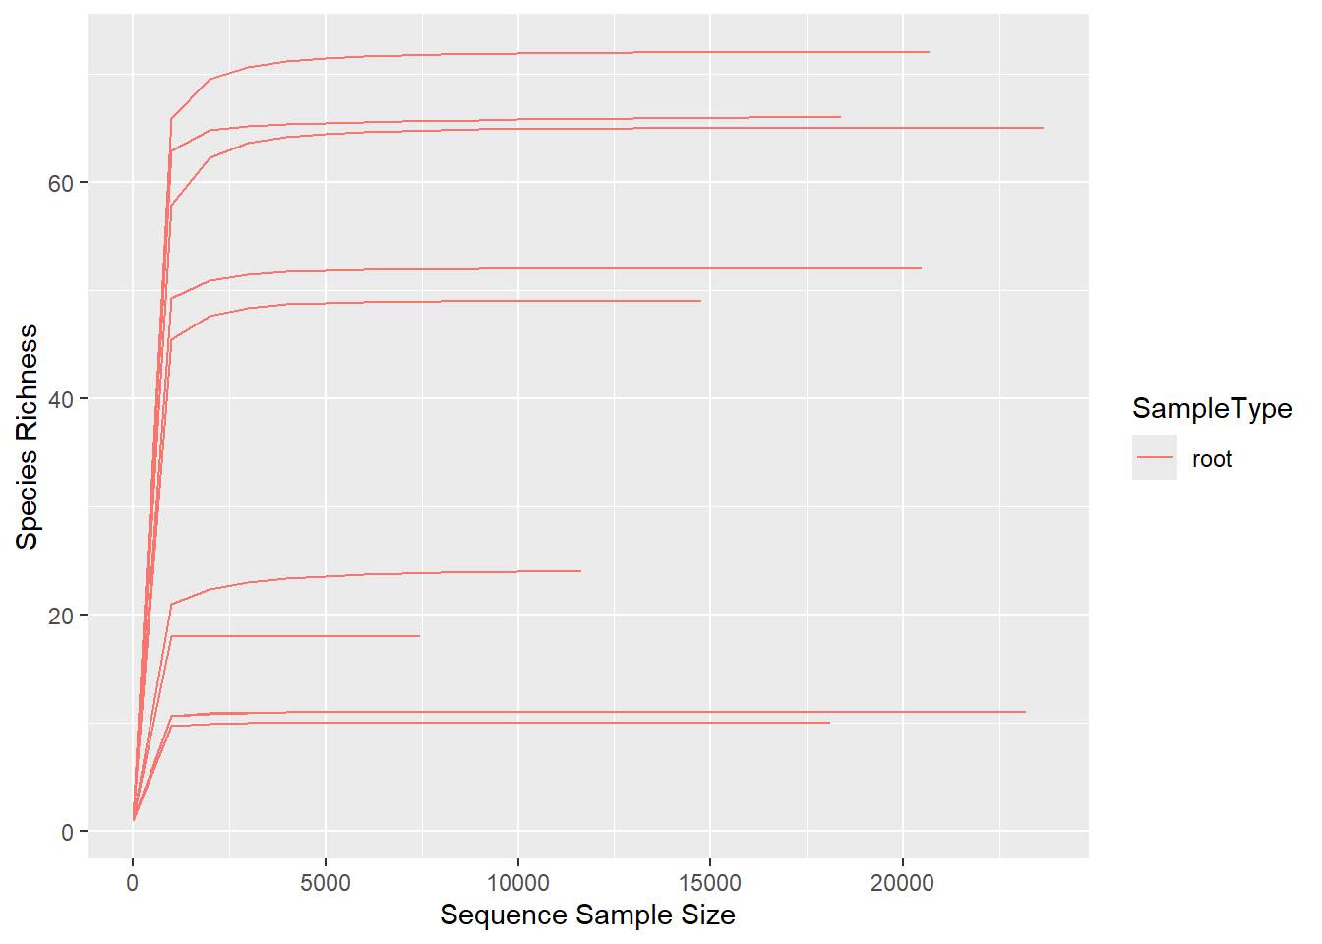
# Migliorare l’aspetto della grafica
rcurve18Sf <- rcurve18S +
theme(strip.background = element_rect(color="white", fill="#585858", size=1),
strip.text.x = element_text(size = 12, color = "white"),
axis.title.x = element_text(size = 12, face = "bold"),
axis.title.y = element_text(size = 12, face = "bold"),
plot.title = element_text(size = 16, face = "bold"),
axis.text.x = element_text(face = "bold"),
axis.text.y = element_text(face = "bold")) +
ylab("Species richness") +
xlab("Sample size") +
facet_grid(~SampleType, scales = "free")
rcurve18Sf
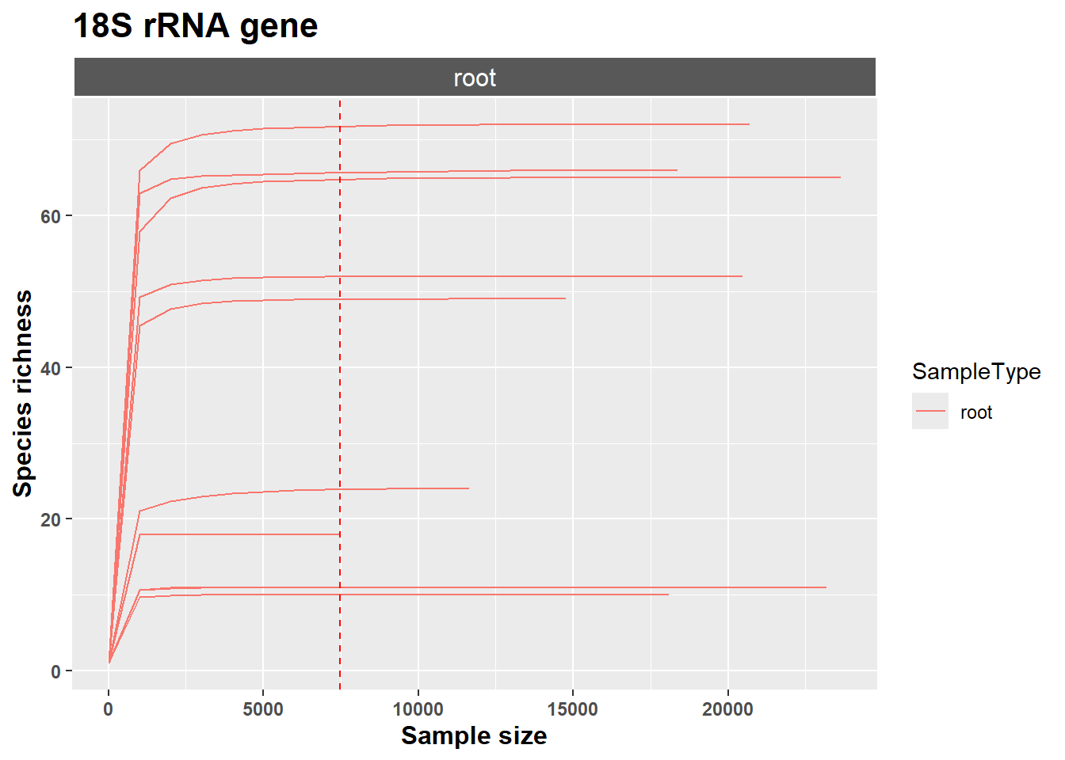
# ---------------------------------------------------
# 3. Rarefazione dei dati
# ---------------------------------------------------
r18S <- rarefy_even_depth(d18S,
sample.size = 7466, # profondità di rarefazione
rngseed = 900, # per riproducibilità
replace = FALSE) # senza sostituzione
###4.2- Fig. 4A- Community composition
# Load required libraries
library(phyloseq)
library(ggplot2)
library(dplyr)
library(grid)
# Agglomerate at Genus level e calcola abbondanza relativa
erie_genus <- r18S %>%
tax_glom(taxrank = "Genus") %>%
transform_sample_counts(function(x) x/sum(x)) %>%
psmelt() %>%
arrange(Genus)
# Trasforma le variabili in factor per plotting e facet
erie_genus$Sampling.Label <- factor(erie_genus$Sampling.Label)
erie_genus$SampleType <- factor(erie_genus$SampleType)
erie_genus$Elevazione..masl. <- factor(erie_genus$Elevazione..masl., levels = c("65 m",
"85 m", "92 m", "103 m"), ordered = TRUE)
# Palette colori coerente per pubblicazione (scegli colori distinti e
# leggibili)
genus_colors <- c("#CBD588", "#5F7FC7", "orange", "#DA5724", "#508578", "#CD9BCD",
"#AD6F3B", "#673770", "#D14285", "#652926", "#C84248", "#8569D5", "#5E738F",
"#8A7C64", "#7CFC00", "#599861", "#FF0000", "#00FF00", "#0000FF", "#FFFF00",
"#00FFFF", "#FFC0CB", "#008000", "#000080", "#808000", "#D1A33D", "#008080",
"#FFD700", "#800080", "#FF00FF", "#ADFF2F", "#32CD32", "#00FF7F", "#C0C0C0",
"#228B22", "#20B2AA", "#40E0D0", "#00BFFF", "#1E90FF", "#4IT9E1", "#0000CD",
"#8A2BE2", "#6A5ACD")
# Nota: puoi aggiungere altri colori se hai più generi
# Creazione del barplot della composizione della comunità a livello di Genus
ggplot(erie_genus, aes(x = Sampling.Label, y = Abundance, fill = Genus)) + geom_bar(stat = "identity",
width = 0.8) + facet_grid(SampleType ~ Elevazione..masl., scales = "free_x",
space = "free") + scale_fill_manual(values = genus_colors) + theme_minimal(base_size = 12) +
theme(axis.text.x = element_text(angle = 45, hjust = 1, size = 10, color = "black"),
axis.text.y = element_text(size = 10, color = "black"), axis.title = element_text(size = 12,
face = "bold"), plot.title = element_text(size = 14, face = "bold", hjust = 0.5),
strip.background = element_rect(fill = "lightgray", color = "black"), strip.text = element_text(size = 12,
face = "bold"), panel.spacing = unit(1, "lines"), legend.position = "bottom",
legend.title = element_text(size = 10, face = "bold"), legend.text = element_text(size = 9)) +
guides(fill = guide_legend(ncol = 6, keywidth = 0.6, keyheight = 0.6)) + ylab("Relative Abundance") +
xlab("Sample") + ggtitle("Lycius 18S Root-Associated Fungal Community (Genus level)")
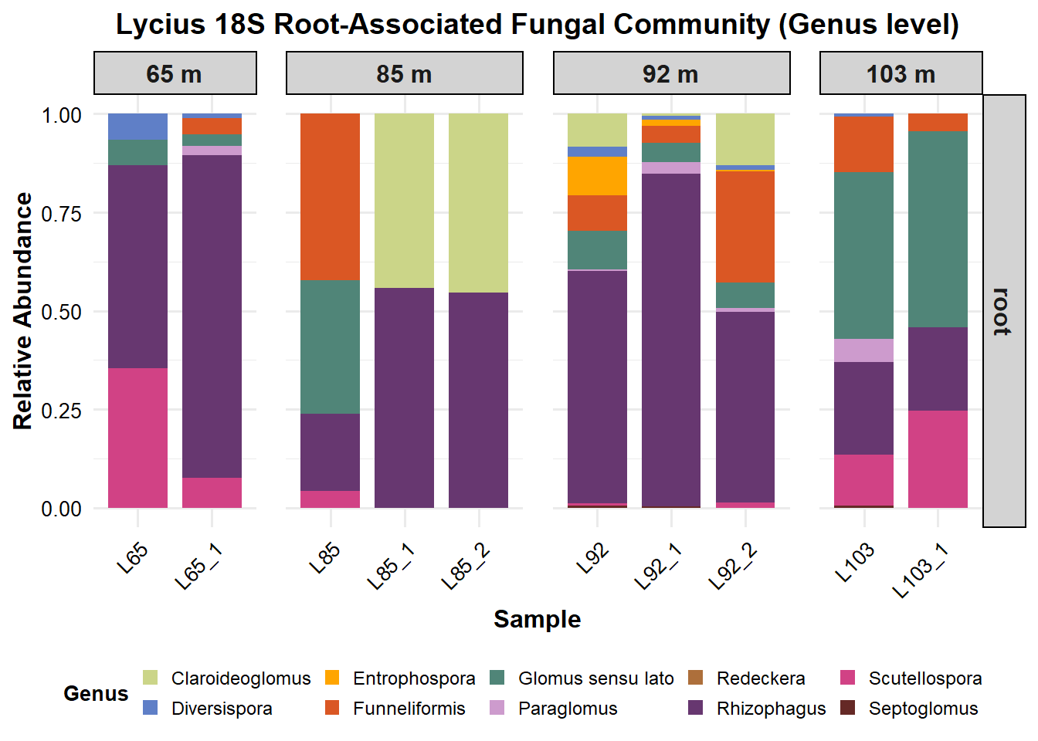
###4.3- Alpha diversity
library(picante)
library(tidyverse)
library(ggpubr)
library(rstatix)
library(ggthemes)
# Estimate alpha-diversity measures
alpha_table <- estimate_richness(r18S, measures = c("Observed", "InvSimpson", "Shannon"))
# Bind with sample data
samp_data <- sample_data(r18S)
alpha_df <- cbind(as.data.frame(samp_data), alpha_table)
####4.3.1 - Fig. 4C
# Convert to factors
alpha_df <- alpha_df %>%
mutate(Sampling.Label = factor(Sampling.Label), SampleType = factor(SampleType),
Elevazione..masl. = factor(Elevazione..masl., levels = c("65 m", "85 m",
"92 m", "103 m"), ordered = TRUE))
# Save CSV for downstream use
write.csv(alpha_df[, c("Sampling.Label", "Observed", "Shannon")], "Alpha_diversity_18S.csv",
row.names = FALSE)
# Color palette
paletteT <- c("#ece7f2", "#b3e0f7", "#3690c0", "#003d6b")
# ---- Observed richness ----
res_obs <- alpha_df %>%
dunn_test(Observed ~ Elevazione..masl., p.adjust.method = "fdr")
stat_obs <- res_obs %>%
add_xy_position(x = "Elevazione..masl.")
plot_obs <- ggplot(alpha_df, aes(Elevazione..masl., Observed)) + geom_jitter(aes(color = Elevazione..masl.),
shape = 17, size = 8, width = 0.2) + labs(x = "Elevation (m)", y = "Observed ASV Richness") +
theme_bw() + theme(panel.grid = element_blank()) + stat_pvalue_manual(stat_obs,
hide.ns = TRUE) + scale_color_manual(values = paletteT)
plot_obs
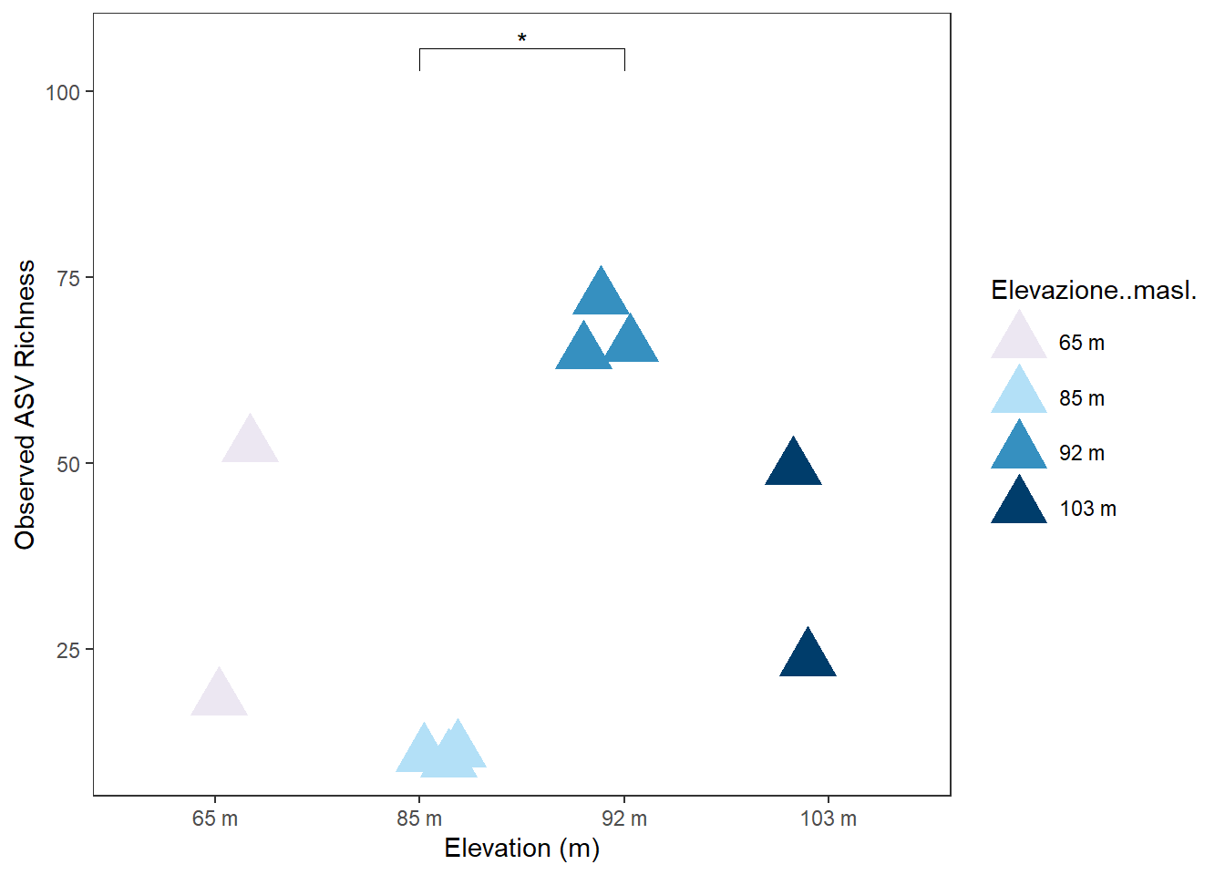
# ---- Shannon diversity ----
res_shan <- alpha_df %>%
dunn_test(Shannon ~ Elevazione..masl., p.adjust.method = "fdr")
stat_shan <- res_shan %>%
add_xy_position(x = "Elevazione..masl.")
plot_shan <- ggplot(alpha_df, aes(Elevazione..masl., Shannon)) + geom_jitter(aes(color = Elevazione..masl.),
shape = 17, size = 8, width = 0.2) + labs(x = "Elevation (m)", y = "Shannon Diversity") +
theme_bw() + theme(panel.grid = element_blank()) + stat_pvalue_manual(stat_shan,
hide.ns = TRUE) + scale_color_manual(values = paletteT)
plot_shan
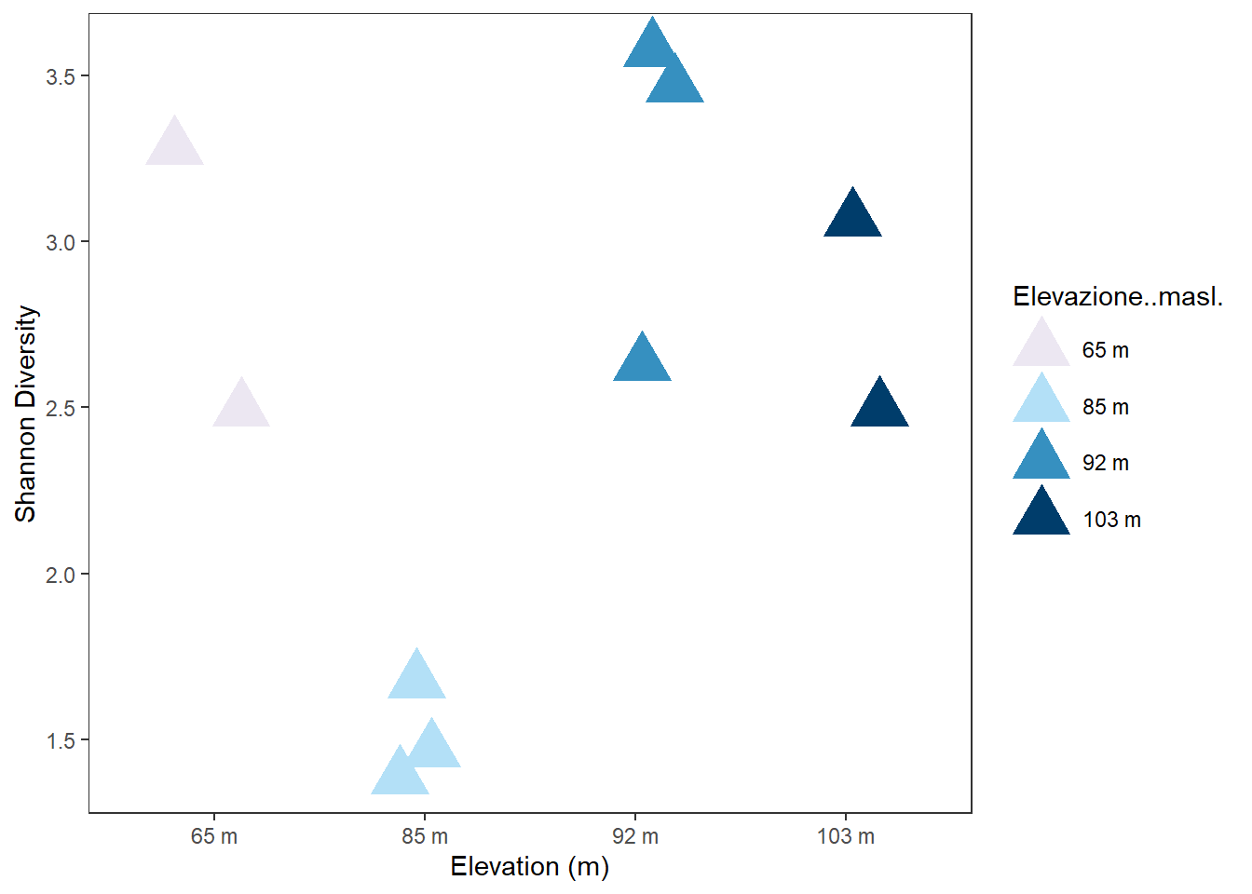
###4.4 - Beta diversity ####4.4.1 - Fig. 4A
# Ensure factors
sample_data(r18S)$Elevazione..masl. <- as.factor(sample_data(r18S)$Elevazione..masl.)
sample_data(r18S)$SampleType <- as.factor(sample_data(r18S)$SampleType)
# Calculate Bray-Curtis distance
bray.16S <- phyloseq::distance(r18S, method = "bray")
mdat.16Sb <- as(sample_data(r18S), "data.frame")
# PERMANOVA test
adonis.16Sbray <- adonis2(bray.16S ~ Elevazione..masl.,
data = mdat.16Sb, perm = 20000, by = "margin")
print(adonis.16Sbray)
## Permutation test for adonis under reduced model
## Marginal effects of terms
## Permutation: free
## Number of permutations: 20000
##
## adonis2(formula = bray.16S ~ Elevazione..masl., data = mdat.16Sb, permutations = 20000, by = "margin")
## Df SumOfSqs R2 F Pr(>F)
## Elevazione..masl. 3 2.0460 0.58939 2.8708 0.00395 **
## Residual 6 1.4253 0.41061
## Total 9 3.4713 1.00000
## ---
## Signif. codes: 0 '***' 0.001 '**' 0.01 '*' 0.05 '.' 0.1 ' ' 1
# Load ggrepel for improved labeling
library(ggrepel)
# PCoA
bray.pcoa.16S_s <- ordinate(r18S, "PCoA", "bray")
# Custom color palette for Elevazione
palette_custom <- c("#ece7f2","#b3e0f7", "#3690c0", "#003d6b")
# Ensure ordered factor for plotting
sample_data(r18S)$Elevazione..masl. <- factor(sample_data(r18S)$Elevazione..masl.,
levels = c("65 m", "85 m", "92 m", "103 m"),
ordered = TRUE)
# Create PCoA plot
i.bray.pcoa.16S <- plot_ordination(r18S,
bray.pcoa.16S_s,
type = "samples",
axes = c(5, 6),
color = "Elevazione..masl.") +
geom_point(aes(fill = Elevazione..masl.),
shape = 24, # triangle
size = 6,
stroke = 0.8,
color = "black") +
scale_color_manual(values = palette_custom) +
scale_fill_manual(values = palette_custom) +
ggtitle("18S rRNA - Bray-Curtis PCoA") +
theme_bw(base_size = 14) + # slightly larger base font for publication
theme(
panel.grid.major = element_blank(),
panel.grid.minor = element_blank(),
panel.background = element_blank(),
axis.title = element_text(face = "bold"),
axis.text = element_text(color = "black"),
plot.title = element_text(face = "bold", hjust = 0.5, size = 16),
legend.title = element_text(face = "bold", size = 12),
legend.text = element_text(size = 10),
legend.position = "right"
) +
guides(fill = guide_legend(title = "Elevation", override.aes = list(size = 5)))
# Display plot
i.bray.pcoa.16S
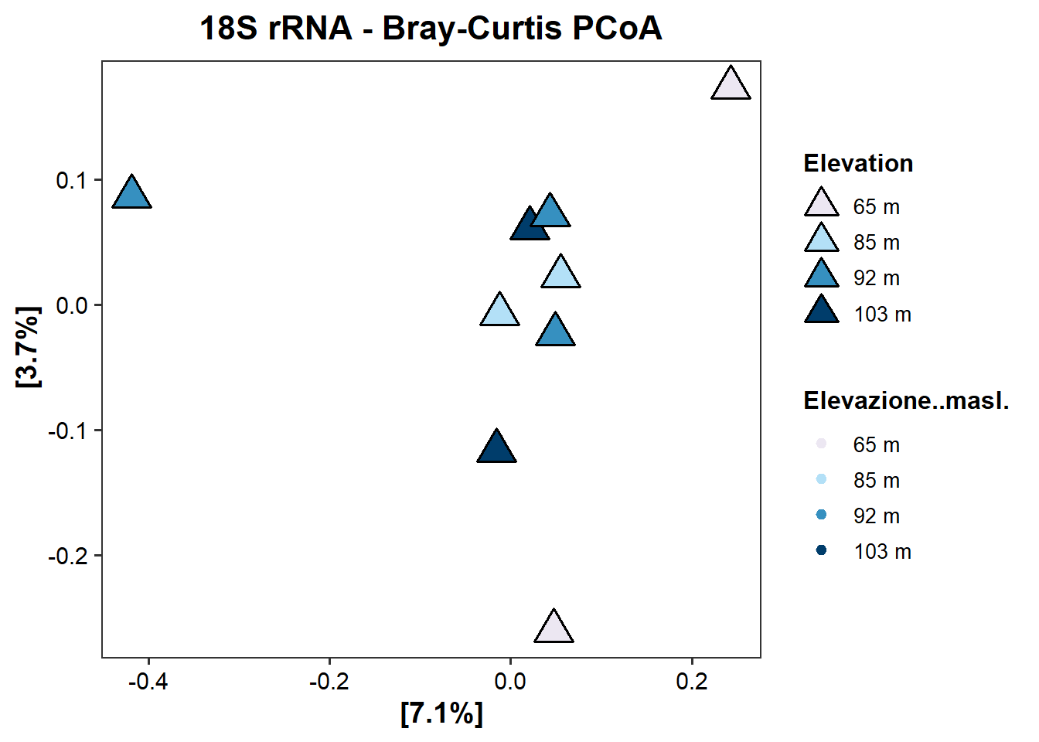
###4.5 - Fig. 5 - compare 18S dataset with ITS dataset
library(dplyr)
library(ggVennDiagram)
library(ggplot2)
#import datasets
## Taxonomy Table
taxa_18S <- read.table(file="C:/Users/Alber/Desktop/DOTTORATO/PROGETTO ERICA/18S/phyloseq object/taxonomy.txt", sep="\t", dec = ".", header=TRUE)#replace with your path
tax_ITS <- read.table(file="C:/Users/Alber/Desktop/DOTTORATO/PROGETTO ERICA/ITS/phyloseq object 2/taxonomy.txt", sep="\t", dec = ".", header=TRUE)#replace with your path
# Rimuove qualsiasi prefisso tipo x__ (una lettera + __)
tax_ITS[] <- lapply(tax_ITS, function(x) gsub("^[a-z]__", "", x))
tax_ITS <- tax_clean(tax_ITS)
## Error in tax_clean(tax_ITS): non trovo la funzione "tax_clean"
# Livelli tassonomici da confrontare
tax_levels <- c("Phylum", "Class", "Order", "Family", "Genus", "Species")
# Palette personalizzata per Venn (colori gradiente)
venn_colors <- c("#edf8fb", "#b3cde3", "#8c96c6", "#8856a7", "#810f7c")
# Loop per generare Venn diagram per ogni livello
for(lvl in tax_levels){
# Filtraggio taxa per ITS solo Glomeromycota se livello > Phylum
if(lvl %in% c("Class","Order","Family","Genus","Species")){
tax_ITS_f <- tax_ITS %>% filter(Phylum=="Glomeromycota")
} else {
tax_ITS_f <- tax_ITS
}
taxa_18S_lvl <- unique(na.omit(taxa_18S[[lvl]]))
taxa_ITS_lvl <- unique(na.omit(tax_ITS_f[[lvl]]))
venn_list <- list("18S" = taxa_18S_lvl, "ITS" = taxa_ITS_lvl)
p <- ggVennDiagram(venn_list, label_alpha = 0) +
scale_fill_gradientn(
colours = venn_colors,
limits = c(0, 19), # due insiemi -> valori da 0 a 2
name = "Shared taxa"
) +
theme_bw() +
ggtitle(paste("sharded taxa between 18S and ITS -", lvl))
print(p)
# Stampa taxa condivisi e unici
shared <- intersect(taxa_18S_lvl, taxa_ITS_lvl)
only_18S <- setdiff(taxa_18S_lvl, taxa_ITS_lvl)
only_ITS <- setdiff(taxa_ITS_lvl, taxa_18S_lvl)
cat("\n---", lvl, "---\n")
cat("Shared:", shared, "\n")
cat("Only 18S:", only_18S, "\n")
cat("Only ITS:", only_ITS, "\n")
}
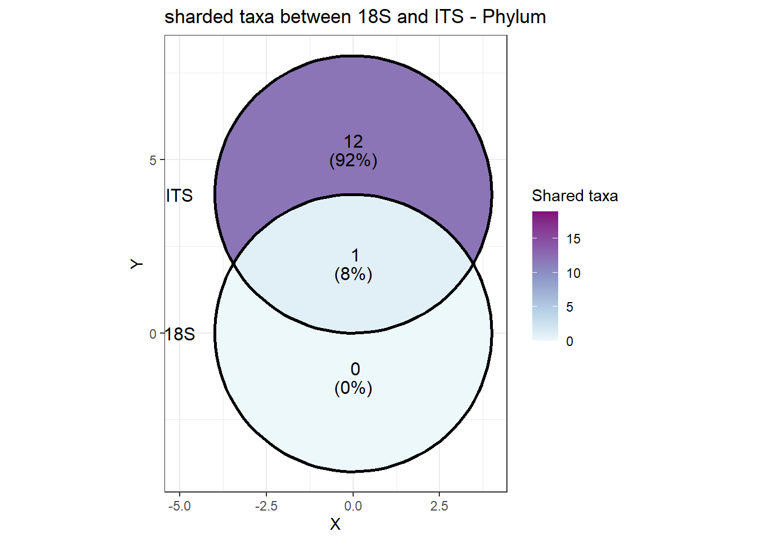
##
## --- Phylum ---
## Shared: Glomeromycota
## Only 18S:
## Only ITS: Basidiomycota Ascomycota Mortierellomycota Chytridiomycota Mucoromycota Entorrhizomycota Rozellomycota Fungi_phy_Incertae_sedis Olpidiomycota Basidiobolomycota Kickxellomycota Calcarisporiellomycota
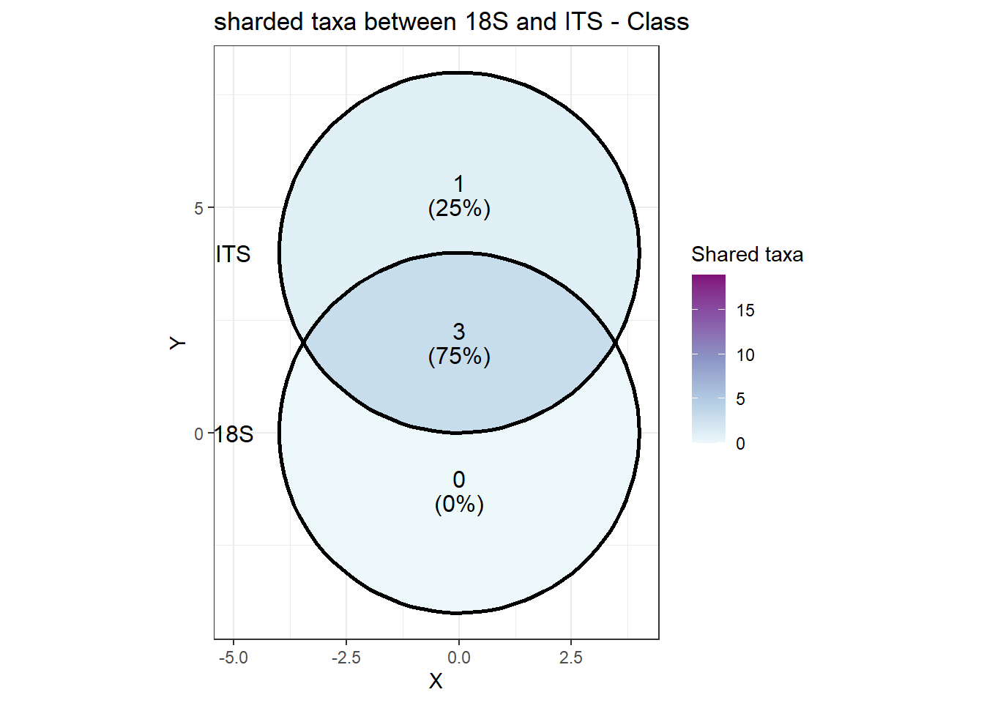
##
## --- Class ---
## Shared: Glomeromycetes Paraglomeromycetes Archaeosporomycetes
## Only 18S:
## Only ITS: Glomeromycota_cls_Incertae_sedis
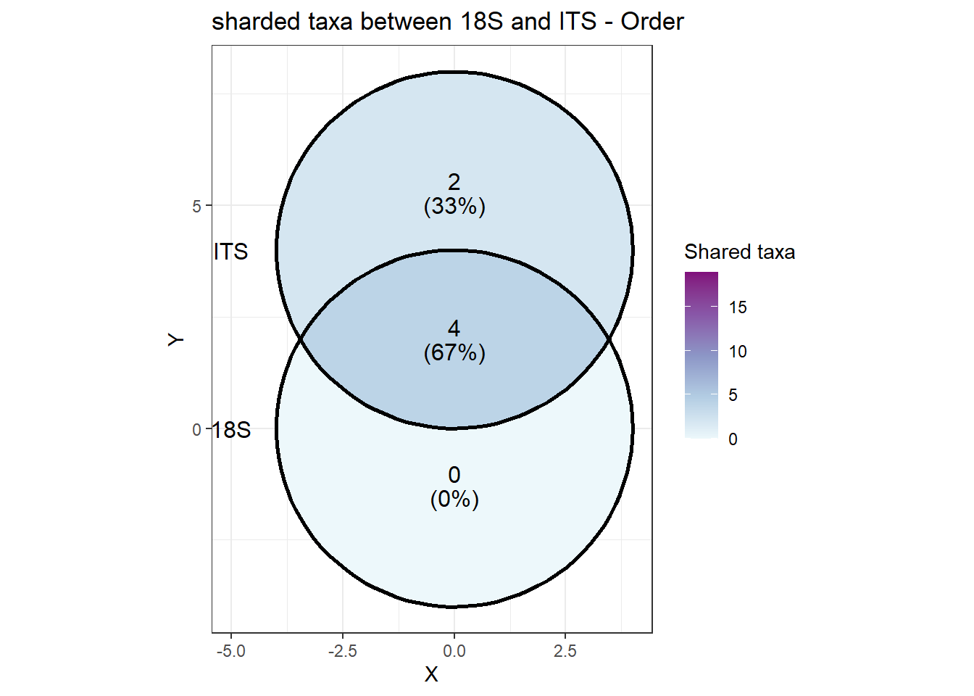
##
## --- Order ---
## Shared: Glomerales Diversisporales Paraglomerales Archaeosporales
## Only 18S:
## Only ITS: Entrophosporales Glomeromycota_ord_Incertae_sedis
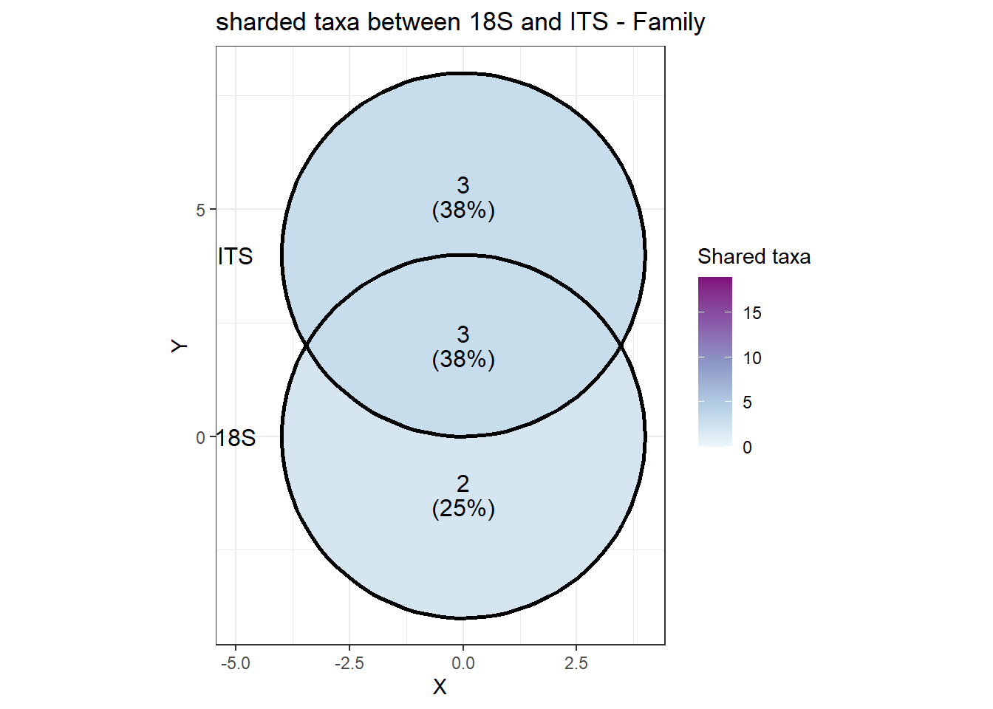
##
## --- Family ---
## Shared: Glomeraceae Paraglomeraceae Diversisporaceae
## Only 18S: Gigasporaceae Claroideoglomeraceae
## Only ITS: Entrophosporaceae Glomeromycota_fam_Incertae_sedis Ambisporaceae
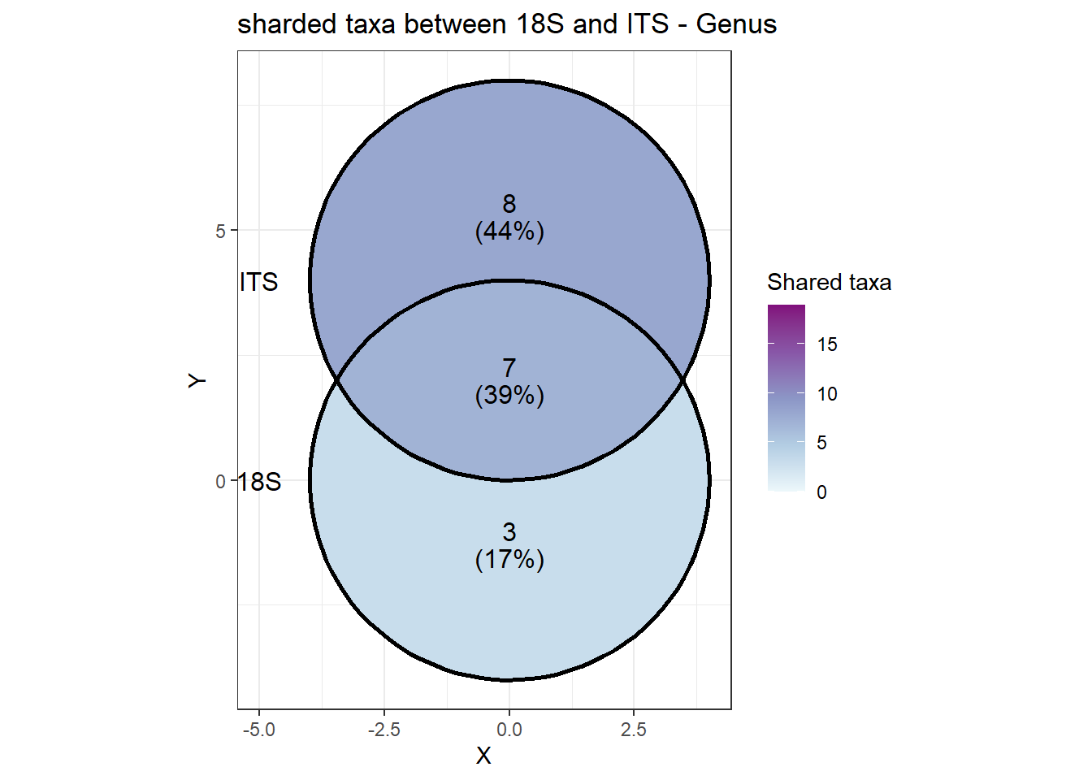
##
## --- Genus ---
## Shared: Rhizophagus Funneliformis Claroideoglomus Paraglomus Entrophospora Diversispora Septoglomus
## Only 18S: Glomus sensu lato Scutellospora Redeckera
## Only ITS: Glomeraceae_gen_Incertae_sedis Kamienskia Glomus Dominikia Rhizoglomus Glomeromycota_gen_Incertae_sedis Corymbiglomus Ambisporaceae_gen_Incertae_sedis
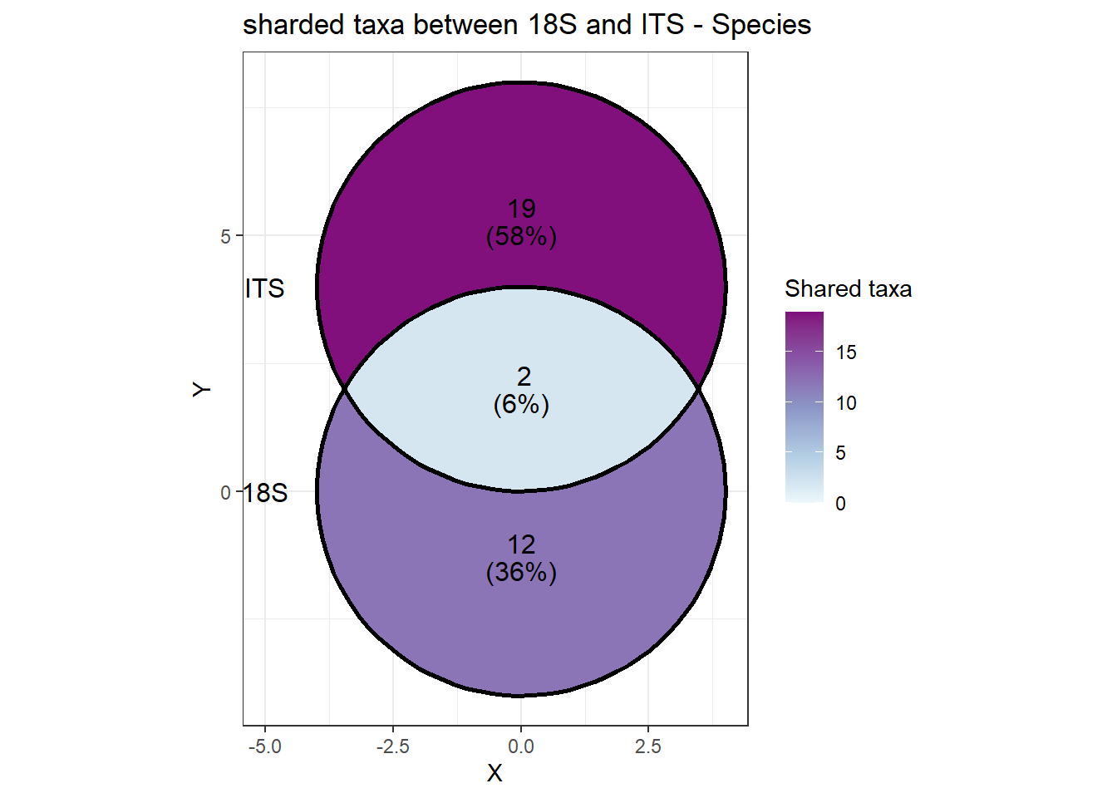
##
## --- Species ---
## Shared: mosseae viscosum
## Only 18S: sp. intraradices caledonius projecturata manihotis lamellosa microaggregatum epigaea clarus spurca prolifer fulva
## Only ITS: irregularis achra aurea silesianum infrequens drummondii bistrata turnauae etunicatum caledonium constrictum macrocarpum lithuanica coronatum corymbiforme gansuensis iranica disticha majewskii

