Frequency
Log2 intensity

TgErbB2 R403Q-αMyHC
Ntg

A
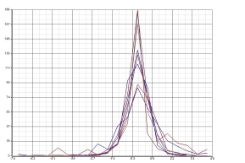
Histogram of the data distribution of each observation in the label-free MS/MS proteomics after median sweep
B
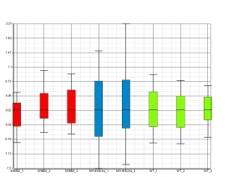
Boxplot of the log2 distribution of each observation in the label-free MS/MS proteomics after median sweep

Log2 intensity

Supplementary Figure 1. Distribution of the label-free data set after median sweep normalization. A) Histogram showing the data distribution of the phosphoproteome log2 intensities of each observation in the label-free MS/MS proteomics. Each line represents one observation and the values represented are the log2 intensity after median subtraction (y-axis) vs frequency. B) Boxplot showing the data distribution per observation, the y-axis represents the phosphoproteome log2 intensity from each observation. The colors indicate the group to which each observation belong, TgErbB2 (red), R403Q-αMyHC (blue), and Ntg (green). Notice in both plots that the median of the data is equal to 0. This method retains the spreading of the original data.

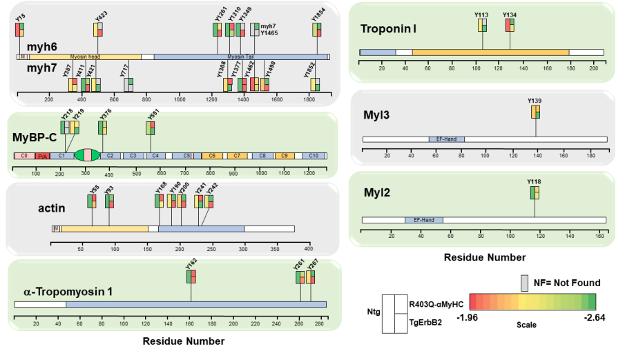

Supplementary Figure 2. Graphic Summary of Label-Free pTyr Site Profiling on Major Myofilaments Proteins. The figure displays the 34 pTyr sites detected on the major myofilaments myh6, myh7, MyBP-C, actin, tropomyosin, troponin I, MLC1 and MLC2, and its localization in relation to their functional domains or protein regions. A color-coded scale of Log2 of Ion Intensity of pTyr Peptides is on the lower right panel of the figure, and each square or rectangle corresponds to a genotype (i.e. Long rectangle Ntg, followed by stacked squares, gray color means that a particular site was not found on that genotype group).

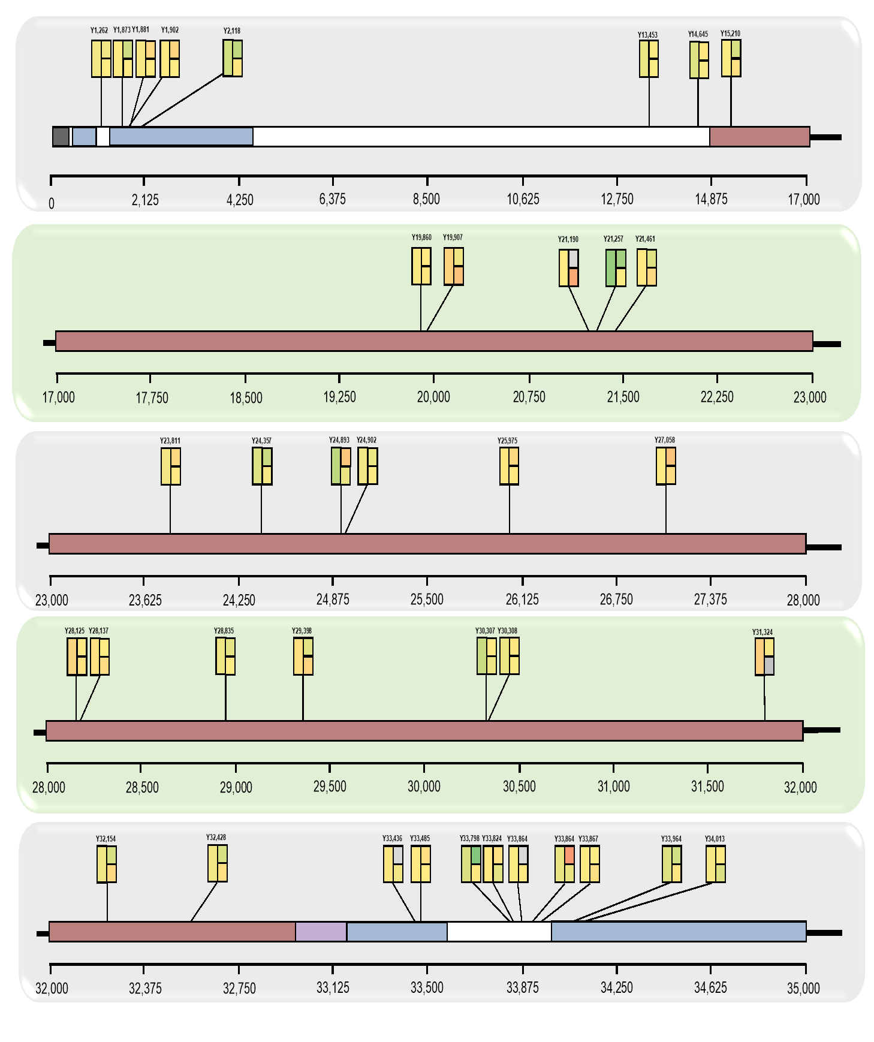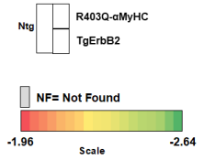

Supplementary Figure 3. Graphic Summary of Label-Free pTyr Site Profiling in titin. The figure displays the 36 pTyr sites detected in titin after pTyr immunoaffinity enrichment followed by MS/MS. A pTyr hotspot was found between the amino-acid 33,789 and 33,864. A color-coded scale of Log2 of Ion Intensity of pTyr Peptides is on the lower right panel of the figure, and each square or rectangle corresponds to a genotype (i.e. Long rectangle Ntg, followed by stacked squares, gray color means that a particular site was not found on that genotype group). To get an estimate of the relative abundance of pTyr sites, we applied MS1 extracted ion chromatograms using MaxQuant, especially on myofilaments in preparation for TMT labeling experiments on myofilaments enriched fraction of Ntg and TgErbB2 mice.

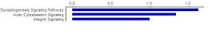

A
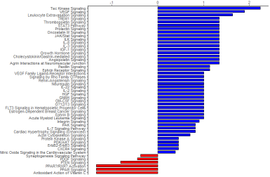Predicted R403Q-αMyHC dysregulated signaling pathways (label free proteomics)
Z-score
B
Predicted TgErbB2 dysregulated signaling pathways (label free proteomics)
Z-score

C
Predicted TgErbB2 dysregulated signaling pathways (TMT-labeled proteomics)
Z-score

Supplementary Figure 4. Canonical pathways upregulated and downregulated according to Ingenuity Pathway Analysis of the pTyr perturbation. The graphs show the statistically significant (p<0.05) upregulated (Z-score > 0) and downregulated (Z-score > 0) pathways detected by the software. A) Canonical pathways predicted upregulation and downregulation by the pathway analysis in R403Q-αMyHC mice pTyr enriched samples from the label free MS/MS proteomics. B) Canonical pathways predicted upregulation and downregulation by the pathway analysis in TgErbB2 mice pTyr enriched samples from the label free MS/MS proteomics. C) Canonical pathways predicted upregulation and downregulation by the pathway analysis in TgErbB2 mice pTyr enriched samples from the TMT-labeled MS/MS proteomics. The graphs omit the statistically significant pathways with Z-scores equal to 0 or Z-scores that were not able to evaluate by the software (see Supplementary tables 8-10 for complete information).

6

Log2 intensity
Log2 intensity
Frequency
Frequency

A
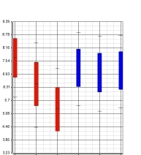
Boxplot of the full proteome log2 intensities distribution in the TMT-labeled MS/MS proteomics before median sweep
Ntg

B TgErbB2
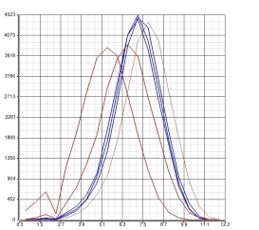
Histogram of the full proteome log2 intensities distribution in the TMT-labeled MS/MS proteomics before median sweep

C
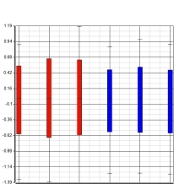
Boxplot of the full proteome log2 intensities distribution in the TMT-labeled MS/MS proteomics after median sweep
Log2 intensity
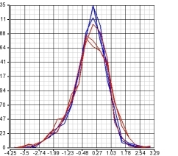
D Histogram of the full proteome log2 intensities distribution in the TMT-labeled MS/MS proteomics after median sweep

Log2 intensity

Supplementary Figure 5. Distribution of the protein expression intensities if the TMT-labeled MS/MS proteomics before and after median sweep normalization. A) Boxplot showing the data distribution of the full proteome intensities from the TMT-labeled MS/MS proteomics before the median sweep. The y-axis represents the log2 intensity and each box represent one observation. B) Histogram showing the data distribution of the full proteome log2 intensity of each observation obtained from the TMT-labeled MS/MS proteomics before the median sweep. Each line represents one observation and the values represented are the log2 intensity after median subtraction (y-axis) vs frequency. C) Boxplot showing the data distribution of the full proteome intensities from the TMT-labeled MS/MS proteomics after the median sweep. The y-axis represents the log2 intensity and each box represent one observation. D) Histogram showing the data distribution of the full proteome log2 intensity of each observation obtained from the TMT-labeled MS/MS proteomics after the median sweep. Each line represents one observation and the values represented are the log2 intensity after median subtraction (y -axis) vs frequency. The colors indicate the group to which each observation belong, Ntg (red), TgErbB2 (blue).

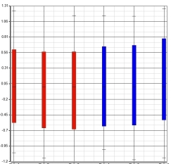
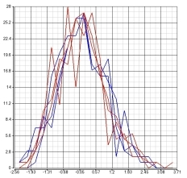
Log2 intensity
Log2 intensity
Frequency
Frequency

A
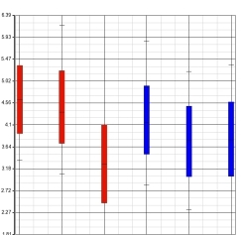
Boxplot of the phosphoproteome log2 intensities distribution in the TMT-labeled MS/MS proteomics before median sweep

C
Boxplot of the phosphoproteome log2 intensities distribution in the TMT-labeled MS/MS proteomics after median sweep
Ntg

TgErbB2

B
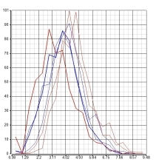
Histogram of phosphoproteome log2 intensities distribution in the TMT-labeled MS/MS proteomics before median sweep

Log2 intensity
D
Histogram of the phosphoproteome log2 intensities distribution
in the TMT-labeled MS/MS proteomics after median sweep

Log2 intensity

Supplementary Figure 6. Distribution of the TMT phosphoproteome intensities data set before and after median sweep normalization. A) Boxplot showing the data distribution of the phosphoproteome intensities from the TMT-labeled MS/MS proteomics before the median sweep. The y-axis represents the log2 intensity and each box represent one observation. B) Histogram showing the data distribution of the phosphoproteome log2 intensity of each observation obtained from the TMT-labeled MS/MS proteomics before the median sweep. Each line represents one observation and the values represented are the log2 intensity after median subtraction (y-axis) vs frequency. C) Boxplot showing the data distribution of the phosphoproteome intensities from the TMT-labeled MS/MS proteomics after the median sweep. The y-axis represents the log2 intensity and each box represent one observation. D) Histogram showing the data distribution of the phosphoproteome log2 intensity of each observation obtained from the TMT-labeled MS/MS proteomics after the median sweep. Each line represents one observation and the values represented are the log2 intensity after median subtraction (y-axis) vs frequency. The colors indicate the group to which each observation belong, Ntg (red), TgErbB2 (blue).

