Supplementary Materials
Warfare dilemma
To test the features of the MTS, the following warfare dilemma was proposed:
“Two countries, A and B, have been at war for years (you are not a citizen of either country). The war was initiated by the rulers of B, against the will of the civilian population. Recently, the military equilibrium has broken, and it is certain that A will win. The question is how, when, and at what cost.

Country A has two strategies available: attacking the opposing army with conventional weapons and bombing the civilian population. They could use one, the other, or a combination of both. Bombing would demoralize country B: The more civilians are killed, the sooner B will surrender, and the fewer soldiers will die—about half from both sides, all willing to fight. Conventional fighting will minimize civilian casualties but maximize lives lost (all soldiers).

How should country A end the war? What do you feel is morally right?”

Table S1. Scenarios of the war dilemma. All quantities are in millions of lives.
Scenario # | Soldiers at risk (S) | Soldiers saved for each civil. sacrificed (S / C) | Feasible set | Pareto inferior solutions
1 | 6.00 | 1.20 | (5,0) (4,1) (3,2) (2,3) (1,4) (0,6) | (0,0) (1,0) (2,0) (3,0) (4,0) (0,1) (1,1) (2,1) (3,1) (0,2) (1,2) (2,2) (0,3) (1,3) (0,4) (0,5)
2 | 7.00 | 1.40 | (5,0) (4,1) (3,2) (2,4) (1,5) (0,7) | (0,0) (1,0) (2,0) (3,0) (4,0) (0,1) (1,1) (2,1) (3,1) (0,2) (1,2) (2,2) (0,3) (1,3) (2,3) (0,4) (1,4) (0,5) (0,6)
3 | 7.00 | 7.00 | (1,0) (0,7) | (0,0) (0,1) (0,2) (0,3) (0,4) (0,5) (0,6)
4 | 3.00 | 1.50 | (2,0) (1,1) (0,3) | (0,0) (1,0) (0,1) (0,2)
5 | 5.00 | 2.50 | (2,0) (1,2) (0,5) | (0,0) (1,0) (0,1) (1,1) (0,2) (0,3) (0,4)
6 | 6.00 | 2.00 | (3,0) (2,2) (1,4) (0,6) | (0,0) (1,0) (2,0) (0,1) (1,1) (2,1) (0,2) (1,2) (0,3) (1,3) (0,4) (0,5)
7 | 7.00 | 1.17 | (6,0) (5,1) (4,2) (3,3) (2,4) (1,5) (0,7) | (0,0) (1,0) (2,0) (3,0) (4,0) (5,0) (0,1) (1,1) (2,1) (3,1) (4,1) (0,2) (1,2) (2,2) (3,2) (0,3) (1,3) (2,3) (0,4) (1,4) (0,5) (0,6)
8 | 5.00 | 1.67 | (3,0) (2,1) (1,3) (0,5) | (0,0) (1,0) (2,0) (0,1) (1,1) (0,2) (1,2) (0,3) (0,4)
9 | 2.00 | 2.00 | (1,0) (0,2) | (0,0) (0,1)
10 | 6.00 | 6.00 | (1,0) (0,6) | (0,0) (0,1) (0,2) (0,3) (0,4) (0,5)
11 | 7.00 | 2.33 | (3,0) (2,2) (1,4) (0,7) | (0,0) (1,0) (2,0) (0,1) (1,1) (2,1) (0,2) (1,2) (0,3) (1,3) (0,4) (0,5) (0,6)
12 | 7.00 | 3.50 | (2,0) (1,3) (0,7) | (0,0) (1,0) (0,1) (1,1) (0,2) (1,2) (0,3) (0,4) (0,5) (0,6)
13 | 5.00 | 2.00 | (2,0) (1,2) (0,4) | (0,0) (1,0) (0,1) (1,1) (0,2) (0,3)
14 | 5.00 | 1.25 | (4,0) (3,1) (2,2) (1,3) (0,5) | (0,0) (1,0) (2,0) (3,0) (0,1) (1,1) (2,1) (0,2) (1,2) (0,3) (0,4)
15 | 4.00 | 4.00 | (1,0) (0,4) | (0,0) (0,1) (0,2) (0,3)
16 | 5.00 | 5.00 | (1,0) (0,5) | (0,0) (0,1) (0,2) (0,3) (0,4)
17 | 3.00 | 3.00 | (1,0) (0,3) | (0,0) (0,1) (0,2)
18 | 6.00 | 1.50 | (4,0) (3,1) (2,3) (1,4) (0,6) | (0,0) (1,0) (2,0) (3,0) (0,1) (1,1) (2,1) (0,2) (1,2) (2,2) (0,3) (1,3) (0,4) (0,5)
19 | 6.00 | 3.00 | (2,0) (1,3) (0,6) | (0,0) (1,0) (0,1) (1,1) (0,2) (1,2) (0,3) (0,4) (0,5)
20 | 7.00 | 1.75 | (4,0) (3,1) (2,3) (1,5) (0,7) | (0,0) (1,0) (2,0) (3,0) (0,1) (1,1) (2,1) (0,2) (1,2) (2,2) (0,3) (1,3) (0,4) (1,4) (0,5) (0,6)
21 | 4.00 | 1.33 | (3,0) (2,1) (1,2) (0,4) | (0,0) (1,0) (2,0) (0,1) (1,1) (0,2) (0,3)
The feasible set is the set of all possible answer options with the first value being the number of sacrificed soldiers and the second value the number of sacrificed civilians. Pareto inferior solutions are outcomes in which a feasible alternative exists that improves at least one dimension without causing a loss in another.

Moral phenotypes
Participants were classified as deontological when the deontological option was selected in every scenario, and as utilitarian when they selected the utilitarian option in every scenario. If participants alternated (i.e., “flip-flopped”) between deontological and utilitarian answers without selecting compromise options, they were classified as “flip-floppers”. Lastly, participants were classified as compromisers when they selected at least one compromise option

Moral spectrum score
Moral spectrum-scores were calculated by quantifying choice in between 0% and 100%, depending on its position on the response of the moral spectrum. The lowest-end response (i.e., the utilitarian option) was assigned 0%, while the highest-end response (i.e., the deontological option) was assigned 100%, with intermediate responses receiving proportionally scaled values based on the number of answer options in each scenario (see Table S1).

Table S2. The calculation model for moral spectrum scores.
Scenario Number | Number of options | Compromise value | Choice_1 | Choice_2 | Choice_3 | Choice_4 | Choice_5 | Choice_6 | Choice_7
1 | 6 | 20% | 100% | 80% | 60% | 40% | 20% | 0% | -
2 | 6 | 20% | 100% | 80% | 60% | 40% | 20% | 0% | -
3 | 2 | - | 100% | 0% | - | - | - | - | -
4 | 3 | 50% | 100% | 50% | 0% | - | - | -
5 | 3 | 50% | 100% | 50% | 0% | - | - | - | -
6 | 4 | 33.33% | 100% | 66.67% | 33.33% | 0% | - | - | -
7 | 7 | 16.67% | 100% | 83.35% | 66.68% | 50.01% | 33.34% | 16.67% | 0%
8 | 4 | 33.33% | 100% | 66.67% | 33.33% | 0% | - | - | -
9 | 2 | - | 100% | 0% | - |  | - | - | -
10 | 2 | - | 100% | 0% | - |  | - | - | -
11 | 4 | 33.33% | 100% | 66.67% | 33.33% | 0% | - | - | -
12 | 3 | 50% | 100% | 50% | 0% |  | - | - | -
13 | 3 | 50% | 100% | 50% | 0% |  | - | - | -
14 | 5 | 25% | 100% | 75% | 50% | 25% | 0% | - | -
15 | 2 | - | 100% | 0% | - | - | - | - | -
16 | 2 | - | 100% | 0% | - | - | - | - | -
17 | 2 | - | 100% | 0% | - | - | - | - | -
18 | 5 | 25% | 100% | 75% | 50% | 25% | 0% | - | -
19 | 3 | 50% | 100% | 50% | 0% | - | - | - | -
20 | 5 | 25% | 100% | 75% | 50% | 25% | 0% | - | -
21 | 4 | 33.33% | 100% | 66.67% | 33.33% | 0% | - | - | -

Preference consistency score
Preference consistency was calculated using GARP, as similarly implemented by Guzman et al (2022). Preference consistency follows rational choice theory, which assumes that if a subject prefers option x over option y in one scenario, this preference remains consistent across similar scenarios. A violation in consistency occurs when a subject faces a scenario and chooses an option that does not align with previously made choices, i.e. is below the feasibility constraints. Consistency score was calculated as 1 – GARP violation ratio.

Moral rightness function
Since each scenario had its own assigned moral weight, the choices within scenarios and its corresponding S / C values could be structured from most equal weight (S / C ≈ 1.167) to least equal weight (S / C = 7). Comparisons in rightness function were made between military and civilian subjects in all 21 scenarios. A logistic function was chosen to account for the expected plateauing effect at higher scenario values, where α represents the upper asymptote (maximum percentage of soldiers saved), β is the growth rate, and σ is the inflection point (the scenario value at which the response reaches 50% of its maximum). The model used was:
$$Soldiers To Be Saved= \frac{α}{1+e^{-β(\frac{S}{C}-σ)}}$$

Several socio-demographic characteristics were taken of our military sample (see Table S3). Groups differed in weight.
Table S3. Demographic characteristics of the study population.
Socio-demographic characteristics | plac/plac | YOH/plac | CORT/plac | YOH/CORT
Socio-demographic characteristics | n = 24 | n = 25 | n = 26 | n = 25 | p values
Age - Mean (SD) | 35.42 (8.63) | 39.16 (11.49) | 39.77 (11.86) | 35.28 (9.06) | 0.417
Height (in cm) - Mean (SD) | 179.83 (8.66) | 181.34 (6.50) | 180.98 (8.26) | 180.18 (8.14) | 0.689
Weight (in kg) - Mean (SD) | 88.36 (14.85) | 86.20 (10.01) | 92.58 (13.09) | 81.01 (13.46) | 0.007**
BMI - Mean (SD) | 27.32 (4.19) | 26.21 (2.70) | 28.29 (3.93) | 24.84 (2.93) | 0.064
Abdomen circumference (in cm) - Mean (SD) | 86.75 (13.17) | 83.92 (9.49) | 86.62 (12.96) | 80.16 (7.63) | 0.189
Sex - Frequency (%) |  |  |  |  | 0.156
Male | 24 (100) | 24 (96) | 23 (88.5) | 21 (84)
Female | 0 (0) | 1 (4) | 3 (11.5) | 4 (16)
Education - Frequency (%) |  |  |  |  | 0.607
ISCED 2 | 0 (0) | 0 (0) | 0 (0) | 3 (12)
ISCED 3 | 10 (41.7) | 7 (28) | 7 (26.9) | 6 (24)
ISCED 4 | 7 (29.2) | 10 (40) | 6 (23.1) | 1 (4)
ISCED 5 | 0 (0) | 0 (0) | 1 (3.8) | 1 (4)
ISCED 6 | 4 (16.7) | 5 (20) | 7 (26.9) | 10 (40)
ISCED 7 | 2 (8.3) | 3 (12) | 5 (19.2) | 4 (16)
ISCED 8 | 1 (4.2) | 0 (0) | 0 (0) | 0 (0)
Operating branch military - Frequency (%) |  |  |  |  | 0.435
Army | 11 (45.8) | 20 (80) | 14 (53.8) | 13 (52)
Navy | 6 (25) | 1 (4) | 6 (23.1) | 5 (20)
Air Force | 4 (16.7) | 3 (12) | 4 (15.4) | 5 (20)
Military Police | 3 (12.5) | 1 (4) | 2 (7.7) | 2 (8)
Current rank - Frequency (%) |  |  |  |  | 0.478
Enlisted | 3 (12.5) | 4 (16) | 1 (3.8) | 3 (12)
Non-commissioned officer | 14 (58.3) | 10 (40) | 13 (50) | 9 (36)
Commissioned officer | 7 (29.2) | 11 (44) | 12 (46.2) | 13 (52)
# of deployments - Mean (SD) | 4.25 (8.16) | 5.16 (5.82) | 4.12 (3.64) | 2.96 (2.85) | 0.355
Years since last deployment - Mean (SD) | 6.24 (5.73) | 4.35 (4.26) | 6.07 (3.19) | 4.24 (4.05) | 0.204
*: p-value <.05
**: p-value <.01
***: p-value <.001

Several questionnaires were taken before stress exposure to get some trait characteristics of our military sample. Groups differed in PID-5 psychoticism and BAS fun-seeking, however these differences did not affect statistical analyses (see Table S4). All questionnaire scores were in conventional ranges. Scores were found to not affect statistical models during model building, as likelihood tests did not support improvement for any outcome.
Table S4. Data on the questionnaires (PID-5, BIS/BAS, PSS-14).
Questionnaires | plac/plac | YOH/plac | CORT/plac | YOH/CORT
Questionnaires | n = 24 | n = 25 | n = 26 | n = 25 | p values
PID-5 – Mean (SD) | 0.70 (0.27) | 0.75 (0.32) | 0.52 (0.21) | 0.64 (0.30) | 0.021*
Negative affect | 0.77 (0.42) | 0.82 (0.40) | 0.64 (0.38) | 0.89 (0.37) | 0.148
Detachment | 0.73 (0.50) | 0.62 (0.60) | 0.66 (0.43) | 0.52 (0.57) | 0.583
Antagonism | 0.64 (0.53) | 0.75 (0.56) | 0.49 (0.38) | 0.69 (0.55) | 0.311
Disinhibition | 0.61 (0.56) | 0.86 (0.62) | 0.48 (0.35) | 0.64 (0.40) | 0.208
Psychoticism | 0.77 (0.54) | 0.70 (0.51) | 0.30 (0.35) | 0.49 (0.44) | 0.002**
BAS – Mean (SD)
Drive | 11.71 (2.16) | 12.48 (2.28) | 11.38 (1.77) | 11.88 (2.01) | 0.291
Fun seeking | 11.04 (1.49) | 12.44 (1.78) | 11.08 (1.55) | 11.60 (1.38) | 0.006**
Reward responsiveness | 17.42 (1.44) | 17.60 (2.18) | 16.92 (1.83) | 17.60 (1.44) | 0.468
BIS – Mean (SD) | 18.25 (3.71) | 16.96 (4.29) | 17.85 (3.44) | 18.36 (4.16) | 0.581
PSS-14 – Mean (SD) | 15.92 (6.47) | 15.48 (6.84) | 14.96 (4.92) | 14.40 (5.82) | 0.833
*: p-value <.05
**: p-value <.01
***: p-value <.001

Supplementary tables showing model building of the LMMs, GLMM, GLM, and LMs did not include model versions that were not supported in the model through likelihood tests (see Table S4 – S8).
Table S5. All linear mixed models of stress outcomes. Each model added another predictor, affecting the AIC, BIC and Log Likelihood. Model comparisons done with log-likelihood tests: model 1 represents the baseline model, while X² values reflect comparisons to preceding model. All models included 100 participants.
Outcome | Model | Fixed effects | Random effects | AIC | BIC | LogLik | ΔAIC | X² | df | p
Alpha-amylase | 1 | Timepoint | Intercept participant | -118.02 | -94.07 | 65.01 | - | - | - | -
 | 2 | - | Slope timepoint | -136.27 | -104.34 | 76.13 | 18.25 | 22.3 | 2 | 0.000***
 | 3 | YOH * CORT | - | -138.07 | -94.16 | 80.04 | 1.8 | 7.8 | 3 | 0.050
 | 4 | Timepoint * YOH + Timepoint * CORT | - | -175.34 | -107.49 | 104.67 | 37.27 | 49.3 | 6 | 0.000***
 | 5 | Age | - | -181.88 | -110.03 | 108.94 | 6.54 | 8.5 | 1 | 0.003**
Cortisol | 1 | Timepoint | Intercept participant | 736.67 | 760.62 | -362.34 | - | - | - | -
 | 2 | - | Slope timepoint | 640.65 | 672.58 | -312.32 | 96.02 | 100 | 2 | 0.000***
 | 3 | YOH * CORT | - | 598.81 | 642.72 | -288.40 |  | 47.84 | 3 | 0.000***
 | 4 | Timepoint * YOH + Timepoint * CORT | - | 368.81 | 436.67 | -167.41 | 230 | 242 | 6 | 0.000***
Pupil size | 1 | Timepoint | Intercept participant | 407.59 | 431.54 | -197.79 | - | - | - | -
 | 2 | - | Slope timepoint | 360.34 | 392.27 | -172.17 | 47.25 | 51.2 | 2 | 0.000***
 | 3 | YOH * CORT | - | 364.29 | 408.20 | -171.15 | -3.95 | 2 | 3 | 0.563
 | 4 | Timepoint * YOH + Timepoint * CORT | - | 333.44 | 401.3 | -149.72 | 30.85 | 42.9 | 6 | 0.000***
 | 5 | Age | - | 325.62 | 397.47 | -144.81 | 7.82 | 9.8 | 1 | 0.002**
 | 6 | Age * CORT | - | 322.80 | 398.64 | -142.40 | 2.82 | 4.8 | 1 | 0.028*
HRV | 1 | Timepoint | Intercept participant | -327.92 | -304.11 | 169.96 | - | - | - | -
 | 2 | YOH * CORT | - | -323.01 | -287.29 | 170.5 | 4.91 | 1.1 | 3 | 0.781
 | 3 | Age | - | -336.92 | -297.24 | 178.46 | 13.91 | 15.9 | 1 | 0.000***
Heart rate | 1 | Timepoint | Intercept participant | 2613 | 2636.7 | -1300.5 | - | - | - | -
 | 2 | - | Slope timepoint | 2610.5 | 2642.2 | -1297.3 | 2.5 | 6.4 | 2 | 0.040*
 | 3 | YOH * CORT | - | 2614.6 | 2658.1 | -1296.3 | -4.1 | 2 | 3 | 0.581
 | 4 | Timepoint * YOH + Timepoint * CORT | - | 2613.5 | 2680.8 | -1289.7 | 1.1 | 13.1 | 6 | 0.042*
 | 5 | Timeslot | - | 2604.1 | 2675.3 | -1284 |  | 11.4 | 1 | 0.001***
Subjective valence | 1 | Timepoint | Intercept participant | 1169.8 | 1193.8 | -578.9 | - | - | - | -
 | 2 | - | Slope timepoint | 1164.4 | 1196.4 | -574.21 | 5.4 | 9.4 | 2 | 0.009**
 | 3 | YOH * CORT | - | 1167.8 | 1211.7 | -572.87 | -3.4 | 2.7 | 3 | 0.444
Subjective arousal | 1 | Timepoint | Intercept participant | 1230 | 1253.9 | -608.98 | - | - | - | -
 | 2 | - | Slope timepoint | 1201.2 | 1233.1 | -592.60 | 28.8 | 32.8 | 2 | 0.000***
 | 3 | YOH * CORT | - | 1201.5 | 1245.4 | -589.74 | -0.3 | 5.7 | 3 | 0.126
 | 4 | Age | - | 1197.1 | 1245 | -586.53 | 4.4 | 6.4 | 1 | 0.011*
 | 5 | Age * YOH | - | 1192 | 1243.8 | -582.98 | 5.1 | 7.1 | 1 | 0.008**
 | 6 | Age * Timepoint | - | 1180.2 | 1244 | -574.08 | 11.8 | 17.8 | 3 | 0.000***
*: p-value <.05
**: p-value <.01
***: p-value <.001

Table S6. All binomial generalized linear mixed models of moral choice. Each model added another predictor, affecting the AIC, BIC and Log Likelihood. Model comparisons done with log-likelihood tests: model 1 represents the baseline model, while X² values reflect comparisons to preceding model. All models included 100 participants.
Choice outcome | Model | Fixed effects | Random effects | AIC | BIC | LogLik | ΔAIC | X² | df | p
Deontological | 1 | YOH * CORT | Intercept participant | 1426.0 | 1454.2 | -708.0 | - | - | - | -
Deontological | 2 | - | Intercept scenario | 1219.0 | 1252.9 | -603.5 | 207 | 208.9 | 1 | 0.000***
Deontological | 3 | Education | - | 1221.4 | 1266.6 | -602.7 | -2.3 | 1.7 | 2 | 0.433
Deontological | 4 | Age | - | 1223.3 | 1274.2 | -602.7 | -2.4 | 0 | 1 | 1
Compromise | 1 | YOH * CORT | Intercept participant | 1786.5 | 1814.8 | -888.3 | - | - | - | -
Compromise | 2 | - | Intercept scenario | 1076.2 | 1110.1 | -532.1 | 710.3 | 712.4 | 1 | 0.000***
Compromise | 3 | Education | - | 1073.2 | 1118.4 | -528.6 | 3 | 7.0 | 2 | 0.030*
Compromise | 4 | Age | - | 1074.9 | 1125.8 | -528.5 | -1.7 | 0.3 | 1 | 0.603
Utillitarian | 1 | YOH * CORT | Intercept participant | 1516.0 | 1544.2 | -753.0 | - | - | - | -
Utillitarian | 2 | - | Intercept scenario | 830.6 | 864.5 | -409.3 | 685.4 | 687.4 | 1 | 0.000***
Utillitarian | 3 | Education | - | 830.5 | 875.7 | -407.3 | 0.1 | 4.1 | 2 | 0.131
Utillitarian | 4 | Age | - | 832.3 | 883.2 | -407.2 | -1.8 | 0.2 | 1 | 0.651
*: p-value <.05
**: p-value <.01
***: p-value <.001

Table S7. All binomial generalized linear models of moral phenotype. Each model added another predictor, affecting the residual deviance, AIC, and BIC. Model comparisons done with log-likelihood tests: model 1 represents the baseline model, while X² values reflect comparisons to preceding model. All models included 100 participants.
Model | Predictor | Residual Deviance | Res. Df | AIC | BIC | ΔAIC | X² | Δdf | p
1 | YOH * CORT | 124.58 | 91 | 132.58 | 142.80 | - | - |  | -
2 | Education | 123.82 | 89 | 135.82 | 151.14 | -3.2 | 0.8 | 2 | 0.684
3 | Age | 123.69 | 88 | 137.69 | 155.56 | -2.1 | 0.1 | 1 | 0.714
*: p-value <.05
**: p-value <.01
***: p-value <.001

Table S8. All linear models of moral spectrum and consistency scores. Each model added another predictor, affecting R² and adjusted R². Model comparisons were done with likelihood tests: model 1 represents the baseline model, while F values reflect comparisons to preceding model.
Outcome | Model | Predictor | R² | Adj. R² | ΔR² | F | p
Spectrum score | 1 | YOH * CORT | 0.01 | -0.02 | - | - | -
 | 2 | Education | 0.03 | -0.03 | -0.02 | 0.91 (2, 94) | 0.407
 | 3 | Age | 0.03 | -0.04 | -0.00 | 0.69 (1, 93) | 0.691
Consistency score | 1 | YOH * CORT | 0.01 | -0.02 | - | - | -
 | 2 | Education | 0.03 | -0.02 | -0.02 | 1.09 (2, 94) | 0.340
 | 3 | Age | 0.04 | -0.03 | -0.00 | 0.21 (1, 93) | 0.650
*: p-value <.05
**: p-value <.01
***: p-value <.001

Table S9. All linear mixed models of certainty scores, response times and choice response times. Each model added another predictor, affecting the AIC, BIC and Log Likelihood. Model comparisons done with log-likelihood tests: model 1 represents the baseline model, while X² values reflect comparisons to preceding model. All models included 100 participants.
Outcome | Model | Fixed effects | Random effects | AIC | BIC | LogLik | ΔAIC | X² | df | p
Certainty score | 1 | YOH * CORT * Choice | Intercept participant | 4324.4 | 4403.5 | -2148.2 | - | - | - | -
 | 2 | Education | - | 4327.5 | 4417.9 | -2147.7 | -3.1 | 0.94 | 2 | 0.624
 | 3 | Age | - | 4325.7 | 4421.7 | -2145.8 | 1.8 | 3.77 | 1 | 0.052
Certainty length | 1 | YOH * CORT + YOH * Length + CORT * Length | Intercept participant | 4460.9 | 4517.4 | -2220.4 | - | - | - | -
 | 2 | - | Intercept scenario | 4307.4 | 4375.2 | -2141.7 | 153.5 | 157.44 | 2 | 0.000***
 | 3 | Education | - | 4311.1 | 4390.2 | -2141.5 | -3.7 | 0.37 | 2 | 0.832
 | 4 | Age | - | 4311.2 | 4395.9 | -2140.6 | -0.1 | 1.88 | 1 | 0.170
Certainty score time | 1 | YOH * CORT + YOH * Choice + CORT * Choice | Intercept participant | 3074.8 | 3142.5 | -1525.4 | - | - | - | -
 | 2 | Education | - | 3076.8 | 3155.9 | -1524.4 | -2 | 1.91 | 2 | 0.384
 | 3 | Age | - | 3075.9 | 3160.7 | -1523 | 0.9 | 2.89 | 1 | 0.089
Certainty length time | 1 | YOH * CORT + YOH * Length + CORT * Length | Intercept participant | 3067.9 | 3118.7 | -1525 | - | - | - | -
 | 2 | Education | - | 3069.9 | 3132 | -1524 | -2 | 2.00 | 2 | 0.368
 | 3 | Age | - | 3069.2 | 3137 | -1522.6 | 0.7 | 2.72 | 1 | 0.099
Choice time | 1 | YOH * CORT + YOH * Choice + CORT * Choice | Intercept participant | 4106.6 | 4174.4 | -2041.3 | - | - | - | -
 | 2 | - | Intercept scenario | 4051.7 | 4125.1 | -2012.8 | 54.9 | 56.9 | 1 | 0.000***
 | 3 | - | Slope choice | 4044.8 | 4146.5 | -2004.4 | 6.9 | 16.9 | 5 | 0.005**
 | 4 | Education | - | 4042.4 | 4155.4 | -2001.2 | 2.4 | 6.4 | 2 | 0.041*
 | 5 | Age | - | 4044.2 | 4162.8 | -2001.1 | -1.8 | 0.2 | 1 | 0.628
Choice length time | 1 | YOH * CORT + YOH * Length + CORT * Length | Intercept participant | 4052.1 | 4102.9 | -2017 | - | - | - | -
 | 2 | - | Slope length | 4007.5 | 4069.6 | -1992.7 | 44.6 | 48.6 | 2 | 0.000***
 | 3 | Education | - | 4003.4 | 4076.9 | -1988.7 | 4.1 | 8 | 2 | 0.018*
 | 4 | Age | - | 4005.4 | 4084.5 | -1988.7 | -2 | 0 | 1 | 0.976
*: p-value <.05
**: p-value <.01
***: p-value <.001

Final models for each analysis (see Table S10 – S23)
Table S10. Final full linear mixed model for salivary alpha-amylase. Outcome was log transformed. Estimation was done with REML. Final model included 100 participants.
Fixed effects | Estimate (SE) | df | t | p
Intercept | 5.297 (0.061) | 105 | 86.684 | 0.000***
ΔT1-T0 | 0.198 (0.030) | 265 | 6.569 | 0.000***
ΔT2-T0 | 0.156 (0.034) | 230 | 4.577 | 0.000***
ΔT3-T0 | 0.130 (0.040) | 108 | 3.270 | 0.001**
YOH | 0.030 (0.084) | 104 | 0.355 | 0.724
CORT | -0.008 (0.084) | 104 | -0.098 | 0.922
Age | 0.008 (0.003) | 95 | 2.912 | 0.004**
ΔT1-T0 * YOH | 0.208 (0.034) | 265 | 6.060 | 0.000***
ΔT2-T0 * YOH | 0.224 (0.039) | 230 | 5.777 | 0.000***
ΔT3-T0 * YOH | 0.220 (0.045) | 108 | 4.848 | 0.000***
ΔT1-T0 * CORT | -0.051 (0.034) | 265 | -1.480 | 0.140
ΔT2-T0 * CORT | -0.047 (0.039) | 230 | -1.210 | 0.228
ΔT3-T0 * CORT | 0.020 (0.045) | 108 | 0.443 | 0.659
YOH * CORT | 0.002 (0.070) | 94 | 0.033 | 0.974
Random effects | Variance (SD) | r
Intercept participant | 0.077 (0.277) | -
Slope timepoint | 0.003 (0.053) | 0.10
Residual | 0.013 (0.115) | -
*: p-value <.05
**: p-value <.01
***: p-value <.001

Table S11. Final full linear mixed model for salivary cortisol. Outcome was log transformed. Estimation was done with REML. Final model included 100 participants.
Fixed effects | Estimate (SE) | df | t | p
Intercept | 0.445 (0.084) | 196 | 5.326 | 0.000***
ΔT1-T0 | -0.088 (0.079) | 234 | -1.112 | 0.267
ΔT2-T0 | -0.139 (0.079) | 285 | -1.754 | 0.080
ΔT3-T0 | -0.141 (0.079) | 119 | -1.774 | 0.079
YOH | -0.052 (0.110) | 163 | -0.470 | 0.639
CORT | -0.043 (0.109) | 165 | -0.391 | 0.696
ΔT1-T0 * YOH | 0.123 (0.090) | 234 | 1.363 | 0.174
ΔT2-T0 * YOH | 0.300 (0.090) | 285 | 3.328 | 0.001***
ΔT3-T0 * YOH | 0.368 (0.090) | 119 | 4.069 | 0.000***
ΔT1-T0 * CORT | 1.467 (0.090) | 234 | 16.290 | 0.000***
ΔT2-T0 * CORT | 1.398 (0.090) | 285 | 15.495 | 0.000***
ΔT3-T0 * CORT | 1.316 (0.090) | 119 | 14.542 | 0.000***
YOH * CORT | -0.032 (0.133) | 96 | -0.237 | 0.813
Random effects | Variance (SD)
Intercept participant | 0.086 (0.293)
Slope timepoint | 0.000 (0.016)
Residual | 0.101 (0.318)
*: p-value <.05
**: p-value <.01
***: p-value <.001

Table S12. Final full linear mixed model for pupil size. Estimation was done with REML. Final model included 100 participants.
Fixed effects | Estimate (SE) | df | t | p
Intercept | 3.122 (0.131) | 99 | 23.878 | 0.000***
ΔT1-T0 | 0.018 (0.053) | 277 | 0.334 | 0.739
ΔT2-T0 | -0.084 (0.063) | 204 | -1.341 | 0.182
ΔT3-T0 | -0.101 (0.077) | 105 | -1.305 | 0.195
YOH | -0.121 (0.183) | 98 | -0.662 | 0.509
CORT | -0.079 (0.180) | 98 | -0.438 | 0.663
Age | -0.005 (0.009) | 94 | -0.611 | 0.542
ΔT1-T0 * YOH | 0.311 (0.060) | 277 | 5.183 | 0.000***
ΔT2-T0 * YOH | 0.397 (0.072) | 204 | 5.530 | 0.000***
ΔT3-T0 * YOH | 0.429 (0.088) | 105 | 4.876 | 0.000***
ΔT1-T0 * CORT | -0.030 (0.060) | 277 | -0.505 | 0.614
ΔT2-T0 * CORT | 0.149 (0.072) | 204 | 2.072 | 0.040*
ΔT3-T0 * CORT | 0.132 (0.088) | 105 | 1.503 | 0.136
YOH * CORT | 0.065 (0.253) | 94 | 0.258 | 0.797
CORT * Age | -0.026 (0.012) | 94 | -2.164 | 0.033*
Random effects | Variance (SD) | r
Intercept participant | 0.385 (0.621) | -
Slope timepoint | 0.013 (0.114) | 0.21
Residual | 0.039 (0.197) | -
*: p-value <.05
**: p-value <.01
***: p-value <.001

Table S13. Final full linear mixed model for heart-rate. Estimation was done with REML. Final model included 98 participants.
Fixed effects | Estimate (SE) | df | t | p
Intercept | 71.474 (2.476) | 109 | 28.871 | 0.000***
ΔT1-T0 | -5.463 (1.192) | 248 | -4.583 | 0.000***
ΔT2-T0 | -4.410 (1.288) | 243 | -3.425 | 0.001***
ΔT3-T0 | -3.559 (1.433) | 108 | -2.484 | 0.015*
YOH | -0.709 (2.853) | 107 | -0.248 | 0.804
CORT | 0.211 (2.797) | 107 | 0.075 | 0.940
Timeslot | -6.504 (1.921) | 93 | -3.386 | 0.001**
ΔT1-T0 * YOH | 4.521 (1.345) | 247 | 3.361 | 0.001***
ΔT2-T0 * YOH | 2.947 (1.454) | 244 | 2.027 | 0.044*
ΔT3-T0 * YOH | 2.868 (1.619) | 108 | 1.771 | 0.079
ΔT1-T0 * CORT | -1.030 (1.346) | 247 | -0.765 | 0.445
ΔT2-T0 * CORT | 0.241 (1.455) | 244 | 0.165 | 0.869
ΔT3-T0 * CORT | -0.973 (1.620) | 108 | -0.601 | 0.549
YOH * CORT | 1.296 (3.765) | 93 | 0.344 | 0.731
Random effects | Variance (SD) | r
Intercept participant | 78.820 (8.878) | -
Slope timepoint | 2.469 (1.571) | 0.02
Residual | 20.317 (4.507) | -
*: p-value <.05
**: p-value <.01
***: p-value <.001

Table S14. Final full linear mixed model for HRV (RMSSD). Estimation was done with REML. Final model included 99 participants.
Fixed effects | Estimate (SE) | df | t | p
Intercept | 1.602 (0.037) | 111 | 43.822 | 0.000***
ΔT1-T0 | 0.117 (0.017) | 290 | 6.869 | 0.000***
ΔT2-T0 | 0.090 (0.017) | 290 | 5.275 | 0.000***
ΔT3-T0 | 0.093 (0.017) | 290 | 5.428 | 0.000***
YOH | 0.018 (0.050) | 94 | 0.369 | 0.713
CORT | 0.003 (0.049) | 94 | 0.065 | 0.948
Age | -0.007 (0.002) | 94 | -4.050 | 0.000***
YOH * CORT | 0.002 (0.070) | 94 | 0.033 | 0.974
Random effects | Variance (SD)
Intercept participant | 0.026 (0.160)
Residual | 0.014 (0.119)
*: p-value <.05
**: p-value <.01
***: p-value <.001

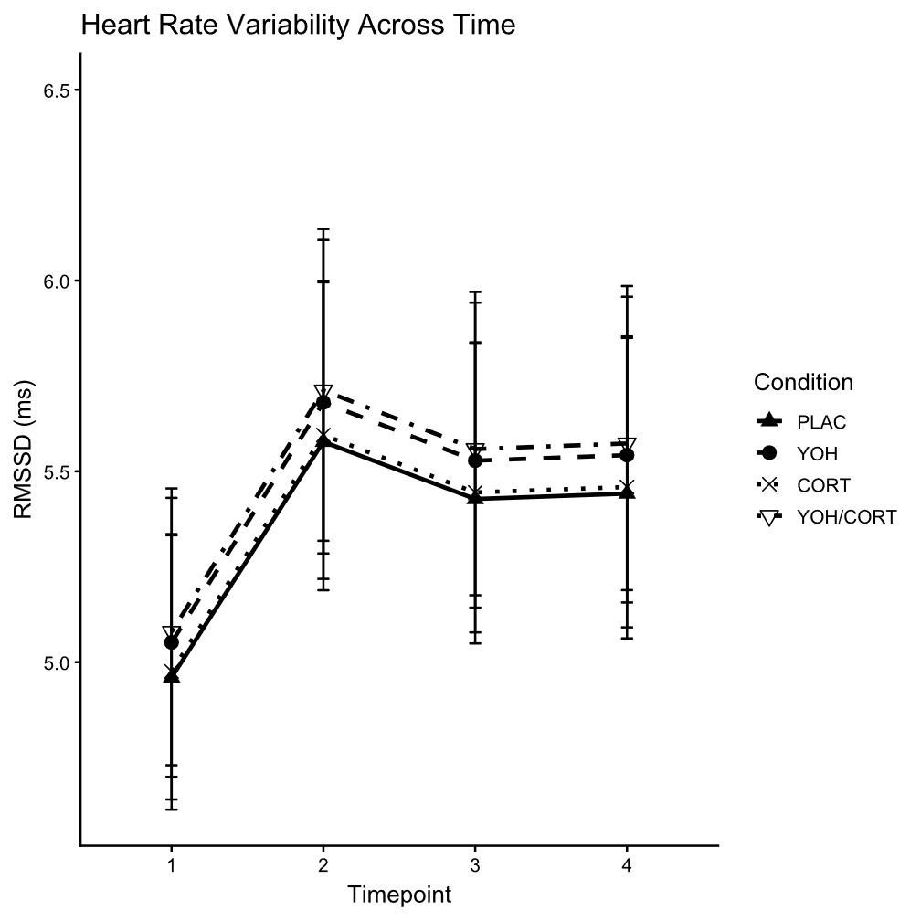
Table S15. Final full linear mixed model for subjective valence score. Estimation was done with REML. Final model included 100 participants.
Fixed effects | Estimate (SE) | df | t | p
Intercept | 6.793 (0.215) | 108 | 31.617 | 0.000***
ΔT1-T0 | -0.270 (0.111) | 251 | -2.428 | 0.016*
ΔT2-T0 | -0.700 (0.117) | 273 | -5.997 | 0.000***
ΔT3-T0 | -0.700 (0.125) | 116 | -5.584 | 0.000***
YOH | -0.279 (0.291) | 96 | -0.958 | 0.340
CORT | 0.175 (0.288) | 96 | 0.608 | 0.545
YOH * CORT | 0.028 (0.407) | 96 | 0.068 | 0.946
Random effects | Variance (SD) | r
Intercept participant | 0.951 (0.975) | -
Slope timepoint | 0.042 (0.204) | 0.51
Residual | 0.598 (0.773) | -
*: p-value <.05
**: p-value <.01
***: p-value <.001

Table S16. Final full linear mixed model for subjective arousal score. Estimation was done with REML. Final model included 100 participants.
Fixed effects | Estimate (SE) | df | t | p
Intercept | 5.485 (0.253) | 113 | 21.714 | 0.000***
ΔT1-T0 | 0.440 (0.102) | 282 | 4.305 | 0.000***
ΔT2-T0 | 0.400 (0.123) | 203 | 3.246 | 0.001**
ΔT3-T0 | 0.380 (0.152) | 106 | 2.502 | 0.014*
YOH | 0.478 (0.332) | 94 | 1.440 | 0.153
CORT | 0.293 (0.334) | 94 | 0.879 | 0.382
Age | 0.081 (0.018) | 119 | 4.524 | 0.000***
YOH * CORT | -0.083 (0.471) | 94 | -0.177 | 0.860
YOH * Age | -0.060 (0.023) | 94 | -2.652 | 0.009**
ΔT1-T0 * Age | -0.033 (0.010) | 282 | -3.350 | 0.001***
ΔT2-T0 * Age | -0.037 (0.012) | 203 | -3.148 | 0.002**
ΔT3-T0 * Age | -0.018 (0.015) | 106 | -1.236 | 0.219
Random effects | Variance (SD) | r
Intercept participant | 1.219 (1.104) | -
Slope timepoint | 0.1578 (0.397) | -0.04
Residual | 0.443 (0.666) | -
*: p-value <.05
**: p-value <.01
***: p-value <.001

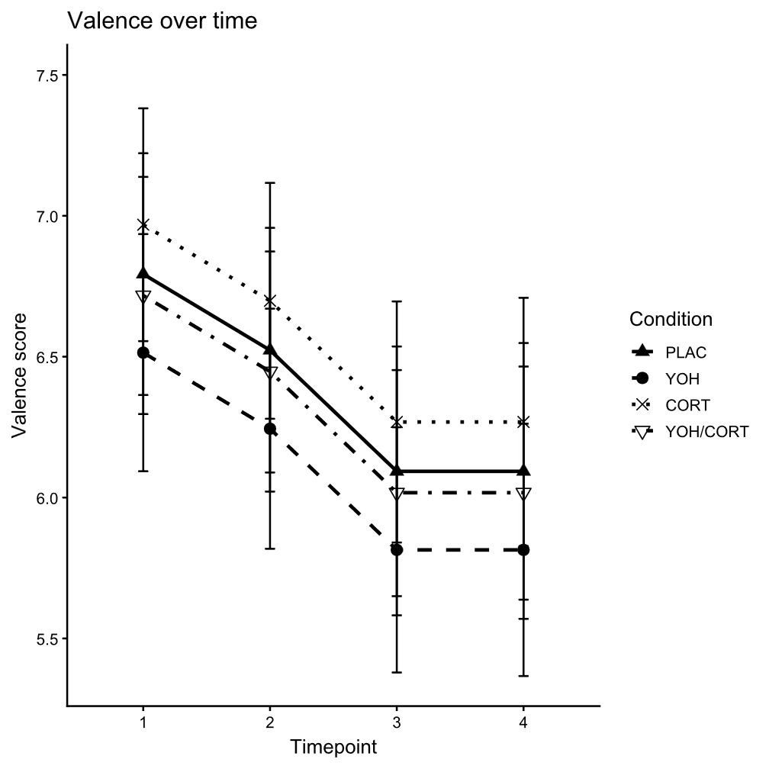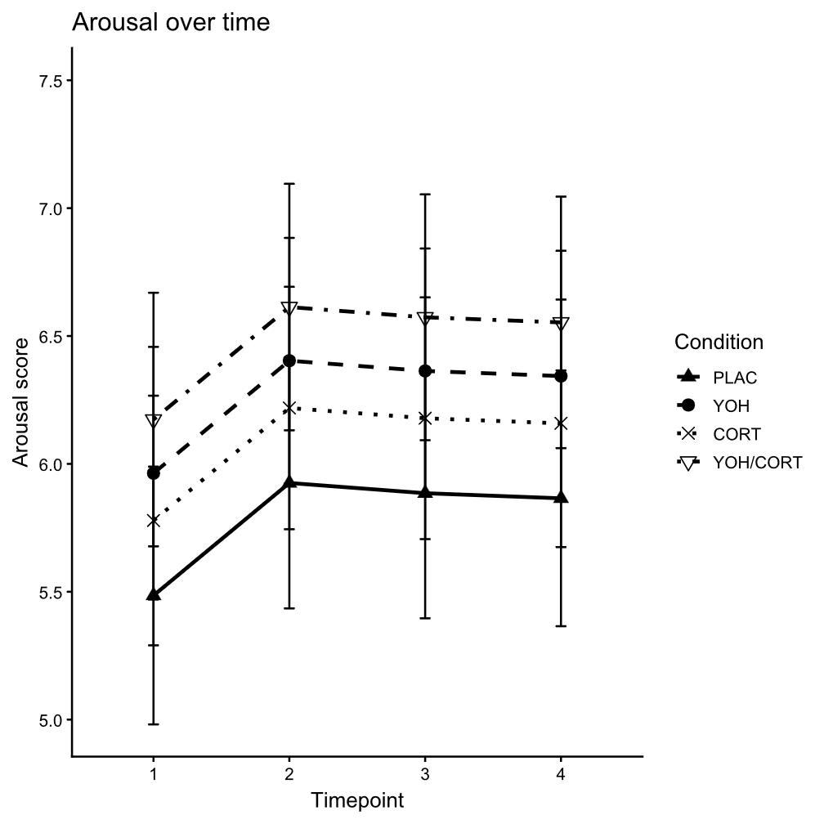
Table S17. Model estimates of three binomial generalised linear mixed models of moral choice. Estimation was done using maximum likelihood with Laplace approximation. Covariates included education and age. All tests included data of 100 participants.
 | Deontological choice |  |  | Compromise choice |  |  | Utilitarian choice
Fixed effects | Estimate (SE) | z | p | Estimate (SE) | z | p | Estimate (SE) | z | p
Intercept | 0.248 (1.749) | 0.142 | 0.887 | -2.561 (1.699) | -1.508 | 0.132 | -8.916 (2.293) | -3.889 | 0.000***
YOH | -0.323 (1.863) | -0.173 | 0.862 | -0.422 (1.350) | -0.312 | 0.755 | 0.635 (2.024) | 0.314 | 0.754
CORT | 0.211 (1.811) | 0.116 | 0.907 | 0.638 (1.334) | 0.478 | 0.633 | -1.700 (2.078) | -0.818 | 0.413
ΔEducation med-low | 2.130 (1.766) | 1.206 | 0.228 | -2.674 (1.320) | -2.027 | 0.043* | 0.238 (2.020) | 0.118 | 0.906
ΔEducation med-high | 1.147 (1.686) | 0.680 | 0.496 | -3.320 (1.272) | -2.610 | 0.009** | 3.139 (1.931) | 1.626 | 0.104
Age | 0.004 (0.065) | 0.067 | 0.947 | -0.026 (0.050) | -0.518 | 0.604 | 0.337 (0.737) | 0.457 | 0.648
YOH * CORT | 0.304 (2.604) | 0.117 | 0.907 | -1.633 (1.951) | -0.837 | 0.402 | 2.865 (2.850) | 1.005 | 0.315
Random effects | Variance |  |  | Variance |  |  | Variance
Intercept participant | 31.616 (5.623) |  |  | 17.310 (4.161) |  |  | 35.020 (5.918)
Intercept scenario | 2.384 (1.544) |  |  | 23.830 (4.882) |  |  | 14.870 (3.857)
*: p-value <.05
**: p-value <.01
***: p-value <.001

Table S18. Model estimates of a generalised linear model of moral phenotype, a linear model of moral spectrum score, and a linear model of moral consistency score. Estimation for phenotype was done with maximum likelihood, while the linear models used OLS. Covariates included education and age. All tests included data of 100 participants.
 | Moral phenotype |  |  | Moral spectrum score |  |  | Consistency score
Coefficients | Estimate (SE) | z | p | Estimate (SE) | t | p | Estimate (SE) | t | p
Intercept | 0.157 (0.498) | 0.316 | 0.752 | 0.737 (0.075) | 9.832 | 0.000*** | 0.990 (0.005) | 203.861 | 0.000***
YOH | 0.041 (0.593) | 0.069 | 0.945 | 0.002 (0.089) | 0.019 | 0.985 | 0.002 (0.006) | 0.364 | 0.716
CORT | 0.636 (0.621) | 1.025 | 0.305 | 0.052 (0.089) | 0.584 | 0.560 | -0.005 (0.006) | -0.781 | 0.437
ΔEducation med-low | 0.521 (0.592) | 0.880 | 0.379 | 0.080 (0.085) | -0.937 | 0.351 | -0.001 (0.005) | -0.100 | 0.921
ΔEducation med-high | 0.066 (0.503) | 0.132 | 0.895 | -0.089 (0.073) | -1.216 | 0.227 | 0.006 (0.005) | 1.192 | 0.236
Age | -0.008 (0.022) | -0.367 | 0.714 | -0.001 (0.003) | -0.399 | 0.691 | 0.000 (0.000) | -0.455 | 0.650
YOH * CORT | -0.658 (0.883) | -0.745 | 0.456 | -0.079 (0.127) | -0.621 | 0.536 | 0.001 (0.008) | 0.064 | 0.949
*: p-value <.05
**: p-value <.01
***: p-value <.001

Table S19. MANCOVA for the asymptotic maximum (α), rate of change (β), and inflection point (σ) of YOH and CORT. Nonlinear least-squares modelling was done per participant.
Predictor | df | Pillai | Approx. F | p
YOH | 1 | 0.082 | 1.485 | 0.230
CORT | 1 | 0.131 | 2.516 | 0.069
Education | 6 | 0.453 | 1.540 | 0.083
Age | 1 | 0.018 | 0.310 | 0.818
YOH * CORT | 1 | 0.046 | 0.797 | 0.501
Residuals | 52
*: p-value <.05
**: p-value <.01
***: p-value <.001

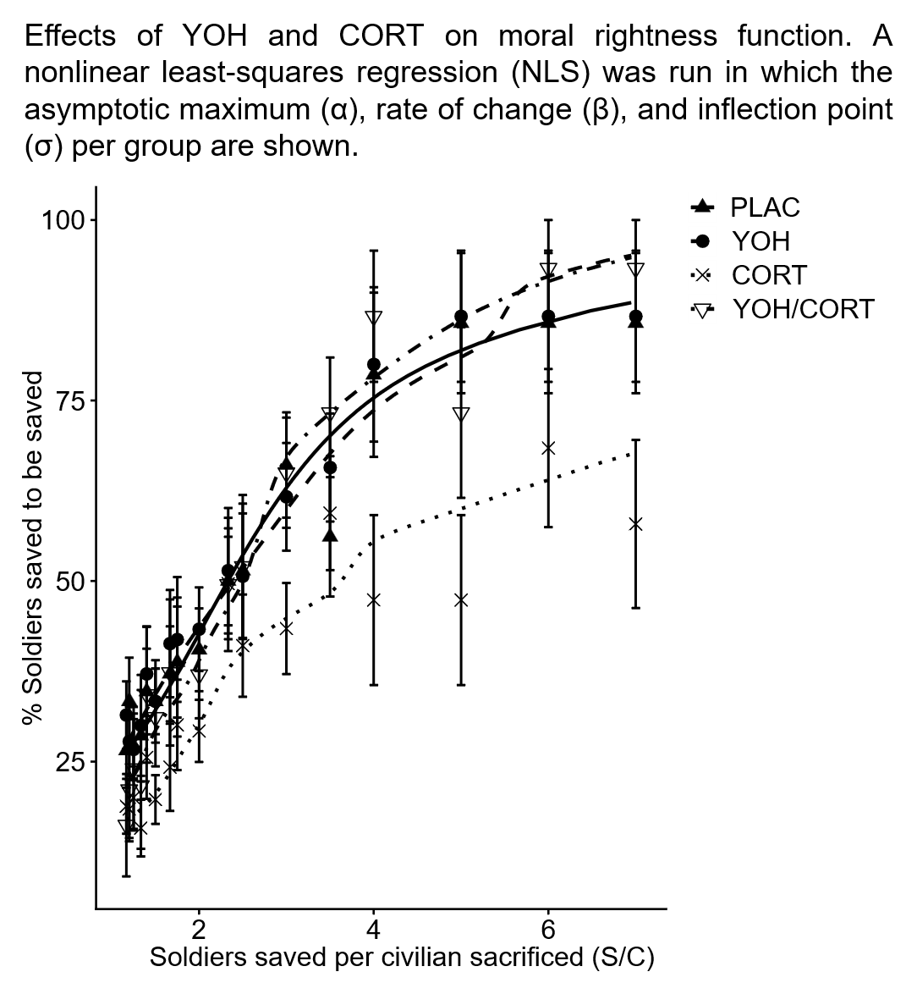
Table S20. Model estimates of a linear mixed model of certainty response time in relation to choice type (U = utilitarian; C = compromise; D = deontological). Outcome was log transformed Estimation was done with REML. Final model included 100 participants.
Fixed effects | Estimate (SE) | df | t | p
Intercept | 0.829 (0.092) | 111 | 9.003 | 0.000***
YOH | 0.066 (0.100) | 111 | 0.661 | 0.510
CORT | 0.022 (0.099) | 109 | 0.226 | 0.822
ΔU-D | 0.027 (0.076) | 1404 | 0.348 | 0.728
ΔC-D | -0.017 (0.067) | 1221 | -0.250 | 0.803
ΔEducation med-low | -0.052 (0.090) | 93 | -0.573 | 0.568
ΔEducation med-high | -0.082 (0.088) | 94 | -0.938 | 0.351
Age | 0.005 (0.003) | 93 | 1.645 | 0.103
YOH * CORT | 0.009 (0.135) | 93 | 0.069 | 0.945
YOH * ΔU-D | 0.101 (0.080) | 1764 | 1.268 | 0.205
YOH * ΔC-D | 0.066 (0.072) | 1658 | 0.919 | 0.358
CORT * ΔU-D | -0.075 (0.082) | 1592 | -0.907 | 0.365
CORT * ΔC-D | 0.013 (0.074) | 1488 | 0.181 | 0.857
Random effects | Variance (SD)
Intercept participant | 0.096 (0.309)
Residual | 0.225 (0.475)
*: p-value <.05
**: p-value <.01
***: p-value <.001

Table S21. Model estimates of a linear mixed model of certainty response time in relation to the number of choice options. Outcome was log transformed. Estimation was done with REML. Final model included 100 participants.
Fixed effects | Estimate (SE) | df | t | p
Intercept | 0.830 (0.087) | 93 | 9.554 | 0.000***
YOH | 0.105 (0.095) | 93 | 1.114 | 0.268
CORT | 0.016 (0.094) | 93 | 0.174 | 0.862
Options | 0.019 (0.012) | 1997 | 1.542 | 0.123
ΔEducation med-low | -0.057 (0.090) | 93 | -0.628 | 0.532
ΔEducation med-high | -0.085 (0.087) | 93 | -0.969 | 0.335
Age | 0.005 (0.003) | 93 | 1.603 | 0.112
YOH * CORT | 0.003 (0.135) | 93 | 0.022 | 0.982
YOH * Options | -0.013 (0.014) | 1997 | -0.933 | 0.351
CORT * Options | -0.028 (0.014) | 1997 | -2.040 | 0.042*
Random effects | Variance (SD)
Intercept participant | 0.096 (0.310)
Residual | 0.225 (0.474)
*: p-value <.05
**: p-value <.01
***: p-value <.001

Table S22. Model estimates of a linear mixed model of choice response time in relation to choice type (U = utilitarian; C = compromise; D = deontological). Outcome was log transformed. Estimation was done with REML. Final model included 100 participants.
Fixed effects | Estimate (SE) | df | t | p
Intercept | 2.104 (0.136) | 119 | 15.503 | 0.000***
YOH | -0.035 (0.142) | 108 | -0.243 | 0.808
CORT | 0.008 (0.143) | 106 | 0.055 | 0.957
ΔU-D | -0.079 (0.107) | 97 | -0.739 | 0.462
ΔC-D | 0.190 (0.113) | 66 | 1.679 | 0.098
ΔEducation med-low | -0.247 (0.119) | 74 | -2.081 | 0.041*
ΔEducation med-high | -0.256 (0.113) | 68 | -2.262 | 0.027*
Age | 0.002 (0.004) | 68 | 0.454 | 0.651
YOH * CORT | 0.105 (0.172) | 64 | 0.608 | 0.545
YOH * ΔU-D | 0.100 (0.112) | 62 | 0.892 | 0.376
YOH * ΔC-D | 0.190 (0.123) | 55 | 1.544 | 0.128
CORT * ΔU-D | -0.117 (0.115) | 71 | -1.016 | 0.313
CORT * ΔC-D | -0.039 (0.125) | 56 | -0.311 | 0.757
Random effects | Variance (SD) | r
Intercept participant | 0.251 (0.501) | - | -
Slope ΔU-D | 0.055 (0.235) | -0.89 | -
Slope ΔC-D | 0.110 (0.332) | -0.51 | 0.61
Intercept scenario | 0.022 (0.147) | - | -
Residual | 0.337 (0.581) | - | -
*: p-value <.05
**: p-value <.01
***: p-value <.001
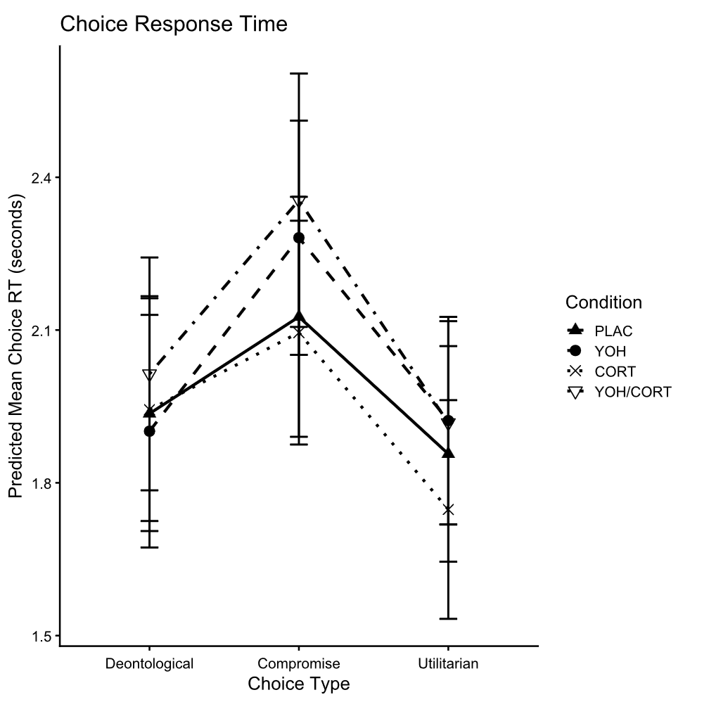
Table S23. Model estimates of a linear mixed model of choice response time in relation to the number of choice options. Outcome was log transformed. Estimation was done with REML. Final model included 100 participants.
Fixed effects | Estimate (SE) | df | t | p
Intercept | 2.135 (0.124) | 101 | 17.260 | 0.000***
YOH | 0.035 (0.135) | 101 | 0.259 | 0.797
CORT | 0.004 (0.135) | 101 | 0.026 | 0.979
Options | 0.124 (0.022) | 97 | 5.623 | 0.000***
ΔEducation med-low | -0.263 (0.123) | 93 | -2.133 | 0.036*
ΔEducation med-high | 0.316 (0.120) | 93 | -2.644 | 0.010**
Age | 0.000 (0.005) | 93 | 0.030 | 0.976
YOH * CORT | 0.026 (0.184) | 93 | 0.144 | 0.886
YOH * Options | 0.012 (0.025) | 97 | 0.490 | 0.625
CORT * Options | -0.005 (0.025) | 97 | -0.208 | 0.836
Random effects | Variance (SD) | r
Intercept participant | 0.222 (0.471) | -
Slope options | 0.009 (0.093) | 0.56
Residual | 0.334 (0.578) | -
*: p-value <.05
**: p-value <.01
***: p-value <.001

