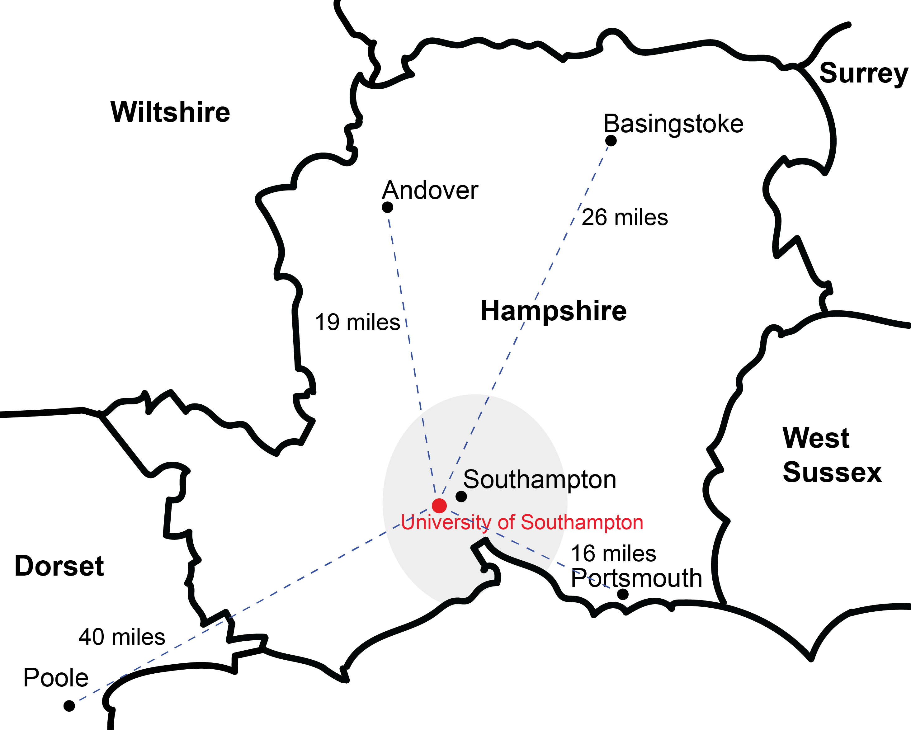
Additional file 4. A map showing the distance in miles from University of Southampton to the surrounding areas where group member respondents live. The grey area represents the city of Southampton where the majority of respondents live.

