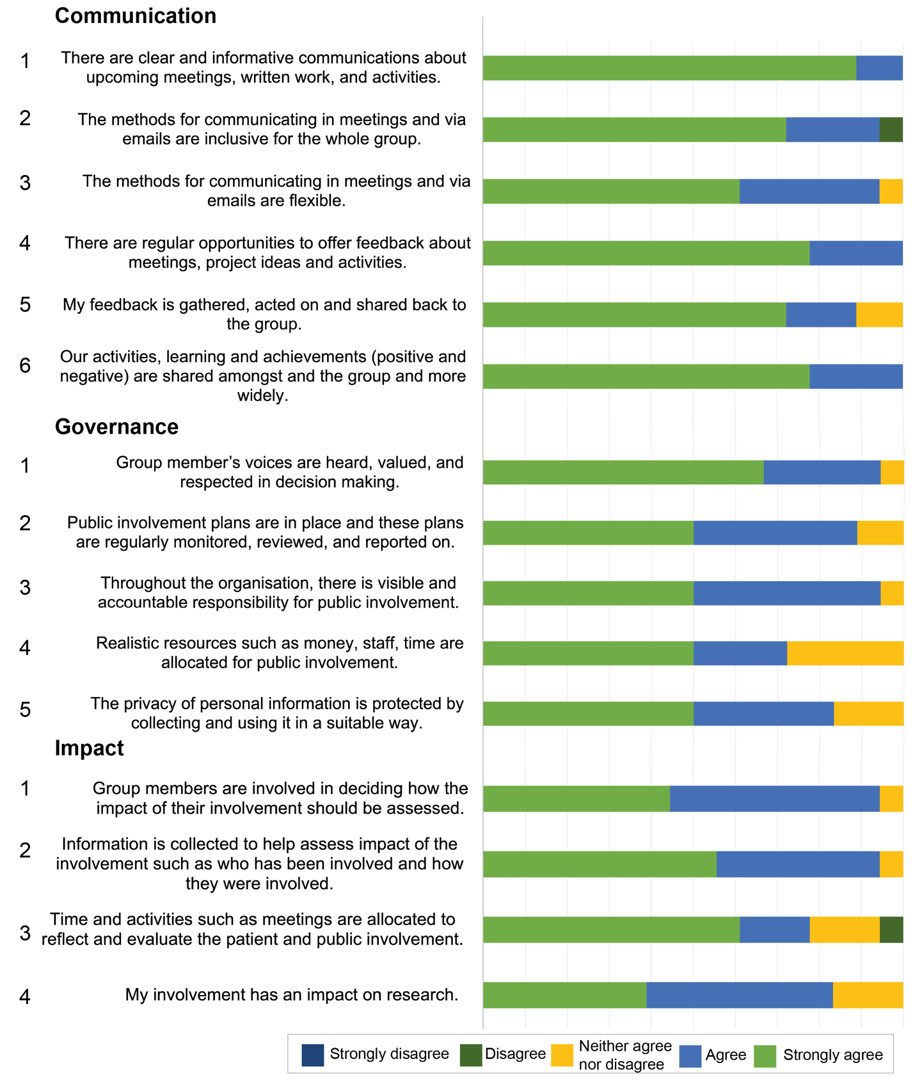
Additional file 5a. Responses from rating scale questions in the group member’s questionnaire for the statements which align with the UK standards for public involvement – Communications, Governance and Impact. The number beside each statement aligns with the numbering used in figure 2 [main text].
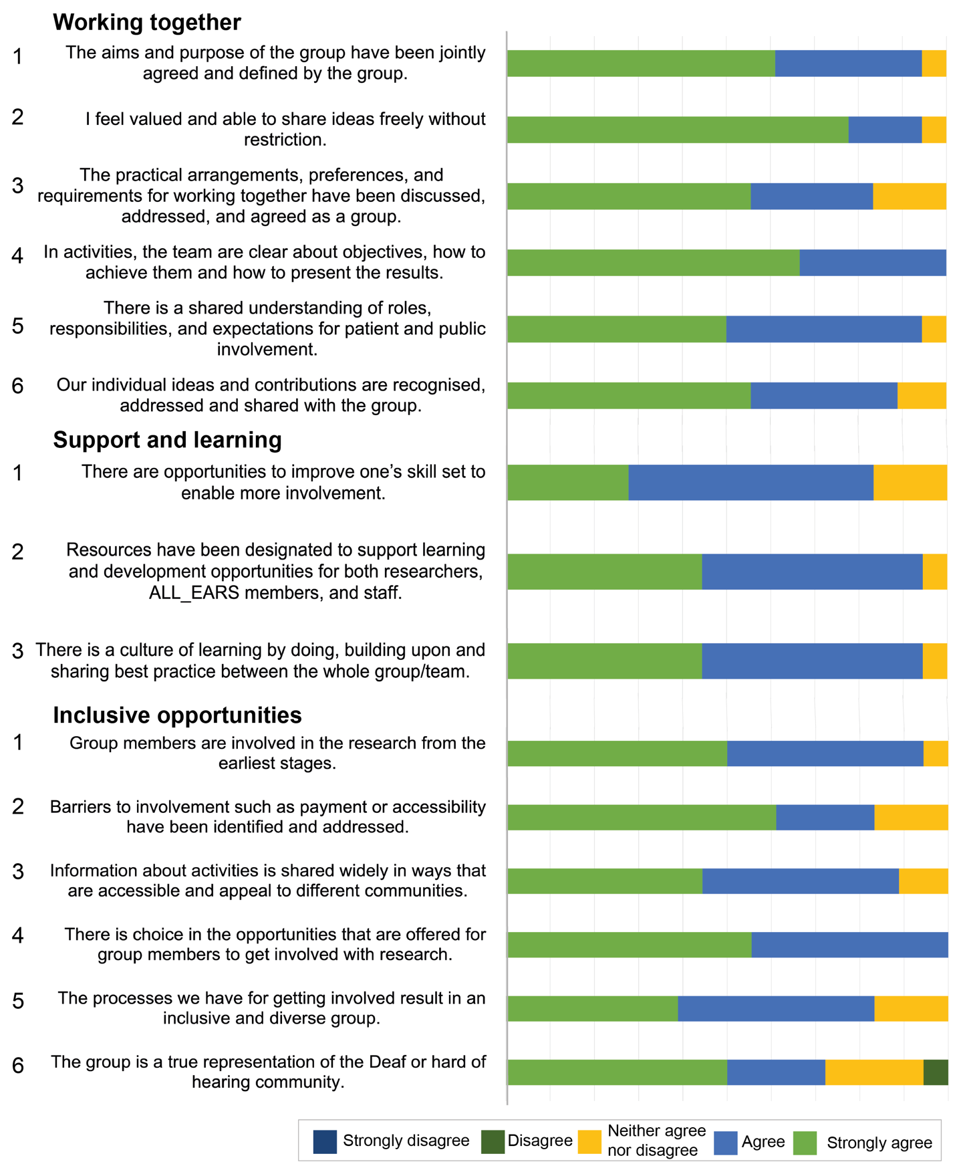
Additional file 5b. Responses from rating scale questions in the group member’s questionnaire for the statements which align with the UK standards for public involvement - Working together, Support and learning,
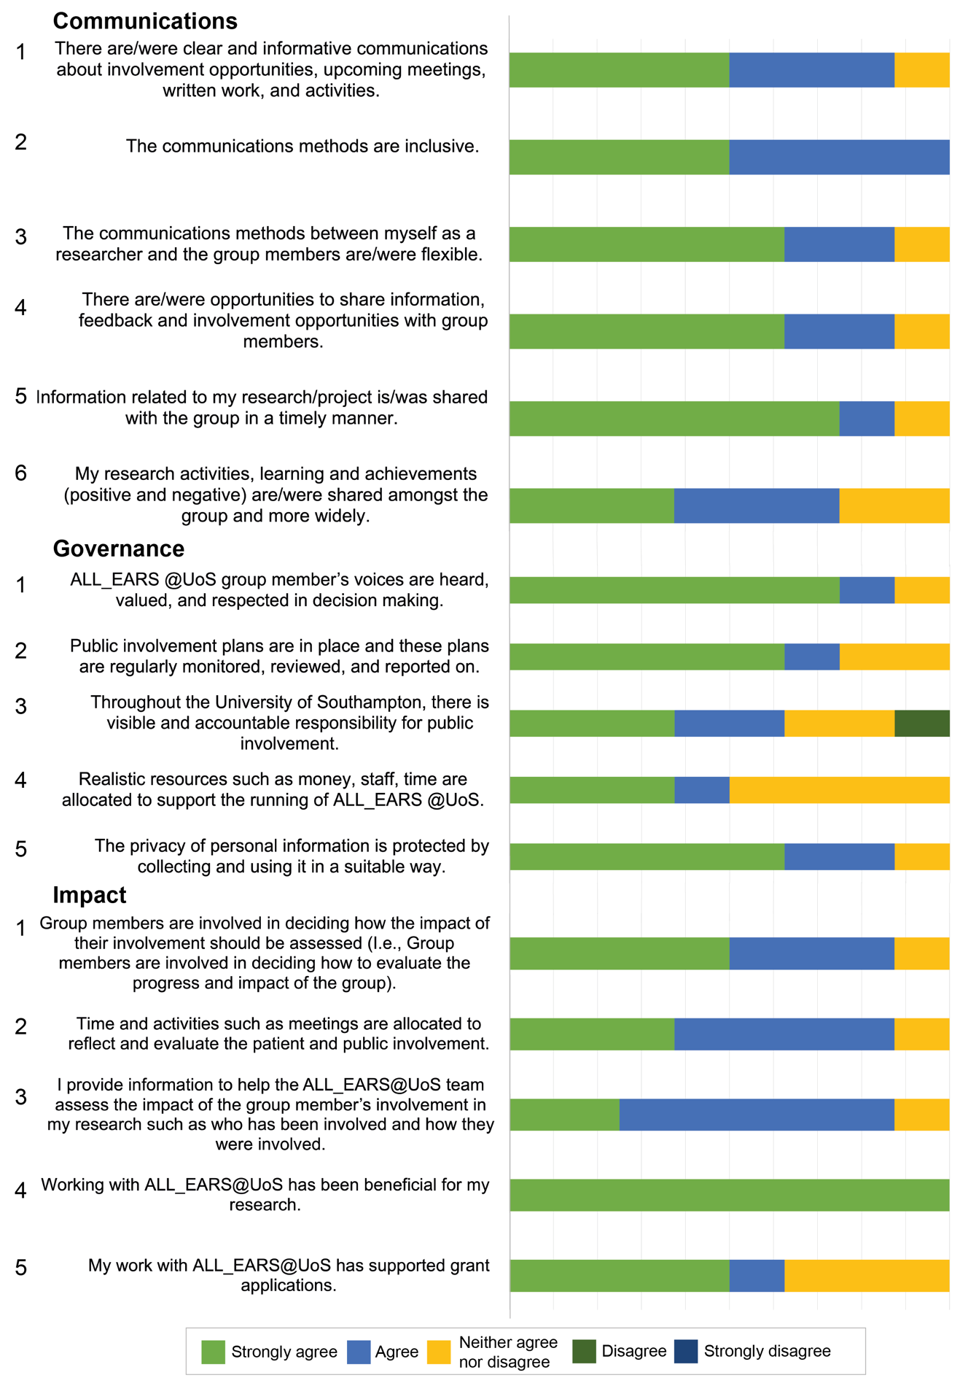
Additional file 5c. Responses from rating scale questions in the researcher’s questionnaire for the statements which align with the UK standards for public involvement – Communications, Governance and Impact. The number beside each statement aligns with the numbering used in figure 6 [main text].

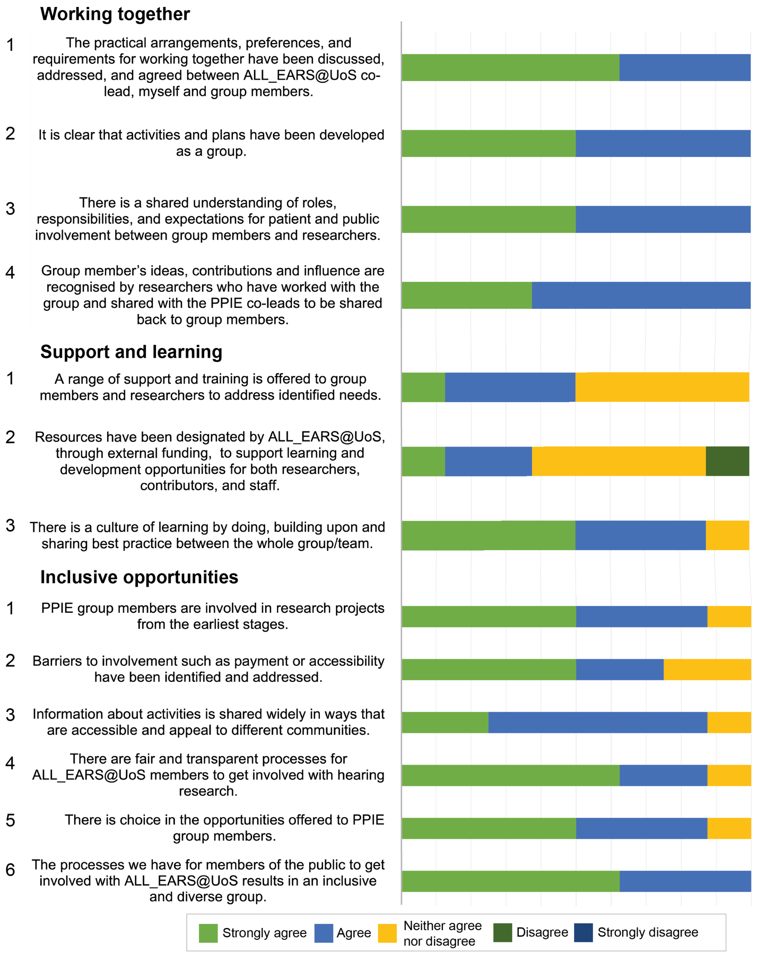
Additional file 5d. Responses from rating scale questions in the researcher’s questionnaire for the statements which align with the UK standards for public involvement - Working together, Support and learning, Inclusive opportunities. The number beside each statement aligns with the numbering used in figure 6 [main text].

