Supplementary information
Synthetic Protocols
Synthesis of N-[9-[(4aR,6R,7R,7aS)-2,2-ditert-butyl-7-hydroxy-4a,6,7,7a-tetrahydro-4H-furo[3,2-d][1,3,2]dioxasilin-6-yl]purin-6-yl]benzamide (SI2)

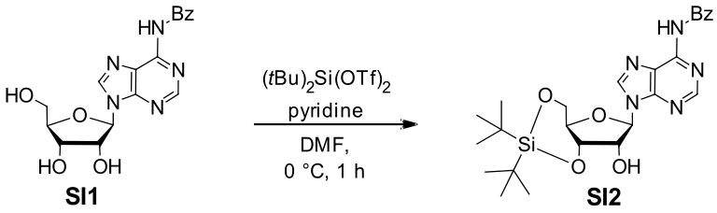

To a solution of N⁶-benzoyl adenosine (1, 7.4 g, 20 mmol, 1.0 eq.) in anhydrous DMF (40 mL) was added pyridine (4.8 mL, 60 mmol, 3.0 eq.) and the mixture was cooled to 0 °C. Di-t-butylsilylbis(trifluoromethansulfonate) (7.2 mL, 22 mmol, 1.1 eq.) was slowly added and the reaction stirred for 1 h until TLC (CH₂Cl₂/MeOH 20:1) indicated full conversion of the starting material. The suspension was diluted with water (200 mL), the precipitate was filtered and dried by co-evaporation with anhydrous toluene (3 x 100 mL) to yield the title compound SI2 as a colorless solid (10.1 g, 19.7 mmol, 99%).

M(C₂₅H₃₃N₅O₅Si): | 511.65 g/mol. |  | 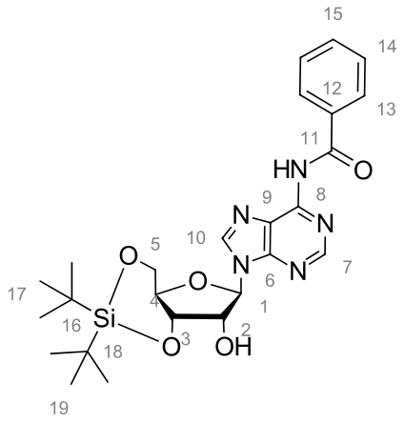
Yield: | 10.1 g (19.7 mmol, 99%).
R_{f}: | 0.40 (CH₂Cl₂/MeOH 20:1).
¹H-NMR: | (499 MHz, CDCl₃) δ [ppm] = 8.77 (s, 1H, H-7), 8.06 (s, 1H, H-10), 8.05 – 8.00 (m, 2H, H-13), 7.65 – 7.59 (m, 1H, H-15), 7.56 – 7.51 (m, 2H, H-14), 6.04 (s, 1H, H-1), 4.88 (dd, J = 9.0, 5.0 Hz, 1H, H-3), 4.75 (d, J = 5.0 Hz, 1H, H-2), 4.48 (dd, J = 8.6, 4.5 Hz, 1H, H-5´), 4.15 (ddd, J = 10.5, 9.0, 4.5 Hz, 1H, H-4), 4.09 (dd, J = 10.6, 8.6 Hz, 1H, H-5), 1.14 (s, 9H, H-17), 1.07 (s, 9H, H-19).
¹³C-NMR: | (126 MHz, CDCl₃) δ [ppm] = 164.7 (C-11), 152.5 (C-7), 151.3 (C-6), 149.8 (C-8), 141.8 (C-10), 133.7 (C-12), 133.0 (C-15), 129.1 (C-14), 128.0 (C-13), 123.8 (C-9), 91.2 (C-1), 75.8 (C-3), 75.3 (C-4), 74.0 (C-2), 67.5 (C-5), 27.5 (C-17), 27.4 (C-19), 22.9 (C-16), 20.5 (C-18).
FT-IR: | (ATR) $\tilde{ν}$ [cm⁻¹] = 3393 (w), 2968 (w), 2930 (w), 2884 (w), 2857 (m), 1697 (m), 1614 (s), 1578 (m), 1535 (w), 1462 (s), 1395 (m), 1362 (m), 1350 (m), 1327 (m), 1258 (m), 1234 (m), 1211 (m), 1192 (m), 1161 (m), 1136 (s), 1101 (m), 1057 (s), 1030 (m), 1009 (s), 995 (s), 951 (m), 935 (m), 889 (m), 872 (m), 854 (m), 826 (s), 799 (s), 762 (m), 750 (s), 739 (s), 689 (s), 665 (m), 650 (s), 638 (s).
HR-MS (ESI): | exact mass [u] | mass found [u] |  | error [ppm]
HR-MS (ESI): | 512.23237 [M+H]⁺ | 512.23243 [M+H]⁺ |  | +0.12
HR-MS (ESI): | 534.21432 [M+Na]⁺ | 534.21421 [M+Na]⁺ |  | -0.21

Synthesis of N⁶-Benzoyl-9-[3,5-(1,1,3,3-tetraisopropyldisiloxane-1,3-diyl)-2-O-(2,3,5-tri-O-benzoyl-β-d-ribofuranosyl)-β-d-ribofuranosyl]adenine (SI3)
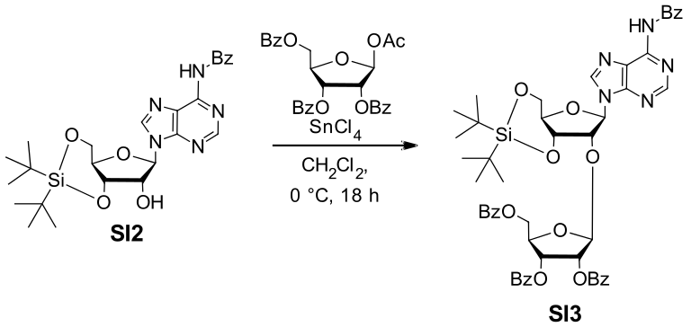

A solution of [(2R,3R,4R,5S)-5-acetyloxy-3,4-dibenzoyloxyoxolan-2-yl]methyl benzoate (3.6 g, 7.2 mmol, 1.5 eq.) in CH₂Cl₂ (40 mL) was cooled to 0 °C. Tin(IV) chloride (1.1 mL, 9.6 mmol, 2.0 eq.) was added in one portion and the solution was stirred for 15 minutes. Subsequently, nucleoside SI2 (2.5 g, 4.8 mmol, 1.0 eq.) was added and the solution stirred at 0 °C for 18 h. The reaction was quenched by the addition of saturated aqueous sodium bicarbonate (100 mL) and the mixture was centrifuged (10 minutes at 5000 rpm). The pellet was removed and rinsed with additional CH₂Cl₂ (100 mL). The aqueous layer was extracted with CH₂Cl₂ (3 x 100 mL). The collected organic layers were then dried over anhydrous Na₂SO₄ before the solvent was removed under reduced pressure. The crude product was purified by column chromatography (SiO₂, CH₂Cl₂/MeOH 80:1) to yield title compound SI3 as a colorless foam (3.5 g, 3.7 mmol, 76%).

M(C₅₁H₅₃N₅O₁₂Si): | 956.08 g/mol. |  | 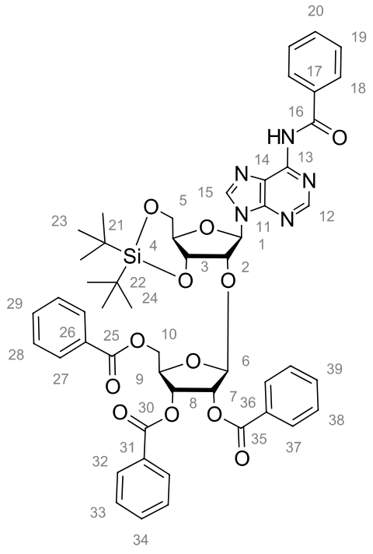
Yield: | 3.5 g (3.7 mmol, 76%).
R_{f}: | 0.16 (CH₂Cl₂/MeOH 80:1).
¹H-NMR: | (499 MHz, CDCl₃) δ [ppm] = 8.98 (s, 1H, NH), 8.74 (s, 1H, H-12), 8.01 (ddd, J = 8.4, 6.3, 1.8 Hz, 4H, Bz), 7.93 (s, 1H, H-15), 7.92 – 7.89 (m, 2H, Bz), 7.86 – 7.83 (m, 2H, Bz), 7.64 – 7.57 (m, 2H, Bz), 7.52 (dt, J = 12.8, 7.5 Hz, 4H, Bz), 7.43 (t, J = 7.8 Hz, 2H, Bz), 7.35 (t, J = 7.8 Hz, 2H, Bz), 7.30 (t, J = 7.8 Hz, 2H, Bz), 6.06 (s, 1H, H-1), 5.95 (dd, J = 6.3, 4.7 Hz, 1H, H-8), 5.91 (d, J = 5.1 Hz, 2H, H-6/H-7), 5.01 (d, J = 4.6 Hz, 1H, H-2), 4.91 (dd, J = 9.6, 4.7 Hz, 1H, H-3), 4.78 (dd, J = 11.5, 3.8 Hz, 1H, H-10´), 4.73 (td, J = 6.3, 3.8 Hz, 1H, H-9), 4.62 (dd, J = 11.5, 6.3 Hz, 1H, H-10), 4.42 (dd, J = 9.1, 4.9 Hz, 1H, H-5´), 4.15 – 4.07 (m, 1H, H-4), 4.01 (dd, J = 10.5, 9.1 Hz, 1H, H-5), 1.08 (s, 9H, H-24), 0.94 (s, 9H, H-23).
¹³C-NMR: | (126 MHz, CDCl₃) δ [ppm] = 166.2 (C-25), 165.5 (C-30), 165.0 (C-35), 164.6 (C-16), 152.9 (C-12), 151.2 (C-11), 149.7 (C-13), 142.0 (C-15), 133.8 (C_{q}-Bz), 133.7, 133.6, 133.4 and 133.0 (p-Bz), 130.0, 129.9 and 129.7 (Bz), 129.6 and 129.2 (C_{q}-Bz), 129.0 (Bz), 129.0 (C_{q}-Bz), 128.6, 128.6, 128.5 and 128.0 (Bz), 123.8 (C-14), 105.6 (C-6), 90.1 (C-1), 80.2 (C-9), 77.3 (C-2), 76.6 (C-3), 75.6 (C-7), 75.0 (C-4), 72.6 (C-8), 67.5 (C-5), 65.3 (C-10), 27.5 (C-24), 27.0 (C-23), 22.9 (C-22), 20.3 (C-21).
FT-IR: | (ATR) $\tilde{ν}$ [cm⁻¹] = 2970 (w), 2938 (w), 2859 (w), 1724 (s), 1603 (m),  1584 (m), 1472 (m), 1450 (m), 1366 (m), 1354 (m), 1315 (m), 1261 (s), 1246 (s), 1217 (m), 1177 (m), 1125 (m), 1094 (s), 1069 (s), 1059 (s), 1024 (s), 1003 (m), 968 (m), 953 (m), 937 (m), 827 (s), 799 (m), 741 (m), 704 (s), 687 (s), 654 (s), 642 (m).
HR-MS (ESI): | exact mass [u] | mass found [u] |  | error [ppm]
HR-MS (ESI): | 956.35328 [M+H]⁺ | 956.35379 [M+H]⁺ |  | +0.53
HR-MS (ESI): | 978.33522 [M+Na]⁺ | 978.33428 [M+Na]⁺ |  | -0.96

Synthesis of N⁶-Benzoyl-9-[2-O-(2,3,5-tri-O-benzoyl-β-d-ribofuranosyl)-β-d-ribofuranosyl] adenine (SI4)

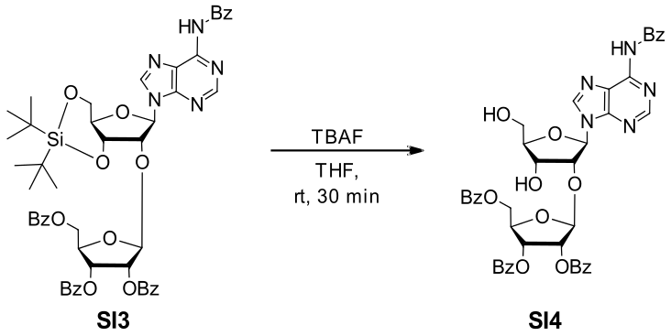

To a solution of SI3 (2.6 g, 2.5 mmol, 1.0 eq.) in THF (7 mL) was added TBAF (1 M solution in THF, 6.2 mL, 6.2 mmol, 2.5 eq.) and the reaction was stirred for 30 minutes at room temperature until complete conversion was observed by TLC (CH₂Cl₂/MeOH 95:5). After all volatiles were removed, the residue was taken up in chloroform (150 mL) and concentrated to dryness. The crude product was purified using column chromatography (SiO₂, CH₂Cl₂/MeOH 100:099:198:2). The title compound SI4 was obtained as colorless solid (1.8 g, 2.1 mmol, 87%).

M(C₄₃H₃₇N₅O₁₂): | 815.78 g/mol. |  | 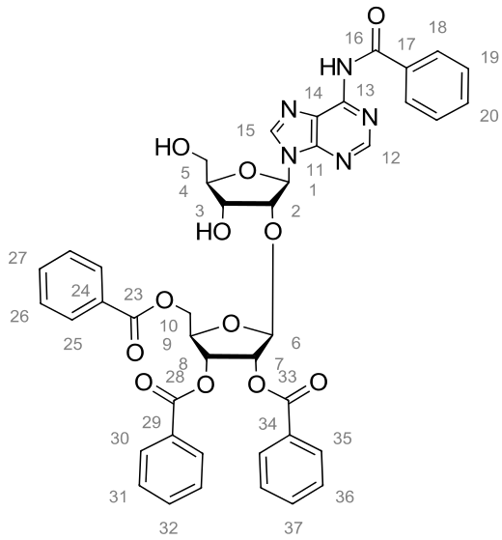
Yield: | 1.8 g (2.1 mmol, 87%).
R_{f}: | 0.18 (CH₂Cl₂/MeOH 95:5)
¹H-NMR: | (499 MHz, CDCl₃) δ [ppm] = 9.36 (s, 1H, NH), 8.80 (s, 1H, H-15), 8.23 (s, 1H, H-12), 8.05 – 7.99 (m, 4H, Bz), 7.91 – 7.84 (m, 4H, Bz), 7.63 – 7.58 (m, 1H, Bz), 7.55 – 7.49 (m, 5H, Bz), 7.42 – 7.37 (m, 2H, Bz), 7.36 – 7.31 (m, 4H, Bz), 6.08 (d, J = 7.4 Hz, 1H, H-1), 5.73 (t, J = 5.1 Hz, 1H, H-8), 5.66 (dd, J = 5.3, 2.1 Hz, 1H, H-7), 5.24 – 5.18 (m, 2H, H-2/H-6), 4.61 (d, J = 4.6 Hz, 1H, H-3), 4.53 – 4.44 (m, 2H, H-9/H-10), 4.27 (q, J = 1.5 Hz, 1H, H-4), 4.07 (dd, J = 11.5, 4.0 Hz, 1H, H-10´), 3.95 (dd, J = 13.1, 1.7 Hz, 1H, H-5), 3.73 (d, J = 13.0 Hz, 1H, H-5´).
¹³C-NMR: | (126 MHz, CDCl₃) δ [ppm] = 166.1, 165.6, 165.5 and 164.7 (C_{q}=O), 152.3 (C-12), 150.5 (C-11), 144.2 (C-15), 133.9, 133.8, 133.8, 133.7 and 133.0 (Bz), 124.3 (C-14), 106.8 (C-6), 89.4 (C-1), 87.4 (C-4), 81.1 (C-2), 80.5 (C-9), 76.0 (C-7), 72.4 (C-8), 71.7 (C-3), 64.1 (C-10), 63.3 (C-5).
FT-IR: | (ATR) $\tilde{ν}$ [cm⁻¹] = 3306 (w), 3065 (w), 2940 (w), 1721 (s), 1603 (m), 1584 (m), 1512 (w), 1485 (w), 1450 (m), 1404 (w), 1352 (w), 1315 (m), 1248 (s), 1219 (m), 1177 (m), 1107 (s), 1094 (s), 1069 (s), 1024 (s), 1001 (m), 984 (m), 961 (m), 935 (m), 893 (m), 866 (m), 831 (w), 799 (m), 704 (s), 685 (s), 669 (m), 640 (m), 617 (m), 606 (m).
HR-MS (ESI): | exact mass [u] | mass found [u] |  | error [ppm]
HR-MS (ESI): | 816.25115 [M+H]⁺ | 816.25215 [M+H]⁺ |  | +1.23
HR-MS (ESI): | 838.23309 [M+Na]⁺ | 838.23363 [M+Na]⁺ |  | +0.64

Synthesis of 2´-O-β-d-ribofuranosyladenosine (Rib-A)

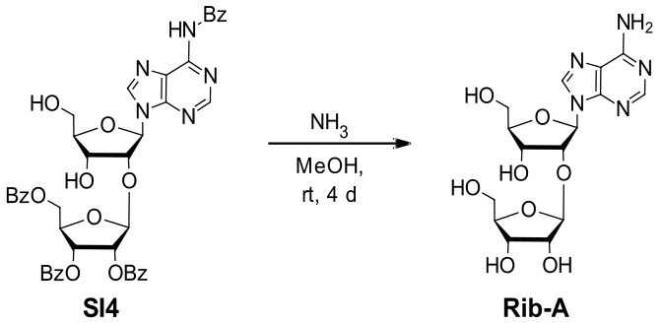

Benzoyl protected ribofuranosyladenosine SI4 (1.0 g, 1.2 mmol, 1.0 eq.) was dissolved in saturated ammonia in MeOH (7 m, 36 mL) and stirred at room temperature for four days. The solvent was removed under reduced pressure and the residue purified via reverse-phase flash-column-chromatography yielding the title compound Rib-A as colorless solid (377 mg, 0.9 mmol, 77%).

M(C₁₅H₂₁N₅O₈): | 399.36 g/mol. |  | 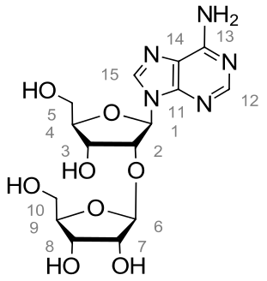
Yield: | 377 mg (0.9 mmol, 77%).
¹H-NMR: | (499 MHz, D₂O) δ [ppm] = 8.32 (s, 1H, H-15), 8.18 (s, 1H, H-12), 6.13 (d, J = 6.3 Hz, 1H, H-1), 5.08 (s, 1H, H-6), 4.77 (d, J = 5.7 Hz, 1H, H-2), 4.57 (dd, J = 5.1, 3.3 Hz, 1H, H-3), 4.31 (q, J = 3.3 Hz, 1H, H-4), 4.16 (d, J = 4.6 Hz, 1H, H-7), 4.02 (dd, J = 7.5, 4.6 Hz, 1H, H-8), 3.95 (dd, J = 13.0, 2.8 Hz, 1H, H-5), 3.86 (ddt, J = 10.6, 6.9, 3.6 Hz, 2H, H-5´/H-9), 3.40 – 3.31 (m, 1H, H-10), 2.79 (dd, J = 11.9, 6.7 Hz, 1H, H-10´).
¹³C-NMR: | (126 MHz, D₂O) δ [ppm] = 155.6 (C-13), 152.5 (C-12), 148.2 (C-11), 140.3 (C-15), 118.9 (C-14), 106.0 (C-6), 87.0 (C-1), 86.3 (C-4), 82.6 (C-9), 78.2 (C-2), 74.3 (C-7), 70.8 (C-8), 68.9 (C-3), 62.7 (C-10), 61.4 (C-5).
FT-IR: | (ATR) $\tilde{ν}$ [cm⁻¹] = 3300 (m), 3281 (m), 3211 (m), 3138 (m), 3117 (m), 3094 (m), 3071 (w), 1686 (m), 1657 (m), 1605 (m), 1574 (w), 1445 (w), 1418 (m), 1381 (m), 1369 (m), 1341 (m), 1296 (m), 1233 (m), 1206 (m), 1128 (m), 1101 (s), 1082 (m), 1028 (s), 982 (s), 953 (m), 939 (m), 901 (w), 866 (m), 839 (m), 826 (m), 779 (m), 719 (s), 683 (m), 640 (s).
HR-MS (ESI): | exact mass [u] | mass found [u] |  | error [ppm]
HR-MS (ESI): | 400.14629 [M+H]⁺ | 400.14637 [M+H]⁺ |  | +0.20
HR-MS (ESI): | 422.12823 [M+Na]⁺ | 422.12827 [M+Na]⁺ |  | +0.09

General Procedure for the synthesis of pRib-AMP analogues with modified phosphates
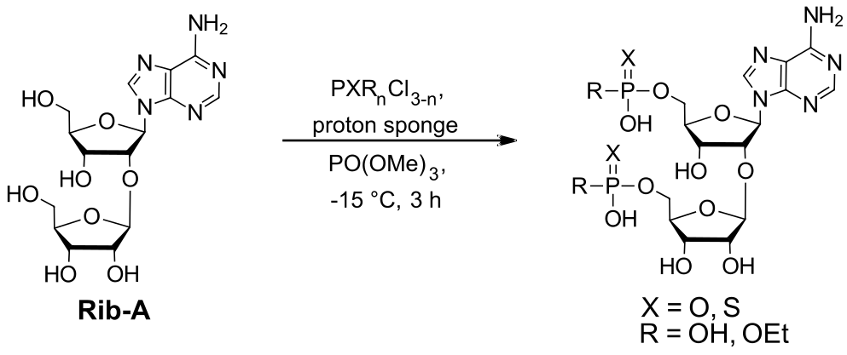
2´-O-β-d-ribofuranosyladenosine (Rib-A, 1.0 eq.) and proton sponge (2.5 eq.) were dissolved in dry TMP (2 mL/100 µmol Rib-A). The solution was stirred for 10 min at room temperature and then cooled to −15 °C. PXR_{n}Cl_{3-n} (4 eq.) was added dropwise and the reaction was stirred at −15 to 0°C for 3 h. The reaction was quenched by adding water (2 mL) and NEt₃ (1.25 eq. per acid chloride). The reaction was washed with CH₂Cl₂ (3 x 5 mL) and the aqueous phase subsequently purified by preparative HPLC (C18-RP, 0.1 M aq. TEAA/ACN 95:5 0:100 in 25 minutes).Synthesis of 2'-(5''-phosphoribosyl)-5'-adenosine monophosphate (pRib-AMP)

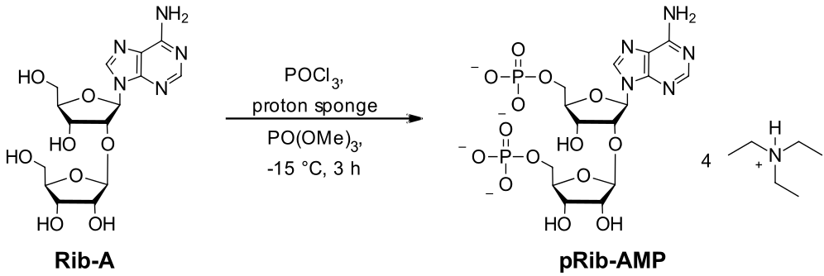
The title compound was prepared according to the general procedure from Rib-A (50 mg, 0.13 mmol, 1.0 eq.), proton sponge (67 mg, 0.31 mmol, 2.5 eq.) and POCl₃ (47 µL, 0.50 mmol, 4.0 eq.). The aqueous phase was freeze-dried and purified by preparative HPLC (C18-RP, 0.1 m aq. TEAB/ACN 95:5 0:100 in 25 minutes). This afforded the title compound pRib-AMP as the triethylammonium salt as a colorless solid (100 mg, 0.10 mmol, 83%).

M(C₃₉H₈₃N₉O₁₄P₂): | 963.55 g/mol. |  | 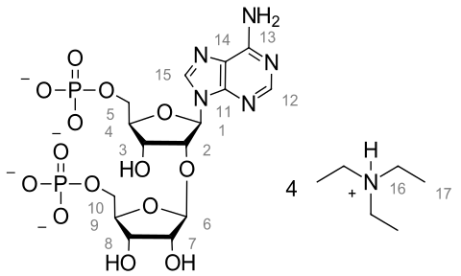
Yield: | 100 mg (0.10 mmol, 83%).
¹H-NMR: | (499 MHz, D₂O) δ [ppm] = 8.60 (s, 1H, H-15), 8.30 (s, 1H, H-12), 6.24 (d, J = 5.9 Hz, 1H, H-1), 5.08 (d, J = 1.5 Hz, 1H, H-6), 4.94 (t, J = 5.7 Hz, 1H, H-2), 4.65 (dd, J = 5.5, 3.8 Hz, 1H, H-3), 4.33 – 4.28 (m, 1H, H-4), 4.23 – 4.16 (m, 2H, H-7/H-8), 4.05 – 3.98 (m, 2H, H-5), 3.92 (q, J = 5.7 Hz, 1H, H-9), 3.61 – 3.54 (m, 1H, H-10´), 3.54 – 3.50 (m, 1H, H-10), 3.19 (q, J = 7.3 Hz, 24H, H-16), 1.27 (t, J = 7.3 Hz, 36H, H-17).
¹³C-NMR: | (126 MHz, D₂O) δ [ppm] = 155.7 (C-13), 153.0 (C-12), 107.7 (C-6), 86.1 (C-1), 84.5 (C-4), 81.9 (C-9), 80.1 (C-2), 74.5 (C-7), 71.4 (C-8), 69.7 (C-3), 65.0 (C-10), 63.4 (C-5), 46.6 (C-16), 8.2 (C-17).
³¹P-NMR: | (121 MHz, D₂O) δ [ppm] = 3.45 (P-1), 2.90 (P-2).
HR-MS (ESI): | exact mass [u] | mass found [u] |  | error [ppm]
HR-MS (ESI): | 558.0642 [M-H]⁻ | 558.0644 [M-H]⁻ |  | +0.36

Synthesis of (2S,3R,4S,5S)-5-[(2R,3R,4R,5R)-2-(9-Adenineyl)-4-hydroxy-5-[(hydroxyethoxyphosphoryloxy)methyl]tetrahydro-3-furyloxy]-2-[(hydroxyethoxyphosphoryloxy)methyl]tetrahydro-3,4-furandiol (mono-Et-pRib-AMP)

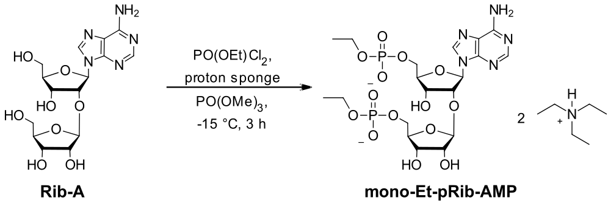
The title compound was prepared according to the general procedure from Rib-A (30 mg, 0.075 mmol, 1.0 eq.), proton sponge (40 mg, 0.19 mmol, 2.5 eq.) and PO(OEt)Cl₂ (36 µL, 0.30 mmol, 4.0 eq.). The aqueous phase was freeze-dried and purified by preparative HPLC (C18-RP, 0.1 m aq. TEAB/ACN 95:5 0:100 in 25 minutes). This afforded the title compound mono-Et-Rib-AMP as the triethylammonium salt as a colorless solid (8 mg, 0.01 mmol, 13%).

M(C₃₁H₆₁N₇O₁₄P₂): | 817.80 g/mol.
Yield: | 8 mg (0.01 mmol, 13%).
LC-MS (ESI): | calc. mass [u] | mass found [u]
LC-MS (ESI): | 616.14 [M+H]⁺ | 616.29 [M+H]⁺

Synthesis of (2R,3S,4R,5S)-5-[(2R,3R,4R,5R)-2-(9-Adenineyl)-5-[(dihydroxy phosphorothioyloxy)methyl]-4-hydroxytetrahydro-3-furyloxy]-2-[(dihydroxypho-sphorothioyloxy) methyl]tetrahydro-3,4-furandiol (Thio-pRib-AMP)

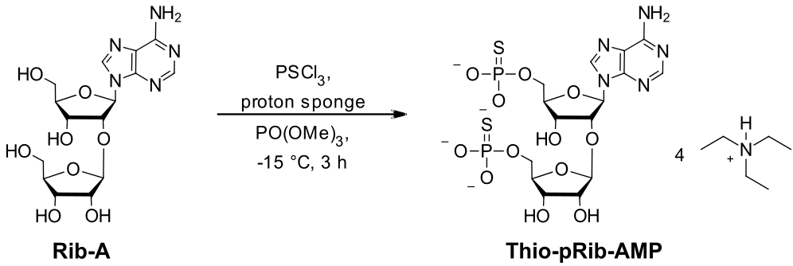
The title compound was prepared according to the general procedure from Rib-A (49 mg, 0.12 mmol, 1.0 eq.) proton sponge (67 mg, 0.31 mmol, 2.5 eq.) and PSCl₃ (51 µL, 0.50 mmol, 4.0 eq.). The aqueous phase was freeze-dried and purified by preparative HPLC (C18-RP, 0.1 M aq. TEAB/ACN 95:5 0:100 in 25 minutes). This afforded the title compound Thio-pRib-AMP as the triethylammonium salt as a colorless solid (42 mg, 0.03 mmol, 24%).

M(C₃₉H₈₃N₉O₁₂P₂S₂): |  | 996.21 g/mol.
Yield: |  | 42 mg (0.03 mmol, 24%).
LC-MS (ESI): |  | calc. mass [u] | mass found [u]
 |  | 592.03 [M+H]⁺ | 592.16 [M+H]⁺
¹H-NMR: | (499 MHz, D₂O) δ [ppm] = 8.67 (s, 1H, H-15), 8.30 (s, 1H, H-12), 6.25 (d, J = 5.9 Hz, 1H, H-1), 5.11 (d, J = 1.5 Hz, 1H, H-6), 4.93 (t, J = 5.6z Hz, 1H, H-2), 4.65 (dd, J = 5.4, 3.6 Hz, 1H, H-3), 4.33 – 4.28 (m, 1H, H-4), 4.23 – 4.17 (m, 2H, H-7/H-8), 4.10 – 4.07 (m, 2H, H-5), 3.92 (q, J = 6.0 Hz, 1H, H-9), 3.65 – 3.59 (m, 1H, H-10´), 3.54 – 3.48 (m, 1H, H-10), 3.19 (q, J = 7.3 Hz, 24H, H-16), 1.27 (t, J = 7.3 Hz, 36H, H-17).
³¹P-NMR: | (121 MHz, D₂O) δ [ppm] = 48.01 (P-1), 46.11 (P-2).

Crystal Structures
N-[9-[(4aR,6R,7R,7aS)-2,2-ditert-butyl-7-hydroxy-4a,6,7,7a-tetrahydro-4H-furo[3,2-d][1,3,2]dioxasilin-6-yl]purin-6-yl]benzamide (SI2)
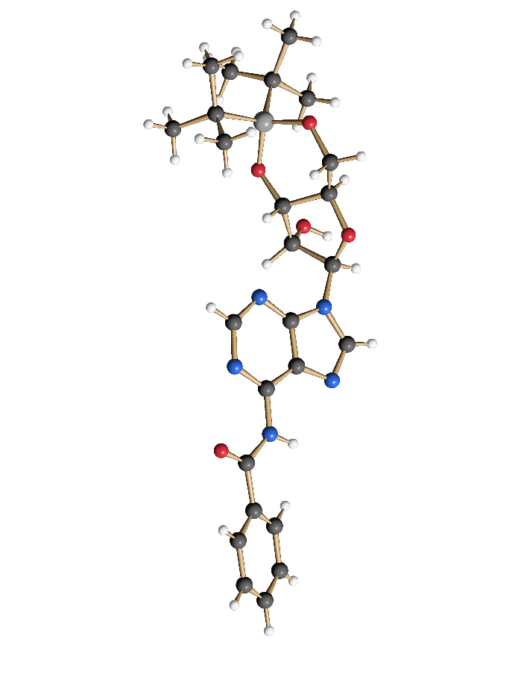
Table S1. Crystal data and structure refinement for SI2. Thermal ellipsoids are shown at 50% probability, colours denote the respective elements as follows: white: hydrogen, black: carbon, blue: nitrogen, red: oxygen, grey: silicon.
CCDC number 2541753
Empirical formula C25 H33 N5 O5 Si
Moiety formula C25 H33 N5 O5 Si
Formula weight 511.65
Temperature 100(2) K
Wavelength 1.54178 Å
Crystal system Monoclinic
Space group P2₁
Unit cell dimensions a = 9.0384(7) Å α= 90°.
b = 6.7418(5) Å β= 95.447(3)°.
c = 20.7836(16) Å γ = 90°.
Volume 1260.73(17) Å3
Z 2
Density (calculated) 1.348 Mg/m3
Absorption coefficient 1.209 mm-1
F(000) 544
Crystal size 0.150 x 0.100 x 0.030 mm3
Theta range for data collection 4.274 to 72.110°.
Index ranges -11<=h<=11, -8<=k<=8, -25<=l<=25
Reflections collected 35306
Independent reflections 4810 [R(int) = 0.0556]
Completeness to theta = 67.679° 99.2 %
Absorption correction Semi-empirical from equivalents
Max. and min. transmission 0.7535 and 0.583
Refinement method Full-matrix least-squares on F2
Data / restraints / parameters 4810 / 1 / 337
Goodness-of-fit on F2 1.020
Final R indices [I>2sigma(I)] R1 = 0.0258, wR2 = 0.0723
R indices (all data) R1 = 0.0269, wR2 = 0.0728
Absolute structure parameter 0.043(8)
Extinction coefficient n/a
Largest diff. peak and hole 0.199 and -0.217 e.Å-3

N⁶-Benzoyl-9-[3,5-(1,1,3,3-tetraisopropyldisiloxane-1,3-diyl)-2-O-(2,3,5-tri-O-benzoyl-β-d-ribofuranosyl)-β-d-ribofuranosyl]adenine (SI3)
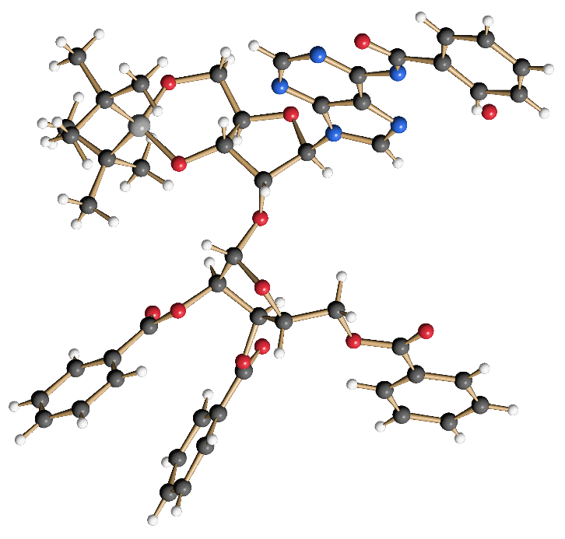
Table S2. Crystal data and structure refinement for SI3. Thermal ellipsoids are shown at 50% probability, colours denote the respective elements as follows: white: hydrogen, black: carbon, blue: nitrogen, red: oxygen, grey: silicon.
CCDC number 2541754
Empirical formula C51 H52 N5 O12 Si [+ solvent]
Moiety formula C51 H52 N5 O12 Si [+ solvent]
Formula weight 956.07
Temperature 103(2) K
Wavelength 1.54178 Å
Crystal system Orthorhombic
Space group P2₁2₁2₁
Unit cell dimensions a = 9.1591(7) Å α= 90°.
b = 22.0037(19) Å β= 90°.
c = 27.2442(19) Å γ = 90°.
Volume 5490.6(7) Å3
Z 4
Density (calculated) 1.157 Mg/m3
Absorption coefficient 0.882 mm-1
F(000) 2016
Crystal size 0.150 x 0.050 x 0.030 mm3
Theta range for data collection 3.244 to 72.897°.
Index ranges -11<=h<=10, -27<=k<=27, -31<=l<=33
Reflections collected 38940
Independent reflections 10817 [R(int) = 0.1245]
Completeness to theta = 67.679° 99.9 %
Absorption correction Semi-empirical from equivalents
Max. and min. transmission 0.7505 and 0.5940
Refinement method Full-matrix least-squares on F2
Data / restraints / parameters 10817 / 0 / 629
Goodness-of-fit on F2 0.975
Final R indices [I>2sigma(I)] R1 = 0.0688, wR2 = 0.1678
R indices (all data) R1 = 0.0937, wR2 = 0.1897
Absolute structure parameter 0.14(4)
Extinction coefficient 0.0054(5)
Largest diff. peak and hole 0.428 and -0.394 e.Å-3

NMR-Spectra
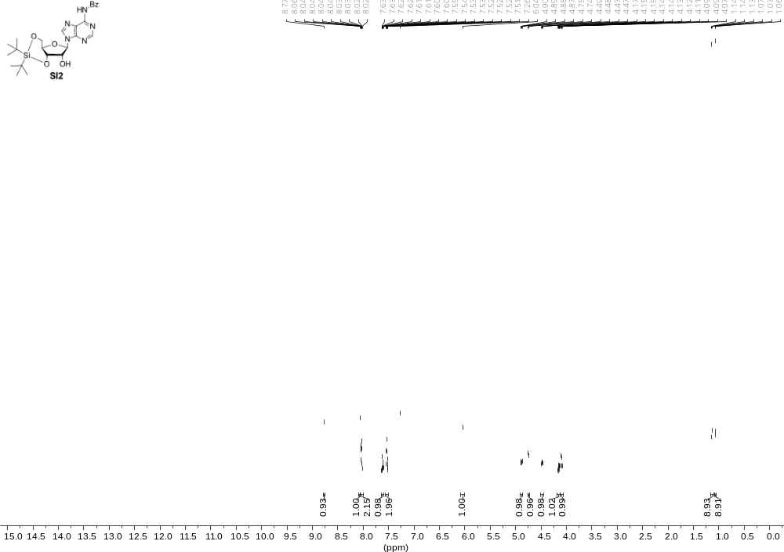
Figure S1. ¹H-NMR spectrum of SI2 at room temperature in CDCl₃ at 499 MHz.

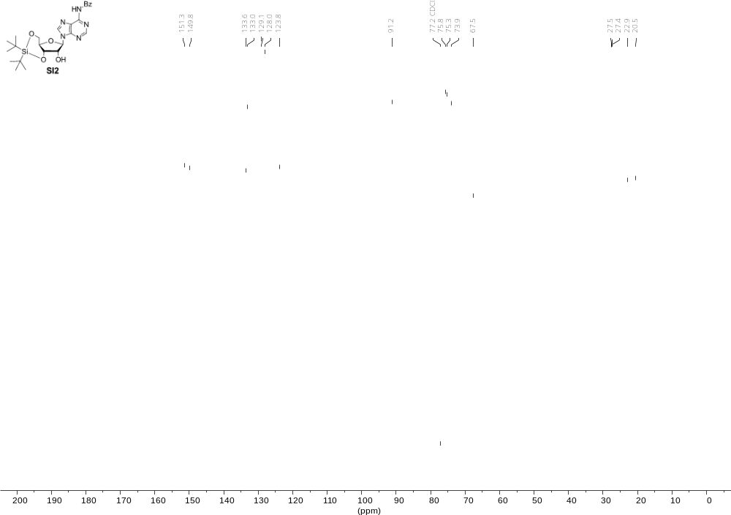
Figure S2. ¹³C-NMR spectrum of SI2 at room temperature in CDCl₃ at 126 MHz.

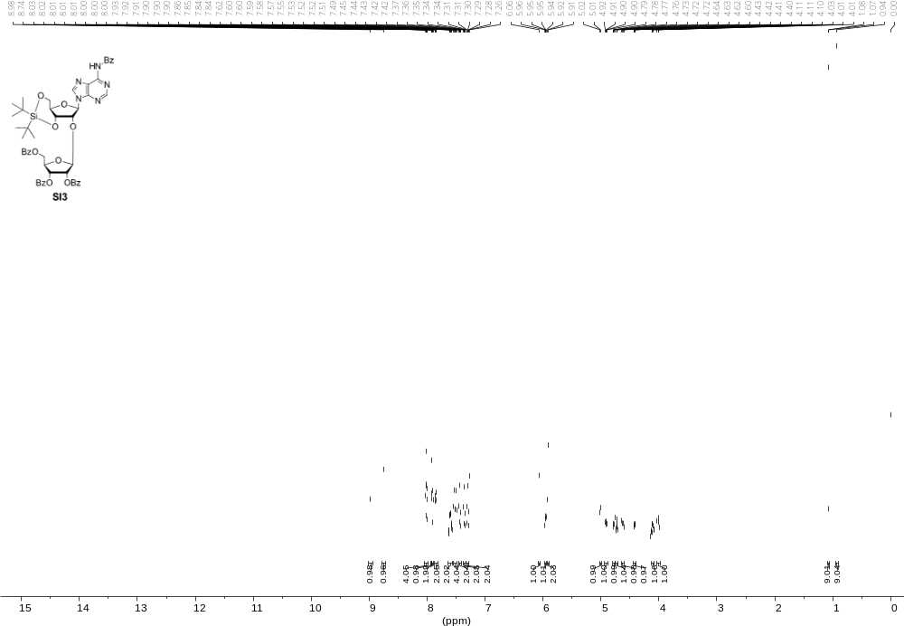
Figure S3. ¹H-NMR spectrum of SI3 at room temperature in CDCl₃ at 499 MHz.
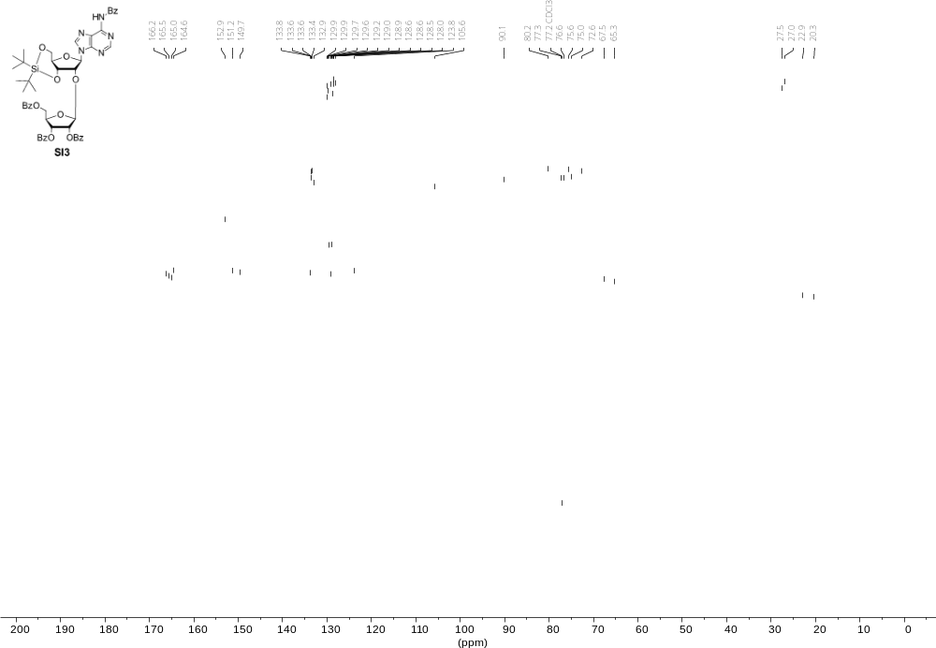
Figure S4. ¹³C-NMR spectrum of SI3 at room temperature in CDCl₃ at 126 MHz.
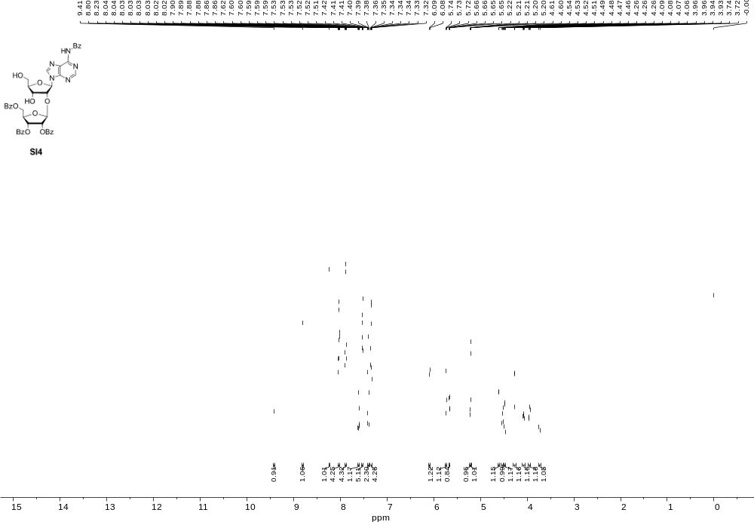
Figure S5. ¹H-NMR spectrum of SI4 at room temperature in CDCl₃ at 499 MHz.
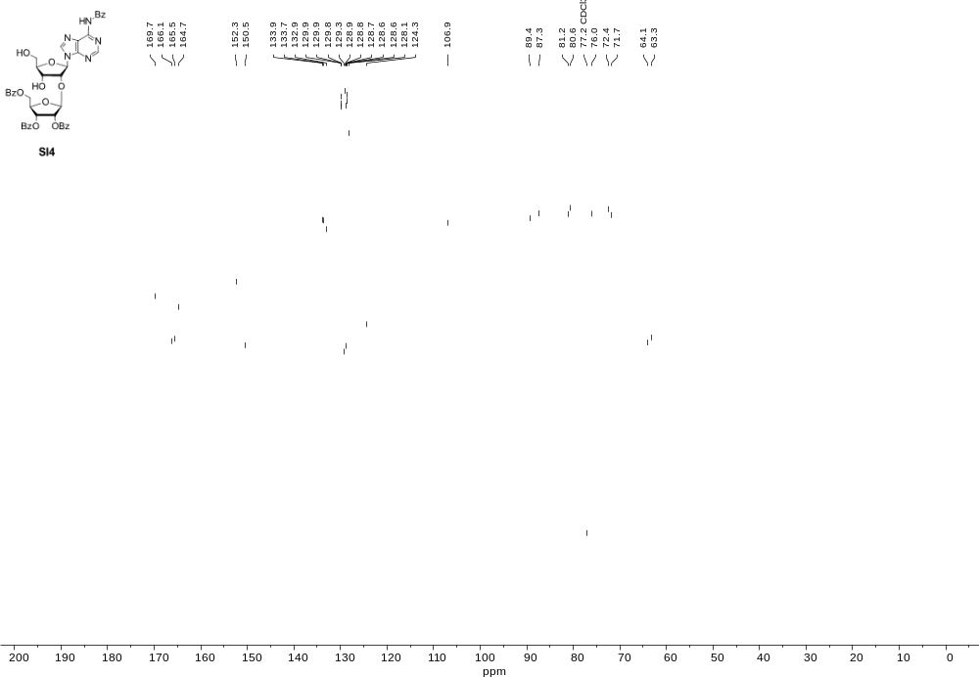
Figure S6. ¹³C-NMR spectrum of SI4 at room temperature in CDCl₃ at 126 MHz.
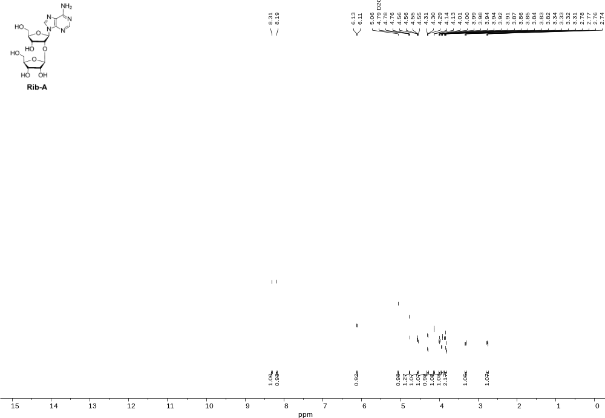
Figure S7. ¹H-NMR spectrum of Rib-A at room temperature in D₂O at 499 MHz.
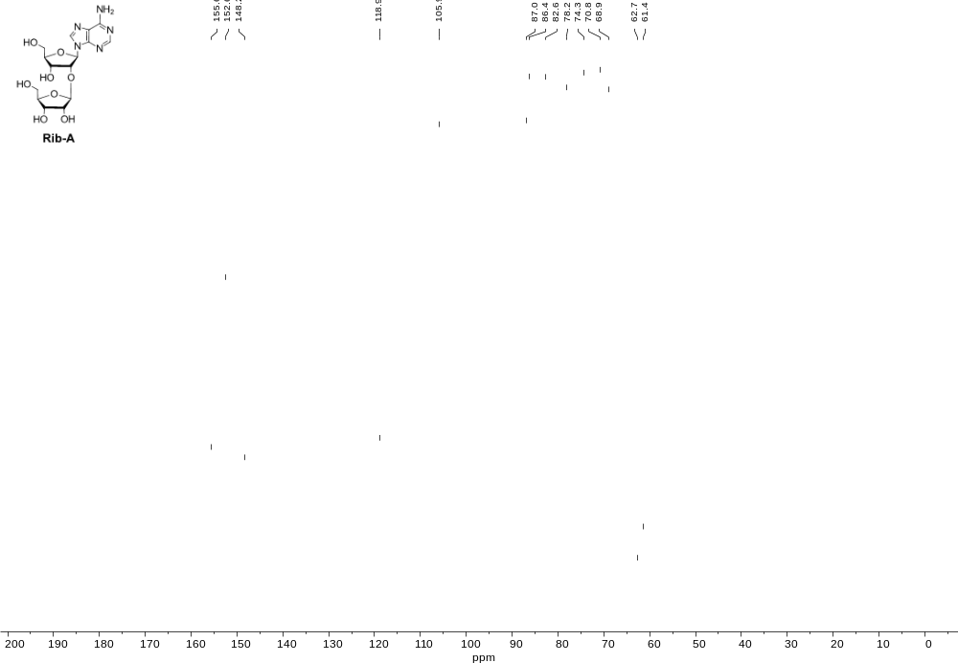
Figure S8. ¹³C-NMR spectrum of Rib-A at room temperature in D₂O at 126 MHz.
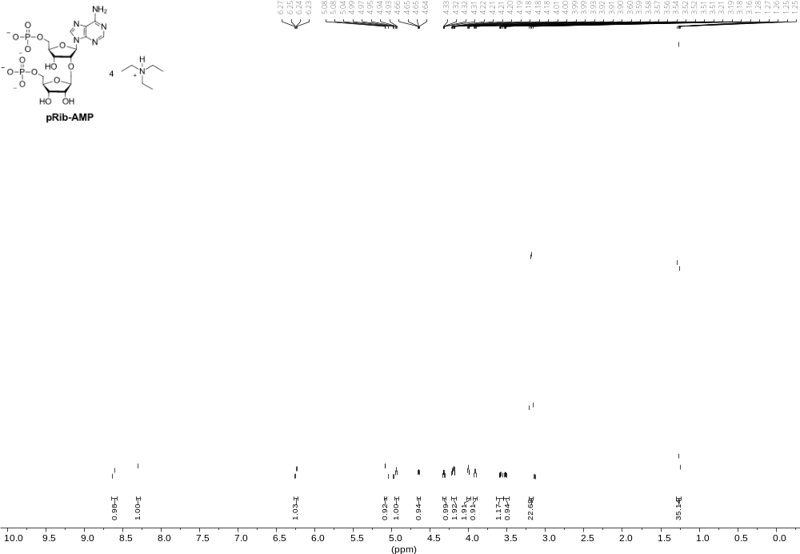
Figure S9. ¹H-NMR spectrum of pRib-AMP at room temperature in D₂O at 499 MHz.
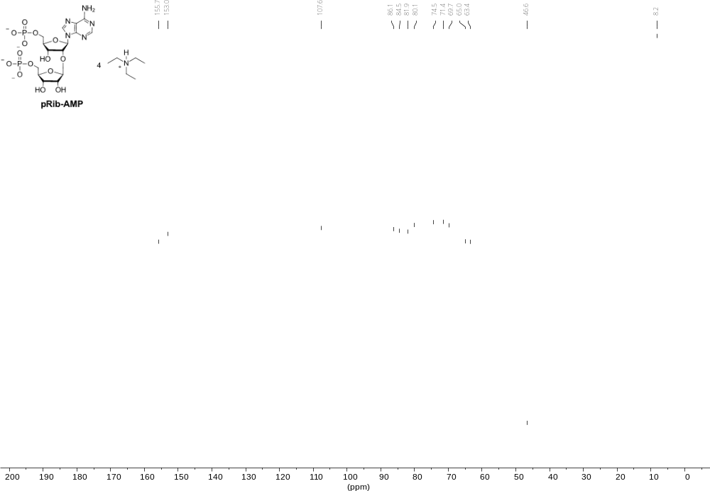
Figure S10. ¹³C-NMR spectrum of pRib-AMP at room temperature in D₂O at 126 MHz.
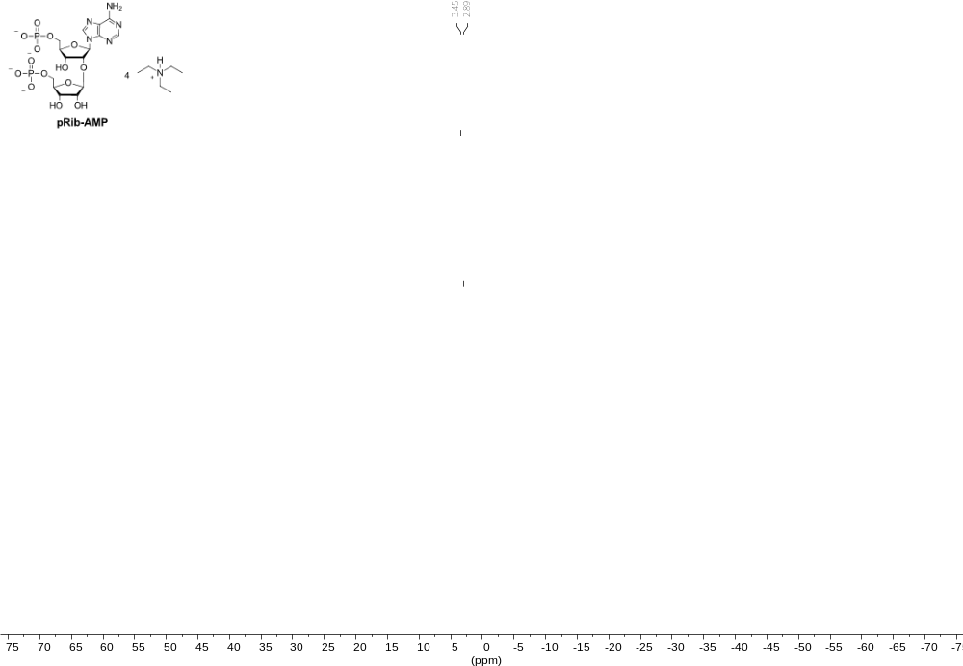
Figure S11. ³¹P-NMR spectrum of pRib-AMP at room temperature in D₂O at 121 MHz.
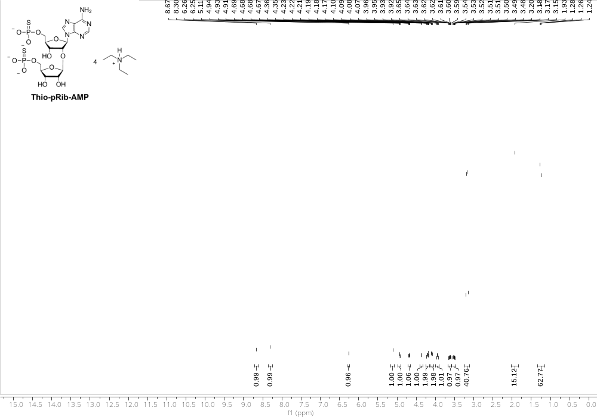
Figure S12: ¹H-NMR spectrum of Thio-pRib-AMP at room temperature in D₂O at 499 MHz.
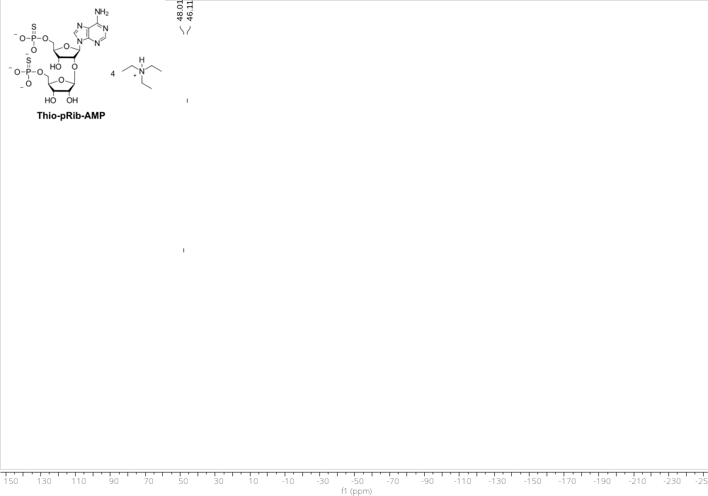
Figure S13: ³¹P-NMR spectrum of Thio-pRib-AMP at room temperature in D₂O at 121 MHz.

